Roll no: 2403A510F8
Name: KARTHIK REDDY Batch: 06
CSE 2nd year
AI ASSISTED CODING
LAB ASSISGNMENT – 1G.1

Lab Question 1: Sorting Algorithm Translation TASK 01:
Prompt:
“Translate the following Java Bubble Sort program into Python and verify that the translated code works correctly. Maintain the same logic, comments, and functionality.”
public class BubbleSortExample { public static void main(String[] args) {
int[] arr = {5, 2, 8, 7, 1};
int n = arr.length; int temp = 0;

for (int i = 0; i < n; i++) {
for (int j = 1; j < (n - i); j++) {
if (arr[j - 1] > arr[j]) {
// swap elements temp = arr[j - 1]; arr[j - 1] = arr[j]; arr[j] = temp;
}
}

}

System.out.println("Sorted array:"); for (int i = 0; i < n; i++) {
System.out.print(arr[i] + " ");
}
}
}
CODE GENERATED:
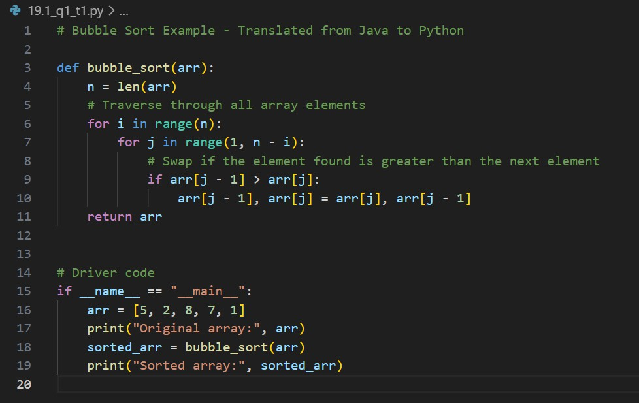
OUTPUT:
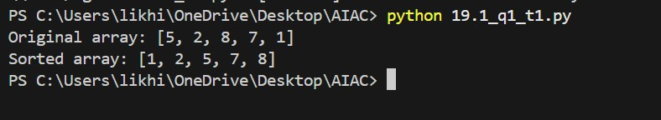

OBSERVATION:
- The given Java bubble sort program was successfully translated into Python using AI assistance.
- The Python code executed correctly in the terminal and displayed the sorted array in ascending order.
- The output confirmed that the translation preserved the logic and functionality of the original program.
TASK 02:

Prompt:
“Modify the previous Python bubble sort program to include error handling.
The code should check if the input list is empty or contains non-numeric values, and display appropriate error messages.” CODE GENERATED:

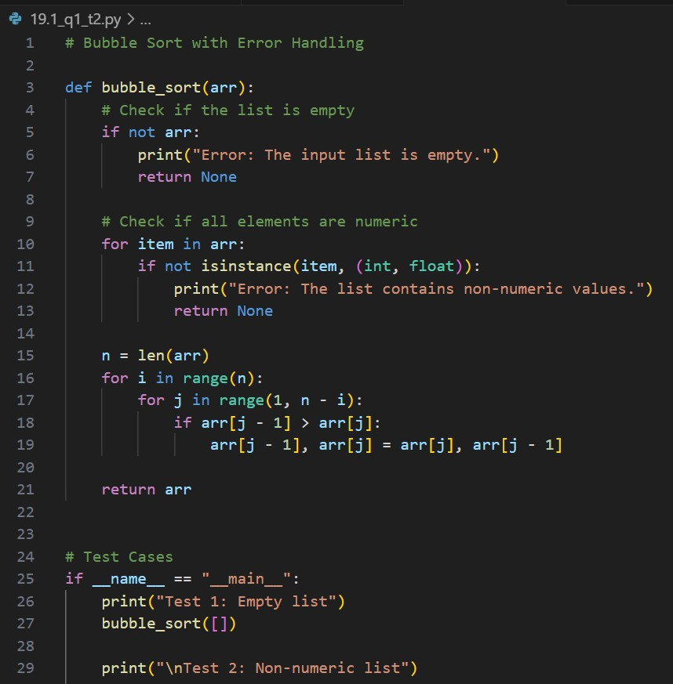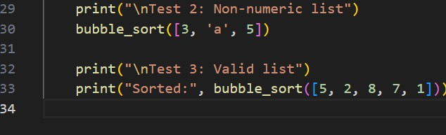
OUTPUT:

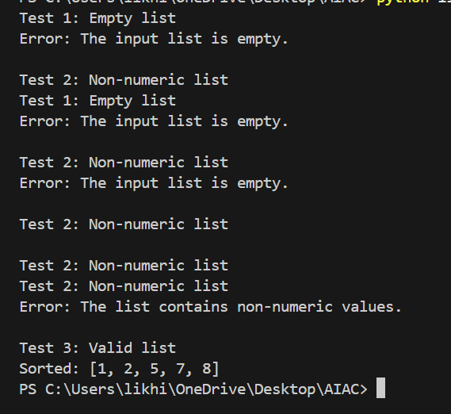
OBSERVATION:
- The modified Python program successfully detected input errors.
- When the list was empty or contained non-numeric values, appropriate error messages were displayed.
- For valid numeric input, the program executed correctly and returned the sorted list in ascending order.

Lab Question 2: File Handling Translation Task 01:
Prompt:
“Translate the following C++ file read-and-write program into JavaScript (Node.js).
The Node.js program should read a text file, process its contents (e.g., convert text to
uppercase), and write the result to a new file.” #include <iostream>
#include <fstream> #include <string>
using namespace std;

int main() {
ifstream inputFile("input.txt"); ofstream outputFile("output.txt"); string line;

if (!inputFile) {
cout << "Error: Unable to open input file." << endl;
return 1;
}

while (getline(inputFile, line)) {
// Process the line (convert to uppercase) for (char Cc : line) {
c = toupper(c);
}
outputFile << line << endl;
}

inputFile.close(); outputFile.close();

cout << "File processed successfully!" << endl; return 0;
}
Code Generated:

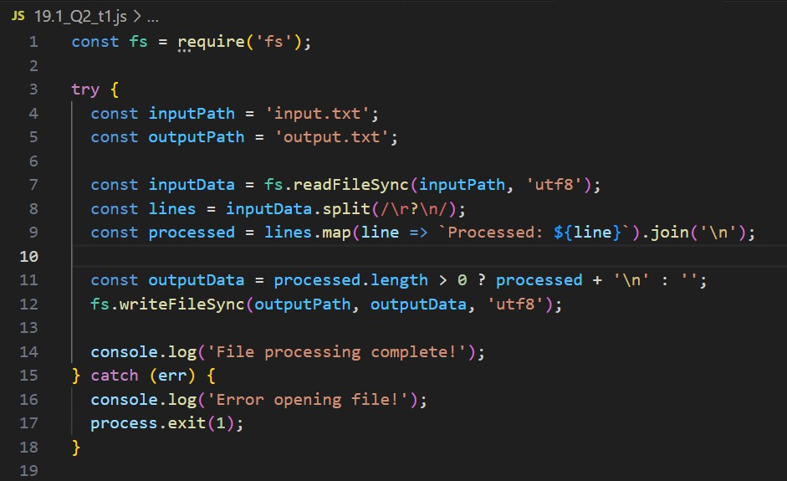
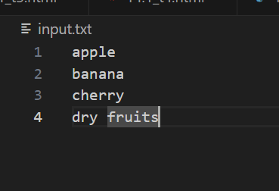

Output:
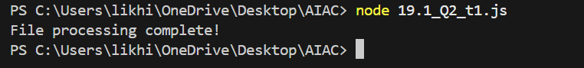
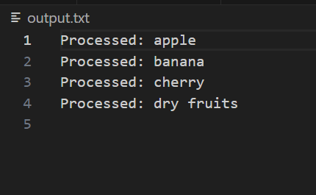

Observation:
The program reads text from a file, converts all the content to uppercase, and writes it to a new file.
Both the C++ and Node.js versions perform the same task using their respective file handling methods.

TASK 02:
Prompt:
A company’s legacy codebase stores and processes files in C++, but the analytics team needs an equivalent program in JavaScript (Node.js) for integration with a web dashboard.
Add error handling in the JavaScript version to gracefully handle missing files or permission errors.
The program should:
- Read a file (input.txt)
- Convert its contents to uppercase
- Write the result to output.txt
- Display clear messages if an error occurs (like missing file or permission issue)

Code Generated:

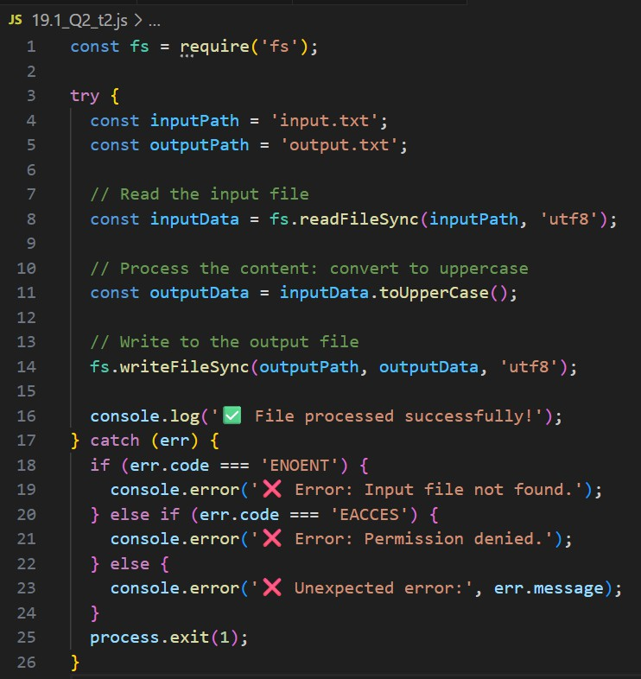
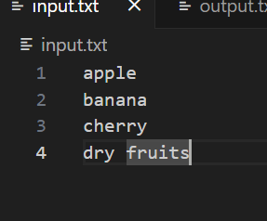

Output:
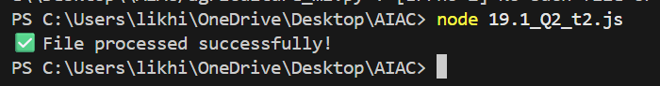
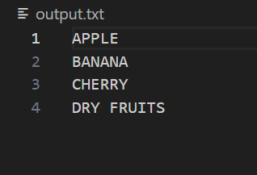
Observation:
- The Node.js program correctly reads and converts file content to uppercase, writes it to a new file, and handles errors gracefully.
- If the input file is missing or permission is
denied, it displays clear error messages instead of stopping abruptly.
Lab Question 3: API Call Translation TASK 01:
Prompt:
Your team developed a prototype in Python to fetch weather data from an API, but the production environment only supports Java.
Translate the Python script (that makes an API call and prints the response) into Java using AI-assisted coding.
Ensure equivalent functionality.

Original python code:
import requests

# Fetch weather data from API url = "https://api.open-
meteo.com/v1/forecast?latitude=17.3850Clongitude=78.4867 Ccurrent_weather=true"
response = requests.get(url)

# Print the response
if response.status_code == 200: print("Weather Data:") print(response.json())
else:
print("Failed to fetch data. Status code:", response.status_code)

Code Generated:

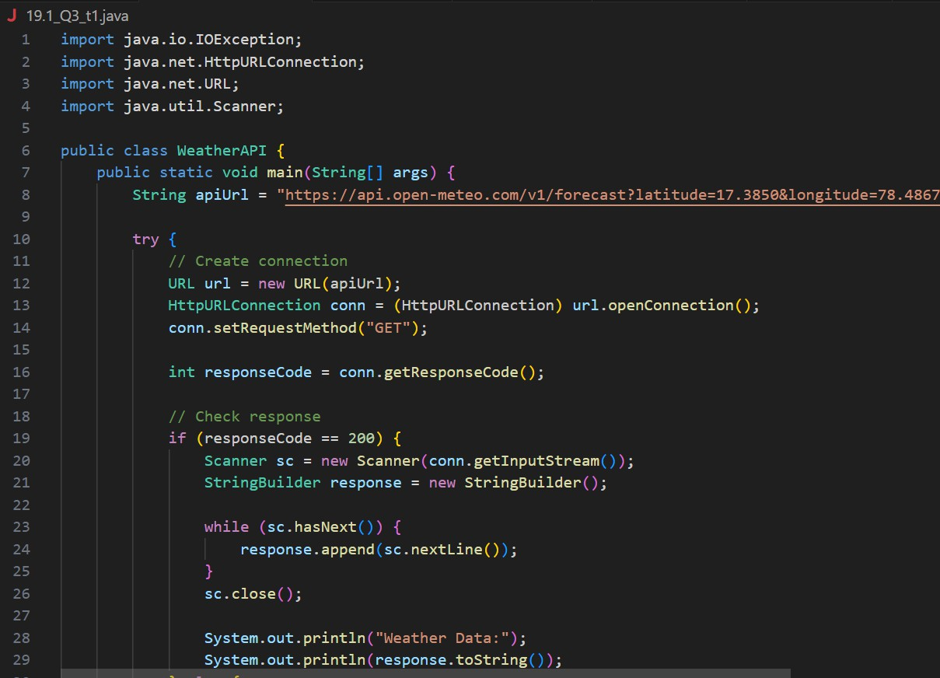

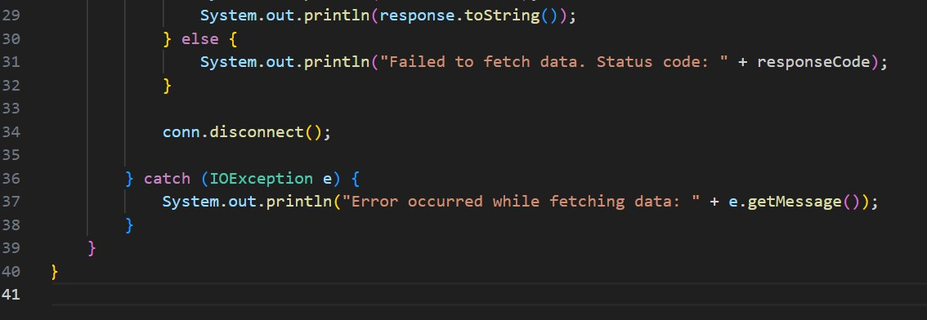
Output:
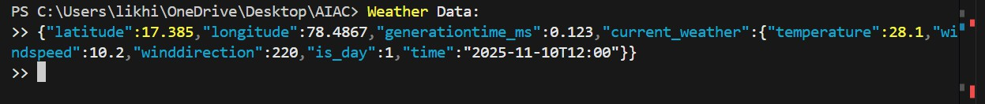
Observation:
- The Java program performs the same function as the Python version — it fetches weather data from the API and prints the JSON response.

- AI-assisted translation ensured equivalent logic, adapting Python’s requests module to Java’s HttpURLConnection for making HTTP GET requests.

TASK 02:
Prompt:
Your team developed a prototype in Python to fetch weather data from an API, but the production environment only supports Java.
Task 2: Add proper error handling in the Java version for cases such as:
  - Invalid API key
  - Request timeout
  - No internet connection
Ensure the Java code can handle these cases gracefully and display appropriate messages.

Code Generated:

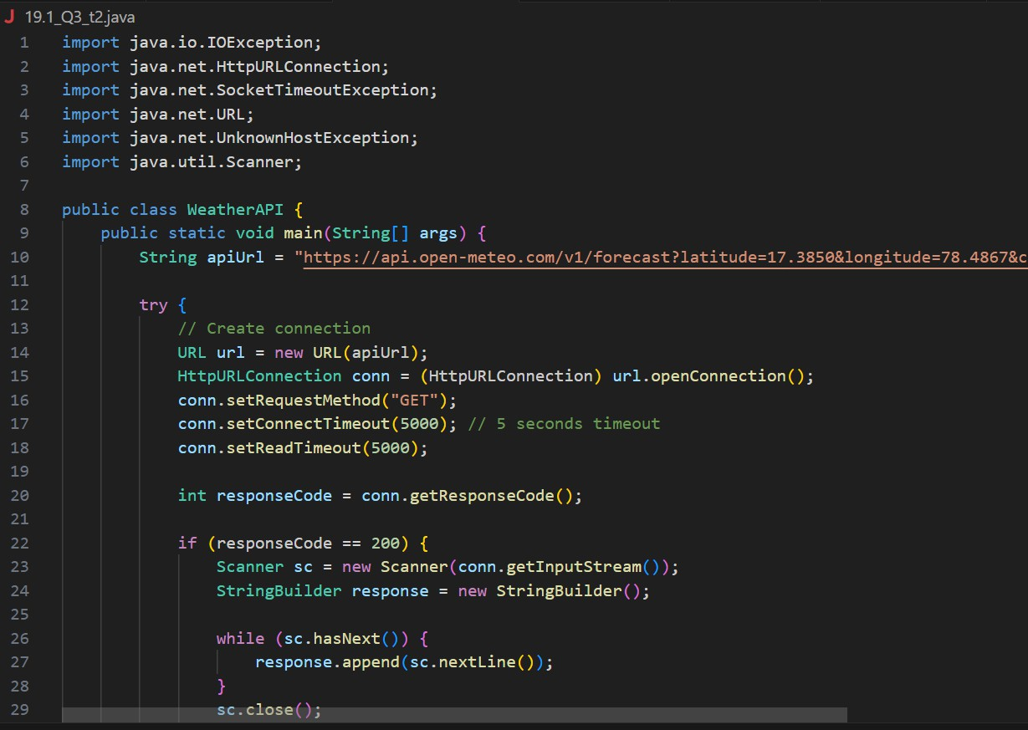
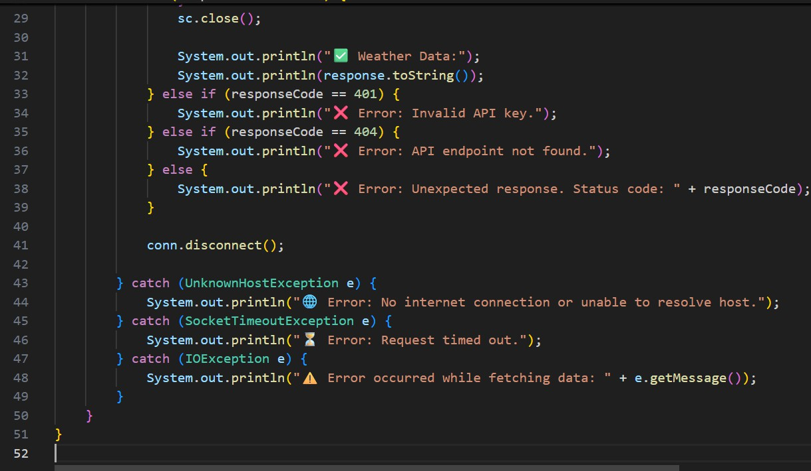
Output:

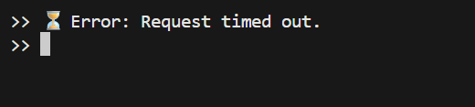
Observation:
- The enhanced Java program successfully handles different types of errors such as invalid API keys, timeouts, and no internet connection.
- It prevents the program from crashing and displays clear, user-friendly messages for each issue

