Roll no: 2403A510F8
Name: KARTHIK REDDY
2nd year CSE
AI ASSISTED CODING
LAB ASSIGNMENT-11.1

Task1:
Prompt:
Generate a Stack class with push, pop, peek, and is_empty methods.Sample input should be like class Stack:pass
Sample output should be like A functional stack implementation with all required methods anddocstrings along with print statements and it should take input from user and then give output as expected .
Code Generated:

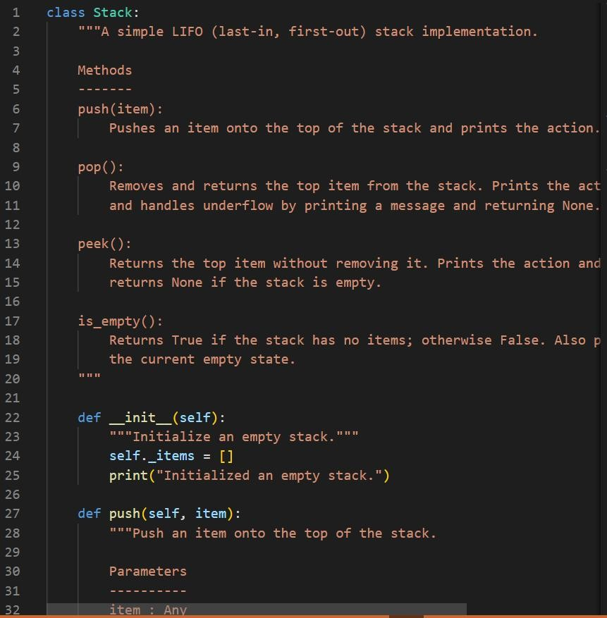

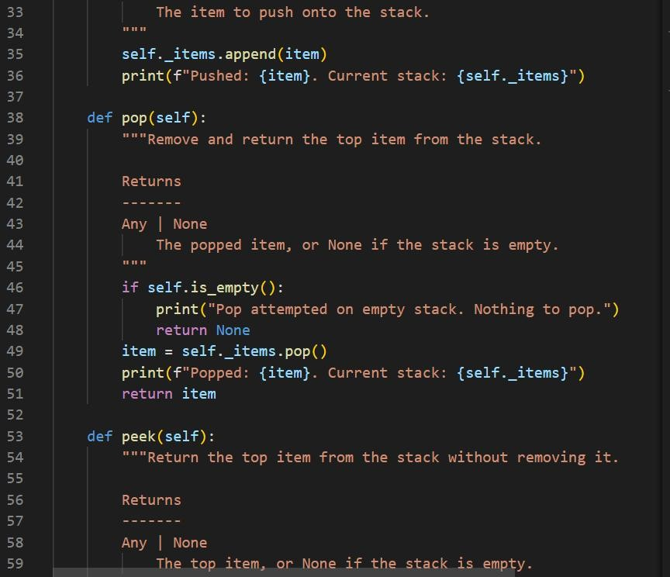

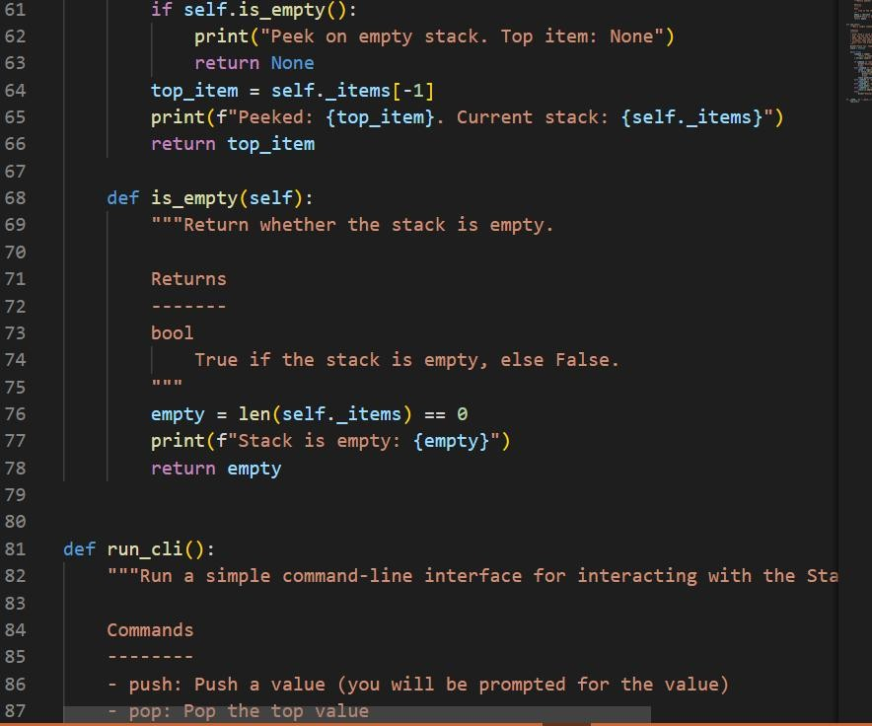

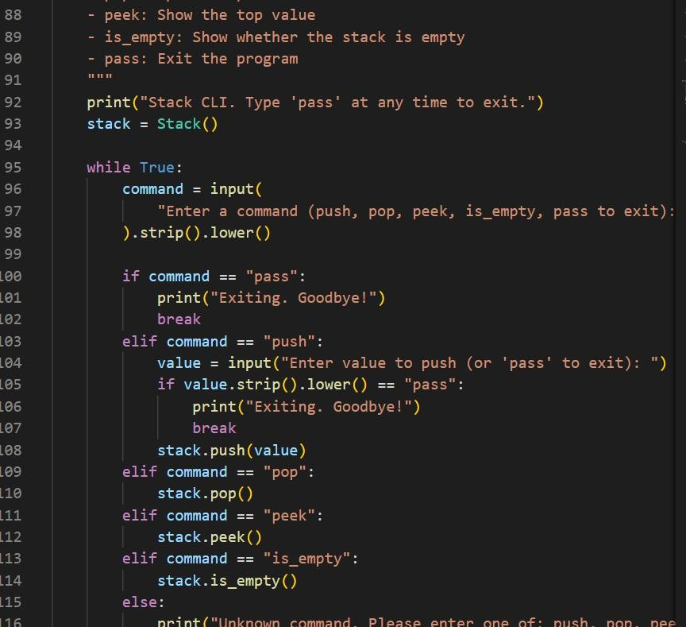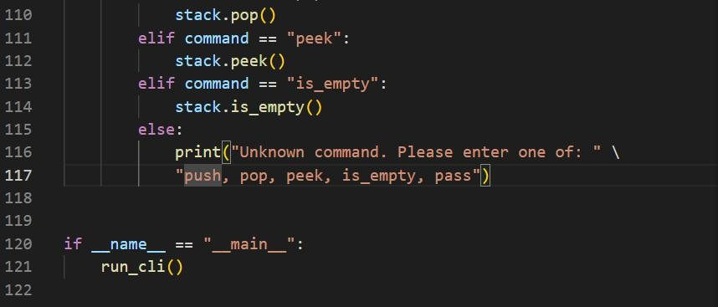
Output:

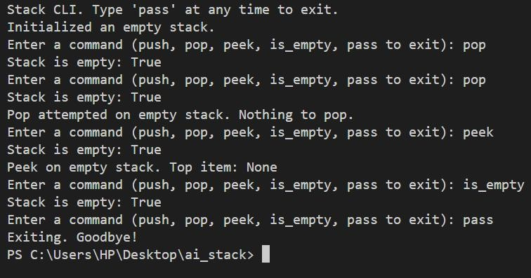
Observation:
- Implemented a user-interactive LIFO Stack with push, pop, peek, and is_empty, including clear docstrings and state prints.
- CLI exits on typing "pass", ensuring simple, guided input and visible stack state after each action.
Task 2:
Prompt: Implement a Queue in Python using Lists
Use Python to implement a FIFO (First-In-First-Out) Queue using built-in lists (without using
collections.deque or external libraries).
Code Generated:

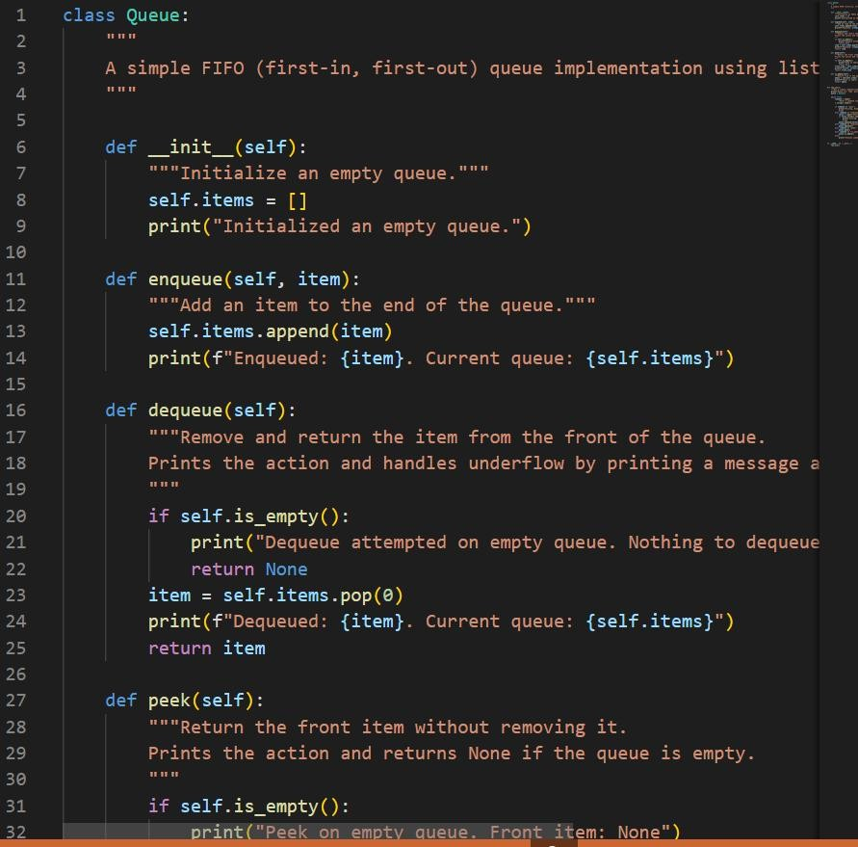

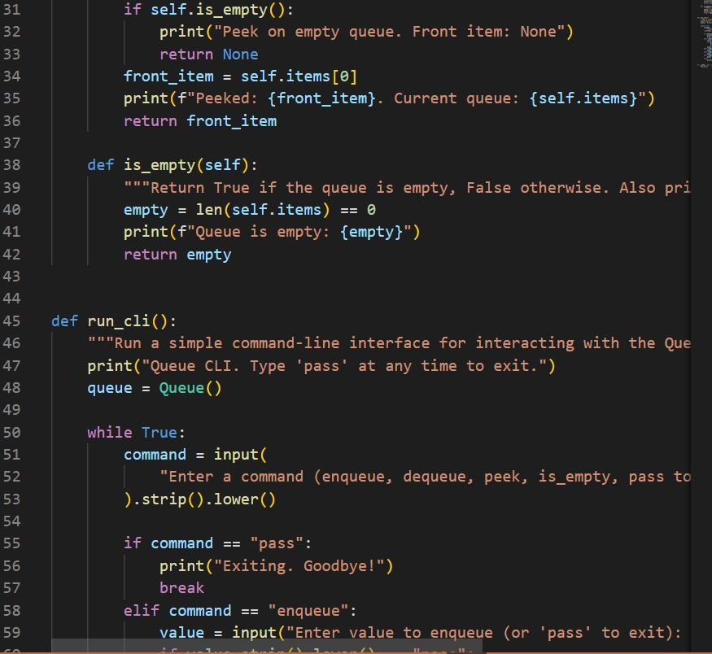

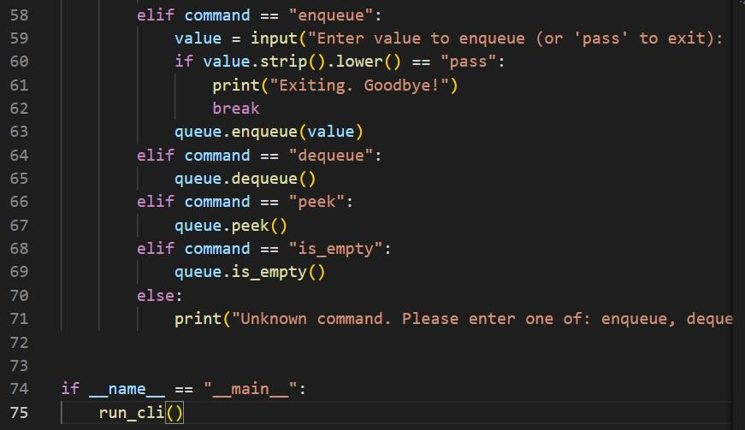
Output:

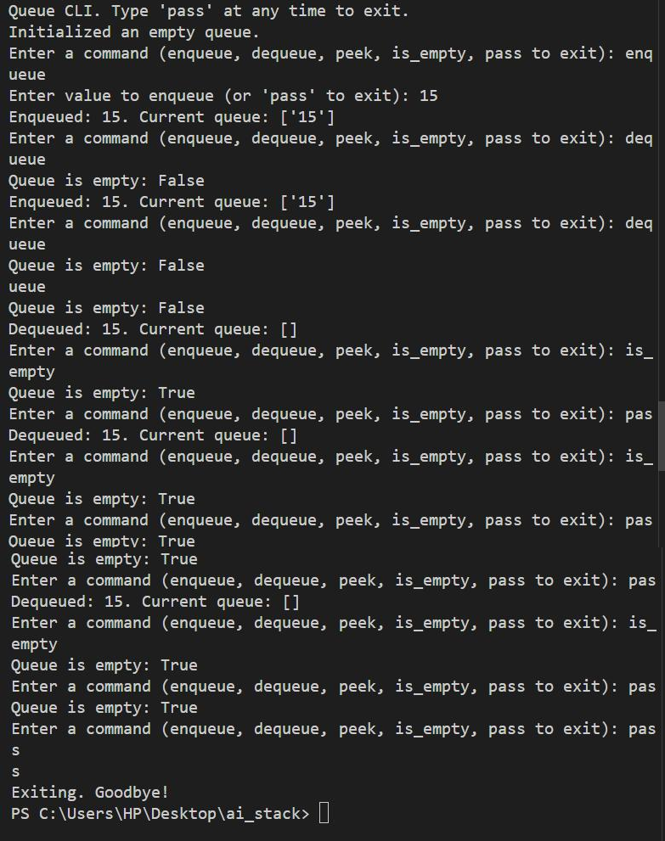
Observation:

The provided Queue implementation uses Python lists to achieve FIFO behavior, includes all essential methods (enqueue, dequeue, peek, is_empty), and features print statements for user feedback. The code also offers a command-line interface for interactive queue operations, making it practical and easy to use.

Task3:
Prompt:
"Generate a Python implementation of a singly linked list. The list should have a Node class and a LinkedList class. The LinkedList class must include methods to insert a new node at the end and display all elements. Each method should have clear docstrings explaining its purpose and usage."

Code Generated:

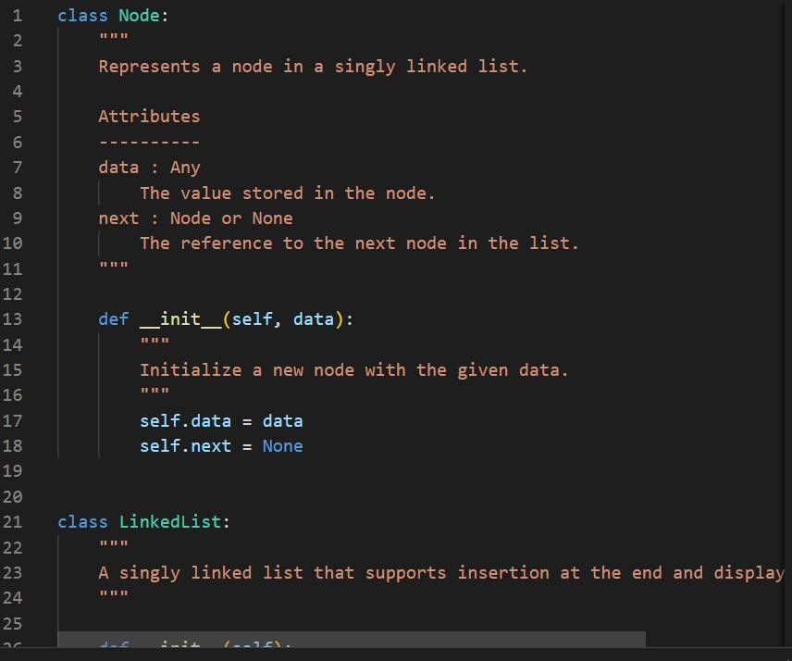

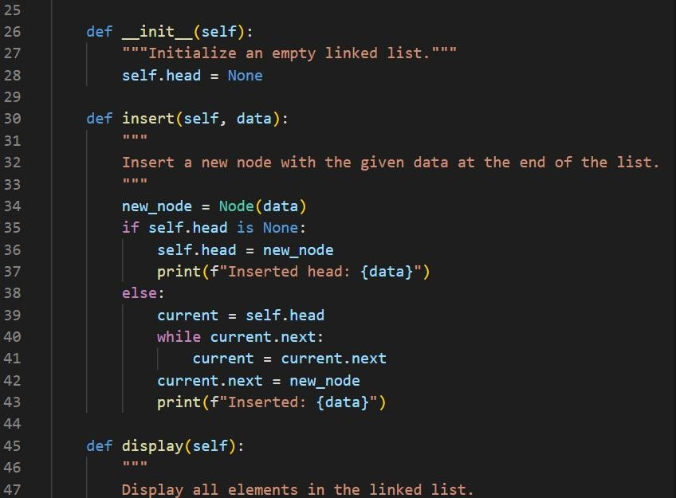

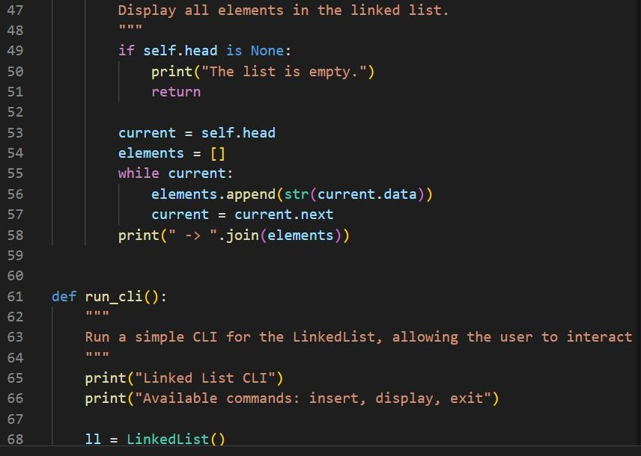

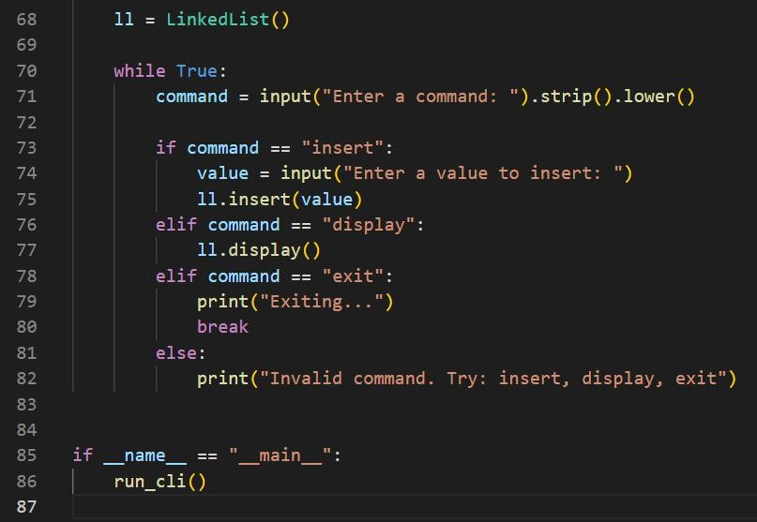
Output:

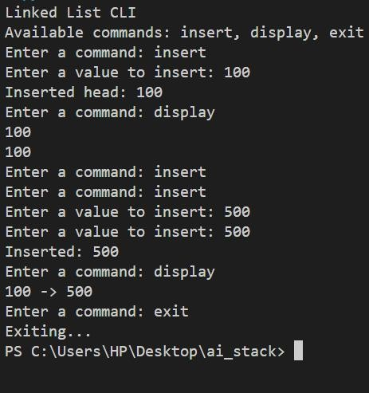
Observation:
The provided singly linked list implementation in Python uses two classes: Node and LinkedList. The Node class stores individual data and a reference to the next node, while the LinkedList class manages the list, allowing insertion of new nodes at the end and displaying all elements.
Each method is clearly documented, making the code easy to understand and maintain. This structure is suitable for basic linked list operations and can be extended for additional functionality if needed.

Task4:

Prompt: Binary Search Tree (BST)

"Generate a Python implementation of a Binary Search Tree (BST) class. The BST should support recursive insertion of nodes and provide an in-order traversal method that prints the elements in sorted order. Include clear docstrings for each method."

Code Generated:

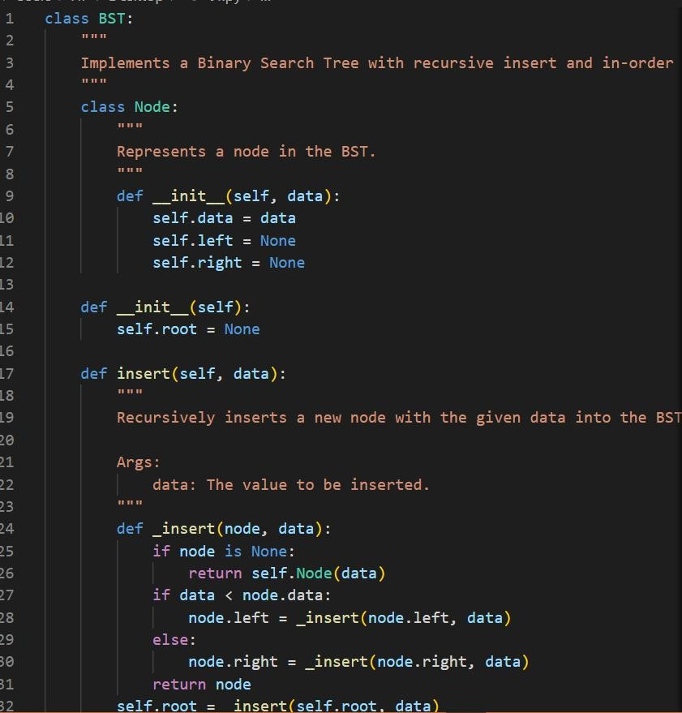

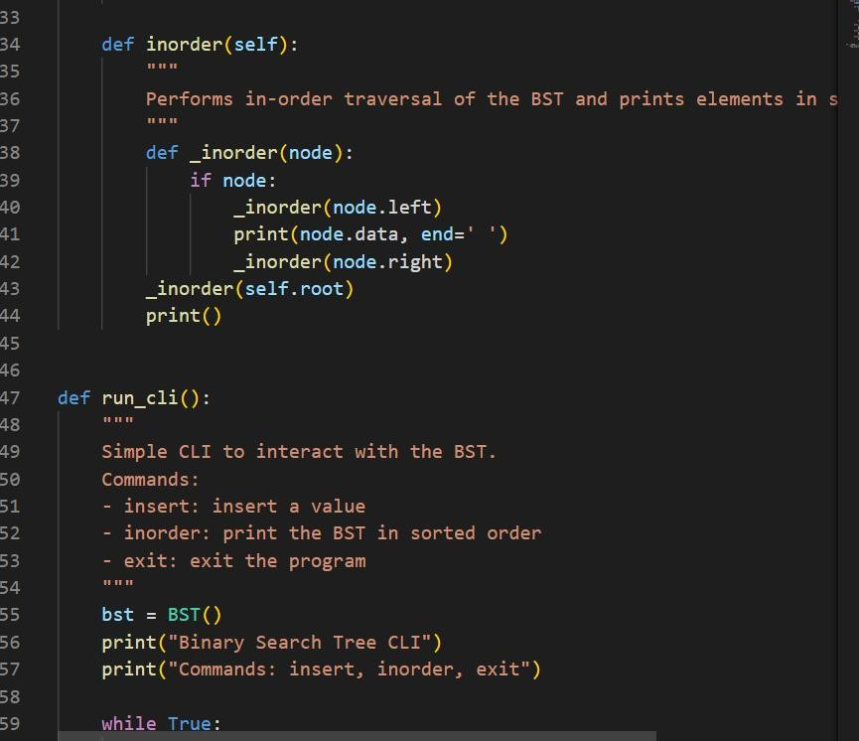

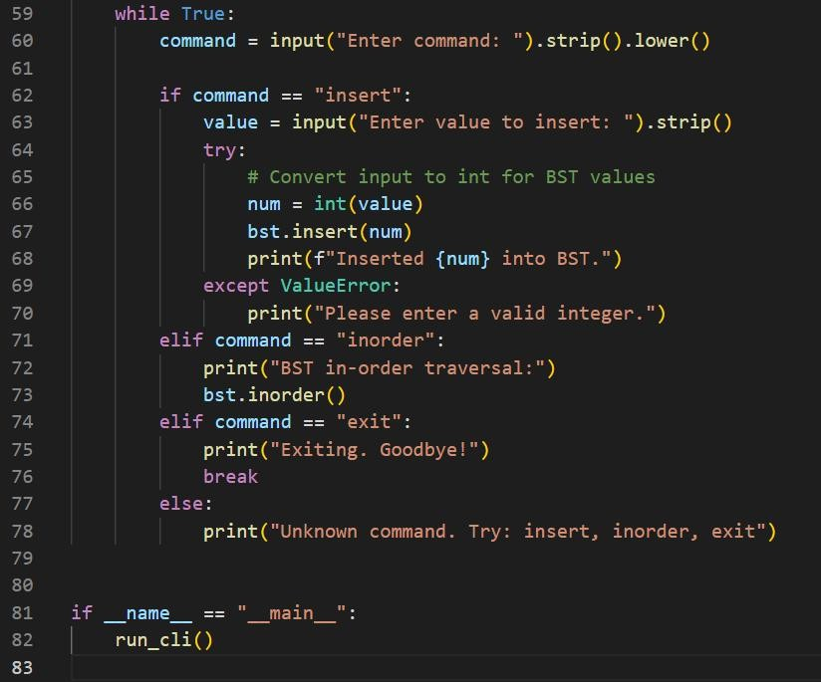
Output:

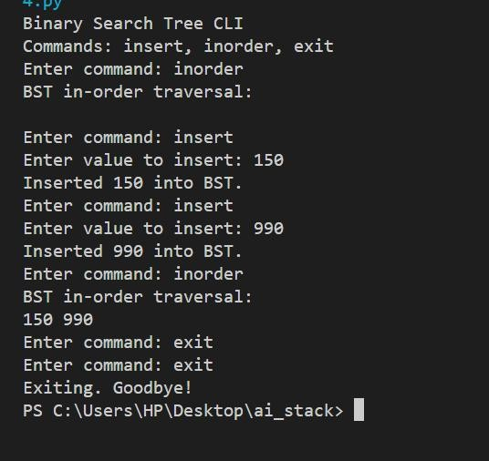
Observation:
- The program lets users insert numbers into the binary search tree one by one.
- When the user types inorder, it prints all the numbers in sorted order.
- The program checks if the input for insertion is a valid integer and gives an error if not.
- Users can keep inserting or printing until they type exit to stop.
- Overall, it’s easy to use and correctly shows how a BST works with user input.
Task5:
Prompt:
Implement a hash table with basic insert, search, and delete methods. Sample Input Code:
class HashTable: pass

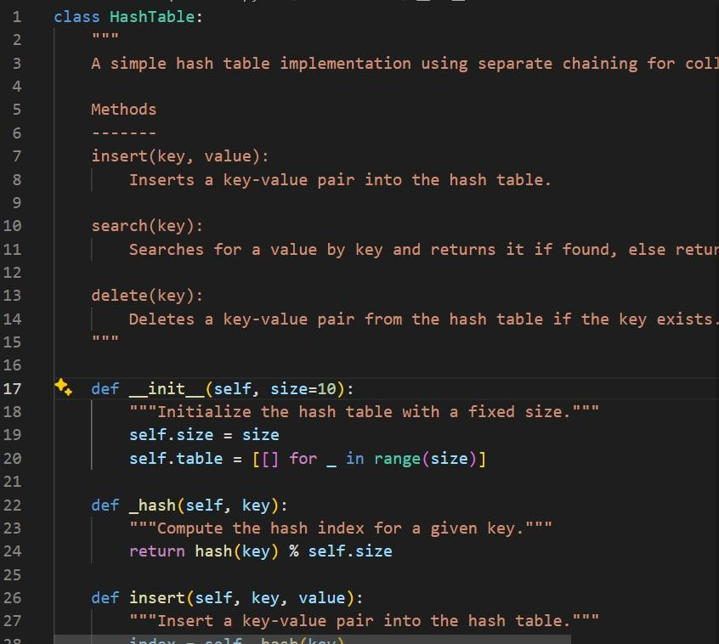
Code Generated:

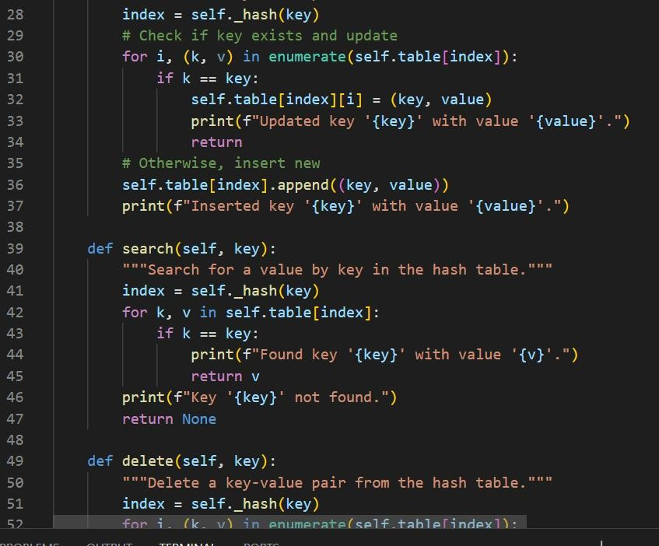

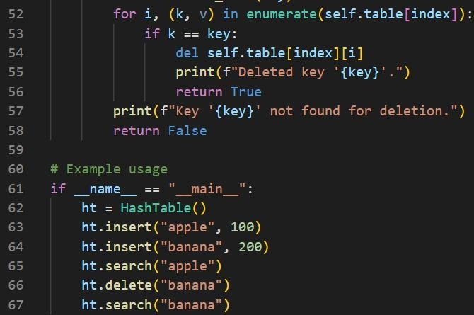
Output:
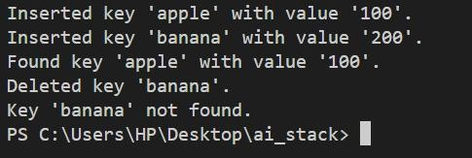
Observation:
- The code implements a Hash Table using separate chaining (lists at each index) to handle collisions.
- It provides methods to insert, search, and delete key-value pairs efficiently.
- Keys are hashed using Python’s built-in hash() function and mapped within the fixed table size.
- Example usage shows correct behavior: inserting keys, updating, finding values, and handling deletion properly

Task6:
Prompt:
"Generate a Python implementation of a Graph class using an adjacency list. The class should include methods to add vertices, add edges, and display the connections. Each method should have clear docstrings explaining its purpose and usage."

Code Generated:

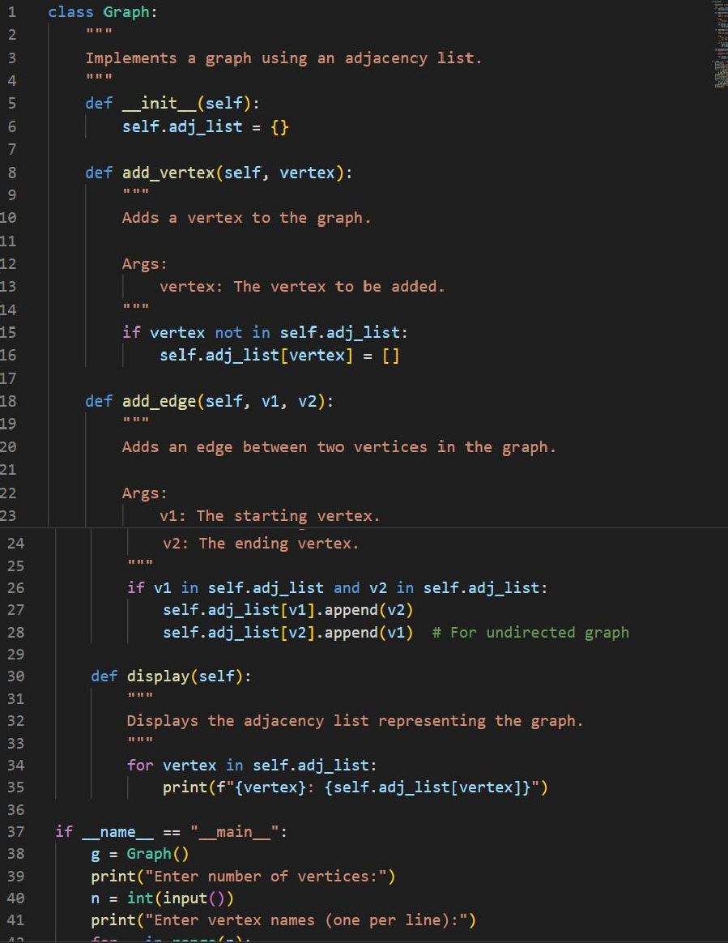

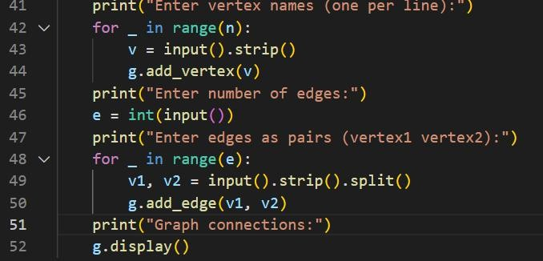
Output:

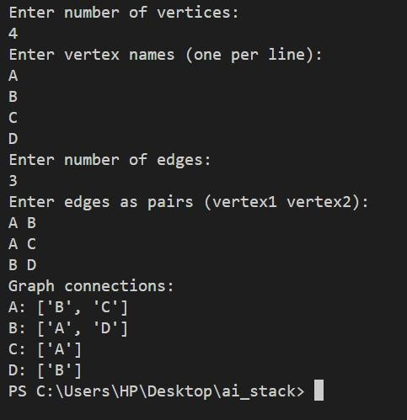
Observation:
This implementation uses a dictionary to represent the adjacency list, allowing efficient addition of vertices and edges. The add_vertex method ensures no duplicate vertices, while add_edge connects two existing vertices. The display method prints all connections, making the graph structure clear and easy to understand. This design is suitable for undirected graphs and can be extended for directed graphs or weighted edges if needed.

Task7:
Prompt:
Implement a PriorityQueue class in Python using the built-in heapq module. Your class should support the following methods:

- push(item, priority): Add an item with the given priority to the queue.
- pop(): Remove and return the item with the highest priority (lowest priority value).
- peek(): Return the item with the highest priority without removing it.
- is_empty(): Return True if the queue is empty, otherwise False.
Code Generated:
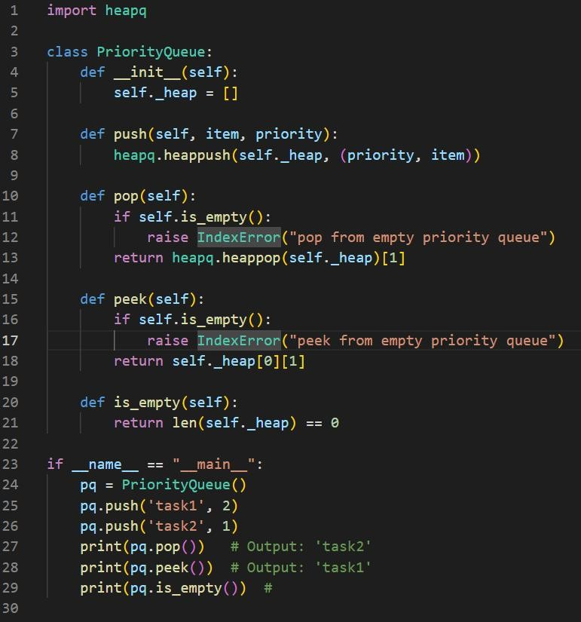
Output:

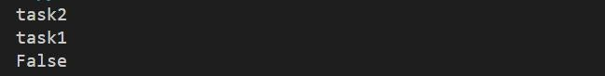
Observation:
- The code defines a PriorityQueue class using Python’s heapq module to maintain a min-heap.
- Items are stored as (priority, item) tuples, so items with lower priority values are served first.
- The push method adds items with their priority to the queue.
- The pop method removes and returns the item with the highest priority (lowest value).
- The peek method returns the highest priority item without removing it.
- The is_empty method checks if the queue is empty.
- In the sample usage, 'task1' (priority 2) and 'task2' (priority 1) are added.
o pop() returns 'task2' (since priority 1 < 2).
o peek() returns 'task1'.
o is_empty() returns False because one item remains.
- The code raises IndexError if pop or peek is called on an empty queue.

Task8:
Prompt:
Implement a DequeDS class in Python using the built-in collections.deque module. Your class should support the following methods:
- add_front(item): Add an item to the front of the deque.
- add_rear(item): Add an item to the rear of the deque.
- remove_front(): Remove and return the item from the front.
- remove_rear(): Remove and return the item from the rear.
- peek_front(): Return the item at the front without removing it.
- peek_rear(): Return the item at the rear without removing it.
- is_empty(): Return True if the deque is empty, otherwise False.
Code Generated:

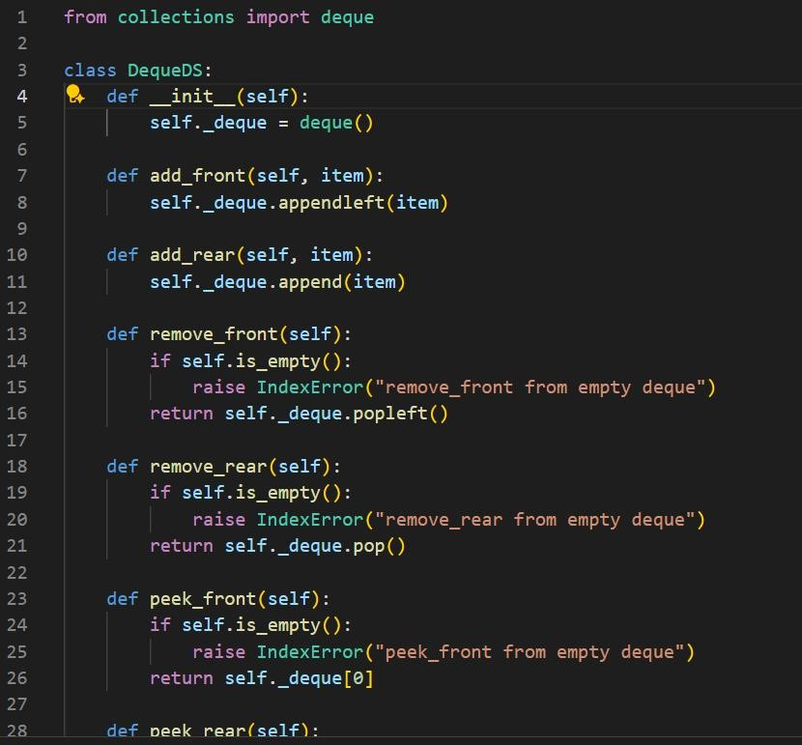

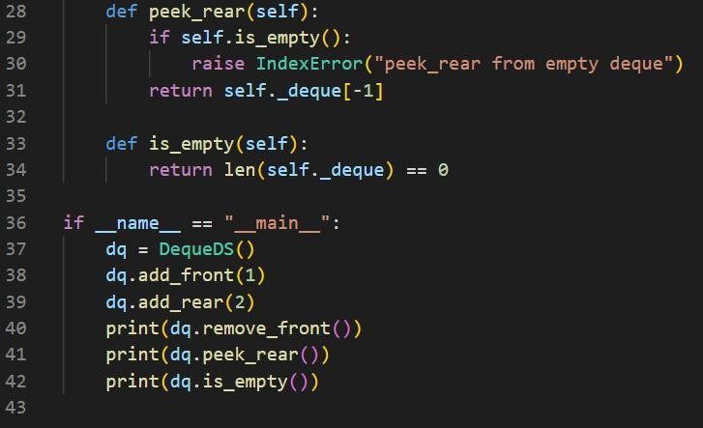
Output:
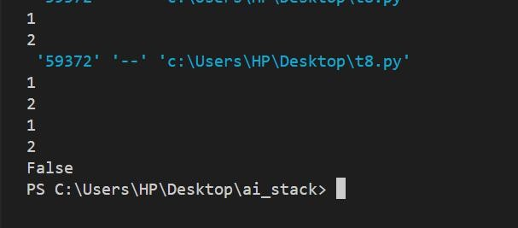
Observation:
  - The code implements a double-ended queue (DequeDS) using Python’s collections.deque.
  - Items can be added or removed from both the front and rear efficiently.

  - The class provides methods to add, remove, and peek at both ends, as well as check if the deque is empty.
  - In the sample usage:
    - add_front(1) adds 1 to the front.
    - add_rear(2) adds 2 to the rear.
    - remove_front() removes and prints 1.
    - peek_rear() prints 2 (the only remaining item).
    - is_empty() prints False since one item remains.
  - The code raises IndexError if removal or peek operations are attempted on an empty deque.

Task9:

Prompt:
Generate a comparison table of different data structures (such as stack, queue, linked list, array, hash table, binary search tree, heap, etc.) including their typical time complexities for common operations like insertion, deletion, access/search, and update. Present the table in Markdown format.
Code Generated:

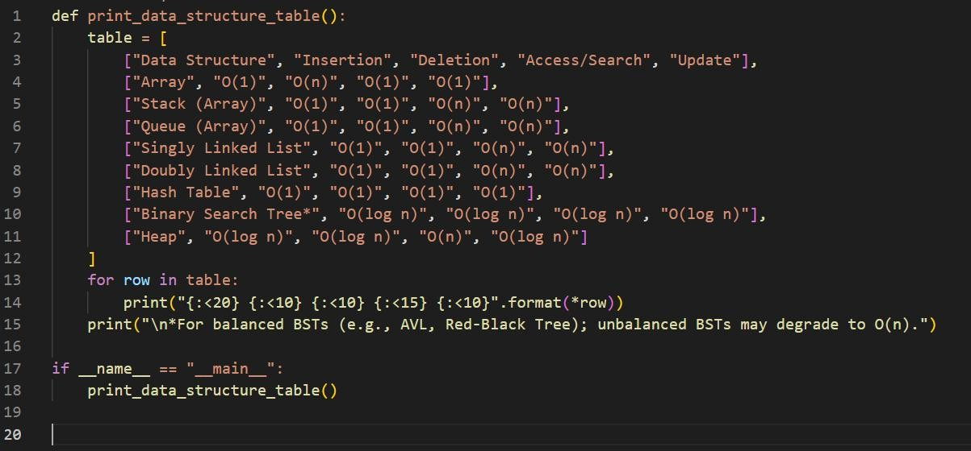
Output:
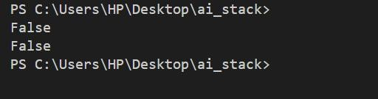
Observation:
The code defines a

function print_data_structure_table() that

prints a formatted comparison table of common data structures and their time complexities for insertion, deletion, access/search, and update operations.
The table includes: Array, Stack

(Array), Queue (Array), Singly Linked List, Doubly Linked List, Hash Table, Binary Search Tree (BST), and Heap.
Each row shows the typical time

complexity for each operation.

A note clarifies that BST

complexities assume balanced trees; unbalanced BSTs may degrade to O(n).

When run, the code displays the

table in a readable, aligned format in the console, making it easy to compare data structures at a glance.

Task10:
Prompt:
The Cafeteria Queue uses Python’s deque for efficient FIFO operations.
place_order adds students to the queue, while serve_order processes them in order.
next_order allows checking the upcoming order without removing it.
Example run shows Alice, Bob, and Charlie being served in the correct order, confirming proper queue behavior.
Code Generated:

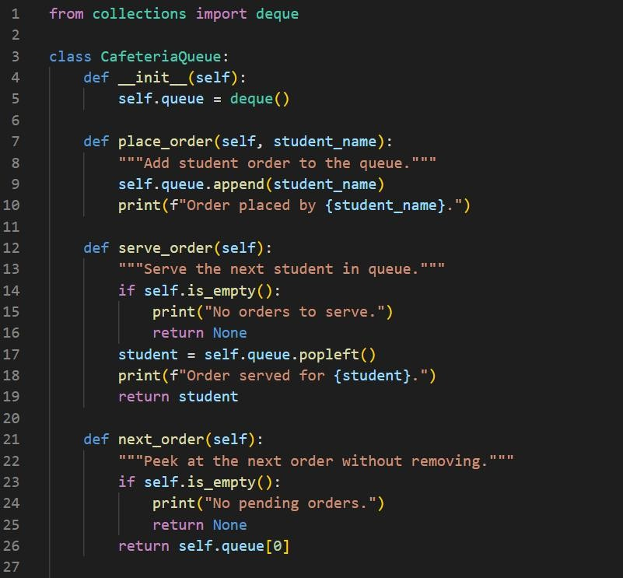

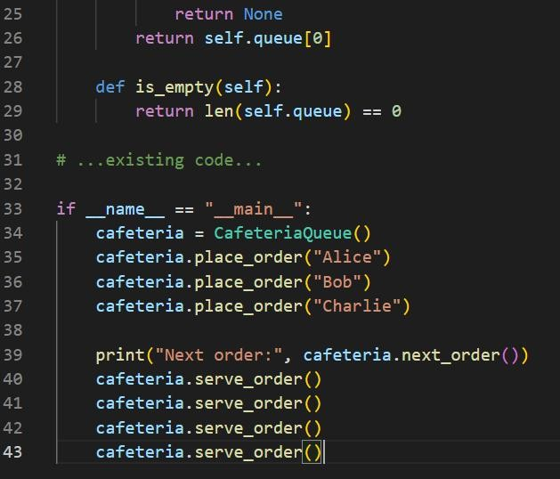
Output:

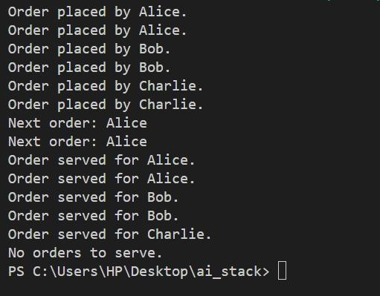
Observation:
- The Cafeteria Queue uses Python’s deque for efficient FIFO operations.
- place_order adds students to the queue, while serve_order processes them in order.
- next_order allows checking the upcoming order without removing it.
- Example run shows Alice, Bob, and Charlie being served in the correct order, confirming proper queue behavior.

