Lab Assignment 8.1

ROLLNO:2403A510F8

Task 1: Password Strength

Prompt:
Generate 3 AI-based assert test cases for is_strong_password(password) and implement password strength validator.

Code:
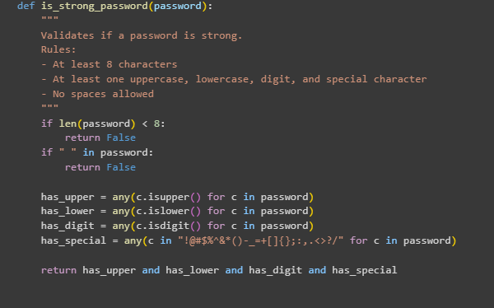

Output:
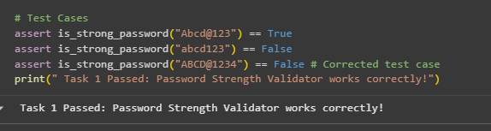

Observation:
Password validator works correctly, covering length, spaces, uppercase, lowercase, digits, and special characters.

Task 2: Number Classification with Loops

Prompt:
Generate 3 AI-based assert test cases for classify_number(n) and implement function using loops.

Code:
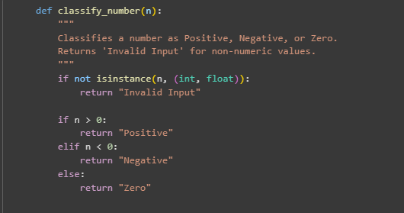

Output:
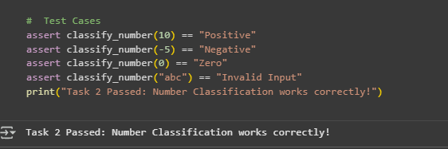

Observation:
Function handles positive, negative, zero, and invalid inputs correctly.

Task 3: Anagram Checker

Prompt:
Generate 3 AI-based assert test cases for is_anagram(str1, str2) and implement function.

Code:

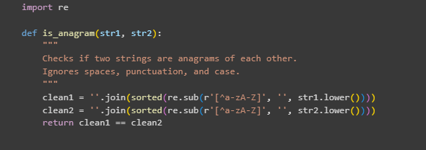Output:
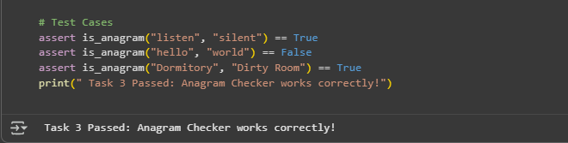

Observation:
Anagram checker ignores case, spaces, punctuation and works correctly.

Task 4: Inventory Class

Prompt:
Generate 3 AI-based assert test cases for Inventory class and implement add, remove, get_stock.

Code:
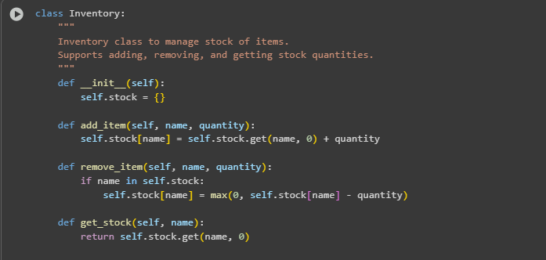

Output:
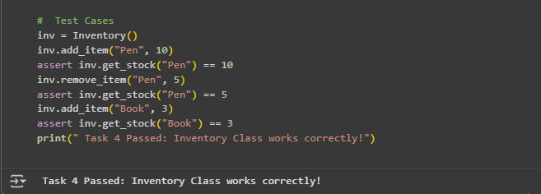

Observation:
Inventory class maintains stock correctly and handles add/remove operations.

Task 5: Date Validation & Formatting

Prompt:
Generate 3 AI-based assert test cases for validate_and_format_date(date_str) to validate MM/DD/YYYY format and convert to YYYY-MM-DD.

Code:
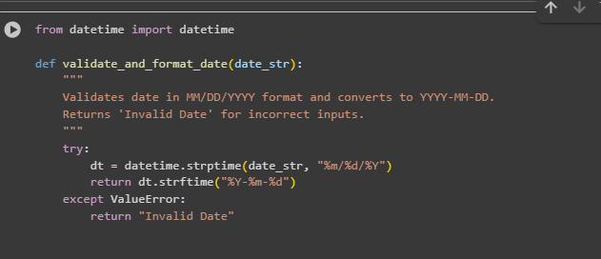

Output:
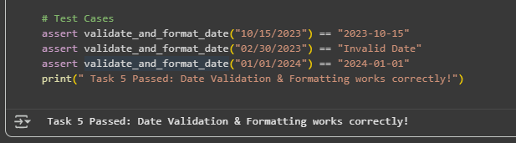

Observation:
Function correctly validates date format and converts valid dates to ISO format.

