AI ASSISTED CODING

LAB ASSIGNMENT: 1.3

NAME: KARTHIK REDDY
ROLLNO:2403A510F8
BATCH: 06
BRANCH: CSE
SUB: AI ASSISTED CODING TASK - 01
Screen shot-1


Screen shot-2

Screen shot-3

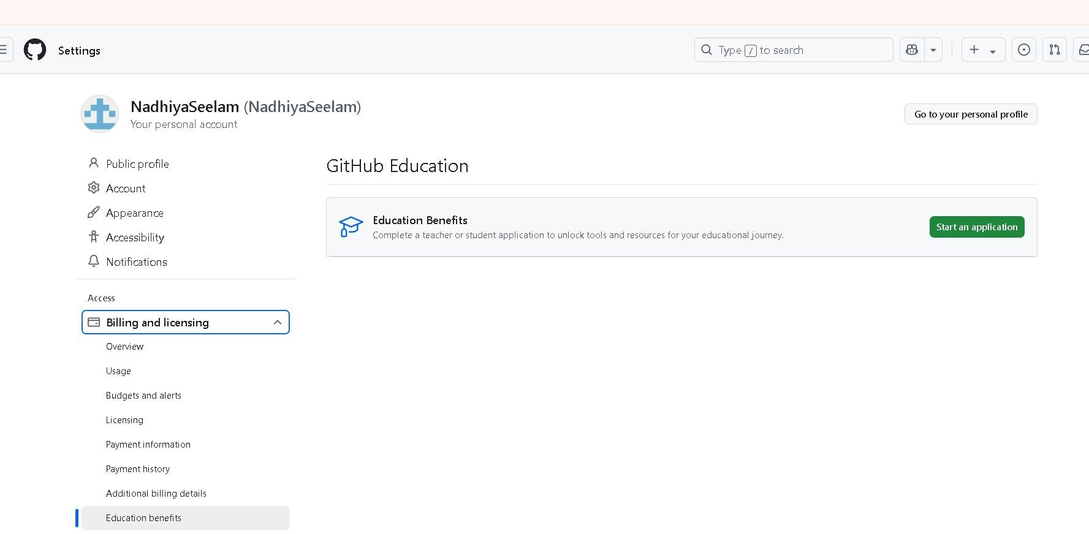

Screen shot-4

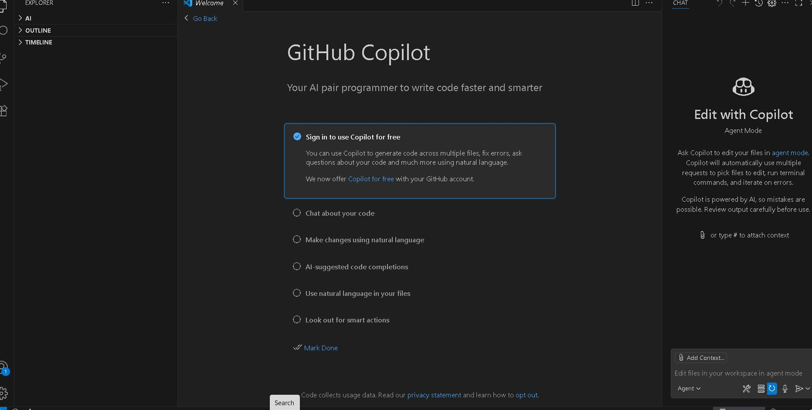
Screen shot-5


Screen shot-6

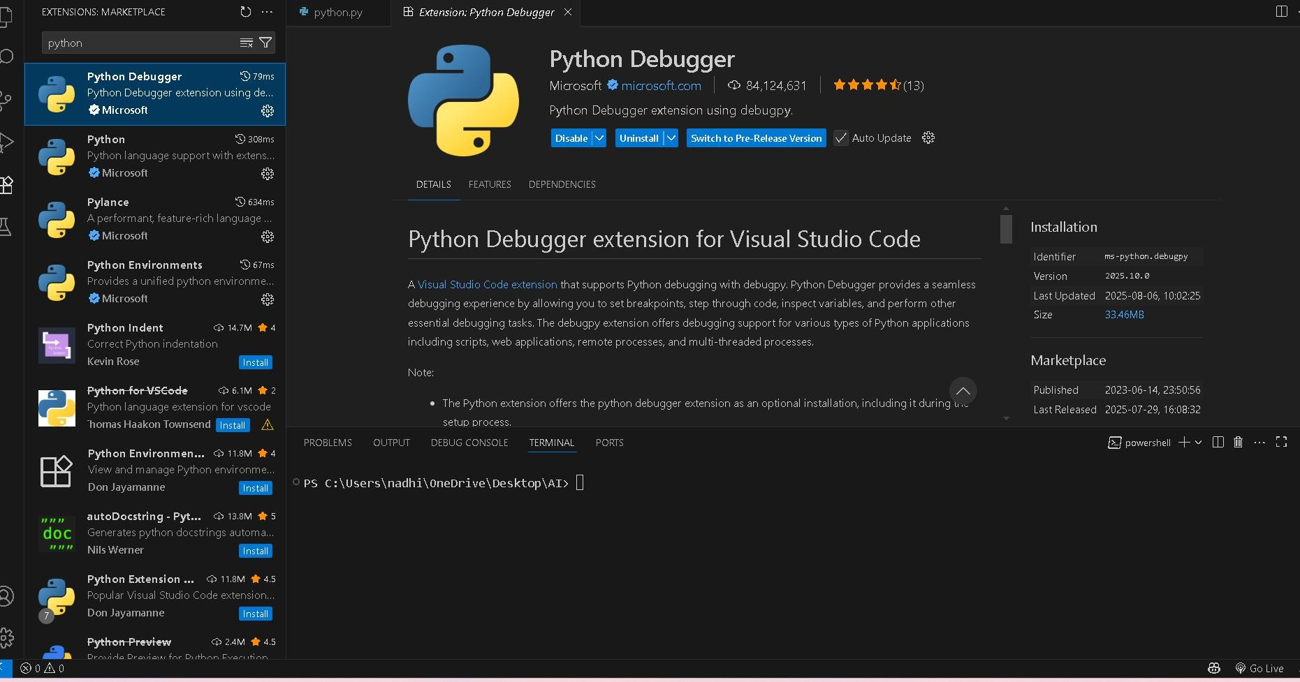
Screen shot-7

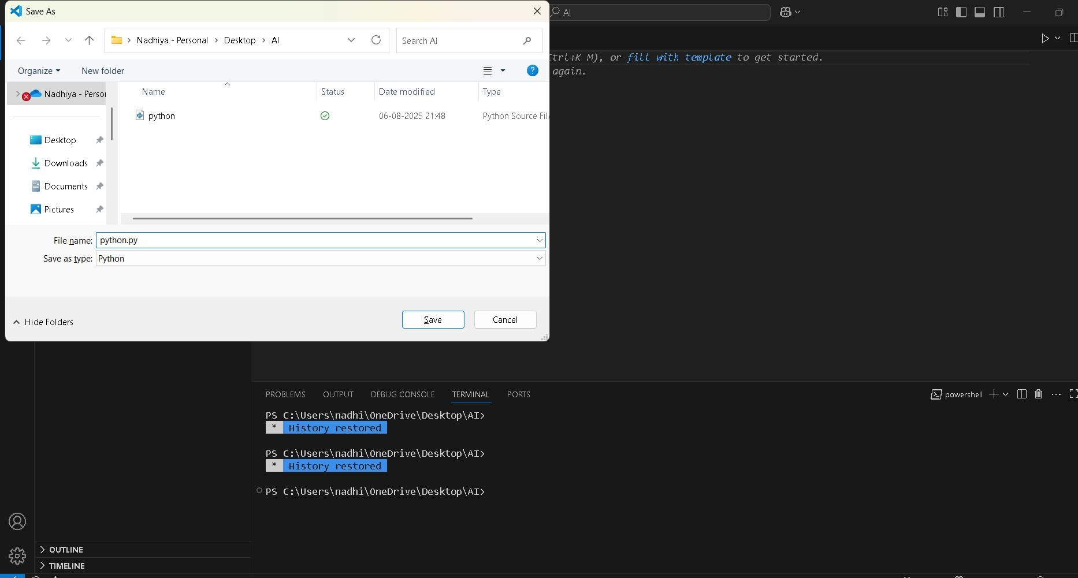
Screen shot-8

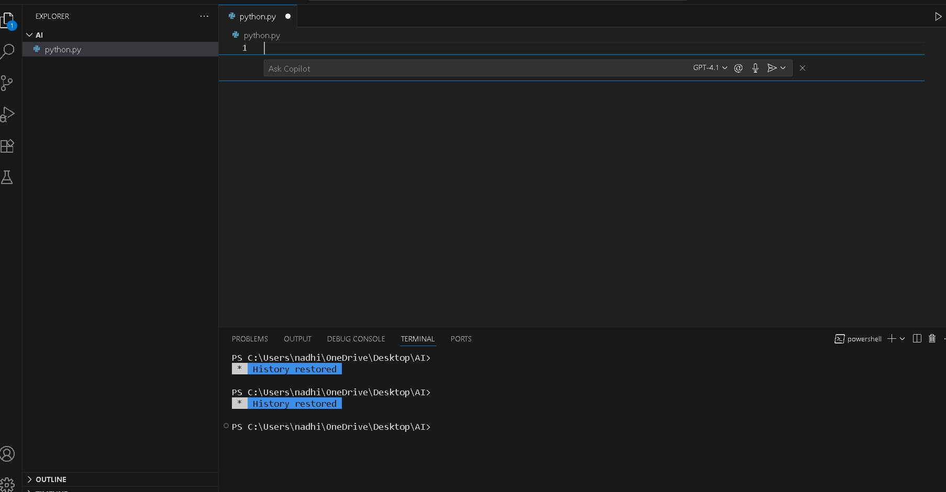
Screen shot-9

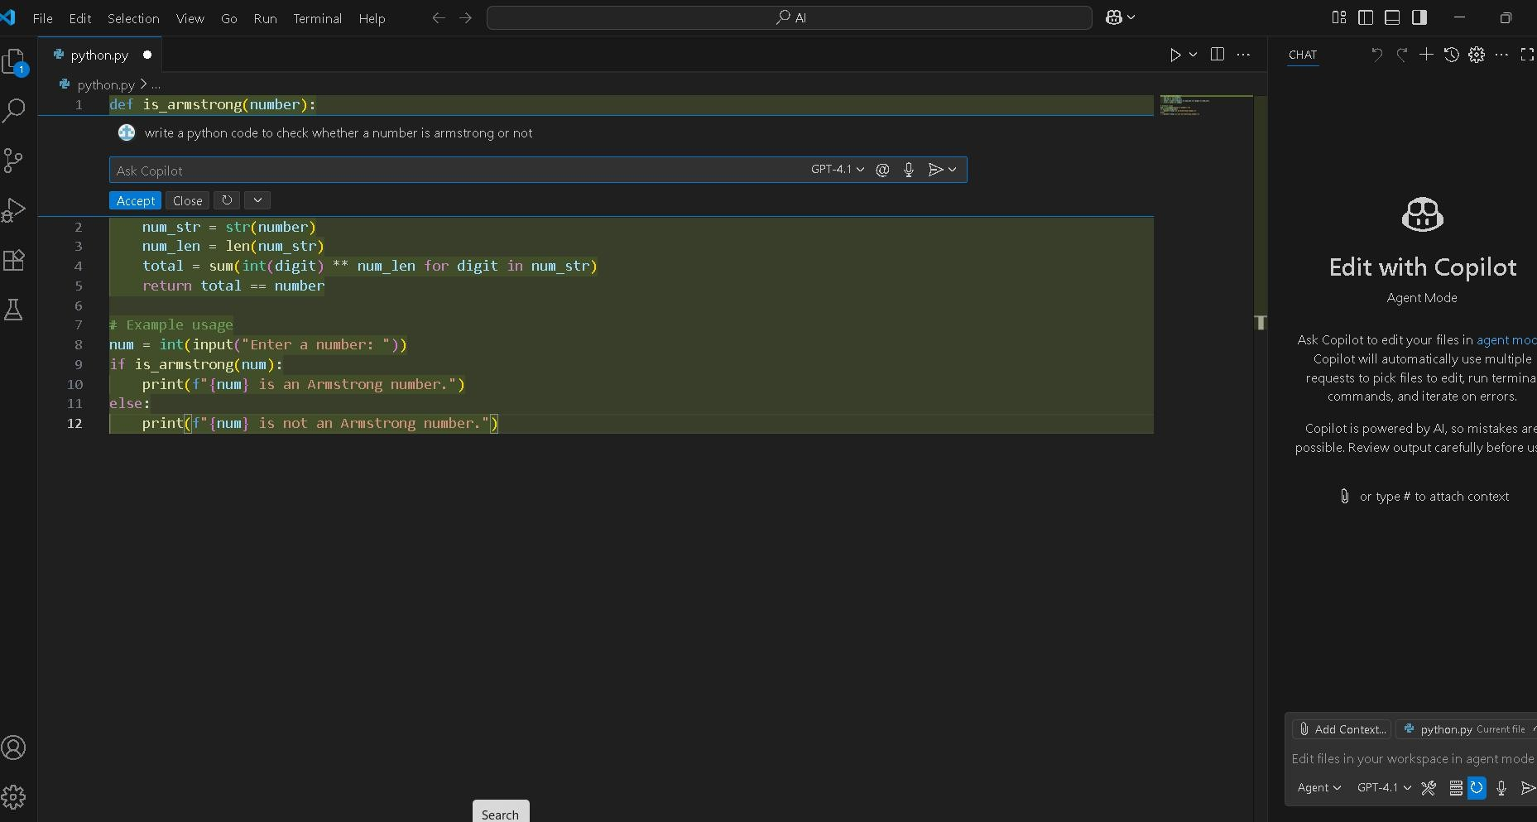
Screen shot-9

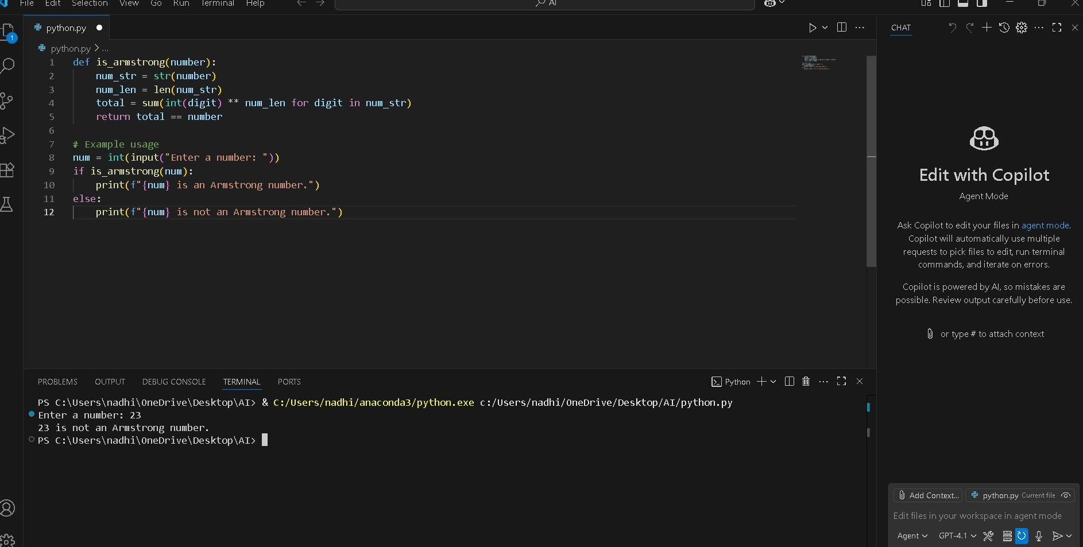

TASK – 02

Prompt : Write a python code to check whether a number is
prime or not.
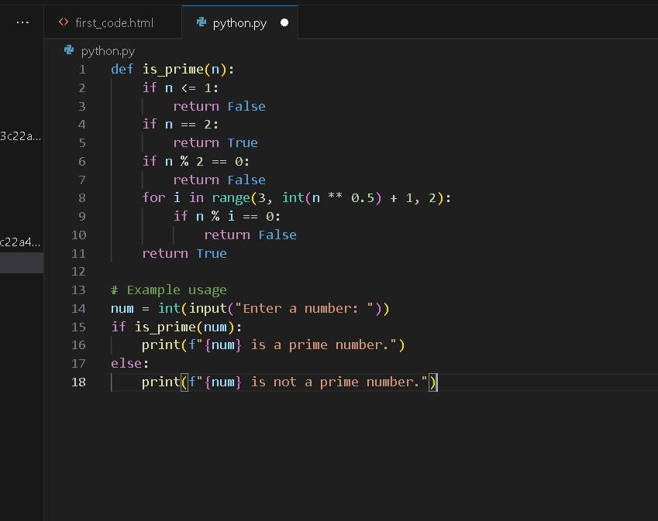
Output: 2 is prime number

Explanation:
- he code checks if a given number is prime.
- A prime number is a number greater than 1 that has no divisors other than 1 and itself.
- The code usually:
  - Returns False if the number is less than or equal to 1.

  - Loops from 2 up to the square root of the number.
  - If the number is divisible by any of these, it returns False.
  - If no divisors are found, it returns True.

Task-3:
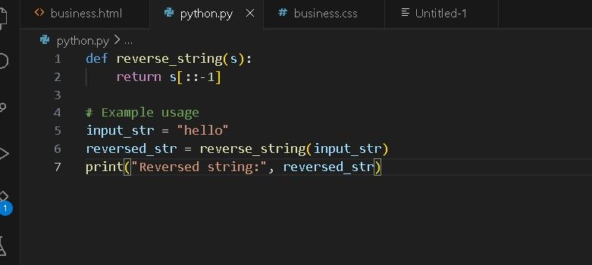
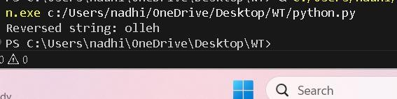

Explanation:
- The function reverse_string(s) takes a string s as input and returns its reverse using slicing (s[::-1]).
- The example usage sets input_str to "hello".

- It calls reverse_string(input_str), which returns "olleh",
and stores it in reversed_str.
- Finally, it prints Reversed string: olleh to the console

Task-04:
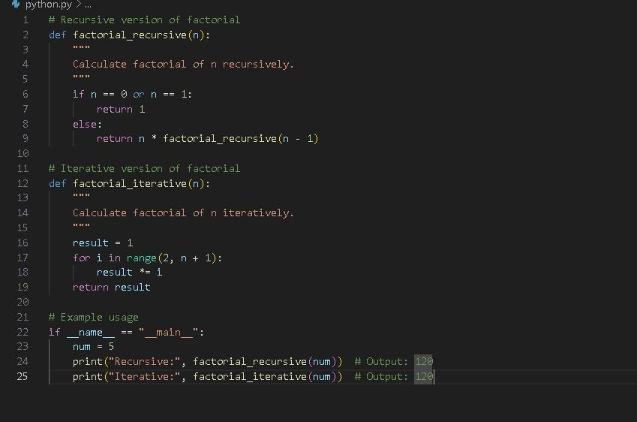

Explanation:
- This function calculates the factorial of n using recursion.
  - If n is 0 or 1, it returns 1 (base case).
  - Otherwise, it returns n * factorial_recursive(n - 1).

factorial_iterative(n):
This function calculates the factorial of n using a loop.
  - It initializes result to 1.
  - Then multiplies result by each number from 2 up to n.

Example usage:
  - If the script is run directly, it sets num = 5.
  - It prints the factorial of 5 using both the recursive and iterative functions.
  - Both methods output 120.

Task-05:

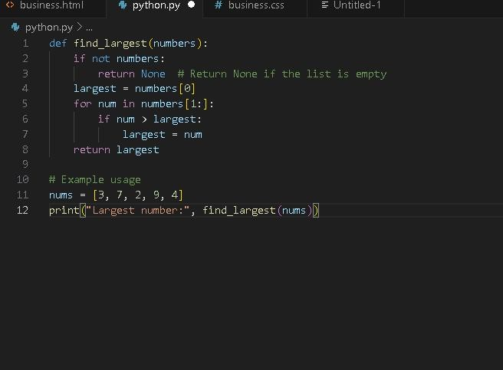
Explanation:

find_largest(numbers):
This function takes a list of numbers and returns the largest value.
  - If the list is empty, it returns None.
  - It starts by assuming the first number is the largest.
  - It then loops through the rest of the list, updating largest if it finds a bigger number.

  - Finally, it returns the largest number found.

Example usage:
  - A list nums = [3, 7, 2, 9, 4] is defined.
  - The function is called with this list, and the result is printed.
  - Output: Largest number: 9

