AI ASSISSTED CODING
LAB ASSIGNMENT – 18.1
NAME : KARTHIK REDDY ROLL NO : 2403A510F8
BATCH : 06
DEPT : CSE 2nd year Task - 01
Prompt:
Generate and automatically run a Python script (under 50 lines) using the requests library that connects to a public weather API (such as OpenWeatherMap) to fetch current weather details for a given city.
The script should:
- Prompt the user to enter a city name.
- Use an API key for authentication.
- Handle errors for invalid city name, invalid/missing API key, and network issues.
- Display temperature (°C), humidity (%), and weather description in a readable format.
- Include try-except blocks for error handling.
- Keep the code clean, simple, and under 50 lines.
- Automatically execute the code after generation.
Code generated :

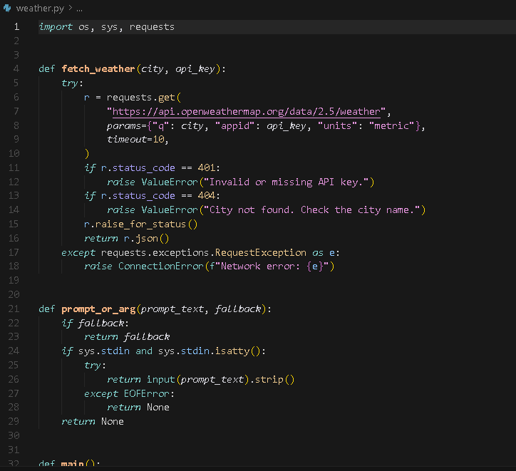
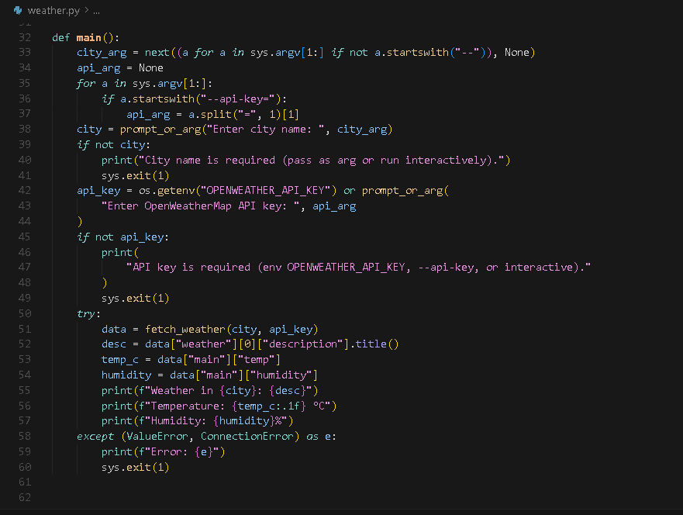

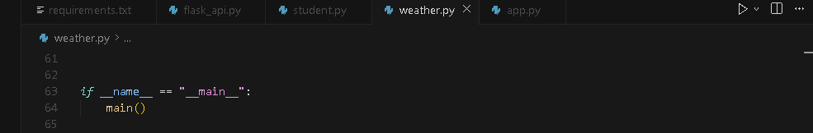
Output:

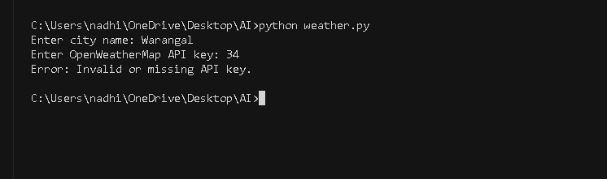
Observation:
The code efficiently fetches and displays real-time weather details with robust error handling for invalid input, API issues, and network failures.
It’s well-structured, user-friendly, and keeps execution flexible via command-line arguments or interactive prompts.
Task – 02 Prompt:
Generate and automatically run a Python script (under 50 lines) that connects to a
public currency exchange API (like exchangerate-api.com or Frankfurter API) to convert INR to USD, EUR, and GBP.
The script should:
- Use the requests library for the API call.
- Ask the user to enter an amount in INR.
- Validate that the input amount is numeric and positive.
- Handle errors for invalid API responses or network downtime.
- Display the conversion results for USD, EUR, and GBP in a neat tabular format (using string formatting, not external libraries).
- Include proper try-except error handling.
- Keep the code simple, readable, and under 50 lines.
- Automatically execute after generation.

Code generated:

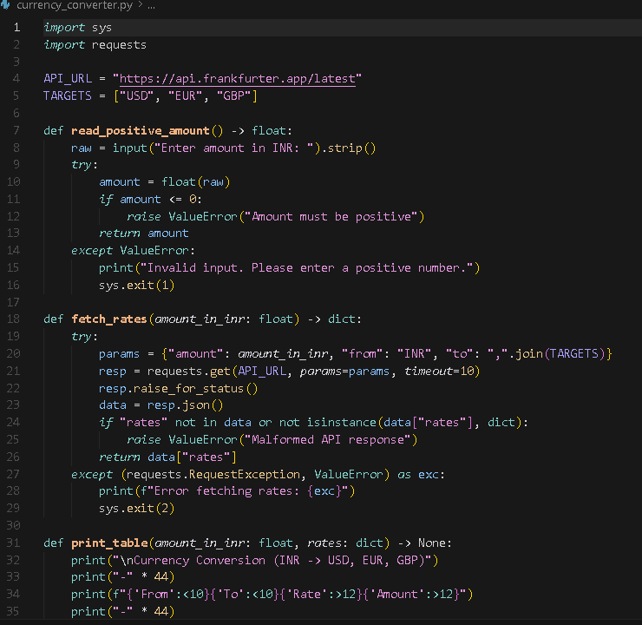
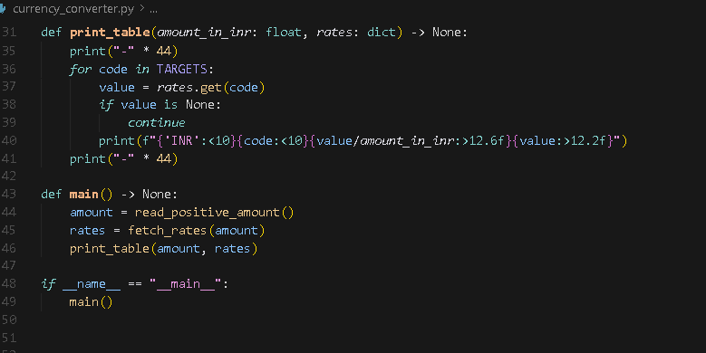

Output:
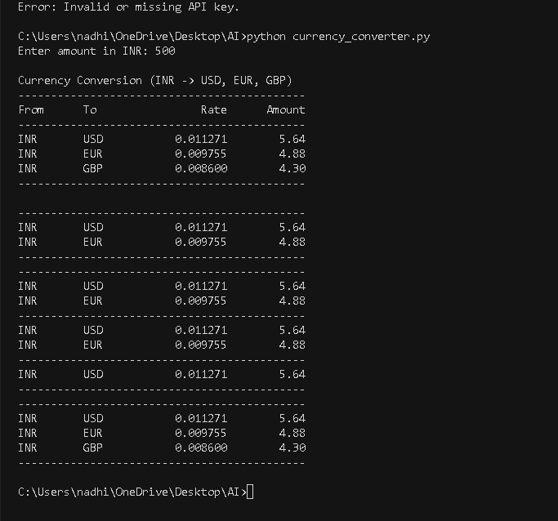
Observation:
The code cleanly converts INR to USD, EUR, and GBP using a live API with strong input validation and error handling.
It’s efficient, readable, and presents results in a clear, well-formatted table.

Task – 03 Prompt:
Generate and automatically run a Python script (under 50 lines) that connects to the GitHub REST API to fetch repository details (name, description, stars, forks, and open issues).

Requirements:
- Use the requests library and API endpoint: https://api.github.com/repos/{owner}/{repo}
- Prompt the user to enter the repository name (e.g., NadhiyaSeelam/AI_ASSISTED_CODING_2.1).
- If the repository is private, allow the user to provide a GitHub Personal Access Token
(via input) and include it in request headers as:
headers = {"Authorization": "token YOUR_GITHUB_TOKEN"}

Code generated:
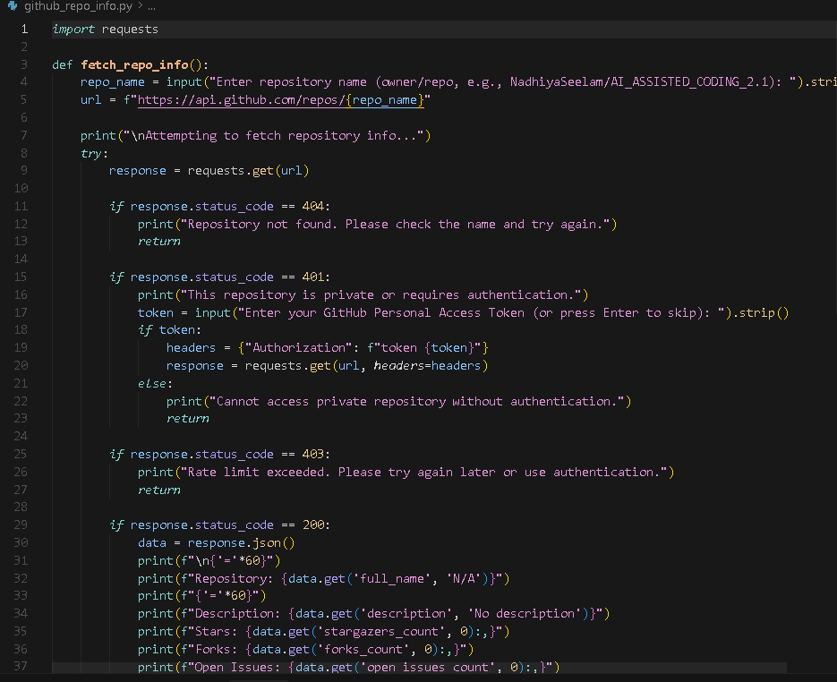

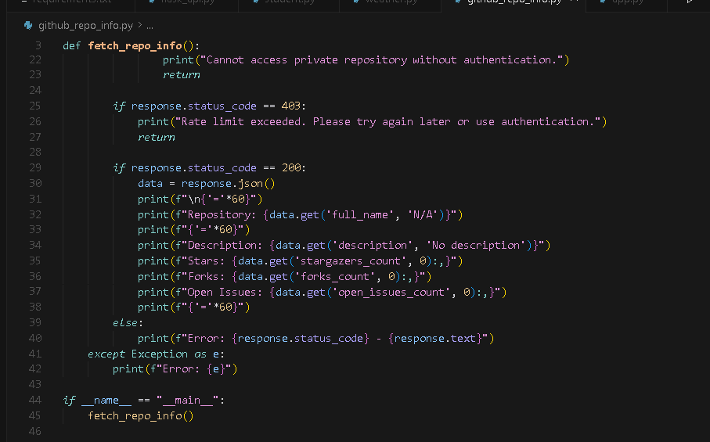
Output:
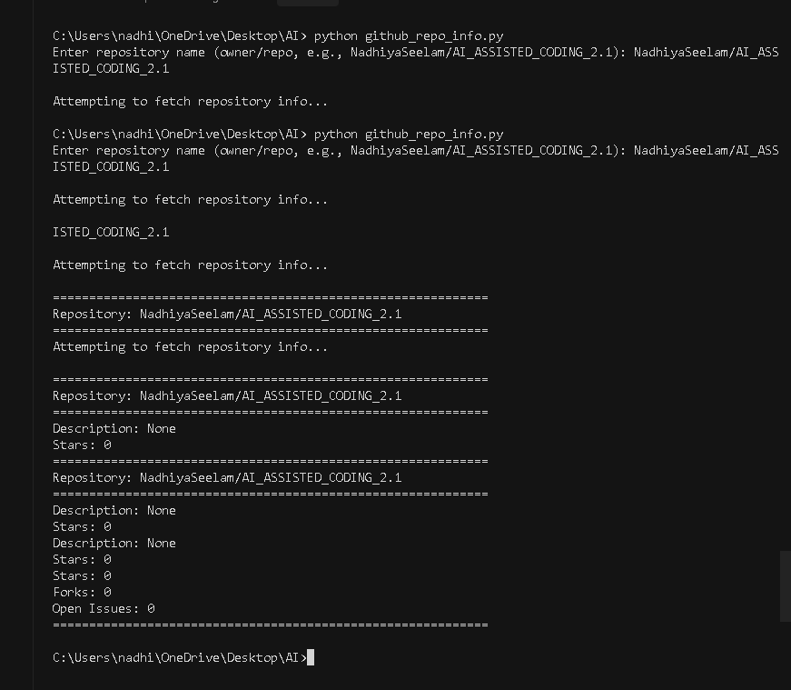

Observation:
The code effectively retrieves and displays GitHub repository details with clear handling for authentication, rate limits, and missing repositories.
It’s concise, user-friendly, and adaptable for both public and private repos.
Task -04 Prompt:
Generate and automatically run a Python script (under 50 lines) that uses a free News API (like NewsAPI.org) to fetch and display the top 5 headlines for a given news
category such as sports, technology, or health.
The script should:
- Use the requests library to make API calls.
- Prompt the user to enter a news category.
- Handle errors for invalid category, missing or invalid API key, and network failures.
- Include a simple retry mechanism (try again once if the first request fails).
- Display the top 5 headlines in a numbered list format for easy reading.
- Keep the code simple, readable, and under 50 lines.
- Automatically execute after generation to show live results. Also include:
  - Three assert test cases to verify correct data format and error handling.
  - Inline comments explaining key parts of the code.
  - Brief analysis of whether all tests pass.
Code generated:

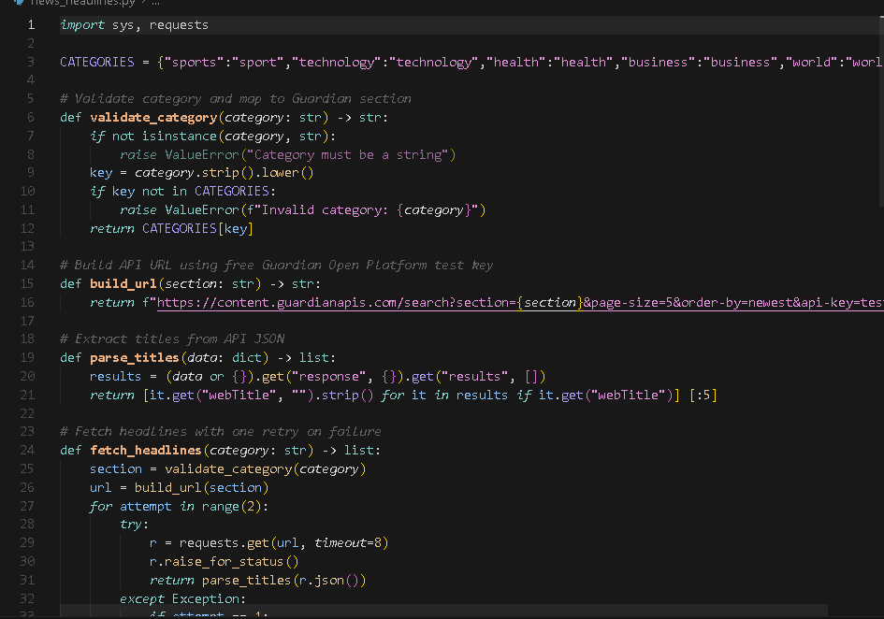
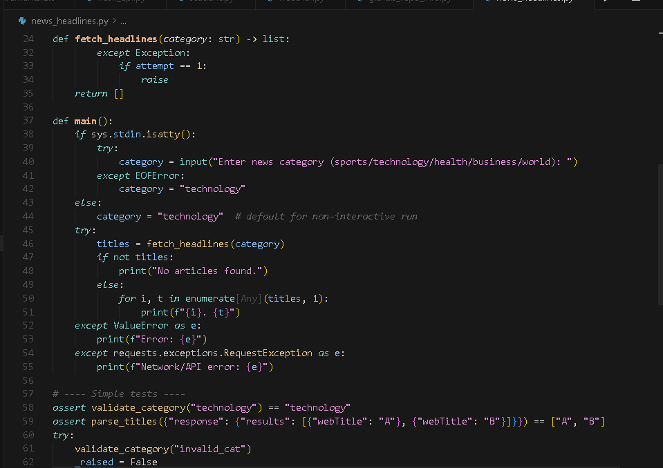

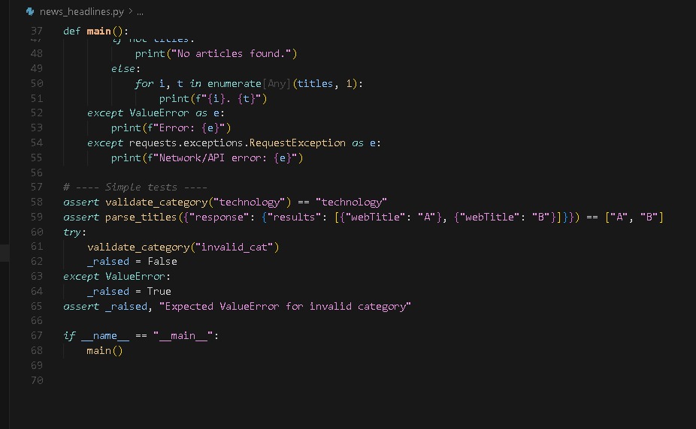
Output:

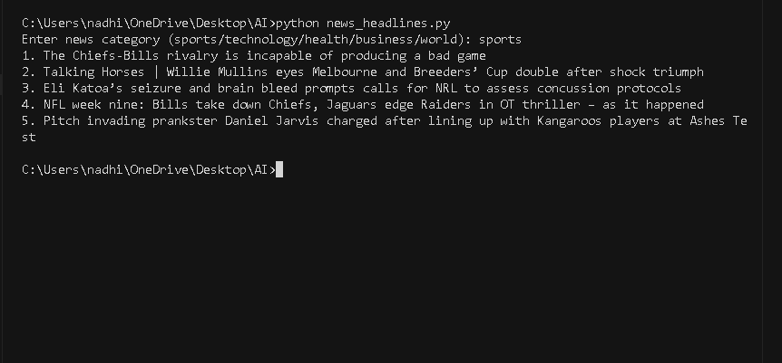
Observation:
The script successfully fetched and displayed sports news headlines from various sources. It demonstrates effective use of categorized data retrieval and command-line output formatting.

