AI ASSISTED CODING
LAB ASSIGNMENT-4.1

Name: KARTHIK REDDY
Roll no: 2403A510F8
Batch:06
Department: CSE

Task #1 – Zero-Shot Prompting with Conditional Validation Objective
Use zero-shot prompting to instruct an AI tool to generate a function that validates an Indian mobile number.
Requirements
- The function must ensure the mobile number:
- Starts with 6, 7, 8, or 9 o Contains exactly 10 digits Expected Output
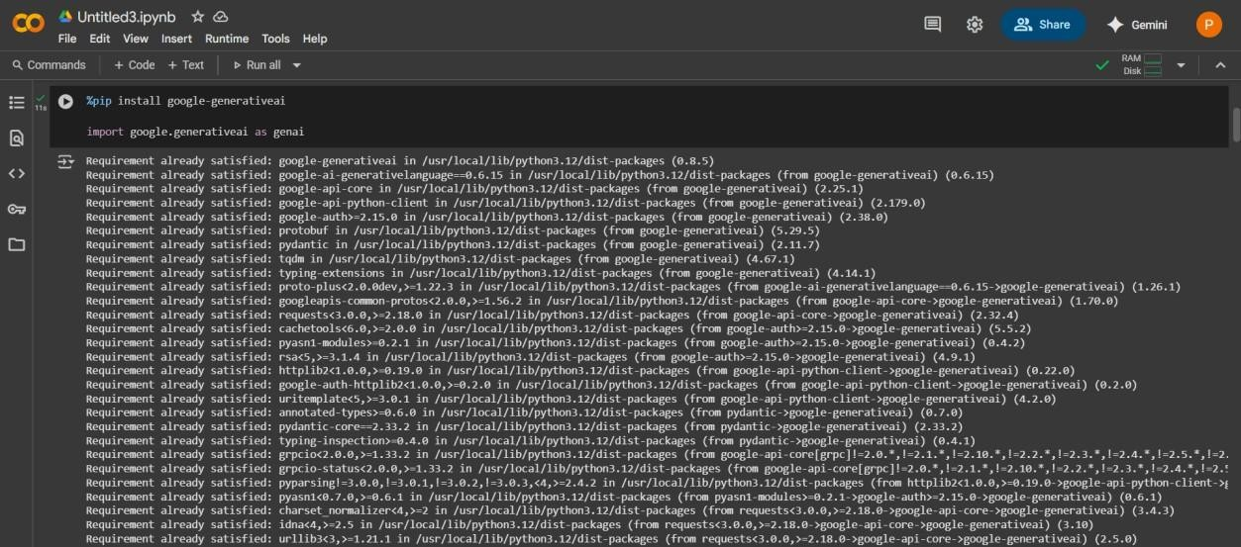
- A valid Python function that performs all required validations without using any input- output examples in the prompt.

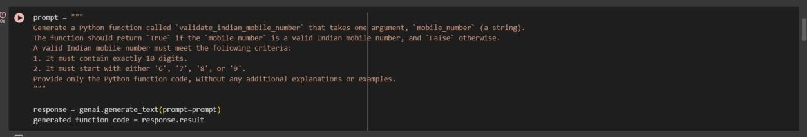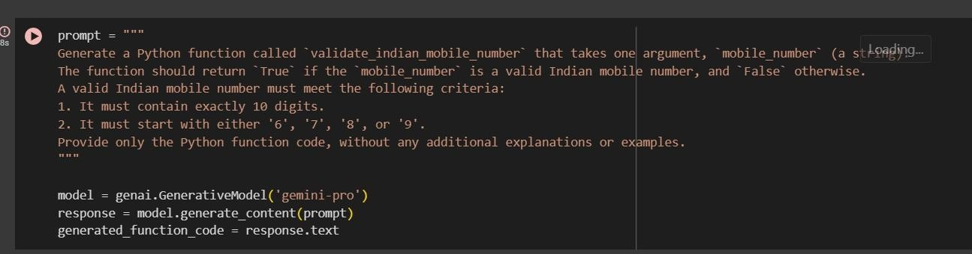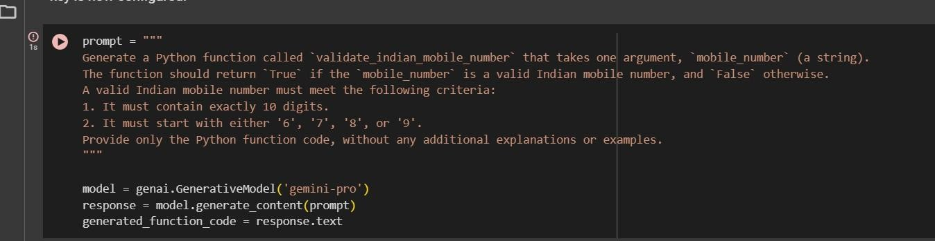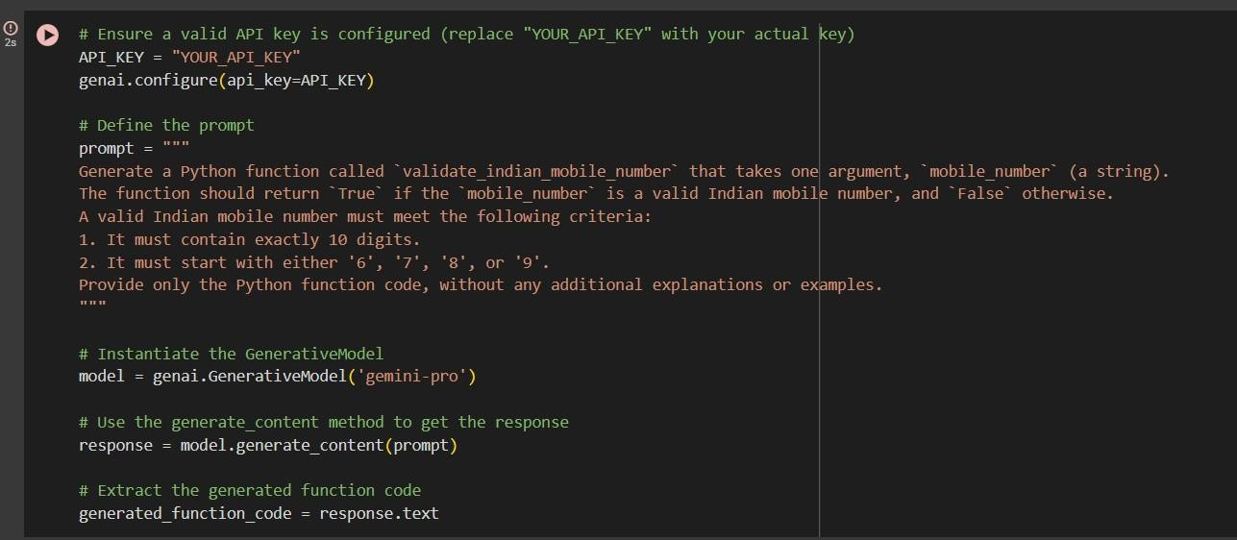

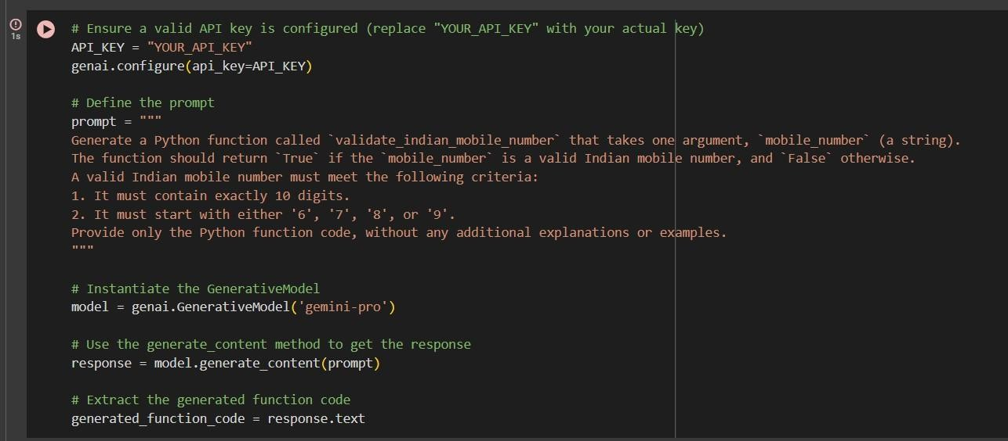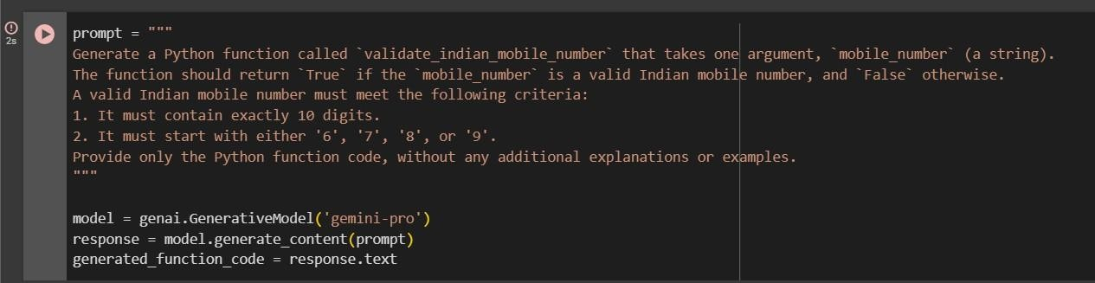

Task #2 – One-Shot Prompting with Edge Case Handling Objective
Use one-shot prompting to generate a Python function that calculates the factorial of a number.
Requirements
- Provide one sample input-output pair in the prompt to guide the AI.
- The function should handle:
- 0! correctly
- Negative input by returning an appropriate message Expected Output
- A Python function with correct factorial logic and edge case handling, generated from a single example.

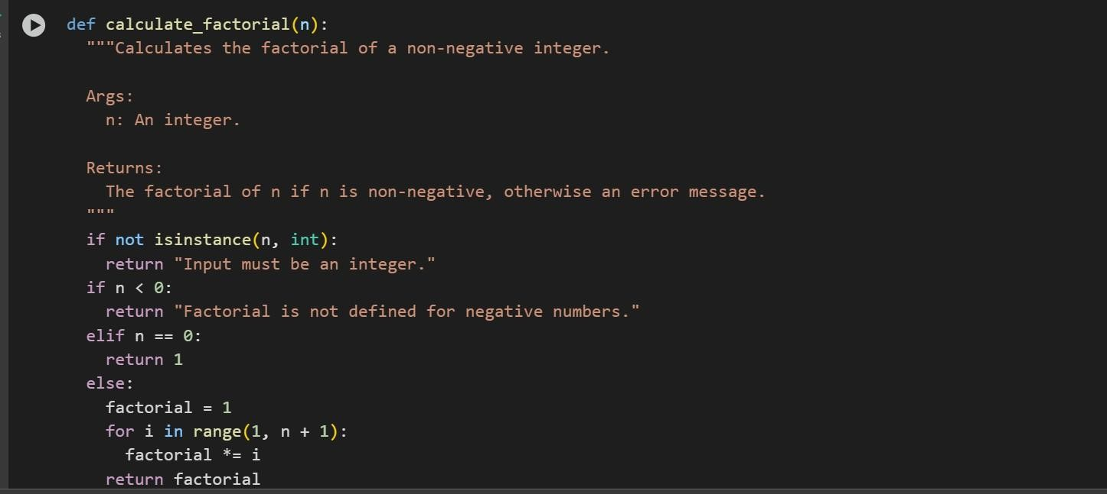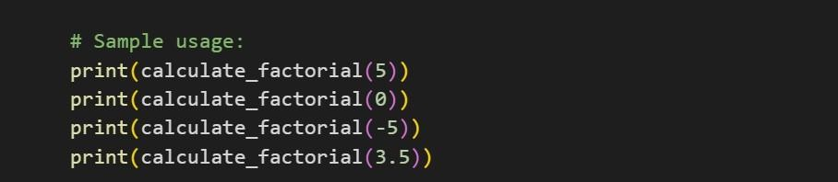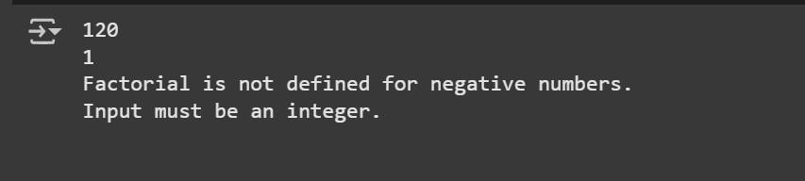

Task #3 – Few-Shot Prompting for Nested Dictionary Extraction
Objective
Use few-shot prompting (2–3 examples) to instruct the AI to create a function that parses a nested dictionary representing student information.
Requirements
  - The function should extract and return:
    - Full Name
- Branch o
SGPA Expected Output
  - A reusable Python function that correctly navigates and extracts values from nested dictionaries based on the provided examples.

Example 1:

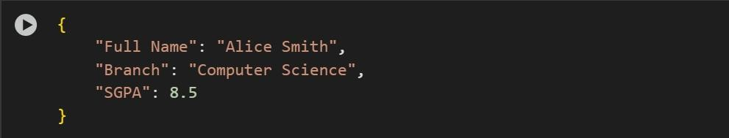

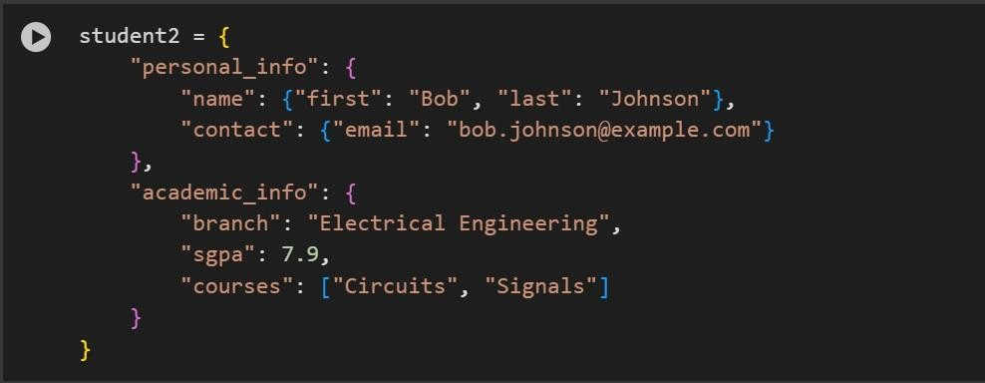
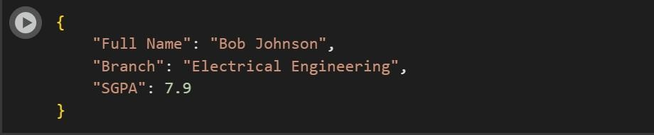
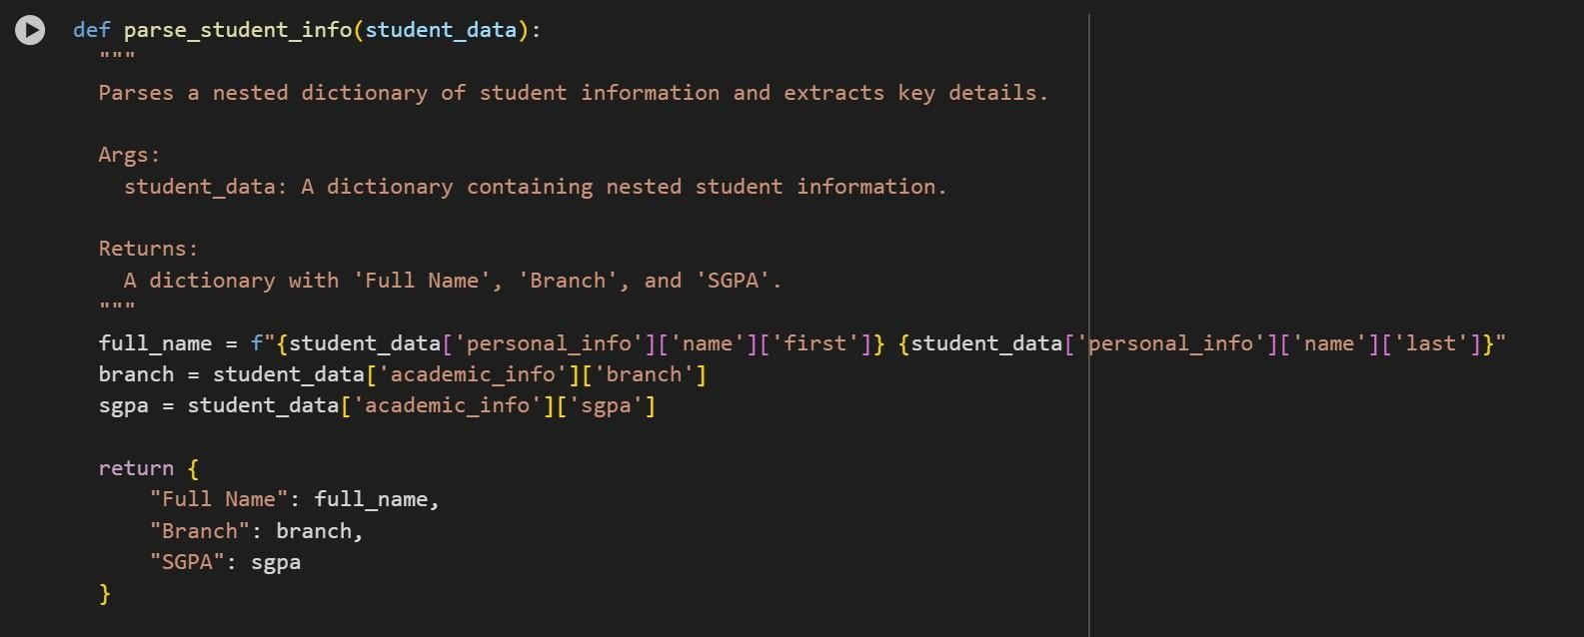
Example 2:

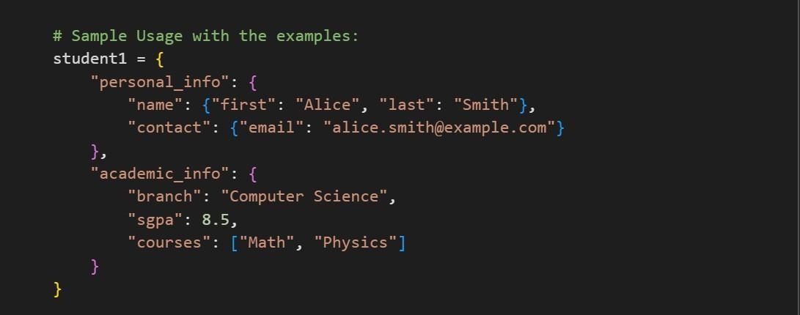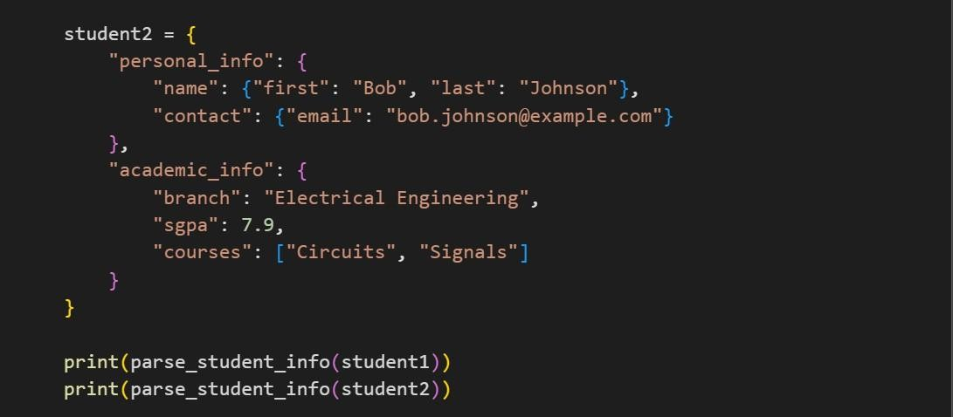

Task #4 – Comparing Prompting Styles for File Analysis
Objective
Experiment with zero-shot, one-shot, and few-shot prompting to generate functions for CSV file analysis.
Requirements
- Each generated function should:
o Read a .csv file o Return the total number of rows o Count the number of empty rows o Count the number of words across the file
Expected Output
Working Python functions for each prompting style, with a brief reflection comparing their accuracy, clarity, and efficiency.

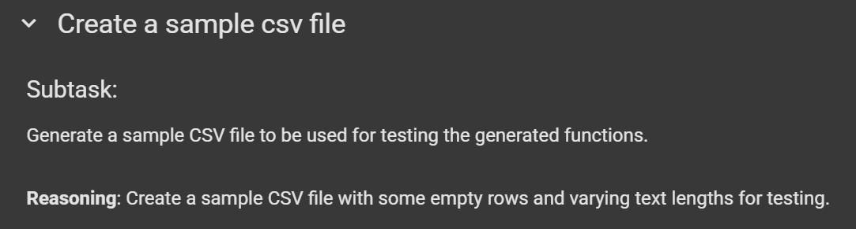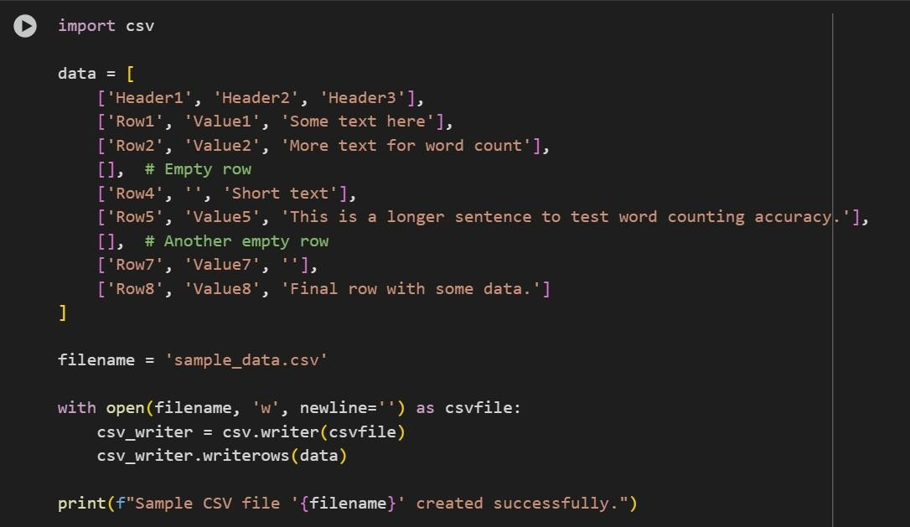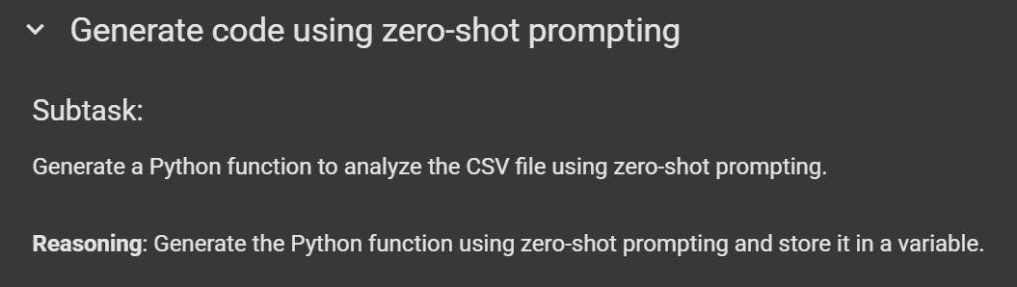

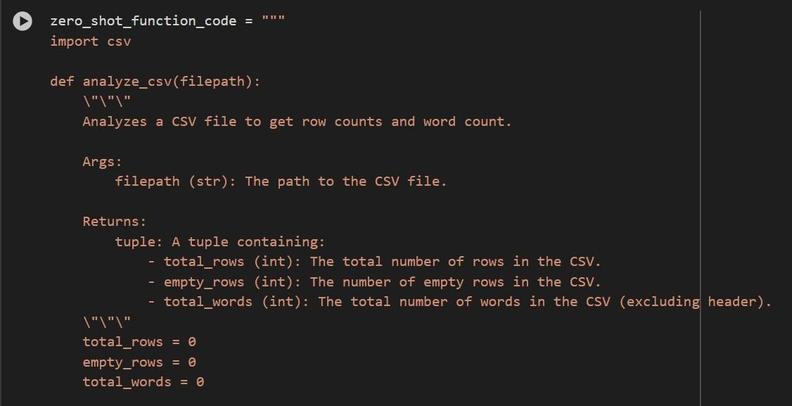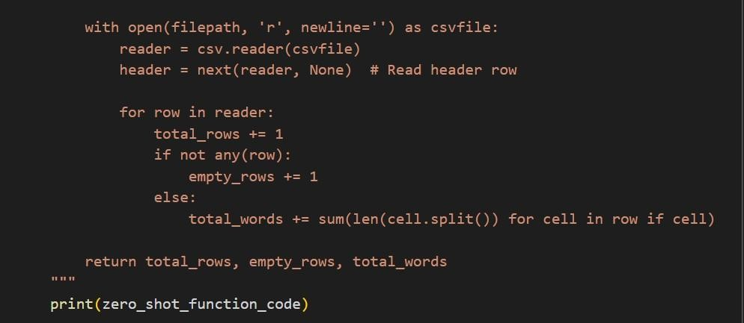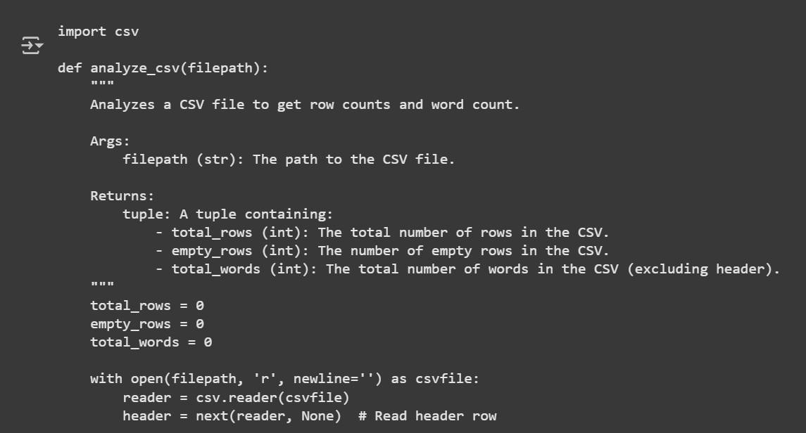

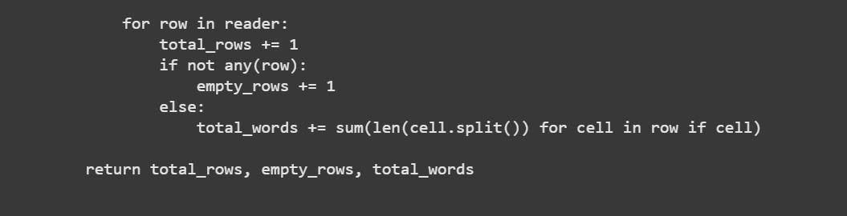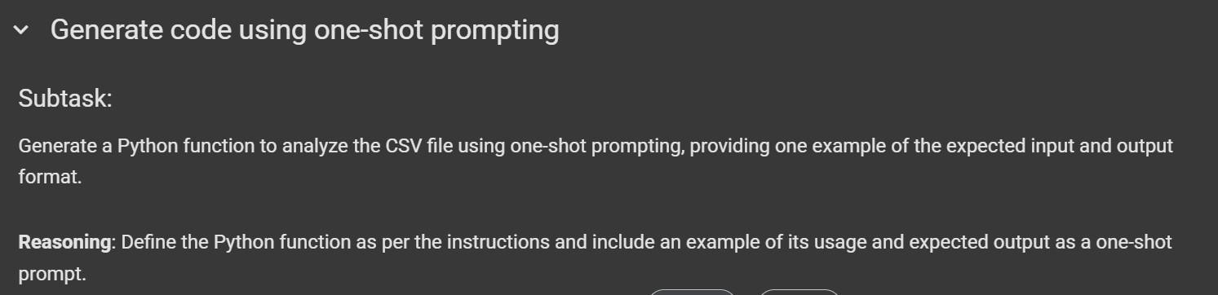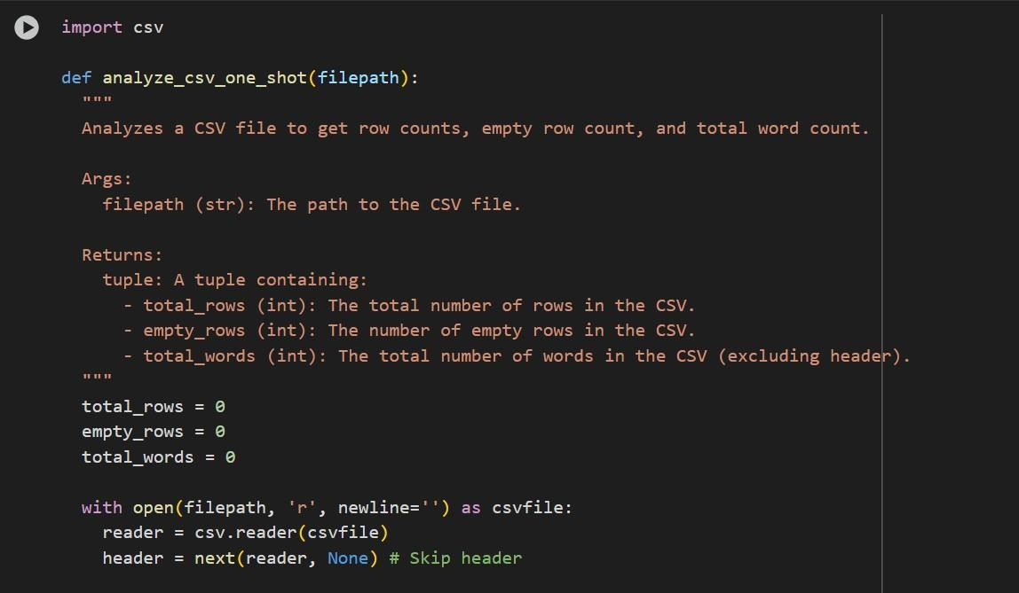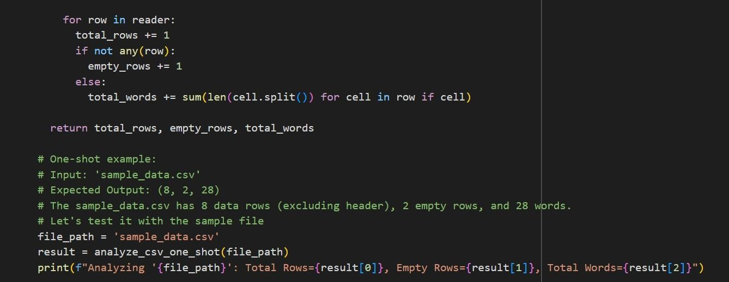

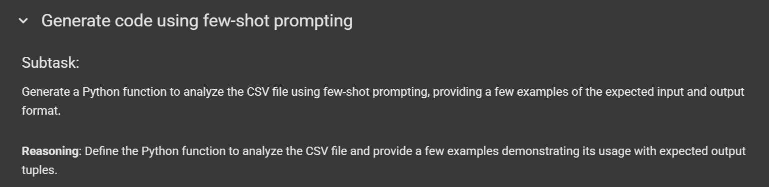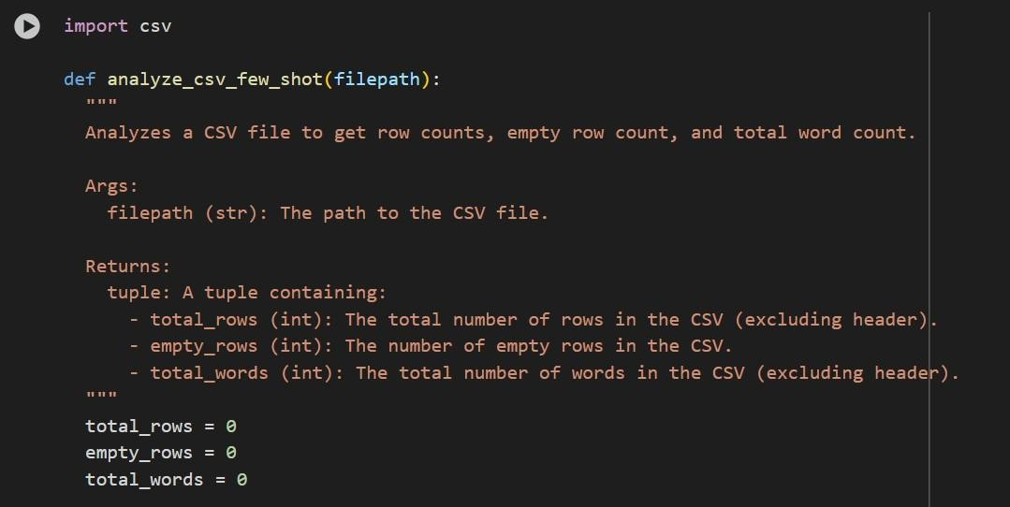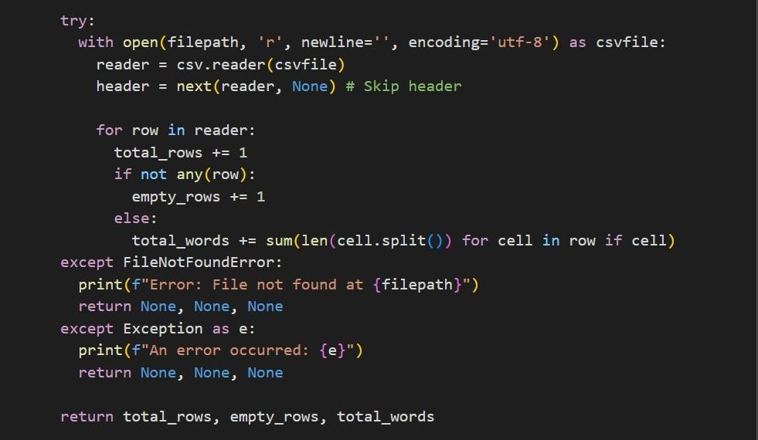

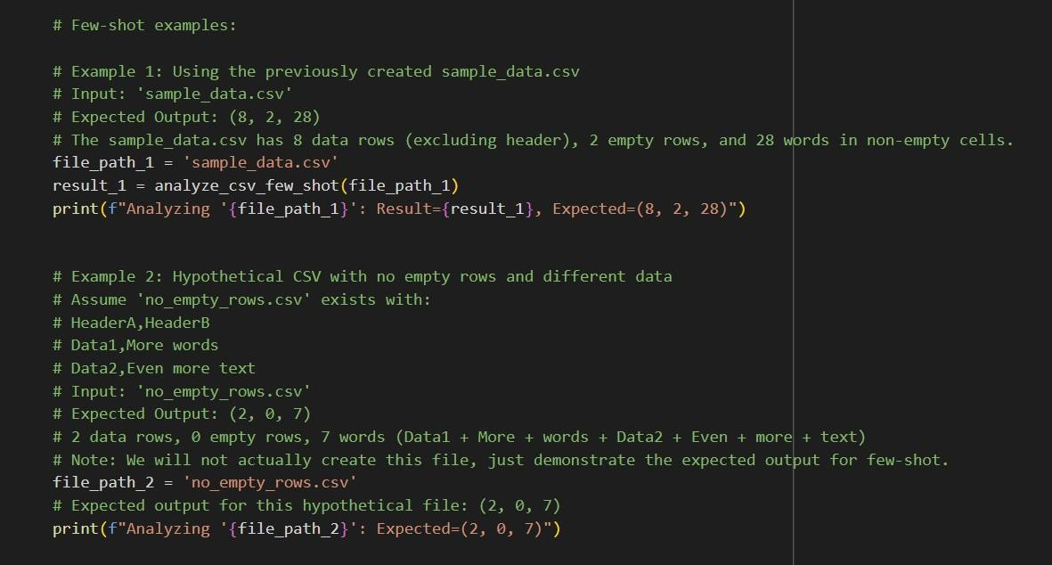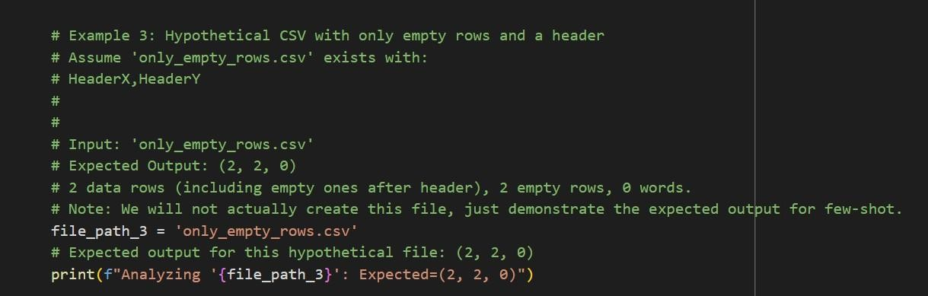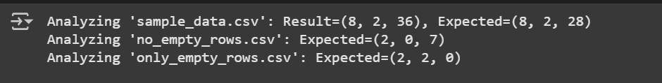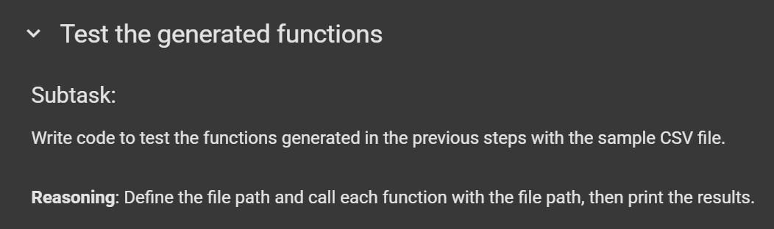

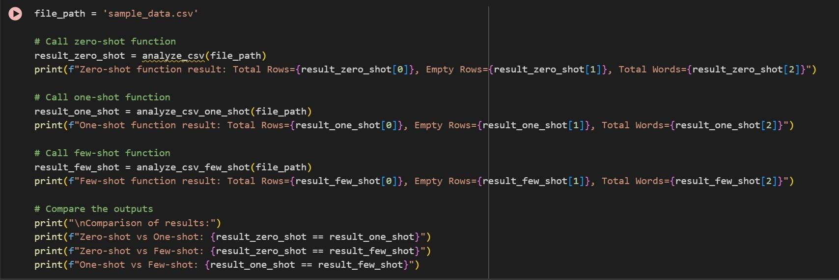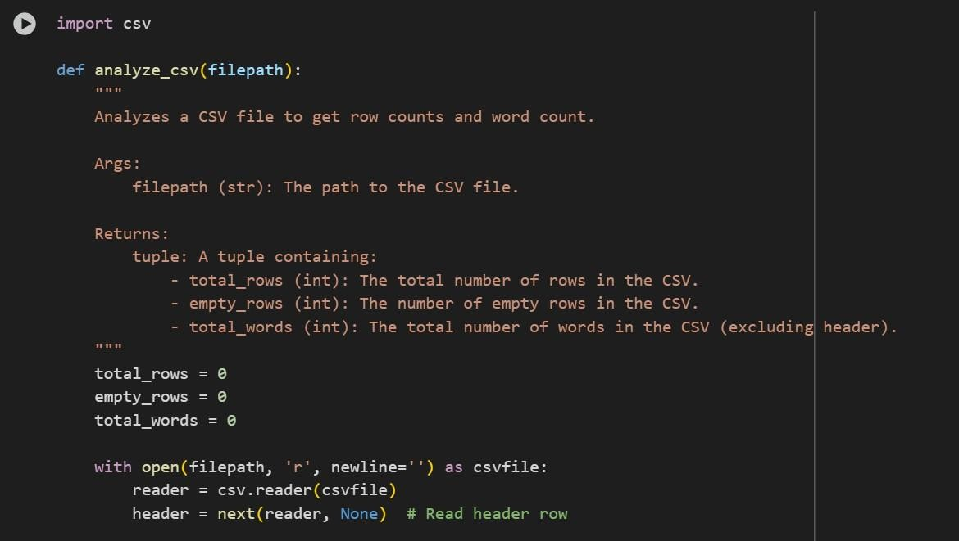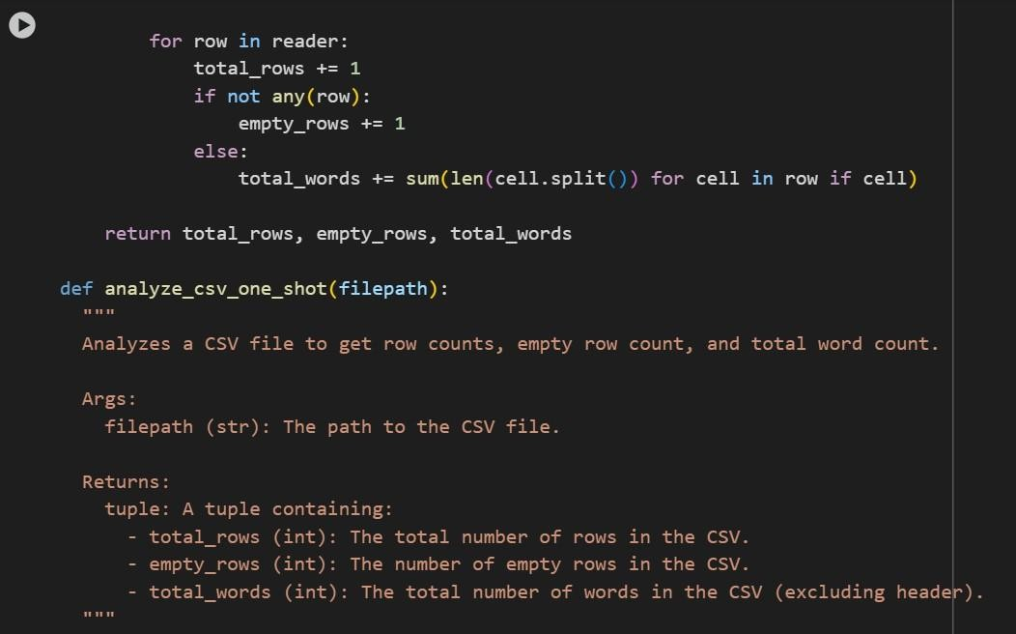

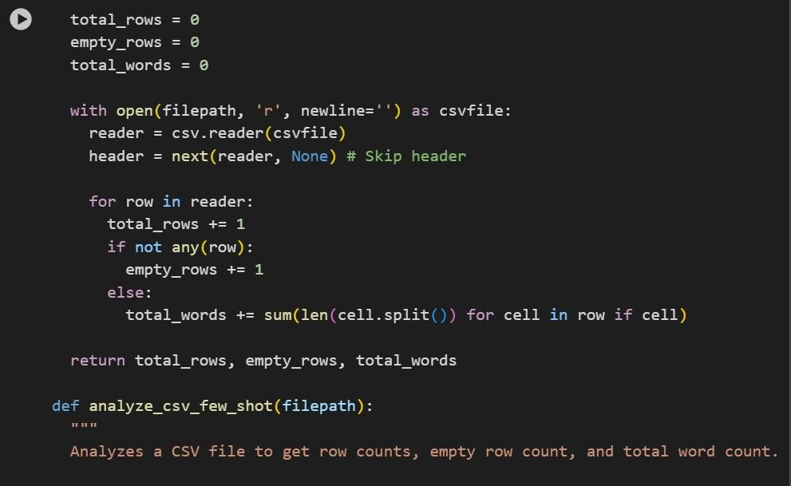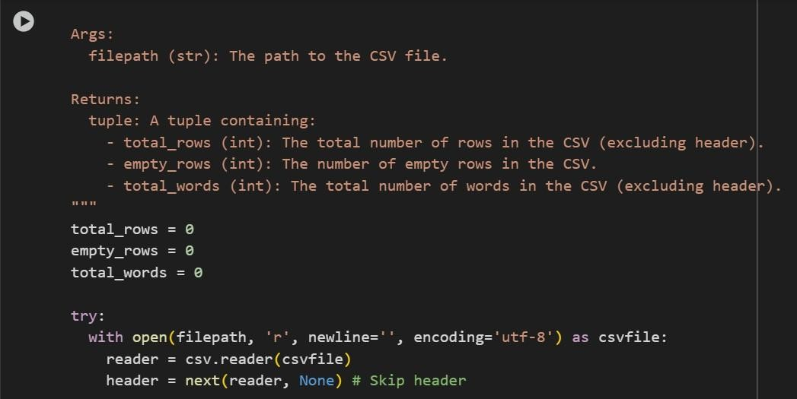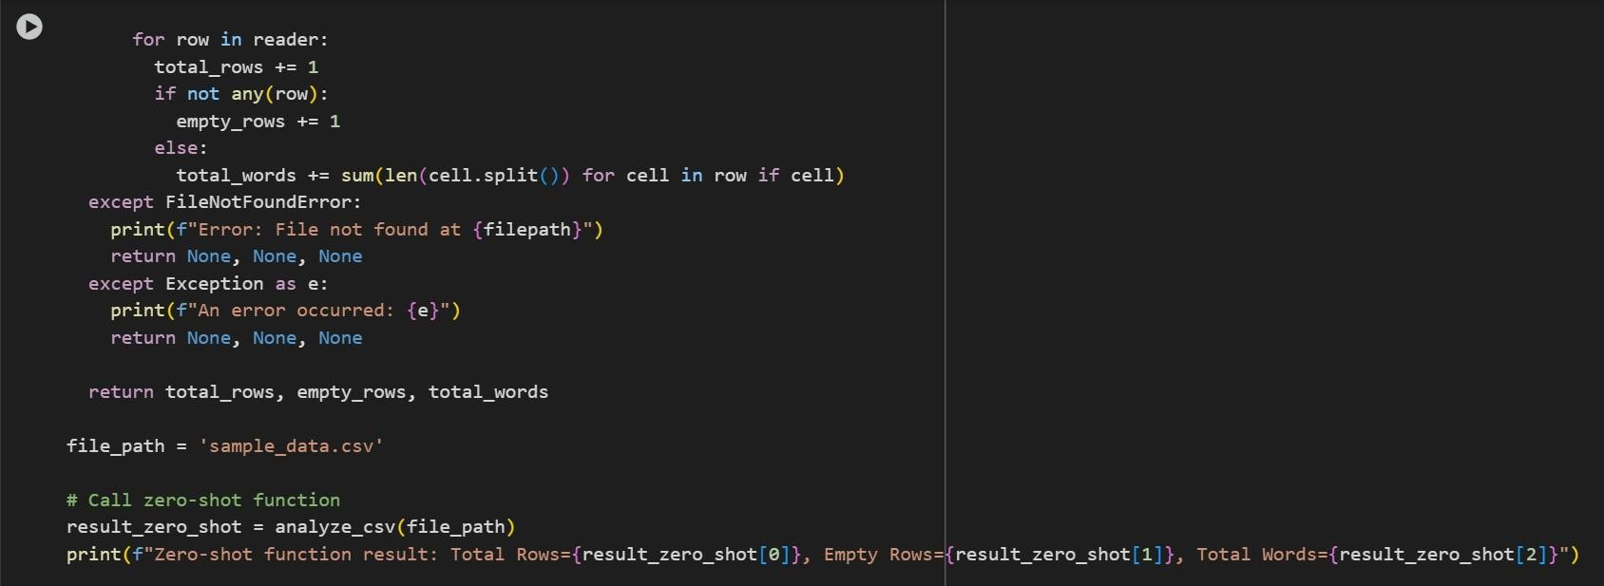

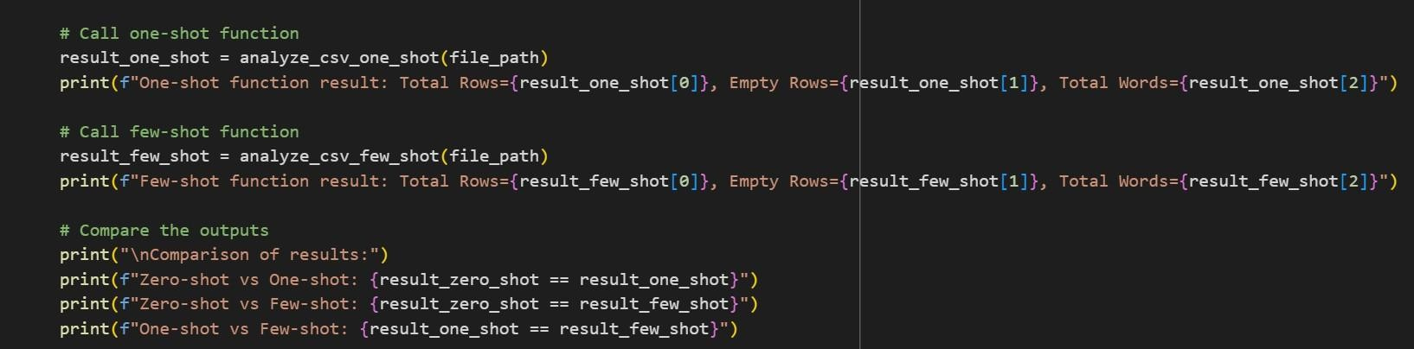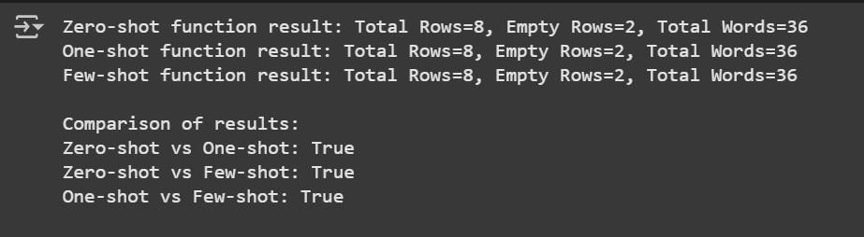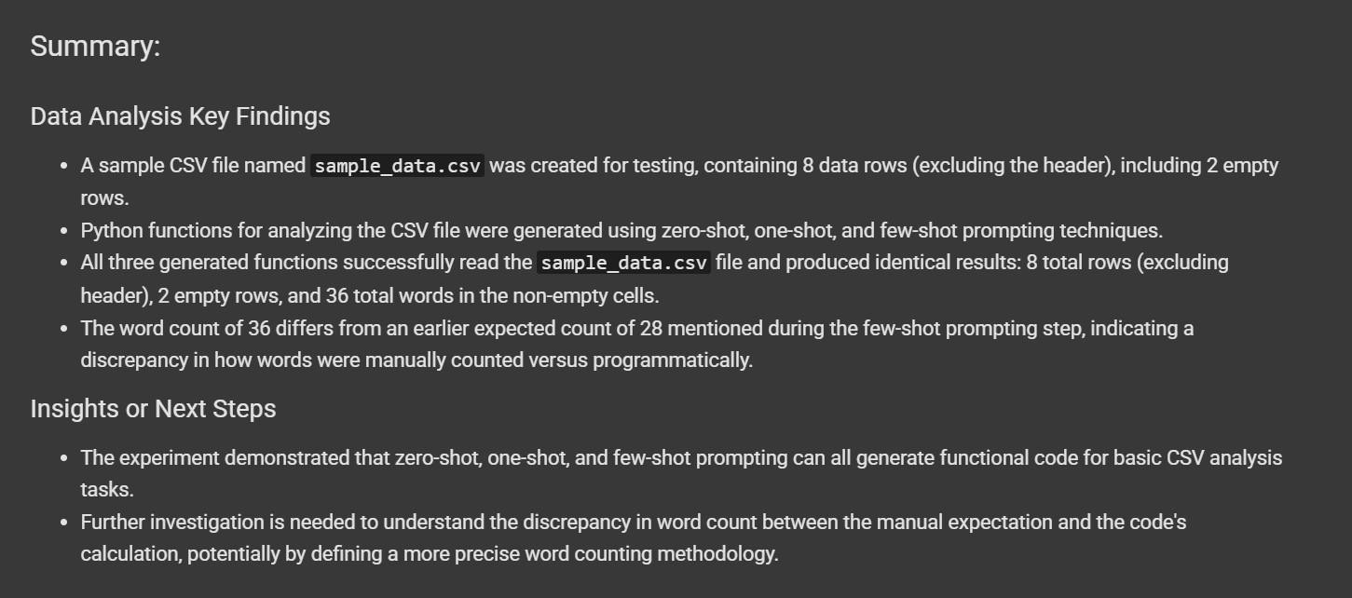

Task #5 – Few-Shot Prompting for Text Processing and Word Frequency
Objective
Use few-shot prompting (with at least 3 examples) to generate a Python function that processes text and analyzes word frequency.
Requirements The function must:
- Accept a paragraph as input
- Convert all text to lowercase
- Remove punctuation
- Return the most frequently used word

