

1
LAB EXPERIMENTS
ECA1011 Microprocessors and Microcontrollers
Submitted To:
Dr. EDWIN DHAS DHASON
Submitted By:
Name: KARTHIKA.B
Reg No: 1912L260004
Department: B.Tech ECE (LATERAL ENTRY)

2
INDEX
S.No | Date | Title of Experiment | Page No
1. | 15/10/26 | 8-bit and 16 bit Arithmetic Operations
2. | 15/10/26 | Logical, Bit-manipulation And Shift  Operations
3.
4.
5.
6.
7.
8.
9.
10.

3
DATE: 15/10/2026
EXPERIMENT 01: ANALYSIS, DEVELOPMENT AND VERIFICATION OF 8-BIT AND 16-BIT
ARITHMETIC OPERATIONS USING ASSEMBLY LANGUAGE PROGRAM
Objective:
1.To analyze, develop & verify 8-bit Addition and Subtraction
2.To analyze, develop & verify 16-bit Addition and Subtraction
3.To analyze, develop & verify 8-bit Multiplication and Division
4.To analyze, develop & verify 16-bit Multiplication and Division
Components Required:
8085 Simulator or 8085 Intel Microprocessor
Procedure:
i. Switch ON the 8085-microprocessor kit or open the 8085 simulator.
ii. Enter the program opcodes into the specified starting memory address using the
memory examine/substitute command.
iii. Store the required input data in the specified memory locations, if provided.
iv. Execute the program from the given starting address using the GO/EXEC command.
v. Examine the memory locations assigned for the results.
vi. Record the output values and verify them with the expected arithmetic results.
vii. Repeat the procedure for all four programs and record the observations.

4
1.Analysis of 8-bit Addition and Subtraction :
PROGRAM [Addition]
MVI C 00h
LDA 4200h
MOV B A
LDA 4201h
ADD B
JNC SKIP
INR C
SKIP : STA 4202h
MOV A C
STA 4203h
HLT
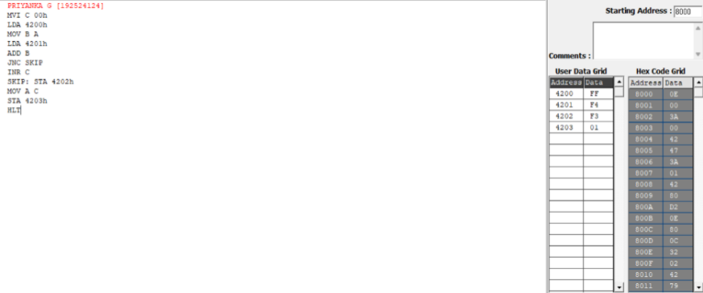
OUTPUT
Memory | Data
4200 | FF
4201 | F4
4202 | F3
4203 | 01

5
PROGRAM [Subtraction]
MVI C 00h
LDA 4201h
MOV B A
LDA 4200h
SUB B
JNC SKIP
CMA
INR A
INR C
SKIP : STA 4202h
MOV A C
STA 4203h
HLT
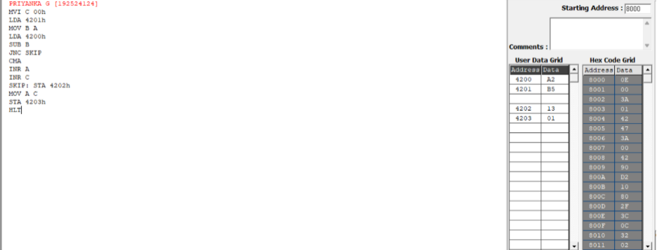
OUTPUT
Memory | Data
4200 | A2
4201 | B5
4202 | 13
4203 | 01

6
2.Analysis of 16-bit Addition and Subtraction:
PROGRAM [Addition]
LHLD 4510
XCHG
LHLD 4512
DAD D
SHLD 4514
MVI A 00
JNC SKIP
MVI A 01
SKIP: STA 4516
HLT
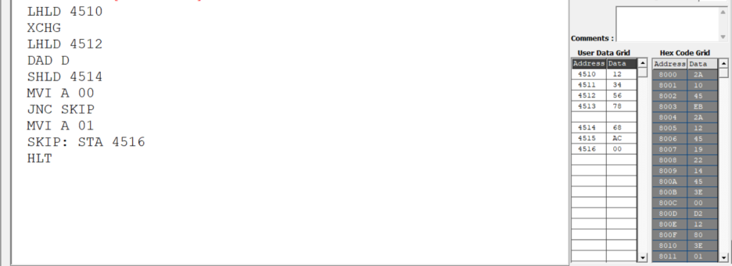
OUTPUT
Memory | Data
4210 | 12
4211 | 34
4212 | 56
4213 | 78
4216 | 68
4217 | AC
4218 (carry) | 00

8
PROGRAM [Subtraction]
LDA 4510
MOV C A
LDA 4511
MOV B A
LDA 4512
SUB C
STA 4516
LDA 4513
SBB B
STA 4517
MVI A 00H
JNC SKIP
MVI A 01
SKIP: STA 4518
HLT
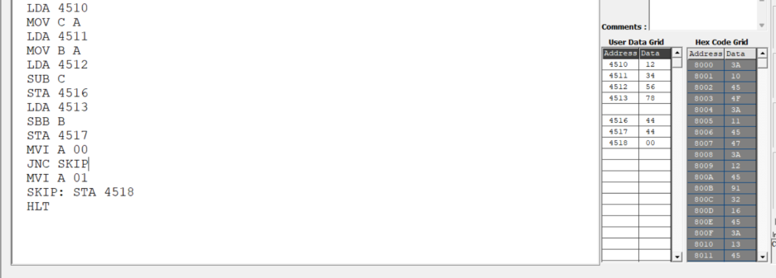
OUTPUT
Memory | Data
4210 | 12
4211 | 34
4212 | 56
4213 | 78
4216 | 44
4217 | 44
4218 (carry) | 00

10
3.Analysis of 8-bit Multiplication and Division:
PROGRAM [Multiplication]
LXI H 0000H
LDA 4201h
MOV E A
LDA 4202
MOV C A
REPEAT : DAD D
DCR C
JNZ REPEAT
SHLD 4203
HLT
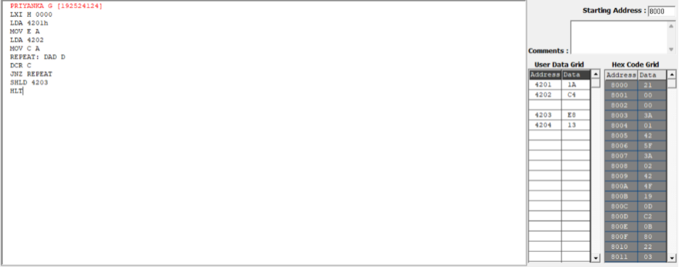
OUTPUT
Memory | Data
4201 | 1A
4202 | C4
4203 | E8
4204 | 13

11
PROGRAM [Division]
LDA 4201h
MOV E A
LDA 4200h
MOV B A
MOV A E
MVI C 00h
AGAIN: CMP B
JC STORE
SUB B
INR C
JMP AGAIN
STORE: STA 4203h
MOV A C
STA 4202h
HLT
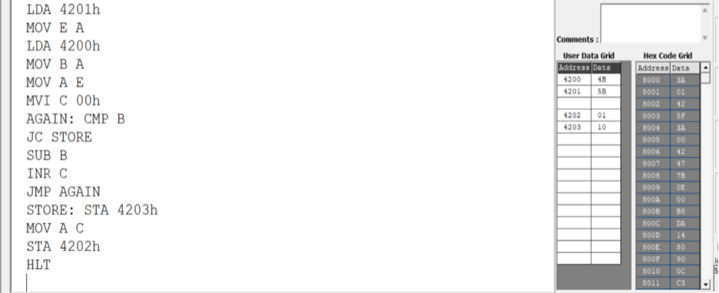
OUTPUT
Memory | Data
4200 | 4A
4201 | 5B
4202 | 01
4203 | 10

13
4.Analysis of 16-bit Multiplication and Division:
PROGRAM [Multiplication]
LXI H 4520
MVI M 00
INX H
MVI M 00
INX H
MVI M 00
INX H
MVI M 00
LHLD 4500
XCHG
LHLD 4502
MOV B H
MOV C L
LOOP: MOV A B
ORA C
JZ DONE
LHLD 4520
DAD D
SHLD 4520
JNC SKIP
LHLD 4522
INX H
SHLD 4522
SKIP: DCX B
JMP LOOP
DONE: HLT

14
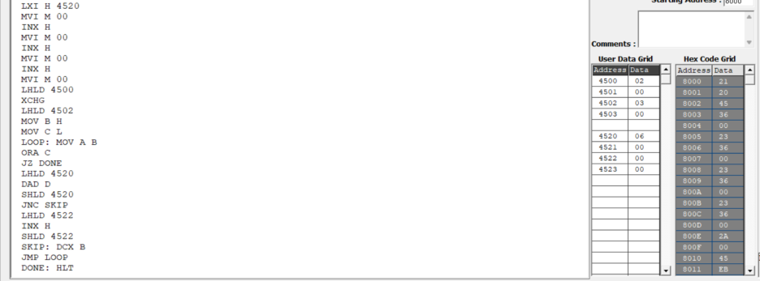
OUTPUT
Memory | Data
4500 | 02
4501 | 00
4502 | 03
4503 | 00
4520 | 06
4521 | 00
4522 | 00
4523 | 00

15
PROGRAM [Division]
LXI H 0000
SHLD 4514
LHLD 4510
XCHG
DIVLOOP:
LHLD 4512
MOV A E
SUB L
MOV E A
MOV A D
SBB H
MOV D A
JC DONE
XCHG
SHLD 4510
XCHG
LDA 4514
INR A
STA 4514
JNZ DIVLOOP
LDA 4515
INR A
STA 4515
JMP DIVLOOP
DONE:
XCHG
SHLD 4516
HLT

16
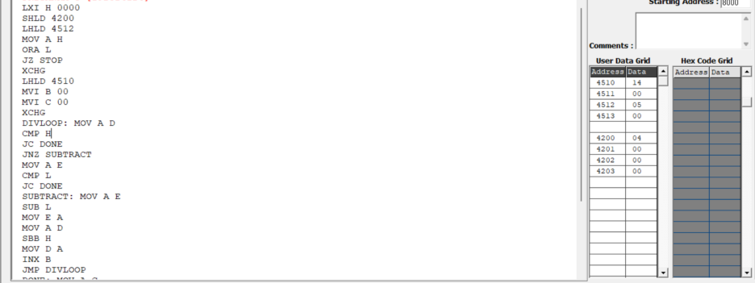
OUTPUT
Memory | Data
4510 | 14
4511 | 00
4512 | 05
4513 | 00
4200 | 04
4201 | 00
4202 | 00
4203 | 00

Result:
Thus, 8-bit and 16-bit addition, subtraction, multiplication, and division programs
were executed successfully using the 8085 microprocessors, and the results were
verified by examining the specified memory locations and flag conditions.

17
DATE: 15/10/2026
EXPERIMENT 02: LOGICAL, BIT-MANIPULATION AND SHIFT OPERATIONS USING 8-BIT
AND 16-BIT DATA
Objective:
1.To analyze, develop and verify logical AND, OR and XOR operations.
2.To analyze, develop and verify one's and two's complement operations on 8-bit
and 16-bit data.
3.To analyze, develop and verify bit setting, clearing, toggling, rotate and shift
operations.
4.To verify the output results and carry flag using the 8085 simulator.
Components Required:
8085 Simulator
Procedure:
i) Switch ON the 8085-microprocessor trainer kit.
ii) Enter the program opcodes at the specified starting memory address using the
memory examine/substitute command.
iii) Store the required input data in the specified memory locations.
iv) Execute Program A from 4100H and Program B from 4200H using the GO/EXEC
command.
v) Examine the memory locations assigned for the output results and flag byte.
vi) Record the output values and verify them against the expected hexadecimal results.
vii) Repeat the procedure for both programs and record the observations.

18
1. Analysis of Logical Operations
PROGRAM [AND,OR,XOR in 8-bit ]
LXI H, 4500H
MOV A, M
INX H
MOV B, M
ANA B
PUSH PSW
STA 4502H
POP H
MOV A, L
STA 4509H
LDA 4500H
ORA B
STA 4503H
LDA 4500H
XRA B
STA 4504H
HLT
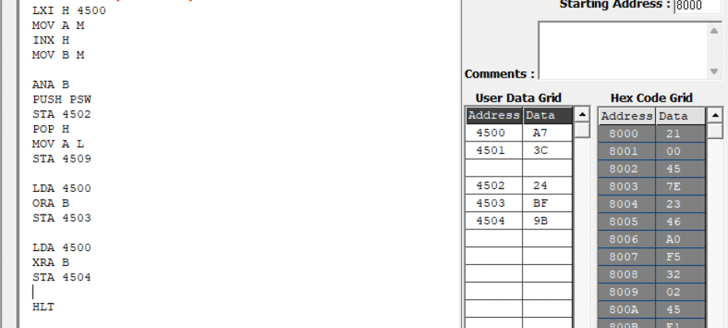
OUTPUT
Memory | Data
4500H | A7H

19
4501H | 3CH
4502H | 24H
4503H | BFH
4504H | 9BH

PROGRAM [AND,OR,XOR in 16-bit ]
LDA 4500
MOV B A
LDA 4502
ANA B
STA 4504
LDA 4501
MOV B A
LDA 4503
ANA B
STA 4505
LDA 4500
MOV B A
LDA 4502H
ORA B
STA 4506
LDA 4501
MOV B A
LDA 4503
ORA B
STA 4507
LDA 4500
MOV B A
LDA 4502
XRA B
STA 4508
LDA 4501
MOV B A
LDA 4503
XRA B
STA 4509
HLT

20
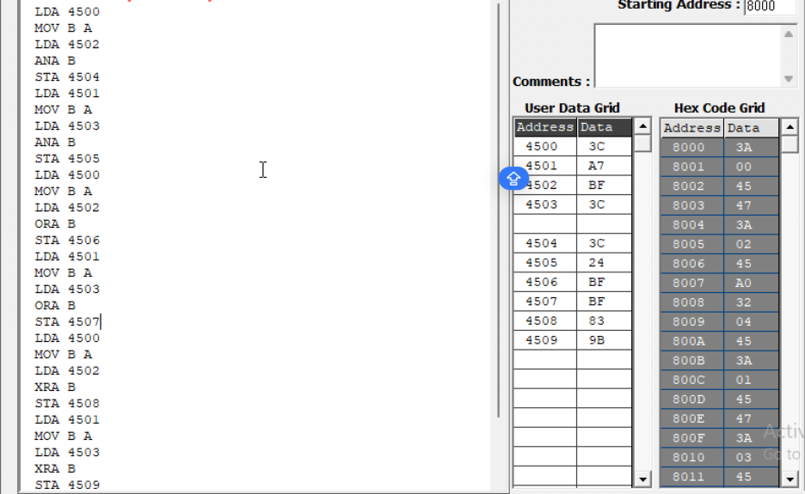
OUTPUT
Memory | Data
4500 | 3CH
4501 | A7H
4502 | BFH
4503 | 3CH
4504 | 3CH
4505 | 24H
4506 | FFH
4507 | BFH
4508 | 83H
4509 | 9BH

21
2. Analysis of One's and Two's Complement
PROGRAM [16-bit]
LDA 4500H
ANI 0FH
STA 4505H
LDA 4500H
ANI F0H
STA 4506H
LDA 4500H
CMA
STA 4507H
INR A
STA 4508H
LHLD 450AH
MOV A, L
CMA
MOV L, A
MOV A, H
CMA
MOV H, A
SHLD 450CH
INX H
SHLD 450EH
HLT

22
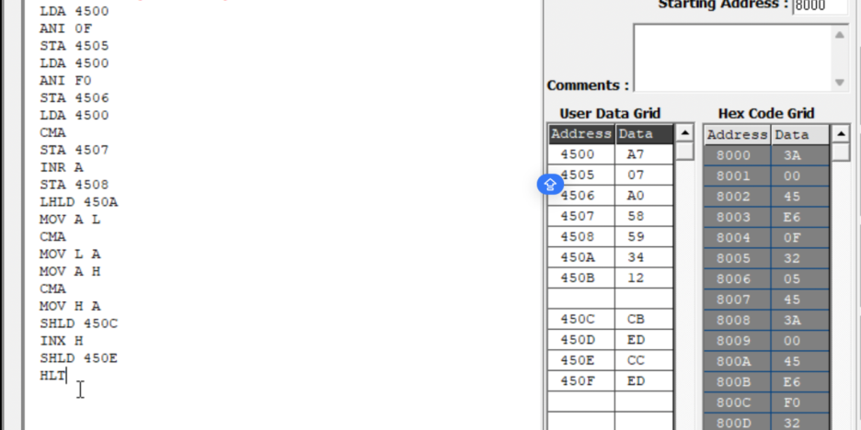
OUTPUT
Memory | Data
4500 | A7
4505 | 07
4506 | A0
4507 | 58
4508 | 59
450A | 34
450B | 12
450C | CB
450D | ED
450E | CC
450F | ED

23
3. Analysis of Bit Setting, Clearing, Rotate
PROGRAM [Bit Manipulation]
LDA 4510H
ORI 81H
STA 4511H
LDA 4510H
ANI F5H
STA 4512H
LDA 4510H
XRI 0FH
STA 4513H
MVI C, 00H
LDA 4510H
ANI 40H
JZ NEXT
INR C
NEXT: MOV A, C
STA 4514H
LDA 4510H
RLC
STA 4515H
LDA 4510H
RRC
STA 4516H
LDA 4510H
ORA A
RAL
STA 4517H
LDA 4510H
ORA A
RAR
STA 4518H
LDA 4510H
MOV B, A
RAL
MOV A, B
RAR
STA 4519H
LDA 4510H
MVI B, 08H
MVI C, 00H
CNT: RLC

24
JNC SKIP
INR C
SKIP: DCR B
JNZ CNT
MOV A, C
STA 451AH
HLT
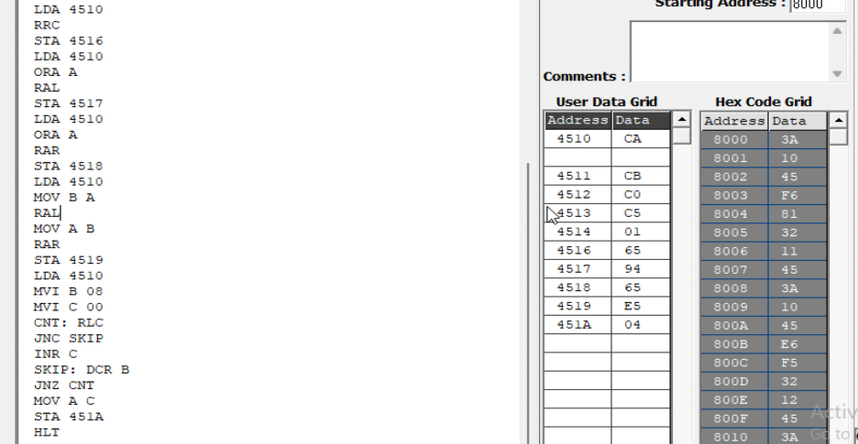
OUTPUT
Memory | Data
4510H | CAH
4511H | CBH
4512H | C0H
4513H | C5H
4514H | 01H
4515H | 95H
4516H | 65H
4517H | 94H
4518H | 65H
4519H | E5H
451AH | 04H

25
4. Analysis of Shift Operations
PROGRAM [16-bit Shift Left]
LHLD 4520H
DAD H
SHLD 4522H
HLT
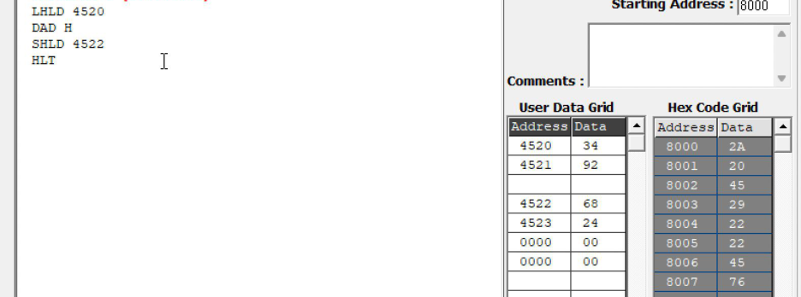
OUTPUT
Memory | Data
4520H | 34H
4521H | 92H
4522H | 68H
4523H | 24H

Result:
Thus, the logical, bit-manipulation, complement, rotate and shift operations were
performed using the 8085 simulator. The output values were examined in memory
and verified against the expected hexadecimal results.

