04.11.2026

Swift basics
Swift is a fast, safe, and modern programming language developed by Apple. Introduced in 2014, it was designed to replace Apple's older language, Objective-C. Today, it serves as the foundational language used to build applications across the entire Apple ecosystem, including iOS, macOS, watchOS, and tvOS, as well as for server-side and cloud services.
- Safety First: Swift eliminates entire categories of common programming bugs. It prevents null pointer crashes by using "optionals" (explicitly handling missing data) and features built-in protection against memory corruption.
- High Performance: Built on the advanced LLVM compiler toolchain, Swift code compiles directly into optimized native machine code. Its speed and efficiency are comparable to languages like C++.
- Modern & Expressive Syntax: The language is clean and highly readable, often looking similar to Python or JavaScript. It cuts out repetitive boilerplate code by using type inference (the computer automatically figures out data types).
- Open-Source & Multiplatform: Though created by Apple, Swift is fully open-source. Beyond iPhones and Macs, it officially runs on Linux and Windows, scaling from small embedded microcontrollers up to massive cloud servers.

Feature | What It Does
Automatic Reference Counting (ARC) | Automatically tracks and manages your app's memory usage so developers don't have to clean up manually.
Structured Concurrency | Uses clean async/await syntax to make complex, multi-threaded background tasks easy to write and read.
Interoperability | Can coexist seamlessly in the exact same codebase alongside C, C++, and Objective-C code.
SwiftUI Integration | Pairs perfectly with Apple's modern framework to build slick, declarative user interfaces with very little code.

Learn to code

// Storing data that changes

var dailyMinutesCoded = 0
dailyMinutesCoded = 30

// Storing data that stays the same

let frameworkToLearn = "SwiftUI"

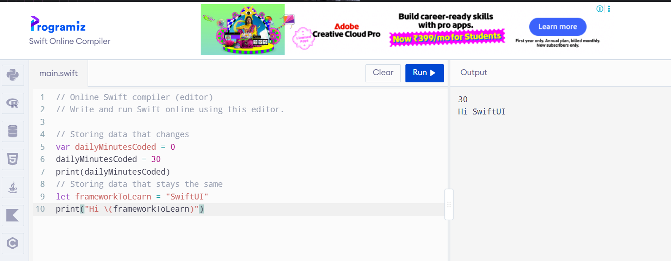

**Variables (`var`) & Constants (`let`)**: Learning when to create data that changes versus data that stays locked.
- **`String`**: How Swift handles text using double quotes.
- **`Int`**: Working with whole numbers.
- **`Double`**: Working with precise decimal numbers.
- **`Bool`**: Using `true` or `false` switches to control logic.


