05.11.2026

Swift Operations & Expressions
var score = 10
score += 5 // Short way of writing: score = score + 5 (score is now 15)

let itemsCount = 3
let itemPrice = 1.99

// let total = itemsCount * itemPrice // ❌ ERROR! Can't multiply Int and Double.

// Fix: Convert the Int to a Double first
let total = Double(itemsCount) * itemPrice // SUCCESS!

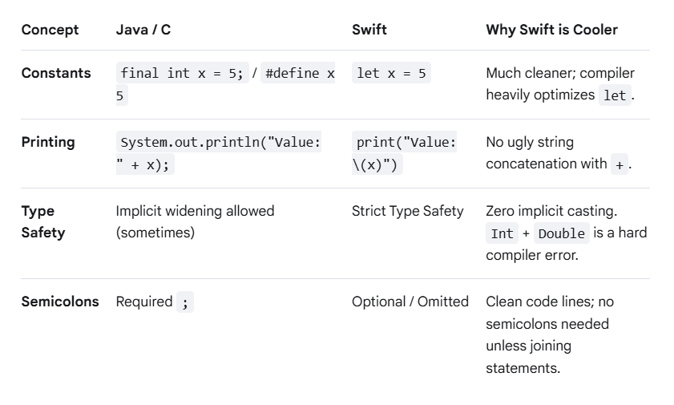

Strict Type Safety (No Implicit Widening)
In Java/C, you can often do double result = 5 + 2.5; because the compiler implicitly promotes the integer 5 to a double. Swift will refuse to compile this. You must explicitly cast.
let integerNum = 5
let decimalNum = 2.5

// ❌ ERROR: Binary operator '+' cannot be applied to operands of type 'Int' and 'Double'
// let result = integerNum + decimalNum

// CORRECT:
let result = Double(integerNum) + decimalNum

Operators & Expressions (The Quick Differences)
Most operators (+, -, *, /, %, ==, !=, &&, ||) work exactly like Java and C. However, Swift introduces a few unique features:
- Compound Assignment: +=, -=, *=, /= work as expected.
- No Increment/Decrement Operators: Swift removed ++ and -- entirely to prevent confusion. You must use += 1 or -= 1.
- Range Operators: Swift introduces an incredibly clean way to express ranges (highly used in loops):
  - Closed Range (...): 1...5 means 1, 2, 3, 4, 5.
  - Half-Open Range (..<): 1..<5 means 1, 2, 3, 4.

