AGRI-COMPANION - A WEB APPLICATION TO PREDICT CROPS, FERTILIZER AND DISEASE DETECTION USING MACHINE LEARNING AND DEEP LEARNING

**Dharshini B 1 Dharshini PK 2 Karthika M 3**

*1 Computer Science & Engineering, Panimalar Engineering College, Tamil Nadu, India*

*2 Computer Science & Engineering, Panimalar Engineering College, Tamil Nadu, India*

*3 Computer Science & Engineering, Panimalar Engineering College, Tamil Nadu, India*

***ABSTRACT-*** *With the help of the online application Agri-Companion, farmers will be able to increase agricultural productivity, minimize soil erosion on cultivated land, use fewer chemicals to produce crops, and make the most of available water resources. The random forest algorithm is used to estimate agricultural productivity and determine product costs using temporal information. The acquired meteorological data has been extensively used to suggest the appropriate crops that the farmers should choose under the given soil and climatic conditions. Due to seasonal climatic variations as well as the importance of essential elements like soil, water, and air, the use of different fertilizers is similarly unpredictable. Agricultural yields are steadily declining in this setting. Offering farmers a user-friendly recommender system is the problem's answer. A model is presented that takes these issues into account. The suggested methodology enables crop selection based on environmental and economic criteria in an effort to increase crop yields and meet the nation's rising food demand. Variables including rainfall, temperature, humidity, soil nutrients, and soil pH are analyzed and the suggested model forecasts crop production. Farmers are able to detect diseases in their plants and regulate the soil's nutrient level thanks to a web application. The accuracy obtained for the crop detection model is 98.4% and for the disease detection model an accuracy of 99.2% is achieved*

***KEYWORDS-*** *Crop prediction, Fertilizer recommendation, ResNet 9, CNN, Disease Detection.*

# **I. INTRODUCTION**

Almost 1.2 billion people live in India, a country that is primarily agricultural. Of this population, agriculture provides a living for about 70% of the people. India's population rely primarily on agriculture as a source of income, and it has a significant impact on the country's economy. Farmers can choose from an infinite array of soil

agricultural products. The farmer's choice of crop has a significant impact on the financial returns. The conventional farming techniques are ineffective. It does not utilize all of the resources effectively. Traditional approaches usually lead to

soil nutrient depletion and weariness because the primary focus is on yield. The earth gets depleted by cultivating only specific crops.

Depending on the crop, various distinct ranges of pH are ideal for plant growth. Since a majority of nutrients are available in this range of pH(6.0 - 7.5), most plants thrive here. The soil pH influences the presence of nutrients for the development of plants. In highly acidic soil, nutrients such as Calcium, Phosphorus, and Aluminium are found in excess which can be hazardous to the plants. In more alkaline soil, there is less concentration of Phosphorus and other micronutrients. The pH of the soil may indicate if it is appropriate and suitable for the selected crop or if changes have to be made by taking some other measures to improve the soil condition thereby making it optimal for the specific plant growth or a wide range of plants.

By specifically identifying these elements at each site, precision agriculture aims to isolate issues. While not all data generated by precision agriculture is trustworthy, it is nevertheless crucial to have precise and correct suggestions because errors can lead to significant material loss and financial loss. Many research initiatives are being carried out in an effort to create a crop forecast model that is more accurate and effective.

The objective is to recommend the optimum crop based on factors such as soil PH, humidity, temperature, rainfall, and inputs such as nitrogen (N), phosphorus (P), and potassium (K). It accurately predicts the crop that can be grown, fertilizers and plant diseases of numerous crops in India, such as rice, maize, chickpea, kidney beans, black gramme, lentil, pomegranate, banana, mango, grapes, watermelon, muskmelon, apple, orange, papaya, coconut, cotton, jute, and coffee crops, using a variety of supervised machine learning techniques. The crop that will be the most profitable and fertilizers that can be used to improve the crop yield are suggested, and the diseases that have affected the plants are identified. The dataset contains a wide range of variables, such as soil pH, soil moisture, nitrogen (N), phosphorus (P), and potassium (K) . The suggested system employed a number of machine learning techniques, including ResNet9 and Random Forest.

# **II. LITERATURE REVIEW**

Abhinav Sharma et al (2020)[1] have mentioned that predicting soil nutrients, soil surface humidity, and meteorological conditions during the crop's lifecycle make up the majority of the soil characteristics prediction. When forecasting crop production, factors such as pH value, soil type and quality, weather patterns including temperature, rainfall, humidity, and sunshine hours, fertilizers, and harvesting dates all play a significant impact. The factors that may affect crop yield can be foreseen with the aid of precise ML models. In this study, the authors have implemented this using Deep CNNs-AlexNet and GoogLeNet for crop prediction and Inception v3 in TensorFlow for disease and weed prediction.

In Dayalini et al’s study[2] and implementation three leaf diseases were studied such as the bacterial blast, brown spot, and leaf blight. The high accuracy and hierarchical model structure of CNN make it a popular choice for picture categorization. In this research, the predictions and suggestions for natural disasters are centred on floods and droughts. The system records user inputs such as the month, year, and disaster preference (disaster, flood, or drought). This system will categorize the disaster's occurrence in accordance with that classification and will offer the user the proper advice.

In Arfat Ahmad khan et al’s research[5], in order to improve the fertilizer recommendation system, this study focuses on the context based on the real-time soil fertility data that the IOT receives. By utilizing the Logistic Regression (LR), Support Vector Machine (SVM), Gaussian Naive Bayes (GNB), and K-Nearest Neighbor (KNN) machine learning models, the effectiveness is examined through a context-aware fertilizer suggestion. The examination of the suggested solution shows that the GNB model is more accurate, with accuracy values from the training and testing datasets of 96% and 94%, respectively.

PE Rubini et al’s implementation[6] involves VGG 16 and DenseNet architecture and the results were analyzed with the same dataset. The dataset taken for implementation is the Plant Village dataset which contains 17000 training images and 200 testing images and achieved an accuracy of 92 using VGG.

Taranjeet Singh et al [9] have implemented a sensor interface based on a microcontroller to read soil characteristics (NPK value). The sensor’s analogue signal output is transformed into a digital signal for further processing using available USB ports to send all reading to the system.constructing an internet application to show the outcome and produce a report.

From the above it has been inferred that data has been collected with the use of IoT devices which is advantageous but only a certain region has been covered. Many other functionalities such as weed detection have been implemented apart from this and a few of the disease classes have only been used to classify the diseases in plants.

# **III. PROPOSED SYSTEM**

The proposed system makes predictions about the crops that may be planted and would produce a high yield based on the nutrient makeup of the soil and the NPK Ratio and the environmental conditions. Every soil differs in its makeup of macronutrients and micronutrients. ​The type of crop that can be produced and the kind of fertilizer that can be used to improve the soil are predicted using this analysis. The application has also been created so that users can upload pictures of diseased plant leaves in order to forecast the illness and suggest treatment options. ​​The proposed system has the following modules:

* Crop prediction and recommendation based on soil parameters.
* Fertilizer prediction and recommendation based on soil parameters.
* Disease identification in crops and preventive measures recommendation.

**CROP RECOMMENDATION**: The NPK value of the soil is used along with other variables such as pH, rainfall, and other values. An API is used to collect these values. The rainfall and temperature values are collected using the Open Weather Map API. The pH value, NPK value, rainfall, and location are factors that are taken into consideration when predicting which crop will do best in a particular area. To forecast the yield, a machine learning system with a 99 percent accuracy rate by the name of Random Forest is applied.

**FERTILISER RECOMMENDATION**: Based on the NPK value acquired from the device for a certain soil and the crop that is to be grown in a soil, a suitable fertilizer is advised for the crop. Proper recommendations for increasing soil fertility are presented (NPK).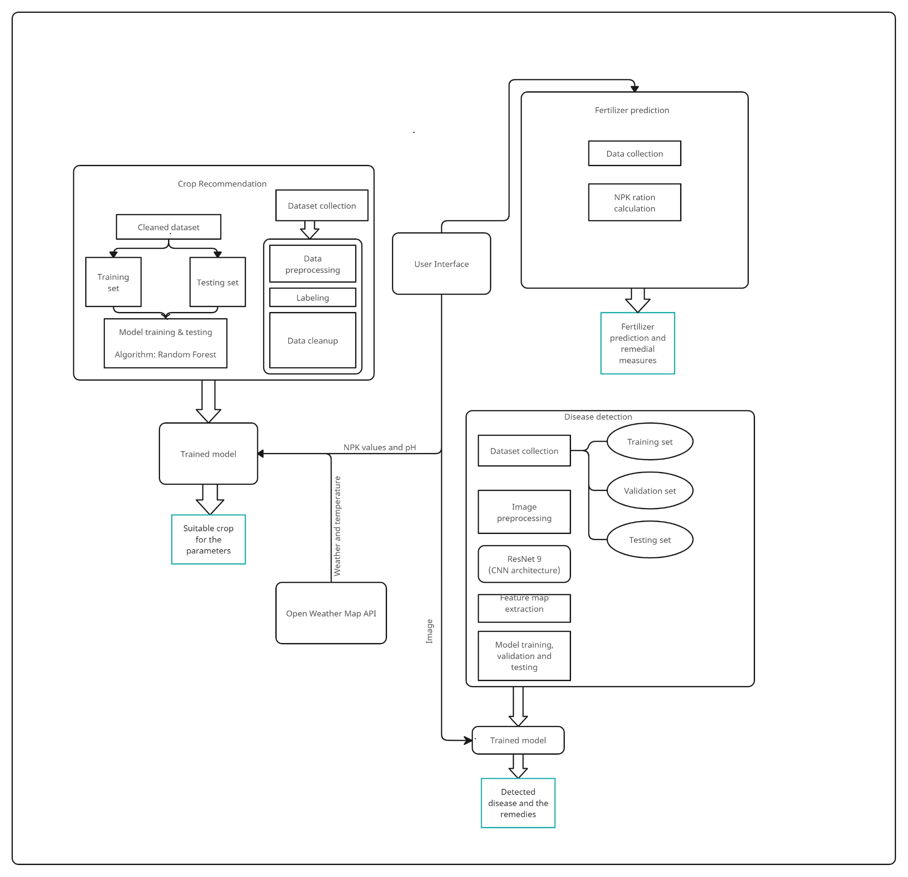

**Figure 1: Proposed System Architecture**

**DISEASE DETECTION:** The image collected from the user is used to detect crop-based illnesses. Deep learning techniques-ResNet and CNN models are used to forecast what disease the crop is affected with, and a viable remedy is then offered to the user. ​

# **IV. MATERIALS AND METHODS**

**A. DATA COLLECTION**

For training the crop prediction model temperature, humidity, ph, rainfall are used. It is combined along with the data set used for fertilizer prediction. For fertilizer prediction model training and testing, custom data sets with five fields crop name, Nitrogen, Phosphorus, Potassium, and pH level. Data sets for disease detection models are collected from ImageNet open source library and Kaggle. The ImageNet dataset is a very large collection of human annotated photographs designed by academics for developing computer vision algorithms.

**B. DATA PREPROCESSING**

For the crop prediction model, the original data set is combined with the fertilizer prediction and noisy data is removed and then the data set is labeled.

The pre-processed data set will contain the following fields.

1. Nitrogen
2. Phosphorus
3. Potassium
4. Temperature
5. Humidity
6. pH
7. Rainfall

For fertilizer prediction after preprocessing the data, a new column for soil moisture is added and irrelevant and noisy data are removed using Pandas.

The preprocessed data set will contain the following fields.

1. Crop
2. Nitrogen
3. Phosphorus
4. Potassium
5. pH value
6. Soil moisture

**C. FEATURE EXTRACTION**

For the images, the torchvision.models.feature_extraction package contains feature extraction utilities that lets us tap into our models to access intermediate transformations of our inputs(images). This is used to convert a PIL image or numpy array to tensor. It converts a PIL Image or numpy.ndarray (H x W x C) in the range [0, 255] to a torch.

**D. MODEL TRAINING AND TESTING**

For the crop recommendation module, the dataset has been split into 80% and 20% for training and testing respectively using sklearn. For the crop recommendation module, various models were trained and tested and the use of two algorithms, Gaussian Naive Bayes and Random Forest algorithms yielded the highest accuracies among all.

Random Forest has been implemented for the prediction of crops. Instead of relying on one decision tree, the random forest takes the prediction from each tree and bases its prediction of the final output on the majority votes of predictions. Random Forest is a classifier that contains a number of decision trees on various subsets of the given dataset and takes the average to improve the predictive accuracy of that dataset.

To take care of the overfitting issue, 20 (n_estimators) decision trees were used. N_estimators are the number of trees used in a Random Forest model.

For the disease detection module, the images are split into multiple folders, each for a different class of disease and into three main folders each for training, validation and testing.

ResNet9 works by taking an input image and passing it through a series of layers in the neural network. These layers are designed to extract different features from the image, such as edges, shapes, and textures. The key innovation of ResNet9 is the use of residual connections between layers. These connections allow information to flow directly from one layer to another, bypassing intermediate layers. This helps to prevent the vanishing gradient problem, which can occur when trying to train very deep neural networks. ResNet9 leverages a technique called convolution to extract features from images. Convolutional neural networks (CNNs) utilize small filters that slide over an input image to detect different features and patterns. The output of each filter is a feature map that emphasizes a specific aspect or component of the image. These feature maps, which represent the input image, visually display where particular features or patterns were identified by the CNN's filters. Later layers in the network then integrate these feature maps to produce more abstract representations of the image, ultimately enabling accurate image classification. As the image passes through the layers of ResNet9, the features extracted from the image become more and more abstract. Overall, feature maps are an important tool for understanding how CNNs extract information from images and how they make predictions. Finally, the output of the neural network is a probability distribution over the different classes that the image could belong to. The class with the highest probability is the one that the neural network predicts the image belongs to. During training, ResNet9 uses a process called backpropagation to adjust the weights of the different layers in the neural network. This allows the network to learn the optimal set of weights for classifying images. Overall, ResNet9 is a powerful and efficient neural network architecture that is particularly well-suited for image classification tasks.

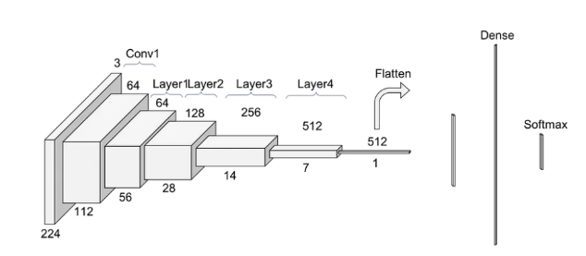

**Figure 2: ResNet9 layers**

*Source: TowardsDataScience*

**PERFORMANCE COMPARISON OF VARIOUS ALGORITHMS FOR CROP RECOMMENDATION**

For the crop detection model, various models with different algorithms were trained and tested and the accuracy comparison has been given below.

| **S.No** | **Algorithm** | **Accuracy** |
| --- | --- | --- |
| **1.** | Decision Tree | 90.00% |
| **2.** | Gaussian Naive Bayes | 99.09% |
| **3.** | Support Vector Machine (SVM) | 97.95% |
| **4.** | Logistic Regression | 95.23% |
| **5.** | Random Forest | 99.09% |
| **6.** | XG Boost | 99.02% |

**Table 1: Accuracy of various algorithms used**

From the above it has been inferred that Guassian Naive Bayes (GNB), Random Forest, and XGBoost result in a higher accuracy model for the given dataset for the Crop Recommendation module.

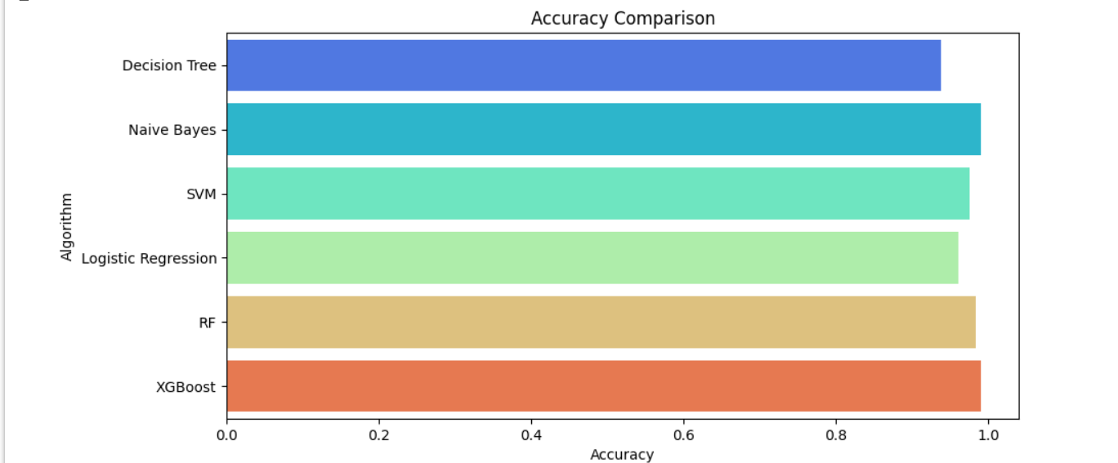

**Figure 3: Accuracy comparison of various algorithms**

# **V. INPUT**

The crop recommendation model has the following fields for each of the classes

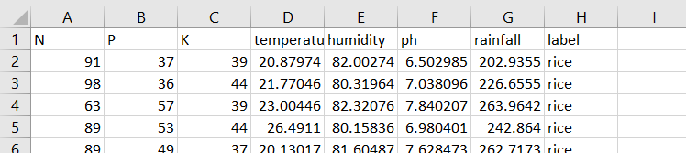

**Figure 4: Sample dataset for crop prediction module**

For the disease detection model training, the input looks like the following,

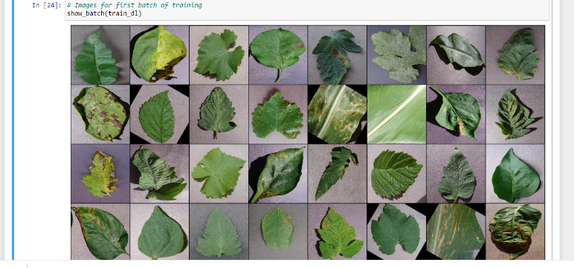

**Figure 5: Sample dataset for disease detection**

From the user for the crop recommendation model, the following input values are required.

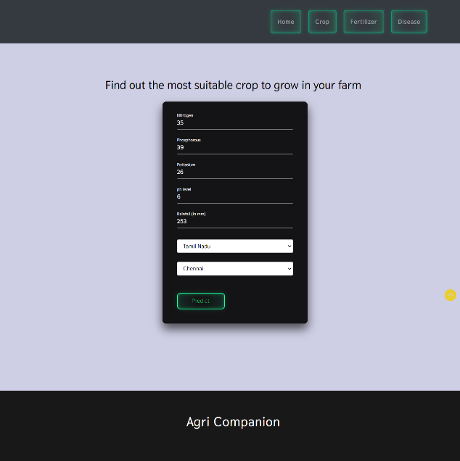

**Figure 6: Crop prediction module UI**

For the fertilizer prediction, the following is the input form..

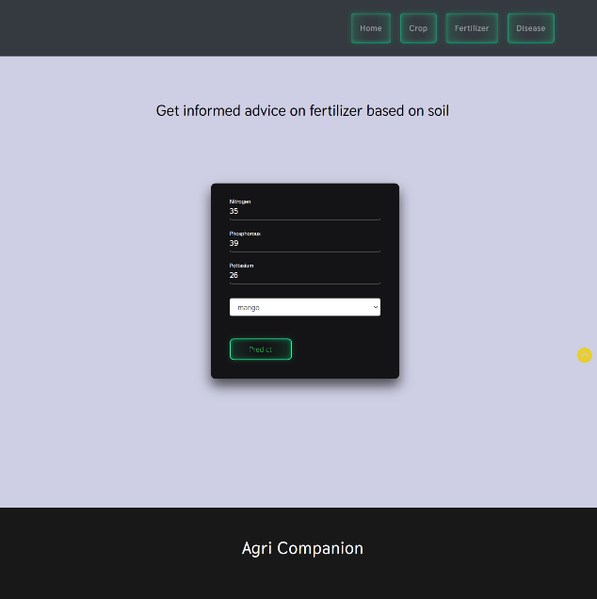

**Figure 7: Fertilizer prediction module UI**

For the disease detection module the image can be dragged and dropped or it can be searched and inserted via the file explorer.

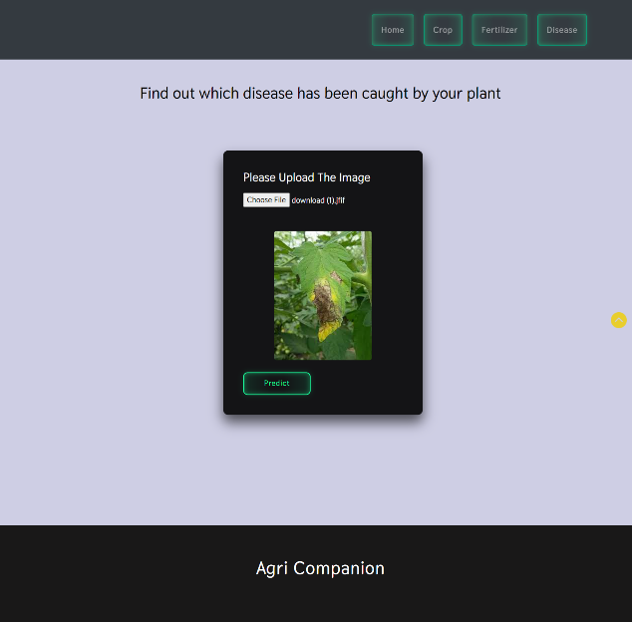

**Figure 8: Disease detection module UI**

# **VI. OUTPUT**

For the crop recommendation module, the UI is designed to fetch the input from the user and display the result of the model’s prediction like below

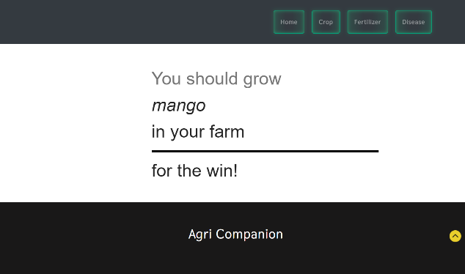

**Figure 9: Crop prediction module sample result**

For the fertilizer prediction module, the issue with the soil’s NPK values and the remedial actions that can be taken is displayed as follows.

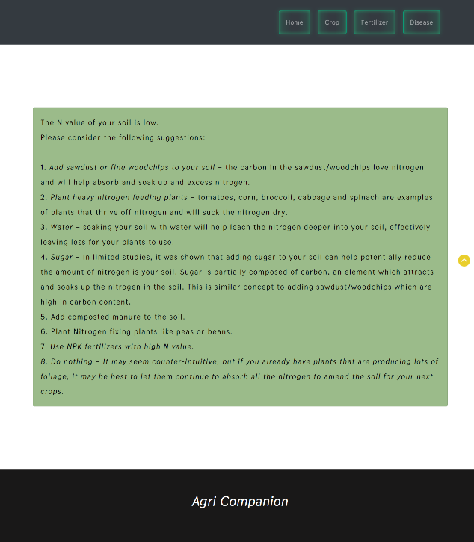

**Figure 10: Fertilizer prediction module sample result**

For the disease detection module, the plant and its disease for the user uploaded image and other information regarding the disease such as cause, preventive measures and remedial measures are displayed.

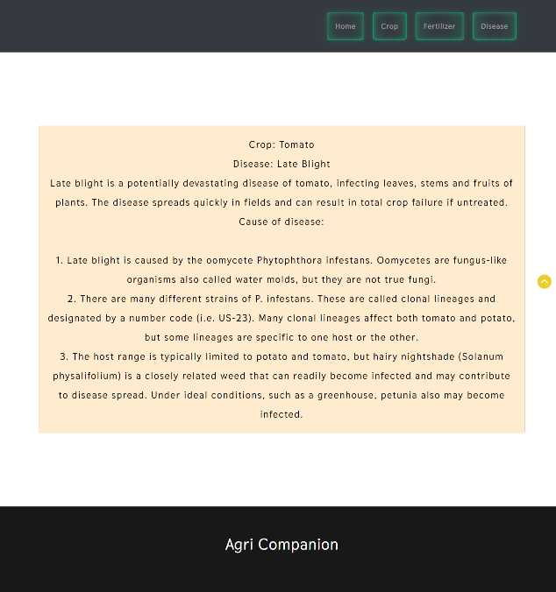

**Figure 11: Disease detection module sample result**

# **VII. RESULTS AND DISCUSSION**

For the crop prediction model using Random Forest, the calculated accuracy is 98.409%.

The confusion matrix for the crop detection model has been given below.

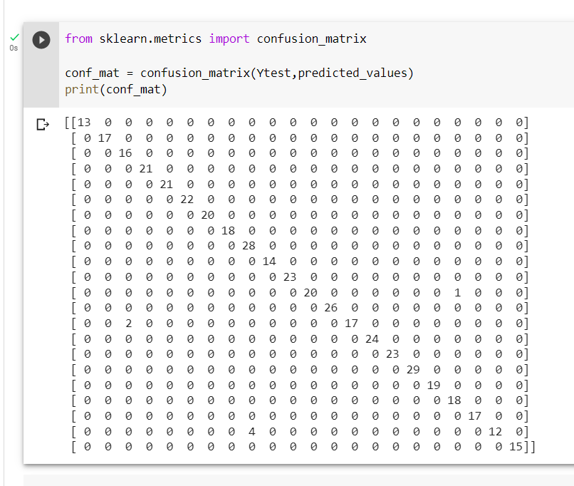

**Figure 12: Confusion matrix for crop prediction model**

The f1 score and precision for each of the classes is as given as follows

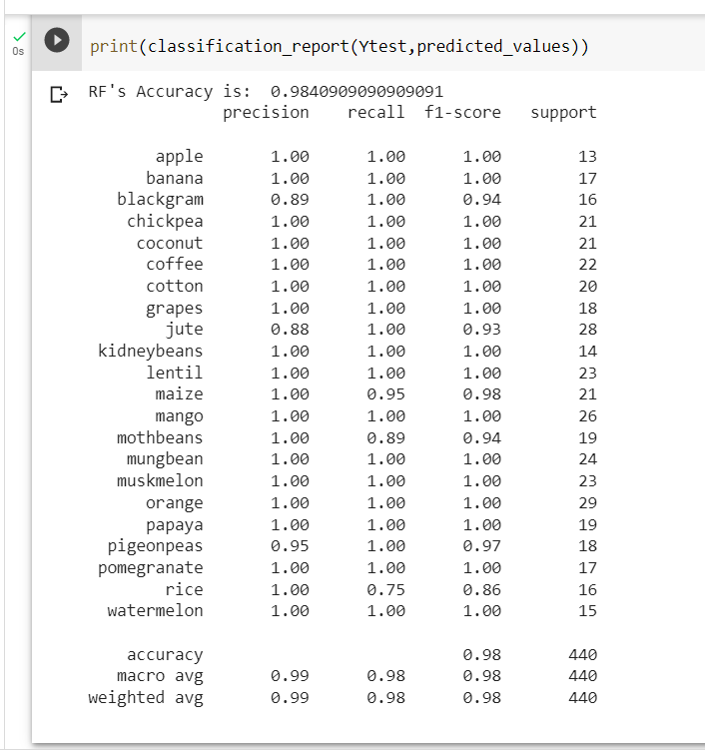

**Figure 13: f1 scores of various classes in crop prediction**

Accuracy = True Positives + True Negatives

________________________

True Positives +

False Positives +

True Negatives +

False Negatives

= 13+17+16+21+21+22+20+18+28+14+23+

20+26+17+24+23+29+19+18+17+12+15

___________________________________

13+17+16+21+21+22+20+18+28+14+23+

20+26+17+24+23+29+19+18+17+12+15+

1+2+4

= 433/440

=0.98409090909

Therefore, the accuracy achieved is 98.4 % for the crop prediction model.

For the disease detection model the model’s accuracy has been validated using the validation set for each class. An accuracy of 99.2 has been achieved in the last epoch.

Epoch [0], Epoch [1],

last_lr: 0.00812, last_lr: 0.00000,

train_loss: 0.7466, train_loss: 0.1248,

val_loss: 0.5865, val_loss: 0.0269,

val_acc: 0.8319 val_acc: 0.9923

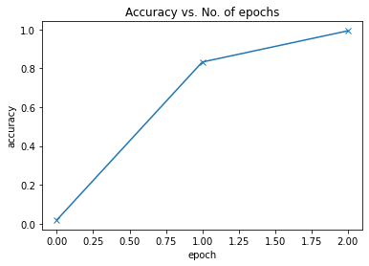

**Figure 14: Accuracy vs Epochs**

A loss of 2.69 has been reported for the validation set.

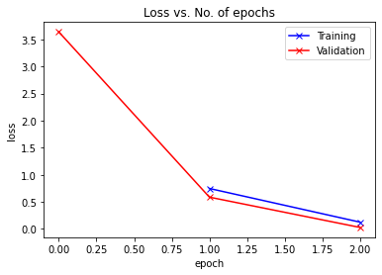

**Figure 15: Loss vs Epochs**

The learning rate has also been visualized below.

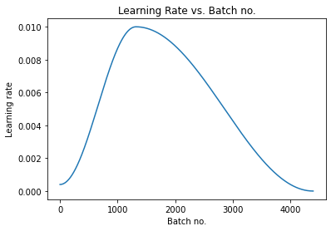

**Figure 16 : Learning rate visualization**

# **VIII. CONCLUSION**

As farming is a significant component of our economy, it is crucial to make sure that even the smallest investment made in the agriculture industry is taken care of. Crop seeds are one such investment. So, it is crucial to confirm that the right crop has been selected for the right soil and that it meets its criteria in order to benefit the farmer. With the use of this technology, farmers would be better able to choose the right crop to plant based on a range of geographical and environmental parameters. By integrating perception and passed-down knowledge with a significantly more dependable solution to a significant problem affecting hundreds of millions of people, the ML and IoT assist them in minimizing costs and making strategic decisions. The next intention is to expand the number of soil variables and the size of the data set for this model in future work.

**CONFLICTS OF INTEREST:**

The author(s) declare(s) that there is no conflict of interest regarding the publication of this paper.

**FUNDING STATEMENT:**

The research was self funded and only open source resources were made use of.

**IX. FUTURE ENHANCEMENTS**

A higher crop production is achievable, as evidenced by the forecast of crop yield based on soil data and effective algorithm implementation. The following features can be included by expanding the work. By uploading agricultural images, creating a website can assist farmers. Image processing is used to detect crop diseases so that users can order pesticides based on disease images and forecast fertilizer needs based on the state of the soil. By offering necessary guidance on crops, their development, and other fundamental knowledge, technology will help farmers. The address of the closest store where farmers may buy fertilizer and other supplies will also be provided. By giving them precise data on market prices and merchant information, it would also help farmers sell their goods to retailers. Also, this application can aid farmers in calculating crop MSP. Using the Internet of Things, the disease detection feature can be expanded (IOT TECHS).

**X. REFERENCES**

[1]. Abhinav Sharma, Arpit Jain, Prateek Gupta and Vinay Choudary, ”Machine Learning application for precision agriculture” published in IEEE Access, Volume 09, (2020).

[2]. Dayalini S, Sathana M, Navodya P.R.N, Narmada Gamage, Anuradha Jaya, “Agro-Mate: A Virtual Assister to Maximize Crop Yield in Agriculture Sector”,Published in IEEE Region 10 Conference(TENCON), (2021).

[3]. Sanidhya Purohit, Deep Sanghani. Naman Senjaliya, Prof. Anuradha Kapoor, “Agro-Farm Care for Crop, Fertilizer & Disease Prediction using Machine Learning”, Published in International Research Journal of Engineering & Technology, Volume: 09, (2022).

[4]. Priyanka Sahu, Amit Prakash Singh, Anuradha chug,Dinesh Singh, “A Case Study of Banana Crop using Machine Learning”, Published in IEEE Region 10 Conference (TENCON), (2022).

[5]. Arfat Ahmad khan, Muhammad Faheem, Rab Nawaz Bashir,Muhammad Zahid Abbas, “IOT Assisted Context Aware Fertilizer Recommendation” , Published in IEEE Access, Volume 10,( 2022).

[6]. PE Rubini, P Kavitha, “Deep Learning model for early prediction of plant disease”, Published in Third International Conference on Intelligent Communication Technologies and Virtual Mobile Networks, (2021).

[7]. Sri Laasya.Kanuru,Amit Kumar Tyagi,Aswathy S UN Sreenath,Terrance Frederick Fernandez,Shashvi Mishra, “Prediction of Pesticides and Fertilizers using Machine Learning and Internet of Things”, Published in International Conference on Computer Communication and Informatics (ICCCI ), (2021).

[8]. Anguraj.K, Thiyaneswaran.B, Megashree. G, Preetha Shri.J.G, Navya.S, Jayanthi.J, “Crop Recommendation on Analyzing Soil using Machine Learning”, Published in Turkish Journal of Computer and Mathematics Education, Volume 12, (2021).

[9]. Taranjeet Singh, Saurabh Anand, Anmol Sehgal, Siddhesh Mahajan, Prof. Pranoti Kavimandan, “CROFED - Crop and Fertilizer Recommendation and Disease diagnosis system using Machine Learning and Internet of Things”, Published in, Volume 09, (2022).

[10]. C.Murugamani,,S.Hemalatha,Pravin R.Kshirsagar,K.Riyazuddin, Quadri Noorulhasan Naveed, Saiful Islam, S.Siddharth, Syed Parween Mazher Ali, & Areda Batu, “Machine Learning Technique for Precision Agriculture Applications in 5G-Based Internet of Things”, Published in Wireless Communications and Mobile Computing Volume, (2022).

[11]. [Manish Kumar](https://ieeexplore.ieee.org/author/38254105800), [Ahlad Kumar](https://ieeexplore.ieee.org/author/37086800982), [Vinay S. Palaparthy](https://ieeexplore.ieee.org/author/37085466225), “Soil Sensors-Based Prediction System for Plant Diseases using Machine Learning”, Published in[IEEE Sensors Journal](https://ieeexplore.ieee.org/xpl/RecentIssue.jsp?punumber=7361) Volume: 21, [Issue: 16](https://ieeexplore.ieee.org/xpl/tocresult.jsp?isnumber=9512558&punumber=7361), 15 August (2021).

[12]. [Ankita Sharma](https://ieeexplore.ieee.org/author/37089512444); [Anushtha Tamrakar](https://ieeexplore.ieee.org/author/37089509860); [Sourajita Dewasi](https://ieeexplore.ieee.org/author/37089510896); [Nenavath Srinivas Naik](https://ieeexplore.ieee.org/author/37088664949), “Early Prediction of Crop Yield in India using Machine Learning”, Published in IEEE Region 10 Symposium (TENSYMP) 3rd July (2022).

[13]. [Garima Garg](https://ieeexplore.ieee.org/author/37089718946), [Shivam Gupta](https://ieeexplore.ieee.org/author/37089717070), [Preeti Mishra](https://ieeexplore.ieee.org/author/37085390582), [Ankit Vidyarthi](https://ieeexplore.ieee.org/author/37085372575), [Aman Singh](https://ieeexplore.ieee.org/author/37088429647), [Asmaa Ali](https://ieeexplore.ieee.org/author/37075908800), “CROPCARE: An Intelligent Real-Time Sustainable IoT System for Crop Disease Detection Using Mobile Vision”, Published in [IEEE Internet of Things Journal](https://ieeexplore.ieee.org/xpl/RecentIssue.jsp?punumber=6488907), [Issued in 4](https://ieeexplore.ieee.org/xpl/tocresult.jsp?isnumber=10038283&punumber=6488907), 15 February (2023).

[14]. K. Sumathi, P. Deepalakshmi, K. Selvarani, “Data Analytics System for Irrigation Alert, Fertilizer and Pesticide Recommendation towards Sustainable Agriculture” Published in International Journal of Recent Technology and Engineering (IJRTE), (2019).

[15]. Dhivya Elavarasan, P. M. Durairaj Vincent, “Crop Yield Prediction Using Deep Reinforcement Learning Model for Sustainable Agrarian Applications”, Published in IEEE Access (2020).

[16]. Meeradevi, Hrishikesh Salpekar, “Design and Implementation of Mobile Application for Crop Yield Prediction using Machine Learning” Published in [2019 Global Conference for Advancement in Technology (GCAT)](https://ieeexplore.ieee.org/xpl/conhome/8966568/proceeding) (2020).

[17]. [Yuxin Miao](https://link.springer.com/article/10.1007/s11119-006-9004-y#auth-Yuxin-Miao), [David J. Mulla](https://link.springer.com/article/10.1007/s11119-006-9004-y#auth-David_J_-Mulla),[Pierre C. Robert](https://link.springer.com/article/10.1007/s11119-006-9004-y#auth-Pierre_C_-Robert), “Identifying important factors influencing corn yield and grain quality variability using artificial neural networks”, Published in (2006).

[18]. Fengdi Li, Zhenyu Liu, Weixing Shen, Yan Wang, Yunlu Wang, Chengkai Ge, “A Remote Sensing and Airborne Edge-Computing Based Detection System for Pine Wilt Disease”, Published in IEEE Access (2021).

[19]. Xanthoula Eirini Pantazi, Dimitrios Moshou, Abdul Mounem Mouazen, Boyan Kuang & Thomas Alexandridis, “Application of Supervised Self Organising Models for Wheat Yield Prediction”, Published in (2014).

[20]. M. Ishak, M. S. Rahaman and T. Mahmud, "FarmEasy: An Intelligent Platform to Empower Crops Prediction and Crops Marketing," Published in 13th International Conference on Information & Communication Technology and System (ICTS), Surabaya, Indonesia, (2021).

[21]. M. T. Shakoor, K. Rahman, S. N. Rayta and A. Chakrabarty, "Agri-cultural production output prediction using supervised machine learning techniques", 1st international conference on next generation computing applications (NextComp), (2017).

[22]. D. A. Bondre and S. Mahagaonkar, "Prediction of crop yield and fertilizer recommendation using machine learning algorithms", International Journal of Engineering Applied Sciences and Technology,(2019).

[23]. S. Bhanumathi, M. Vineeth and N. Rohit, "Crop yield prediction and efficient use of fertilizers", International Conference on Communication and Signal Processing (ICCSP), (2019).

[24]. N. K. Dhanush Vishwakarma and M. N, "Crop prediction using machine learning approaches", International Journal of Engineering Research, August, (2020)

.

[25]. N. Gandhi, L. J. Armstrong, O. Petkar and A. K. Tripathy, "Rice crop yield prediction in India using support vector machines", 2016 13th International Joint Conference on Computer Science and Software Engineering (JCSSE), (2016).

[26]. S. A. Z. Rahman, K. C. Mitra and S. M. Islam, "Soil classification using machine learning methods and crop suggestion based on soil series", 21st International Conference of Computer and Information Technology (ICCIT), (2018).

[27]. M. Rashid, B. S. Bari, Y. Yusup, M. A. Kamaruddin and N. Khan, "A Comprehensive Review of Crop Yield Prediction Using Machine Learning Approaches With Special Emphasis on Palm Oil Yield Prediction," in IEEE Access,(2021).

[28]. N. Prasad, N. Patel and A. Danodia, "Crop yield prediction in cotton for regional level using random forest approach", Spatial Inf. Res., (2020).

[29]. Prasad, N.R., Patel, N.R. & Danodia, A. Crop yield prediction in cotton for regional level using random forest approach. Spat. Inf. Res., (2021).

[30]. P. Parameswari, N. Rajathi and K. J. Harshanaa, "Machine Learning Approaches for Crop Recommendation," 2021 International Conference on Advancements in Electrical, Electronics, Communication, Computing and Automation (ICAECA), (2021).

[31]. F. Balducci, D. Impedovo and G. Pirlo, "Machine Learning Applications on Agricultural Datasets for Smart Farm Enhancement",(2018).

[32]. E. Manjula and S Djodiltachoumy, "A Model for Prediction of Crop Yield", International Journal of Computational Intelligence and Informatics, (2017).