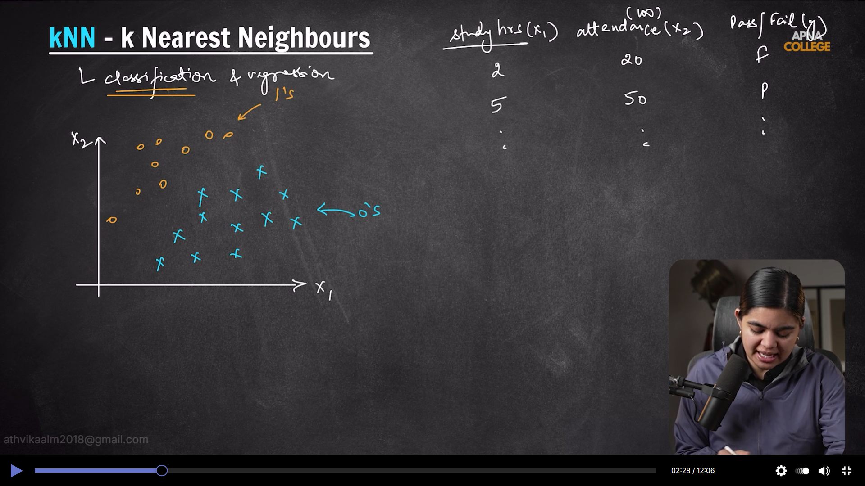

Hyperparameters are lambda and alpha based on the algorithm it changes
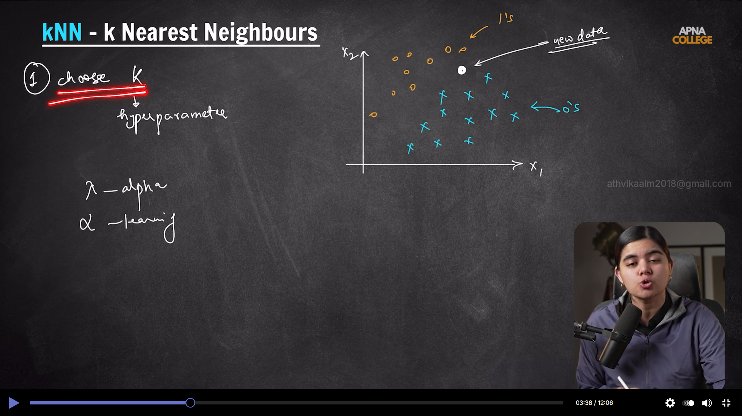

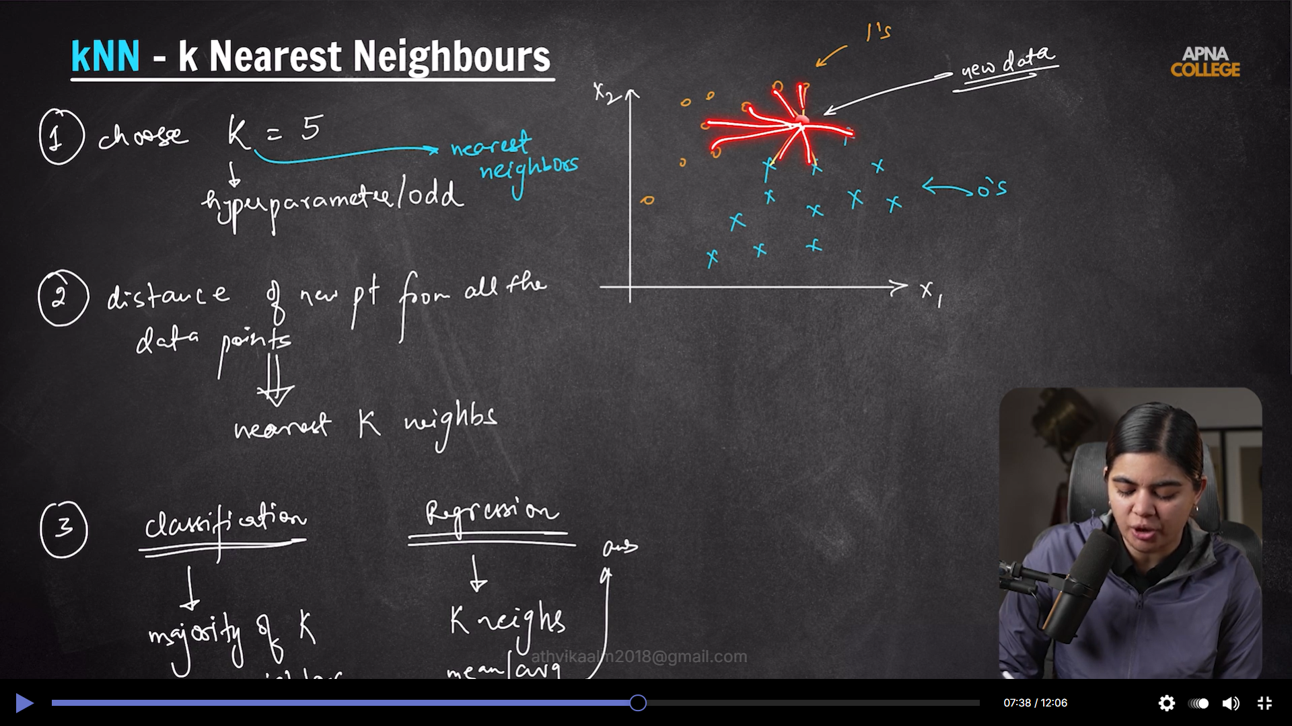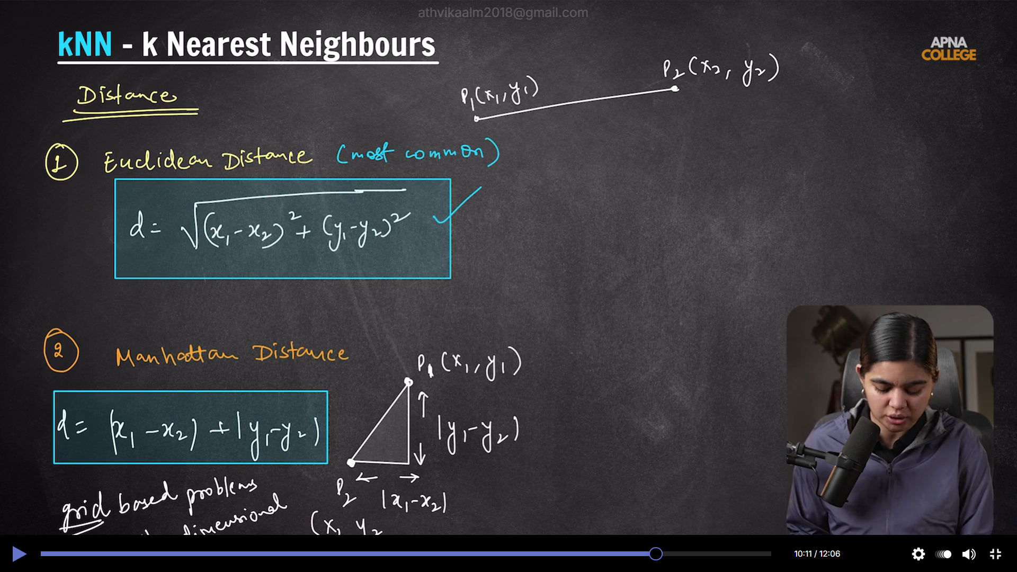
Grid and high dimensional data – knn
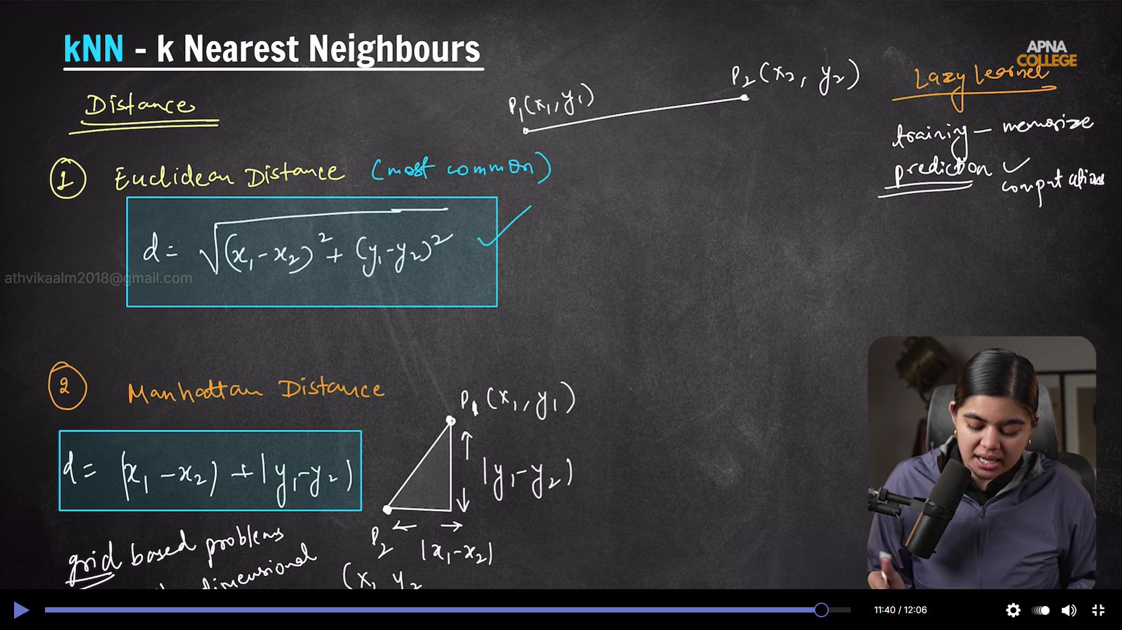

Optimizing tool selection...Great question. In most cases, you do not scale y_train because y is the target, not an input feature.

For KNN classification:
1. X features need scaling because KNN uses distance, and large-scale features dominate.
2. y_train is class labels (for example 0/1 or cat/dog), so scaling would destroy class meaning.

For regression:
1. You can scale y in some models, but it is optional and situation-dependent.
2. If you do scale y, you must inverse-transform predictions before interpreting results.
3. A safer pattern is to use a target-transform wrapper (like TransformedTargetRegressor) rather than manually scaling y.

So the rule of thumb is: scale X_train/X_test almost always for distance-based models, but scale y_train only in specific regression workflows, not in classification.

Recall gets priority over precision when missing a true positive is more costly than raising a false alarm.

Simple way to remember:
1. Precision asks: “Of predicted positives, how many were actually positive?”
2. Recall asks: “Of actual positives, how many did we catch?”

Recall is prioritized in cases like:
1. Disease screening: missing a sick patient (false negative) is dangerous.
2. Fraud detection: missing fraud can cause major loss.
3. Spam/abuse/security detection: missing harmful content can be risky.

Precision is prioritized when false positives are costly, like:
1. Marking good emails as spam.
2. Wrongly rejecting valid loan applicants.

So if your use case says “don’t miss positives,” recall > precision.
If it says “don’t raise false alarms,” precision > recall.

If you want balance between both, use F1-score.

Try with multiple hyperparameters to get optimal value
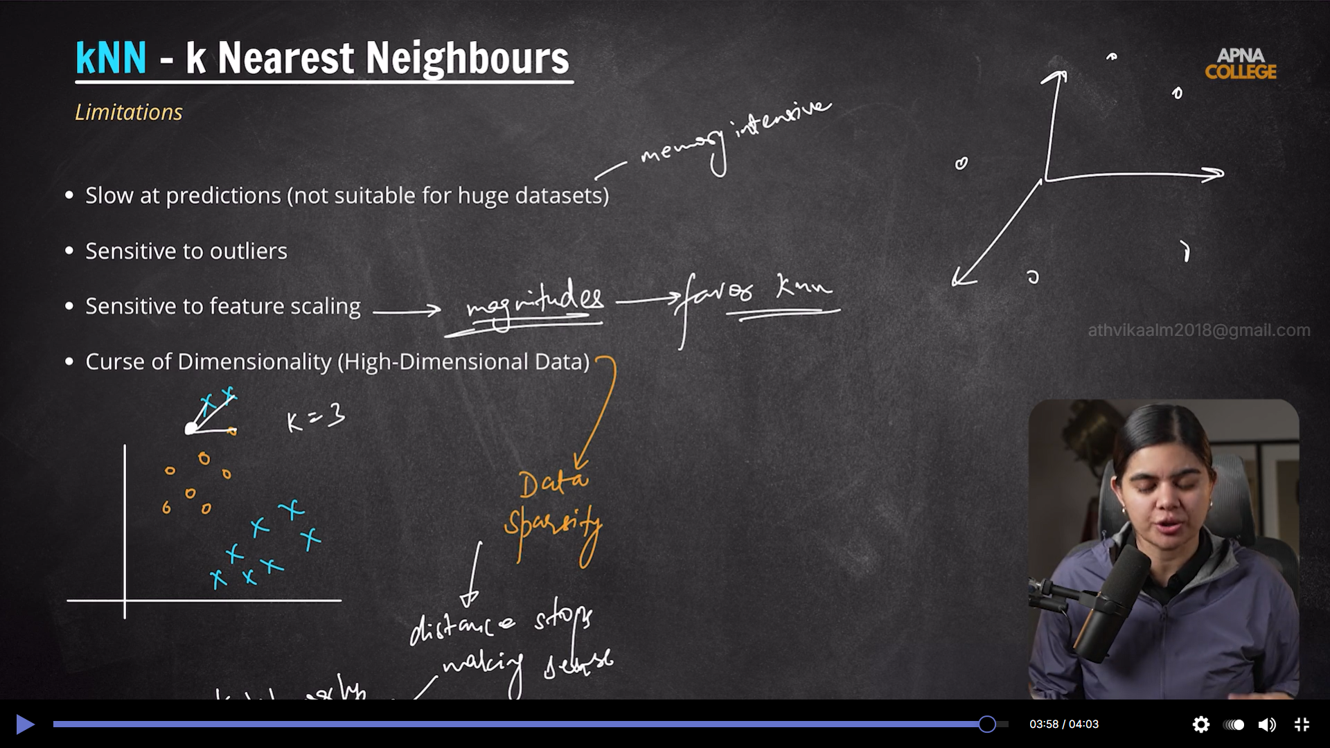

Knn poorly performs – high dimensional data then replace it with svm or logistic regression

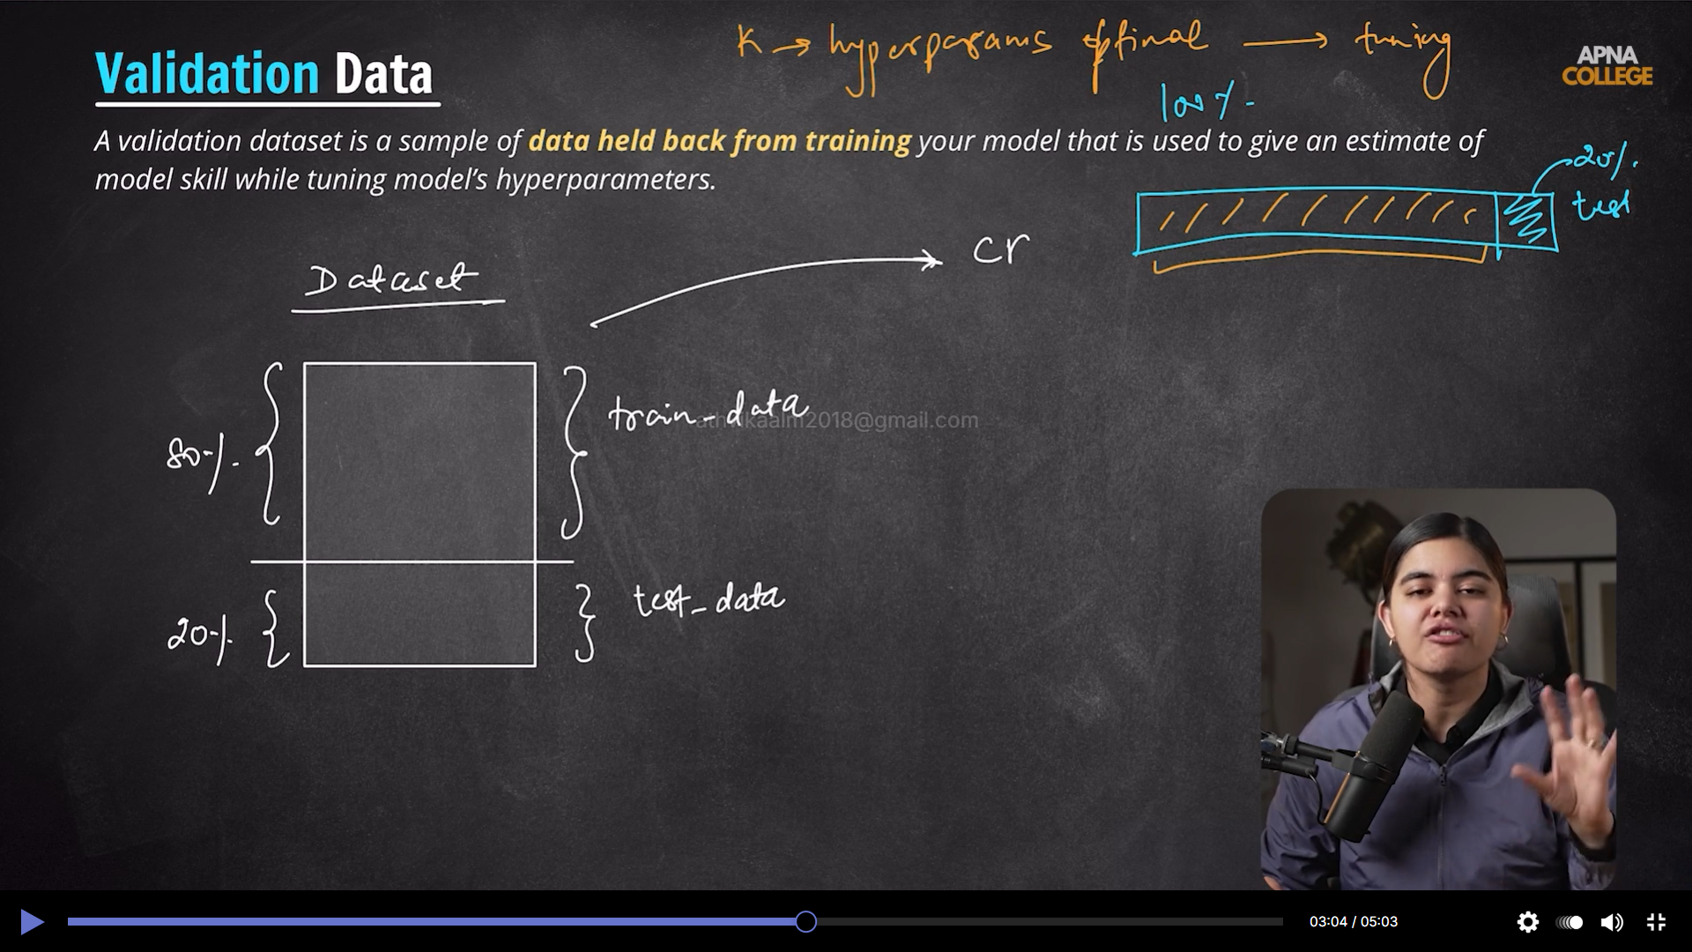

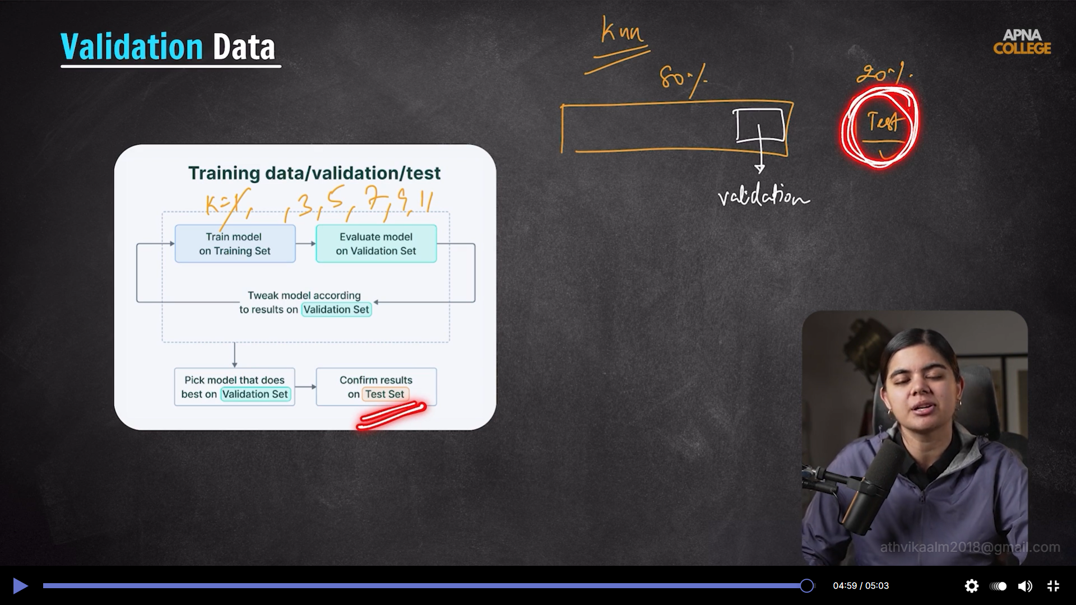

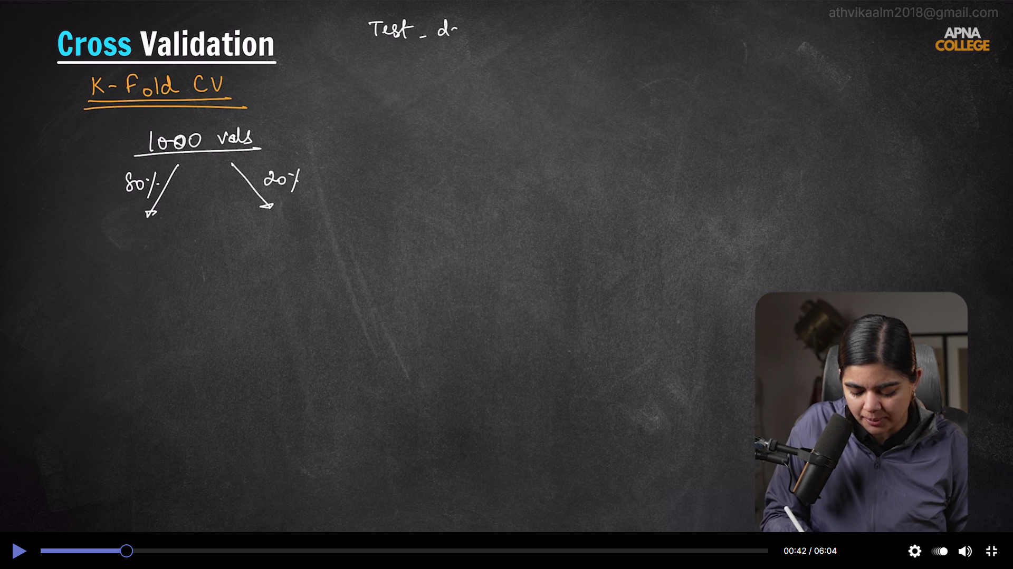

Validation data is the testing data inside training data
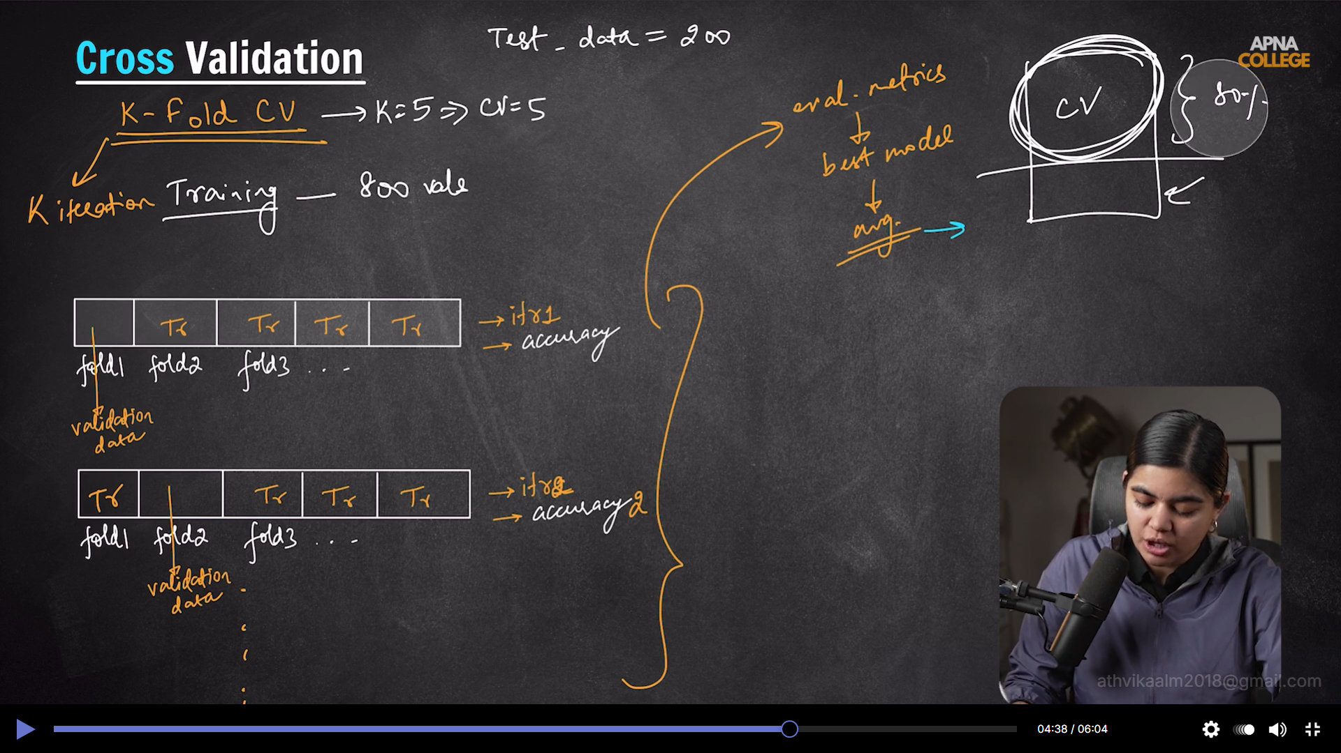

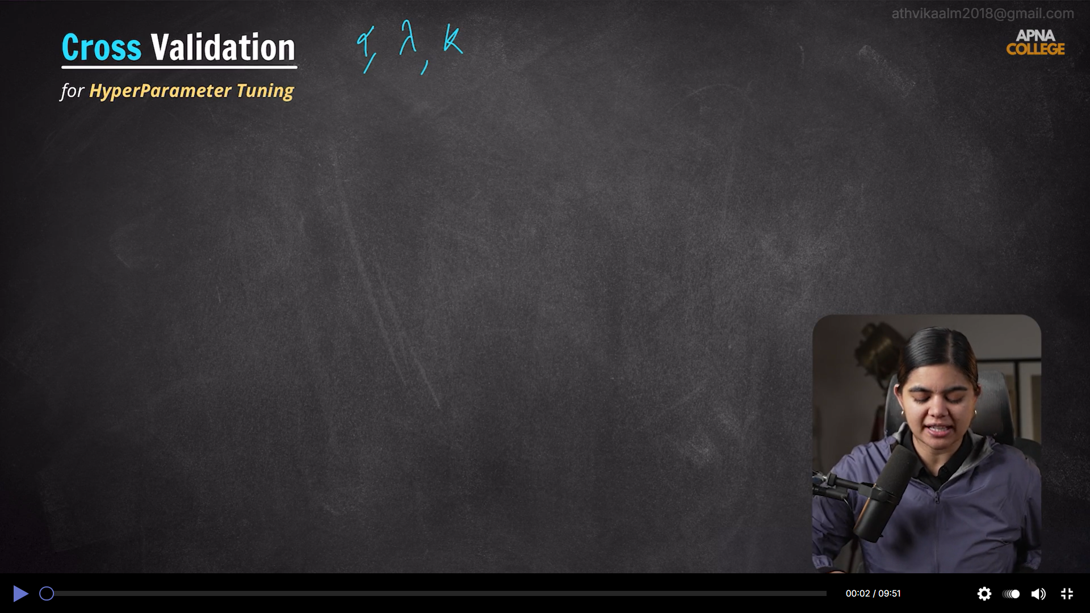

Cross validation gives reliable answer compared to manual method
KNN – gridSearchCV,
lassoRegression – lassoCV
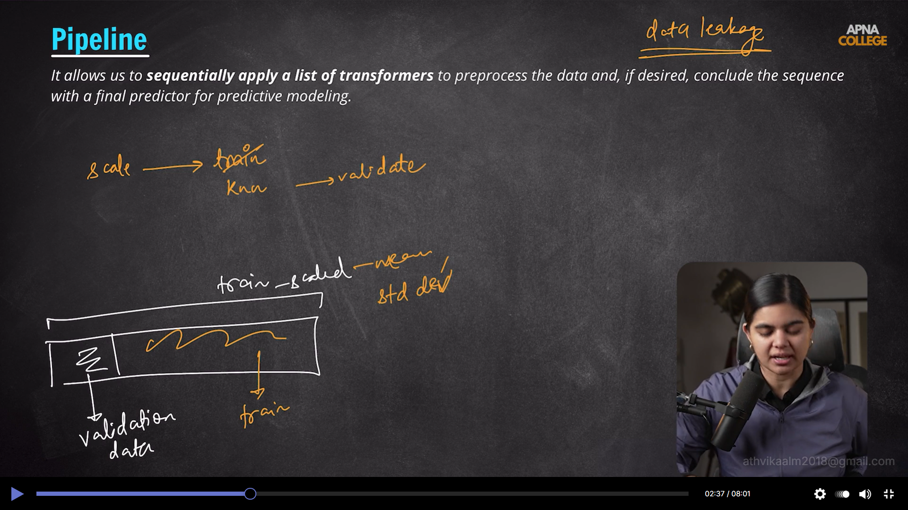

__ - hierarchical separator which indicates n_neighbors is inside knn



