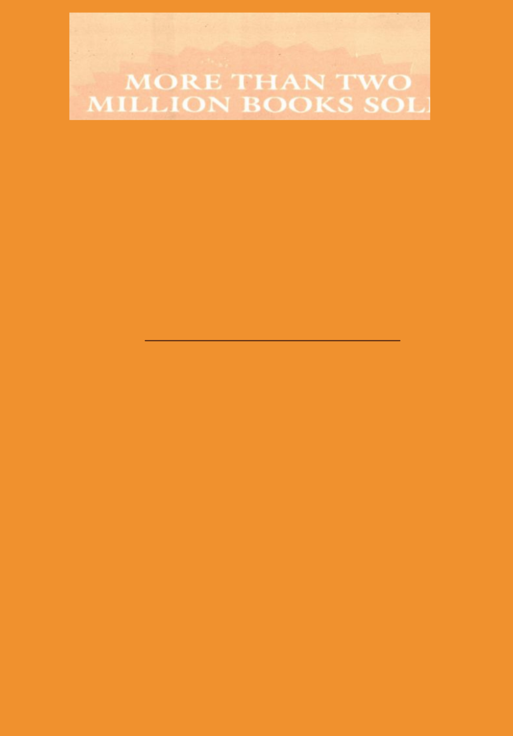
0

SIGNET

THE SUCCESS SECRETS OF THE ANCIENTS - THE MOST INSPIRING BOOK ON WEALTH EVER WRITTEN

GEORGE S. CLASON

