M KARTHIKEYAN

727721EUIT070

**SOFTWARE TESTING**

**TEST -1:**

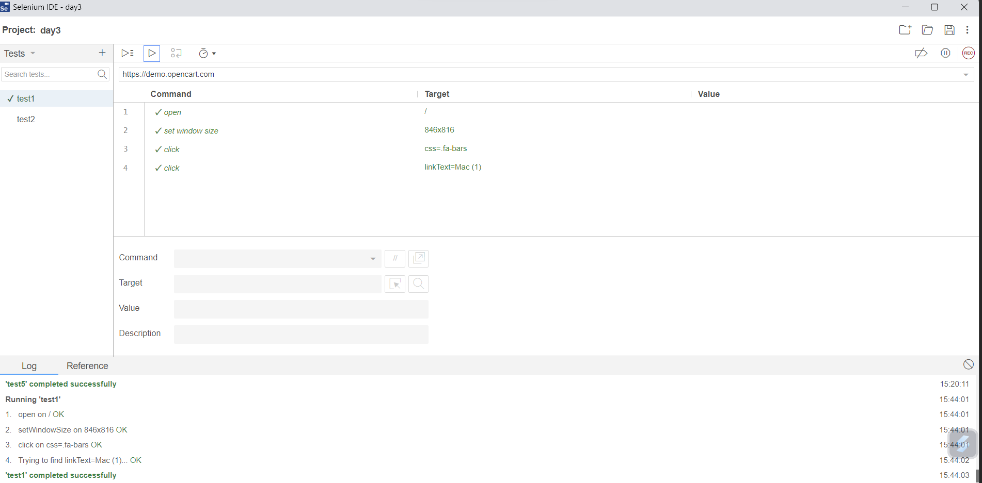

**TEST -2:**

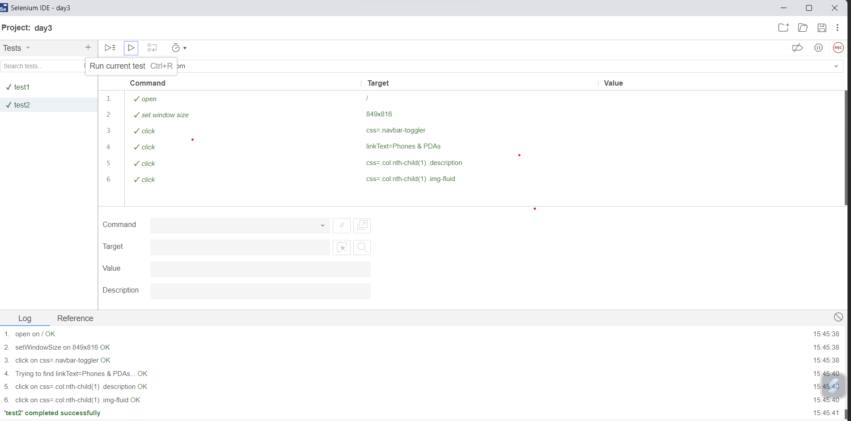

TEST -3:

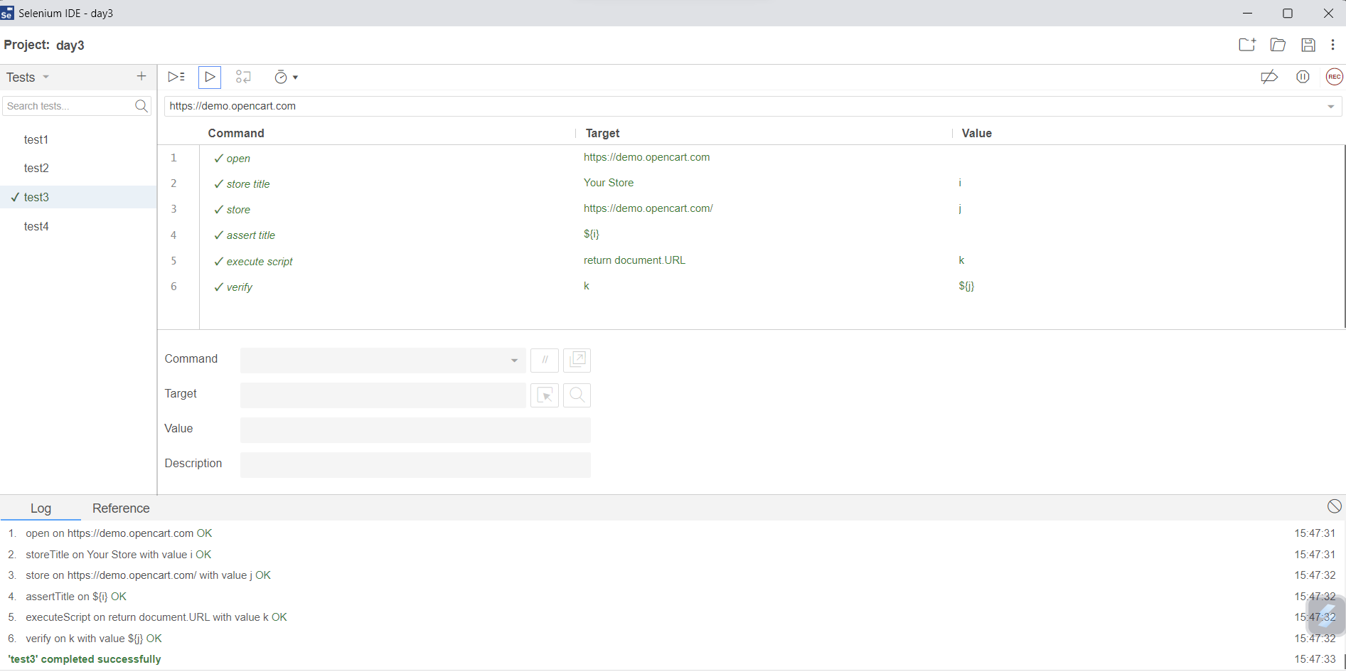

TEST -4:

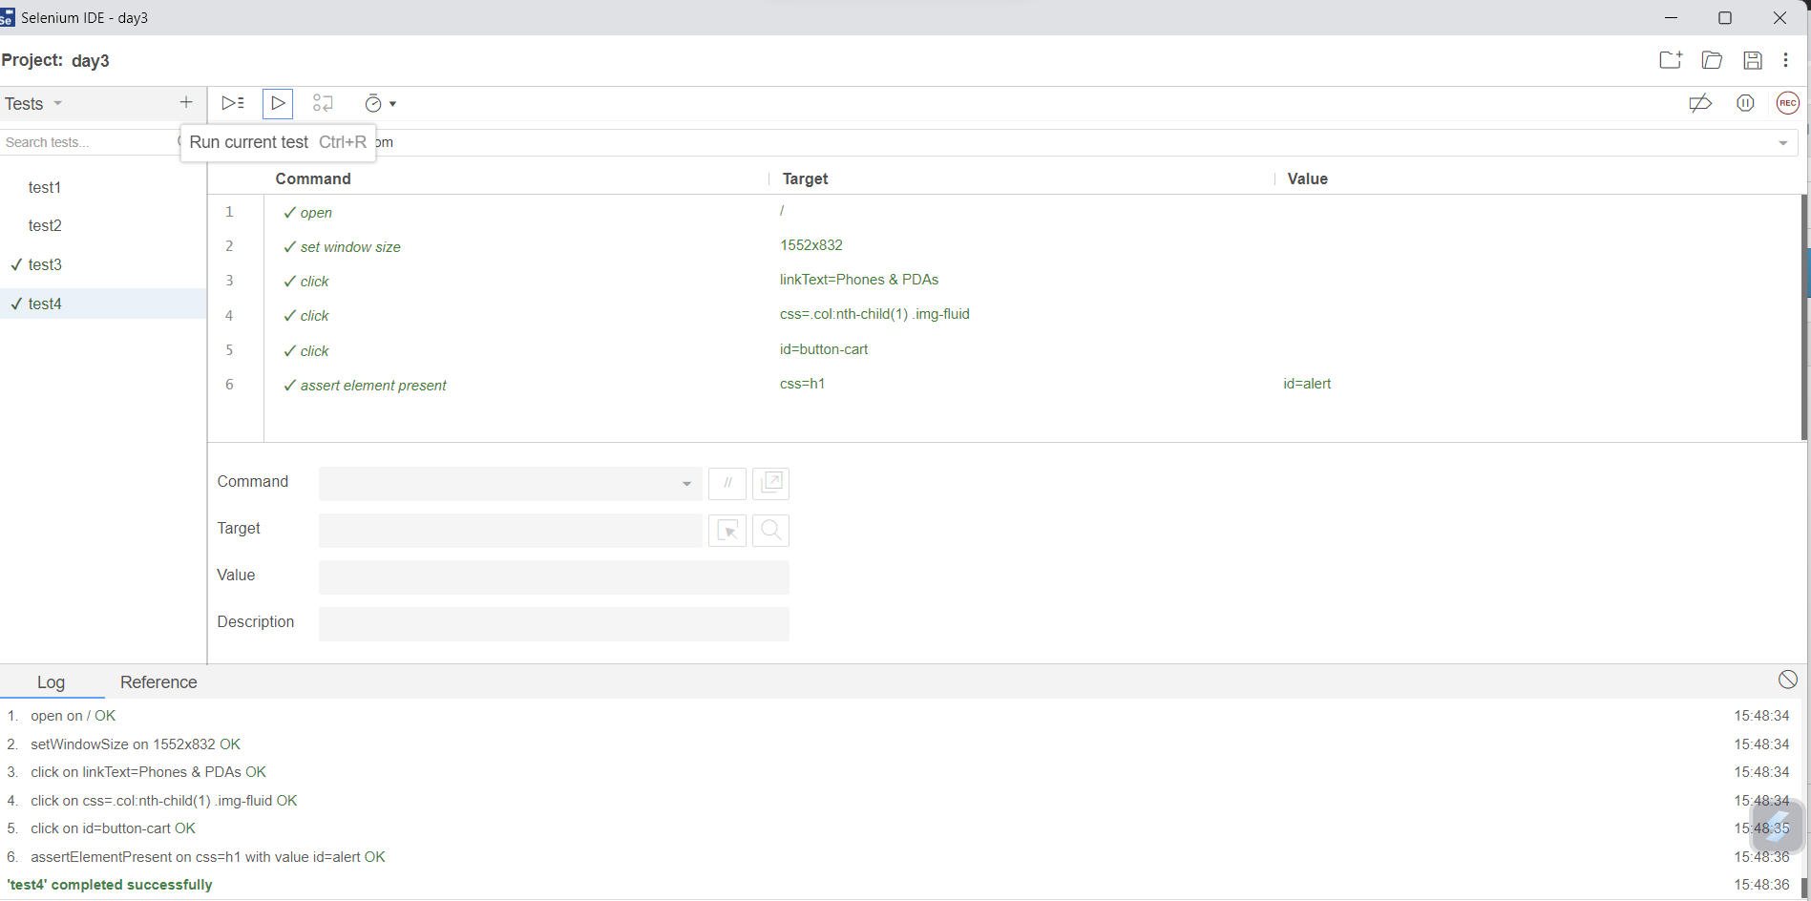

TEST -5:

