**Aspect Based Sentiment Analysis to Determine**

**Success and Failure of Mobile phones**

Karthik KM

Symbiosis Centre for Information Technology,

Symbiosis International (Deemed University)

Pune, India

karthik.km[@associates.scit.edu](mailto:abraham.joseph@associates.scit.edu)

Adarsh Joseph Abraham

Symbiosis Centre for Information Technology,

Symbiosis International (Deemed University)

Pune, India

[abraham.joseph@associates.scit.edu](mailto:abraham.joseph@associates.scit.edu)

***Abstract -*** With the advent of emerging e-commerce/ m-commerce, people buy products online. Buying products online has become increasingly popular due to its convenience and accessibility. One of the most critical aspects of buying products online is gathering information about the product to make informed decisions. Online reviews from users are one of the easiest methods to learn how the product works for the end user. Thus, the study focuses on the aspect-based sentiment analysis of reviews of two mobile phones with similar features and nearly in the same price segment.

Sentiment analysis, also referred to as opinion mining, is an approach for extracting the sentiment and emotional tone implied in reviews. It can be done at three levels – sentence, document, and aspect-based.

This study provides an aspect-based, comparative sentiment analysis of two mobile phones. The study focuses on sentiment polarity and the emotions such as positive, negative, or neutral considering different aspects of the product.

Keywords: Sentiment Analysis, Sentiment

Classification, Feature Extraction, Naïve Bayes, Aspect

Based Sentiment Analysis.

Keywords: Sentiment Analysis, Sentiment

Classification, Feature Extraction, Naïve Bayes, Aspect

Based Sentiment Analysis.

***Keywords****: Sentiment Analysis, Sentiment Classification, Feature Extraction, Naïve Bayes, Aspect Based Sentiment Analysis.*

1. INTRODUCTION:

The advent of the internet and the surge in mobile phone usehave revolutionized commerce, giving rise to the phenomenon known as e-commerce and m-commerce. There has been a massive increase in the number of people using e-commerce due to the experience and convenience it provides. When shopping online, individuals highly rely on the reviews and opinions of those who have already purchased and used the product. With the analysis of these reviews, we can easily conclude that studying the mood or sentiment of the customer reviews is crucial for consumers' purchasing decisions and sellers' efforts to enhance their goods.

In this study we compare product reviews to determine users' sentiment based on different aspects (features) of the mobile phone. Here, we have considered the user reviews of two mobile phones of two different brands of the same price bracket with approximately similar features. Henceforth in our study we refer those mobile phones as Phone1 and Phone2. The analysis can help buyers make informed decisions before buying and helping the manufacturers to improve the product according to the users' requirements.

Aspect-Based Sentiment Analysis (ABSA) holds immense potential for mobile phone manufacturers to gain insight into customers' sentiments, opinions, and preferences. Manufacturers may examine particular features of mobile phones, such as camera quality, battery life, design, performance, cost and more, using ABSA analysis of mobile phone reviews. Understanding this will facilitate them to make an informed decision to improve the specific aspect or feature of the product according to the targeted customer segment. It can also enable them to make a cost-effective product by cutting the cost of less used or required features in a mobile phone.

For end consumers, Aspect-Based Sentiment Analysis (ABSA) of mobile phones is crucial in making an informed decision before purchasing them. ABSA helps gauge user the real-world performance of different aspects of the products and help users make informed decision among available products according to the actual requirements.

Ultimately, the study will bring out the failure of one product in comparison to another in the same price range with nearly the same features. The performance, battery life, camera, cost, display on of two different mobile phones have influenced the opinions of their existing end customers in different ways. Document-level sentiment analysis, sentence-level sentiment analysis, and aspect-based sentiment analysis are the three types of sentiment analysis. Document-level sentiment analysis categorizes the overall sentiment of the document as positive, negative, or neutral. Sentence-level sentiment analysis, on the other hand, concentrates on the sentiment extractions of individual sentences.[1]

Aspect-based sentiment analysis, on the other hand, is a Natural Process Language (NPL) approach. It operates in two steps to understand the sentiment conveyed in a text:

Extraction of Aspect Terms: The aspects or features associated with the subject of the analysis are identified and extracted during the aspect term extraction phase. (For example, camera, pricing, battery, performance, and so on.)

Classification of Aspects and Sentiments: The identified aspects are classified to be positive, negative, or neutral during this phase. [1]

The corpus of user-generated reviews found in e-commerce platforms requires a thorough analysis, as it is significant for consumers to select the product and for the manufacturer to refine their product based on the sentiments of the end consumer’s review. These corpora of user-generated are usually plain text and can be complicated to analyse as there is noise in the data. NLP Natural Language Processing is the text analytics technique used to analyse sentiment analysis. It is a state-of-the-art technique to deal with this task. [2]

Currently, there are many tools. Available to perform sentiment analysis, such as Linguistic Inquiry and Word Count (LIWC), offers quite good means of extracting features from the texts. However, these tools require some programming knowledge to gain some insight from the texts.

VADER is an NLTK module used to perform aspect-based sentiment analysis. According to Gilbert and Hutto, the VADER lexicon performs exceptionally well in the social media context in analysing sentiment analysis. [3].

Therefore, we use VADER to perform sentiment analysis on the reviews of the two products , based on the aspects:

Camera, Price, Battery, Performance, Display, and Brand.

The paper will further discuss the literature, methodology, and conclusion about the comparison of the products.

1. RELATED WORK

The study conducted by Mukherjee et al, looks to spot feature-specific opinions in reviews of products with various features and conflicting feelings and classify them as either positive or negative, provided a product rating that contains a number of features. The above process will produce a list of possible features in the review that need to be reduced or cutoff in order to achieve the precise features. This is important if there isn’t any prior knowledge of the review's domain in the form of untagged or tagged data pertaining to that domain. In comparison to both the selected sophisticated baseline and the naive baseline, the system demonstrated improved accuracy. given that does not utilise any domain-specific data for training, it was able to perform on par with cutting-edge systems despite its data restrictions. It was also found that, when utilising supervised classification, the system significantly outperforms the naive baseline. [4]

The study conducted by D’Aniello et al, highlights the most important concerns linked to current trends in this sector while providing a summary of the state-of-the-art techniques and approaches for ABSA. Following this investigation, the KnowMIS-ABSA model, a new reference model for SA and ABSA, is suggested. The approach is based on the understanding that sentiment, affect, emotion, and opinion are completely unlike notions, and that it is fundamentally incorrect to use the same scale and technique to quantify them. Three tools for sentiment analysis are used, Google Cloud NL API, Python NLTK, ParralelDots API. It was found out that Review-level sentiment analysis is more effective than sentence-level analysis. The neutral class appears to be the greatest challenge for the three tools, since it is more challenging to discern whether a user's view is positive or negative as opposed to neutral, But Even in the absence of sentiment or an expressive response, a statement might have an orientation.[5]

In a research conducted by Sonal Meenu Singh et al. [6], they gathered data on the basis of eight Aspects, which include price, size, battery, camera, operating system, CPU, storage, and screen, it classified user reviews of mobile devices into three sentiments as positive, negative, or neutral. 80 reviews of the iPhone 6, the Moto G3, and the Blackberry Z10, were gathered for the study; the reviews were taken from commercial websites like Amazon.The reviews colle

cted were pre-processed and POS tagging or position tagging was used to extract the different aspects. After the pre-processing was finished, SentiWordNet was used to determine ratings for each facet. The system is shown to have an accuracy of 75% when compared to online resources like WordNet, SentiWordNet

Research conducted by Francis F. Balahadia et al [7], focused on a creating an evaluation tool. A tool that will enable teachers to be evaluated on the basis of the feedback the teachers receive. Based on the positive and negative comments from students in English or another language, sentiment analysis is done on this feedback data. the study helps to identify the teaching staff members' strengths and weaknesses with the help of sentiment analysis. The polarity of opinions has been extracted and assessed using the Naive Bayes technique.

A study conducted by Zeenia Singla et al, the research is on sentiment analysis based on customer product reviews. The author developed an analysis framework called the Statistical and Sentiment Analysis (SACP). The researcher has gathered more than 350000 reviews of phones from e-commerce websites for the first step in the framework, which is data gathering and preprocessing. The data collected is preprocessed to remove any irrelevant data. For the subsequent feature selection and analysis process for text mining, the authors employed the 'tm' package. The data is then statistically analysed by the module to ascertain how closely the attributes are related in order to forecast both the polarity and the sentiment, the system studies the text using sentiment analysis in the final stage of the module. Based on the Support Vector Machine's (SVM) cross-validated accuracy of 84.87%, the authors claim that the categorization is successful. [8]

Paramita Ray et al. [9], conducted research on sentiment analysis with the help of the Lexicon method. The sentiment analysis of product reviews was done on tweets because people share their opinions about different products on social media platforms like Twitter. The sentiment analysis of Twitter data was done with the help of R software using Twitter API. The Twitter data collected was pre-processed, and the lexicon method of classification was done on different aspects. Some of the aspects are service, picture quality, battery quality, and voice quality. [9]

Perera et al. [10] have conducted research on aspect-based sentiment analysis, the sentiment analysis was done on restaurant reviews. For the purpose of analysis, reviews form 15 plus restaurant has been collected from food delivery apps like Zomato. The data extracted is subjected to pre-processing. The aspects were selected some of them being food, service, time, and staff. SentiWordNet is used for scoring the opinion, SentiWordNet is a lexical resource that associates each WordNet synset with three numerical scores: positivity, negativity, and objectivity.[10]

Santhosh Kumar K L et al, [11]. have conducted a study on sentiment analysis and opinion mining on product reviews online. The study uses Naïve Bayes classifier, Logistic Regression and SentiWordNet algorithm to extract data or reviews automatically and classify them as either positive or negative. The study also suggests that Naïve Bayes classification is the most efficient algorithm in opinion mining.[11]

1. METHODOLOGY

The goal behind the research is to perform aspect-based sentiment analysis on two smartphones. The smartphones selected has almost the same pricing and features. Furthermore, the difference Between the two smartphones is that one smartphone is extremely successful while the other is a failed product. Therefore, aspects like "phone", "camera", "price", "battery", and "performance" have been opted for after the reviews were analysed in order to determine the success and failure of the product. The system has to follow a sequential approach in order to achieve the objective, including Data Extraction, Pre-Processing, and Aspect Extraction.

1. *Data Extraction*

The very first stage was to extract data or collect product reviews, which would be used as the system's initial inputs. We use Beautiful Soup, a Python library, to extract product reviews from an ecommerce website.

The extracted reviews include "Star rating", "Review title", and "Review content". The star rating offers us a rating between 1 and 5, the review title gives us a short title for the review, and the review content gives us the detailed product review. The Review content section is taken into account for the purposes of this research.

1. *Data Pre-processing*

Following the completion of the data extraction stage, the following stage is pre-processing. The majority of the collected data will contain undesirable characters, such as emojis, special characters, emoticons, and missing values, which might impede the analysis process. This makes pre-processing a crucial step. Finding any missing values was the initial step in the pre-processing process. We used the "random library" to generate random star ratings in the range of 1 to 5, and we appended the random values to the Star rating list to fill in the missing numbers in the star rating column. There were numerous duplicate contents in the review, so we eliminated them. Additionally, the phrases "READ MORE" were repeated several times. Therefore, we used the "str.replace" method to replace "READ MORE" in the Review field with an empty string. The retrieved data had a lot of repetitive or duplicate values. Therefore, we used the "drop_duplicates" function to eliminate any duplicate values in order to delete the repeated values. Emojis might be found in the review's content. To get rid of the values other than "ascii" values, a function was used.

1. *Aspect Based Sentiment Analysis*

The reviews are prepared for further study after pre-processing processes. First, we have selected features like the camera, battery, price, performance, display, and brand name, as the aspects because these are the features that customers focus on the most when buying a mobile phone and are also the terms that are most frequently used when writing reviews online. The SentimentIntensityAnalyzer library was used to generate the sentiment score, while the VADER sentiment analysis package from NLTK was applied to identify the sentiment. A float value between -1 and 1, where -1 represents a negative mood, 1 a positive mood, and 0 a neutral mood is the sentiment score generated for each review. In order to get a basic understanding of the user's sentiment, we ran a general sentiment analysis on each review. It shows us how positive, negative, or neutral the reviews are, as well as the altogether (compound) mood of each. Then, for each review associated with each of the considering aspects, we ran sentiment analysis, obtaining the sentiment score for each review related to the aspect addressed. Additionally, the average sentiment score of each aspect comprising all reviews is computed, revealing how all users feel about every aspect in general. Fig.1 shows example of aspect based sentiment analysis.

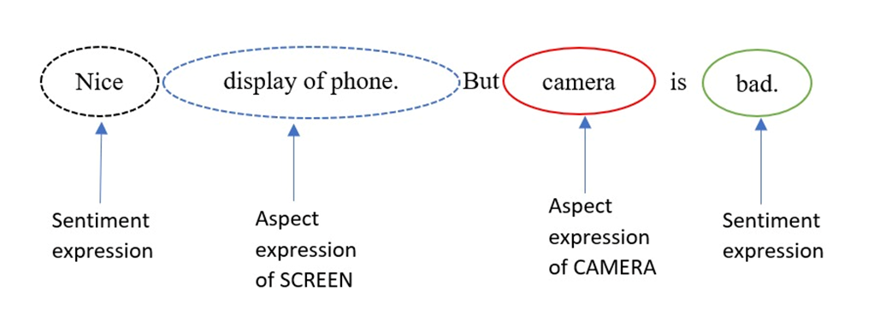

Fig. 1. Aspect Based Sentiment Analysis

1. RESULTS

In this section, we present the outcomes of our aspect-based sentiment analysis to evaluate the success and failure of mobile phones. We performed study on two smartphones, Phone1 and Phone2, which represent the segment's best and worst rated smartphones, respectively.

Our sentiment analysis results for the Phone1 smartphone are shown in the Fig. 2 and it indicate that it is high rated in the segment. Phone1 obtained predominantly positive sentiment scores across all aspects. Positive sentiment scores across different aspects indicate users' overall contentment with Phone1.

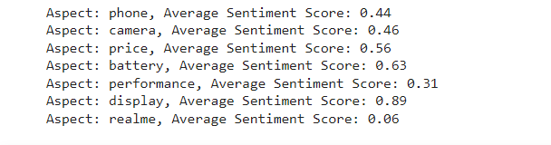

 Fig. 2. Average Sentiment score of each aspects for Phone1

In contrast, Phone2, the lowest-rated smartphone in the segment, received low sentiment scores across all aspects as shown in the Fig. 3 . The negative sentiment scores across the aspects point out Phone2's flaws and overall dissatisfaction.

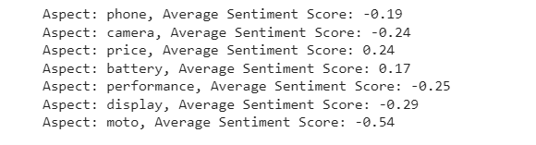

 Fig. 3. Average Sentiment score of each aspects for Phone2

To further highlight the disparity between Phone1 and Phone2, we analyzed their sentiment scores. The results are shown in Fig. 4 and it clearly illustrate that Phone1 outperforms Phone2 in every aspects, establishing its position as the best-rated smartphone in the segment.

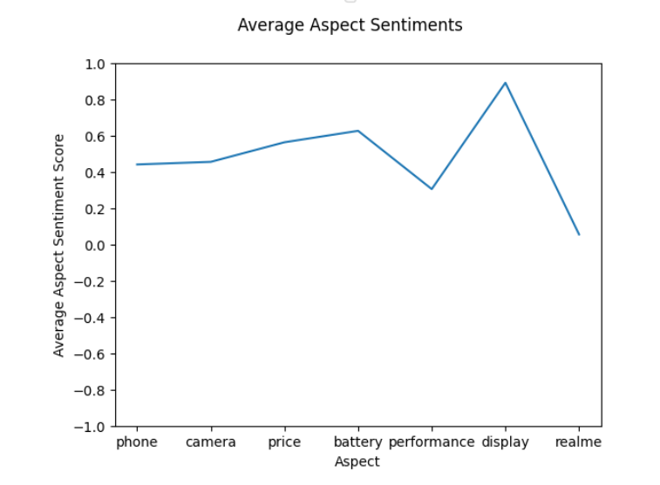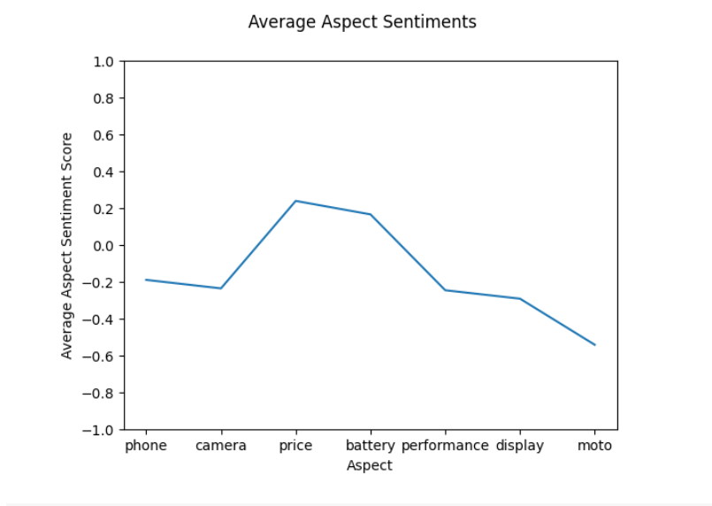

**Fig. 4. Comparison of Average Sentiment scores of Phone1 and Phone2 in Graph**

Our results from the aspect-based sentiment analysis are in line with the overall market ratings and reputation of Phone1 and Phone2. The positive sentiment around Phone1 proves its success, but the negative sentiment surrounding Phone2 reflects its inability to satisfy consumer expectations.

The results provide significant insights into the elements that influence the success and failure of mobile phones on the market.

1. CONCLUSION

The objective of the research was to determine the sentiment associated with the different aspects of the two smartphones, both within the same price range and features. The findings highlight the significance of aspect-based sentiment analysis in understanding user feelings and determining product success or failure in the mobile phone industry. It also offers a deeper understanding of user sentiments, which can help manufacturers and stakeholders make educated decisions.

In the future, the sentiment analysis process can be improved by using machine learning techniques for sentiment classification. Furthermore, widening the scope of aspects examined for analysis and integrating a bigger sample of mobile phones can provide a more comprehensive picture of user sentiments in the market.

1. REFERENCES
2. K. Bayraktar, U. Yavanoglu and A. Ozbilen, "A Rule-Based Holistic Approach for Turkish Aspect-Based Sentiment Analysis," IEEE, Los Angeles, 2019.
3. Y. Yiran and S. Srivastava, "Aspect-based Sentiment Analysis on mobile phone reviews with LDA," Association for Computing Machinery, New York, NY, United States, 2019.
4. C. Hutto and E. Gilbert, "VADER: A Parsimonious Rule-Based Model for Sentiment Analysis of Social Media Text," vol. 8, no. 1, pp. 216-225, 2014.
5. Mukherjee, Subhabrata, and Pushpak Bhattacharyya. "Feature specific sentiment analysis for product reviews." International conference on intelligent text processing and computational linguistics. Berlin, Heidelberg: Springer Berlin Heidelberg, 2012.Nazir, Ambreen, et al. "Issues and challenges of aspect-based sentiment analysis: A comprehensive survey." IEEE Transactions on Affective Computing 13.2 (2020): 845-863
6. D’Aniello, Giuseppe, Matteo Gaeta, and Ilaria La Rocca. "KnowMIS-ABSA: an overview and a reference model for applications of sentiment analysis and aspect-based sentiment analysis." Artificial Intelligence Review 55.7 (2022): 5543-5574.
7. Singh, Sonal Meenu, and Nidhi Mishra. "Aspect based opinion mining for mobile phones." 2016 2nd International Conference on Next Generation Computing Technologies (NGCT). IEEE, 2016.
8. Balahadia, Francis F., Ma Corazon G. Fernando, and Irish C. Juanatas. "Teacher's performance evaluation tool using opinion mining with sentiment analysis." 2016 IEEE region 10 symposium (TENSYMP). IEEE, 2016.
9. Z. Singla, S. Randhawa and S. Jain, "Statistical and Sentiment Analysis of Consumer Product Reviews," 8th ICCCNT 2017,IEEE - 40222,July 3-5, 2017, IIT Delhi,Delhi, India , Delhi, 2017.
10. Ray, Paramita, and Amlan Chakrabarti. "Twitter sentiment analysis for product review using lexicon method." 2017 International Conference on Data Management, Analytics and Innovation (ICDMAI). IEEE, 2017.
11. Perera, I. K. C. U., & Caldera, H. A. (2017, September). Aspect based opinion mining on restaurant reviews. In 2017 2nd IEEE International Conference on Computational Intelligence and Applications (ICCIA) (pp. 542-546). IEEE.
12. Kumar, KL Santhosh, Jayanti Desai, and Jharna Majumdar. "Opinion mining and sentiment analysis on online customer review." 2016 IEEE International Conference on Computational Intelligence and Computing Research (ICCIC). IEEE, 2016.