**Enhancing Customer Engagement and**

**Menu Performance**

**Key Insights:**

**1. Popular Dishes:** The top dishes our users love is:

* **Grilled Chicken** and **Spaghetti**: 23 orders each
* **Pancakes**: 18 orders
* **Caesar Salad**: 17 orders
* **Veggie Burger**: 10 orders
* **Oatmeal**: 9 orders

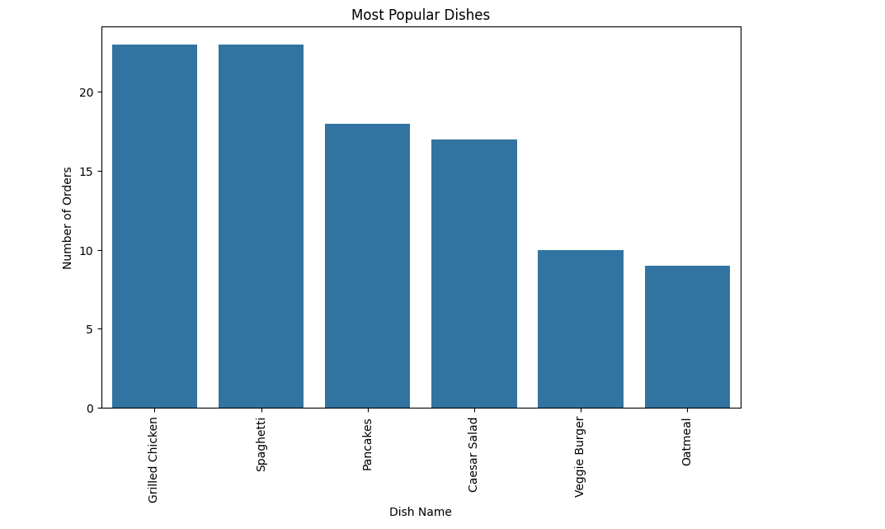

**This mix shows people enjoy a balance of comfort foods and healthy choices.**

**2. Orders by Age:**

* **Ages 28, 35, and 42** were the most active, each with 27 orders.
* Other age groups like **27, 30, 25, 31, and 38** had fewer orders, suggesting we can do more to reach them.

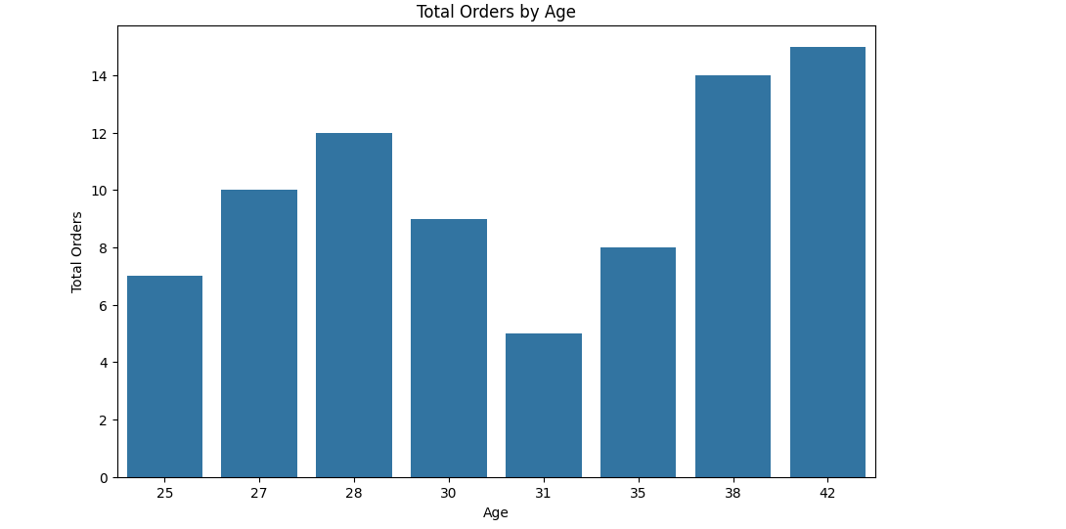

**3. Orders by Location:**

* **Chicago, Los Angeles, and New York** are hotspots, with 27 orders each.
* Cities like **San Francisco** and **Seattle** had 8 orders, while **Austin, Boston, and Miami** recorded just 1.

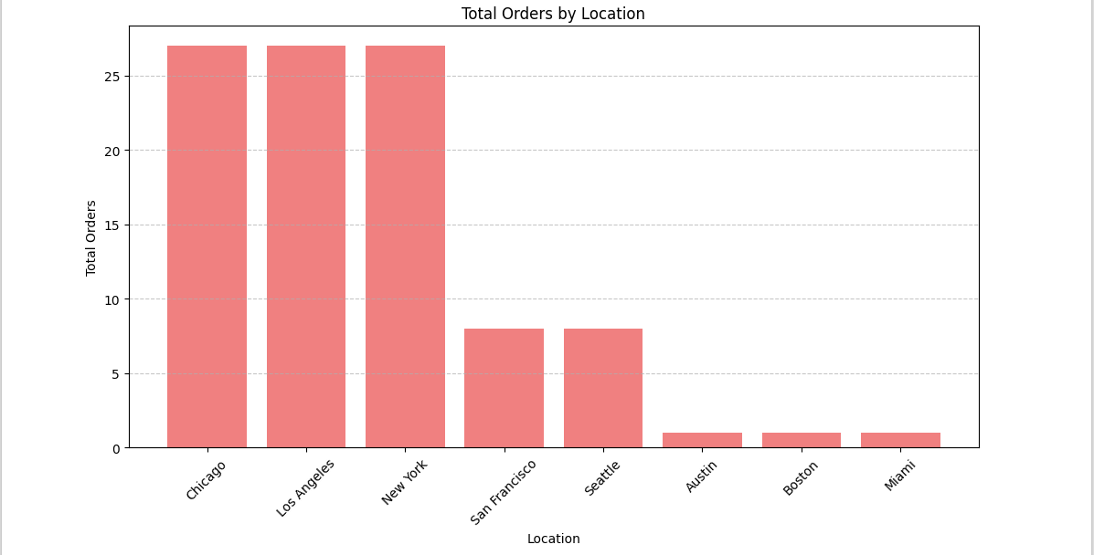

**4. Meal Preferences:**

* **Dinner** is the top choice with 37 orders.
* **Lunch** is close behind with 35 orders.

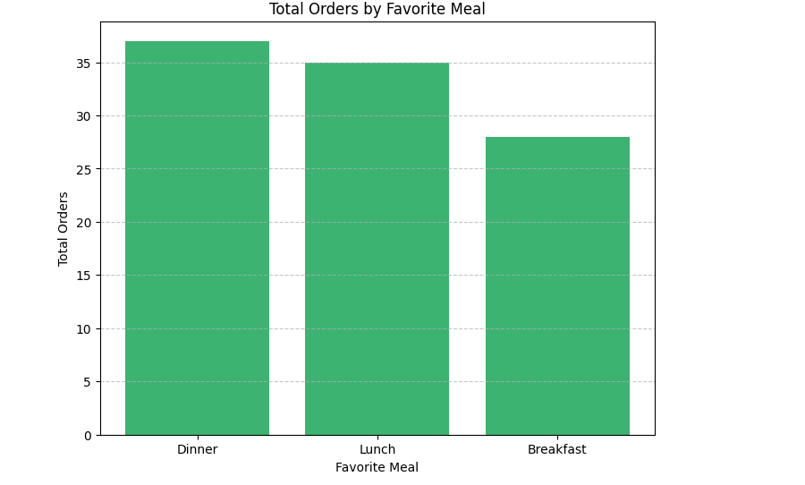

**Business Recommendations:**

1. **Highlight Favorite Dishes:**
   * Promote the top dishes (Grilled Chicken, Spaghetti) with catchy campaigns.
   * Add creative variations of these dishes to keep things exciting.
2. **Age-Focused Outreach:**
   * Tailor ads for ages 28, 35, and 42—they’re already engaged.
   * Offer fun incentives, like discounts, to draw in the quieter age groups.
3. **Boost in Big Cities:**
   * Strengthen presence in Chicago, LA, and New York—our superstars!
   * Dig into feedback from Austin, Boston, and Miami to figure out what’s missing.
4. **Meal-Time Deals:**
   * Dinner is the king—let’s create special dinner bundles!
   * For lunch, let’s craft quick, easy combos for busy professionals.
5. **Keep Them Coming Back:**
   * Introduce loyalty perks for regulars in top cities.
   * Use referral programs to grow in quieter markets.
6. **Adapt and Expand:**
   * Dive deeper into data to roll out new dishes or services that match what people love.