Lab Assignment-10.5

Name: K.SATHWIK REDDY
Hall Ticket no: 2303A51611
Batch No: 19

Task -1:
Prompt:
Task: Use AI to improve unclear variable names.
Sample Input Code: def f(a, b): return a + b print(f(10, 20)) Expected Output:
• Code rewritten with meaningful function and variable names.
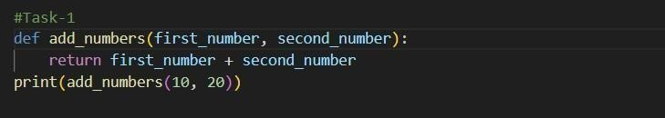
OUTPUT:
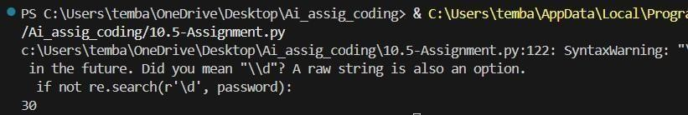

Justification:
The refactored code improves readability by using descriptive names. The function name clearly indicates its purpose. Adding a docstring improves documentation. The updated version follows PEP 8 naming conventions and enhances maintainability

Task 2:
Prompt:
ask Description #2 – Missing Error Handling Task:
Use AI to add proper error handling.
Sample Input Code: def divide(a, b): return a / b print(divide(10, 0)) Expected Output:
• Code with exception handling and clear error messages
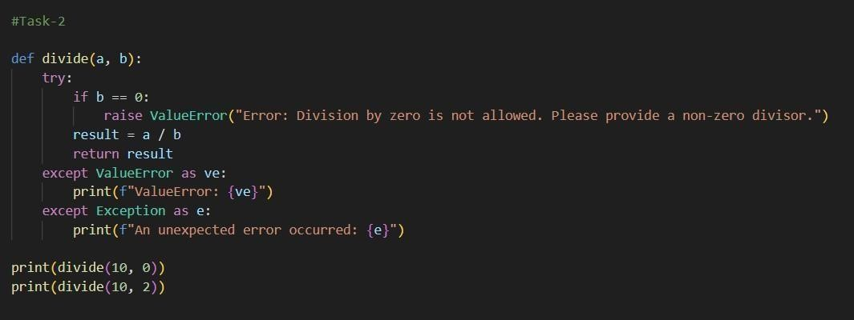

Output:
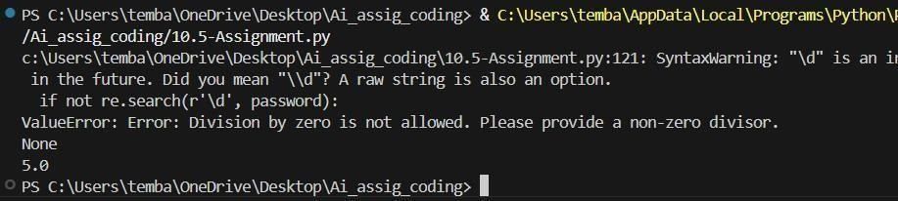
Justification: The AI-enhanced version prevents program crashes by adding exception handling. It provides meaningful error messages instead of terminating execution. This improves robustness and user experience.
Task-3:
Prompt:
Task Description #3: Student Marks Processing System
The following program calculates total, average, and grade of a student, but it has poor readability, style issues, and no error handling.
marks=[78,85,90,66,88] t=0 for i in marks: t=t+i a=t/len(marks) if a>=90: print("A") elif a>=75: print("B") elif a>=60:
print("C") else: print("F") Task:
- Use AI to refactor the code to follow PEP 8 standards.
- Add meaningful variable names, functions, and comments.
- Add basic input validation and documentation.

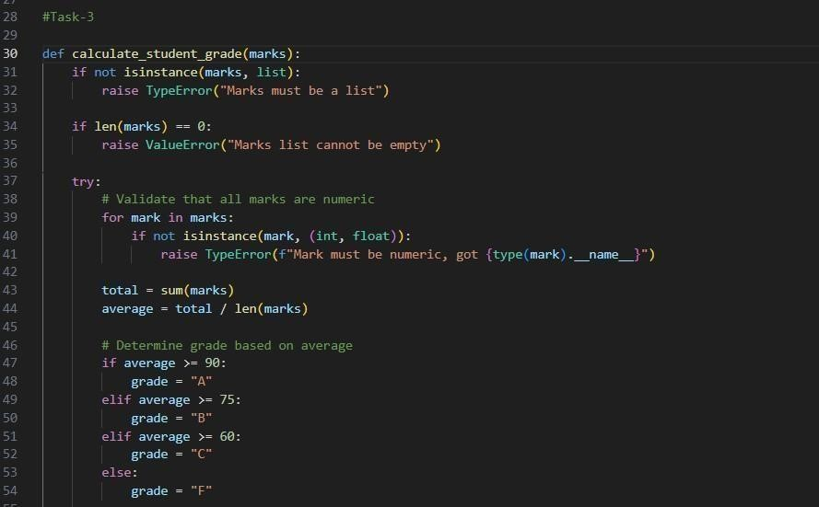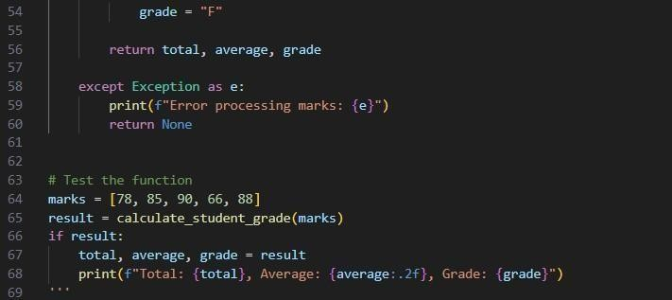

Output:
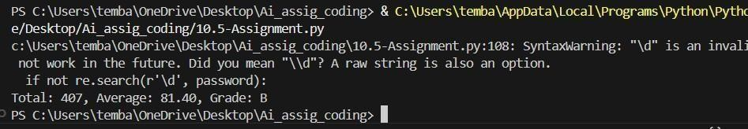

Justification:
The AI refactored the code into a structured function, improving modularity and reusability. Meaningful variable names increase clarity. Input validation ensures safety. The code now follows PEP 8 guidelines and improves maintainability.

Task 4:
Prompt:
ask Description #4: Use AI to add docstrings and inline comments to the following function. def factorial(n):
result = 1 for i in range(1,n+1):
result
*= i return result
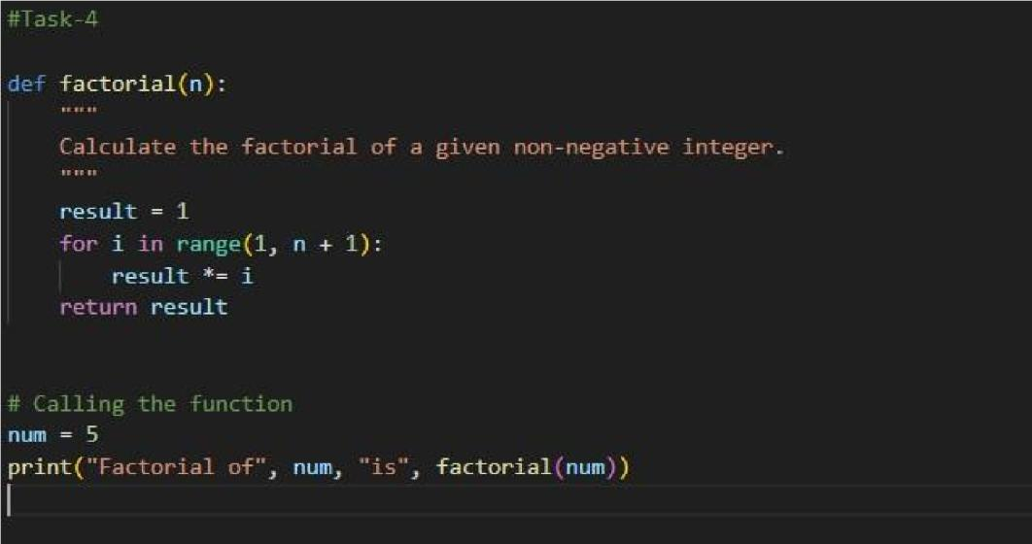
Output:
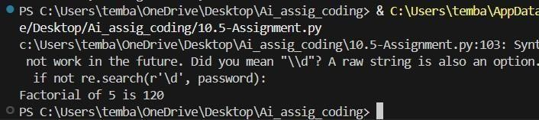
Justification:
The addition of docstrings and inline comments improves readability and documentation quality. The function now explains its purpose, parameters, and return values clearly.

Task 5:
Prompt:
Task Description #5: Password Validation System (Enhanced) The following Python program validates a password using only a minimum length check, which is insufficient for real-world security requirements.
pwd = input("Enter password: ") if len(pwd) >= 8: print("Strong") else: print("Weak") Task:
- Enhance password validation using AI assistance to include multiple security rules such as: o Minimum length requirement o Presence of at least one uppercase letter o Presence of at least one lowercase letter o Presence of at least one digit o Presence of at least one special character
- Refactor the program to: o Use meaningful variable and function names o Follow PEP 8 coding standards o Include inline comments and a docstring
- Analyze the improvements by comparing the original and AI- enhanced versions in terms of: o Code readability and structure o Maintainability and reusability o Security strength and robustness
- Justify the AI-generated changes, explaining why each added rule and refactoring decision improves the overall quality of the program.
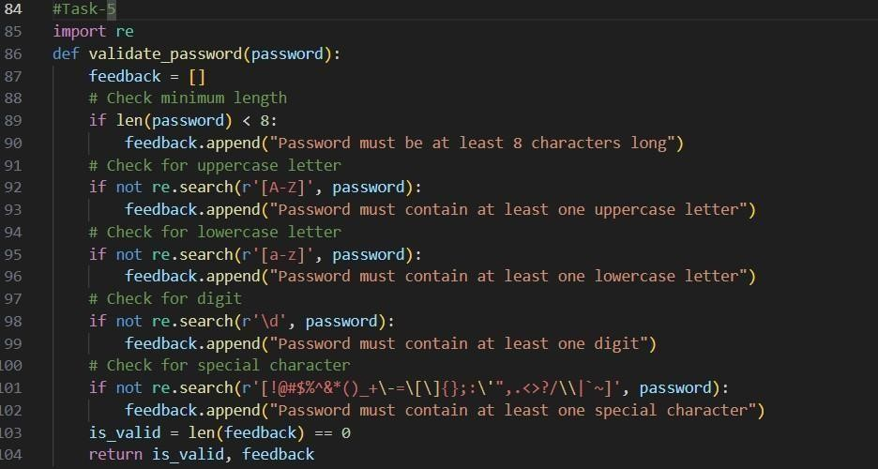

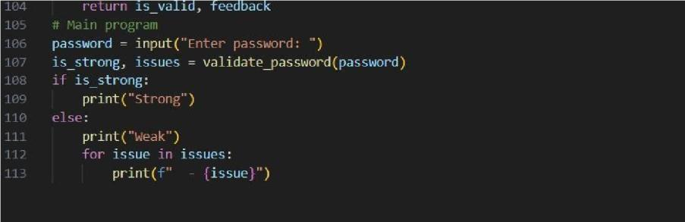
Output:
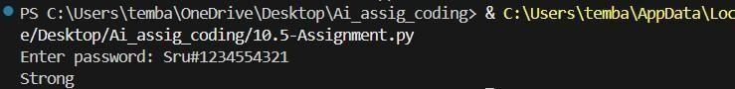

Justification:
The enhanced version significantly improves security by enforcing multiple validation rules. The use of regular expressions increases flexibility and maintainability. The program is modular, readable, and follows PEP 8 standards. Compared to the original version, the AI-enhanced version provides stronger validation, improved structure, and better real-world applicability

