How to remove only dangling (untagged and unused) images:
Run: in PowerShell or cmd
- docker system df --- It shows how much disk space Docker is using on your machine.
- docker images -a --- To list all images in your machine
- docker image prune -- To remove only dandling images
What it does the docker image purne syntax
- Removes dangling images (unused, untagged images)
- Safe cleanup (won’t remove images used by containers)
docker image prune -a → delete all unused images
Since you’re low on storage, usually better to run:
- docker system prune -a -- delete images, containers, network and cache

Keep in mind that when working with Docker, there is a high chance that the storage usage on the C: drive will increase significantly, as Docker images can exceed 30 GB when rebuilding images frequently.

- “docker build -t imagename:tag .”
- Docker creates new layers
- The old image becomes untagged (<none>)
- That old image → becomes a dangling image
- This happens especially if you rebuild frequently (CI/CD, local testing).
- What are dangling images:
When you run:
- docker images -a
Dangling images look like:
<untagged> 1fa86cffba80 33.8GB
<untagged> 3c906f06f6a7 33.7GB
<untagged> 1fa86cffba80 33.8GB
<untagged> 3c906f06f6a7 33.7GB
These are images without a tag (no name, no version).
2. Intermediate build layers
During docker build, Docker creates temporary layers.
- If build changes or fails
- Some intermediate layers remain
These show up as dangling images
3. Updating tags
Example:
docker tag image1 myapp:v1
docker tag image1 myapp:latest
Later if latest is updated → old reference may lose tag → becomes dangling
4. Interrupted builds / failed builds
If:
- Build fails midway
- Or you cancel it
Partial layers/images remain → dangling

5. CI/CD pipelines (very relevant for you)
Since you work with builds:
- Each pipeline run builds new images
- Old ones lose tags
- Accumulate quickly
This is very common in DevOps environments
Where are these stored?
On Windows (Docker Desktop):
- Typically, under:
C:\ProgramData\Docker
You can check attached below images as references:
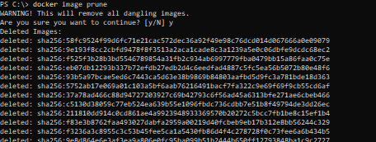
Deleting all dangling images will free up disk space.

