-- RollNo: 21MA60R39

-- Name: Mohammed Kashif Mohammed Moizuddin

-- DBMS_ASSIGNMENT_02

-- Assumptions Made:

-- 1. Along with students, faculties and staff members also taking courses from academics.

-- 2. There are faculties from departments other than 'CS' but still they are teaching courses

-- of 'CS' department, such as CN, C++, DSA, OS.

-- 3. Basic subjects are prerequisite for advanced subjects.

-- 4. Highest qualification of STAFF is 'BTECH' and that of faculties is 'PHD'.

-- 5. Courses from 'CS' department can be taken by other department students.

CREATE database college;

create table RegUser(RNo int, RName varchar(20),ROccu varchar(10),

Age int, HighestQual varchar(5), PRIMARY KEY(RNo));

create table Faculty (FId int, ResearchArea varchar(4),

FDept varchar(3), PRIMARY KEY(FId),

FOREIGN KEY fk_std_0(FId) REFERENCES RegUser(RNo));

create table Course(CId int, CName varchar(10), CDuration varchar(10),

CDept varchar(3), FId int, PRIMARY KEY(CId),

FOREIGN KEY fk_std_1(FId) REFERENCES Faculty(FId));

create table Prerequisite (CId int, PreqCId int,

FOREIGN KEY fk_std2(CId) REFERENCES Course (CId),

FOREIGN KEY fk_std3(PreqCId) REFERENCES Course (CId),

PRIMARY KEY(CId, PreqCId));

create table CourseReg(RNo int, CId int, Score int, PRIMARY KEY(RNo, CId),

FOREIGN KEY fk_std4(RNo) REFERENCES RegUser (RNo),

FOREIGN KEY fk_std5(CId) REFERENCES Course (CId));

use college;

show tables;

INSERT INTO RegUser

VALUES(2022001,'Ravi','STUDENT',23,'BTECH');

INSERT INTO RegUser

VALUES(2022002,'Hari','STUDENT',24,'BTECH');

INSERT INTO RegUser

VALUES(2022003,'shami','STUDENT',22,'BTECH');

INSERT INTO RegUser

VALUES(2022104,'John','STUDENT',25,'MTECH');

INSERT INTO RegUser

VALUES(2022105,'Viraj','STUDENT',25,'MTECH');

INSERT INTO RegUser

VALUES(2022206,'Raj','STUDENT',28,'PHD');

INSERT INTO RegUser

VALUES(2022207,'Mike','STUDENT',27,'PHD');

INSERT INTO RegUser

VALUES(2022308,'Munna','STUDENT',30,'PHD');

INSERT INTO RegUser

VALUES(2022309,'Michel','STUDENT',31,'PHD');

INSERT INTO RegUser

VALUES(2022310,'JACK','STUDENT',31,'MTECH');

-- ----------------------------------

INSERT INTO RegUser

VALUES(33001,'Shankar','FACULTY',37,'PHD');

INSERT INTO RegUser

VALUES(33002,'PAWAN','FACULTY',33,'PHD');

INSERT INTO RegUser

VALUES(33003,'Nilesh','FACULTY',46,'PHD');

INSERT INTO RegUser

VALUES(33104,'Sundar','FACULTY',55,'MTECH');

INSERT INTO RegUser

VALUES(33105,'Harsh','FACULTY',35,'MTECH');

INSERT INTO RegUser

VALUES(33206,'Monica','FACULTY',38,'PHD');

INSERT INTO RegUser

VALUES(33207,'Tison','FACULTY',53,'PHD');

-- ----------------------------------

INSERT INTO RegUser

VALUES(44001,'pooja','STAFF',33,'BTECH');

INSERT INTO RegUser

VALUES(44002,'Imad','STAFF',36,'BTECH');

INSERT INTO RegUser

VALUES(44003,'Dhoni','STAFF',34,'BTECH');

select * FROM RegUser;

-- -----------------------------------------------------------------------

INSERT INTO Faculty

VALUES(33001, 'ALGO', 'ECE');

INSERT INTO Faculty

VALUES(33002, 'ML', 'CS');

INSERT INTO Faculty

VALUES(33003, 'AI', 'CS');

INSERT INTO Faculty

VALUES(33104, 'DBMS', 'ME');

INSERT INTO Faculty

VALUES(33105, 'ML', 'EE');

INSERT INTO Faculty

VALUES(33206, 'AI', 'ECE');

INSERT INTO Faculty

VALUES(33207, 'ALGO', 'ME');

-- --------------------------------------------------------------------------

select * FROM Faculty;

INSERT INTO Course

Values (55001, 'LA for AI','MEDIUM','ECE',33206);

INSERT INTO Course

Values (55002, 'LA for AI','MEDIUM','CS',33003);

INSERT INTO Course

Values (55003, 'LA for ML','MEDIUM','CS',33002);

INSERT INTO Course

Values (55004, 'ADV AI','MEDIUM','ECE',33206);

INSERT INTO Course

Values (55005, 'ADV AI','LONG','CS',33003);

INSERT INTO Course

Values (55006, 'ADV ML','LONG','CS',33002);

INSERT INTO Course

Values (55007, 'ADV ALGO','LONG','ECE',33001);

INSERT INTO Course

Values (55008, 'BASIC ALGO','SHORT','ECE',33001);

INSERT INTO Course

Values (55009, 'ADV ALGO','LONG','ME',33207);

INSERT INTO Course

Values (55010, 'BASIC ALGO','SHORT','ME',33207);

INSERT INTO Course

Values (55011, 'BASICS ML','MEDIUM','EE',33105);

INSERT INTO Course

Values (55012, 'DSA','MEDIUM','CS',33206);

INSERT INTO Course

Values (55013, 'C++','LONG','CS',33206);

INSERT INTO Course

Values (55014, 'CN','MEDIUM','CS',33105);

INSERT INTO Course

Values (55013, 'OS','LONG','CS',33105);

SELECT * FROM Course;

-- ---------------------------------------------------------------

INSERT INTO Prerequisite

VALUES (55005,55002);

INSERT INTO Prerequisite

VALUES (55004,55001);

INSERT INTO Prerequisite

VALUES (55005,55003);

INSERT INTO Prerequisite

VALUES (55007,55008);

INSERT INTO Prerequisite

VALUES (55009,55010);

SELECT * FROM Prerequisite;

-- ----------------------------------------------------

INSERT INTO CourseReg

VALUES (2022001,55001,95);

INSERT INTO CourseReg

VALUES (2022001,55008,89);

INSERT INTO CourseReg

VALUES (2022001,55006,65);

INSERT INTO CourseReg

VALUES (2022002,55002,58);

INSERT INTO CourseReg

VALUES (2022002,55003,93);

INSERT INTO CourseReg

VALUES (2022002,55006,79);

INSERT INTO CourseReg

VALUES (2022002,55011,99);

INSERT INTO CourseReg

VALUES (2022003,55010,86);

INSERT INTO CourseReg

VALUES (2022003,55003,87);

INSERT INTO CourseReg

VALUES (2022003,55004,77);

INSERT INTO CourseReg

VALUES (2022104,55010,78);

INSERT INTO CourseReg

VALUES (2022104,55001,88);

INSERT INTO CourseReg

VALUES (2022104,55005,63);

INSERT INTO CourseReg

VALUES (2022105,55001,59);

INSERT INTO CourseReg

VALUES (2022105,55008,62);

INSERT INTO CourseReg

VALUES (2022105,55006,68);

INSERT INTO CourseReg

VALUES (2022206,55004,78);

INSERT INTO CourseReg

VALUES (2022206,55006,74);

INSERT INTO CourseReg

VALUES (2022206,55009,99);

INSERT INTO CourseReg

VALUES (2022207,55002,100);

INSERT INTO CourseReg

VALUES (2022207,55003,89);

INSERT INTO CourseReg

VALUES (2022207,55007,77);

INSERT INTO CourseReg

VALUES (44003,55004,93);

INSERT INTO CourseReg

VALUES (44003,55006,95);

INSERT INTO CourseReg

VALUES (44003,55007,98);

INSERT INTO CourseReg

VALUES (33206,55005,96);

INSERT INTO CourseReg

VALUES (33206,55006,92);

INSERT INTO CourseReg

VALUES (33206,55009,88);

INSERT INTO CourseReg

VALUES (33207,55002,99);

INSERT INTO CourseReg

VALUES (33207,55003,82);

INSERT INTO CourseReg

VALUES (33207,55011,93);

INSERT INTO CourseReg

VALUES (33203,55002,89);

INSERT INTO CourseReg

VALUES (33203,55003,92);

INSERT INTO CourseReg

VALUES (33203,55011,83);

INSERT INTO CourseReg

VALUES (2022308,55012,89);

INSERT INTO CourseReg

VALUES (2022308,55013,91);

INSERT INTO CourseReg

VALUES (2022308,55015,73);

INSERT INTO CourseReg

VALUES (2022309,55012,100);

INSERT INTO CourseReg

VALUES (2022309,55014,95);

INSERT INTO CourseReg

VALUES (2022309,55015,84);

INSERT INTO CourseReg

VALUES (2022310,55013,74);

-- _______________________________________________________________________________

-- ------------------------------ Q1 --------------------------------------------

-- (RId, RName, FId, FName, CId, CName)

SELECT x.RNo AS RId, x.RName, f.FId,y.RName AS FName, cr.CId, c.CName

FROM RegUser x,RegUSer y, Faculty f, CourseReg cr, course c

WHERE x.RNo = cr.RNo

AND cr.CId = c.CId

AND c.FId = f.FId

AND y.RNo = f.FId

ORDER BY x.RNo;

|  |  |  |  |  |  |
| --- | --- | --- | --- | --- | --- |
| RId | RName | FId | FName | CId | CName |
| 33206 | Monica | 33207 | Tison | 55009 | ADV ALGO |
| 33206 | Monica | 33003 | Nilesh | 55005 | ADV AI |
| 33206 | Monica | 33002 | PAWAN | 55006 | ADV ML |
| 33207 | Tison | 33003 | Nilesh | 55002 | LA for AI |
| 33207 | Tison | 33002 | PAWAN | 55003 | LA for ML |
| 33207 | Tison | 33105 | Harsh | 55011 | BASICS ML |
| 44003 | Dhoni | 33206 | Monica | 55004 | ADV AI |
| 44003 | Dhoni | 33001 | Shankar | 55007 | ADV ALGO |
| 44003 | Dhoni | 33002 | PAWAN | 55006 | ADV ML |
| 2022001 | Ravi | 33206 | Monica | 55001 | LA for AI |
| 2022001 | Ravi | 33001 | Shankar | 55008 | BASIC ALGO |
| 2022001 | Ravi | 33002 | PAWAN | 55006 | ADV ML |
| 2022002 | Hari | 33002 | PAWAN | 55006 | ADV ML |
| 2022002 | Hari | 33003 | Nilesh | 55002 | LA for AI |
| 2022002 | Hari | 33002 | PAWAN | 55003 | LA for ML |
| 2022002 | Hari | 33105 | Harsh | 55011 | BASICS ML |
| 2022003 | shami | 33002 | PAWAN | 55003 | LA for ML |
| 2022003 | shami | 33206 | Monica | 55004 | ADV AI |
| 2022003 | shami | 33207 | Tison | 55010 | BASIC ALGO |
| 2022104 | John | 33206 | Monica | 55001 | LA for AI |
| 2022104 | John | 33003 | Nilesh | 55005 | ADV AI |
| 2022104 | John | 33207 | Tison | 55010 | BASIC ALGO |
| 2022105 | Viraj | 33002 | PAWAN | 55006 | ADV ML |
| 2022105 | Viraj | 33001 | Shankar | 55008 | BASIC ALGO |
| 2022105 | Viraj | 33206 | Monica | 55001 | LA for AI |
| 2022206 | Raj | 33207 | Tison | 55009 | ADV ALGO |
| 2022206 | Raj | 33206 | Monica | 55004 | ADV AI |
| 2022206 | Raj | 33002 | PAWAN | 55006 | ADV ML |
| 2022207 | Mike | 33003 | Nilesh | 55002 | LA for AI |
| 2022207 | Mike | 33001 | Shankar | 55007 | ADV ALGO |
| 2022207 | Mike | 33002 | PAWAN | 55003 | LA for ML |
| 2022308 | Munna | 33206 | Monica | 55012 | DSA |
| 2022308 | Munna | 33206 | Monica | 55013 | C++ |
| 2022308 | Munna | 33105 | Harsh | 55015 | OS |
| 2022309 | Michel | 33206 | Monica | 55012 | DSA |
| 2022309 | Michel | 33105 | Harsh | 55014 | CN |
| 2022309 | Michel | 33105 | Harsh | 55015 | OS |
| 2022310 | JACK | 33206 | Monica | 55013 | C++ |

-- ------------------------------ Q2 --------------------------------------------

-- (RId, RName, FId, FName, CId, CName)

SELECT x.RNo AS RId, x.RName, f.FId,y.RName AS FName, cr.CId, c.CName

FROM RegUser x,RegUSer y, Faculty f, CourseReg cr, course c

WHERE x.RNo = cr.RNo

AND cr.CId = c.CId

AND c.FId = f.FId

AND y.RNo = f.FId

AND x.ROccu = 'STUDENT'

ORDER BY x.RNo;

|  |  |  |  |  |  |
| --- | --- | --- | --- | --- | --- |
| RId | RName | FId | FName | CId | CName |
| 2022001 | Ravi | 33206 | Monica | 55001 | LA for AI |
| 2022001 | Ravi | 33002 | PAWAN | 55006 | ADV ML |
| 2022001 | Ravi | 33001 | Shankar | 55008 | BASIC ALGO |
| 2022002 | Hari | 33003 | Nilesh | 55002 | LA for AI |
| 2022002 | Hari | 33002 | PAWAN | 55003 | LA for ML |
| 2022002 | Hari | 33002 | PAWAN | 55006 | ADV ML |
| 2022002 | Hari | 33105 | Harsh | 55011 | BASICS ML |
| 2022003 | shami | 33002 | PAWAN | 55003 | LA for ML |
| 2022003 | shami | 33206 | Monica | 55004 | ADV AI |
| 2022003 | shami | 33207 | Tison | 55010 | BASIC ALGO |
| 2022104 | John | 33206 | Monica | 55001 | LA for AI |
| 2022104 | John | 33003 | Nilesh | 55005 | ADV AI |
| 2022104 | John | 33207 | Tison | 55010 | BASIC ALGO |
| 2022105 | Viraj | 33206 | Monica | 55001 | LA for AI |
| 2022105 | Viraj | 33002 | PAWAN | 55006 | ADV ML |
| 2022105 | Viraj | 33001 | Shankar | 55008 | BASIC ALGO |
| 2022206 | Raj | 33206 | Monica | 55004 | ADV AI |
| 2022206 | Raj | 33002 | PAWAN | 55006 | ADV ML |
| 2022206 | Raj | 33207 | Tison | 55009 | ADV ALGO |
| 2022207 | Mike | 33003 | Nilesh | 55002 | LA for AI |
| 2022207 | Mike | 33002 | PAWAN | 55003 | LA for ML |
| 2022207 | Mike | 33001 | Shankar | 55007 | ADV ALGO |
| 2022308 | Munna | 33206 | Monica | 55012 | DSA |
| 2022308 | Munna | 33206 | Monica | 55013 | C++ |
| 2022308 | Munna | 33105 | Harsh | 55015 | OS |
| 2022309 | Michel | 33206 | Monica | 55012 | DSA |
| 2022309 | Michel | 33105 | Harsh | 55014 | CN |
| 2022309 | Michel | 33105 | Harsh | 55015 | OS |
| 2022310 | JACK | 33206 | Monica | 55013 | C++ |

-- ------------------------------ Q3 --------------------------------------------

-- (RId, RName, FId, FName, CId, CName)

SELECT x.RNo AS RId, x.RName, f.FId,y.RName AS FName, cr.CId, c.CName

FROM RegUser x,RegUSer y, Faculty f, CourseReg cr, course c

WHERE x.RNo = cr.RNo

AND cr.CId = c.CId

AND c.FId = f.FId

AND y.RNo = f.FId

AND x.HighestQual = 'BTECH'

ORDER BY x.RNo;

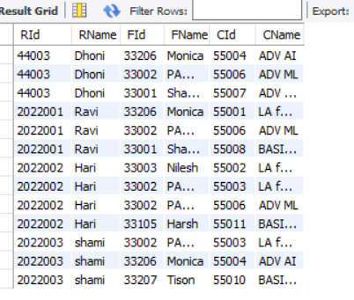

-- ------------------------------ Q4 --------------------------------------------

-- (RId, RName, FId, FName, CId, CName)

SELECT x.RNo AS RId, x.RName, f.FId,y.RName AS FName, cr.CId, c.CName

FROM RegUser x,RegUSer y, Faculty f, CourseReg cr, course c

WHERE x.RNo = cr.RNo

AND cr.CId = c.CId

AND c.FId = f.FId

AND y.RNo = f.FId

AND x.HighestQual = 'MTECH'

AND f.FDept = 'CS'

ORDER BY x.RNo;

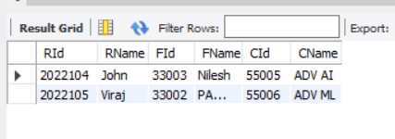

-- ------------------------------ Q5 --------------------------------------------

-- (RId, RName, FId, FName, CId, CName)

SELECT x.RNo AS RId, x.RName, f.FId,y.RName AS FName, cr.CId, c.CName

FROM RegUser x,RegUSer y, Faculty f, CourseReg cr, course c

WHERE x.RNo = cr.RNo

AND cr.CId = c.CId

AND c.FId = f.FId

AND y.RNo = f.FId

AND x.ROccu <> 'STAFF'

AND c.CDuration = 'SHORT'

ORDER BY x.RNo;

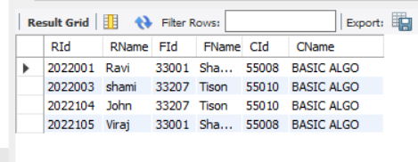

-- ------------------------------ Q6 --------------------------------------------

-- (RId, RName, FId, FName, CId, CName)

SELECT x.RNo AS RId, x.RName, f.FId,y.RName AS FName, cr.CId, c.CName

FROM RegUser x,RegUSer y, Faculty f, CourseReg cr, course c

WHERE x.RNo = cr.RNo

AND cr.CId = c.CId

AND c.FId = f.FId

AND y.RNo = f.FId

AND x.HighestQual <> 'PHD'

AND f.ResearchArea in (

SELECT ff.ResearchArea

FROM faculty ff

WHERE (ff.ResearchArea = 'AI' AND ff.ResearchArea = 'ML')

OR(ff.ResearchArea = 'ALGO')

)

ORDER BY x.RNo;

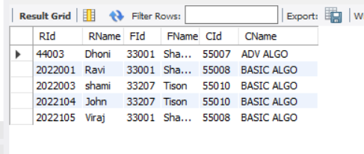

-- ------------------------------ Q7 --------------------------------------------

-- (RId, RName, FId, FName, CId, CName)

SELECT x.RNo AS RId, x.RName, f.FId,y.RName AS FName, cr.CId, c.CName, c.Cdept,f.FDept

FROM RegUser x,RegUSer y, RegUSer z,Faculty f, CourseReg cr, course c

WHERE x.RNo = cr.RNo

AND cr.CId = c.CId

AND c.FId = f.FId

AND y.RNo = f.FId

AND c.CDept='CS'

AND f.FDept <>'CS'

AND (SELECT COUNT(*) FROM RegUser WHERE x.RNo = z.RNo)>1

GROUP BY x.RNo, c.CName

ORDER BY x.RNo;

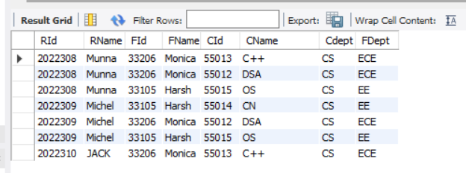

-- ------------------------------ Q8 --------------------------------------------

-- (RId, RName, FId, FName, CId, CName)

SELECT x.RNo AS RId, x.RName, f.FId,y.RName AS FName, cr.CId, c.CName

FROM RegUser x,RegUSer y, Faculty f, CourseReg cr, course c

WHERE x.RNo = cr.RNo

AND cr.CId = c.CId

AND c.FId = f.FId

AND y.RNo = f.FId

AND c.CDuration<> 'LONG'

AND (f.FDept = 'EE' OR f.FDept = 'CS')

ORDER BY x.RNo;

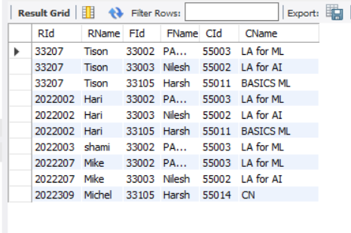

-- ------------------------------ Q9 --------------------------------------------

-- (RId, RName, FId, FName, CId, CName)

SELECT x.RNo AS RId, x.RName, f.FId,y.RName AS FName, cr.CId, c.CName, c.CDept

FROM RegUser x,RegUSer y, Faculty f, CourseReg cr, course c

WHERE x.RNo = cr.RNo

AND cr.CId = c.CId

AND c.FId = f.FId

AND y.RNo = f.FId

AND x.HighestQual = 'BTECH'

AND f.ResearchArea <> 'DBMS'

AND (C.CDept <> 'EE' AND c.CDept <> 'ME')

ORDER BY x.RNo;

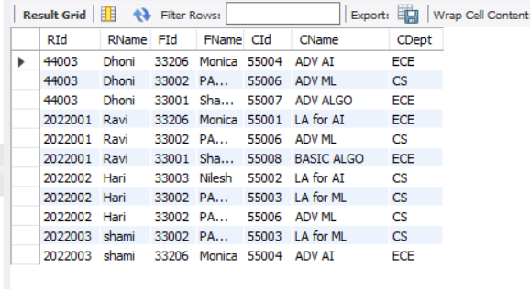

-- ------------------------------ Q10 --------------------------------------------

-- (RId, RName, FId, FName, CId, CName)

SELECT x.RNo AS RId, x.RName, f.FId,y.RName AS FName, cr.CId, c.CName

FROM RegUser x,RegUSer y, Faculty f, CourseReg cr, course c

WHERE x.RNo = cr.RNo

AND cr.CId = c.CId

AND c.FId = f.FId

AND y.RNo = f.FId

AND x.HighestQual<> 'PHD'

AND c.CDuration = 'MEDIUM'

AND (f.FDept = 'EE' OR f.FDept ='ECE')

AND c.CDept <> 'ME'

AND (f.ResearchArea = 'AI' OR f.ResearchArea = 'ML' )

ORDER BY x.RNo;



 