**MESF6910J, Term 2, 2017-2018**

**Assignment #3:**

**Topology Optimization of a Michell-Type Structure (Part 1)**

***Due: 7 PM, 12 April, Thursday***

*The structure*: A Michell-type structure is considered with three loads at its bottom, spaced in equal distance between the two supports, as shown in the Figure. The rectangular design domain is with . The structure has a fixed and a simple support at the bottom corners. The loads are  and . The material has a modulus of elasticity of 100 Mpa and the Poisson’s ratio of = 0.3. This structure is fully described in Assignment #1.

*The problem*: In the topology optimization using the SIMP method for the minimization of the strain energy function c as defined in the lecture. For this assignment, do not employ sensitivity filtering by setting suitable parameter “rmin”. You shall conduct the following studies:

1. Solutions without penalization. The parameter “penal” is the penalization power. It will be set to equal to 1. “volfrac” is the volume fraction, and it is specified to be 0.30. You will find optimal design for the two cases of finite element mesh, and show your optimal design in grey-scale.
   1. A mesh of  quadrilateral elements will be used.

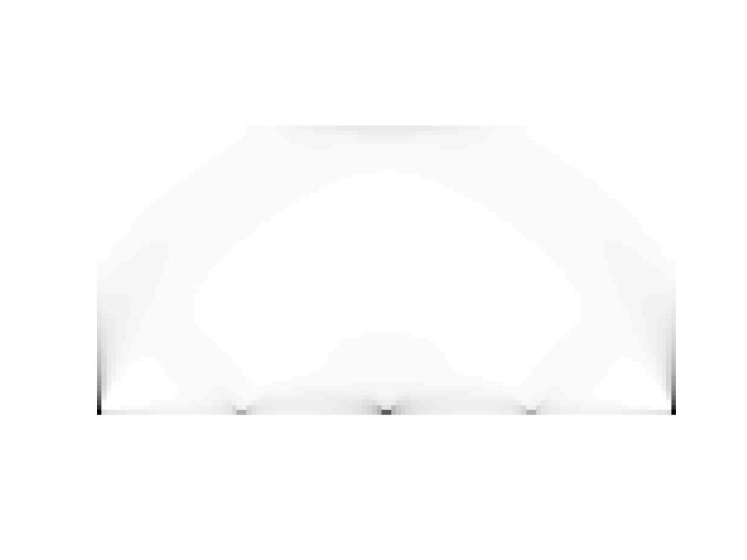

Top99_120_60(120, 60, 0.3, 1, 1e-8)

It.: 9Obj.: 0.0087 Vol.: 0.013 ch.: 0.008

* 1. A mesh of  quadrilateral elements will be used.



Top99_240_120(240,120,0.3,1,0.0001)

1. Solutions with penalization. The parameter “penal” is the penalization power. It will be set to equal to 3. “volfrac” is the volume fraction, and it is specified to be 0.30. You will find optimal design for the two cases of finite element mesh, and show your optimal design in grey-scale.
   1. A mesh of  quadrilateral elements will be used.

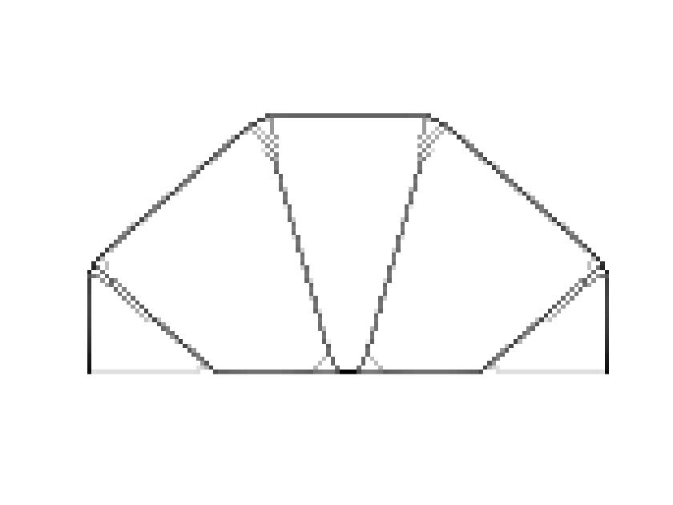

Top99_120_60(120, 60, 0.3, 3, 1e-8)

move = 0.1(The original move 0.2 used in paper cannot lead to converge)

It.: 336Obj.: 0.0093 Vol.: 0.044 ch.: 0.093(converged)

* 1. A mesh of  quadrilateral elements will be used.

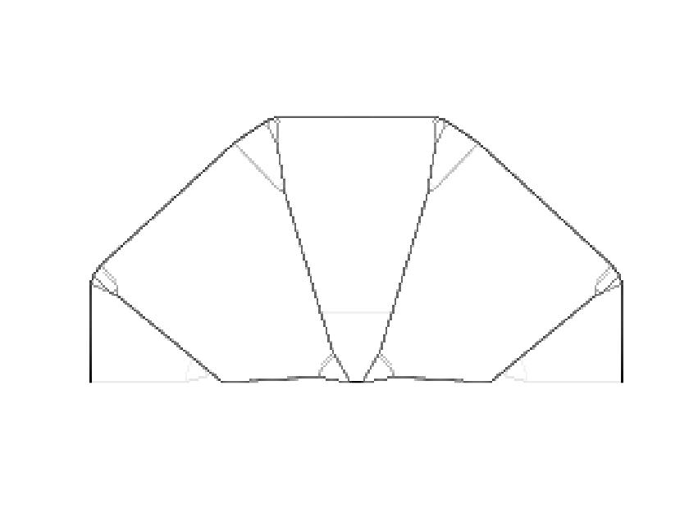

Top99_240_120(240, 120, 0.3, 3, 0.00001)

Move = 0.05

It.: 411Obj.: 0.0210 Vol.: 0.024 ch.: 0.024(converged)

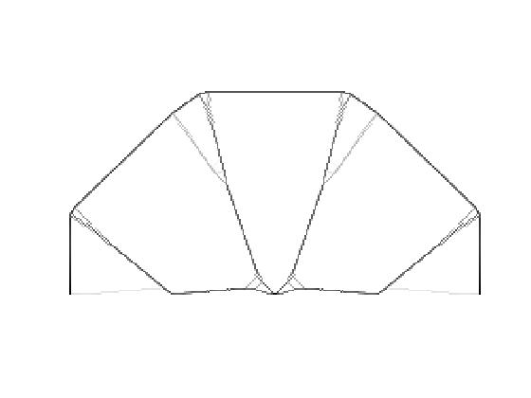

Top99_240_120(240, 120, 0.3, 3, 0.00001)

Move = 0.01

It.:2363Obj.: 0.0211 Vol.: 0.025 ch.: 0.008(converged)

1. The parameter “penal” is set to equal to 5. “volfrac” is the volume fraction, and it is specified to be 0.30. You will find optimal design for the two cases of finite element mesh, and show your optimal design in grey-scale.
   1. A mesh of  quadrilateral elements will be used.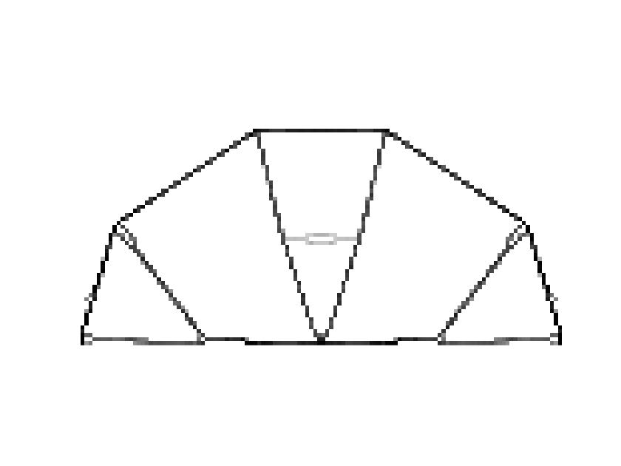

Top99_120_60(120, 60, 0.3, 5, 1e-8)

Move lift = 0.1

It.:1096Obj.: 0.0084 Vol.: 0.059 ch.: 0.100 (not converged)

* 1. A mesh of  quadrilateral elements will be used.

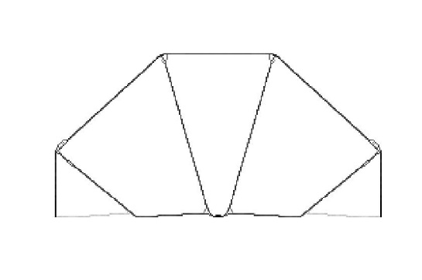

Top99_240_120(240, 120, 0.3, 5, 0.0001)

Move lift = 0.05

It.: 407Obj.: 0.0162 Vol.: 0.031 ch.: 0.050 (not converged)

1. Based on the designs you have obtained above, briefly discuss the effects of the penalization parameter “penal” and the FEM mesh on the obtained optimization results.

From the numerical tests, the convergence of this algorithm should be discussed further. The loop stopping criteria (change <= 0.01) and the move lift (0.2 in the paper) need to be looked together since change is related to the parameter move (change = max(max(abs(x-xold))))

In some special cases, the optimal criteria cannot meet the converge condition. Instead it oscillates between two states, making the change = move lift. When this problem happens, we know that the move lift is too big for this special case, so I set a smaller move lift and run the program again. The change now is smaller than move lift (change < move lift).

Using the bigger penalization parameter “penal” can lead to a better black-white solution. We can see that the case penal = 5 has fewer micro-structure than the case penal = 3. The bigger penalization parameter leads to a much clearer and distinct boundary. The outer boundary is easier to be detected because it is a black-or-white solution rather than grey boundary. Also, the mesh number effect the final solution. The bigger mesh size has different topology compared with the smaller mesh size. It shows mesh-dependency of the method. The 240×120 mesh tends to get some micro-structure which not exist in the 120×60 mesh.

