LETSUPGRADE

Cloud Computing -AWS Essentials

ASSESSMENT 1

DETAILS

NAME – KATAM PAVAN KUMAR REDDY

MAIL ID – [katam.pavan072@gmail.com](mailto:katam.pavan072@gmail.com)

MOBILE : 8247835857

TASK 1:

CREATING AND MANAGING WINDOWS MACHINE

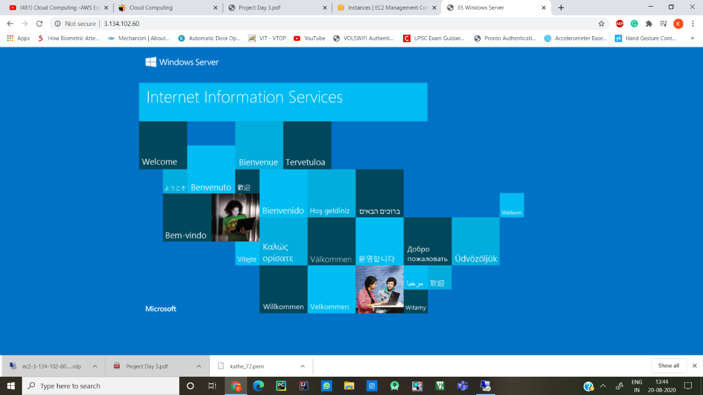

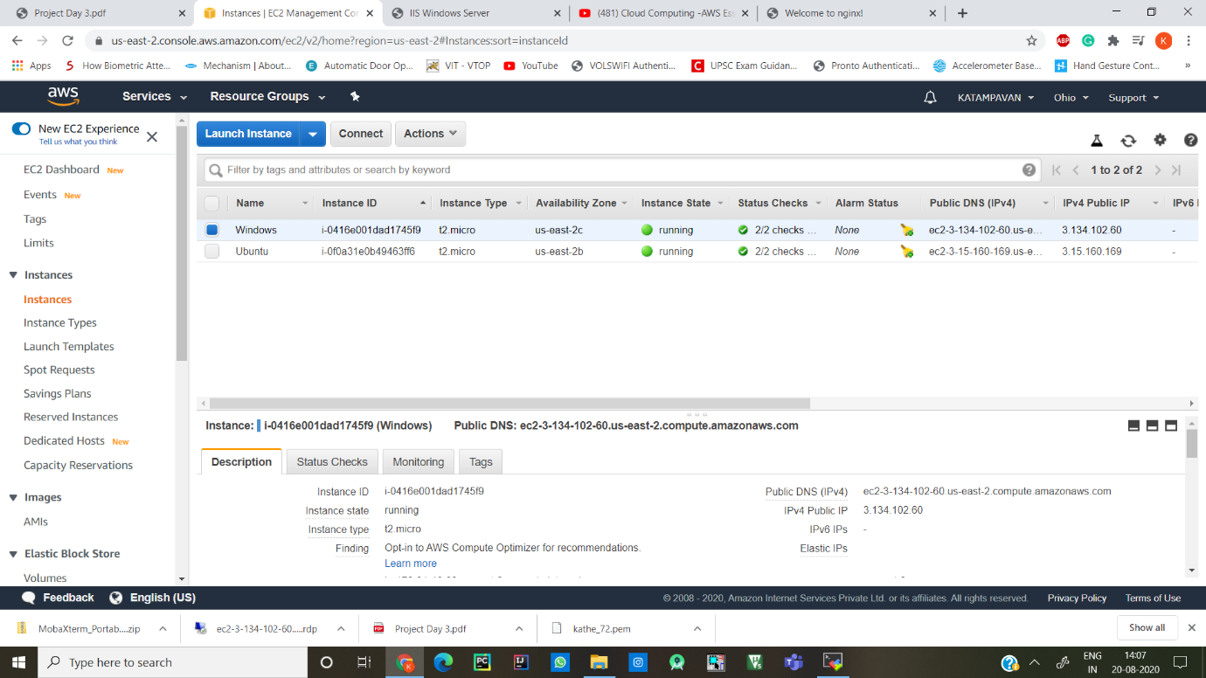

TASK 2:

CREATING AND MANAGING UBUNTU MACHINE

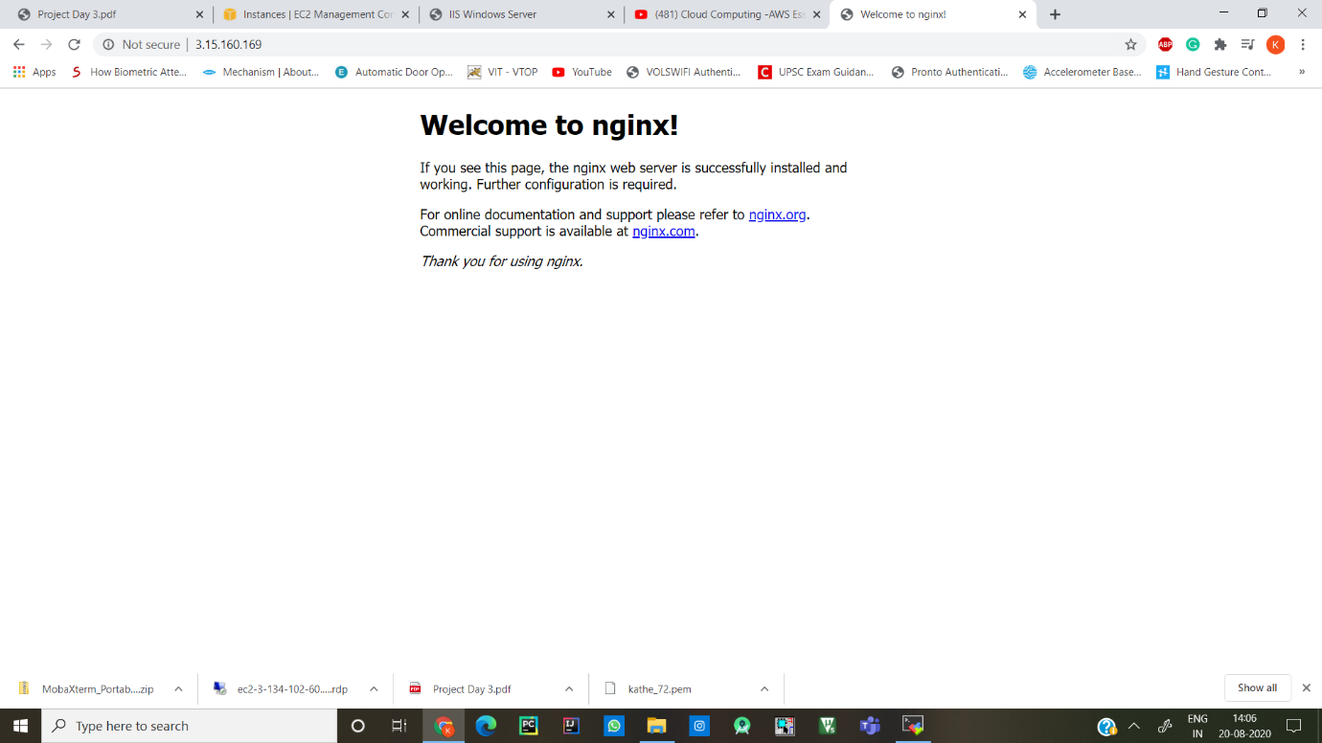

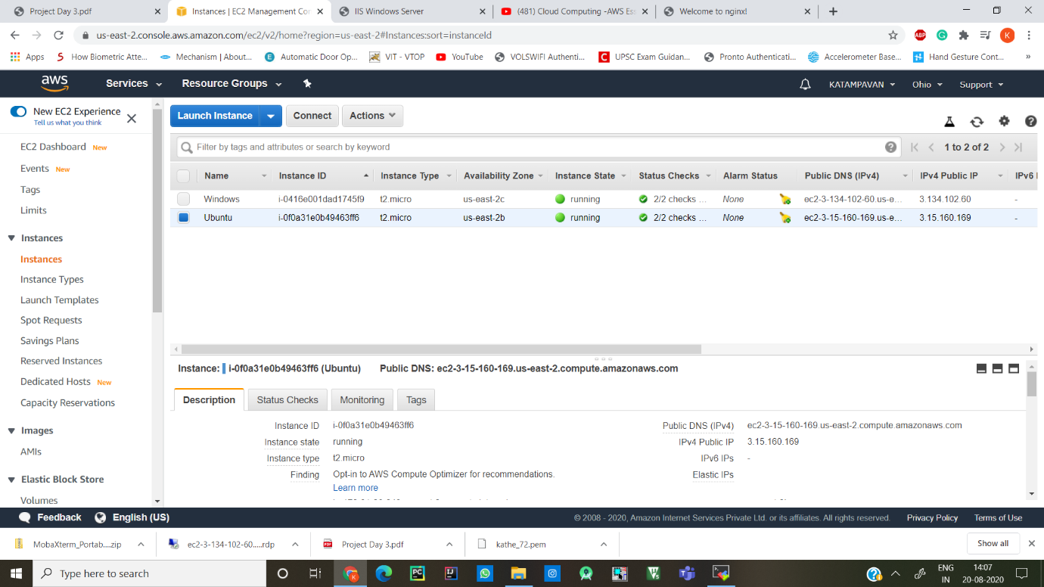

FINAL STATUS OF BOTH MACHINES

