**Project Charter Document**



**Project Name:** Text Extraction from store bills

**Department:** Retail

**Focus Area:** Market Analysis

**Product/Process:** Data Analysis



**Prepared By**

|  |  |
| --- | --- |
| **Document Owner(s)** | **Project/Organization Role** |
| Katari Adithya | Project intern |
|  |  |
|  |  |
|  |  |
|  |  |
|  |  |

**Project Charter Version Control**

|  |  |  |  |
| --- | --- | --- | --- |
| **Version** | **Date** | **Author** | **Change Description** |
| 1.0 | 28/05/2023 | Katari Adithya | Document created |
|  |  |  |  |

**TABLE OF CONTENTS**

1 PROJECT CHARTER PURPOSE 3

2 PROJECT EXECUTIVE SUMMARY 3

3 PROJECT OVERVIEW 3

4 PROJECT SCOPE 4

4.1 Goals and Objectives 4

4.2 Project Deliverables 4

4.3 Deliverables Out of Scope 4

4.4 Project Duration 4

5 PROJECT CONDITIONS 5

5.1 Project Assumptions 5

5.2 Project Issues 5

5.3 Project Risks 5

5.4 Project Constraints 5

6 Project Structure Approach 6

7 Project Team Organization Plans 6

8 PROJECT REFERENCES 6

9 APPROVALS 6

10 APPENDICES 8

10.1 Document Guidelines 8

10.2 Project Charter Document Sections Omitted 8

# PROJECT CHARTER PURPOSE

The project charter defines the scope, objectives, and overall approach for the work to be completed. It is a critical element for initiating, planning, executing, controlling, and assessing the project. It should be the single point of reference on the project for project goals and objectives, scope, organization, estimates, work plan, and budget. In addition, it serves as a contract between the Project Team and the Project Sponsors, stating what will be delivered according to the budget, time constraints, risks, resources, and standards agreed upon for the project.



# PROJECT EXECUTIVE SUMMARY

* Project goals

Text Extraction from store bills

* Objectives
  + Data prepossessing
* Scope
* Assumptions
* Risks
* Costs
* Timeline
* Approach
* Organization



# PROJECT OVERVIEW



# PROJECT SCOPE

## Goals and Objectives

|  |  |
| --- | --- |
| **Goals** | **Objectives** |
| * Text Extraction from store bills | * Minimize the time taken to extract the text |

## Project Deliverables

|  |  |
| --- | --- |
| **Milestone** | **Deliverable** |
| * Identifying Constraints and design the project architecture, explore various public forums to collect relevant data, Data Preparation. | * Deliverable 1.1—Identifying Constraints and design the project architecture. * Deliverable 1.2—Explore various public forums to collect relevant data. * Deliverable 1.3— Data Preparation |
| * Descriptive Analytics, Model Building for TEXT extraction using paddle ocr | * Deliverable 2.1— EDA and Descriptive Analytics * Deliverable 2.2— Model Building for Association (Fuzzy Algorithm) and Recommendation |
| * Deployement and pushing into database | * Deliverable 3.1— Model Evaluation, tuning and insights. * Deliverable 3. 2— Deployment |
| * Show case and review, Final Presentation and documentation, Handover and KT. | * Deliverable4.1 – show case and review * Deliverable4.2 – Final Presentation and documentation * Deliverable4.3 – Handover and KT |

## Deliverables Out of Scope

* designs
* mobile app

## Project Duration (start date: 15/09/2021 End date: 15/10/2021)

|  |  |  |  |
| --- | --- | --- | --- |
| **Project Milestone** | **Date Estimate** | **Deliverable(s) Included** | **Confidence Level** |
| * Identifying Constraints and design the project architecture, explore various public forums to collect relevant data, Data Preparation. | [15/09/2021]  -  [21/09/2021] | * Deliverable 1.1—Identifying Constraints and design the project architecture. * Deliverable 1.2—Explore various public forums to collect relevant data. * Deliverable 1.3— Data Preparation | [High] |
| * Descriptive Analytics, Model Building for TEXT extraction using paddle ocr | [22/09/2021]  -  [28/09/2021] | * Deliverable 2.1— EDA and Descriptive Analytics * Deliverable 2.2— Model Building for Association (Fuzzy Algorithm) and Recommendation | [High] |
| * Deployement and pushing into database | [29/09/2021]  -  [05/10/2021] | * Deliverable 3.1— Model Evaluation, tuning and insights. * Deliverable 3. 2— Deployment | [High] |



# PROJECT CONDITIONS

## Project Assumptions

* Work on data which is extracted from public sources.
* Can create a web API by using flask or streamlit.
* Cloud deployment should be done.
* **Robust Tested:** Application should be tested for noise data also.

## Project Issues

**Priority Criteria**

1 − High-priority/critical-path issue; requires immediate follow-up and resolution.

2 − Medium-priority issue; requires follow-up before completion of next project milestone.

3 − Low-priority issue; to be resolved prior to project completion.

4 − Closed issue.

|  |  |  |  |  |  |
| --- | --- | --- | --- | --- | --- |
| **#** | **Date** | **Priority** | **Owner** | **Description** | **Status & Resolution** |
| 1 | 23/06/2023 | High | Katari Adithya | Extracting columns from text | By using particular regex we can able to extract columns |
| 2 |  | High |  |  |  |

## Project Risks

|  |  |  |  |  |
| --- | --- | --- | --- | --- |
| **#** | **Risk Area** | **Likelihood** | **Risk Owner** | **Project Impact-Mitigation Plan** |
| 1 | [Project Risk] | [High/Medium/Low] |  |  |
| 2 | [Project Risk] | [High/Medium/Low] |  |  |

## Project Constraints



# Project Structure Approach

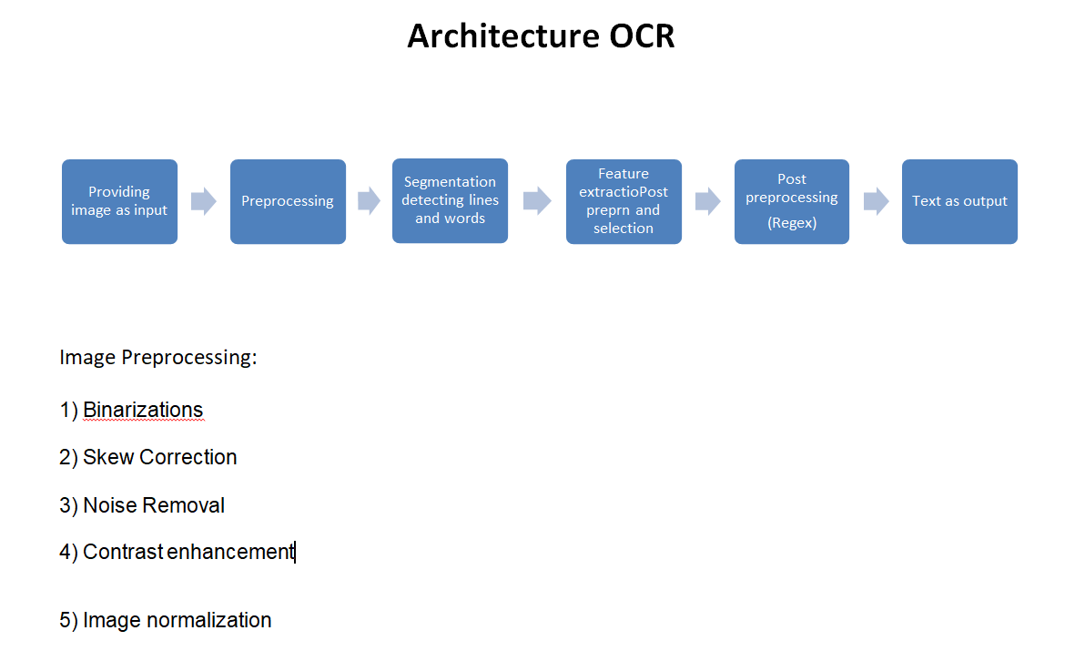



# Project Team Organization Plans

|  |
| --- |
| * Deliverable 1.1—MOM * Deliverable 1.2—CRISP ML(Q) * Deliverable 1.3— Project charter |
| * Deliverable 2.1—Daily work report * Deliverable 2.2—Architecture of the model * Deliverable 2.3—Text extraction pipeline code and documentation. |
| * Deliverable 3.1— Image preprocessing * Deliverable 3. 2— Deployment |
| * Deliverable4.1 –Project Final Code * Deliverable4.2 – PPT |



# PROJECT REFERENCES

|  |  |
| --- | --- |
| **Milestone** | **Deliverable** |
| [ |  |
|  |  |
|  |  |

# APPROVALS

**Prepared by** Katari Adithya________________________________

Project Manager

**Approved by** Sharat Chandra M____________________

Project Sponsor

__________________________________

Executive Sponsor

__________________________________

Client Sponsor



# APPENDICES

## Document Guidelines

## Project Charter Document Sections Omitted

