Workforce Platform · WF-001
Database Schema Blueprint
37 tables · 249 fields · 54 relationships · 9 modules · 13 diagrams
Derived from | Functional Specification WF-001 v2 (2026-08-31)
Supersedes | The 29-table schema circulated separately; the 54-table workbook model
Owner / Technical owner | Akshat Mishra / Aayushi Pandey
Version / Status | V2 — 7 September 2026 · Draft for technical review
What this is
- Covers all eight FSD modules plus a ninth for data lifecycle, including the features marked "specified, not yet built", so the schema will not need reworking later.
- Supersedes the 29-table schema circulated separately and the 54-table workbook model. Four of the circulated design's choices are adopted unchanged and credited below.
- Read the map on page 3 first, then the module you need. Every relationship in the schema is listed once, exactly, on pages 4 to 5.
The rules that shape everything
Rule | What it means in the schema
Tier is never stored | Read from ROLE.base_tier across all currently held seats, on every request. A seat is a team lead if another seat points at it.
References are keys, never names | Every reference to a human is a foreign key to person_id, so a rename is one UPDATE with nothing to cascade.
History is closed, not overwritten | Placements and seats carry valid_from / valid_to. Visas, authorizations and reviews supersede.
Append-only is a permission | UPDATE and DELETE revoked on the audit tables — the only way the claim holds for the founder too.
Configuration is data | Requirements, eligibility rules, leave categories and holidays are rows. No release needed to add a country.
Sensitive data is separated | Immigration in its own tables; date of birth out of directory views.
Adopted unchanged from the circulated design
Design choice | Why it is kept
EXPIRY_ALERT: three nullable FKs + CHECK exactly one + UNIQUE across all four | Beats a polymorphic column, which has no referential integrity.
Catch-all lowest-priority eligibility rule | Resolves Open Item 5 in data rather than a code branch.
LEAVE_ENTITLEMENT keyed by category and year | The previous model had no per-year balance at all.
Opaque file_storage_key and reissued_from_token_id | Keeps Open Items 3 and 9 out of the schema entirely.
What changed, and why
Was | Now | Reason
PERSON held worker_type, contractor_mode and stage | Split into PERSON + EMPLOYMENT | A person may be engaged more than once. One table cannot represent that.
No dates on department or role assignment | EMPLOYMENT_ASSIGNMENT and PERSON_ROLE effective-dated | Changing department overwrote the old value, so headcount for any past date was unanswerable.
One WORKER_DOCUMENT row per upload | WORKER_DOCUMENT = item, DOCUMENT_FILE = each version | A rejected-then-reuploaded document must keep both files and both decisions.
region on DOCUMENT_REQUIREMENT with nothing to match it | WORK_LOCATION carries region and time zone | The checklist branches on region, but no region existed on the worker side. A real defect.
SESSION linked straight to PERSON | USER_ACCOUNT between them, one-to-one | Nowhere to record the Google subject, verified flag, domain, or that an account is disabled.
Data lifecycle not covered | MIGRATION_BATCH and RETENTION_ACTION | The FSD requires migration reconciled before acceptance and deletion provable.

How everything connects
Two hubs. PERSON carries what outlives a contract — identity, immigration, sign-in. EMPLOYMENT carries everything belonging to one engagement, and is what retention removes.
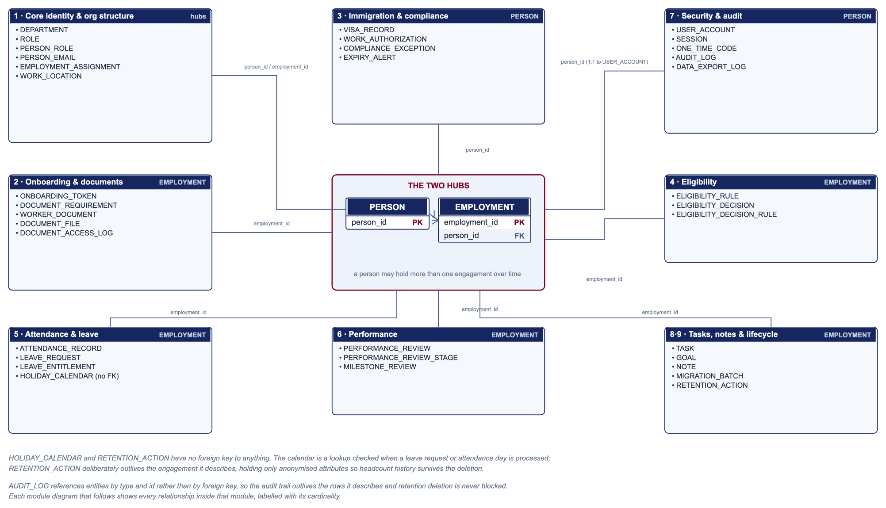

Every relationship, once
All 54 foreign keys, stated exactly. Read a row as: this child field points at that parent field. The module diagrams show the same relationships visually; this is the reference for looking one up.
# | Child (table.field) | Parent (table.field) | Card. | On delete | What that means
1 | department.parent_department_id | department.department_id | M : 1 (self) | RESTRICT | Re-parent children explicitly; a cascade would delete a subtree.
1 | role.department_id | department.department_id | M : 1 | SET DEFAULT → root | FSD: deleting a department moves its seats to the company root. None are lost.
1 | role.reports_to_role_id | role.role_id | M : 1 (self) | SET NULL | Retiring a manager seat leaves subordinates unparented rather than deleted.
1 | person_role.person_id | person.person_id | M : 1 | RESTRICT | Who held which seat is permanent.
1 | person_role.role_id | role.role_id | M : 1 | RESTRICT | Seat history must survive the seat being retired.
1 | person_email.person_id | person.person_id | M : 1 | CASCADE | An address has no meaning without its owner.
1 | employment.person_id | person.person_id | M : 1 | RESTRICT | Retention deletes engagements, never people with remaining history.
1 | employment_assignment.employment_id | employment.employment_id | M : 1 | CASCADE | Placements belong to the engagement and go with it at retention.
1 | employment_assignment.department_id | department.department_id | M : 1 | RESTRICT | A department with historical assignments is deactivated, not deleted.
1 | employment_assignment.hr_lead_person_id | person.person_id | M : 1 | SET NULL | The dated row survives; only the pointer thins.
1 | employment_assignment.work_location_id | work_location.work_location_id | M : 1 | RESTRICT | Reference data.
2 | onboarding_token.employment_id | employment.employment_id | M : 1 | CASCADE | The link exists only for the engagement.
2 | onboarding_token.reissued_from_token_id | onboarding_token.token_id | M : 1 (self) | SET NULL | The chain may break; no token is deleted.
2 | worker_document.employment_id | employment.employment_id | M : 1 | CASCADE | Checklist belongs to the engagement.
2 | worker_document.requirement_id | document_requirement.requirement_id | M : 1 | RESTRICT | A requirement in use is deactivated, never deleted.
2 | worker_document.current_file_id | document_file.file_id | M : 1 | SET NULL | If the current file is purged the item remains, showing no file.
2 | document_file.document_id | worker_document.document_id | M : 1 | CASCADE | Versions belong to the checklist item.
2 | document_file.reviewed_by_person_id | person.person_id | M : 1 | RESTRICT | Attribution of an approval is permanent.
2 | document_access_log.file_id | document_file.file_id | M : 1 | CASCADE | Access log follows the file at retention.
2 | document_access_log.actor_person_id | person.person_id | M : 1 | RESTRICT | Who viewed a passport is permanent.
3 | visa_record.person_id | person.person_id | M : 1 | RESTRICT | Immigration history is removed only by retention, deliberately.
3 | visa_record.superseded_by_visa_id | visa_record.visa_id | M : 1 (self) | SET NULL | Chain may break; neither record is deleted.
3 | work_authorization.person_id | person.person_id | M : 1 | RESTRICT | As visa.
3 | work_authorization.visa_id | visa_record.visa_id | M : 1 | SET NULL | An authorization can outlive the visa row it derived from.
3 | work_authorization.superseded_by_auth_id | work_authorization.auth_id | M : 1 (self) | SET NULL | Chain may break; records persist.
3 | compliance_exception.person_id | person.person_id | M : 1 | CASCADE | Belongs to the person.
3 | expiry_alert.visa_id | visa_record.visa_id | M : 1 | CASCADE | Alerts follow the record they warned about.
3 | expiry_alert.work_authorization_id | work_authorization.auth_id | M : 1 | CASCADE | As above. Exactly one of the three is set.
3 | expiry_alert.document_id | worker_document.document_id | M : 1 | CASCADE | As above.
4 | eligibility_decision.employment_id | employment.employment_id | M : 1 | RESTRICT | A recorded decision must not vanish with a tidied engagement.
4 | eligibility_decision.override_actor_id | person.person_id | M : 1 | RESTRICT | Override attribution is permanent.
4 | eligibility_decision.override_otp_id | one_time_code.otp_id | M : 1 | RESTRICT | The verification that authorised it must stay provable.
4 | eligibility_decision_rule.decision_id | eligibility_decision.decision_id | M : 1 | CASCADE | Reasons belong to the decision.
4 | eligibility_decision_rule.rule_id | eligibility_rule.rule_id | M : 1 | RESTRICT | The rule that decided must remain readable. A published rule is never deleted while a decision cites it.
5 | attendance_record.employment_id | employment.employment_id | M : 1 | CASCADE | Attendance belongs to the engagement.
5 | attendance_record.leave_id | leave_request.leave_id | M : 1 | RESTRICT | A leave day must always trace to its approved request.
5 | leave_request.employment_id | employment.employment_id | M : 1 | CASCADE | Leave belongs to the engagement.
5 | leave_request.decided_by_person_id | person.person_id | M : 1 | SET NULL | Decision timestamp survives; approver pointer may thin.
5 | leave_entitlement.employment_id | employment.employment_id | M : 1 | CASCADE | Balances belong to the engagement.
6 | performance_review.employment_id | employment.employment_id | M : 1 | CASCADE | Reviews belong to the engagement.
6 | performance_review.supersedes_review_id | performance_review.review_id | M : 1 (self) | SET NULL | Breaking the chain never deletes the superseded round.
6 | performance_review_stage.review_id | performance_review.review_id | M : 1 | CASCADE | Stages belong to the round.
6 | performance_review_stage.reviewer_person_id | person.person_id | M : 1 | SET NULL | A locked rating stays even if the reviewer record goes.
6 | milestone_review.employment_id | employment.employment_id | M : 1 | CASCADE | Belongs to the engagement.
7 | user_account.person_id | person.person_id | M : 1 | RESTRICT | Unlinking would orphan the audit trail. Disable the account instead.
7 | session.account_id | user_account.account_id | M : 1 | CASCADE | Sessions are worthless without the account.
7 | one_time_code.account_id | user_account.account_id | M : 1 | CASCADE | As sessions.
7 | audit_log.actor_person_id | person.person_id | M : 1 | SET NULL | The event survives; actor_tier and the summary remain.
7 | data_export_log.actor_person_id | person.person_id | M : 1 | RESTRICT | Who took data out is permanent.
8 | task.employment_id | employment.employment_id | M : 1 | CASCADE | Belongs to the engagement.
8 | goal.employment_id | employment.employment_id | M : 1 | CASCADE | Belongs to the engagement.
8 | note.employment_id | employment.employment_id | M : 1 | CASCADE | Belongs to the engagement.
9 | migration_batch.loaded_by_person_id | person.person_id | M : 1 | RESTRICT | Load attribution permanent.
9 | migration_batch.hr_signed_off_by_person_id | person.person_id | M : 1 | RESTRICT | Sign-off attribution permanent.

Module 1 · Core identity and org structure
The foundation every other module depends on. Access tier and Team Lead status are never stored as columns — they are computed by walking the org chart at query time, matching the FSD principle that access is "recomputed on every request, never stored, never client-supplied".
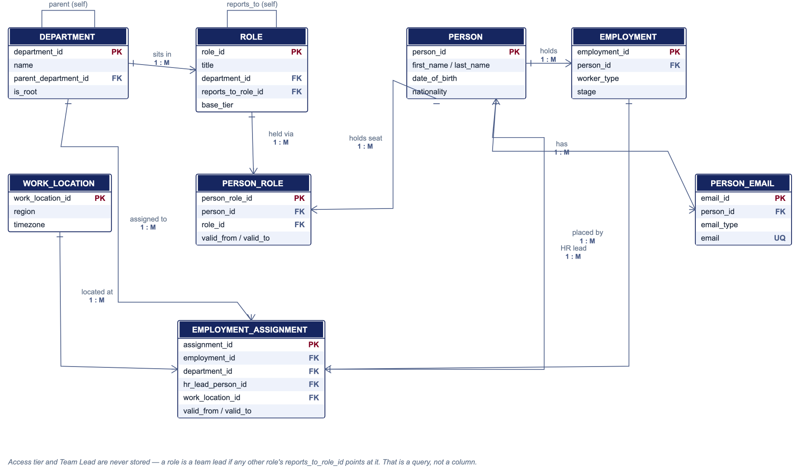

Module 1 · Core identity and org structure — fields
DEPARTMENT
One department in the company tree. · Current state
Field | Type / Key | Notes
department_id | uuid PK
name | string
parent_department_id | uuid FK → self | Nullable. Builds the department tree.
is_root | boolean | True for the one department that cannot be deleted.
is_active | boolean | Closed departments are deactivated, never deleted, so historical assignments still resolve.
ROLE
One seat in the org chart. Exists whether or not somebody holds it. · Current state
Field | Type / Key | Notes
role_id | uuid PK
title | string
department_id | uuid FK → Department | Where the seat sits in the chart.
reports_to_role_id | uuid FK → self | Nullable. The reporting line. Zero populated today per the FSD Key Dependencies.
base_tier | string | founder / hr_admin / employee / intern. CHECK constrained.
is_active | boolean | A seat can be retired without deleting who held it.
PERSON
The human being. Everything that belongs to the person rather than to any engagement. · Current state
Field | Type / Key | Notes
person_id | uuid PK
first_name, last_name, preferred_name | string
gender | string | Nullable.
date_of_birth | date | Nullable. Restricted-access field per the FSD. Never in directory views.
nationality | string | Nullable.
immigration_status | string | Nullable. One summary field. Full visa detail lives in Module 3.
created_at | datetime
PERSON_ROLE
Which seat a person holds, and when. · HISTORICAL — closed by setting valid_to, never overwritten
Field | Type / Key | Notes
person_role_id | uuid PK
person_id | uuid FK → Person
role_id | uuid FK → Role
is_primary | boolean | Marks the main seat when a person holds more than one.
valid_from | date | ADDED. Effective from.
valid_to | date | Nullable. ADDED. Nullable = currently held. This is what makes a vacancy a fact rather than an absence.
PERSON_EMAIL
Email addresses, held as rows so one constraint enforces the FSD uniqueness rule. · Current state
Field | Type / Key | Notes
email_id | uuid PK
person_id | uuid FK → Person
email_type | string | personal / professional.
email | string | Unique index on lower(email) across ALL rows — both types, org-wide.
EMPLOYMENT
One engagement of one person. Separate from Person because a person may be engaged more than once. · HISTORICAL — a re-engagement is a NEW row; both are retained
Field | Type / Key | Notes
employment_id | uuid PK
employment_code | string | EMP-001. The number people quote.
person_id | uuid FK → Person | Many engagements over time, one human.
worker_type | string | Employee / Contractor / Intern. Drives the document checklist.
contractor_mode | string | Nullable. Only meaningful for Contractor.
employment_type | string | Nullable. Full-time / Part-time / Contract.
designation | string
joined_on | date
exited_on | date | Nullable = current. Starts the retention clock.
stage | string | Invited / Verifying / Verified / Active / Inactive.
retention_due_on | date | Nullable. Generated: exited_on + 3 years. Indexed for the retention sweep.
EMPLOYMENT_ASSIGNMENT
Where an engagement sits, and under whom. Effective-dated. · HISTORICAL — the source of truth for "which department was she in last March"
Field | Type / Key | Notes
assignment_id | uuid PK
employment_id | uuid FK → Employment
department_id | uuid FK → Department | Authoritative department for the engagement.
hr_lead_person_id | uuid FK → Person | Nullable. A key, not a name — which is why a rename needs no cascade.
hr_lead_unresolved | string | Nullable. A name matching nobody. Surfaced as a warning, never silently repointed.
work_location_id | uuid FK → Work_Location | Supplies the region that selects the document checklist.
change_reason | string | Nullable. Transfer, promotion, re-organisation.
valid_from | date
valid_to | date | Nullable = current. Exactly one current row per engagement.
WORK_LOCATION
A place of work, and the region and time zone that follow from it. · Current state
Field | Type / Key | Notes
work_location_id | uuid PK
name | string
country | string
region | string | India / US. Selects which document requirements apply.
timezone | string | Attendance is displayed in this zone, never server time.
Key rules
- Employment is split from Person. A person may be engaged more than once — an intern who returns as an employee is two engagements and one human. Holding worker_type and stage on Person cannot represent that, and duplicates personal data per engagement.
- Employment_Assignment is effective-dated. Changing department closes the current row and opens a new one, so headcount by department stays correct for any past date. A mutable department column on Person has no memory at all.
- Department is authoritative on Employment_Assignment, not derived from the person's role, because contractors and interns may sit in a department without holding a formal seat. Role.department_id positions the seat in the chart; the two are normally identical and may legitimately differ for a secondment.

Module 2 · Onboarding and documents
Document_Requirement is the checklist definition — which of the 6 to 12 documents apply, based on worker type, region and contractor mode. Worker_Document is one required item for one engagement; Document_File is each actual upload against it.
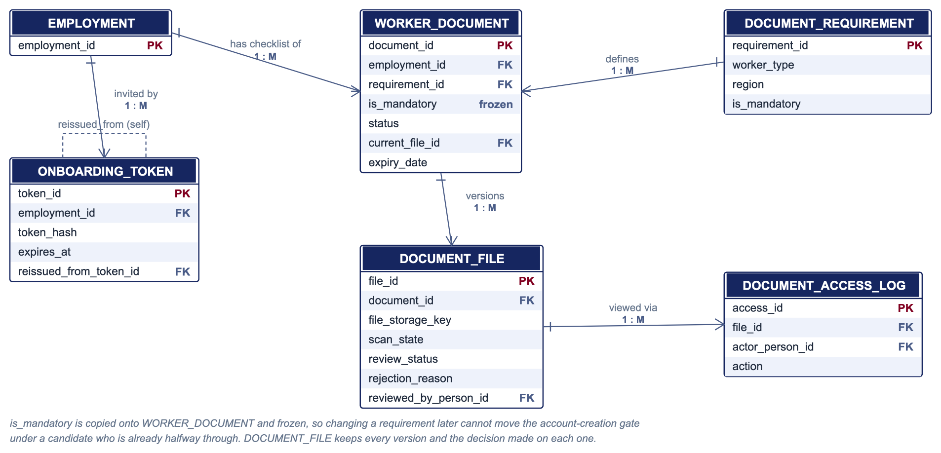

Module 2 · Onboarding and documents — fields
ONBOARDING_TOKEN
The tokenized link sent to a candidate. · Current state
Field | Type / Key | Notes
token_id | uuid PK
employment_id | uuid FK → Employment | Belongs to the engagement being onboarded.
token_hash | string | Only the hash is stored, so a database leak yields no working links.
issued_at | datetime
expires_at | datetime | 7 days from issue per the FSD.
status | string | active / expired / revoked.
reissued_from_token_id | uuid FK → self | Nullable. Supports Open Item 9.
DOCUMENT_REQUIREMENT
The checklist definition — which documents apply to which kind of worker. · Current state
Field | Type / Key | Notes
requirement_id | uuid PK
worker_type | string | Nullable = applies to all types.
region | string | Nullable = all regions. This is how the US tax form appears only for US workers.
contractor_mode | string | Nullable = all modes.
document_name | string
is_mandatory | boolean | Only mandatory items gate account creation.
validity_months | int | Nullable. 12 for the US tax withholding form. Nullable = does not expire.
WORKER_DOCUMENT
One checklist item for one engagement, and where it stands. · Current state
Field | Type / Key | Notes
document_id | uuid PK
employment_id | uuid FK → Employment
requirement_id | uuid FK → Document_Requirement
is_mandatory | boolean | Copied and FROZEN at creation, so a later config change cannot move the gate under an in-flight candidate.
status | string | Outstanding / Pending / Approved / Rejected.
current_file_id | uuid FK → Document_File | Nullable. The version in force.
expiry_date | date | Nullable. For time-limited documents. Picked up by the same daily scan as visas.
DOCUMENT_FILE
One uploaded file, with the decision made on it. · HISTORICAL — a rejected-then-reuploaded document keeps both files and both decisions
Field | Type / Key | Notes
file_id | uuid PK
document_id | uuid FK → Worker_Document
file_storage_key | string | Opaque reference; storage backend is Open Item 3. Carries no name or number.
file_name | string
uploaded_at | datetime
scan_state | string | pending / clean / infected. Quarantined until clean.
review_status | string | Nullable. Approved / Rejected. Nullable until reviewed.
rejection_reason | string | Nullable. Required when rejected.
reviewed_by_person_id | uuid FK → Person | Nullable.
reviewed_at | datetime | Nullable.
DOCUMENT_ACCESS_LOG
Who viewed or downloaded a document. · HISTORICAL — append-only
Field | Type / Key | Notes
access_id | uuid PK
file_id | uuid FK → Document_File
actor_person_id | uuid FK → Person
action | string | view / download.
occurred_at | datetime
Key rules
- Document_File is separate from Worker_Document so a rejected-then-reuploaded document keeps both files and both decisions. The decision sits on the file, not the item, because a decision is always about a specific version.
- The token belongs to the engagement, not the person, so a returning worker being onboarded again gets a clean second run rather than mutating the first.

Module 3 · Immigration records and compliance
Two design choices carry the weight of this module: how a record supersedes itself instead of being edited, and how one alert table points at three different kinds of thing.
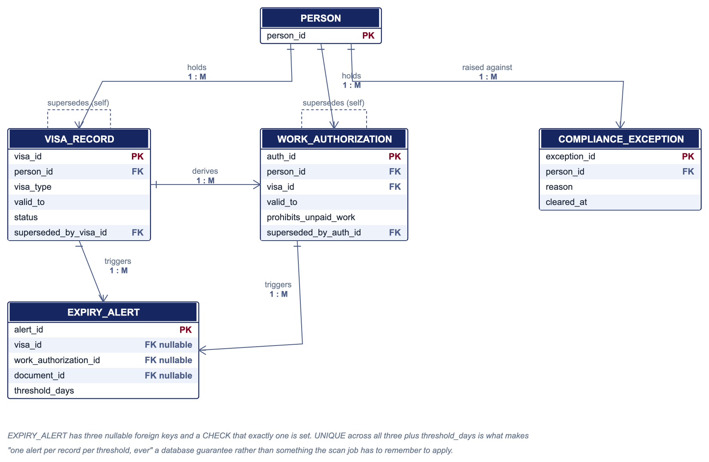

Module 3 · Immigration records and compliance — fields
VISA_RECORD
A visa held by a person. Never edited — a change supersedes. · HISTORICAL — supersession chain; nothing is overwritten
Field | Type / Key | Notes
visa_id | uuid PK
person_id | uuid FK → Person | Attaches to the human, not the engagement — a visa outlives a contract.
visa_type | string | CHECK-constrained controlled vocabulary, so rules match reliably.
issuing_country | string
valid_from, valid_to | date
status | string | current / superseded.
superseded_by_visa_id | uuid FK → self | Nullable. Forms the renewal chain.
WORK_AUTHORIZATION
The right to work, its duration and its restrictions. · HISTORICAL — supersession chain
Field | Type / Key | Notes
auth_id | uuid PK
person_id | uuid FK → Person
visa_id | uuid FK → Visa_Record | Nullable. Often but not always derived from a visa.
auth_type | string
valid_from, valid_to | date
duration_type | string | Nullable. One-year, two-year and other lengths are the same shape.
prohibits_unpaid_work | boolean | The exact flag behind the FSD unpaid-internship rule.
restrictions | text | Nullable.
status | string | current / superseded.
superseded_by_auth_id | uuid FK → self | Nullable.
COMPLIANCE_EXCEPTION
A raised problem that blocks dependent engagements until cleared. · HISTORICAL — cleared exceptions are retained as evidence
Field | Type / Key | Notes
exception_id | uuid PK
person_id | uuid FK → Person
reason | string
raised_at | datetime
cleared_at | datetime | Nullable. Cleared by recording a renewal.
EXPIRY_ALERT
An alert already sent. The row existing is what stops the scan resending it. · HISTORICAL — append-only; this is the idempotency ledger
Field | Type / Key | Notes
alert_id | uuid PK
visa_id | uuid FK → Visa_Record | Nullable.
work_authorization_id | uuid FK → Work_Authorization | Nullable.
document_id | uuid FK → Worker_Document | Nullable. Exactly one of the three FKs must be set — CHECK constraint.
threshold_days | int | 90 / 60 / 30 / 7 / 0.
alerted_at | datetime
message_status | string | Written only once the message is accepted for delivery.
Key rules
- Visa_Record and Work_Authorization both reference themselves through a superseded_by column. Updating a visa means inserting a new row and pointing the old row at it, so "never overwritten — a change supersedes and both are retained" becomes a structural guarantee, not a habit.
- These records attach to Person rather than Employment. A visa outlives any single contract, and a returning worker keeps it.

Module 4 · Eligibility engine
Eligibility_Rule rows are pure configuration — nobody codes "if India and H-1B then deny", it is a data row with a priority number, exactly matching the FSD assumption that the product carries no legal knowledge of its own.
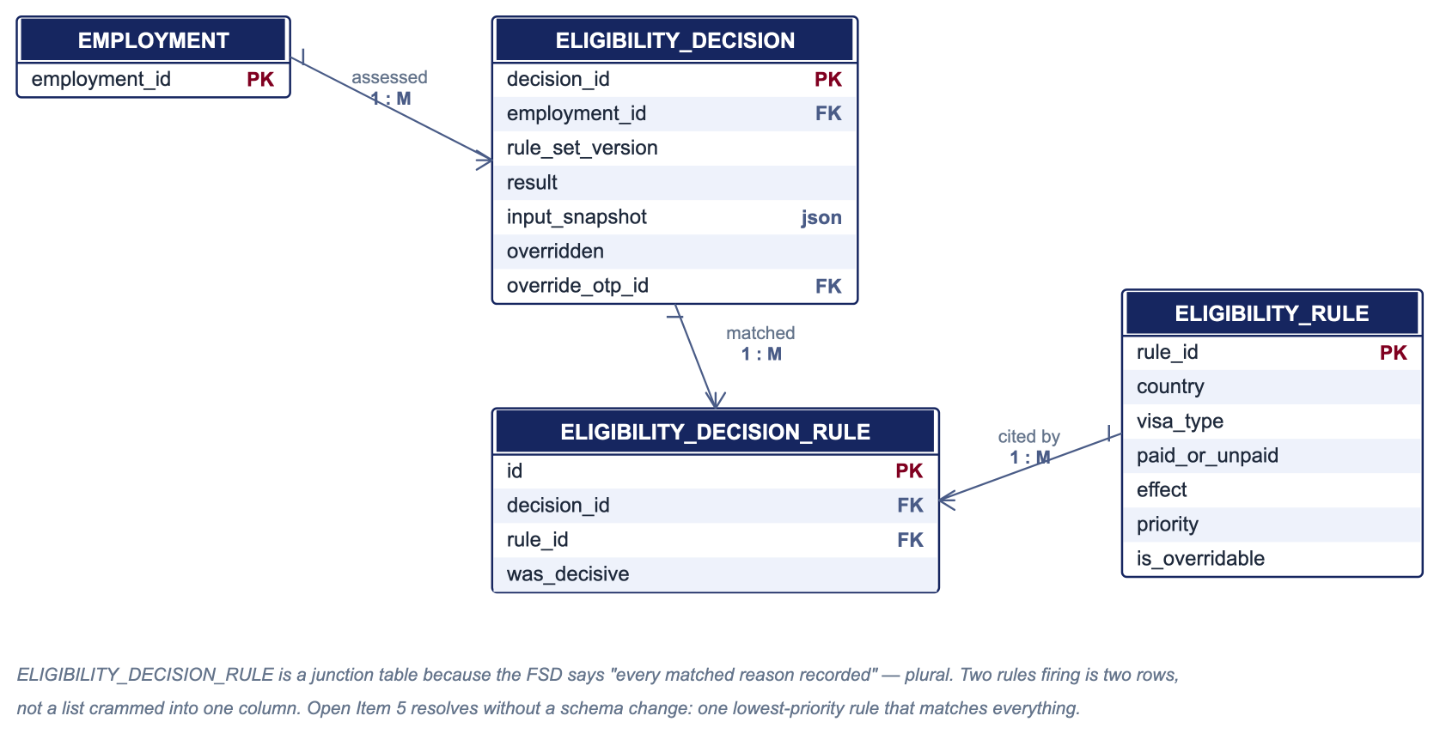

Module 4 · Eligibility engine — fields
ELIGIBILITY_RULE
One rule. Pure configuration — no legal knowledge is coded into the product. · Current state
Field | Type / Key | Notes
rule_id | uuid PK
country | string | Nullable = any.
visa_type | string | Nullable = any.
employment_type | string | Nullable = any.
paid_or_unpaid | string | Nullable = either. This is how unpaid internships are matched separately.
effect | string | allow / deny / needs_review.
priority | int | Unique per rule set, so the winning rule is never ambiguous.
is_overridable | boolean | A non-overridable rule is refused regardless of tier.
rule_set_version | int | Which published version this rule belongs to.
ELIGIBILITY_DECISION
One recorded decision, with an immutable copy of what it was based on. · HISTORICAL — insert-only; a re-assessment is a new row
Field | Type / Key | Notes
decision_id | uuid PK
employment_id | uuid FK → Employment | Paid versus unpaid is a property of the engagement, so the decision belongs here.
rule_set_version | int | The exact version evaluated. This is what makes the decision reproducible.
result | string | Eligible / Ineligible / NeedsReview.
input_snapshot | json | Immutable; frozen at decision time.
overridden | boolean
override_reason | text | Nullable. Required when overridden.
override_actor_id | uuid FK → Person | Nullable.
override_otp_id | uuid FK → One_Time_Code | Nullable. Ties the override to the step-up that authorised it.
decided_at | datetime
ELIGIBILITY_DECISION_RULE
Which rules matched a decision. Every matched reason, not just the winner. · HISTORICAL — append-only
Field | Type / Key | Notes
id | uuid PK
decision_id | uuid FK → Eligibility_Decision
rule_id | uuid FK → Eligibility_Rule
was_decisive | boolean | Separates the rule that decided from those that merely matched.
Key rules
- Eligibility_Decision_Rule is a junction table because the FSD says "every matched reason recorded" — plural. If two rules fired for one decision, that is two rows here, not a list crammed into one column.
- input_snapshot is a JSON value frozen at decision time. That is what makes a decision reproducible after rules change: a past decision is never re-evaluated against today's rules, it is read back exactly as it was decided.

Module 5 · Attendance and leave
Holiday_Calendar sits apart with no line to Person — it is a lookup checked when a leave request or attendance day is processed ("a holiday is not leave"), not something a person owns.
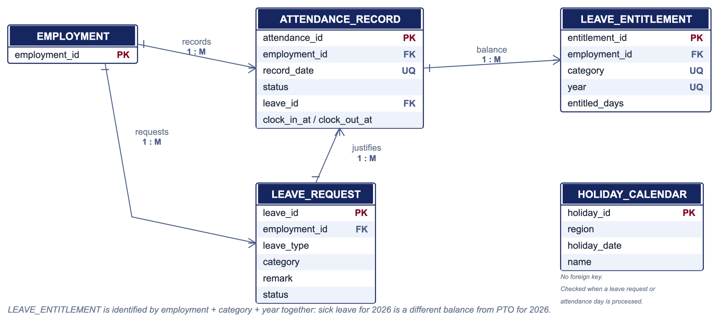

Module 5 · Attendance and leave — fields
ATTENDANCE_RECORD
What one person did on one day. · HISTORICAL — accumulates indefinitely, never pruned during employment
Field | Type / Key | Notes
attendance_id | uuid PK
employment_id | uuid FK → Employment
record_date | date | Unique together with employment_id — one record per day.
status | string | present / absent / holiday / leave.
leave_id | uuid FK → Leave_Request | Nullable. Required when status is leave, so a leave day always traces to an approved decision.
clock_in_at, clock_out_at | datetime | Nullable.
source | string | self / hr / system.
place | string | Nullable.
LEAVE_REQUEST
A request for leave and its decision. · HISTORICAL — a decided request is never edited; a change is a new request
Field | Type / Key | Notes
leave_id | uuid PK
employment_id | uuid FK → Employment
leave_type | string | paid / unpaid.
category | string | Nullable. Sick / Bereavement / PTO. Nullable — paid leave only.
start_date, end_date | date | end_date not before start_date.
remark | text | Nullable. Required when leave_type is unpaid.
status | string | Pending / Approved / Rejected.
decided_by_person_id | uuid FK → Person | Nullable. A person may not approve their own request.
decided_at | datetime | Nullable.
LEAVE_ENTITLEMENT
How much leave of one category one engagement has, in one year. · Current state
Field | Type / Key | Notes
entitlement_id | uuid PK
employment_id | uuid FK → Employment
category | string | Unique together with employment_id and year.
year | int
entitled_days, accrued_days, carried_over_days | decimal | Nullable. NULL until HR sets them — Open Item 22.
HOLIDAY_CALENDAR
A company holiday, per region. A holiday is not leave. · Current state
Field | Type / Key | Notes
holiday_id | uuid PK
region | string | India / US. Unique together with holiday_date.
holiday_date | date
name | string
Key rules
- Leave_Entitlement's real identity is the combination of employment, category and year together. Sick leave for 2026 is a different balance from PTO for 2026 — an example of Second Normal Form, covered in the normalization section.
- Leave_Request.category is nullable on purpose: only paid leave carries Sick / Bereavement / PTO. Unpaid leave carries a written remark instead, per the FSD rule that a reason is required on every unpaid request.

Module 6 · Performance and milestones
Performance_Review_Stage is its own table rather than three columns on Performance_Review, because the FSD lock-after-submission rule needs to apply per stage — Self can be locked while Team Lead is still open.
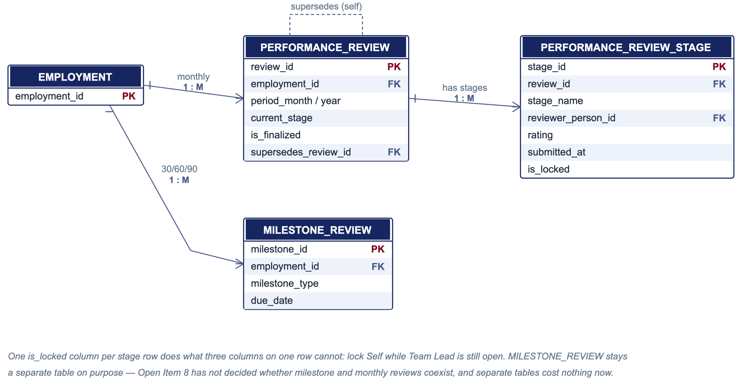

Module 6 · Performance and milestones — fields
PERFORMANCE_REVIEW
One monthly review round for one engagement. · HISTORICAL — superseded rounds remain visible
Field | Type / Key | Notes
review_id | uuid PK
employment_id | uuid FK → Employment
period_month, period_year | int | Unique together with employment_id for live rows.
current_stage | string | Self / TeamLead / HR / Finalized.
is_finalized | boolean
supersedes_review_id | uuid FK → self | Nullable. A correction is a new round, not an edit.
PERFORMANCE_REVIEW_STAGE
One stage of one review round. · HISTORICAL — locked on submission
Field | Type / Key | Notes
stage_id | uuid PK
review_id | uuid FK → Performance_Review
stage_name | string | Self / TeamLead / HR. Unique together with review_id.
reviewer_person_id | uuid FK → Person | Nullable. Who filled it. Retained even if they later leave.
rating | int | Nullable.
feedback | text | Nullable.
submitted_at | datetime | Nullable.
is_locked | boolean | Enforces lock-after-submission independently per stage.
MILESTONE_REVIEW
A 30, 60 or 90-day milestone review. · Current state
Field | Type / Key | Notes
milestone_id | uuid PK
employment_id | uuid FK → Employment
milestone_type | string | 30 / 60 / 90.
due_date | date | Derived from Employment.joined_on.
completed_at | datetime | Nullable.
rating | int | Nullable.
feedback | text | Nullable.
Key rules
- One is_locked column per stage row does what three columns on one row cannot: lock each stage independently as it is submitted.
- Milestone_Review is a separate table on purpose, reflecting Open Item 8 — the FSD has not decided whether 30/60/90-day milestone reviews are superseded by monthly reviews or coexist. Separate tables cost nothing now and avoid forcing that decision into the schema early.

Module 7 · Security and audit
Audit_Log.event_category covers everything the FSD lists as required-but-not-built — sign-in attempts, profile changes, permission changes, document access, immigration changes, eligibility decisions, exports — in one table rather than seven, since they all share the same shape: who did what to what, when.
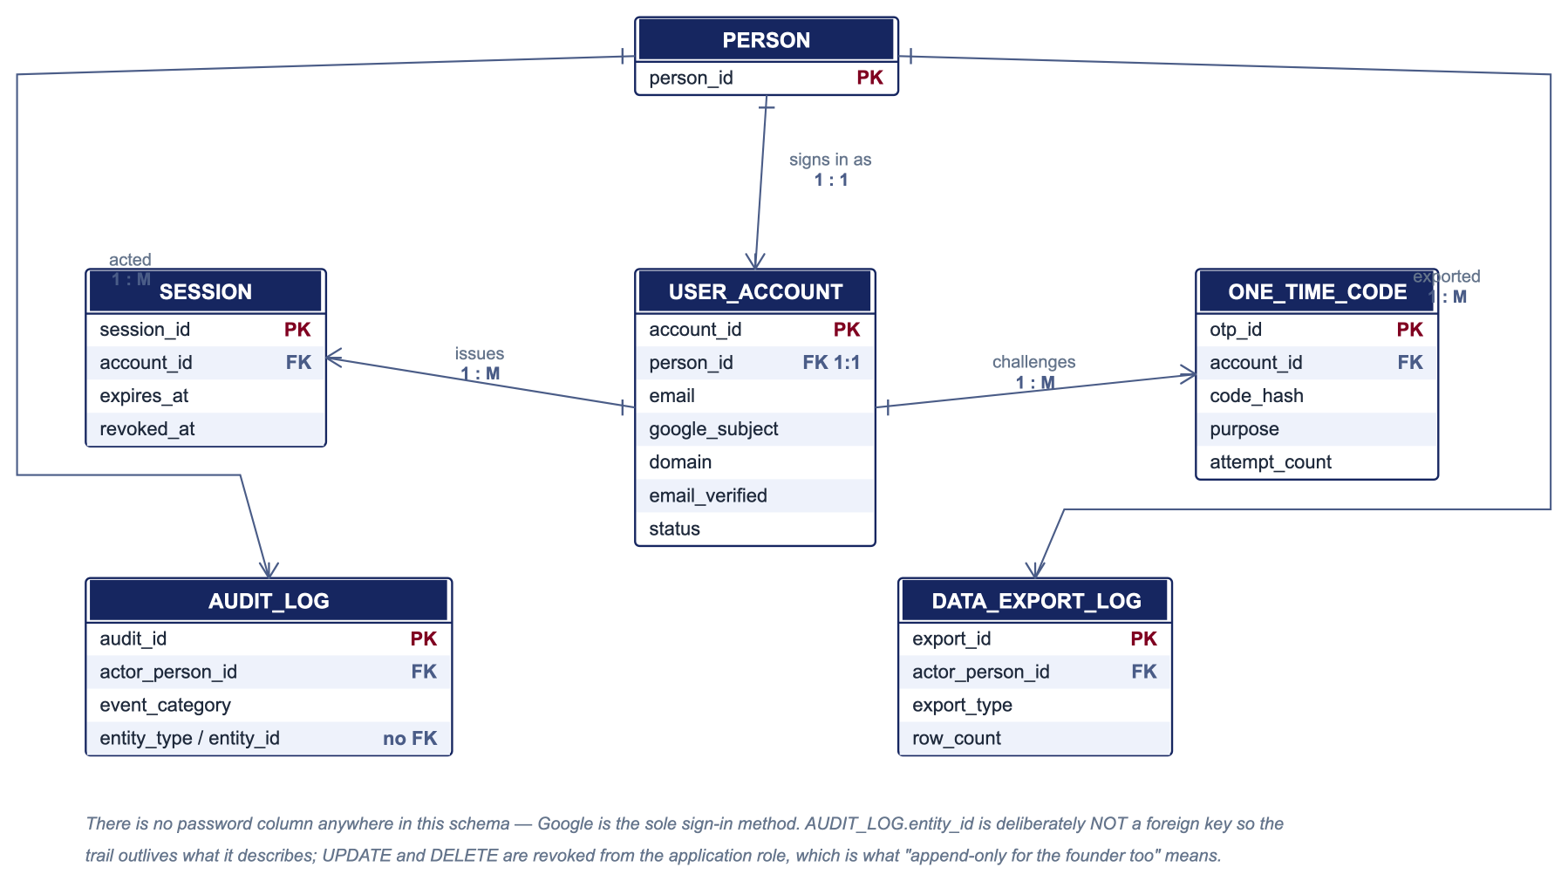

Module 7 · Security and audit — fields
USER_ACCOUNT
The sign-in identity. Deliberately separate from the employee record. · Current state
Field | Type / Key | Notes
account_id | uuid PK
person_id | uuid FK → Person | One-to-one. The single bridge between authentication and workforce data.
email | string | The address Google asserts.
google_subject | string | Google's immutable subject id. Survives the user changing their email at Google.
domain | string | Must equal the company domain or sign-in is refused.
email_verified | boolean | An unverified address is refused.
status | string | active / disabled. Disabling blocks sign-in without deleting history.
SESSION
One issued session. · HISTORICAL — expired and revoked sessions are retained
Field | Type / Key | Notes
session_id | uuid PK
account_id | uuid FK → User_Account
created_at, expires_at | datetime
revoked_at | datetime | Nullable. Exists specifically to support Open Item 11.
ip_address | string | Nullable.
ONE_TIME_CODE
A code issued for step-up verification. · HISTORICAL — retained as audit evidence
Field | Type / Key | Notes
otp_id | uuid PK
account_id | uuid FK → User_Account
code_hash | string | Only the hash is stored.
purpose | string | step_up / eligibility_override / sensitive_export.
created_at, expires_at | datetime
attempt_count, max_attempts | int | Drives the attempt limit and lockout.
status | string | issued / consumed / locked_out / expired.
AUDIT_LOG
Every sensitive action. Append-only for every tier including founder. · HISTORICAL — append-only, retained beyond worker retention as proof of deletion
Field | Type / Key | Notes
audit_id | uuid PK
actor_person_id | uuid FK → Person | Nullable — null for system-initiated events.
actor_tier | string | Nullable. Captured at the time, because tier is derived and may since have changed.
event_category | string | sign_in / profile_change / permission_change / document_access / immigration_change / eligibility_decision / export / structural.
entity_type, entity_id | string / uuid | Deliberately NOT a foreign key, so the trail outlives what it describes.
before_state, after_state | json | Nullable.
ip_address | string | Nullable.
occurred_at | datetime
DATA_EXPORT_LOG
Who took data out of the system. · HISTORICAL — append-only
Field | Type / Key | Notes
export_id | uuid PK
actor_person_id | uuid FK → Person
export_type | string | roster / attendance / audit.
row_count | int | Scale of the extract.
filter_applied | json | Nullable. Reproduces exactly what left.
exported_at | datetime
Key rules
- User_Account is separate from Person because a person can exist in the org chart with no account, and an account can be disabled without touching employment data. It is a strict one-to-one, and it is the only bridge between the authentication tables and the workforce tables.
- There is no password column anywhere in this schema. Google is the sole sign-in method, so there is nothing to steal.
- One rule here must be a database permission, not just a schema note: Audit_Log must never allow update or delete, only insert, for every tier including founder. UPDATE and DELETE are revoked from the application role. That is what "append-only for the highest tier" means in practice.

Module 8 · Tasks and notes
The simplest module in the schema — three flat tables with no interesting relationships between them. Each belongs to one engagement, which is why a sentence covers what a diagram would.
TASK
A personal to-do item. · Current state
Field | Type / Key | Notes
task_id | uuid PK
employment_id | uuid FK → Employment
title | string
description | text | Nullable.
status | string
due_date | date | Nullable.
GOAL
A goal set for an engagement. · Current state
Field | Type / Key | Notes
goal_id | uuid PK
employment_id | uuid FK → Employment
title | string
description | text | Nullable.
target_date | date | Nullable.
status | string
NOTE
A notebook entry. · Current state
Field | Type / Key | Notes
note_id | uuid PK
employment_id | uuid FK → Employment
content | text
created_at | datetime
Key rules
- These attach to Employment rather than Person so they end with the engagement and are removed by the retention sweep along with everything else that belongs to it.

Module 9 · Data lifecycle
Two tables that exist only because the FSD added a data-lifecycle section: migration must be cleansed and reconciled before acceptance, and retention deletion must be provable while anonymised aggregates survive it.
MIGRATION_BATCH
One load of external data, with the reconciliation evidence. · HISTORICAL — permanent evidence that the load was correct
Field | Type / Key | Notes
batch_id | uuid PK
source_description | string | Where the data came from — Open Item 19 names the source.
loaded_by_person_id | uuid FK → Person
source_row_count, loaded_row_count, rejected_row_count | int | Reconciled against the source.
hr_signed_off_by_person_id | uuid FK → Person | Nullable. A sample checked by HR before the dataset is accepted.
accepted_at | datetime | Nullable = not yet accepted.
RETENTION_ACTION
Proof that retention deletion happened, and the aggregate that survives it. · HISTORICAL — deliberately outlives the data it describes
Field | Type / Key | Notes
retention_id | uuid PK
employment_code | string | The code is kept deliberately; the engagement row is gone.
worker_type, department_name | string | Anonymised attributes retained so headcount history survives deletion.
joined_on, exited_on | date
documents_deleted | int
executed_at | datetime | Proof of when deletion occurred.
Key rules
- Migration_Batch holds the counts and the HR sign-off. Without it, "the dataset was validated" is a claim nobody can check afterwards.
- Retention_Action is written BEFORE the deletion runs, holding only anonymised attributes — a code, a worker type, a department name and two dates. It carries no name, no email and no identifier, so headcount history survives without re-identifying anyone.

One employee across the whole database
EMP-001 traced end to end. Every arrow names the exact key. Left column: what belongs to the human and survives the engagement. Right of it: what belongs to this engagement and goes at retention.
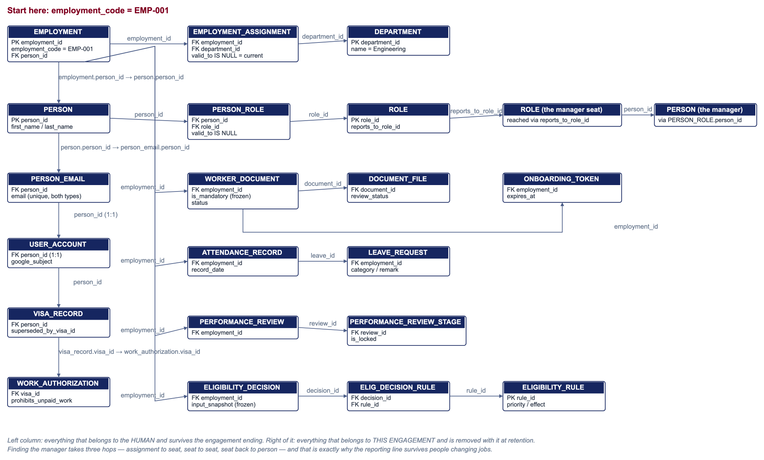

Data flow · A new worker is created
Verification-first onboarding. The sign-in account is created last, not first.
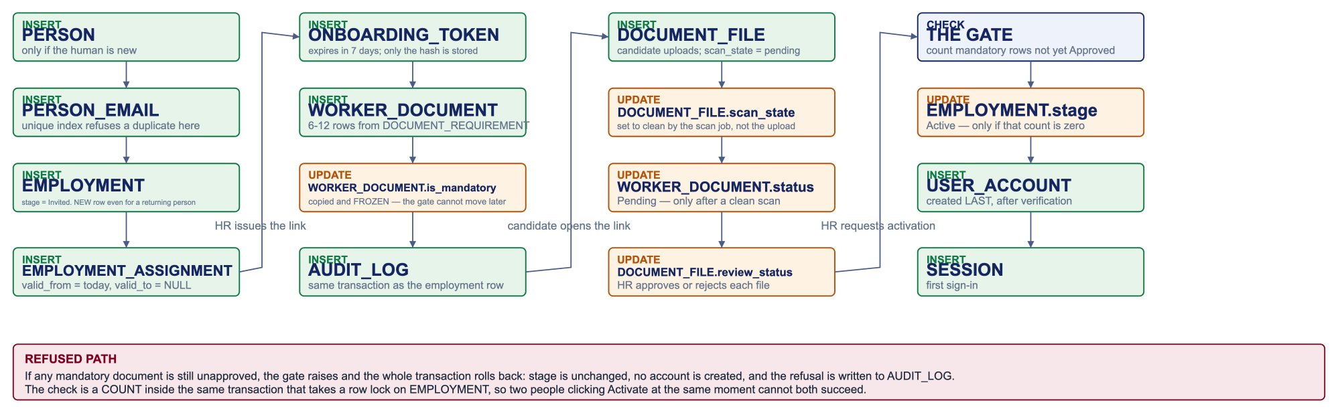

Data flow · A worker changes department
The event a flat schema gets wrong. Nothing is overwritten.
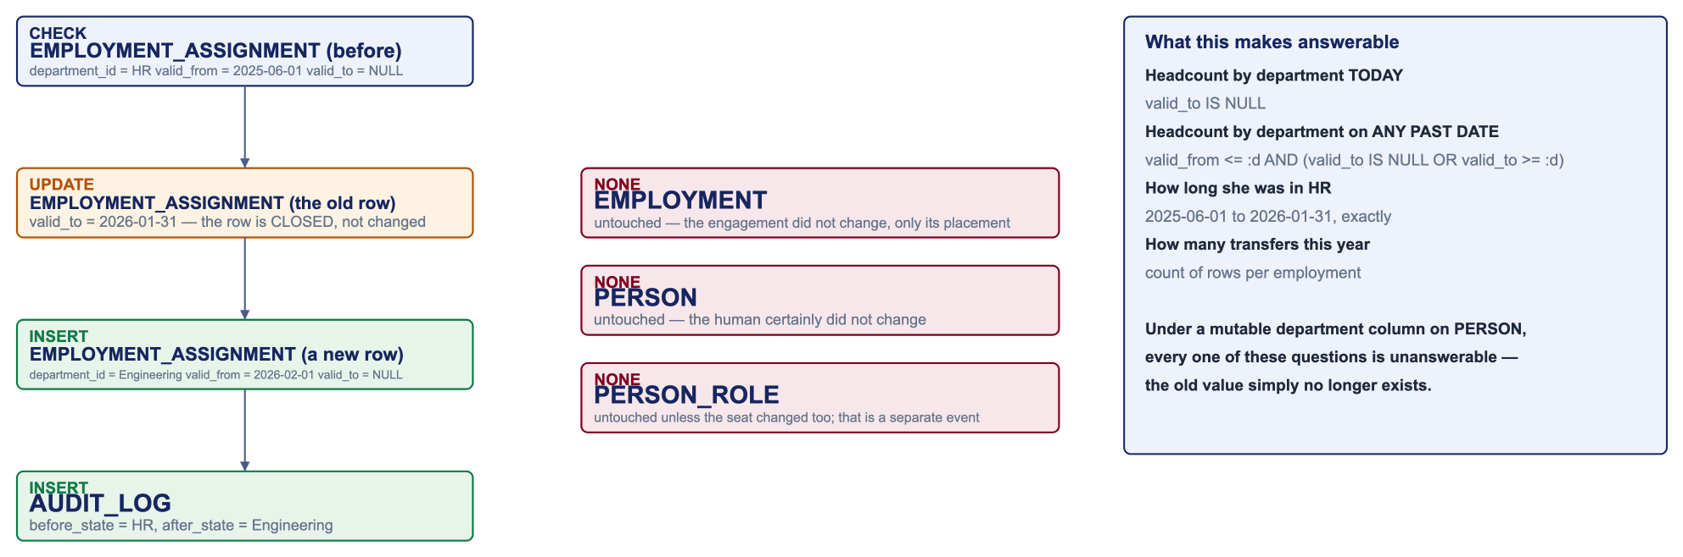

Data flow · A visa is renewed
Supersession rather than editing — and why the alert ledger must never be cleared.
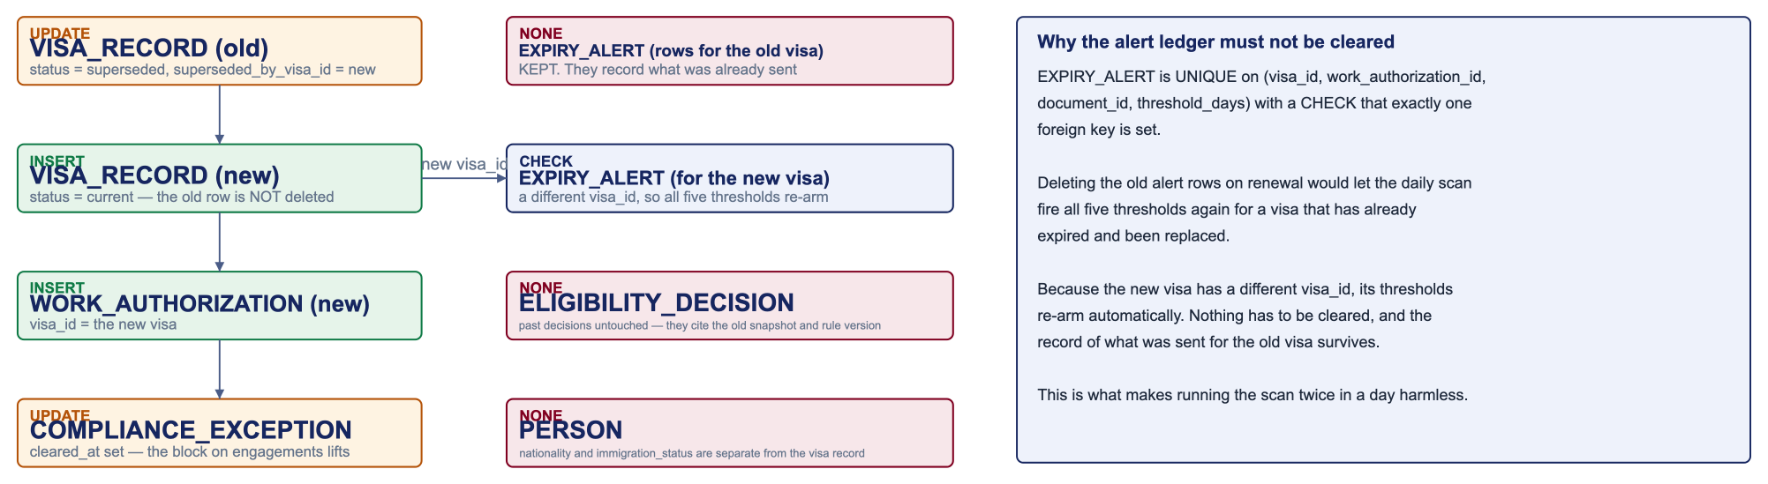

Data flow · A worker leaves
What is deactivated, what is closed, what is kept, and what retention does three years later.
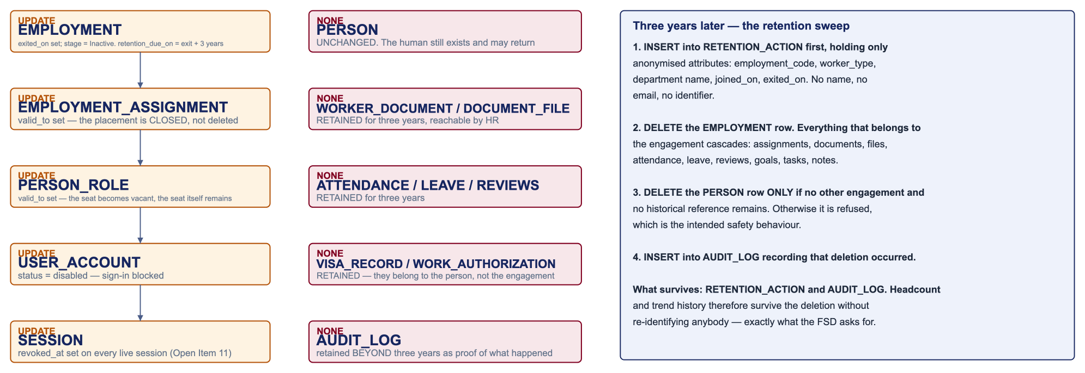

Business rules and where each is enforced
Every rule the FSD states as non-negotiable, and the database object that makes it true. Application code cannot forget these and a second code path cannot bypass them.
Rule | Enforced in | Mechanism
One email identifies one worker — case-insensitive, across both address types, org-wide | PERSON_EMAIL | UNIQUE index on lower(email). One constraint; race-free. Two columns on PERSON could not do this.
No account until every mandatory document is approved | WORKER_DOCUMENT + EMPLOYMENT | COUNT of mandatory rows not yet Approved, inside a transaction holding a row lock on EMPLOYMENT. Two simultaneous activations cannot both succeed.
One alert per record per threshold, ever | EXPIRY_ALERT | UNIQUE (visa_id, work_authorization_id, document_id, threshold_days) + CHECK that exactly one FK is set. A repeat scan inserts nothing.
One attendance record per person per day | ATTENDANCE_RECORD | UNIQUE (employment_id, record_date).
A leave day must trace to an approved request | ATTENDANCE_RECORD | leave_id required when status = leave; ON DELETE RESTRICT.
Unpaid leave requires a written reason; paid leave requires a category | LEAVE_REQUEST | CHECK on (leave_type, remark, category).
Leave balance is per category per year | LEAVE_ENTITLEMENT | UNIQUE (employment_id, category, year).
A submitted review stage is locked | PERFORMANCE_REVIEW_STAGE | is_locked per stage row, so Self locks while Team Lead stays open. A correction is a superseding round.
Review stages run Self → Team Lead → HR | PERFORMANCE_REVIEW_STAGE | The prior stage row must exist and be submitted. Checked against rows, not a status column.
Exactly one current placement, seat, visa and authorization | EMPLOYMENT_ASSIGNMENT, PERSON_ROLE, VISA_RECORD, WORK_AUTHORIZATION | Partial UNIQUE where valid_to IS NULL / status = current.
A visa or authorization is never overwritten | VISA_RECORD, WORK_AUTHORIZATION | superseded_by self-reference. Insert the new row, point the old one at it. Both retained.
A rejection must carry a reason | DOCUMENT_FILE | CHECK: rejection_reason required when review_status = Rejected.
Audit is append-only for every tier including founder | AUDIT_LOG, DOCUMENT_ACCESS_LOG, EXPIRY_ALERT | REVOKE UPDATE, DELETE from the application role. A schema note cannot make this claim; a permission can.
Access tier and Team Lead are never stored | ROLE, PERSON_ROLE | Tier read from ROLE.base_tier across all currently held seats. A seat is a team lead if another seat's reports_to_role_id points at it. Query, not column.
Reporting cycles refused before commit | ROLE.reports_to_role_id | The one rule the database cannot enforce declaratively — detecting a cycle means walking the chain. Checked inside the writing transaction.
Retention: three years after exit, aggregates survive | EMPLOYMENT, RETENTION_ACTION | retention_due_on generated from exited_on. RETENTION_ACTION is written before deletion and holds only anonymised attributes.
Department is authoritative on the engagement, not derived from the seat | EMPLOYMENT_ASSIGNMENT | Contractors and interns may sit in a department without holding a formal seat. ROLE.department_id positions the seat; the two normally match and may differ for a secondment.
Source of truth, and what is historical
For every concept: the one table that owns it, whether it holds current state or the record of what happened, and what depends on it. Nothing else may store a competing copy.
Concept | Source | Current / historical | Referenced by, or note
A human being | PERSON | Current | EMPLOYMENT, PERSON_ROLE, PERSON_EMAIL, USER_ACCOUNT, VISA_RECORD, AUDIT_LOG
An engagement | EMPLOYMENT | Historical — a re-engagement is a new row | Everything in modules 2, 4, 5, 6, 8
Current department | EMPLOYMENT_ASSIGNMENT, valid_to IS NULL | Historical — closed rows retained | Not a column on PERSON or EMPLOYMENT. This is the central correction in this design
Department history | EMPLOYMENT_ASSIGNMENT, closed rows | Historical | Same table; only valid_to distinguishes them
The department itself | DEPARTMENT | Current, soft-deleted | ROLE, EMPLOYMENT_ASSIGNMENT
A seat in the chart | ROLE | Current, soft-deleted | PERSON_ROLE, ROLE (reports_to)
Who holds a seat | PERSON_ROLE, valid_to IS NULL | Historical | A vacancy is the absence of a current row
Who reports to whom | ROLE.reports_to_role_id | Current | Open Item 4 settled: the chart is authoritative. No competing field exists
Access tier | No table — derived | n/a | Computed from ROLE.base_tier on every request
Sign-in identity | USER_ACCOUNT | Current | SESSION, ONE_TIME_CODE. One-to-one with PERSON
Email address | PERSON_EMAIL | Current | One unique index covers both types
Checklist definition | DOCUMENT_REQUIREMENT | Reference data | WORKER_DOCUMENT (is_mandatory frozen at creation)
A checklist item and its status | WORKER_DOCUMENT | Current | DOCUMENT_FILE
An upload and its decision | DOCUMENT_FILE | Historical — every version kept | DOCUMENT_ACCESS_LOG
Leave entitlement | LEAVE_ENTITLEMENT | Current per year | Balance derived from approved requests, never stored
A working day | ATTENDANCE_RECORD | Historical | The unique pair IS the one-per-day rule
Holidays | HOLIDAY_CALENDAR | Reference data | No foreign key anywhere — a lookup, not an owned record
Current visa / authorization | VISA_RECORD, WORK_AUTHORIZATION where status = current | Historical — supersession chain | WORK_AUTHORIZATION, EXPIRY_ALERT
An eligibility decision | ELIGIBILITY_DECISION | Historical — insert-only, frozen snapshot | ELIGIBILITY_DECISION_RULE
Alerts already sent | EXPIRY_ALERT | Historical — append-only | The unique constraint is the mechanism, not an optimisation
What anybody did | AUDIT_LOG | Historical — append-only | References entities by type and id, not by FK, so it outlives them
That deletion happened | RETENTION_ACTION | Historical — outlives its subject | Anonymised; no name, email or identifier
Deliberate denormalisation
Where | What | Why
WORKER_DOCUMENT.is_mandatory | Copied from DOCUMENT_REQUIREMENT and frozen at creation | So editing a requirement cannot move the activation gate under a candidate already halfway through onboarding.
EMPLOYMENT.retention_due_on | Generated from exited_on | The retention sweep becomes one indexed query, and because the database computes it, it cannot drift.
RETENTION_ACTION attributes | Department name and dates copied as text | The row must survive the deletion of everything it refers to.
AUDIT_LOG.actor_tier | Tier captured at the moment of the action | Tier is derived, so it must be frozen or the record stops being explainable later.
The design is in third normal form throughout, with the four deliberate exceptions above. Region is not stored on the engagement — it is reached through EMPLOYMENT_ASSIGNMENT to WORK_LOCATION, so it can never contradict the location. A current_department_id on EMPLOYMENT was considered and refused: it would make one query faster and destroy the history the FSD needs.
Indexes
Index | Access pattern it serves
EMPLOYMENT_ASSIGNMENT (employment_id) WHERE valid_to IS NULL | The current-placement lookup — the most frequent read in the product.
EMPLOYMENT_ASSIGNMENT (department_id, valid_from, valid_to) | Headcount by department, today and for any past date.
PERSON_ROLE (person_id) WHERE valid_to IS NULL | Tier resolution, which runs on every request. The hottest path in the system.
ROLE (reports_to_role_id) | Walking the chart for scope, and finding team leads.
WORKER_DOCUMENT (employment_id) WHERE is_mandatory AND status <> Approved | This partial index IS the set the activation gate counts.
WORKER_DOCUMENT (status) WHERE status = Pending | The HR verification queue: a small slice of a growing table.
ATTENDANCE_RECORD (employment_id, record_date) | Every attendance lookup filters on both; the unique constraint provides it.
VISA_RECORD / WORK_AUTHORIZATION (valid_to) WHERE status = current | The daily expiry scan reads only live rows.
EMPLOYMENT (retention_due_on) WHERE NOT NULL | The retention sweep, which only touches exited engagements.
AUDIT_LOG (occurred_at) and (entity_type, entity_id) | Date-range retention scans, and the per-record audit view.
Trigram on PERSON (first_name, last_name) | Directory search tolerant of misspelling; removes the need for a separate search product.
Security and sensitive data
Field or table | Class | Control | Requirement
PERSON.date_of_birth | Restricted | Excluded from directory views | FSD: held with restricted access
Visa / authorization document numbers | Identifier-class | Encrypted by the application; a deterministic hash column allows lookup without decrypting | FSD: identifiers require encryption at rest
Immigration tables | Sensitive | Founder and HR tiers only; separated from directory data | FSD: ordinary lookups must not expose sensitive fields
DOCUMENT_FILE.file_storage_key | Opaque | Carries no name, email or number, so a leaked key discloses nothing | FSD: never served from a public path
Token and one-time-code hashes | Credential | Hash only; the value itself is never stored | A database leak must not yield working links or codes
AUDIT_LOG before / after state | May contain personal data | Founder and HR only; append-only | Audit must be complete to be useful
RETENTION_ACTION | Anonymised | No name, email or identifier | Must survive deletion without re-identifying anyone
Passwords | Not stored anywhere | Google is the sole sign-in method | There is nothing to steal
Requirement coverage
Every FSD requirement and the tables that deliver it. Read the other way, every table appears here at least once — which is how we know none is speculative.
Functional requirement | Tables
Google sign-in, domain and verified checks | USER_ACCOUNT, SESSION, AUDIT_LOG
Access derived from the org chart | PERSON_ROLE, ROLE, DEPARTMENT
Employee records, profiles and placement history | PERSON, PERSON_EMAIL, EMPLOYMENT, EMPLOYMENT_ASSIGNMENT, WORK_LOCATION
Duplicate email prevention | PERSON_EMAIL
Document checklist, verification and access logging | DOCUMENT_REQUIREMENT, WORKER_DOCUMENT, DOCUMENT_FILE, DOCUMENT_ACCESS_LOG
Account-creation gate | WORKER_DOCUMENT, EMPLOYMENT, USER_ACCOUNT, AUDIT_LOG
Seven-day tokenized onboarding link | ONBOARDING_TOKEN
Attendance, clock in/out, holidays | ATTENDANCE_RECORD, HOLIDAY_CALENDAR
Leave requests, categories, balances | LEAVE_REQUEST, LEAVE_ENTITLEMENT
Monthly reviews and 30/60/90 milestones | PERFORMANCE_REVIEW, PERFORMANCE_REVIEW_STAGE, MILESTONE_REVIEW
Tasks, goals, notebook | TASK, GOAL, NOTE
Immigration status, visas, right to work | PERSON, VISA_RECORD, WORK_AUTHORIZATION, COMPLIANCE_EXCEPTION
Eligibility engine and reproducible decisions | ELIGIBILITY_RULE, ELIGIBILITY_DECISION, ELIGIBILITY_DECISION_RULE
Expiry alerting at 90/60/30/7/0 days | EXPIRY_ALERT, VISA_RECORD, WORK_AUTHORIZATION, WORKER_DOCUMENT
One-time codes and step-up verification | ONE_TIME_CODE, ELIGIBILITY_DECISION
Structural audit log and export logging | AUDIT_LOG, DATA_EXPORT_LOG
Migration cleansing and reconciliation | MIGRATION_BATCH
Retention, deletion and surviving aggregates | EMPLOYMENT, RETENTION_ACTION
Employee handbook | No table — authored content versioned with the code
FSD open items
Only the items where the schema encodes an assumption or is deliberately built to stay neutral until the decision lands.
Item | Open item | How the schema handles it
1 | Which role model is authoritative | ROLE.base_tier holds the tiers; Team Lead is computed. Needs the values confirmed, not a schema change.
3 | Where documents live | file_storage_key is opaque — only the stored value changes.
4 | Manager: team-lead field or org chart | Settled: ROLE.reports_to_role_id is the one answer. No competing field exists.
5 | Eligibility default when no rule matches | A catch-all lowest-priority rule. The engine always finds a match.
8 | Monthly versus milestone reviews | Separate tables, so the schema forces no answer.
9 | Onboarding link expiry behaviour | reissued_from_token_id already gives a reissue trail either way.
11 | Does deactivation revoke sessions | USER_ACCOUNT.status and SESSION.revoked_at both exist for this.
18 | Is the "documents submitted" stage intended | EMPLOYMENT.stage is a plain enumeration; dropping a value is one line.
19 | Migration source and validation | MIGRATION_BATCH records source, counts and HR sign-off.
21 | Which tiers may export what | DATA_EXPORT_LOG records every export; access rules layer on top.
22 | Paid leave entitlements | Three columns deliberately left null until HR sets them.
23 | Holiday calendar ownership | Rows per region. Structure settled, content and owner are not.
Decisions needed before build
# | Question | Why it matters | Owner
1 | Approve the split of PERSON from EMPLOYMENT | The central structural decision — everything else follows from it. | Akshat Mishra + Ashish Katyayan
2 | Approve effective dating on EMPLOYMENT_ASSIGNMENT and PERSON_ROLE | Confirms department and role history are preserved, not overwritten. | Akshat Mishra
3 | May a person hold two concurrent engagements | Sequential re-engagement is allowed; overlap is currently unconstrained. One exclusion constraint settles it. | Akshat Mishra
4 | Is designation on the engagement or the seat | EMPLOYMENT.designation and ROLE.title both exist and may legitimately differ. | Akshat Mishra
5 | Confirm the tier list (Open Item 1) | Mechanism is fixed; the values are not. | Akshat Mishra
6 | Set leave entitlements (Open Item 22) | Three columns are waiting. | Akshat Mishra
7 | Confirm retention period and identifier-class field list (Open Item 12) | Needs legal input for India and US. | Ashish Katyayan
Approval
Role | Name | Decision | Date
Functional owner | Akshat Mishra | Pending
Technical owner | Aayushi Pandey | Pending
HR / Process owner | Akshat Mishra | Pending
Project sponsor | Ashish Katyayan | Pending

