**E/19/129**

**K.H. Gunawardana**

**CO543 – Image Processing – Lab 1**

**Implement basic image processing functions using Python-OpenCV**

* Resizing

* Rotation

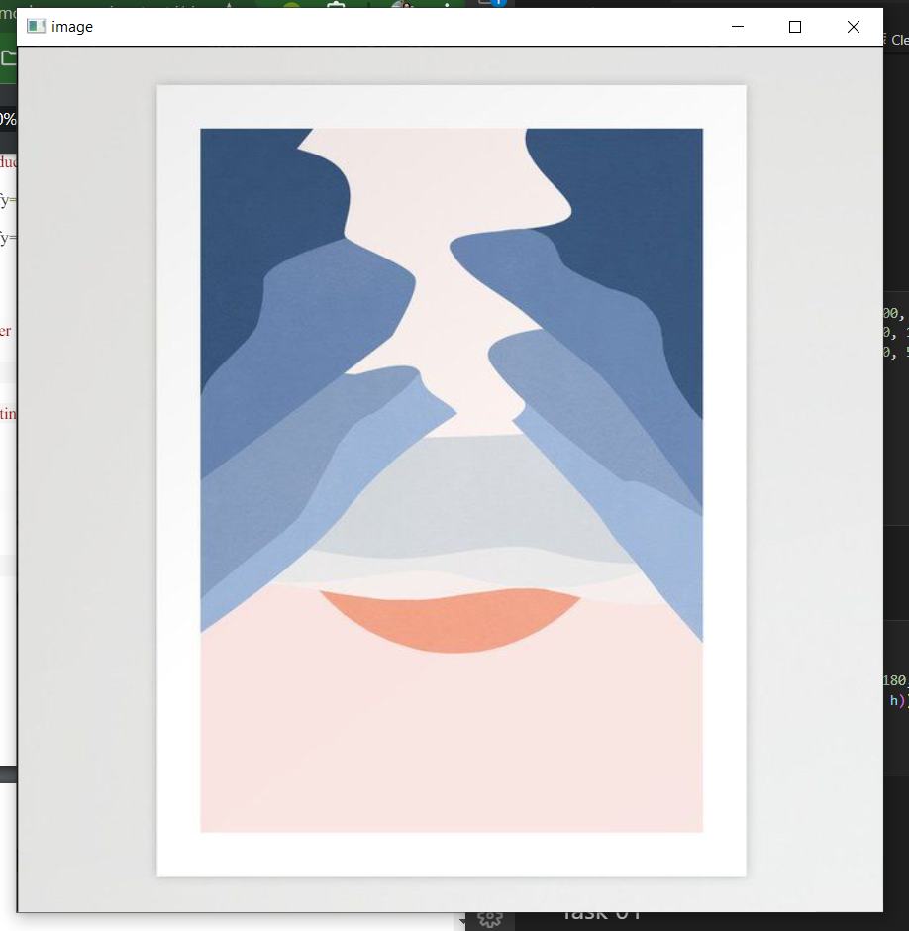

* Cropping

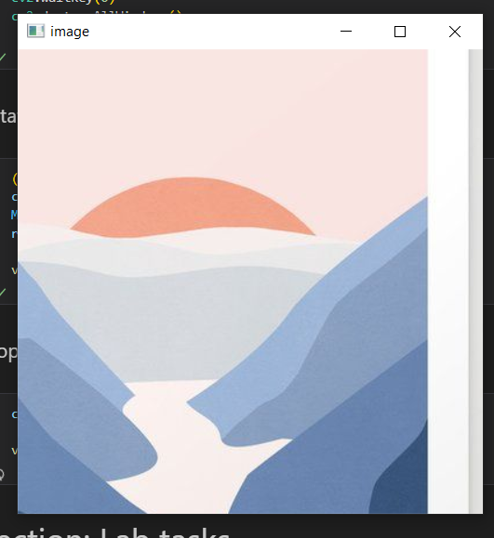

* Complementing

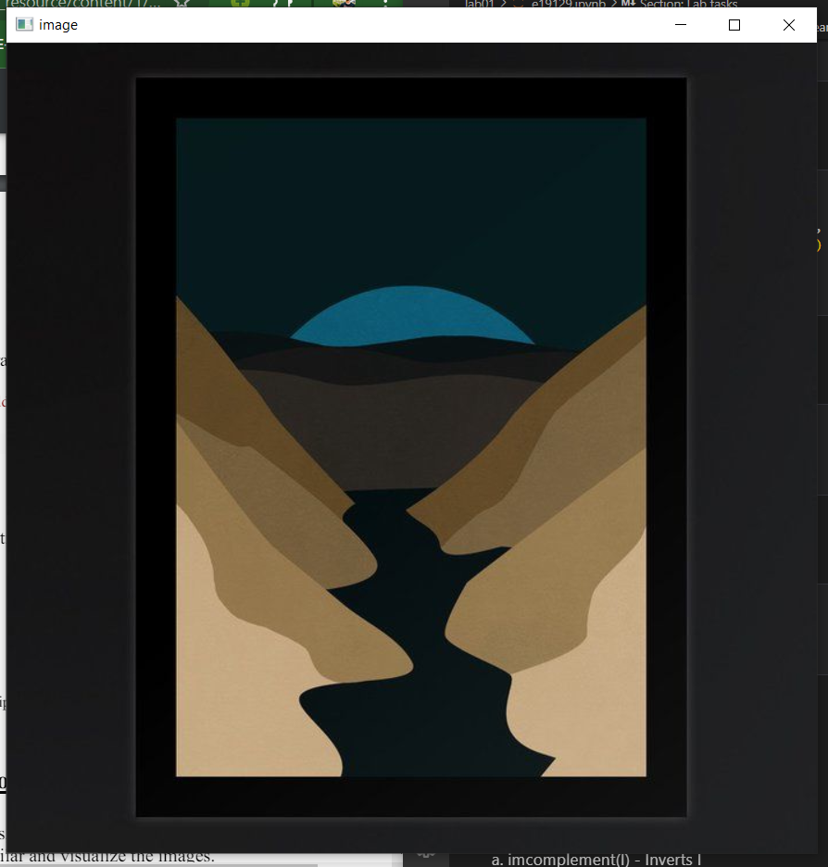

* Flipping an image

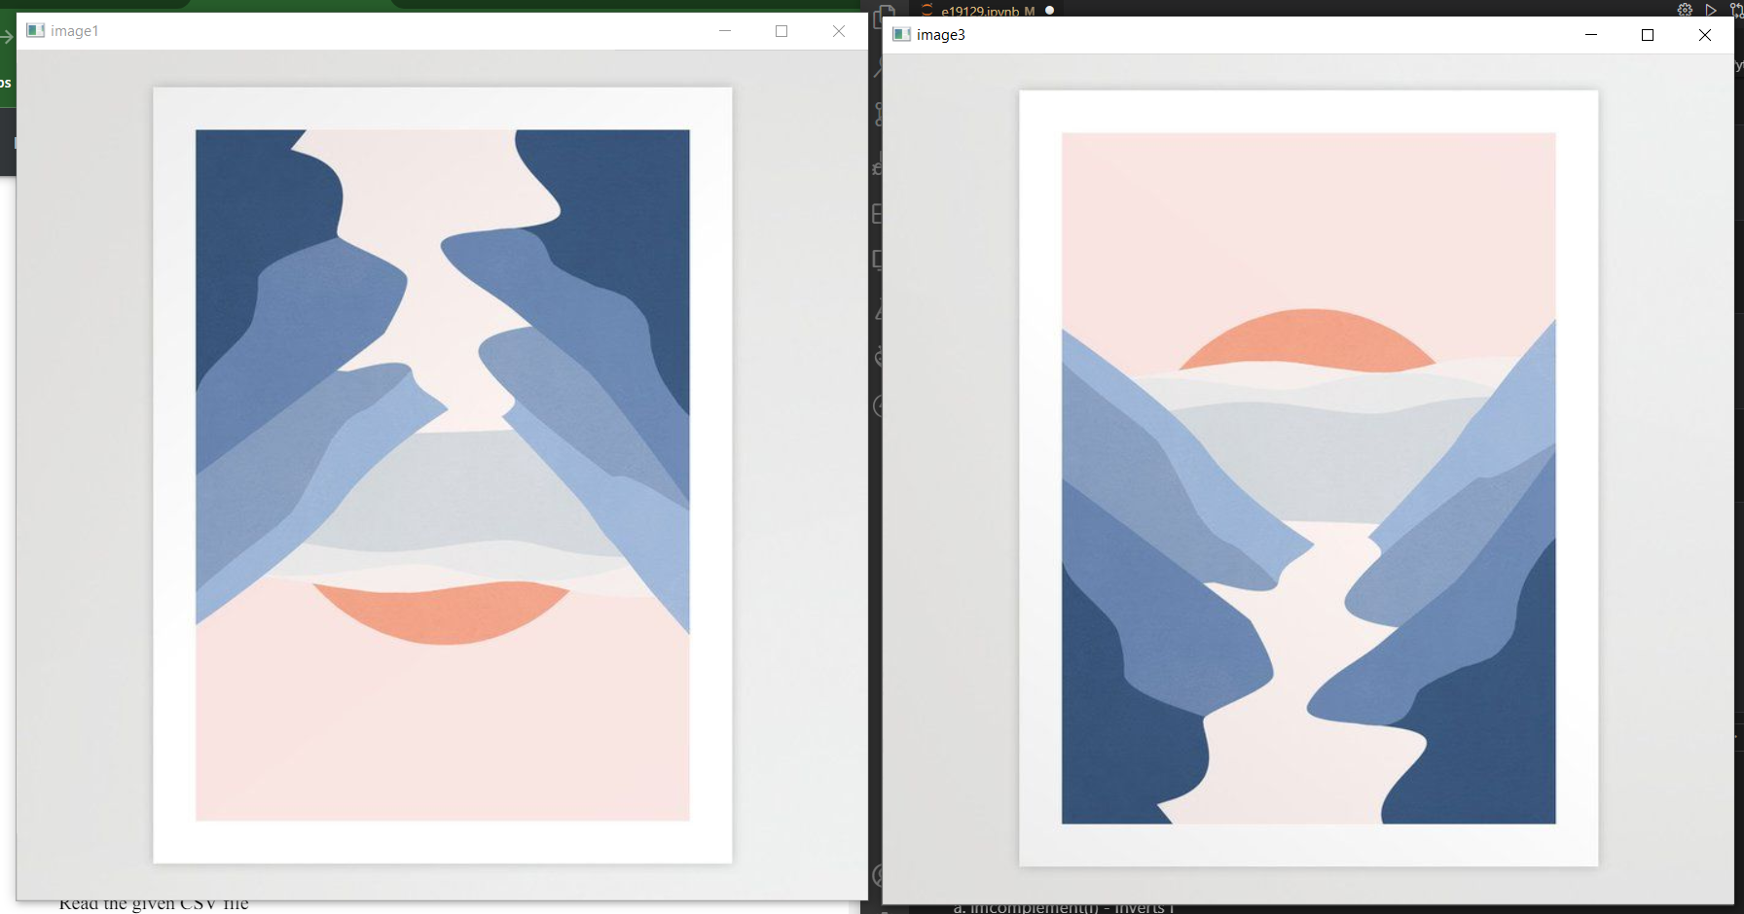

**Task 01**

**Implement the following functions on your own using PythonOpenCV.**

1. imcomplement(I) - Inverts I

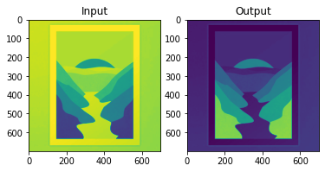

1. flipud(I) - Flips image along x-axis

1. fliplr(I) - Flips image along y-axis

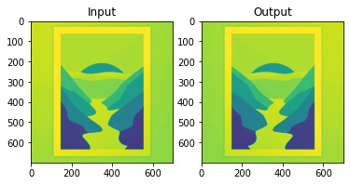

1. imresize(I,[x y]) with nearest-neighbour interpolation

**Task 02**

**Implement the 4 geometric transformation functions using OpenCV in addition to the given example.**

* Translation

* Shearing - Horizontal

* Shearing – Vertical

* Scaling

