Organisation Name
Mutumane Kota and Grilled Chicken
Category
Small Business
What is the organisation about
Mutumane Kota and Grilled Chicken is a local fast-food eatery specializing in traditional South African street food and flame-grilled meat
A brief history of the Organisation
​Smokey Springs Kota & Chicken Grill started in 2018 as a humble weekend street stall, where founder Thabo Molefe prepared flame-grilled chicken and stuffed kotas on a simple drum braai outside his home. Strong word-of-mouth and steady demand allowed the business to open its first permanent takeaway shop near a busy transport hub in 2020 via Philip in Soshanguve. To keep up with orders from nearby office workers and residents, the shop launched a local phone-and-scooter delivery service in 2023. Today, Smokey Springs is a popular neighborhood staple, but its reliance on phone calls and WhatsApp for delivery orders causes bottlenecking during peak hours, creating a strong need for an online ordering website.
Vision Statement
To become the leading township-style fast-food brand in the region, celebrated for authentic flame-grilled flavours, reliable neighbourhood delivery, and accessible daily meals
Mission Statement
To serve fresh, high-quality kotas and flame-grilled chicken efficiently and affordably, leveraging convenient online ordering and reliable local delivery to feed our community with speed and pride.
​Website Goals
- ​Drive Direct Delivery Sales: Enable online menu customization, delivery radius selection, and instant order placement to increase total meal volume.
- ​Streamline Operations: Reduce phone line congestion and order errors during peak lunch/dinner hours by shifting orders to a digital queue.
- ​Increase Brand Visibility: Establish a professional web presence that attracts nearby workers, students, and residents searching online for local fast food.
Target audience
Students, local workforce, neighborhood families, and fast-food enthusiasts looking for affordable, filling, and convenient meals.
Students, local workforce, neighborhood families, and fast-food enthusiasts looking for affordable, filling, and convenient meals.
Functionalities and features
Customer Features
- Interactive customization menu
It will enable users to select items and customize toppings and sides
- Delivery Request Form
Users input exact delivery address details, landmark notes and contacts phone numbers for the driver
- Real time order tracking
Displays live order status updates (Request Received, Preparing in kitchen, out for delivery)
Kitchen Features (Order Management on a Tablet)
- Live order queue on the Tablet
Displays a digital list of incoming orders with a clear item breakdown of incoming orders and customization notes
- Instant Order Accept/ Reject
Confirmation to accept incoming orders or pause incoming orders when the kitchen reaches full capacity
- Status progress control
This will allow the staff to update order statuses (e.g. “In kitchen”, “Ready for Dispatch”)
Design and User Experience
- Colour Scheme: Warm charcoal Gray (#1E1E1E), fiery orange (#E65100), and warm yellow (#FFB300) will be used to create a bold, energetic design inspired by Kota and flame-grilled chicken street food.
- Typography: Poppins will be used for headings and menu titles, while Inter will be used for body text, descriptions, prices, and navigation to ensure readability across mobile and desktop devices.
- Layout and Design: The website will use a modern, mobile-first layout with a large landing-page hero section, clear food categories, menu cards, and prominent Order Now button. The design will use high-contrast colours, large touch-friendly buttons, and responsive layouts.
- User Experience Considerations: The website will provide simple navigation through Home, Menu, Orders, About Us, Contact, and Cart. Customers will be able to browse food, add items to their cart, complete a simple checkout process, and view their order status. The ordering process will be designed to require minimal steps.
- Low-Fidelity Wireframes: Low-fidelity wireframes will be developed to visualise the website's layout and information hierarchy, including the Landing Page, Menu Page, Cart and Checkout, and Orders Page.

Landing page/Home page
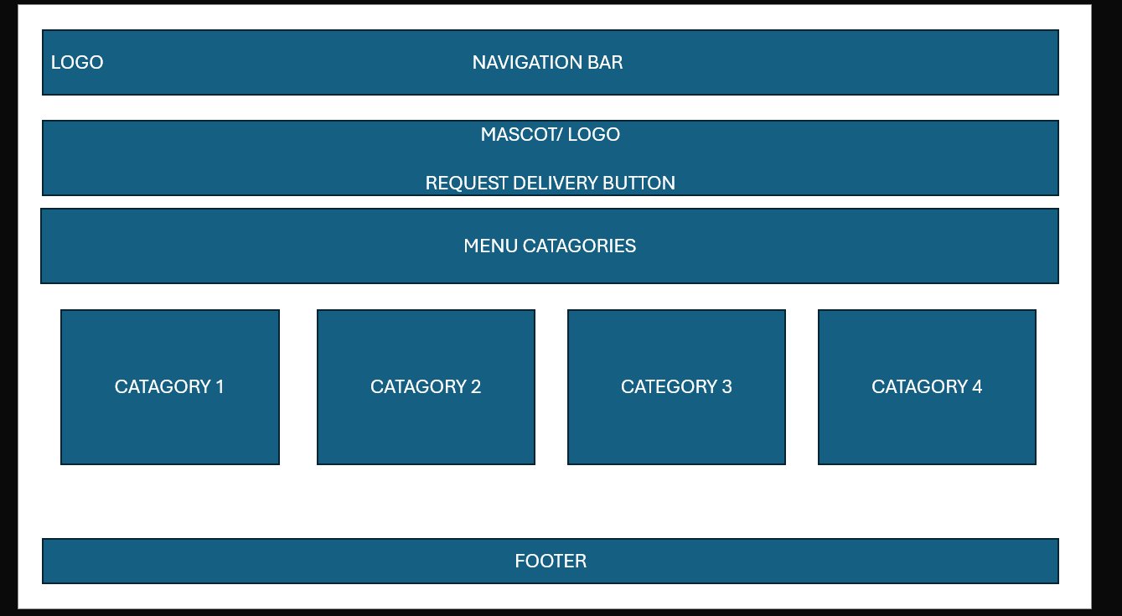

Menu Page
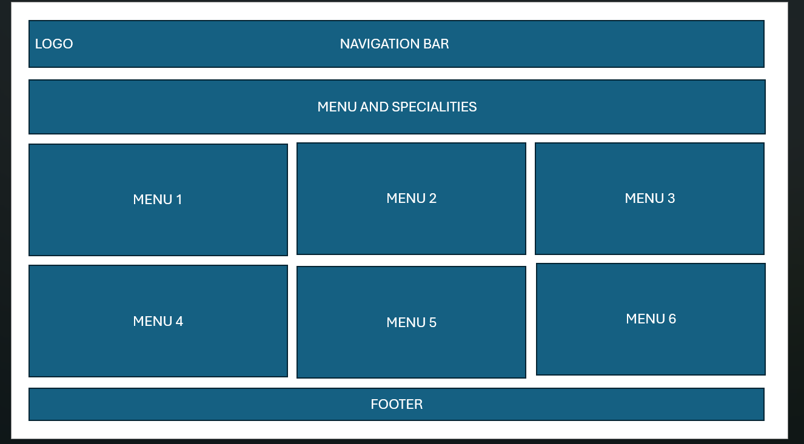

Order Page
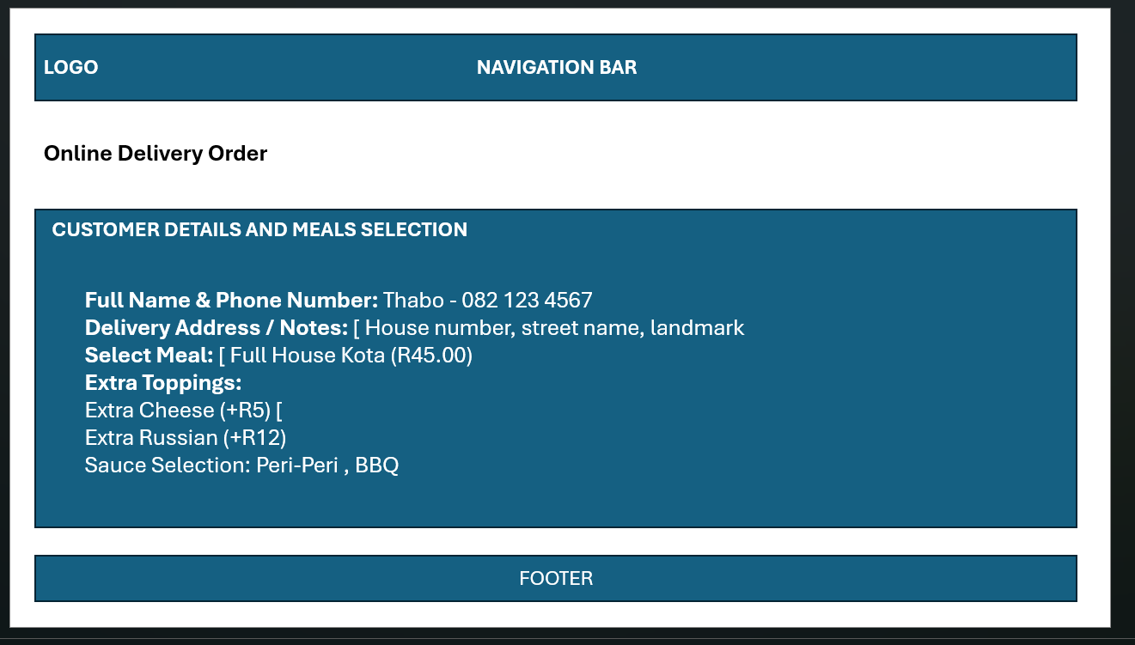

About Page
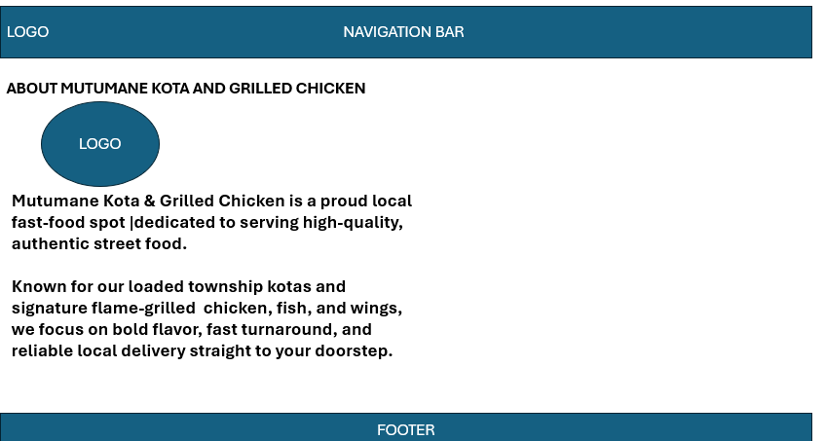

Enquiry Page

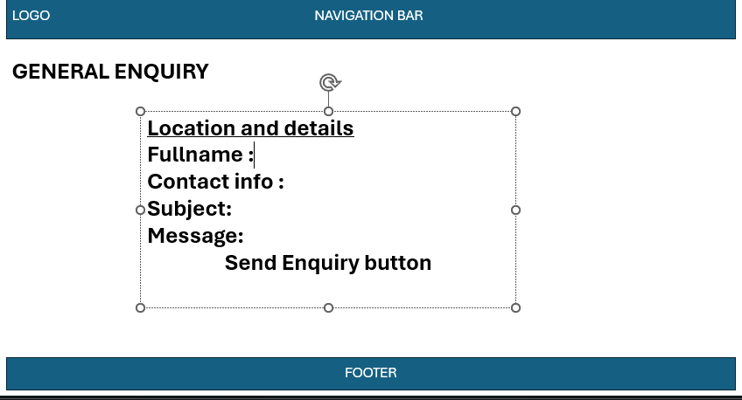

Contact Page
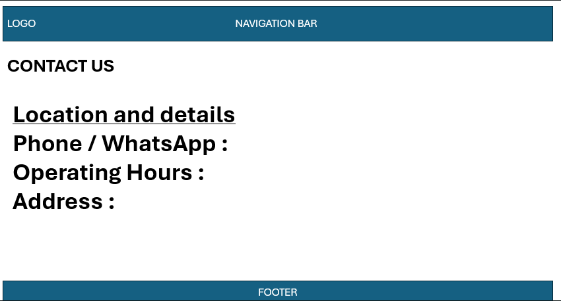

Technical requirements
- Hosting and domain
Custom domain registration (mutumanekota.co.za)
- Frontend
- HTML5
- CSS3
- JavaScript
- Backend
Firebase Firestore for real-time database
Timeline and Milestones
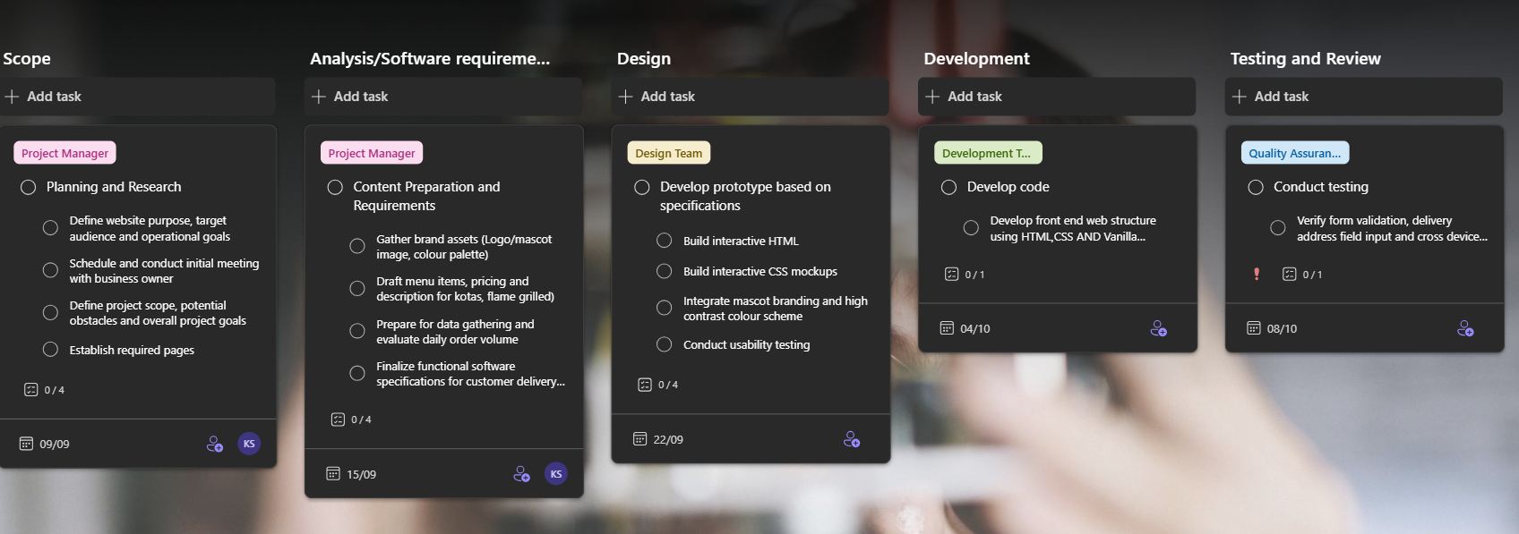
Budget
Category | Description | Billing Cycle | Cost
Domain Registration | Registration for mutumane.co.za | Annual | R89-R100
Database and Realtime Queue | Firebase Realtime Database (1GB storage,10 GB/mo transfer) | Free Tier | R0.00
Hardware Setup | Entry-level Android tablet for kitchen display queue (if needed) | Once-off | R1,200-R1,800
Development and design | Internal project build (HTML, CSS, JS, Firebase integration) | Once-off | R1,500
TOTAL |  |  | R2,800-R3,000

References
Website Structure and Planning
Sitemap
- Homepage (index.html): Features the brand logo and mascot graphic, main headline ("Flame-Grilled Flavor & Loaded Kotas"), primary "Request Delivery" CTA button, and sticky top navigation menu linking to all sections.
- About Us (about.html): Highlights Mutumane's local history, brand story, food passion, kitchen hygiene promise, and community involvement.
- Menu/Products (menu.html): Categorized menu offerings detailing loaded Kotas, flame-grilled chicken meals, fish, wings, pricing, and custom toppings/basting options.
- Online Orders (orders.html): Interactive delivery request form capturing customer name, contact details, delivery address notes, item selections, and live status updates synced directly to the kitchen queue.
- Enquiry (enquiry.html): Form for general customer questions, feedback, catering requests, or event bookings.
- Contact (contact.html): Displays kitchen contact numbers, operating hours, delivery zone radius, embedded map coordinates, and multiple physical location points (e.g., Main Kitchen Hub & Pop-Up Event Stall)

