MIDSEM ASSIGNMENTS

Assignment_1(b)

Developing and Deploying a Node.js app from Docker to Kubernetes

From,
TEAM_4
(Darshan R P(18bcs023)
Neha Mahindrakar(18bec032)
Kavana S Salunkhe(18bcs039)
Sreehari Premkumar(18bec045)
Palshini B Limbani(18bcs062)
Pavan Kumar (18bcs064)
Raghuprasad J N(18bcs073)
Sripathi Kalyan(18bcs084))

To,
Dr.Uma Sheshadri
Professor,CSE(HOD)

1.Creating Node.js app

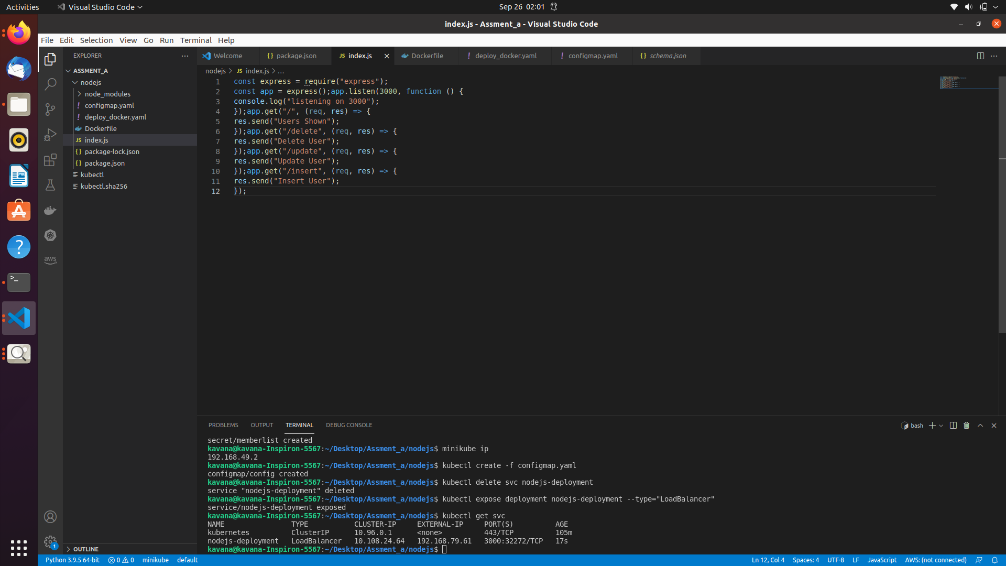
2.Package.json(containing project details and dependencies)
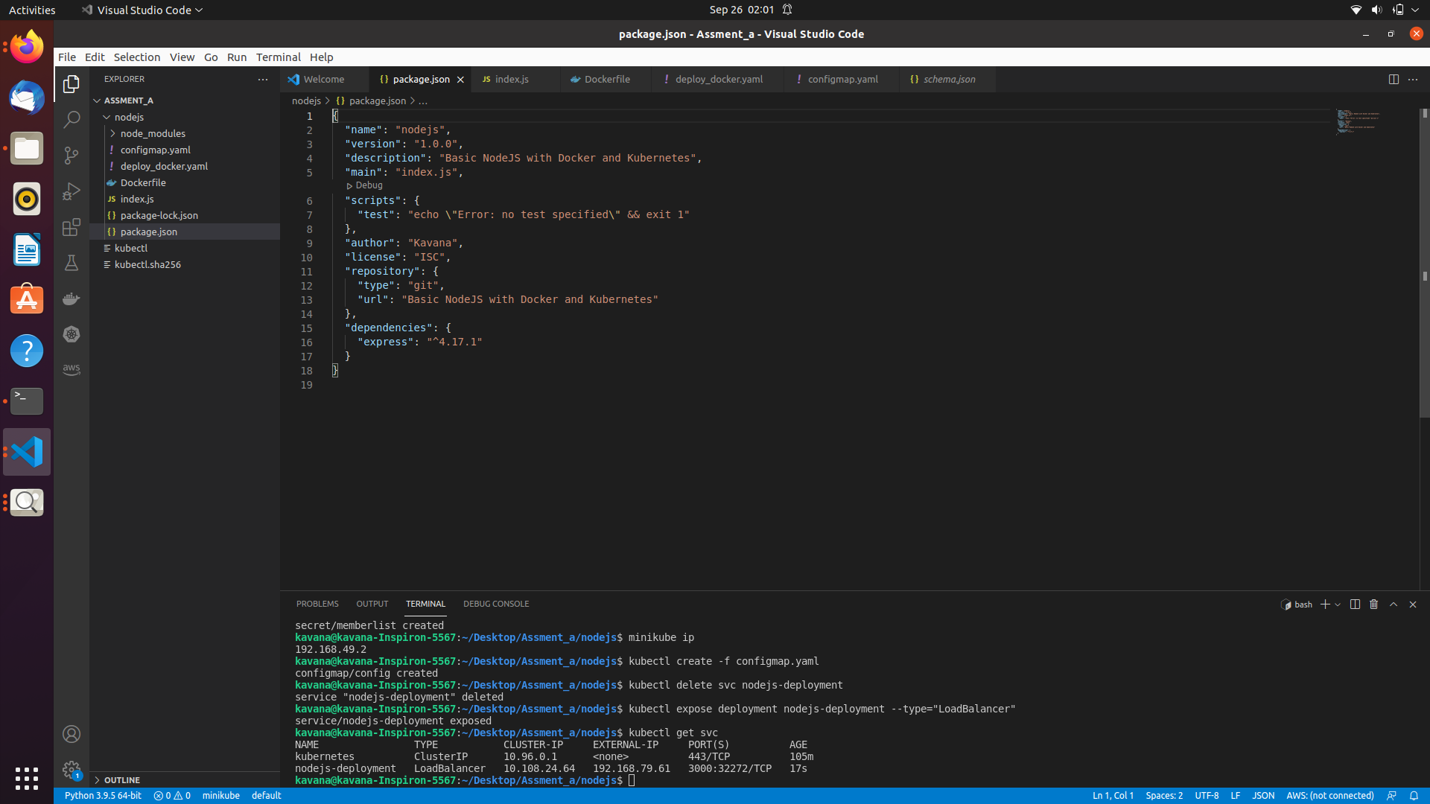

3. Test Node.js app (on local host)

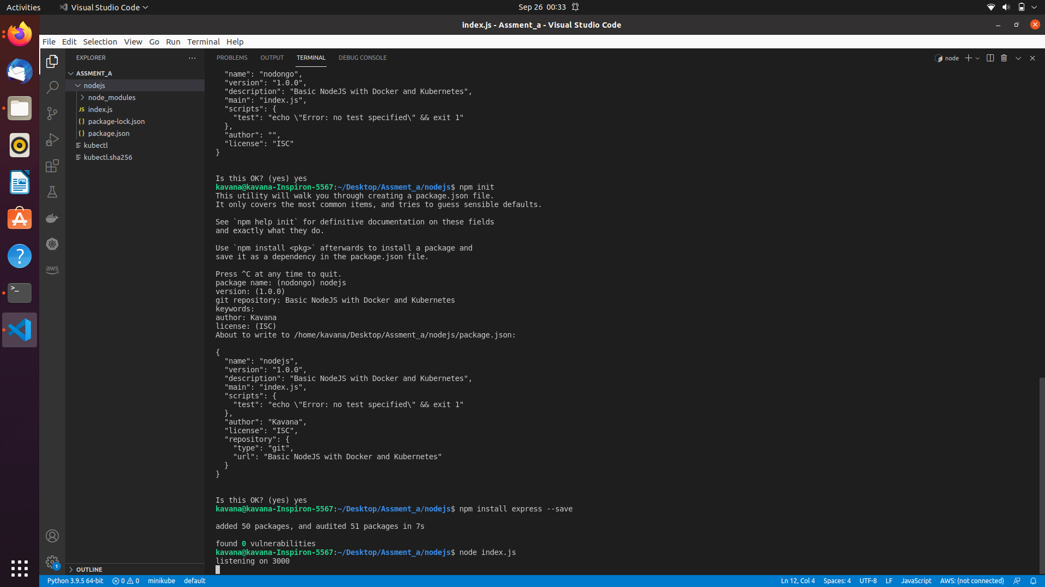
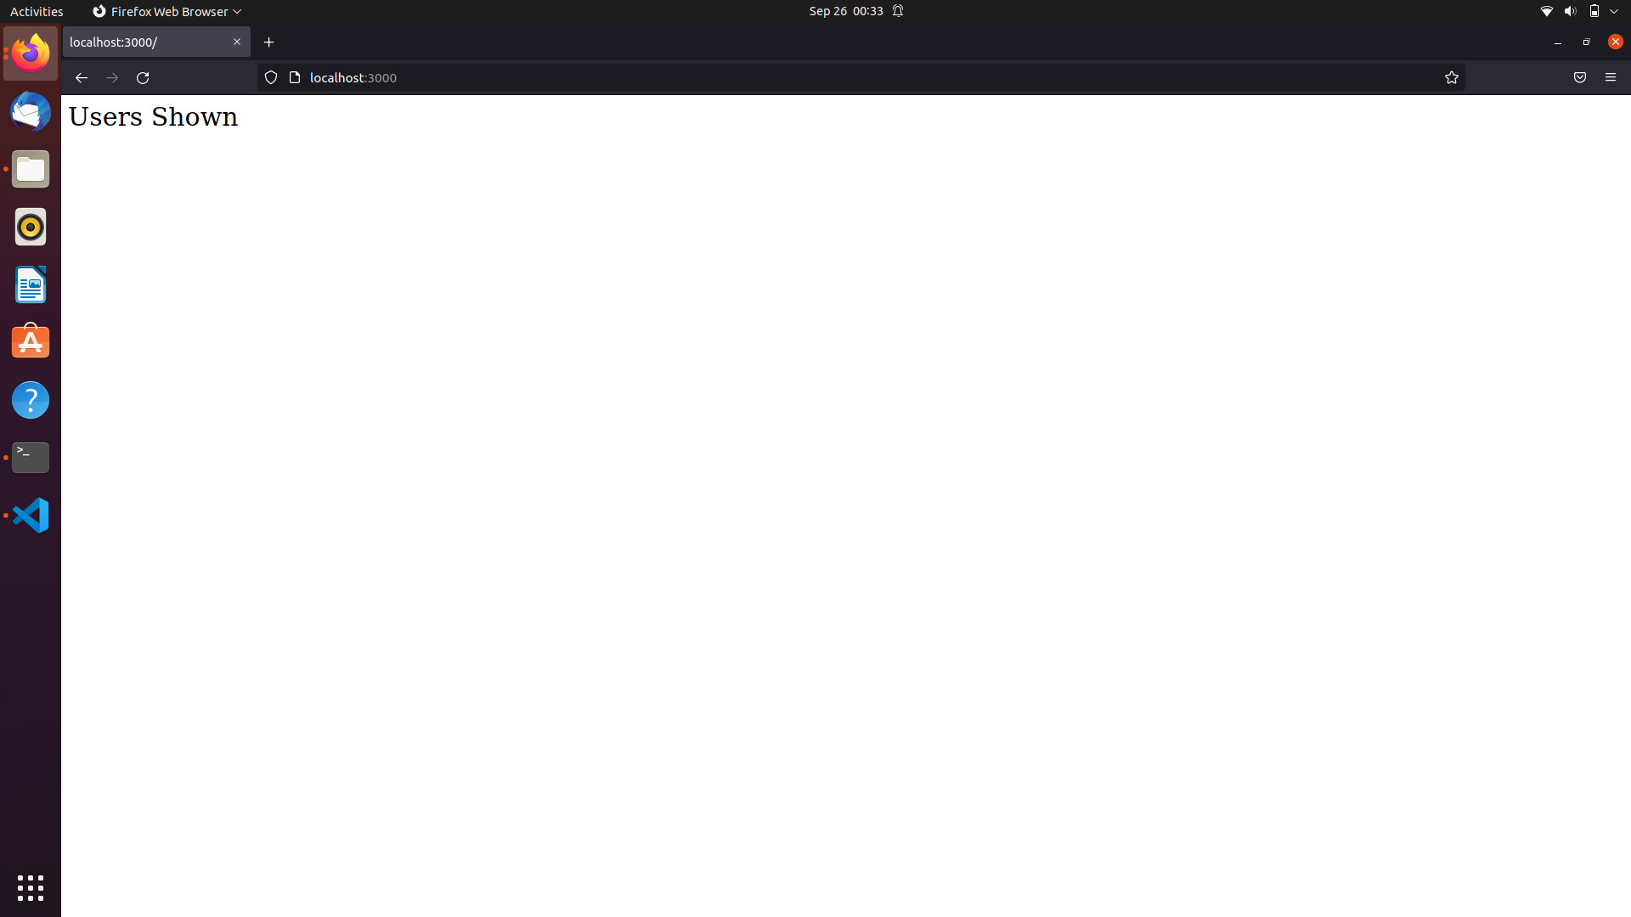
4.Dockerising node server creating a dockerfile
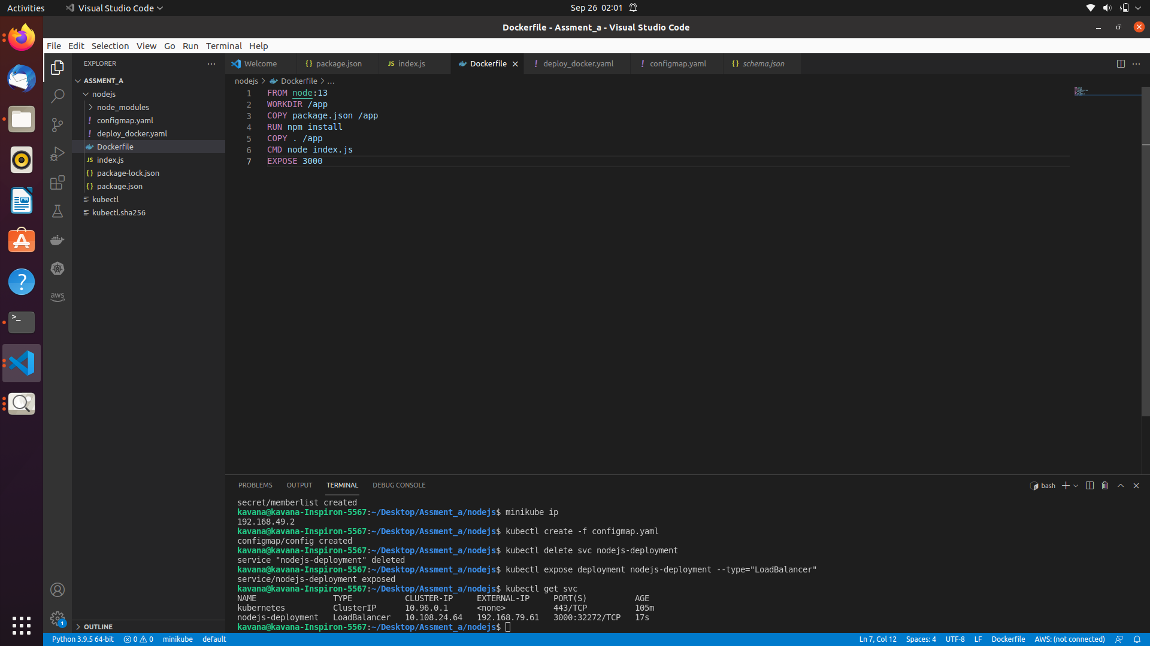
5.Building our image dockerfile and ,Creating and running the container
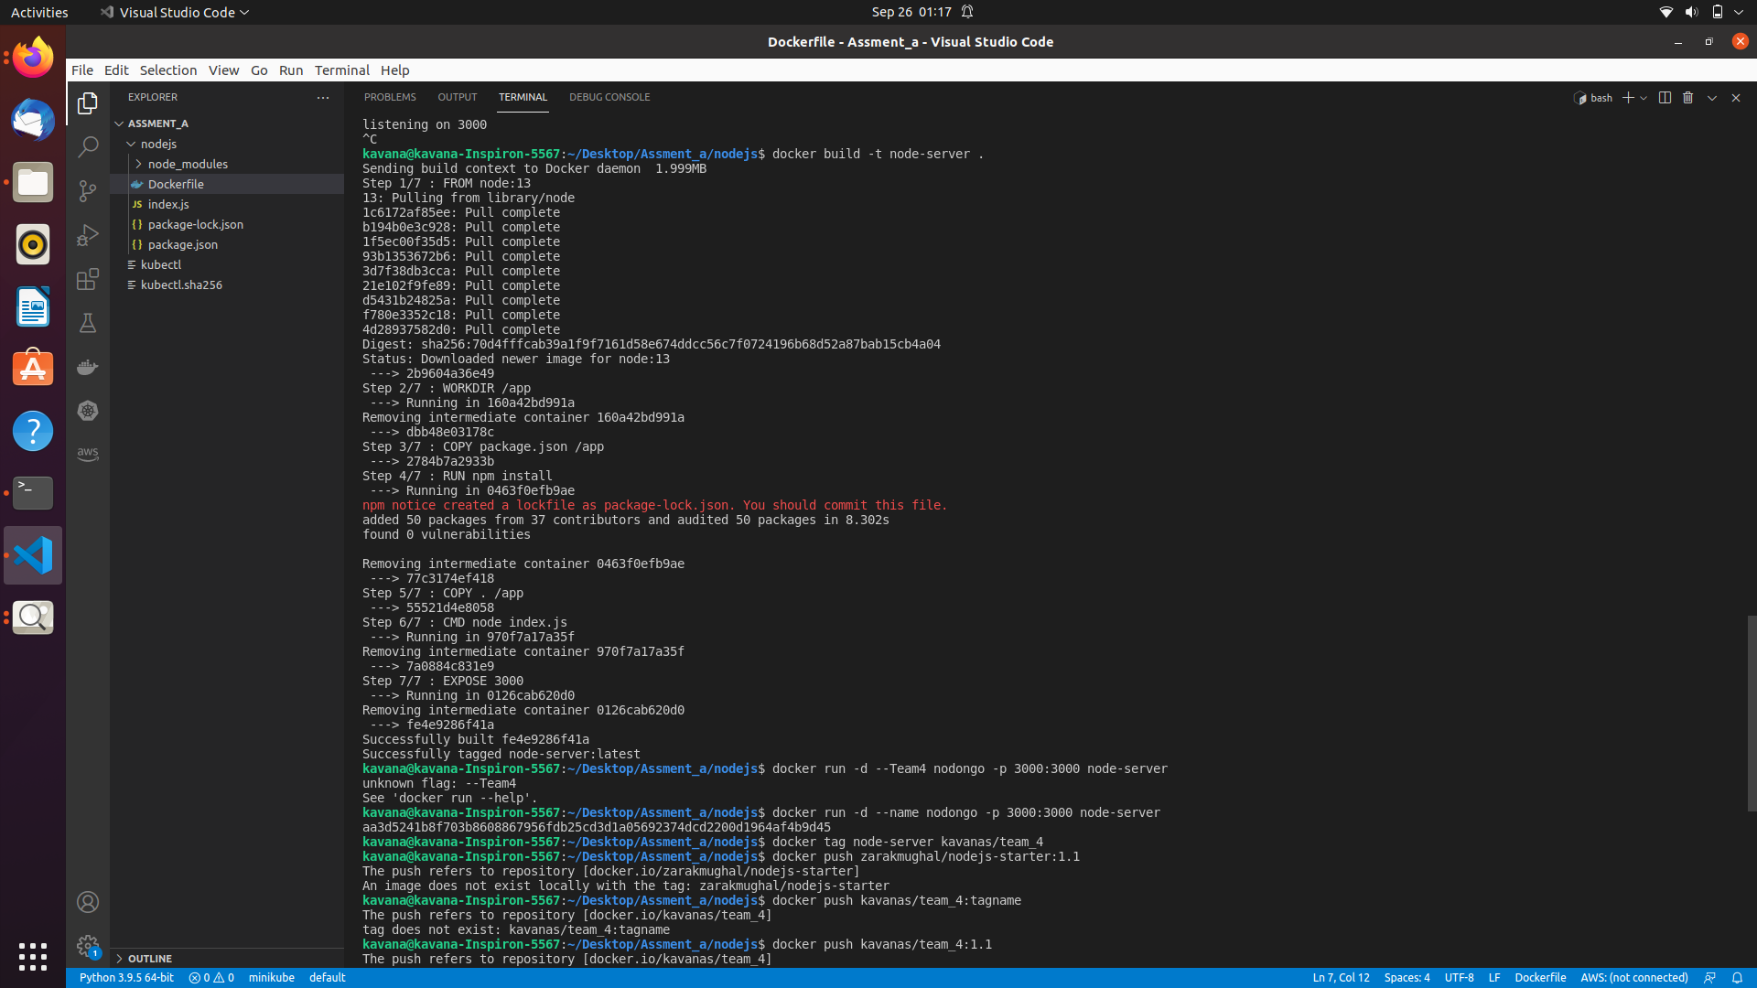

6.Uploading The Image To Docker Registry Docker Hub

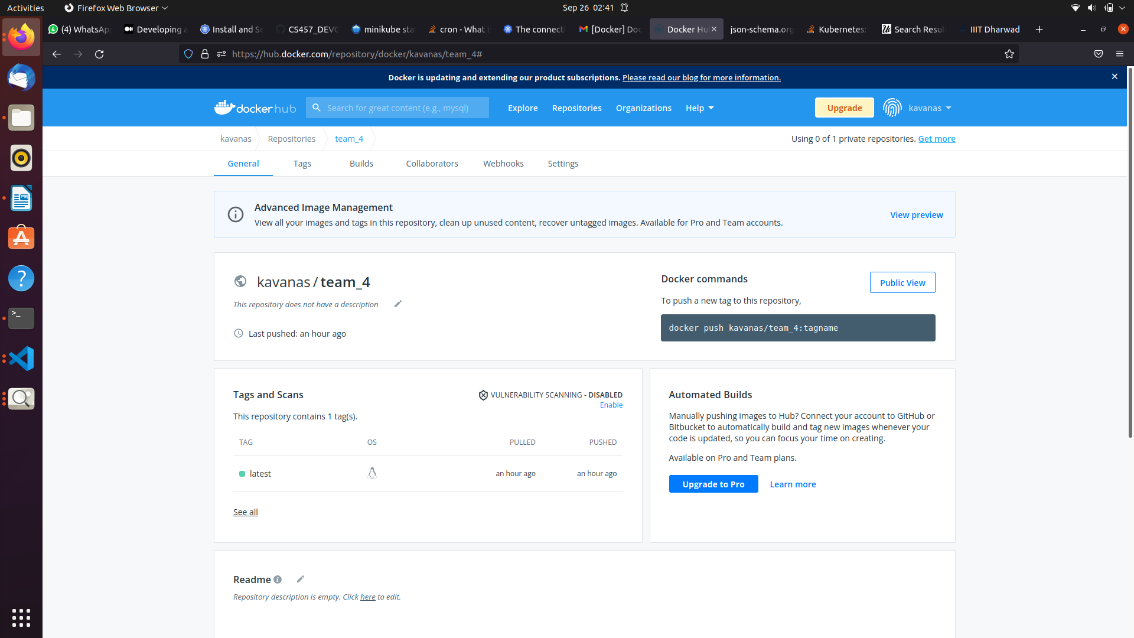
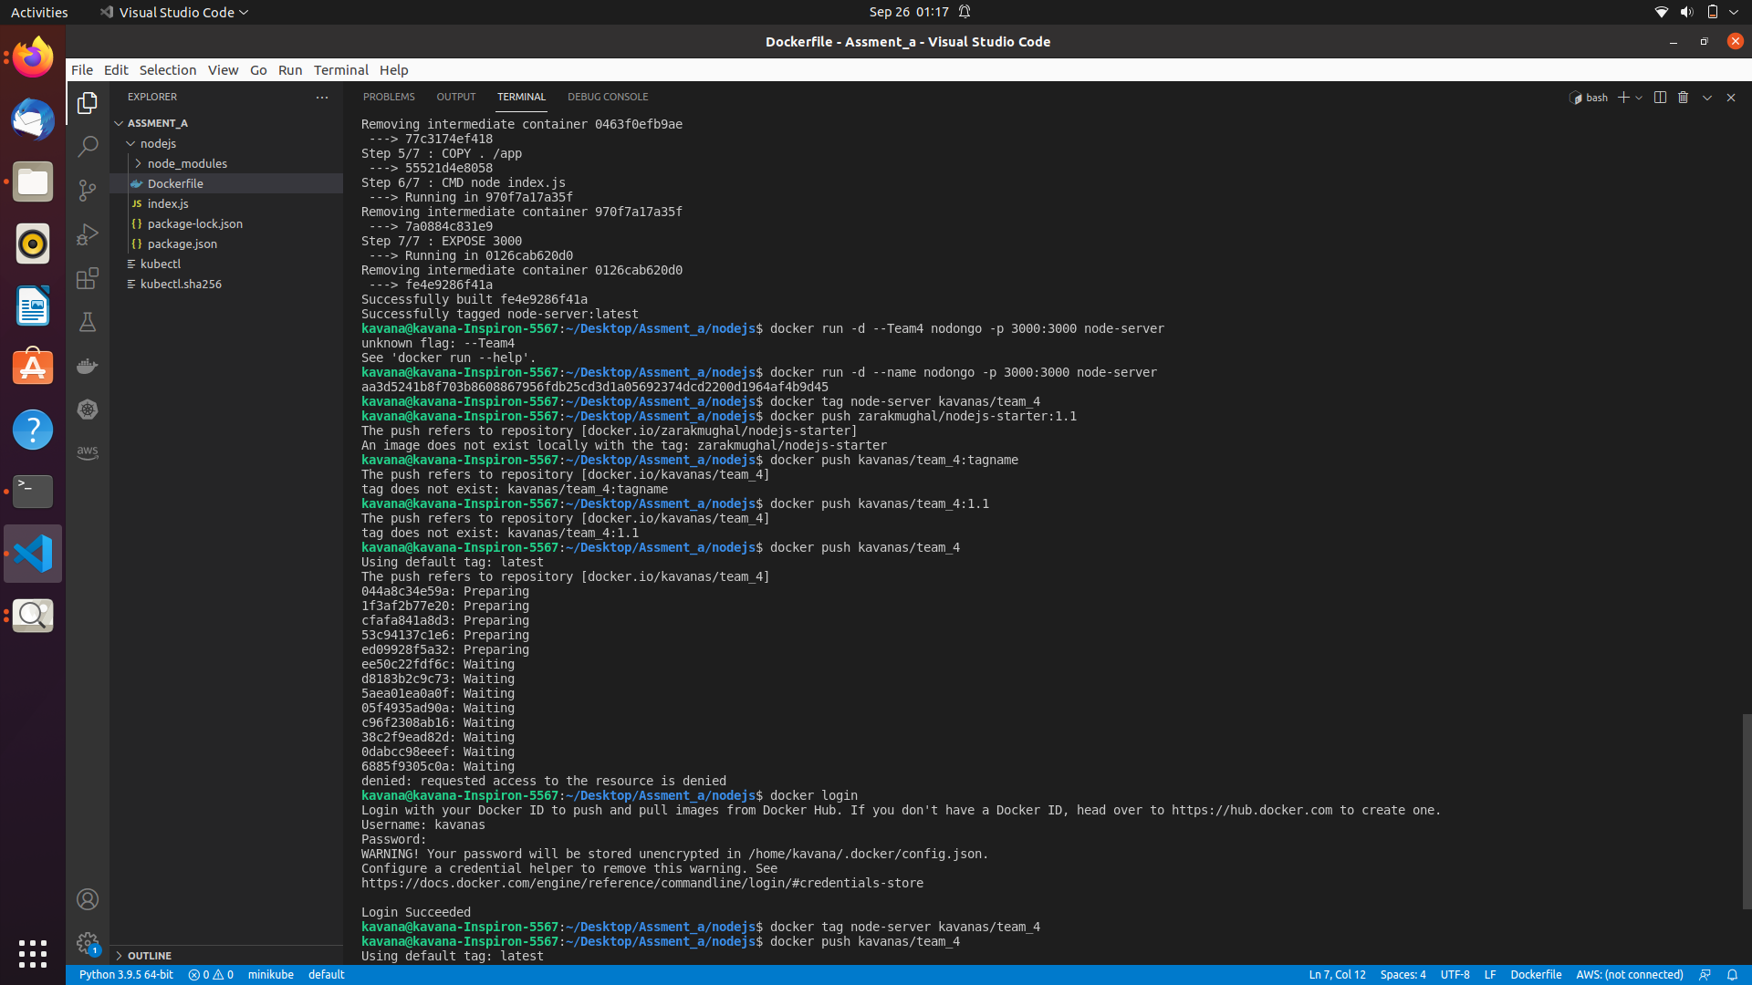

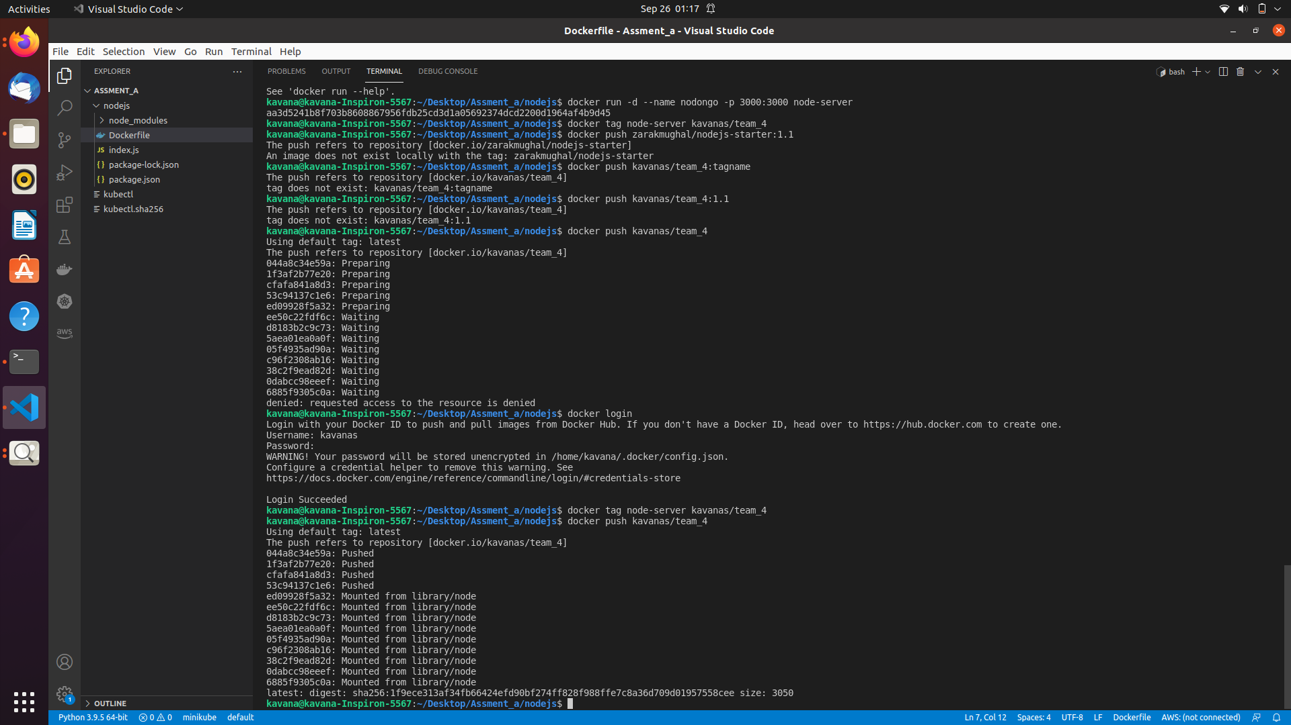
7.Starting The Kubernetes Cluster
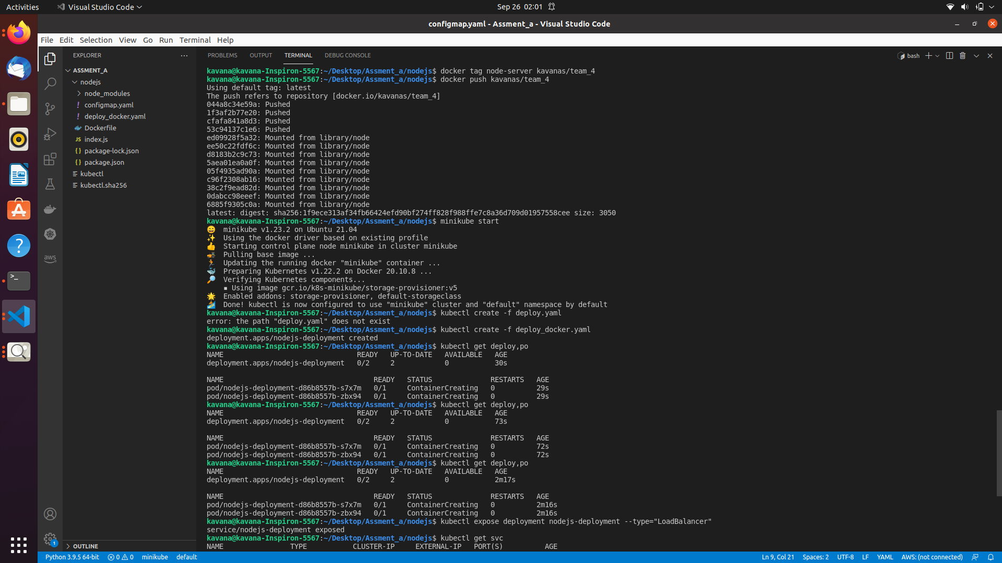
8.Writing yaml file to deploy into kubernete cluster

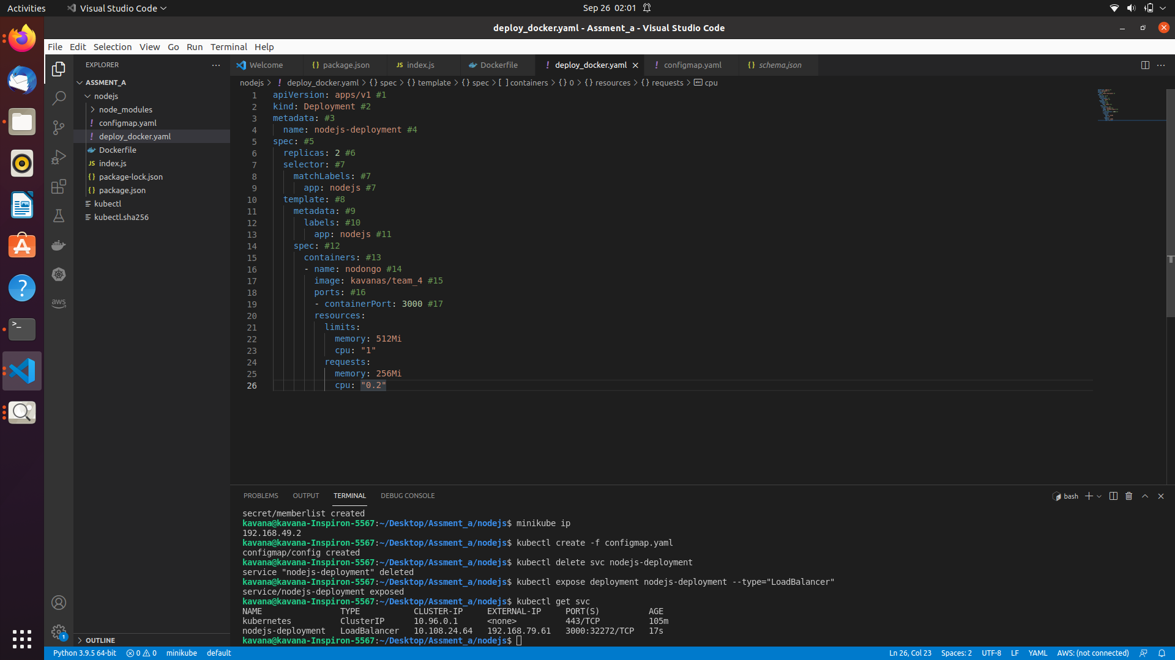

9.Exposing deployment to internet
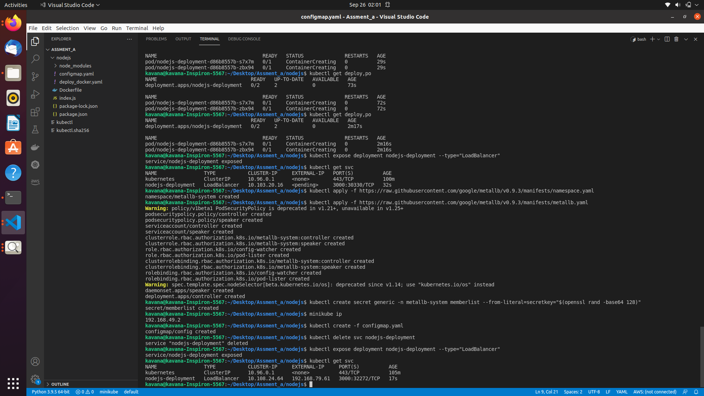

10.Commands to get external IP address

11.Creating a config map file for the address pool

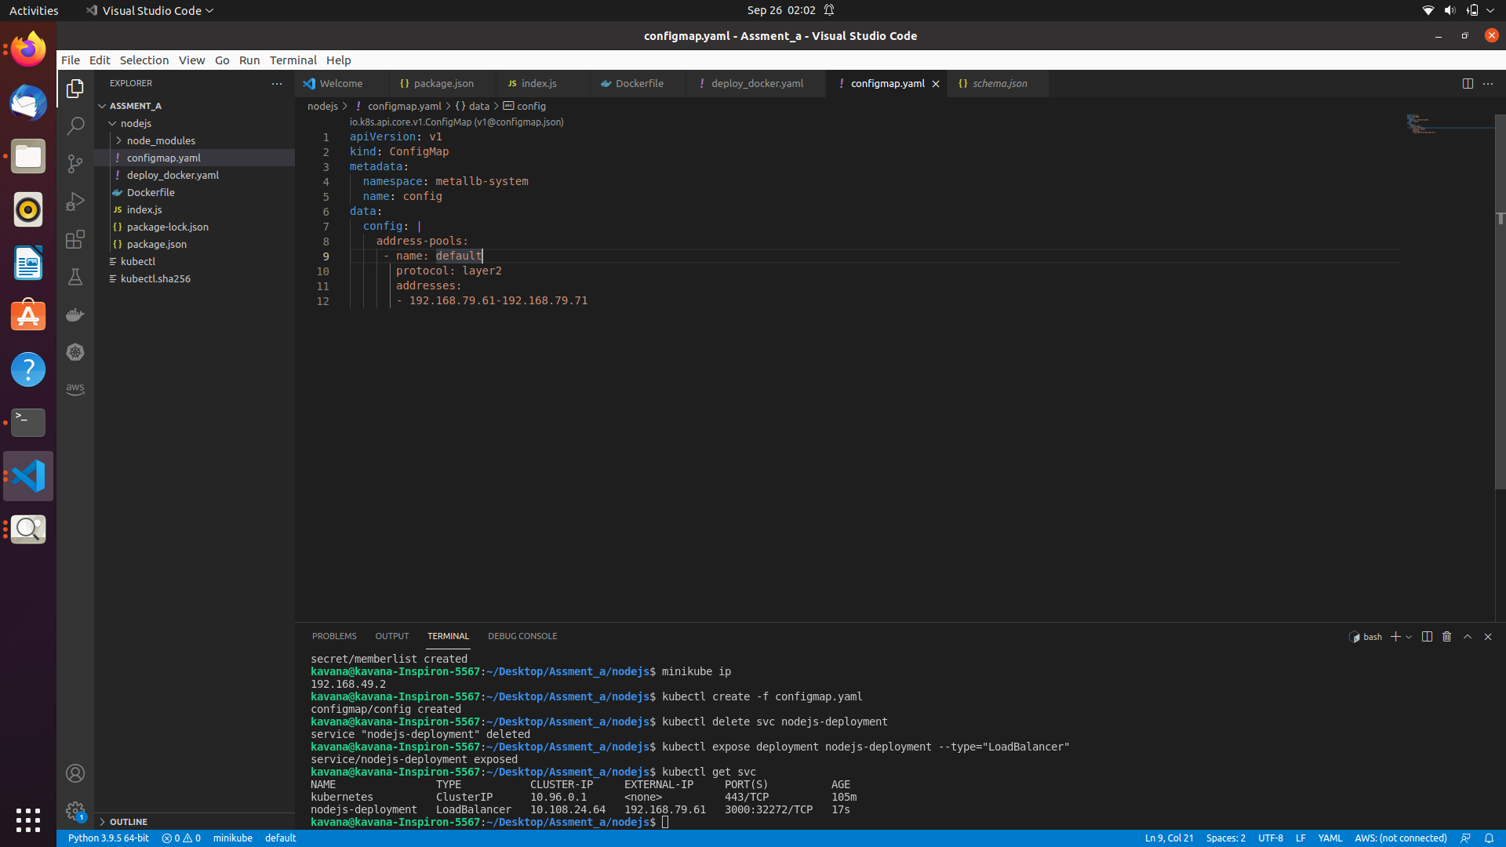
12.Verifying External IP
codelink:https://github.com/KAVANA-S-SALUNKHE/Devop_assignment1-code-

