Phone as PC Game Controller
Feasibility analysis, layout concepts, constraints and breakthrough fixes
Focus: replacing physical triggers using touch, haptics and the gyroscope
Prepared October 4, 2026

1. Executive summary
Turning a phone into a PC controller is technically solved: several apps already stream touch input to a Windows host that presents a virtual gamepad to games. The unsolved problem is ergonomics. A phone has no triggers, no bumpers and no tactile landmarks, so a touch controller loses to a real pad in anything that needs analog triggers or eyes-free input.
This document sets out five layout concepts that attack that problem from different angles, a haptic and gyro design that restores some of the missing physical feedback, a feasibility assessment, the hard constraints, and the fixes with the best chance of being a genuine breakthrough.
Verdict: feasible and worth building. Digital triggers are easy. Analog triggers are achievable with slide-travel strips plus haptic detents. True trigger resistance is not achievable on a phone, but haptics can imitate it well enough to be useful. The differentiator is an adaptive layout that learns the player's hands, combined with a haptic engine that gives eyes-free confirmation.

2. Problem and goals
- The gap. A console-style pad has two analog triggers and two bumpers that sit under the index fingers. Phones expose none of these.
- The cost. On-screen controls give no feedback about where the thumb is, so players look down and lose focus on the game.
- The goal. Triggers that can be pressed together with sticks and face buttons, analog where the game needs it, and with confirmation the player can feel without looking.
- Constraints on the solution. Low enough latency for action games, no per-game setup, works with Steam Input and any XInput or DualShock title.

3. Research findings

3.1 What exists today
Current offerings share one architecture: a phone app sends input over UDP on the local network to a Windows host, which creates a virtual Xbox 360 controller through the ViGEmBus driver. Examples reviewed include the open-source Virtual Gamepad (Flutter app plus C# host), Phone to Pad (Xbox 360 and DualShock 4 output), the browser-based VGamepadWeb (WebRTC and WebSockets, Xbox and DS4 emulation) and iOS apps such as VSteer and VGamepad that add gyro steering and haptics.
None of the products reviewed treats triggers as the central design problem. Most ship a standard Xbox-style layout with presets for shooters and racing, optional gyro aiming, and basic vibration.

3.2 Platform and driver facts
- ViGEmBus is retired. The ViGEmBus driver and client libraries are marked as retired by their author. They still work, but a new product should not depend on them alone.
- DS4 emulation carries gyro. A ViGEm client library supports DualShock 4 motion data and multi-touch touchpad data, and delivers rumble and LED output back to the client. This makes DS4 emulation the practical route for gyro passthrough.
- Android haptics are expressive but device-dependent. Android lets an app compose vibration primitives, scale each one, and place delays between them. Support depends on the phone's actuator and manufacturer, and there is no fallback for unsupported primitives.

3.3 Human factors
- Tactile gap is documented. A lab study of four smartphone gamepads (directional buttons, D-pad, floating joystick, tilt) found that on-screen controls lack tactile feedback, that D-pad and joystick designs encourage drifting when attention is on the remote screen, and that a floating joystick reduces glances at the device.
- Reach zones matter. Thumb reach is easiest at the bottom of the screen and hardest at the top, and differs between left and right hands. For a two-handed landscape grip, the top corners are reached by the index fingers, not the thumbs.

4. System architecture
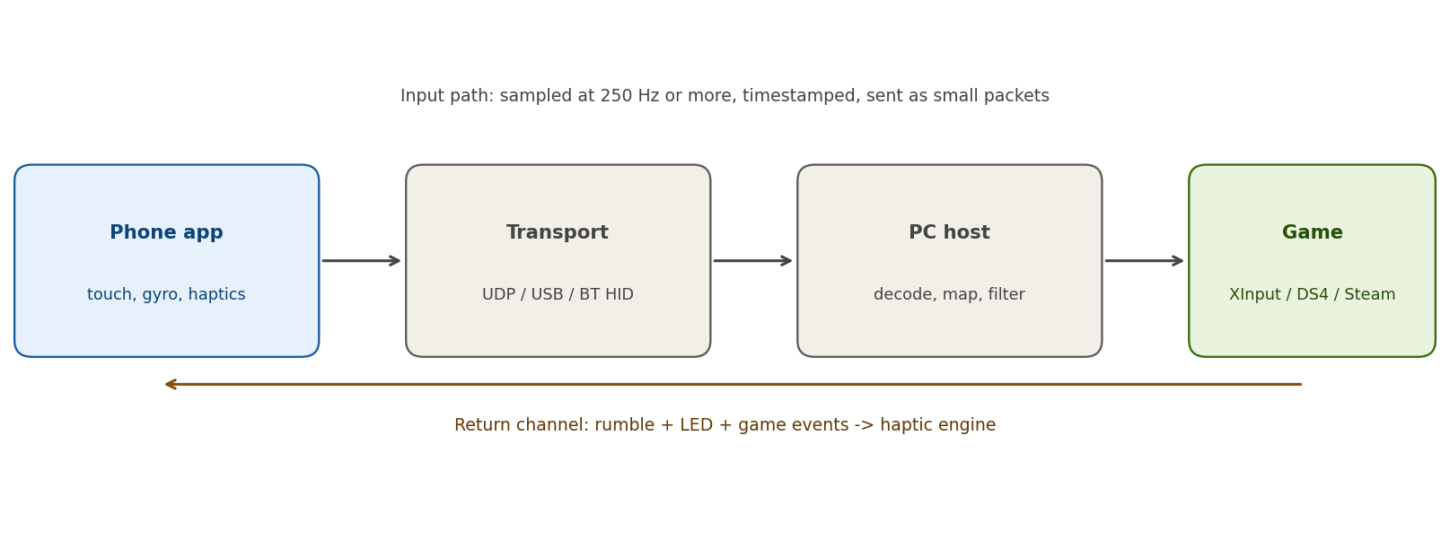
Figure 1. Input path and haptic return channel
- Phone. The app samples touch and motion at 250 Hz or more, timestamps each packet, and sends compact state snapshots rather than events, so a lost packet costs nothing.
- Transport. UDP over 5 GHz Wi-Fi is the default. USB tethering is the low-jitter option. Bluetooth HID on Android would remove the need for any PC driver (not yet verified; prototype before committing).
- PC host. Decodes packets, applies dead zones and curves, and presents an Xbox 360 or DualShock 4 device to games. Reads rumble and LED output and sends it back.
- Return channel. Rumble from the game is translated into phone vibration by frequency and strength, and the app adds its own interface haptics locally with zero network delay.

5. Layout concepts
All concepts assume landscape orientation with a two-handed grip. They differ in where the missing trigger and bumper functions live.

Concept 1: Claw corners
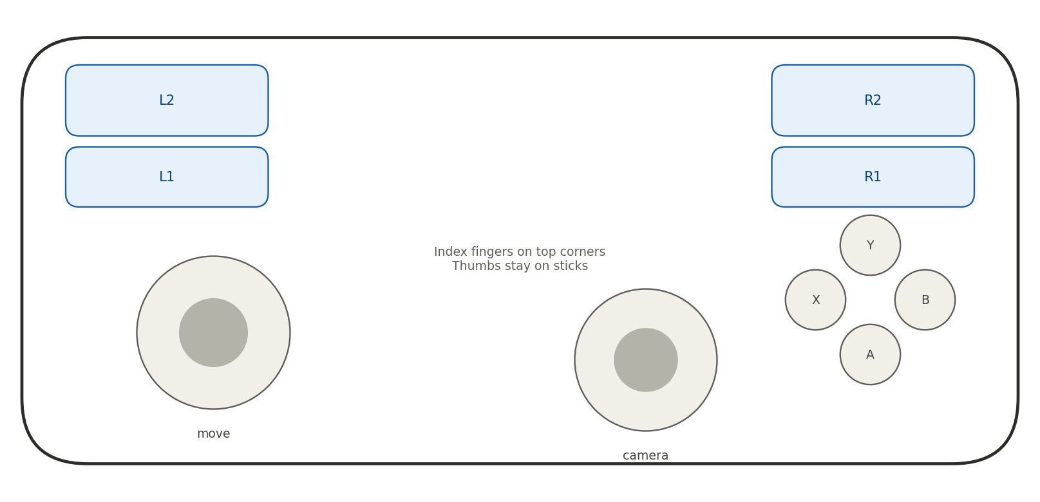
Figure 1. Claw corners (landscape, phone held with both hands)
Best for: Action, platformers, third-person games.
How triggers work: L1, L2, R1 and R2 are four rectangles in the top corners, tapped by the index fingers. They are digital by default.
Haptics: A short click on press and a soft edge tick when a finger drifts off its zone, so the player can find the corners without looking.
Strengths: Closest to console muscle memory. Thumbs never leave the sticks. Simple to build.
Weaknesses: Triggers are digital, so no analog throttle. Index fingers must stay lifted above the screen.

Concept 2: Slide triggers
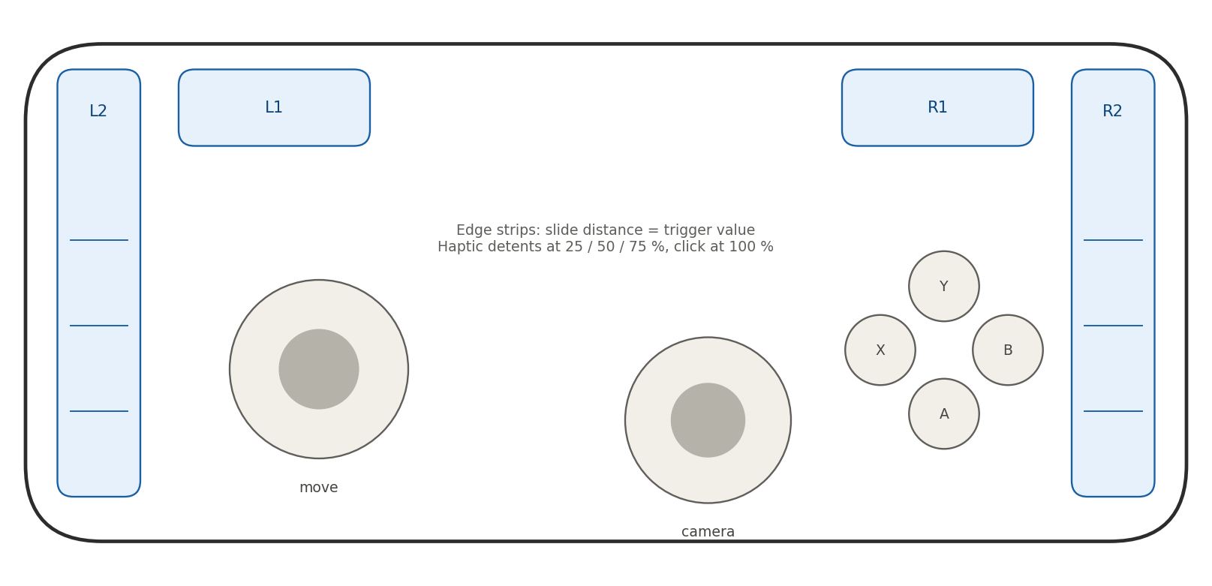
Figure 2. Slide triggers (landscape, phone held with both hands)
Best for: Shooters and any game that needs analog L2 and R2.
How triggers work: L2 and R2 are tall strips along the left and right edges. The trigger value is how far the finger slides along the strip. L1 and R1 stay as corner buttons.
Haptics: Detents at 25, 50 and 75 percent, and a hard click at 100 percent. Intensity rises with travel to imitate a spring.
Strengths: Genuine analog control. Edge strips are findable by feel because the finger rests against the phone's bezel.
Weaknesses: Holding a trigger means holding a slide position. Edge swipes can collide with system gestures on some phones.

Concept 3: Volume keys and gyro
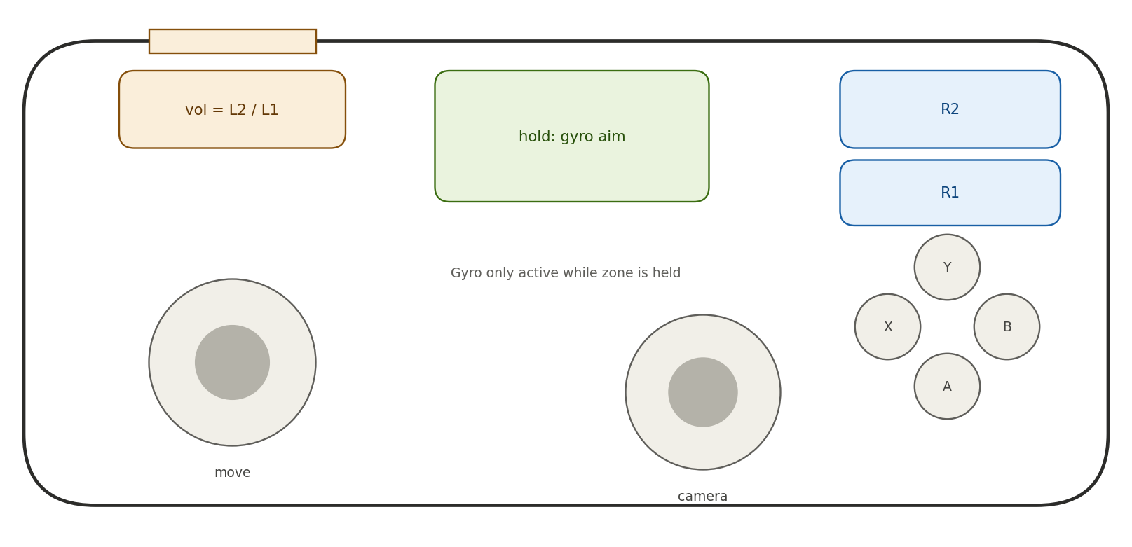
Figure 3. Volume keys and gyro (landscape, phone held with both hands)
Best for: Players who want real clicks, and gyro aiming.
How triggers work: The volume rocker, intercepted by the app while it is in the foreground, acts as two physical triggers on one hand. The other hand uses touch zones. A green gyro zone enables gyro aim only while it is held.
Haptics: Physical keys need no haptics. The gyro zone gives a short pulse on engage and release.
Strengths: Only concept with true mechanical feedback. Gyro cannot drift because it is gated by touch.
Weaknesses: The rocker is on one edge, so it serves one hand. Key interception is more reliable on Android than on iOS. Not all phones place the rocker conveniently in landscape.

Concept 4: Racing tilt
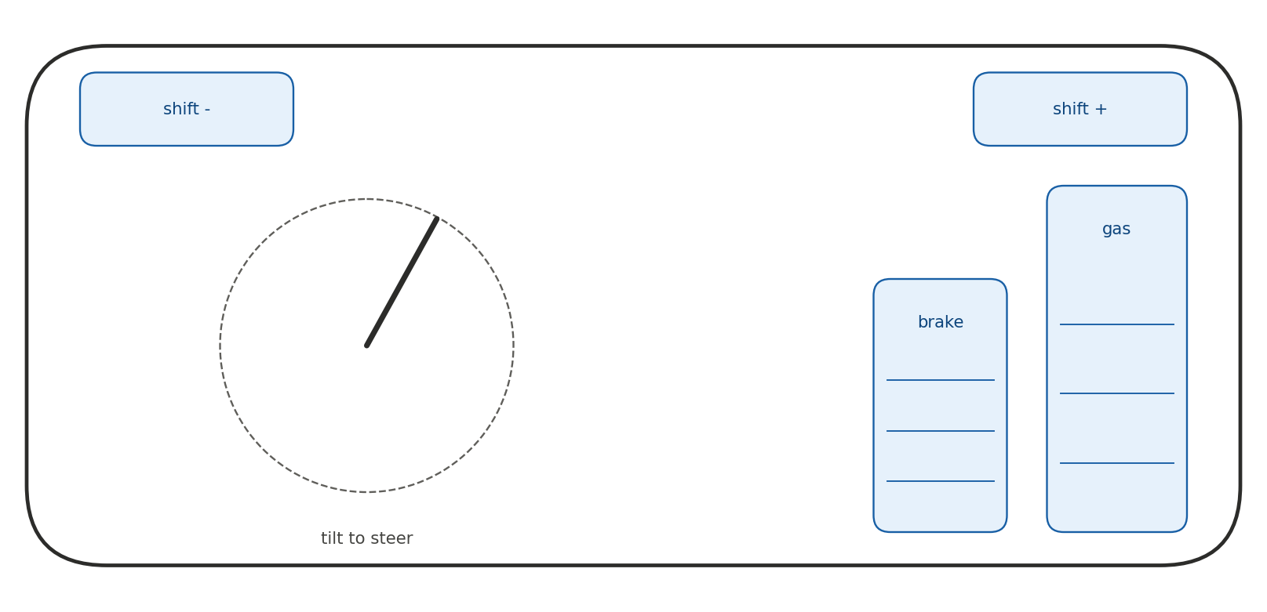
Figure 4. Racing tilt (landscape, phone held with both hands)
Best for: Racing and flight games.
How triggers work: The whole phone is the steering wheel. Brake and gas are slide-analog pedals under the right thumb. L1 and R1 become paddle shifters.
Haptics: Vibration tracks engine rev, ABS and kerbs from the game rumble, plus detents on the pedals.
Strengths: Natural for the genre and very simple to learn.
Weaknesses: Only suits a narrow set of games. Screen angle changes while steering.

Concept 5: Tilt triggers
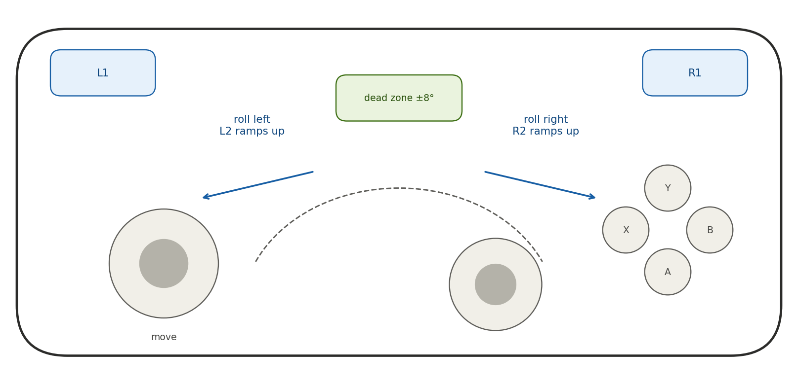
Figure 5. Tilt triggers (landscape, phone held with both hands)
Best for: Optional mode for slow or single-trigger games.
How triggers work: Rolling the phone left past a dead zone of roughly 8 to 10 degrees ramps L2. Rolling right ramps R2. Gravity plus gyro gives the angle, with a neutral position that recalibrates when the grip changes.
Haptics: A tick leaving the dead zone, vibration that grows with angle, and a click at full pull.
Strengths: Frees the screen of trigger zones. Fun and discoverable.
Weaknesses: L2 and R2 are mutually exclusive, so no aim-and-fire together. Conflicts with gyro aiming. Tiring to hold an angle. No spring to push back. Recommended only as an opt-in mode, or a snap-flick gesture for a digital press.

5.1 Concept comparison
Concept | Analog triggers | Tactile feedback | Build effort | Best genre | Overall
1 Claw corners | No | Haptic only | Low | Action | Strong default
2 Slide triggers | Yes | Haptic detents | Medium | Shooters | Best analog option
3 Volume + gyro | Digital | Mechanical (one hand) | Medium | Aim-heavy | Strong on Android
4 Racing tilt | Yes (pedals) | Haptic | Medium | Racing | Niche, excellent
5 Tilt triggers | Yes | Haptic | Medium | Slow games | Opt-in mode only

6. Haptic design
Haptics are the main tool for replacing what the screen cannot give: landmarks and resistance.
- Confirmation. Light tick on touch-down, firmer click on full press, so the player feels each button engage.
- Imitated resistance. Intensity and primitive type change with slide distance, with detents at fixed points, to imitate an adaptive trigger.
- Edge awareness. A soft tick when a finger leaves a zone gives eyes-free awareness of drift, which is the gap the research flags.
- Game rumble mapping. The large motor becomes a low, slow primitive and the small motor a sharp high-frequency tick, so different game effects feel different.
- Compatibility. Effects that rely on specific primitives need a fallback to simple waveform vibration on phones without them.

7. Gyro and tilt design
- Touch-gated gyro. Gyro aim is active only while a designated zone or button is touched, which removes drift and accidental aiming.
- Flick turning. A quick wrist turn spins the camera by a set angle, useful for turning without moving a thumb off the sticks.
- Tilt steering. Tilt steering with adjustable range and self-centring for racing.
- Grip detection. Gravity direction identifies which hand is holding the phone and whether it has been lifted or put down, allowing auto-pause and layout switching.
- Conflict rule. Tilt triggers and gyro aim must not run at the same time unless one is gated off, since both read the same motion.

8. Feasibility analysis
Area | Feasibility | Assessment
Virtual gamepad on PC | High | Proven by multiple shipping apps and open-source projects.
Digital triggers and bumpers | High | Plain touch zones. Main risk is ergonomics, not technology.
Analog slide triggers | High | Straightforward to compute from touch position. Needs good dead zones and curves.
Haptic trigger imitation | Medium | Works on phones with capable actuators. Quality varies widely across devices.
Gyro aim over network | Medium to high | Needs DS4 emulation for passthrough. Latency must be measured on real hardware.
Volume keys as triggers | Medium | Reliable on Android in the foreground. Limited on iOS.
Tilt triggers | Medium | Technically easy, ergonomically limited. Opt-in only.
Bluetooth HID (no driver) | Unverified | Android supports a HID device role from version 9. Needs prototype to confirm latency and PC compatibility.
True trigger resistance | Not feasible | No spring or force feedback is available on a phone. Only imitation through vibration.
Competitive-grade latency | Medium | Possible on a clean 5 GHz link or USB. Wi-Fi jitter is the main risk.

9. Constraints
Constraint | Detail
No tactile landmarks | Flat glass gives no feel for where controls are. Players look down, which breaks focus.
Finger occlusion | Thumbs and fingers cover the controls and part of the screen if the game is shown on the phone.
No resistance | No physical spring. Imitation only.
Haptic hardware variance | Android actuators differ by phone, and primitives may be missing. iPhone is more uniform but has other limits.
Network latency and jitter | Wi-Fi congestion causes spikes that affect fast games more than average delay.
Driver dependency | ViGEmBus is retired. Windows driver signing is also a barrier for any replacement.
OS gesture conflicts | Edge swipes may trigger system back or home gestures on some phones.
Battery and heat | High-rate sensor sampling and haptics drain the battery. Long sessions warm the phone.
Motion conflicts | Tilt triggers, tilt steering and gyro aim all use the same sensors.
iOS limits | Volume key interception and low-level HID roles are more restricted than on Android.

10. Breakthrough fixes
These are the ideas most likely to move this from a workable app to something genuinely better than existing phone controllers.
Constraint | Fix | Why it could be a breakthrough
No landmarks | Haptic boundary ticks and edge-anchored strips that the finger can feel against the bezel. | Gives eyes-free awareness without hardware.
Finger drift | Adaptive zones: controls re-centre under the thumb on touch-down, and the app learns resting positions over time. | Layout reshapes to the player's hands instead of the other way round.
No resistance | Haptic detents plus intensity that ramps with travel, tuned like an adaptive trigger. | Makes slide triggers feel like pulling something.
One-handed volume keys | Add a second physical input: fingerprint sensor, or a clip-on or case accessory later. | Brings real clicks to both hands.
Motion conflicts | Gyro gated by touch, with trigger tilt disabled while gyro is engaged. | Lets tilt and gyro coexist without fighting.
Latency spikes | Packet snapshots instead of events, USB or Bluetooth HID fallback, and local-only haptic feedback. | Removes the network from the feel of every press.
Driver risk | Bluetooth HID gamepad on Android, so the PC needs no driver. | Zero-install setup and no signing issues. Needs verification.
Grip uncertainty | Gyro and touch pattern detect which grip is in use and switch layouts automatically. | Feels like the controller understands the player.

11. Roadmap
Phase | Scope | Exit criteria
1 MVP | Flutter or native app, Windows host, UDP, Xbox and DS4 output, Claw and Slide layouts. | Playable in three test games with measured end-to-end latency.
2 Haptics | Return channel, rumble mapping, detents, edge ticks, fallback waveforms. | Blind test: players find controls without looking.
3 Motion | Touch-gated gyro, flick turning, tilt steering, optional tilt triggers. | Gyro works in Steam Input with no drift.
4 Adaptive | Re-centring zones, resting-position learning, grip detection. | Measurable drop in missed presses versus a fixed layout.
5 Driverless | Android Bluetooth HID prototype and decision on dropping ViGEm. | Latency and compatibility at least as good as UDP path.

12. Risks and open questions
- Which phone models to target first, since haptic quality is device-specific.
- Whether Bluetooth HID latency is low enough for fast action games.
- How system edge gestures affect slide triggers on different Android skins.
- Whether players accept learning a new layout, or need console-style presets first.
- Policy for anti-cheat software, which may flag virtual input devices.

13. Sources
- Virtual Gamepad open-source project (github.com/KaifCoding/virtual-gamepad).
- Phone to Pad (aileck.itch.io/phone2pad) and VGamepadWeb (sourceforge.net/p/vgamepadweb).
- VSteer iOS app listing and VGamepad iOS app listing.
- ViGEmBus repository README (retired status) and the vigem-rust crate documentation.
- Android developer documentation: custom haptic effects, and haptic constants and primitives.
- Baldauf, Fröhlich, Adegeye and Suette, Investigating On-Screen Gamepad Designs for Smartphone-Controlled Video Games.
Bluetooth HID, volume-key behavior and latency figures come from general platform knowledge rather than the sources above and should be verified on target devices.

