**Introduction**

The main objective of this assignment is to help us understand the concepts and apply AI techniques to a real word problem and prepare a research report. The synchronization of our team made us choose the topic of machine vision in the gaming industry. We have used python libraries such as pygame, opencv, cv zone to develop the game. Nowdays, AR and VR is used gaming industry. Therefore, in nearing future we can use recognition of human features can enhance the level of gaming. In our project, we have developed four games in which the controls of the game can be handled by hands with use of web camera in the machine.

**Abstract**

Computer vision is widely used in gaming industries for enhancing the

experience while gaming. Machine vision in gaming refers to the use of computer vision techniques to enhance the gaming experience. This can include using cameras to track player movements, recognizing and responding to objects in the game environment, and providing more realistic graphics. Examples of machine vision in gaming include motion-controlled gaming, augmented reality games, and facial recognition for player login. Technology has the potential to revolutionize the way we interact with games and can lead to more immersive and interactive experiences.

Machine vision technology can also be used in virtual reality (VR) and augmented reality (AR) gaming. VR headsets use cameras and sensors to track the player's head movements and adjust the game's perspective accordingly. AR games, on the other hand, use cameras and sensors to overlay virtual elements onto the player's real-world surroundings.

Overall, machine vision technology can greatly enhance the gaming experience by making it more immersive and interactive. It can also open up new possibilities for game design, allowing developers to create more realistic and engaging games.

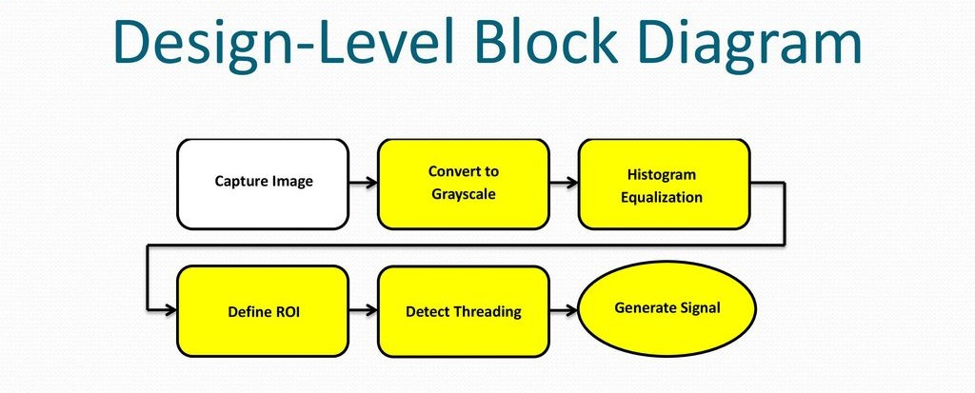

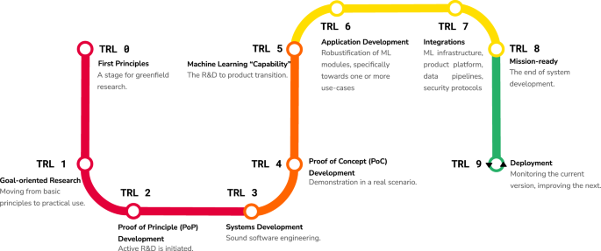

**5.Machine Vision in Gaming Domain:**

* In this Machine Vision domain,we have developed Four Games which can be controlled by using hands instead of key strokes.
* Libraries Used:
* CV zone
* Open CV
* Mediapipe
* Pygame
* **The Codes are Provided in the text file called game.txt .**

**PING PONG GAME:**

**CONTROLS:**

**By the motion of the hands the steel on the both sides can be controlled.**

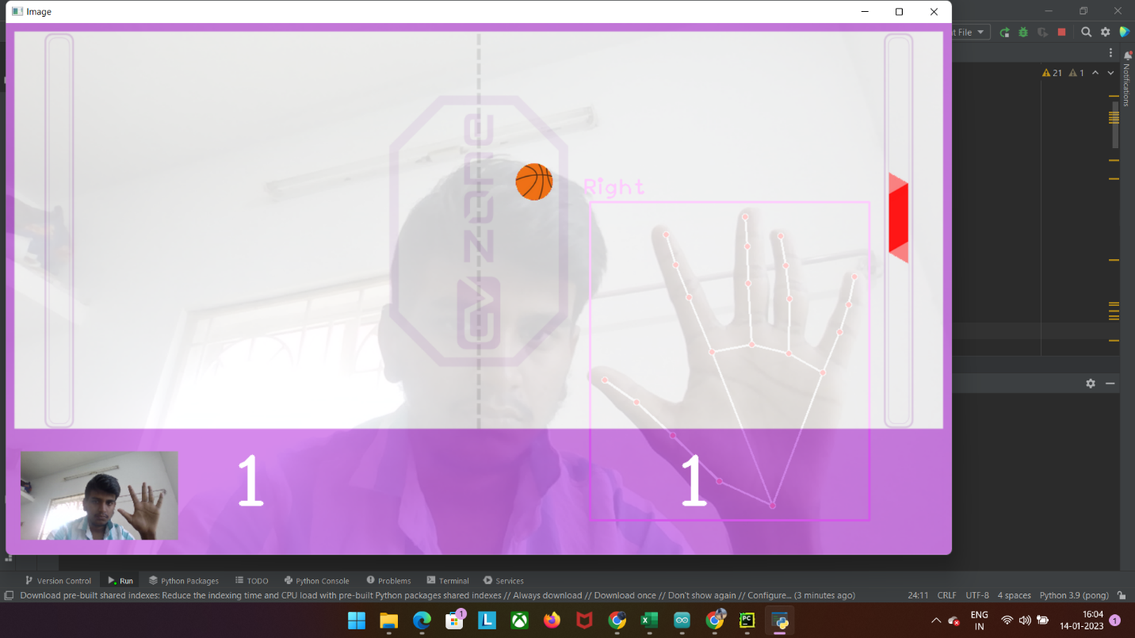

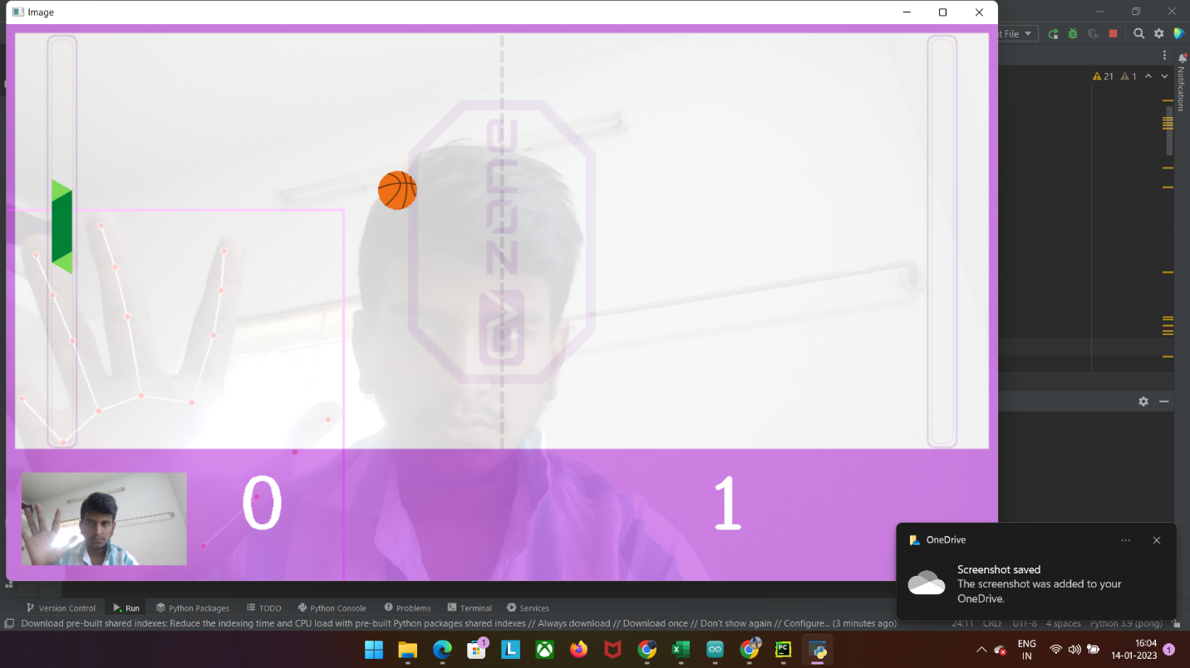

**SPACE WAR:**

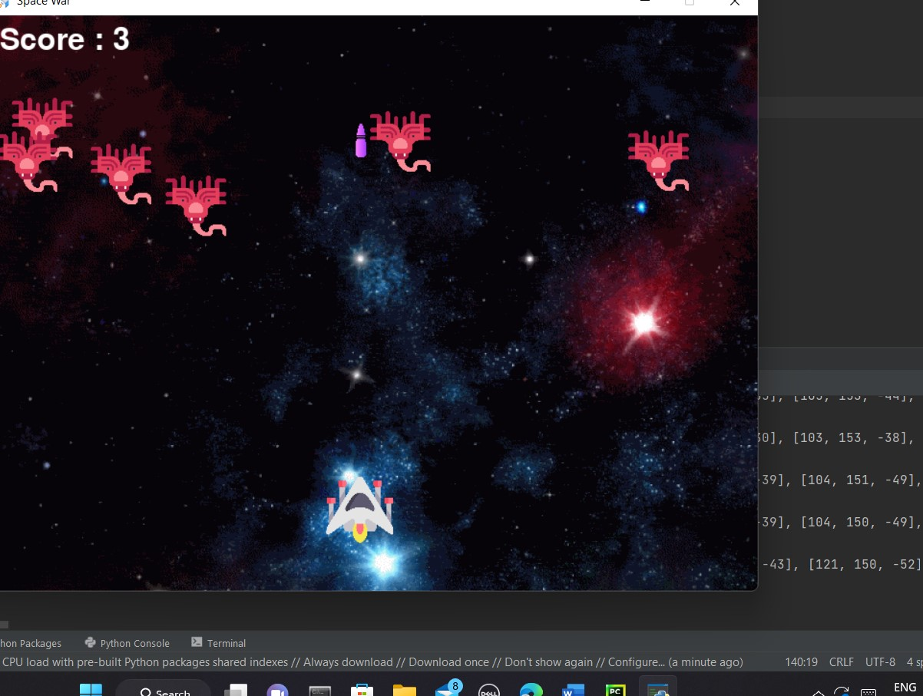

**Controls:**

**The Five Fingers Are represented as Array.**

**Five Fingers – [Thumb,Index Finger,Middle Finger,Ring Finger,Little Finger]**

**0 --** THE FINGER IS NOT VISIBLE.

**1 –**  THE FINGER IS VISIBLE.

LEFT – [1,1,1,1,1]

RIGHT – [0,0,0,0,0]

Shoot – [0,1,0,0,0]

**BIKE RACING GAME:**

**Controls:**

**The Five Fingers Are represented as Array.**

**Five Fingers – [Thumb,Index Finger,Middle Finger,Ring Finger,Little Finger]**

**0 --** THE FINGER IS NOT VISIBLE.

**1 –**  THE FINGER IS VISIBLE.

LEFT – [0,1,1,0,0]

RIGHT – [0,1,1,1,0]

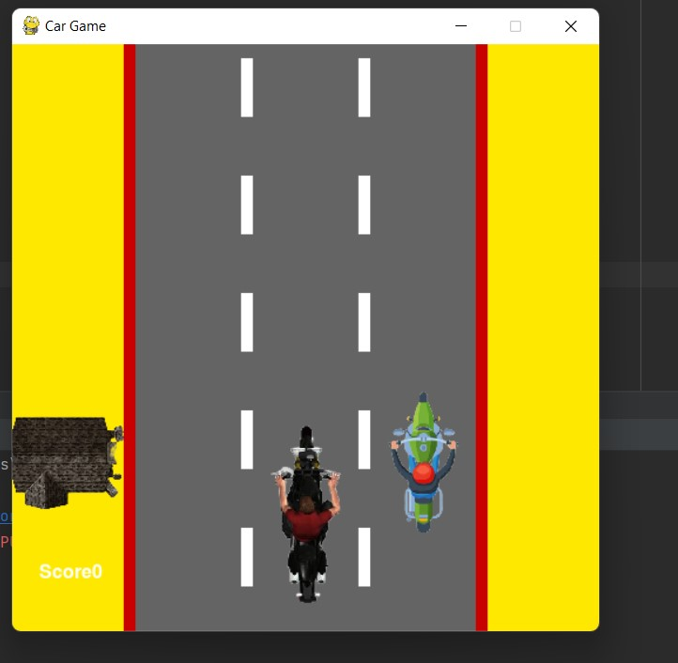

**BALLON POP GAME:**

