EXP NO: 5
Servlet Example Demonstrating HTTP GET vs POST Methods with Form Handling

AIM:
Write a Servlet to demonstrate the difference between HTTP GET and POST methods by creating a form and handling requests accordingly.

CODE:
SignUp.html
<!DOCTYPE html>
<html>
<head>
<meta charset="ISO-8859-1">
<title>Sign_up</title>
</head>
<body>
<form action="./SignUpdetails" method="post">
<label for="fname">FirstName:</label>
<input type="text" name="fname" placeholder="Enter Your First Name"><br><br>

<label for="lname">LastName:</label>
<input type="text" name="lname" placeholder="Enter Your First Name"><br><br>

<label for="age">Age:</label>
<input type="number" name="age" placeholder="Enter Your Age"><br><br>

<label for="date">Date Of Birth:</label>
<input type="date" name="datee"><br><br>

<label for="gender">Male</label>
<input type="radio" name="gender"><br><br>
<label for="gender">Female</label>
<input type="radio" name="gender"><br><br>

<label for="address">Address:</label>
<textarea name="address" ></textarea>

<input type="submit" value="Sign-Up">

</form>
</body>
</html>

SignupDetails.java
package com.karthick.servlet;

import java.io.IOException;
import java.io.PrintWriter;

import javax.servlet.ServletException;
import javax.servlet.annotation.WebServlet;
import javax.servlet.http.HttpServlet;
import javax.servlet.http.HttpServletRequest;
import javax.servlet.http.HttpServletResponse;

/**
* Servlet implementation class SignUpdetails
*/
@WebServlet("/SignUpdetails")
public class SignUpdetails extends HttpServlet {
private static final long serialVersionUID = 1L;

/**
* @see HttpServlet#HttpServlet()
*/
public SignUpdetails() {
super();
// TODO Auto-generated constructor stub
}

protected void doPost(HttpServletRequest request, HttpServletResponse response) throws ServletException, IOException {
String firstname=request.getParameter("fname");
String lastname=request.getParameter("lname");
int age=Integer.parseInt(request.getParameter("age"));
String date=request.getParameter("date");
String gender=request.getParameter("gender");
String address=request.getParameter("address");

PrintWriter p = response.getWriter();
p.println("FirstName :"+firstname);
p.println("LastName :"+lastname);
p.println("Age :"+age);
p.println("Date Of Birth :"+date);
p.println("Gender :"+gender);
p.println("Address :"+address);

}

}
OUTPUT: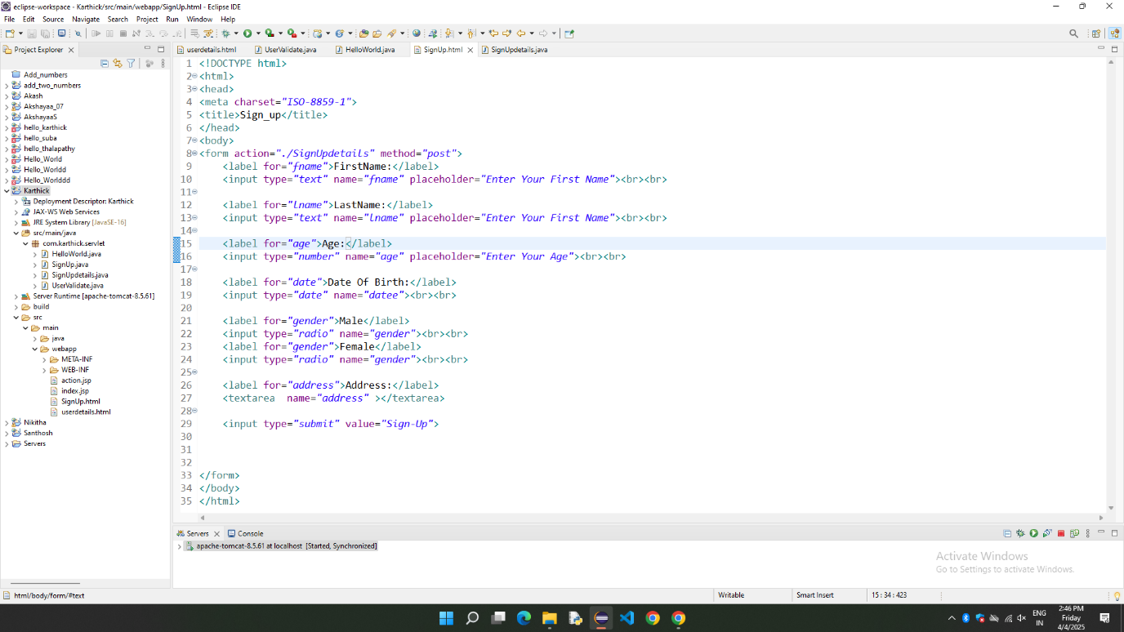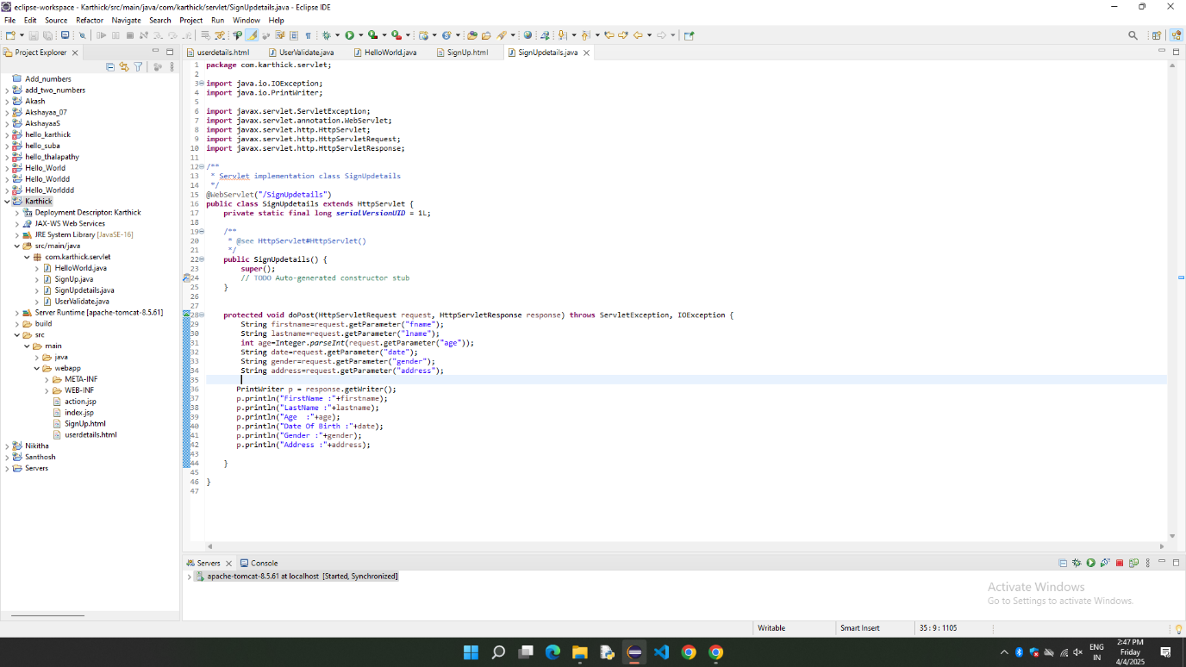
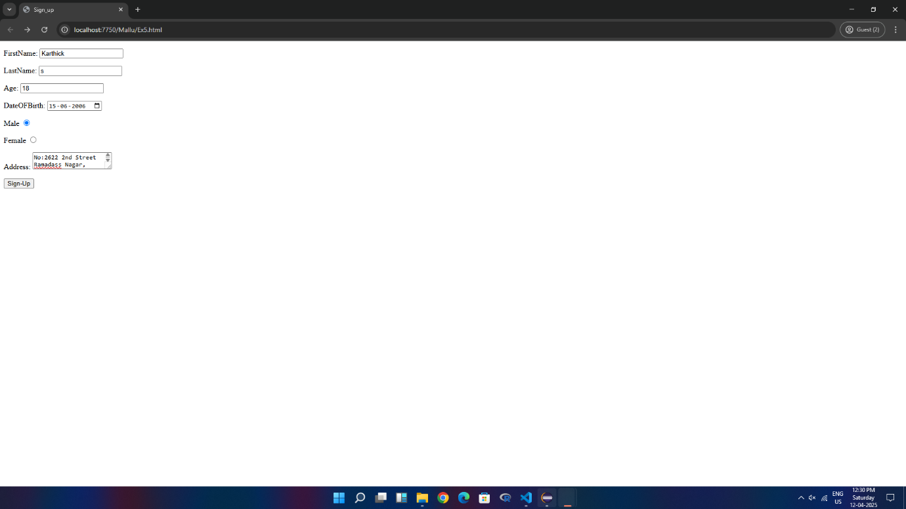

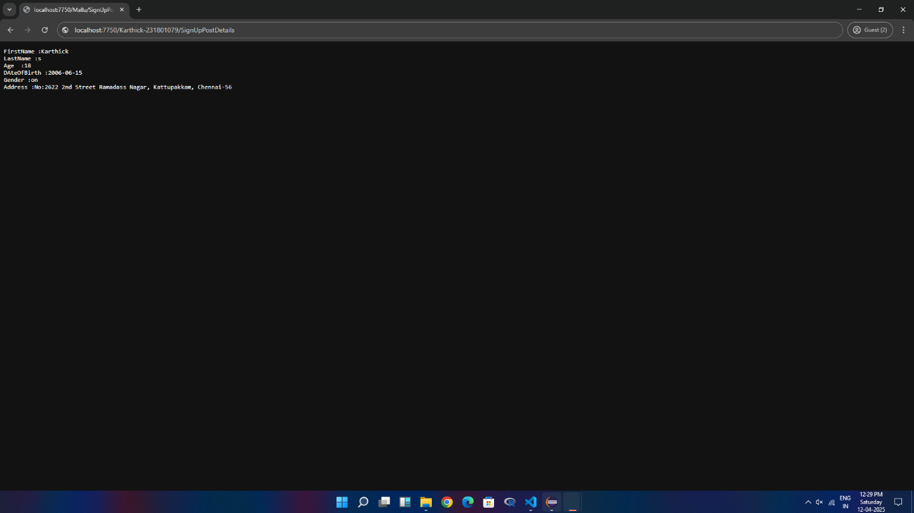

RESULT:
Thus, the difference between HTTP GET and POST Method is Successful demonstrated by creating a form and handling requests.

