Version control

Types of version control

Centralised
Distributed

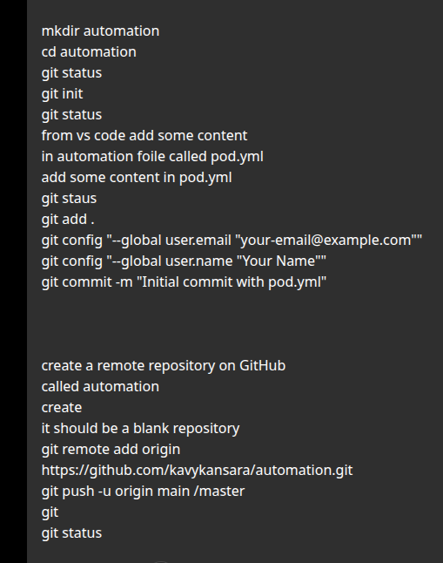

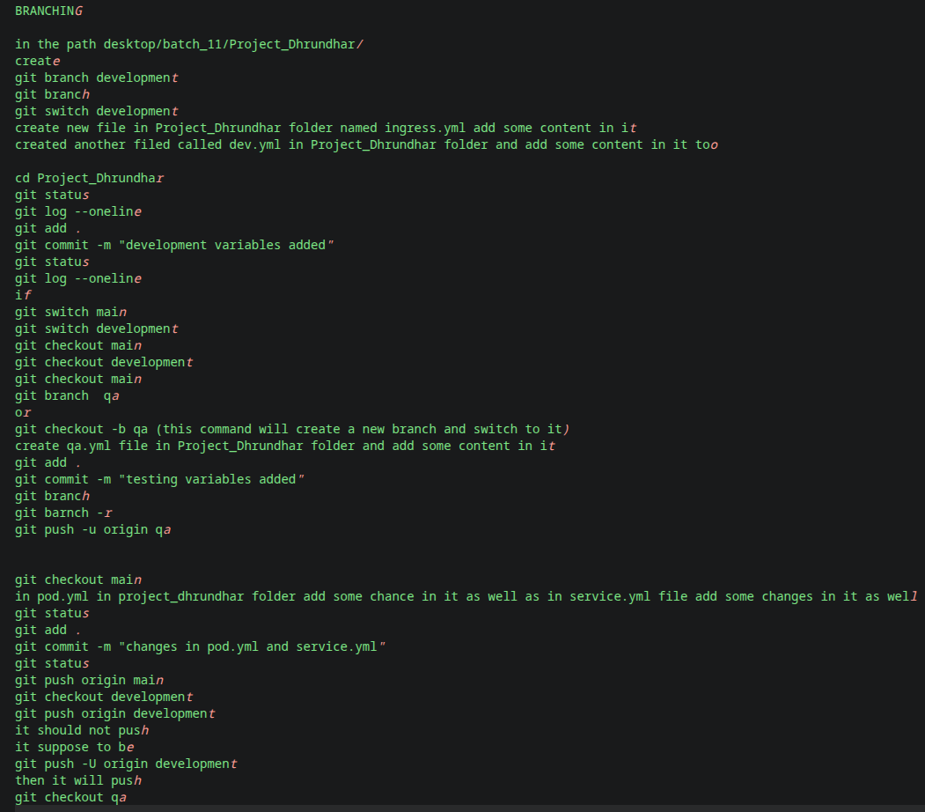

STEP 1 - Go to the project

cd ~/Desktop/Batch_11/Project_Dhrundhar

STEP 2 - Create Development Branch

git branch development git branch
git switch development

OR

git checkout development

STEP 3 - Create files on Development branch

Create:

ingress.yml

dev.yml

Add some sample content in both files

STEP 4 - Commit changes on Development branch

git status git log --oneline
git add .
git commit -m "development variables added"
git status git log --oneline

STEP 5 - Switch between branches (Practice)

git switch main git switch development

OR
git checkout main git checkout development
git checkout main

STEP 6 - Create QA branch

git checkout -b qa

OR

git branch qa

git switch qa

STEP 7 - Create qa.yml

Create:

qa.yml

Add some sample content

STEP 8 - Commit QA changes

git status
git add .
git commit -m "testing variables added"
git branch git branch -r

STEP 9 - Push QA branch

git push -u origin qa

STEP 10 - Switch back to Main

git checkout main

Edit:

pod.yml

service.yml

Add some sample content

STEP 11 - Commit Main branch changes

git status
git add .
git commit -m "changes in pod.yml and service.yml"
git status

STEP 12 - Push Main

git push origin main

STEP 13 - Push Development branch

git checkout development
git push origin development

If Git says there is no upstream branch:
git push -u origin development

STEP 14 - Switch to QA

git checkout qa
git status git branch

git flow

