1. **Pull any image from the docker hub, create its container, and execute it showing the output.**

First of all we have to know what is docker ?. Docker is a software platform to create, test and deploy applications. Docker uses container to package up an application. It allows applications to use the kernel and other resources of the host operating system. Docker Hub is a centralized repository service that allows you to store container images and share them with your team.

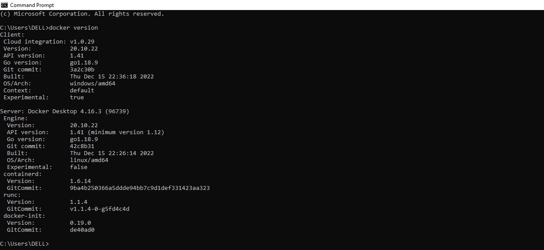

You can use Pull and Push command to upload and download images to and from the Docker Hub.

At first we have to pull image from the docker hub using the docker pull <imagename>

Here I have choosen redhat so I redhat image from the dockerhub. When the image is downloaded then we will get the output as below shown.

After that create a container from the reference of the downloaded image.Then we will create the container and run the container.

After pulling the image we can see it in the docker desktop we can see the required output.

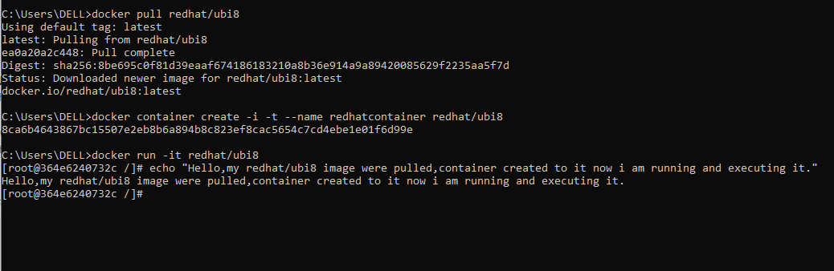

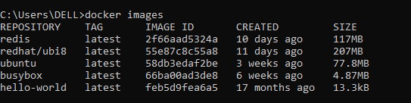

Here we open docker desktop to view whether the container is created or not. we can see a container is created .

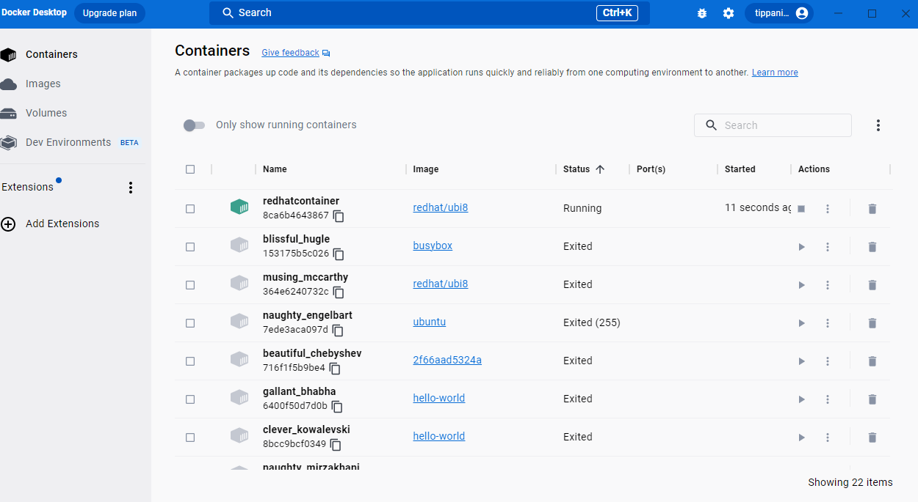

1. **Create the basic java application, generate its image with necessary files, and execute it with docker.**

Creating the basic java application.

Step1 : Create a directory, it is used to store the files.



Step2: go to the directory that you have created.

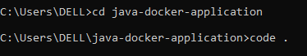

Step3:Create a java file,save it as Hello.java

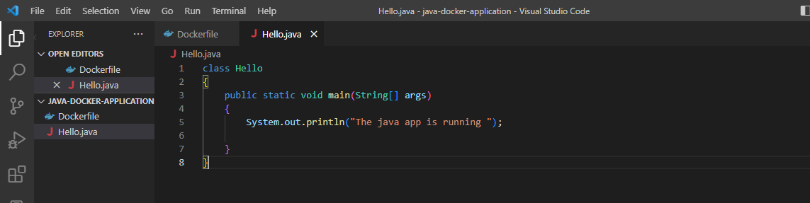

Step4:Create a docker file.

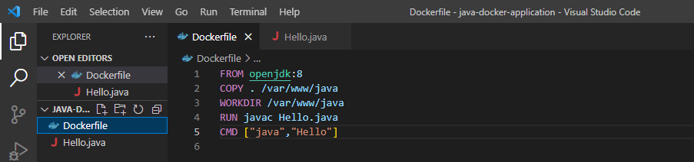

Step5: Now create an image by following below command. we must login as root in order to create a image . In the following command ,java-app is name of the image. We can have any name for our docker image.

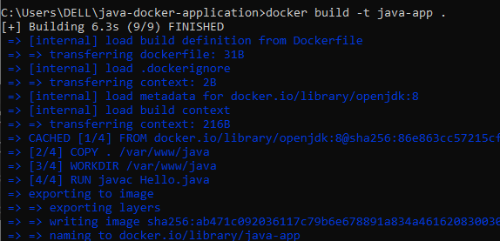

Step6: After successfully building the image, now we can run docker by using run command.



After executing this command open docker and then we can see with the java application the

Image is generated.

