Step1:In step1 we created an ec2 instance with ubuntu AMI

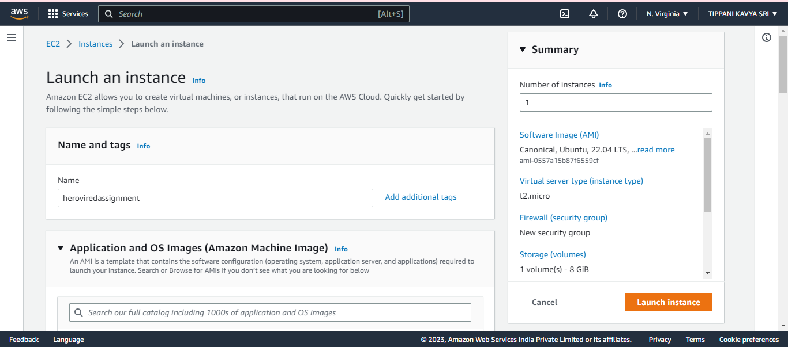

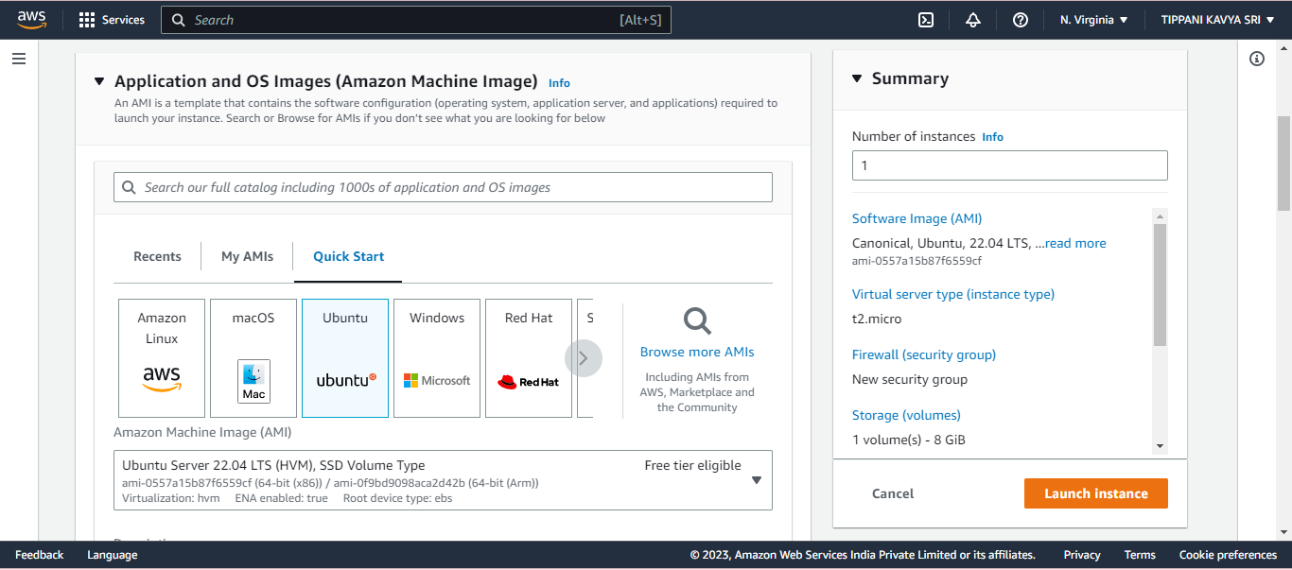

Step2:here we created a key pair for SSH access.

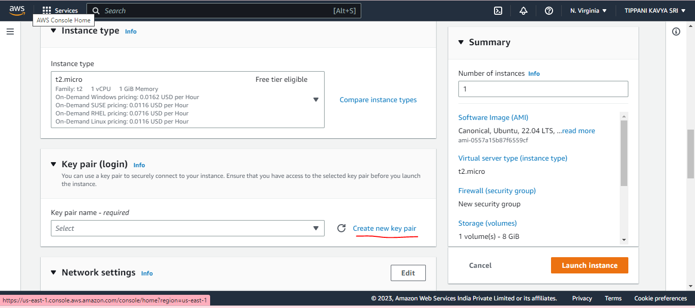

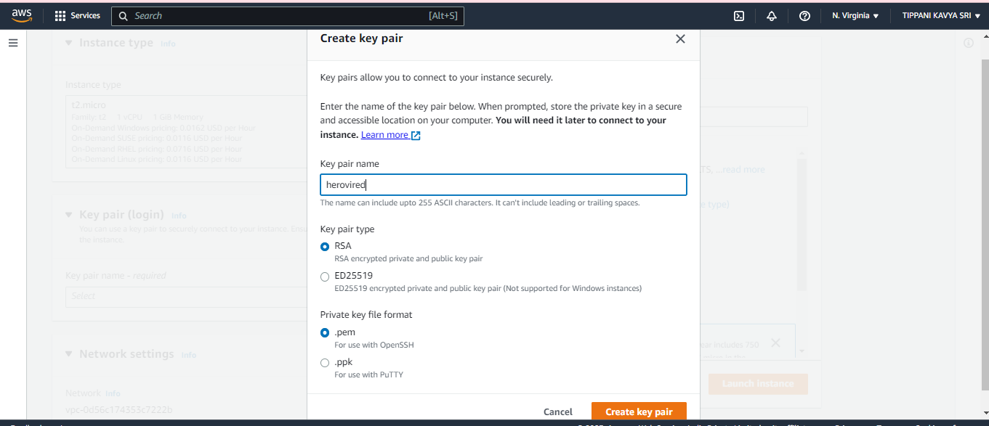

Step3: Create Security Group with SSH and HTTP/HTTPs Ports Enabled.

Now tick the allow HTTPS traffic from the internet and also tick Allow HTTP traffic from the internet

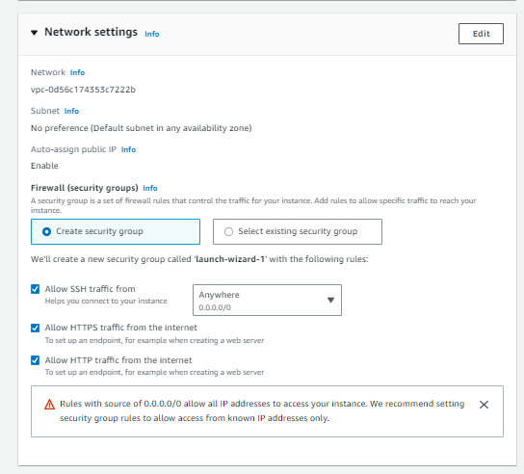

Now then click launch instance

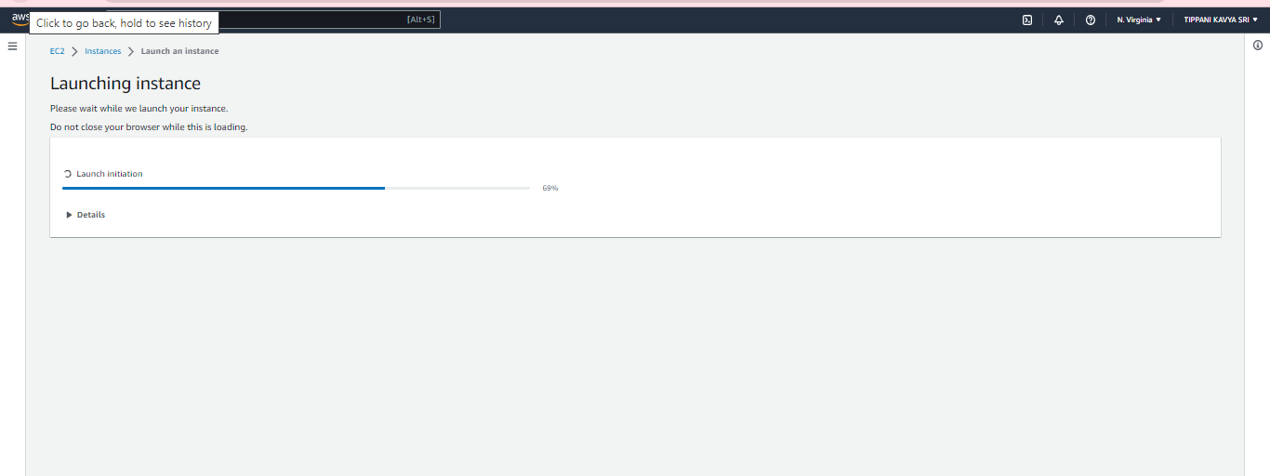

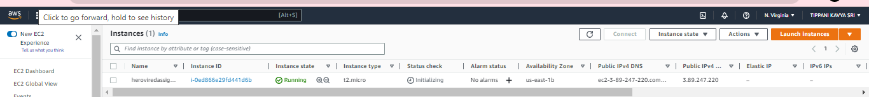

Now click on the created instance and connect it

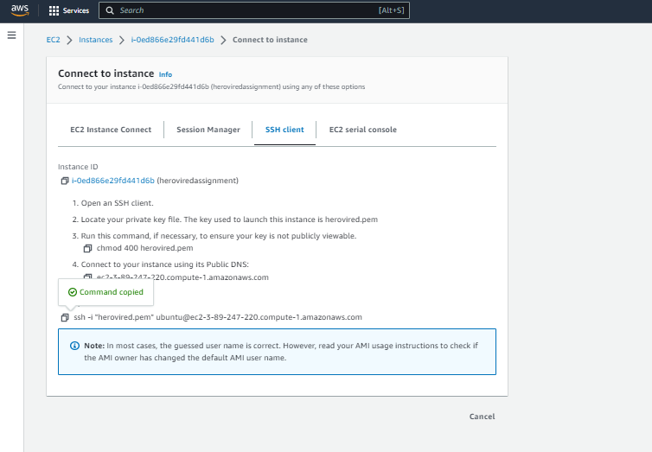

Copy the link of the ssh client example and save it for later use

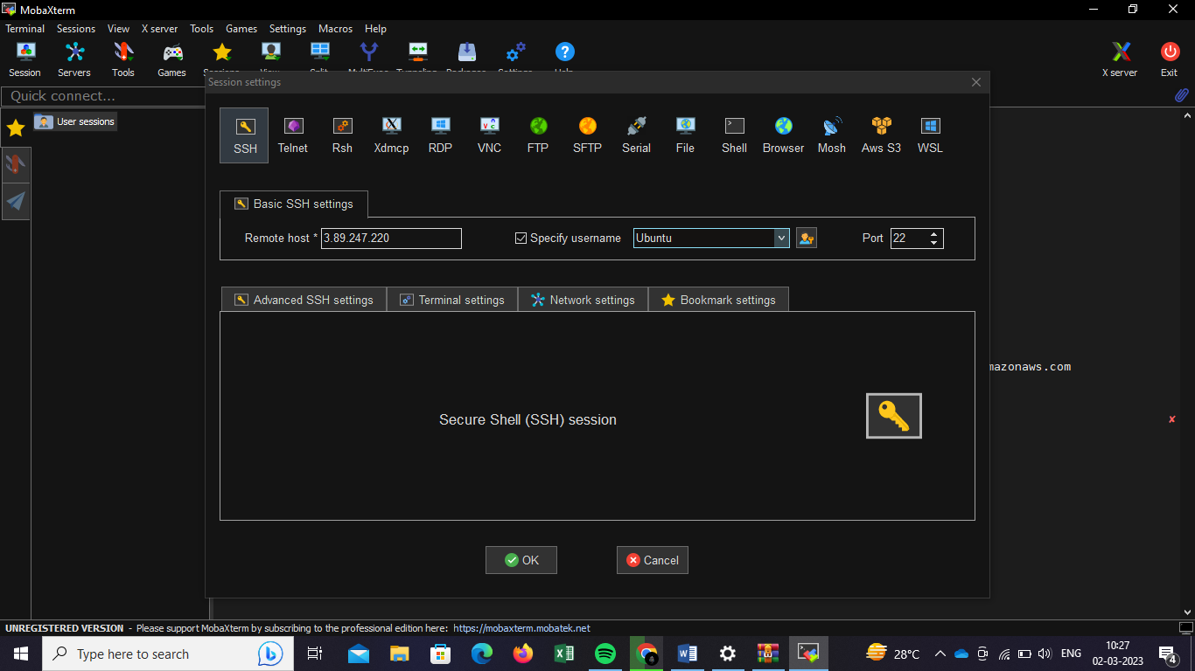

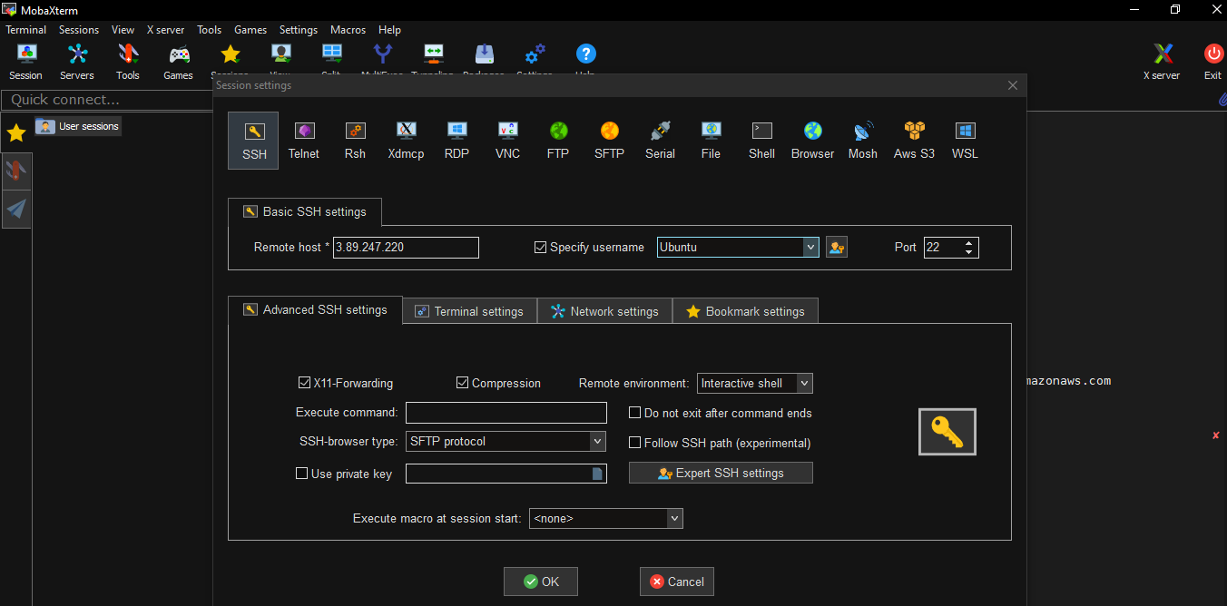

Remote host is the public IP address of the ec2 instance in the AWS.

Specify username as:ubuntu

Give private key as the downloaded keypair path in the computer

Step4: SSH Created EC2 Instance to local Machine.

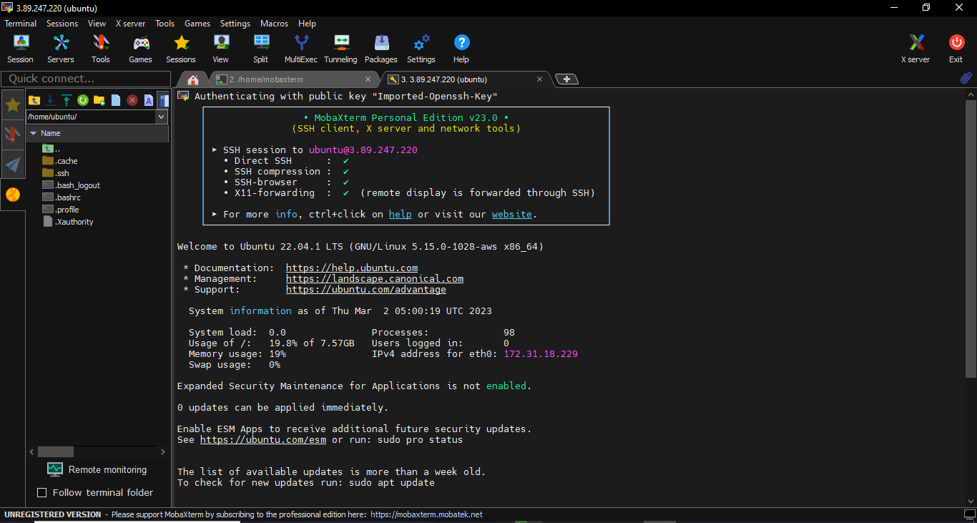

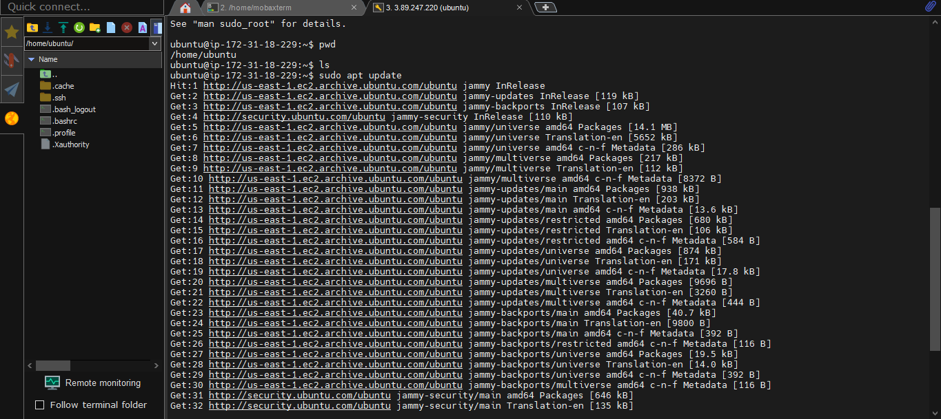

Step5: Install Nodejs in th Ubuntu machine.

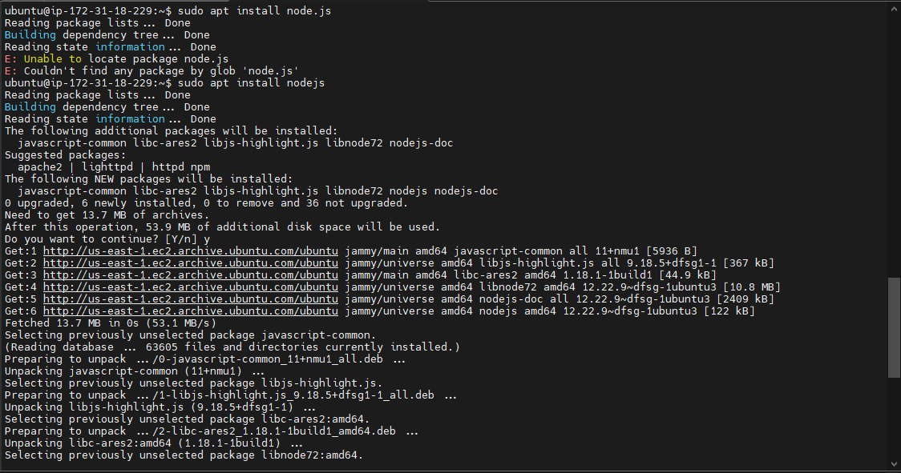

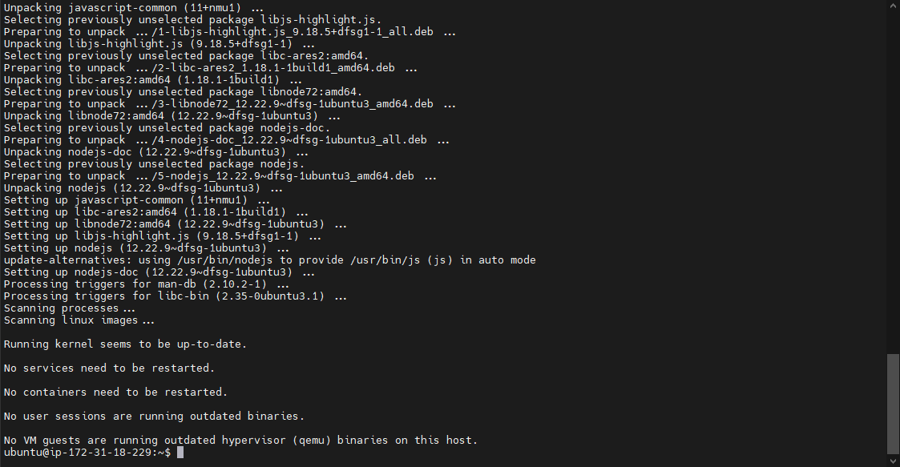

Step6: Now, Check the status of nodeJs.



