**Kubernetes assessment**

**Task Statement :**

**For minikube, go through the documentation given in the below link:**

[**https://minikube.sigs.k8s.io/docs/start/**](https://minikube.sigs.k8s.io/docs/start/)

**Start your minikube cluster using the commands mentioned in the documentation, if you face any issue with the minikube start command ,use**

**minikube start --driver=virtualbox --no-vtx-check**

**This command works for those who have Virtual box with them.**

**For further help visit :**[**https://github.com/snehal-herovired/Devops_Batch_Aditya**](https://github.com/snehal-herovired/Devops_Batch_Aditya)**,in the issue , you will find Kubernetes issue and in this issue you have different links to help you resolve the error you get while starting minikube.**

**After minikube ,has started , again follow the documentation and try to deploy the hello-minikube application as a testing application.**

**Step1:**first of all install kuberenetes using the powershell and type the following command in the powershell

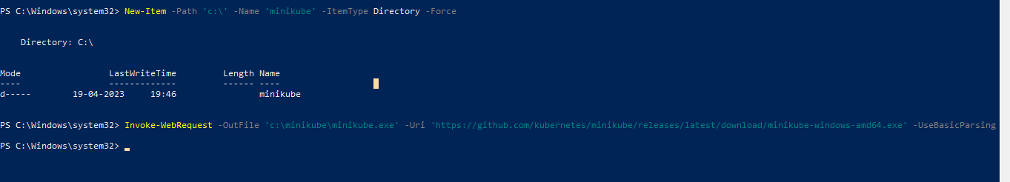

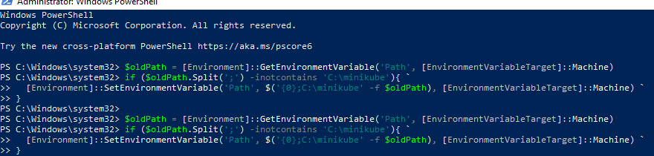

**Step2:** Go to command line and run as adminstartor

**THEN GIVE THE FOLLOWING COMMAND**

1.**minikube start**

After that to interact with our cluster type the following commands

1.kubectl get po –A

2.minikube kubectl – get po –A

3.minikube dashboard

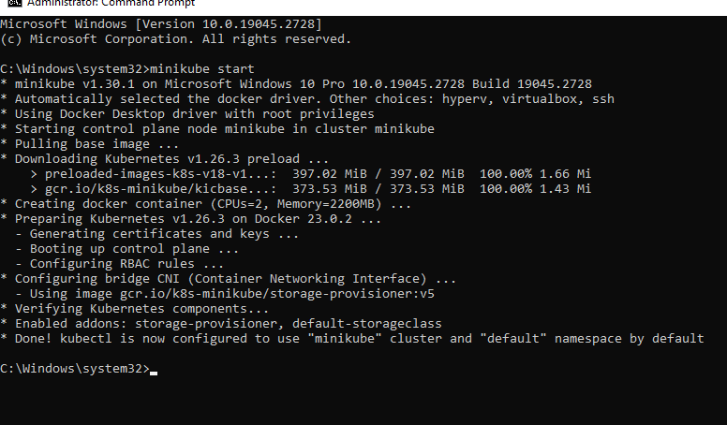

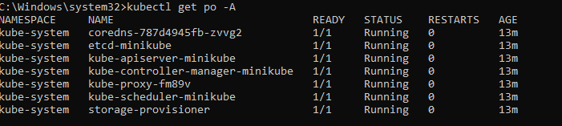

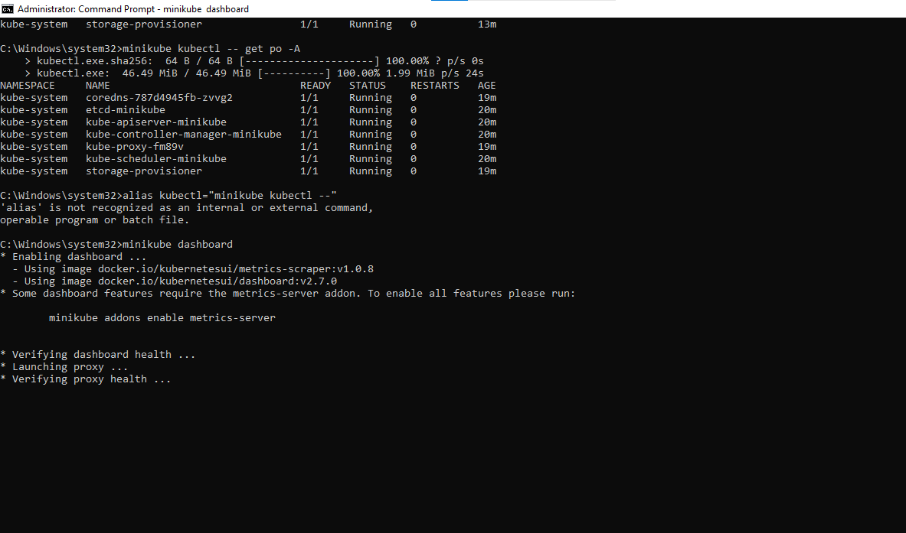

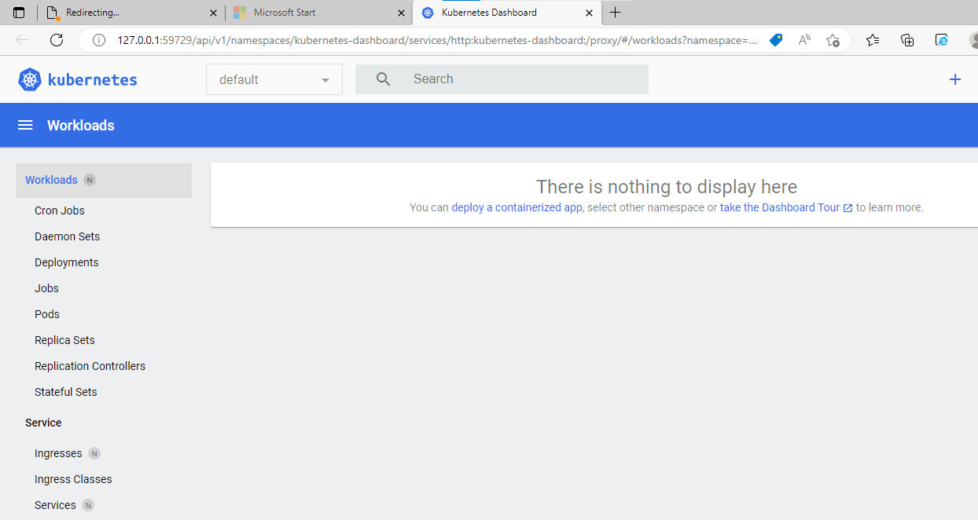

Now to deploy the hello-minikube application as a testing application we again open cmd

Create a sample deployment and expose it on port 8080:

**Give the following commands**

**kubectl create deployment hello-minikube --image=kicbase/echo-server:1.0**

**kubectl expose deployment hello-minikube --type=NodePort --port=8080**

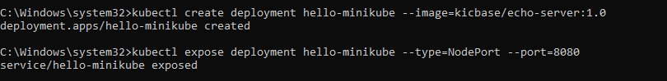

Now

**kubectl get services hello-minikube**



To access this service is to let the minikube launch a webrowser .

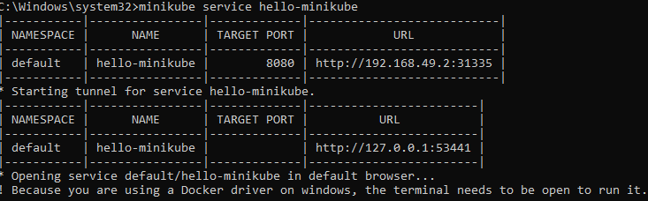

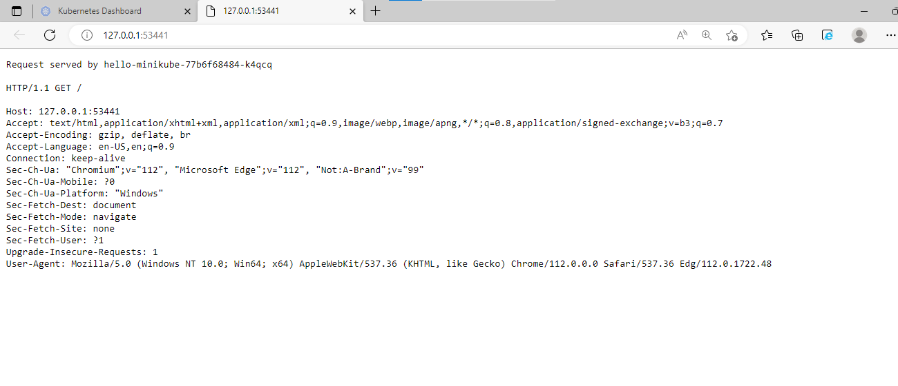

To forward the port use the following command

*Your application is now available at <http://localhost:7080/>

**kubectl port-forward service/hello-minikube 7080:8080**

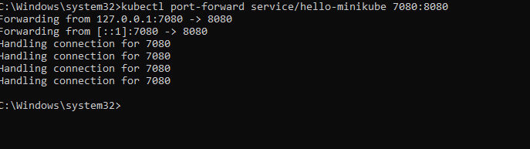

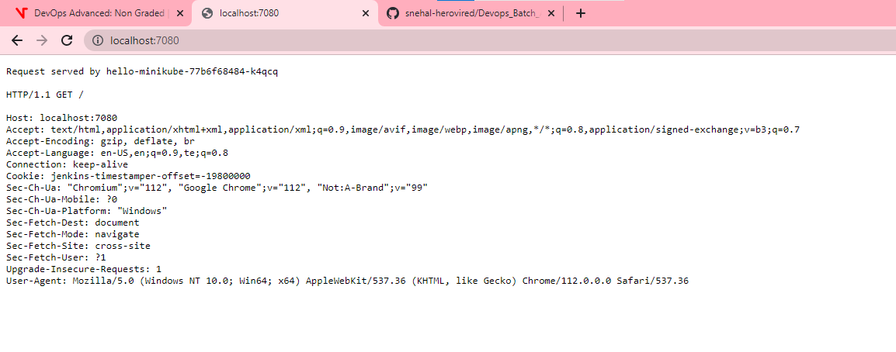

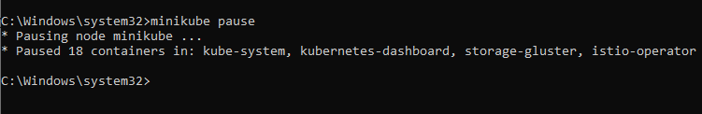



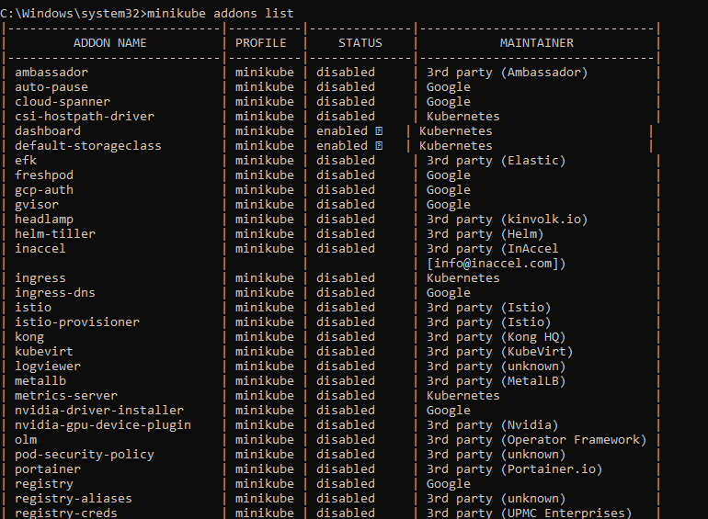

##### AND

**For EKS, use eksctl and go through the documentation:**

[**https://docs.aws.amazon.com/eks/latest/userguide/eksctl.html**](https://docs.aws.amazon.com/eks/latest/userguide/eksctl.html)

**Or**

[**https://eksctl.io/**](https://eksctl.io/)

**Follow the documentation to create your first cluster and after that**

**as a testing delete the cluster after creation.**

**For creation of second cluster , use command mentioned below:**

##### eksctl create cluster -n cluster1 - -nodegroup-name ng1 - -region us-east-1 - - node-type t2.micro - -nodes 2

**To create cluster in EKS using eksctl**

eksctl is a simple CLI tool for creating and managing clusters on EKS - Amazon's managed Kubernetes service for EC2. It is written in Go, uses Cloud Formation, was created by Weaveworks and it welcomes contributions from the community.

**Step1:**We need to create an IAM user

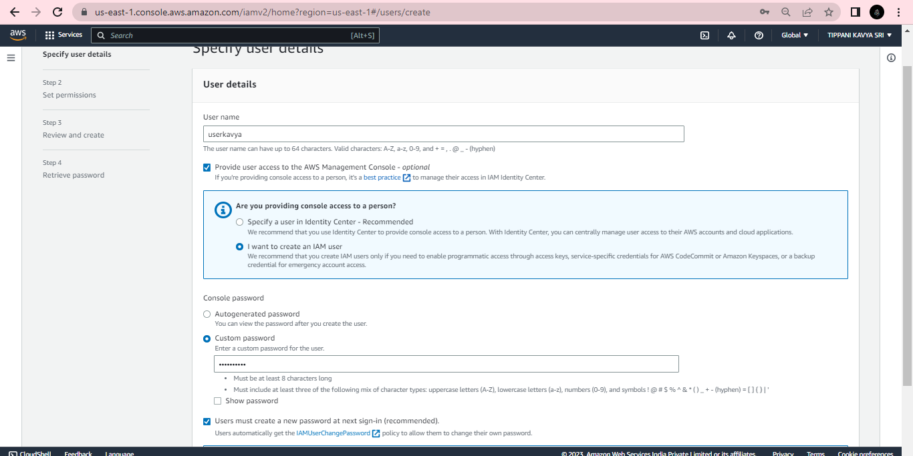

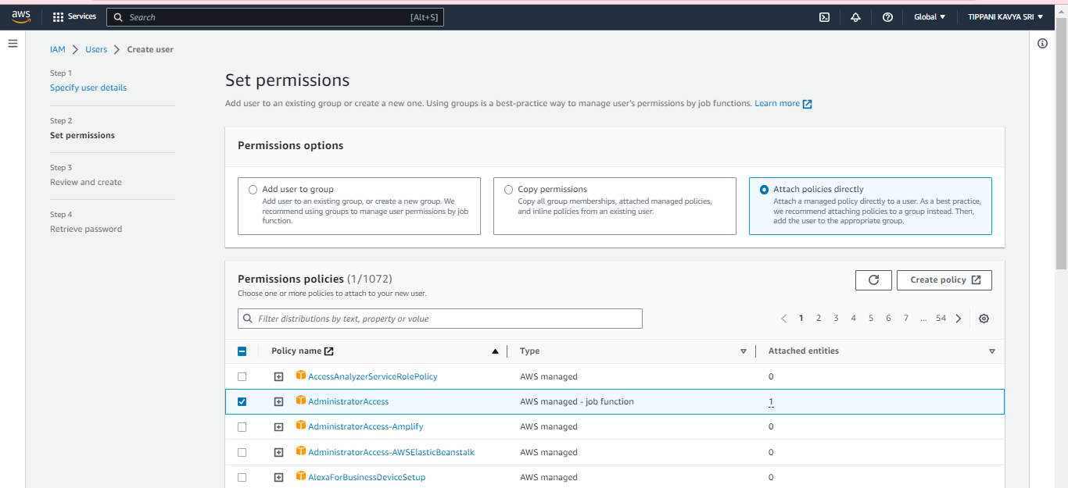

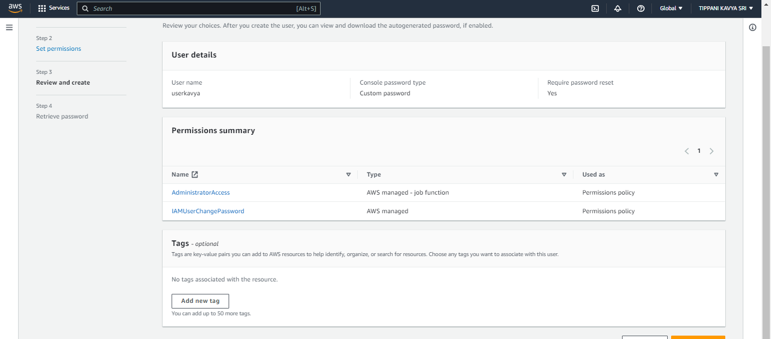

After creation of user click on user and then create an access key

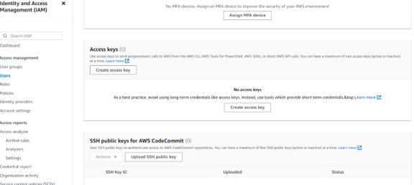

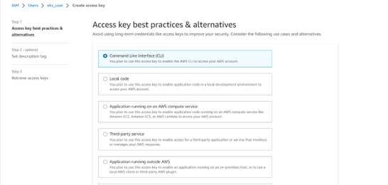

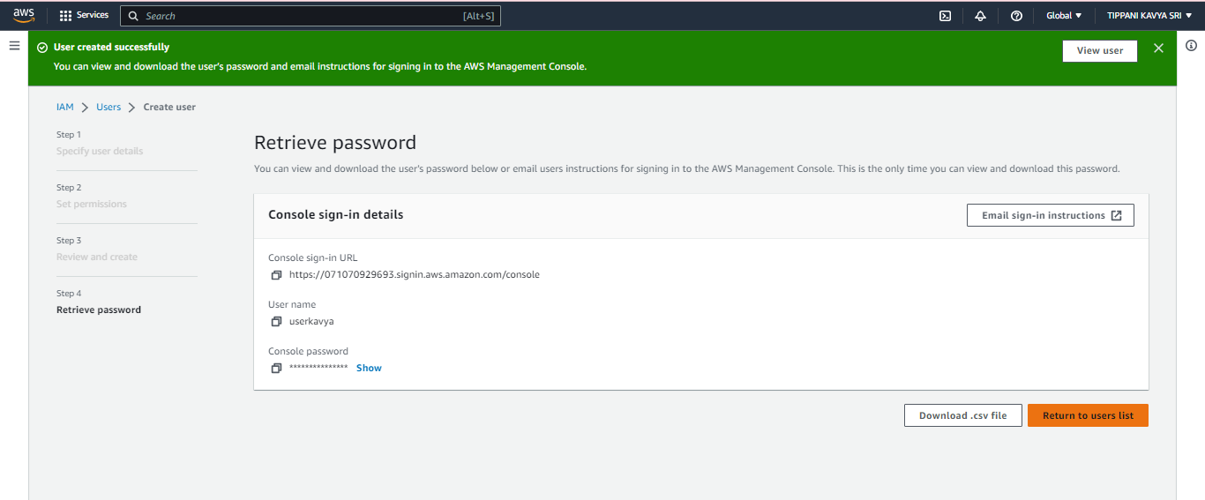

Download the csv file that consists of the access key and secret key

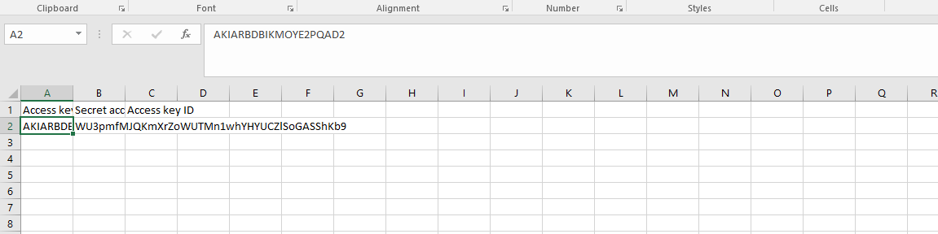

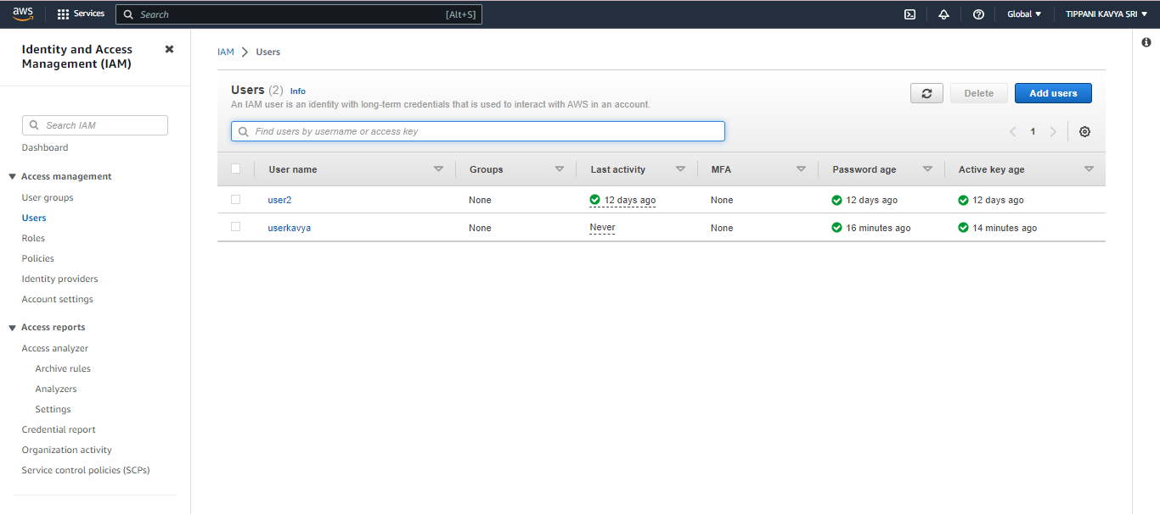

**Step2:**

Now install eksctl using chocolatey

By using the following command

**Choco install eksctl**

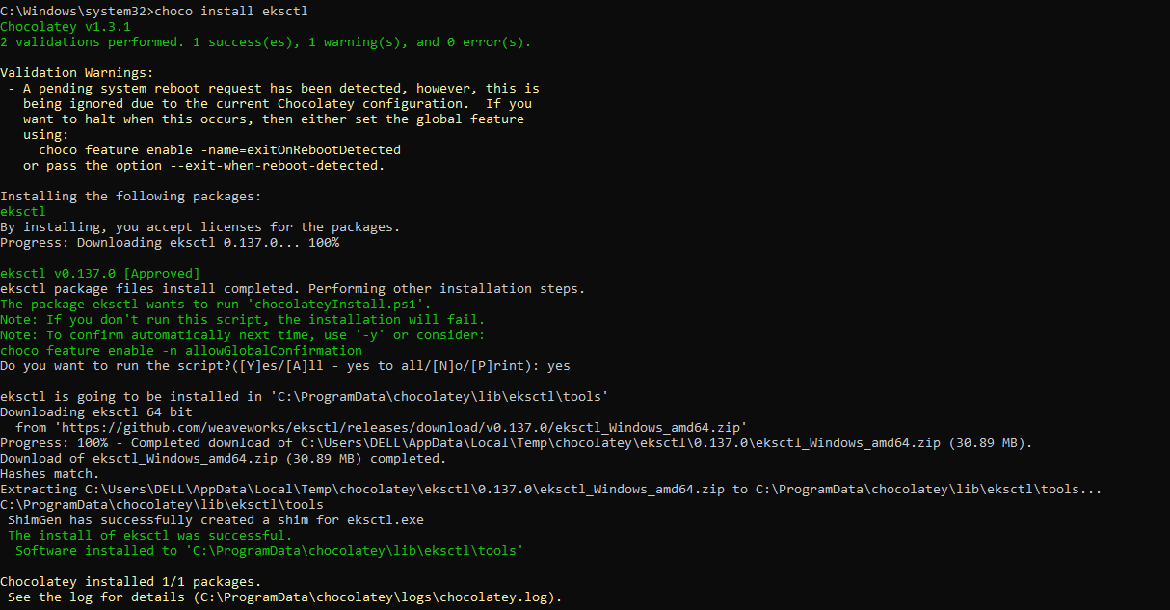

**Step3:** Then go to cmd and type **aws configure** then it will ask access key and secret key

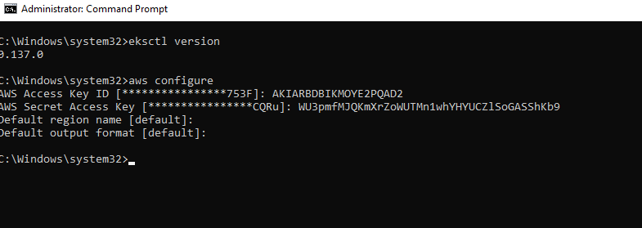

**Step4:** To create a cluster, apply command

**create cluster –name <name> –region <region>**

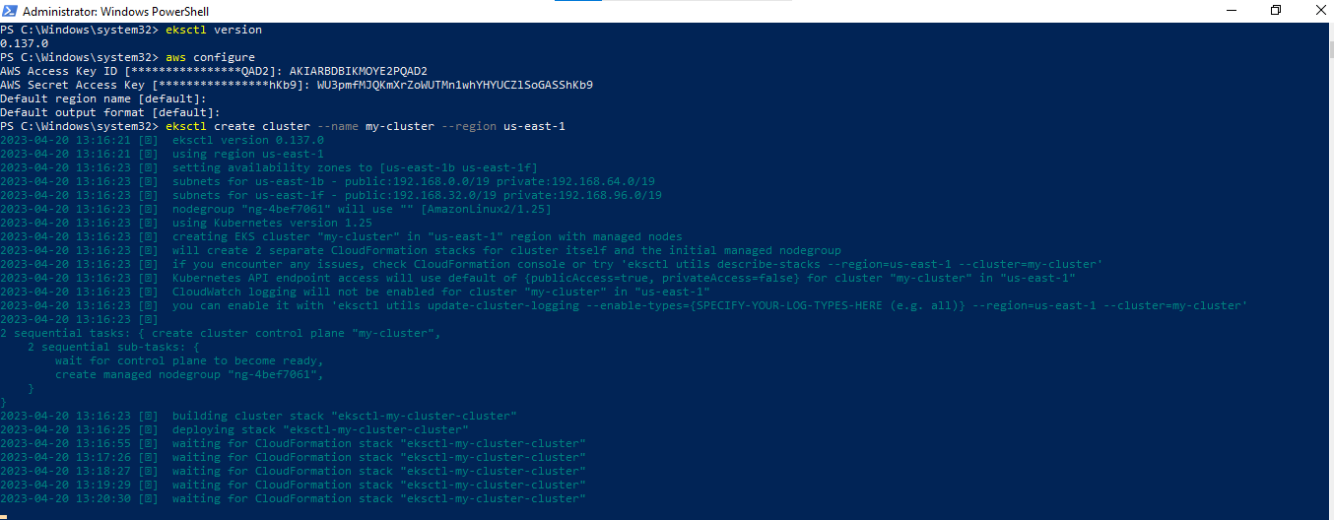

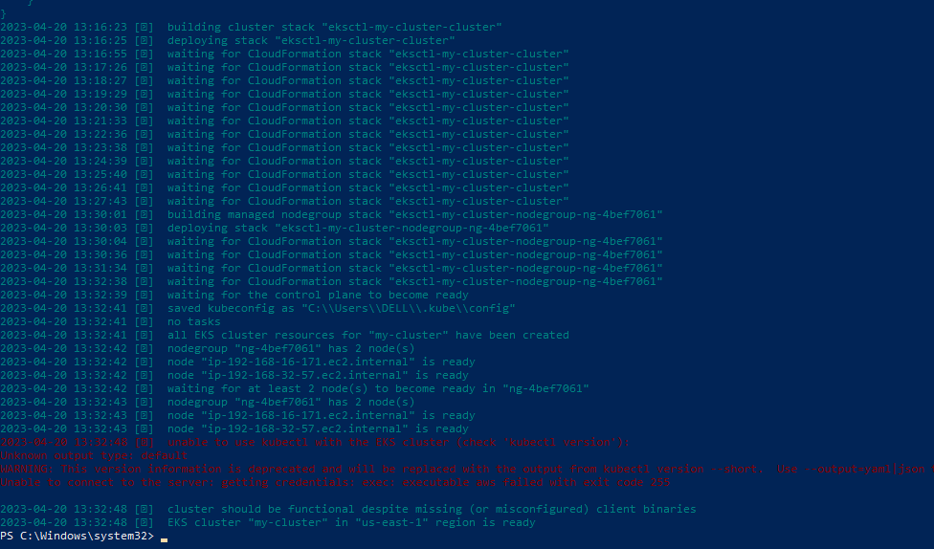

Here I have given the name as my-cluster

After that

you can see a cluster is created in EKS in AWS console and a stack in Cloud Formation and 2 instances in EC2.

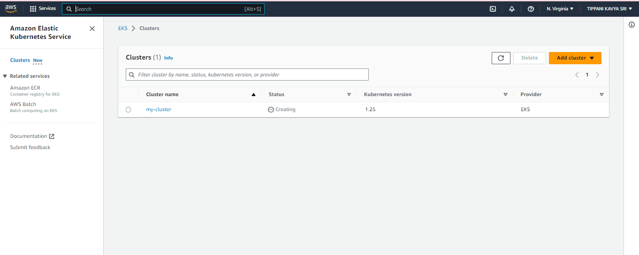

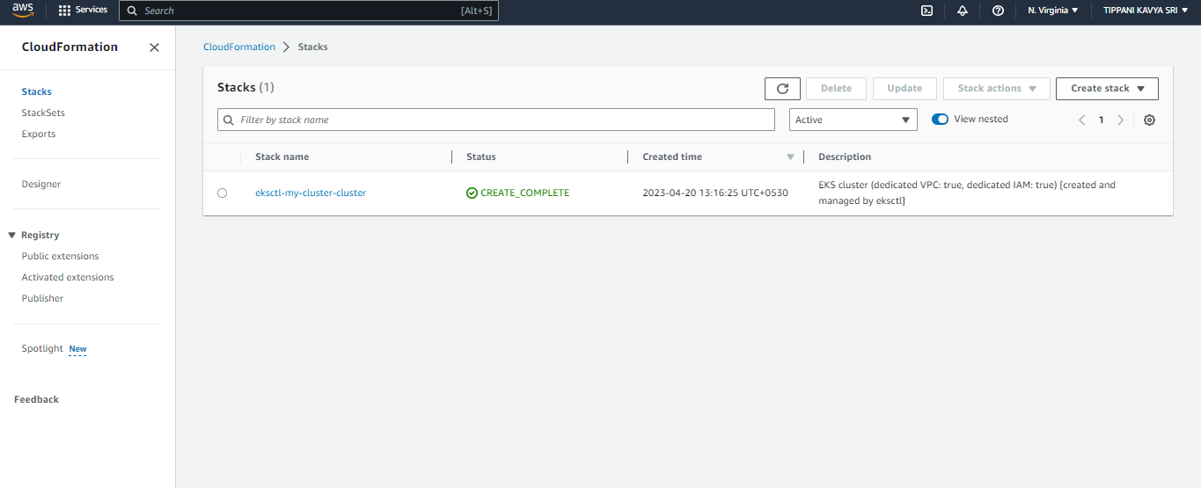

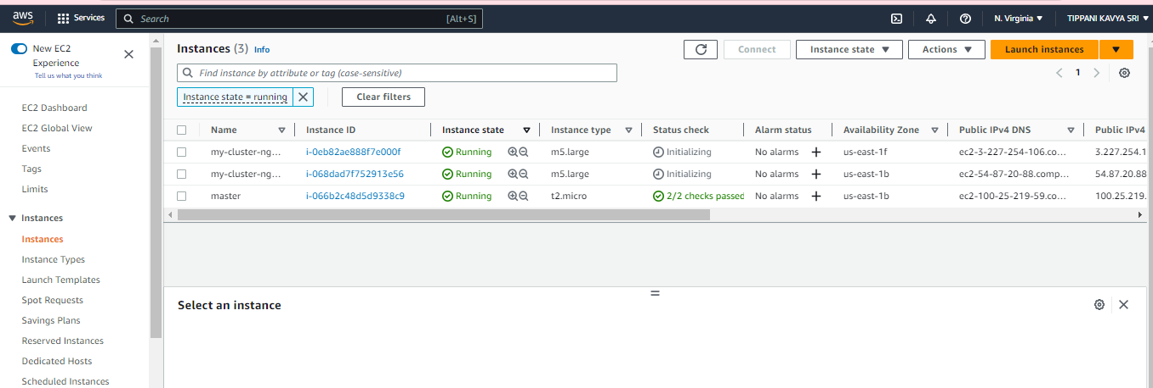

**Step 5:** to delete a cluster, use the command **delete cluster –name <name> --region <region>**

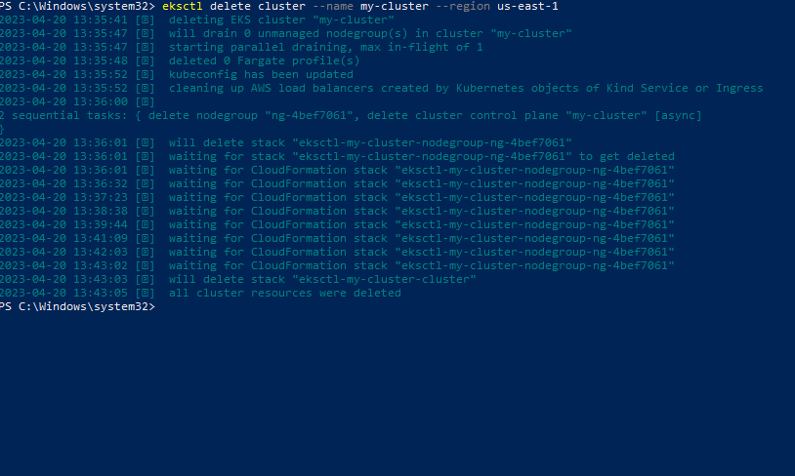

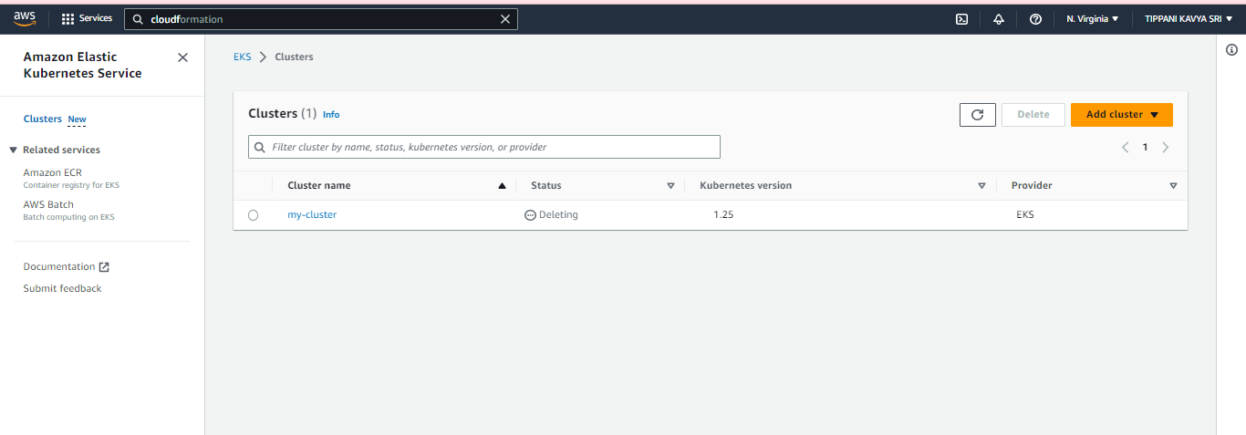

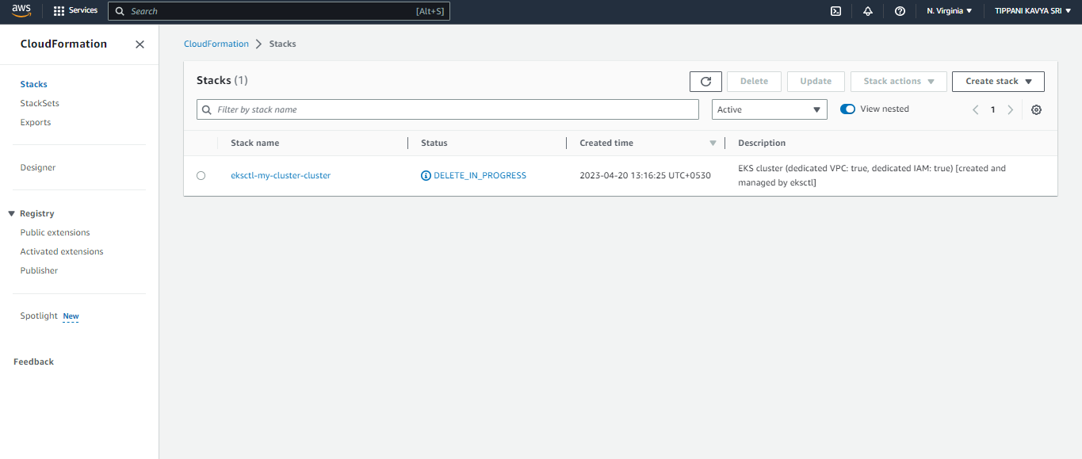

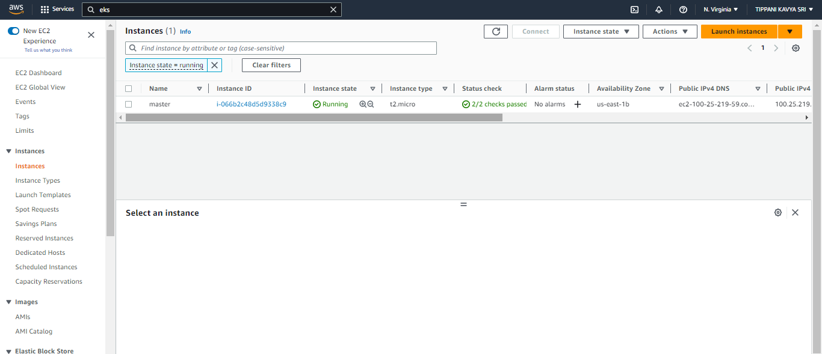

We can see the cluster, stack and 2 instances are no longer in AWS console page.

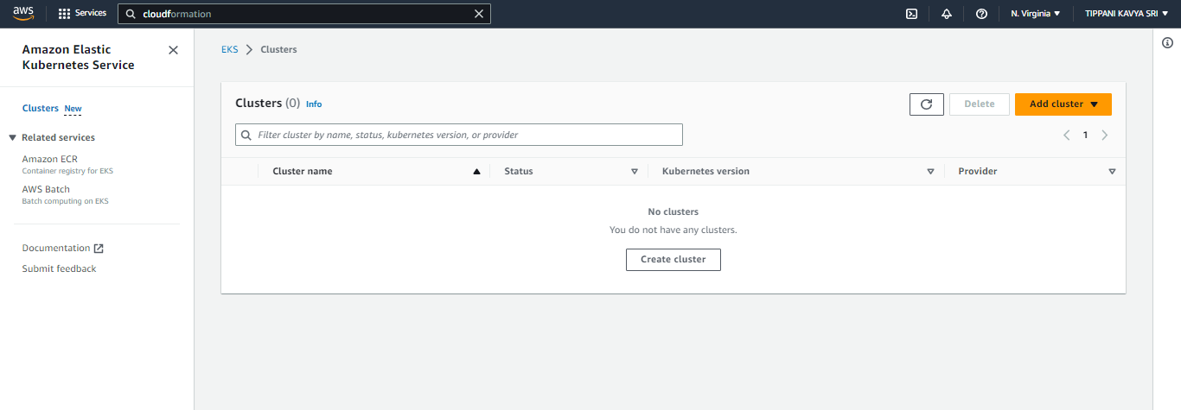

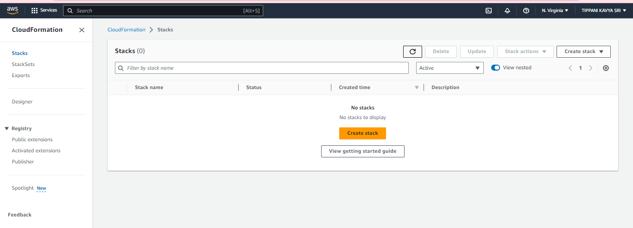

**Step6**: For creation of second cluster , use command mentioned below:

***eksctl create cluster -n cluster1 - -nodegroup-name ng1 - -region us-east-1 - - node-type t2.micro - -nodes 2***

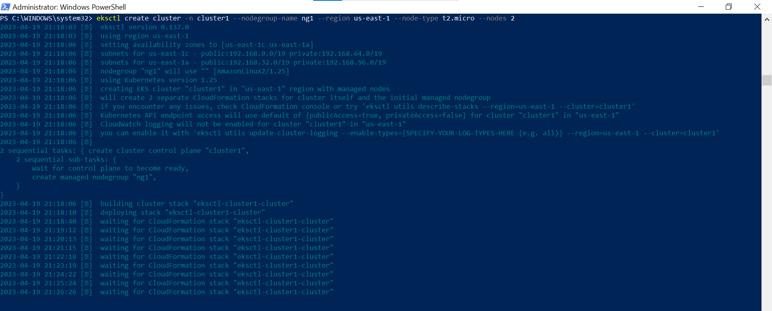

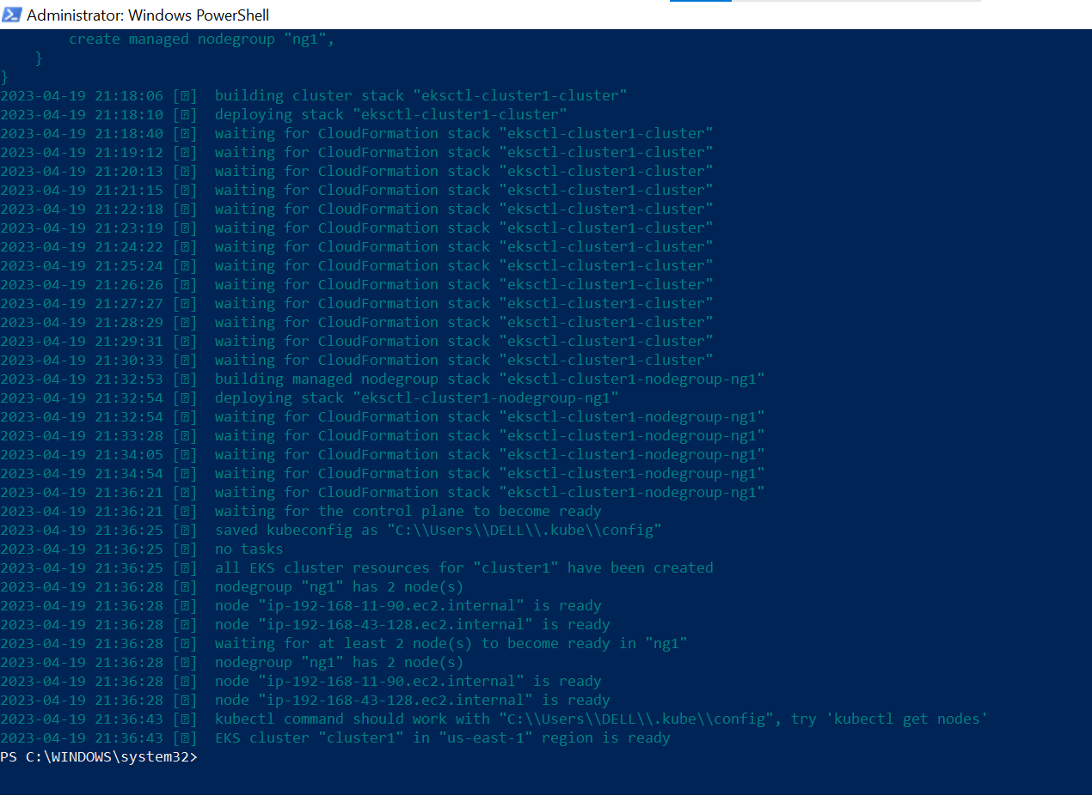

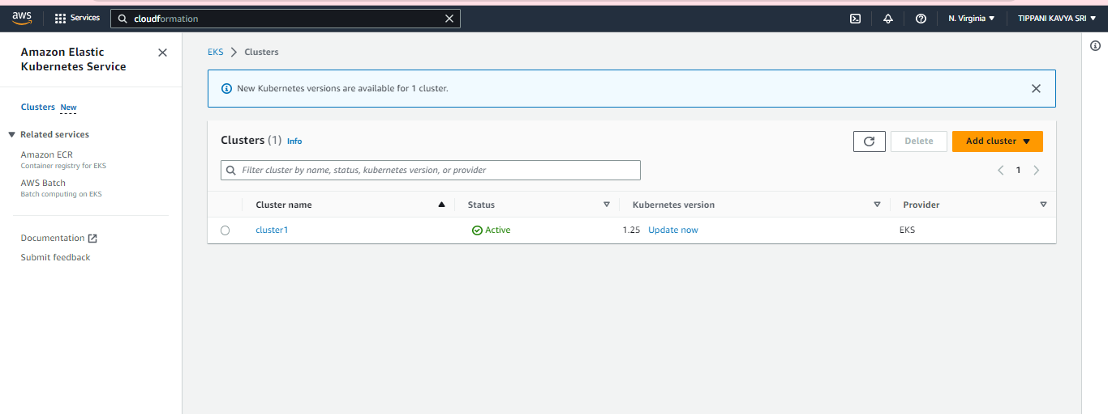

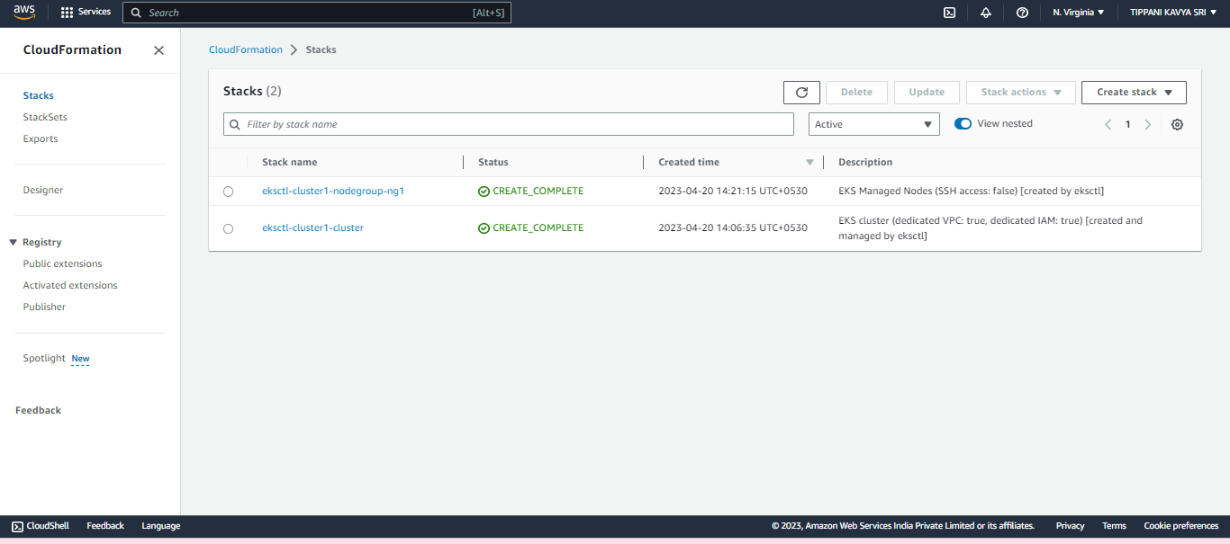

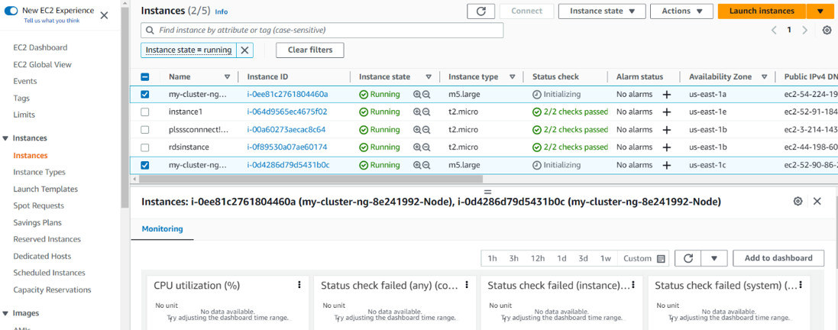

**Step 7:** to delete the created clusters use command, **delete cluster –name <name> --region <region>.**