WGCNA report

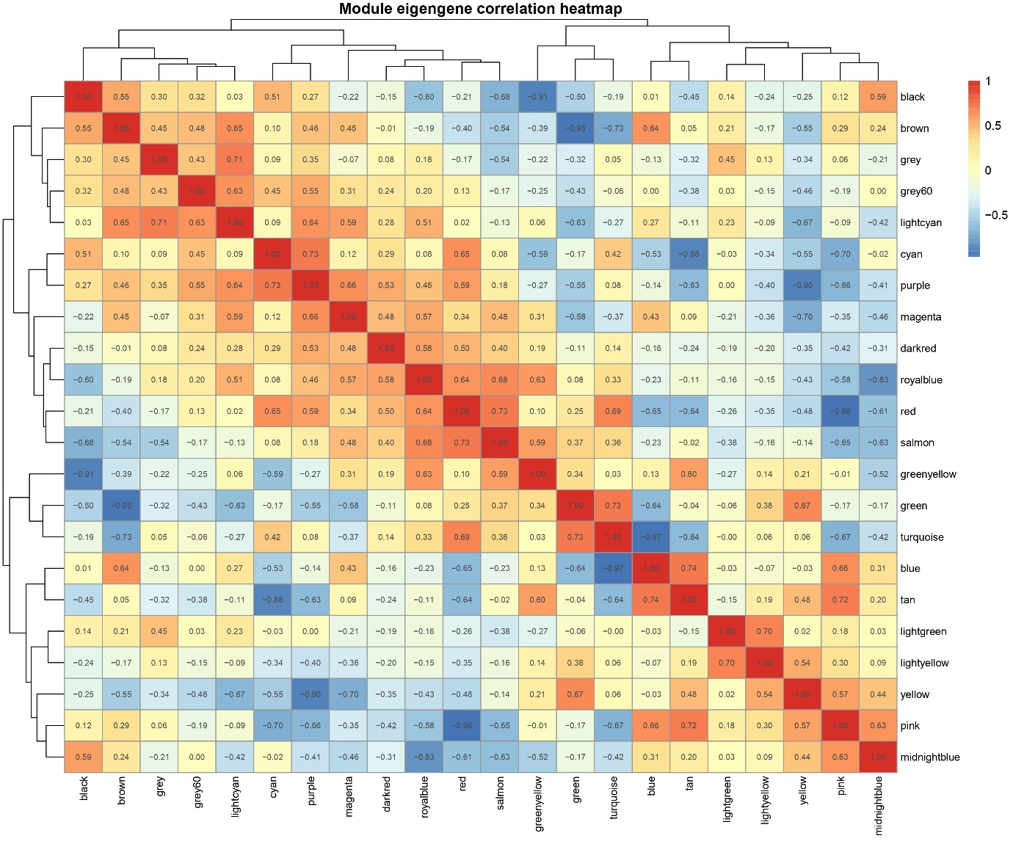

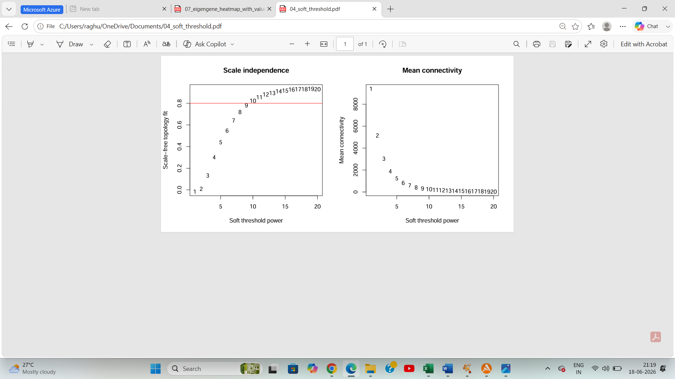

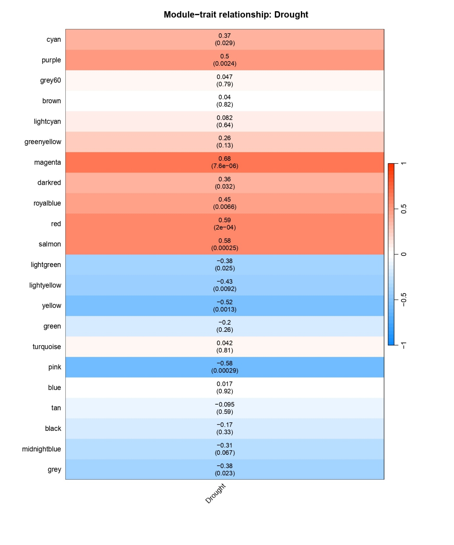

The top 5 modules which I got is : meganta, red, salmon, pink,yellow


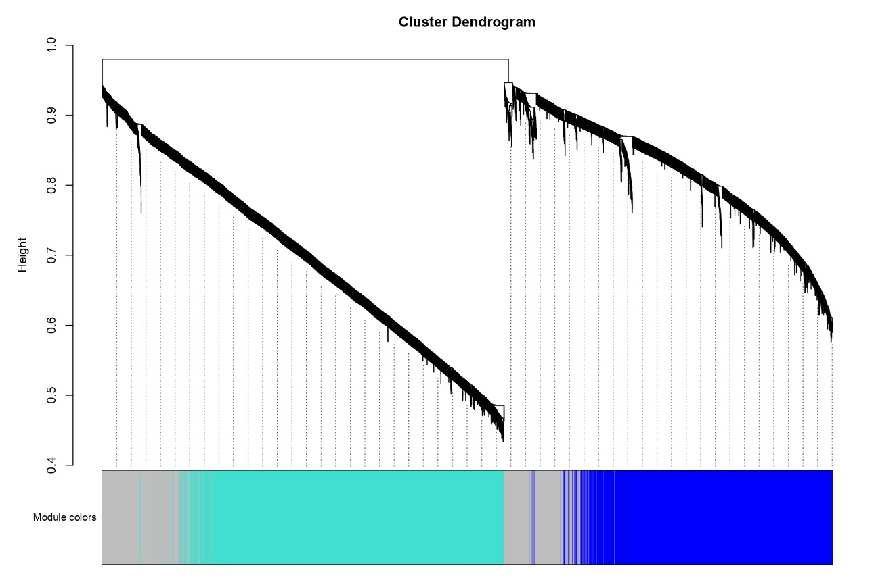

Meganta module
OsDAO2- enzymes degrade polyamines (putrescine, cadaverine, etc.) and generate H₂O₂, an important stress-signaling molecule. This signaling is involved in many abiotic stress responses.
Fraudentali, I., Rodrigues-Pousada, R. A., Angelini, R., Ghuge, S. A., & Cona, A. (2021). Plant copper amine oxidases: key players in hormone signaling leading to stress-induced phenotypic plasticity. International Journal of Molecular Sciences, 22(10), 5136. https://doi.org/10.3390/ijms22105136
OsKOB1 expression as a key regulator of rice seed germination under osmotic stress, modulating ABA homeostasis, osmoprotectant biosynthesis, and antioxidant defense to enhance stress resilience.
Tian, J., Yin, M., Huang, K., Zhou, S., Chen, T., Tang, N., ... & Jiang, X. (2025). The expression of Aldo-keto reductase gene OsKOB1 coordinates ABA homeostasis and antioxidant defense to maintain seed vigor under osmotic stress. Scientific Reports, 15(1), 27413. https://doi.org/10.1038/s41598-025-13633-9


Red module
Os09g0394700-Lysophospholipases participate in membrane lipid metabolism and remodeling. During drought, cell membranes experience oxidative damage and lipid peroxidation, so enzymes involved in phospholipid turnover can contribute to stress adaptation and membrane stability.
Sarma, B., Kashtoh, H., Lama Tamang, T., Bhattacharyya, P. N., Mohanta, Y. K., & Baek, K. H. (2023). Abiotic stress in rice: visiting the physiological response and its tolerance mechanisms. Plants, 12(23), 3948.https://doi.org/10.3390/plants12233948
OsTPKa- OsTPKa belongs to the TPK (Two-Pore K⁺ Channel) family, which regulates potassium movement across the vacuolar membrane (tonoplast) and helps maintain cellular K⁺ homeostasis.
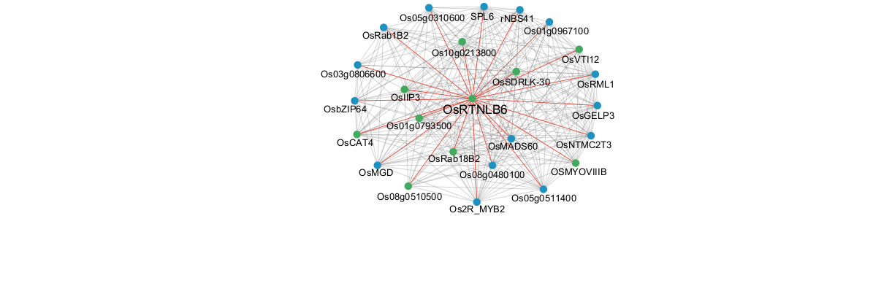
Isayenkov, S., Isner, J. C., & Maathuis, F. J. (2011). Membrane localisation diversity of TPK channels and their physiological role. Plant Signaling & Behavior, 6(8), 1201-1204. https://doi.org/10.4161/psb.6.8.15808

Salmon module
OsRTNLB6 belongs to the Reticulon-Like B (RTNLB) family, a group of proteins associated with the endoplasmic reticulum (ER) membrane.
Cao, G. H., Guo, X. L., Yang, Y. J., Xie, B., & Tang, L. L. (2025). RTN family and its response to abiotic stress in Oryza sativa. Scientific Reports, 15(1), 13134. https://doi.org/10.1038/s41598-025-97261-3

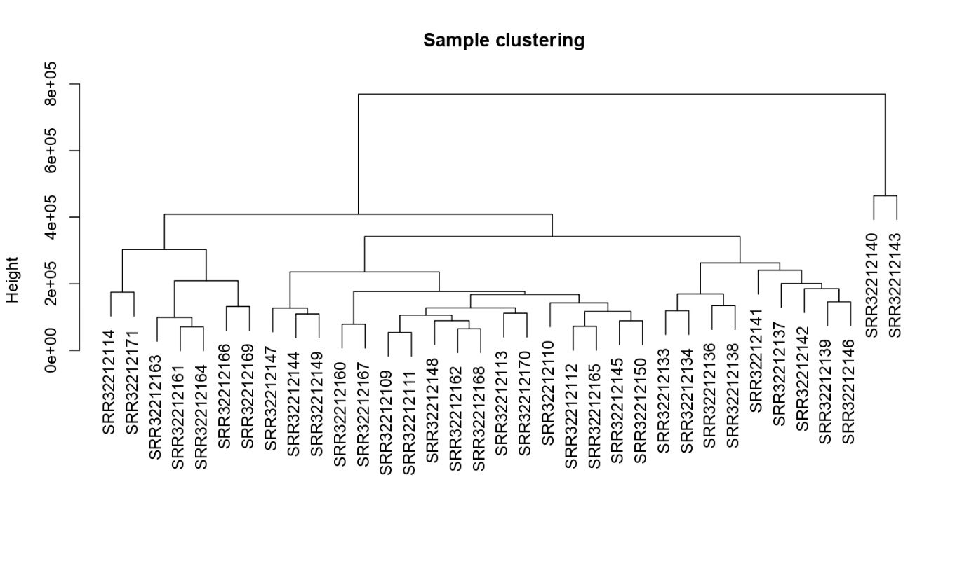

Top 50 important genes produced by AIML were distributed in the top 5 modules
Gene_id | Hubs by PPI | Importance | Module
Os01g0884300 | OsNAC6 | 0.061047 | magenta
Os01g0935400 |  | 0.046883 | red
Os01g0209800 | OsCAT1 | 0.046419 | magenta
Os02g0611500 |  | 0.044858 | yellow
Os02g0827100 |  | 0.03927 | yellow
Os04g0640900 | IIP5 | 0.037359 | yellow
Os01g0850000 |  | 0.032692 | magenta
Os10g0550900 | OsProDH | 0.030522 | red
Os06g0665500 | OsAAH | 0.02738 | red
Os07g0539300 | Gns13 | 0.027126 | yellow
Os03g0823400 | OSJNBb0081B07.13 | 0.024225 | yellow
Os03g0850400 | OsAK | 0.02159 | yellow
Os01g0850050 |  | 0.019777 | red
Os01g0693800 |  | 0.019772 | yellow
Os06g0524300 |  | 0.01893 | pink
Os02g0797500 | AST | 0.018839 | yellow
Os03g0203200 | D14 | 0.018035 | yellow
Os10g0390500 | ALAAT | 0.017785 | yellow
Os12g0621000 |  | 0.017566 | yellow
Os11g0143300 | OSRR9 | 0.017292 | pink
Os04g0482000 | OsMSRA2.1 | 0.016688 | magenta
Os12g0538700 | OsGRXC15 | 0.01581 | yellow
Os01g0144000 |  | 0.015574 | yellow
Os06g0684000 | P0009H10.17-1 | 0.015144 | yellow
Os11g0637700 | RBPA | 0.013317 | yellow
Os03g0752500 |  | 0.012873 | red
Os01g0612600 |  | 0.012448 | magenta
Os03g0254800 | OsCS | 0.011363 | yellow
Os03g0815100 | SNAC1 | 0.011358 | magenta
Os01g0766200 | OsRDCP3 | 0.011129 | red
Os05g0567600 |  | 0.01017 | red
Os02g0517531 | ML4 | 0.010013 | yellow
Os02g0258900 |  | 0.009783 | yellow
Os01g0853700 |  | 0.009329 | red
Os09g0516500 |  | 0.009024 | yellow
Os01g0559600 | OsVPE2 | 0.008421 | magenta
Os03g0665200 | OSJNBb0031A14.9 | 0.008193 | yellow
Os02g0221900 | Os1900 | 0.008 | magenta
Os01g0130900 |  | 0.007793 | yellow
Os02g0518000 |  | 0.007781 | magenta
Os03g0167500 | OsRMR3 | 0.007739 | pink
Os01g0261200 | OsNAC8 | 0.007557 | magenta
Os09g0469950 |  | 0.007366 | yellow
Os03g0129400 |  | 0.006463 | yellow
Os07g0678600 | OsCIPK02 | 0.006446 | red
Os05g0560200 | OsDOG1L-3 | 0.006216 | yellow
Os02g0813500 | OsGR2 | 0.00604 | magenta
Os10g0140200 |  | 0.005811 | pink
Os10g0344000 |  | 0.005808 | red
Os03g0425300 | OSJNBa0020H02.13 | 0.005591 | red

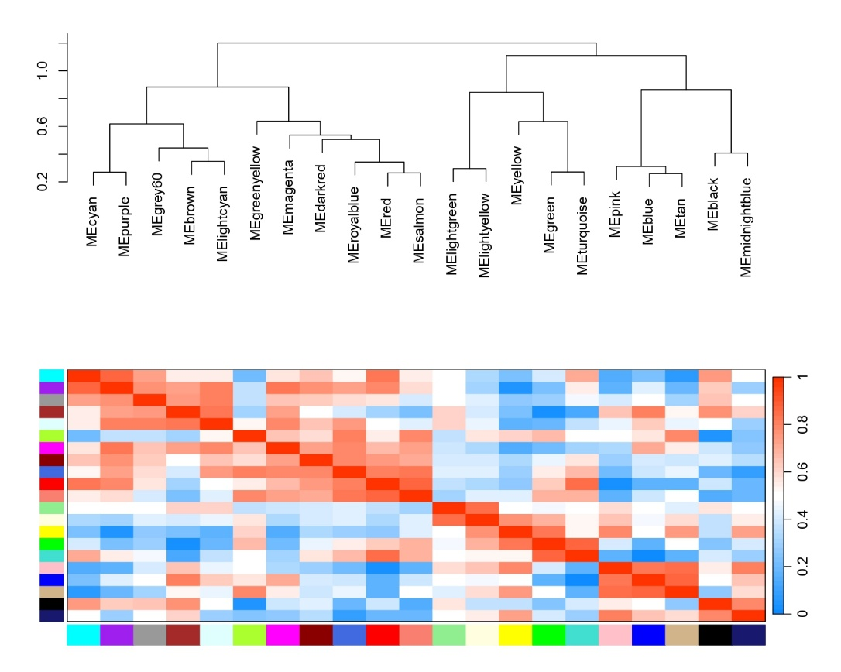
Processing threshold network: magenta
Original genes: 843
Genes kept: 563
Edges: 11122

Processing threshold network: red
Original genes: 1455
Genes kept: 1363
Edges: 249877

Processing threshold network: salmon
Original genes: 393
Genes kept: 247
Edges: 2804

Processing threshold network: pink
Original genes: 1158
Genes kept: 1050
Edges: 119785

Processing threshold network: yellow
Original genes: 1675
Genes kept: 1661
Edges: 593448

