**JOLENE-VOICE ASSISTANT**

A PROJECT REPORT

## Submitted by

**KAWALMEET SINGH**



# Institute for Systems Studies & Analyses

# Defense Research and Development Organization

24/04/2022 -- 25/06/2022

# ACKNOWLEDGEMENT

I have tried to put all my efforts in this project. However, this project would not have been possible without few people who helped me to complete this project.

I am highly obliged to our In-charge “Smt. Neha Aggarwal”, Sc-‘D’at DRDO, for her guidance and support. She also provided all necessary information for the completion of project.

I would also like to thank my teachers who helped me and guided me at every stage. I can't say thank you enough for their continuous support and help.

I would also like to express my gratitude towards my friends also who willingly helped me out according to their skills.

# CONTENT

1. Chapter-1 Introduction
2. Chapter-2 Artificial Intelligence
   1. Branches of AI
   2. Applications of AI
3. Chapter-3 Why Python For AI
4. Chapter-4 Working

4.1 How Jolene Run

4.2 Taking Commands

1. Chapter-5 Features
2. Chapter-6 Main function and modules
3. Chapter-7 Source code
   1. Basic Section
   2. Main Section
   3. Glimpses
4. Chapter-8 References

# Chapter-1 Introduction

There are many modern inventions and pieces of technology that may simplify your life. A person may also seek to improve the functionality of their daily chores.

As of right now, Siri, Alex, and Google Assistant are examples of technology that simplifies routine activities. These jobs involve, among others, looking up information on "Wikipedia baseball" and the current date.

Jolene is a voice assistant model like Alexa and Siri. She is coded in Python and is based on the Natural Language Processing (NLP) which means she can take commands in the common human language. She is capable of telling the time with only one command and many others, and for that one command, one only has to voice the command.She will carry out the request and offer the person the desired outcome.

# Chapter-2 Artificial Intelligence

Artificial intelligence (AI) is the process of transferring human intelligence to a computer that has been trained to replicate human behavior.

The capacity of AI to reason and carry out actions that have the best chance of achieving a particular objective is its ideal feature. Machine Learning is a subtype of artificial intelligence, which refers to a computer program's ability to autonomously learn and adapt to new knowledge without human supervision. Deep learning approaches allow for autonomous learning by ingesting enormous volumes of unstructured data, such as text and images**.** AI is currently applied in a wide variety of settings and contexts. Machines that can perceive, reason, think, and act are needed. AI and brain research are closely connected fields of study. AI, according to researchers, can be developed by comprehending how the human brain functions. A machine can be built with the aid of AI ideas.

# 2.1 Branches of artificial intelligence

It is important to understand the various fields of study within AI so that a person can choose the right framework to solve a given real-world problem. Some of the branches of AI are:

1. **Machine learning**: This is arguably the most widely used type of AI. We create and create computer programs that can learn from data. On the basis of these learning models, we make predictions about ambiguous data. The fact that these programs are constrained by the data's power is one of the major limitations in this situation. The learning models would be constrained if the dataset was small.
2. **Deep Learning:** Deep learning involves using neural networks to large amounts of data in order to derive insights and create solutions. Advanced machine learning techniques, such as deep learning, can be utilized to address increasingly complex issues. The face verification algorithm on Facebook, autonomous vehicles, virtual assistants like Siri and Alexa, and other systems operate using deep learning.
3. **Natural Language Processing**: Natural Language Processing (NLP) is the study of using natural human language to extract information that may be used to build companies and interact with technology.
4. **Robotics**: A subfield of artificial intelligence called robotics focuses on the various uses and applications of robots. Artificial intelligence (AI) robots are agents that operate in the real world and achieve results by assuming responsibility for their actions.
5. **Fuzzy Logic**: Instead of the typical modern computer logic, which is Boolean in nature, fuzzy logic is a computing technique based on the principles of "degrees of truth."
6. **Expert Systems**: An AI-based computer system known as an expert system learns from and mimics the decision-making abilities of a human expert. Expert systems handle complex issues using if-then logical notations. It is independent of traditional procedural programming. The main applications of expert systems are in information management, healthcare facilities, loan analysis, virus detection, and other fields.

# 2.2 Applications of AI

1. **Education**: Grading can be automated by AI, giving the instructor more time to educate. A teaching assistant AI chatbot can interact with pupils. In the future, AI might serve as a convenient personal virtual tutor for students, available at any time and anywhere.
2. **Automotive Industry**: Some sectors in the automotive sector are utilizing AI to give its users virtual assistants for better performance. Tesla, for example, recently unveiled TeslaBot, a clever virtual assistant. Many industries are actively attempting to build self-driving automobiles that can increase the safety and security of your journey.
3. **Speech Recognition:** These devices have the ability to hear and comprehend spoken language. On our cellphones, for instance, there are intelligent personal assistants that can hear what we are saying and provide pertinent information or take an action depending on that.
4. **Games:** The game business makes substantial use of AI. Designing intelligent agents that can compete with humans is done using it. For instance, the computer program Alpha Go is capable of playing the strategy game Go. Many other game genres where we anticipate sophisticated AI behavior employ it as well.
5. **Healthcare:** In the recent five to ten years, AI has become more beneficial for the healthcare sector and is expected to have a big impact on this sector. AI is being used in the healthcare sector to diagnose patients more quickly and accurately than humans. AI can assist doctors with diagnoses and also alert them when patients' conditions deteriorate so that treatment can be administered before the patient is hospitalized.

# Chapter-3 Why Python for Artificial Intelligence

One of the most widely utilized programming languages among developers right now is Python. It was invented by Guido Van Rossum in 1991, and since then, along with C++, Java, and other languages, it has become one of the most popular.

Python has established a commanding lead in the race to choose the best programming language for AI and neural networks.

Python artificial intelligence is one of the best concepts. Characteristics and Benefits of Python is an interpreted language, which means that the developer can use it immediately to run the program without having to first compile it into machine language instructions. As a result, it is thorough enough for the language to be understood by a person,

Given its high level of abstraction, it can be used to complex situations. High level languages make a program more complete and usable by dealing with variables, arrays, objects, complicated math or Boolean expressions, and other abstract computer science ideas.

Python offers the least code among others and is in fact 1/5 the number compared to other OOP languages. Python is also a General-purpose programming language which means it can be used across domains and technologies. Python also features dynamic type system and automatic memory management supporting a wide variety of programming paradigms including object-oriented, imperative, functional, and procedural to name a few.

# Chapter-4 Working

**4.1 How Jolene run**

Since Jolene is based on a branch of Artificial Intelligence which is Natural Language Processing (NLP), she mostly responds to human voice commands. When she initially launches, she will greet the user with a greeting based on the time zone, for instance, "Good Morning Sir, I am Jolene. Please tell know how I may help you.” The screen will then display listening, which is the point at which the user issues a command. The command will move forward in one of two situations.

The first time the command is understood and carried out as the user requested. Second, if the command is improperly supplied or the application doesn't understand it.In this situation, the application will ask “could you say it again please” and goes back to the initial to the first level.

**4.2 Taking Commands**

As mentioned above after wishing the user Jolene will take commands and will try to fulfil the command . After the fulfilment of the command , she will continue to take commands until the user command “offline” and she will stop taking the command .

# Chapter-5 Features

There are several features in the program, some of them are described below:

1. **System Status:** In order to check the battery level while working, a person may simply ask the application to inform him of the system status rather than constantly checking the status bar.
2. **YouTube—**YouTube is the most often visited website by all users, and the program makes it simpler by accessing it at the user's request. The application can display the most recent news to the user by the command of news and it will open the website's updated page.
3. **Date and Time –** Users must update the date and time, which the program does for them, making it easy.
4. **Joke-** The purpose of humor comes into play when there is a need to periodically alleviate the user's mind.
5. **Wikipedia-** This website's function is useful when a user requires information on a specific subject.
6. **Chrome-** Since Chrome is the most popular and widely used web browser, the application includes a mechanism for opening Chrome.

# Chapter-6 Main function and modules

1. **Pyttsx3**:

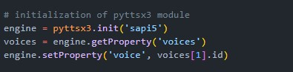pyttsx3 is a text-to-speech conversion library in Python. Unlike alternative libraries, it works offline and is compatible with both Python 2 and 3. An application invokes the pyttsx3. init() factory function to get a reference to a pyttsx3.

1. **Date and time:**

It is a library that connects with the current time zone of the area and shows the specific date and time.

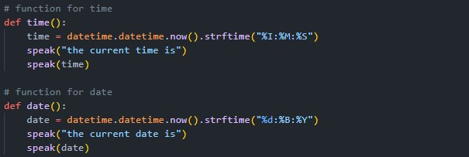

1. **Speech recognition**

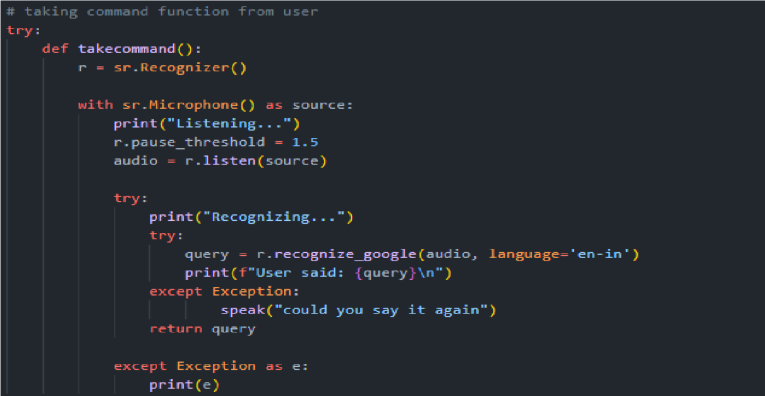Python's speech recognition module uses Py audio, which is only necessary if you want to use microphone input (microphone). It is necessary to use Py Audio version 0.2.11 or later because earlier versions have memory management issues when recording from microphones in some circumstances. Everything in the library will still function without it, with the exception that trying to instantiate a microphone object will result in an Attribute Error. After that, we set up

the module's recognizer function.

1. **Pyjokes**

Python module that offers jokes that programmers are likely to understand

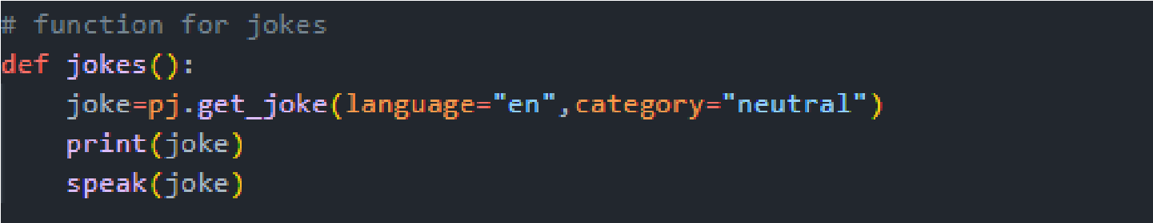

1. **Psutil**

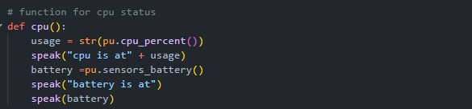The cross-platform library psutil (python system and process utilities) is used to retrieve data on active processes and system utilisation (CPU, memory, discs, network, sensors) in Python. It is most helpful for managing currently running processes, limiting process resources, profiling, and system monitoring.

1. **Wishing function**

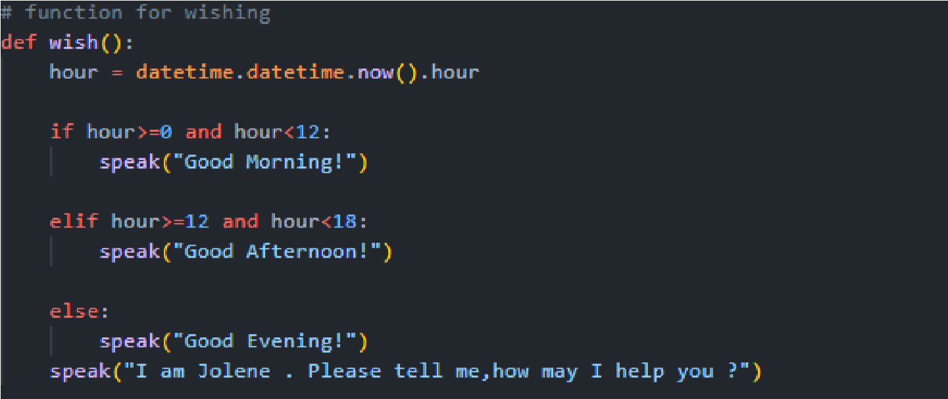This function uses the Python date and time module to wish users a good morning, noon, after noon, evening, and night.

**7. Selenium**

Selenium WebDriver bindings for the Python language. Python web browser interaction can be automated with the help of the selenium package. Firefox, Chrome, and Internet Explorer are just a few of the drivers and browsers that are supported, along with the Remote protocol.

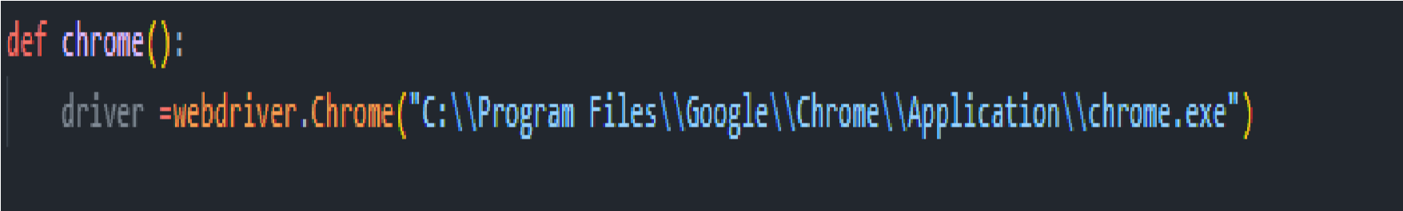

# Chapter-7 Source Code

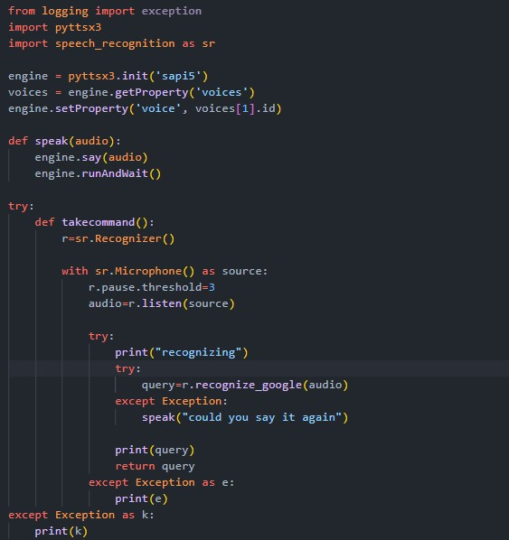

.1

**7.1 Basic Section**

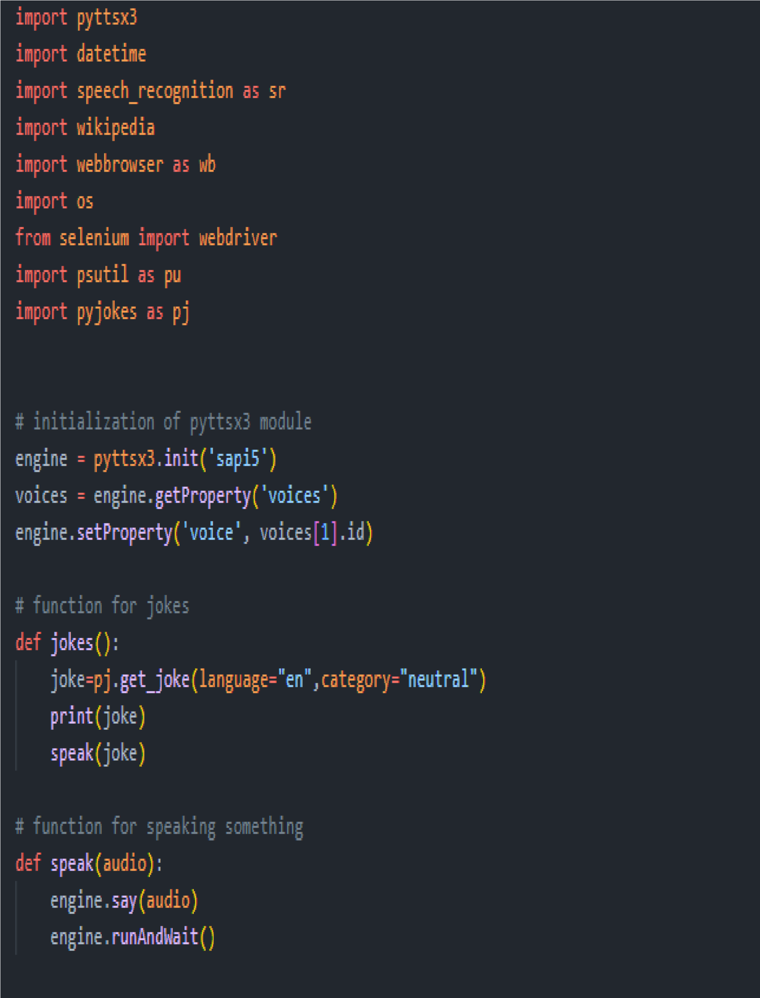**7.2 Main Section**

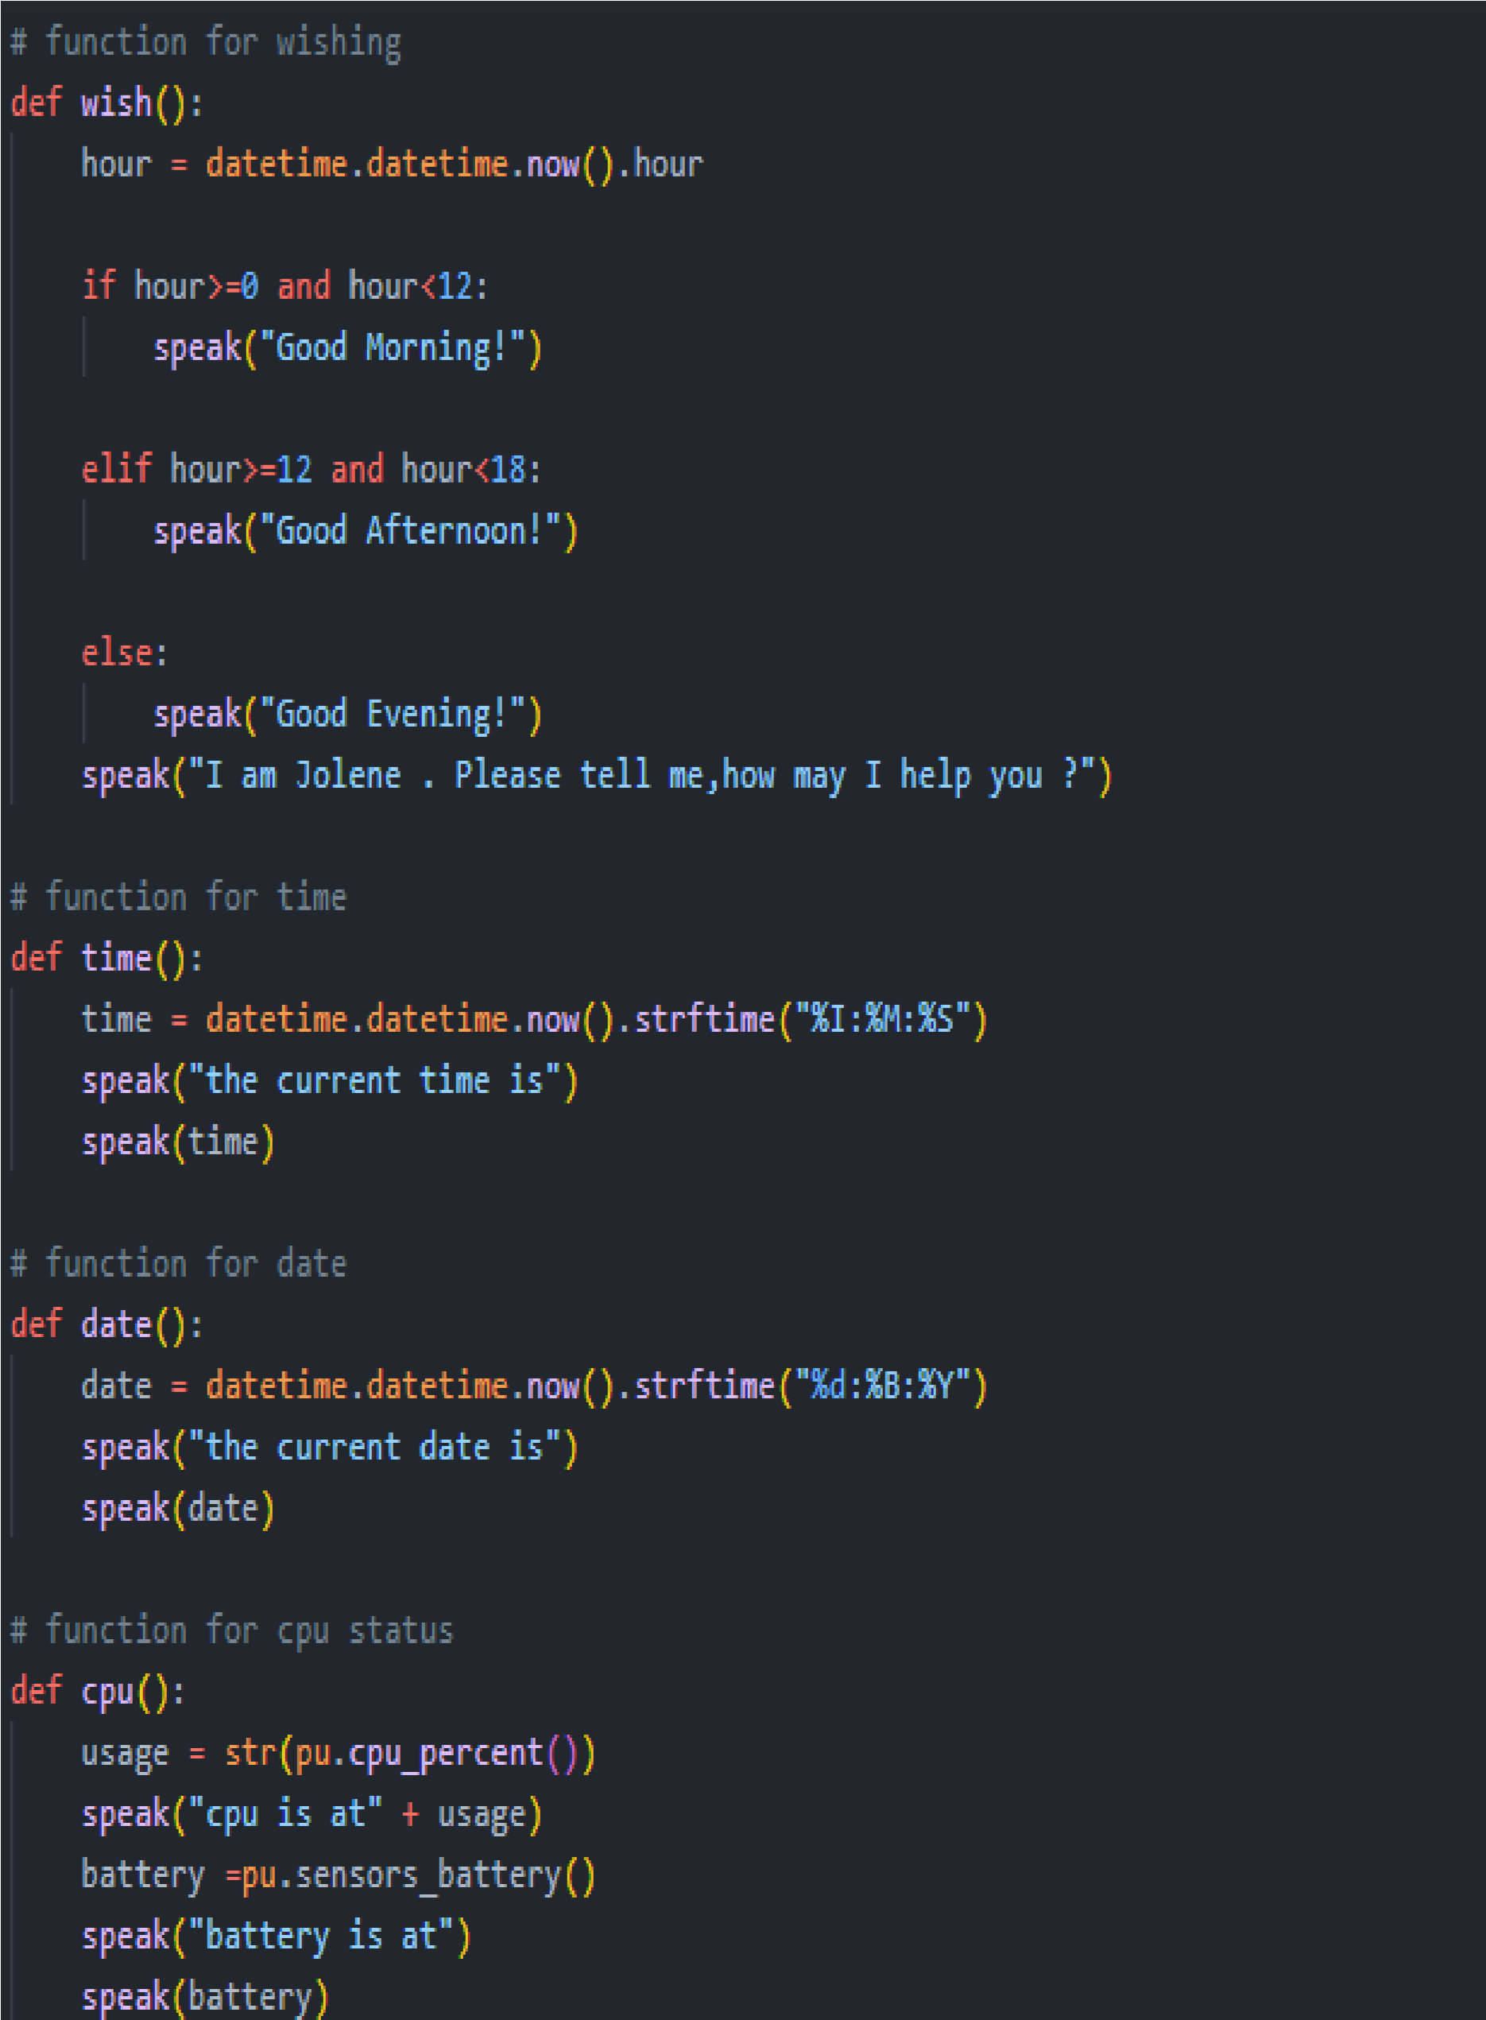

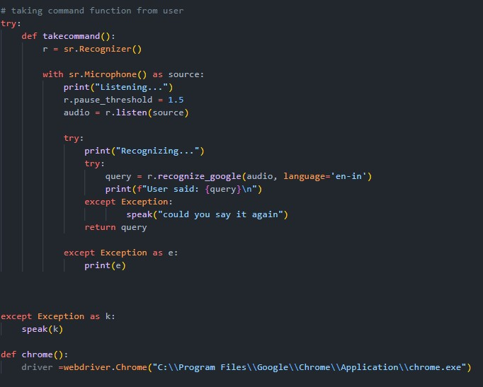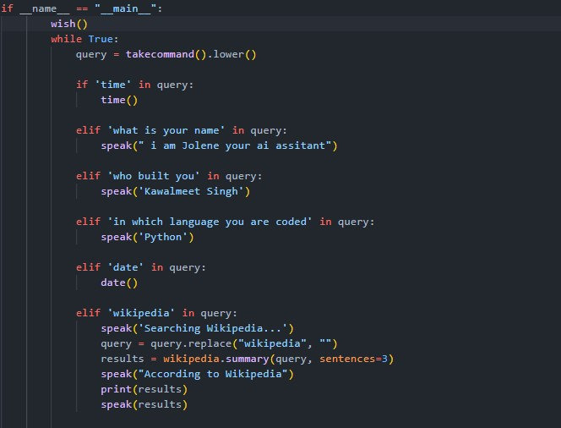

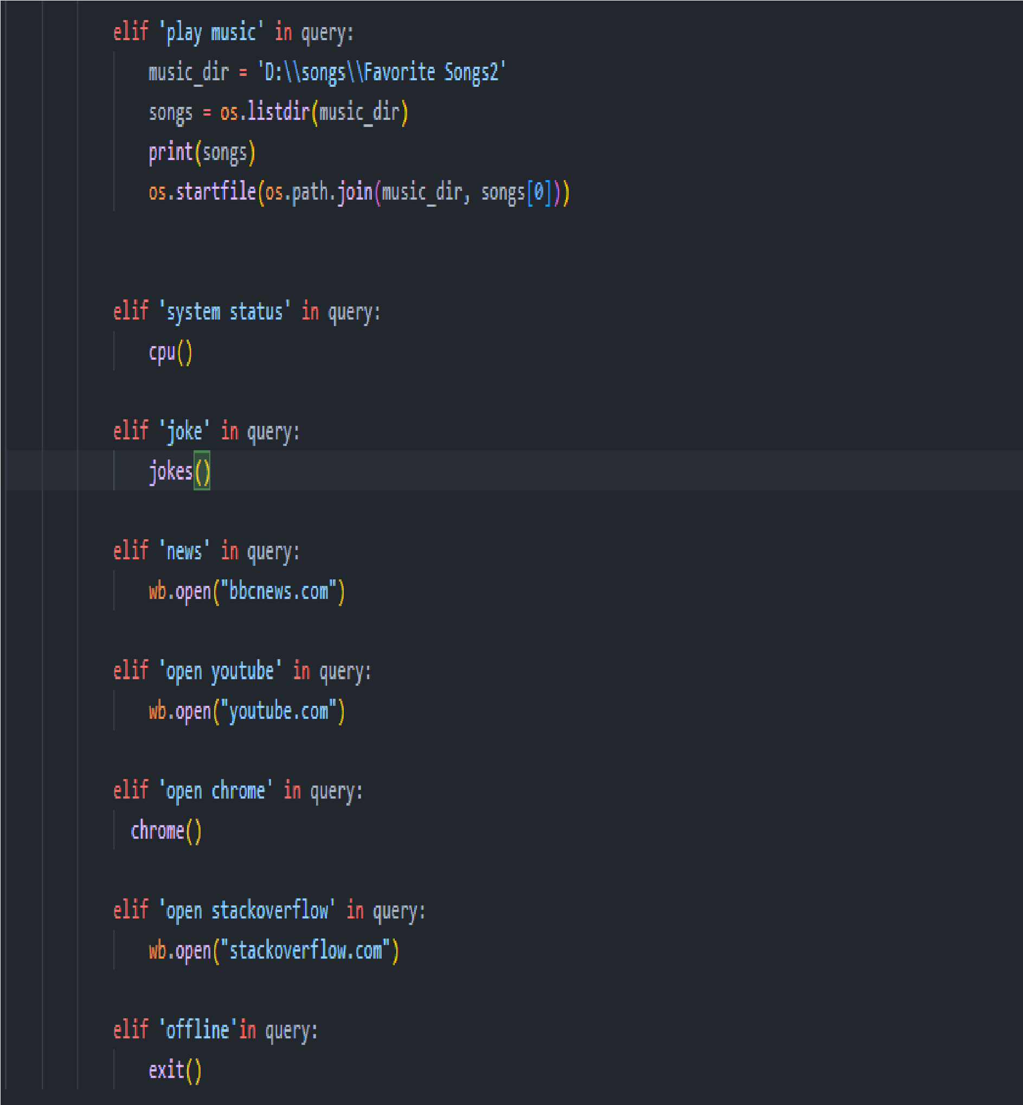

* 1. **Glimpses**

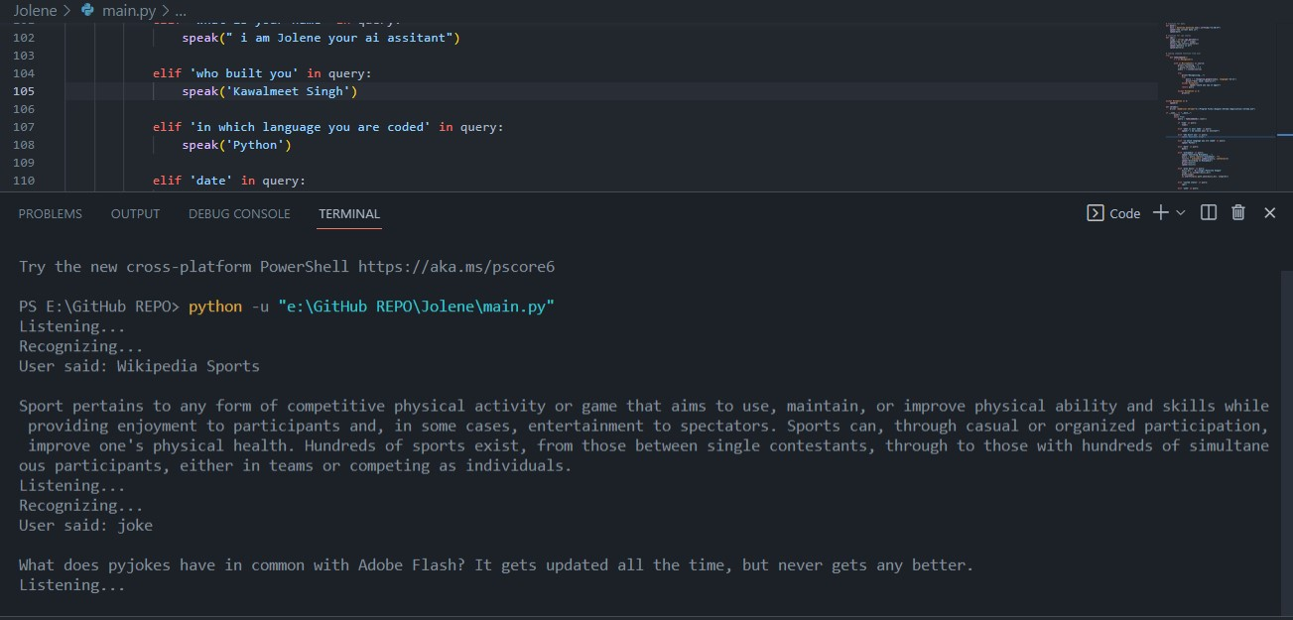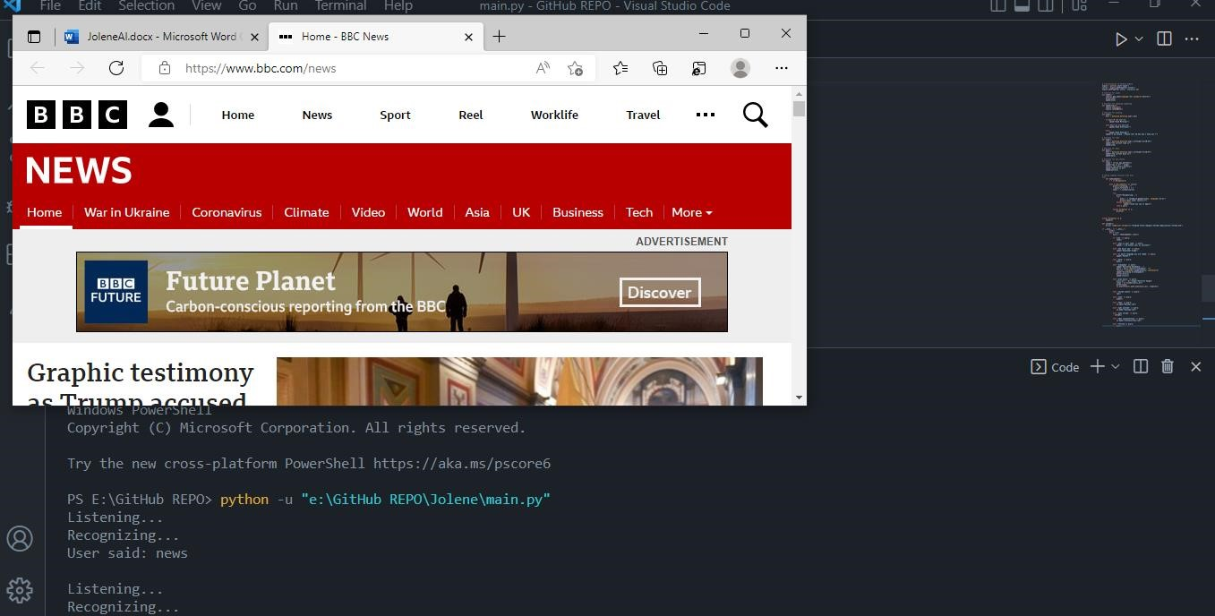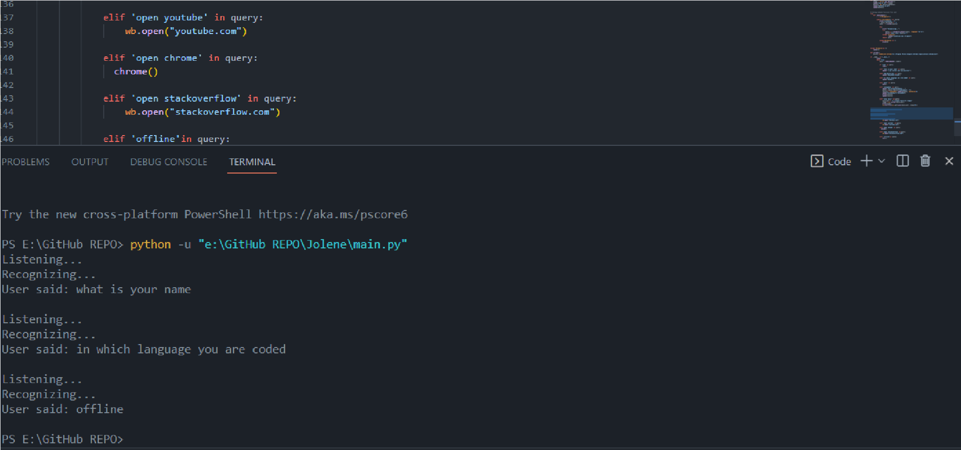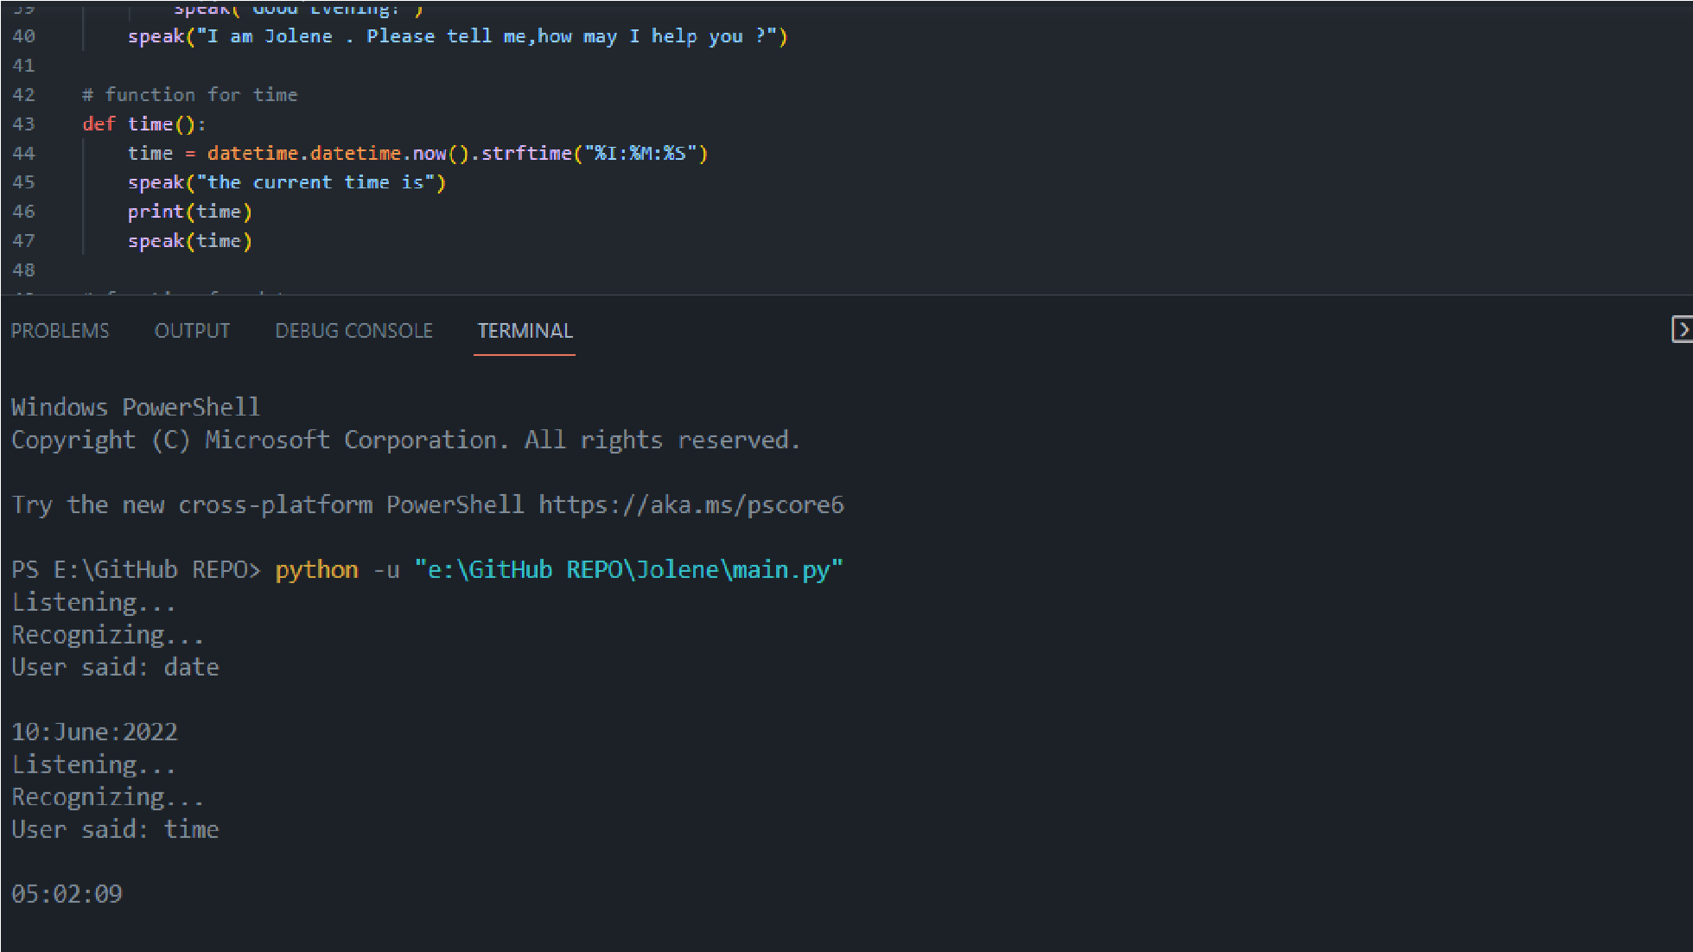

# Chapter- 8 References

1. www.Pypi.org
2. <https://www.javatpoint.com/artificial-intelligence-tutorial>
3. <https://stackoverflow.com/questions>
4. https://docs.python.org/3
5. https://www.edureka.co/blog/artificial-intelligence