PROJECT REPORT

IoT-Based Smart Electronics
Laboratory Safety and Asset
Monitoring System
Using ESP32

TRAINER

Miss Divya

MEMBERS

MOHANAKRISHNAN S
KAWINKUMAR P
ABINANDHAN A V
MANISHANKAR V

IoT-Based Smart Electronics Laboratory Safety and
Asset Monitoring System Using ESP32

Introduction

An Electronics Laboratory contains sensitive and expensive equipment such as oscilloscopes, function generators, power supplies, and soldering stations. Ensuring the safety of such a laboratory from hazards like gas leakage, fire, and unauthorized equipment movement is critical.

In this project, an IoT-Based Smart Electronics Laboratory Safety and Asset Monitoring System is developed using the ESP32 microcontroller. The system continuously monitors environmental and physical conditions inside the laboratory and instantly alerts users through LEDs, a buzzer, LCD display, and a cloud-based IoT dashboard.

The system integrates multiple sensors including a DHT11 for temperature and humidity, an MQ-5 for gas leakage detection, a Flame Sensor for fire detection, and an HC-SR04 ultrasonic sensor for equipment movement detection. Real-time data is uploaded to the ThingSpeak IoT platform and can be monitored from any location using a mobile phone or laptop.

Objectives of the Project

- To continuously monitor temperature and humidity inside the electronics laboratory
- To detect gas leakage (LPG, smoke) and trigger an immediate alert
- To detect fire using an infrared flame sensor and raise an alarm
- To detect unauthorized movement of laboratory equipment using ultrasonic sensing
- To indicate the alert source instantly using color-coded LEDs
- To transmit real-time sensor data to the ThingSpeak cloud platform via Wi-Fi
- To display live sensor readings and alert status on an LCD display
- To build a low-cost, efficient, and scalable laboratory safety system

Components Used

Hardware Components

Component | Description / Purpose
ESP32 DevKit V1 | Main MCU with Wi-Fi & Bluetooth
DHT11 Sensor | Measures Temperature & Humidity
MQ-5 Gas Sensor | Detects LPG / Smoke / Gas Leakage
Flame Sensor | Detects Fire / Infrared Flame
HC-SR04 Ultrasonic | Detects Equipment Movement
LCD I2C (16x2) | Displays System Status & Readings
Buzzer | Audio Alert on any Danger Detected
Green LED | Indicates Normal / Safe Condition
Yellow LED | Indicates Gas Leakage Alert
Red LED | Indicates Fire Detection Alert
Blue LED | Indicates Equipment Movement Alert
Breadboard & Wires | Circuit Assembly & Connections
Power Supply (5V) | Powers ESP32 and all components

Software Components

- Arduino IDE – Used for coding and uploading programs to ESP32
- ThingSpeak Platform – IoT cloud platform for real-time data monitoring and graphing
- LiquidCrystal_I2C Library – For controlling the 16x2 LCD via I2C protocol
- DHT Library – For reading temperature and humidity from DHT11
- WiFi.h and HTTPClient.h – Built-in ESP32 libraries for Wi-Fi and HTTP communication

Pin Connection Details

Component | Pin | ESP32 GPIO
DHT11 | DATA | GPIO 4
MQ-5 | AO (Analog Out) | GPIO 34
Flame Sensor | DO (Digital Out) | GPIO 19
HC-SR04 | TRIG | GPIO 26
HC-SR04 | ECHO | GPIO 27
LCD I2C | SDA | GPIO 21
LCD I2C | SCL | GPIO 22
Buzzer | + | GPIO 18
Green LED | Anode (220Ω) | GPIO 13
Yellow LED | Anode (220Ω) | GPIO 12
Red LED | Anode (220Ω) | GPIO 14
Blue LED | Anode (220Ω) | GPIO 25

Explanation of the System

The IoT-Based Smart Electronics Laboratory Safety and Asset Monitoring System operates by collecting environmental and physical data through multiple sensors connected to the ESP32 microcontroller. The ESP32 processes this data in real time, drives the appropriate LED indicators and buzzer, updates the LCD display, and transmits data to the ThingSpeak cloud platform at regular intervals.

Working Principle

On power-up, the system displays "LAB SAFETY / SYSTEM" on the LCD and establishes a Wi-Fi connection. It then captures the initial distance reading from the HC-SR04 sensor as a reference value for equipment movement detection. The main loop continuously reads all sensors and evaluates the following priority-based alert logic:

- Priority 1 – Fire Alert: If the flame sensor detects infrared radiation from a flame, the Red LED turns ON, the buzzer activates, and "FIRE ALERT!" is displayed on the LCD.
- Priority 2 – Gas Alert: If the MQ-5 analog reading exceeds the threshold (2500), the Yellow LED turns ON, the buzzer activates, and "GAS LEAKAGE!" with the gas value is displayed.
- Priority 3 – Equipment Movement Alert: If the current distance measured by HC-SR04 differs from the reference distance by more than 10 cm, the Blue LED turns ON, the buzzer activates, and "EQUIP MOVED" is displayed.
- Normal Mode: If none of the above conditions are met, the Green LED turns ON, the buzzer turns OFF, and the LCD displays live temperature, humidity, and gas values.

Data Flow

Sensors → ESP32 → Wi-Fi → ThingSpeak Cloud

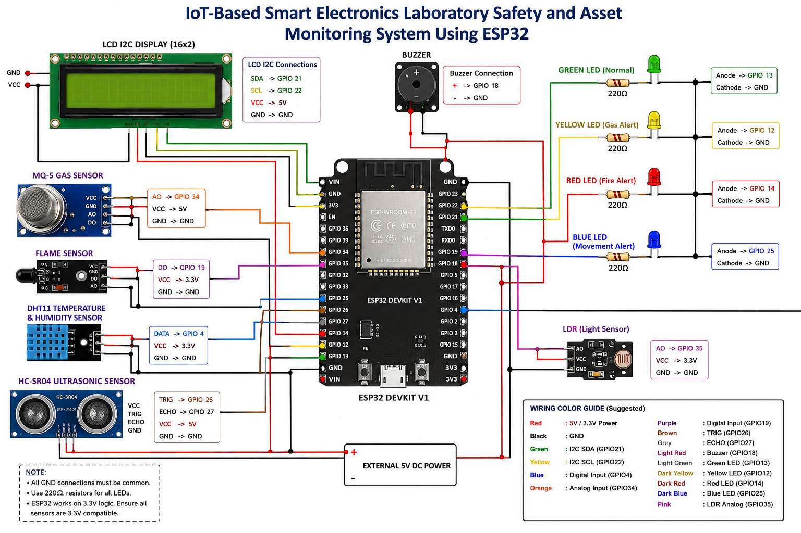

Alert Indication Logic

Condition | LED Indicator | Buzzer
Normal / Safe | Green LED ON | OFF
Gas Leakage Detected | Yellow LED ON | ON
Fire Detected | Red LED ON | ON
Equipment Moved | Blue LED ON | ON

Sensor Details

DHT11 – Temperature & Humidity Sensor
- Measures ambient temperature in °C and relative humidity in %
- Operates at 3.3V; connected to GPIO 4 of ESP32
- Used for environmental monitoring of the laboratory

MQ-5 – Gas Sensor
- Detects combustible gases including LPG, methane, and smoke
- Operates at 5V; analog output connected to GPIO 34 (ADC input)
- Alert is triggered when analog reading exceeds 2500

Flame Sensor
- Detects infrared radiation emitted by a flame
- Operates at 3.3V; digital output connected to GPIO 19
- Output goes LOW when flame is detected

HC-SR04 – Ultrasonic Distance Sensor
- Measures distance using ultrasonic pulses; range: 2 cm to 400 cm
- TRIG pin: GPIO 26; ECHO pin: GPIO 27 (use voltage divider for 3.3V safety)
- Equipment movement is detected when distance deviates by more than 10 cm from reference

About ESP32

- Powerful dual-core microcontroller operating at up to 240 MHz
- Built-in Wi-Fi (802.11 b/g/n) and Bluetooth 4.2
- Supports multiple ADC, PWM, I2C, SPI, and UART interfaces
- Low power consumption suitable for IoT applications
- Faster and more capable than traditional Arduino Uno

About ThingSpeak IoT Platform

- Free IoT platform for uploading, visualizing, and analyzing sensor data
- Supports HTTP GET requests for data upload from ESP32
- Provides real-time graph visualization of all sensor fields
- Data is accessible from any device with an internet connection
- Free plan allows updates every 15 seconds or more

ThingSpeak Field | Data Uploaded
Field 1 | Temperature (°C)
Field 2 | Humidity (%)
Field 3 | Gas Level (Analog Value)
Field 4 | Distance (cm)
Field 5 | Alert Status (NORMAL / GAS / FIRE / MOVED)

Project Development Phases

- Phase 1: LCD Testing – Verified LCD working with I2C (0x27 address)
- Phase 2: Temperature & Humidity Monitoring – DHT11 integrated; readings shown on LCD
- Phase 3: Gas Leakage Detection – MQ-5 integrated; Yellow LED and Buzzer alert added
- Phase 4: Fire Detection – Flame sensor integrated; Red LED and Buzzer alert added
- Phase 5: Equipment Movement Detection – HC-SR04 integrated; Blue LED and Buzzer alert added
- Phase 6: Multi-LED Status Indication – Color-coded LEDs for instant alert identification
- Phase 7: Startup Self-Test – System checks all components on power-up for professionalism
- Phase 8: ThingSpeak IoT Cloud – Wi-Fi enabled; all sensor data uploaded to ThingSpeak every 20 seconds

Advantages of the System

- Real-time monitoring of multiple environmental and physical parameters simultaneously
- Priority-based alert logic ensures the most critical hazard is always displayed first
- Color-coded LED system allows instant visual identification of the alert source
- Remote monitoring from anywhere via ThingSpeak cloud dashboard
- Low cost and easily replicable using widely available components
- Scalable – additional sensors can be integrated with minimal code changes

Applications

- Electronics and Computer Science laboratory safety monitoring
- Industrial floor safety systems with gas and fire hazard detection
- Asset tracking and unauthorized movement detection in research labs
- Smart building automation and environmental monitoring
- Educational institutions for demonstrating IoT-based embedded systems

Conclusion

The IoT-Based Smart Electronics Laboratory Safety and Asset Monitoring System successfully demonstrates the integration of multiple sensors with an ESP32 microcontroller and IoT cloud platform. The system provides comprehensive real-time safety monitoring including temperature, humidity, gas leakage, fire, and equipment movement detection.

The priority-based alert logic combined with color-coded LED indicators, LCD display, and buzzer ensures that laboratory personnel are immediately informed of any hazard. The ThingSpeak integration further enhances the system by enabling remote monitoring and historical data analysis from any location.

This project proves that a low-cost, efficient, and scalable laboratory safety system can be built using readily available IoT components, making it ideal for practical deployment in educational and industrial environments.

Future Enhancements

- Add SMS / Email alerts using Twilio or IFTTT when a danger condition is detected
- Integrate a camera module for visual verification of alerts
- Add a wind speed or CO2 sensor for more comprehensive air quality monitoring
- Implement a web-based custom dashboard for real-time and historical data visualization
- Add data logging to an SD card for offline storage and analysis
- Implement machine learning-based anomaly detection for predictive safety alerts

Thank You

