

**Department of Electrical and Computer Engineering**

**North South University**

**Spring 2020**

**CSE 327: Software Engineering**

**Software Requirement Specification**

**for**

**Online Java Compiler**

**Section: 8**

|  |  |
| --- | --- |
| **Sudman Bin Manjur** | **1510794042** |
| **Ariful Hasan Kawshiq** | **1510313042** |
| **Zonaid Ar Rafi** | **1632882642** |
| **Tauhid Rahman** | **1510449042** |

**Faculty Advisor:**

**Dr. Md Musfique Anwar**

**ECE Department**

**17 February, 2020**

# Contents

1. Introduction 02

1.1 Purpose ………………………………………………………… 02

1.2 Intended Audience………………………………………………. 02

1.3 Intended Use…………………………………………………….. 02

1.4 Product Scope………………………………………………….... 02

1.5 Risk Definitions…………………………………………………. 02

2. Overall Description 03

2.1 User Classes and Characteristics………………………………... 03

2.2 User Needs……………………………………………………… 04

2.3 Operating Environment…………………………………………. 04

2.4 Constraints………………………………………………………. 04

2.5 Assumptions…………………………………………………….. 04

3. Requirements 05

3.1 Functional Requirements……………………………………….. 05

3.2 Non Functional Requirements………………………………….. 05

4. Conclusion 07

Chapter 1

Introduction

**1.1 Purpose**

**The** main purpose of this project is to provide an online platform for both teachers and students where teachers can take online assignments based on Java programming language and students can practice Java programming without installing compiler in his system. This is a web application which works online.

**1.2 Intended Audience**

This web application is basically for all students and teachers. It will help the both users to have their academic learning and teaching quite easy than before. This web application has various types of functions which supports the whole system to be more helpful for them.

**1.3 Intended Use**

In this application teacher can submit a programming-based problem as well as a sample output with it. Students will write Java code on online compiler and press run button to test the codes. After submitting the code, system will send information to server for compiling and it will test the code at server side and send result information to client within few seconds. Students will have option to post the submitted codes so that teacher can review on it.

**1.4 Product Scope**

In present scenario, usage of technology has widely increased. Usage of internet has reached to every house. Installing entire C or Java development kit will be a time taking process. So students can use this online application without taking any sort of trouble like that.

This application provides security for code by using encryption and decryption algorithm. Editor will encrypt while sending data to server and decrypt after receiving data from server.

**1.5 Risk Definitions**

This is a web-based application. And this application is very secure and easy to fix. So, there is no worry about any problem about anything. If some issues occur somehow, it can be fixed very easily.

Chapter 2

Overall Description

**2.1 User Classes and characteristics**

On our website there are two different login systems, as a student and as a teacher. So, we have two roles as online user: teacher and student. And another is the system role. So, in our project we have the following roles and characteristics

Teacher: A teacher can register/login as a teacher and post coding related problems. He can see how many students submitted the solution along with the submitted codes. A teacher can also review on the student’s answer.

Student: A student can register/login as a student. He can submit the solution codes in the compiler for testing and also can post the answer. He can communicate with teacher also. A student can only see his own profile and solution that he/she has submitted. Besides, students can also practice coding in practice section.

System: System will control the authentication for users, take user inputs, compile the codes, send data to the server, send back outputs to the user from the server, error handling.

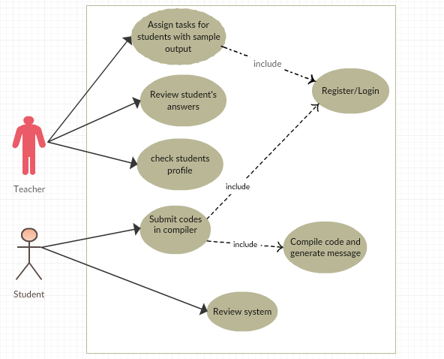

Figure 1: Use Case Diagram (Initial)

* 1. **User Needs**

A user needs to register and login as a teacher or as a student and update profile. A teacher needs to upload the problem from his dashboard, check answers and review. A student needs to submit solution codes, communicate with teacher.

**2.3 Operating Environment**

* Operating system: Windows
* database: SQL+ database
* platform: PHP
* A browser which supports CGI, HTML & JavaScript

This app is internet based so it will run in any operating system with internet access through a web browser.

**2.4 Constraints**

Though this works perfectly as a web-based application, it is not fully functional in mobile view. We are hopeful that we can also upgrade it into mobile view also. It will help the users’ way better than before.

**2.5 Assumptions**

As far as our concern, the web application will be okay with everything running properly. Still there might be some errors with codes and login process.

Chapter 3

Requirements

**3.1 Functional Requirements**

* A user can register/login as a teacher or as a student and update profile.
* A teacher can upload the problem from his dashboard, check answers and review.
* A student can submit solution codes, communicate with teacher.
* System will be able to compile the codes, generates output and handle errors.

**3.2 Non-Functional Requirements**

1. **Performance:**

The application should perform well based on it’s speed and reliability. It should not slow down with increase in the number of users. Search functionality should he fast to enable better end-user experience. The system should be quick enough to be able to respond to the user actions within a short period of time. The internet speed should also be good for a better performance

1. **Safety:**

The database may get crashed at any certain time due to virus or operating system failure. Therefore, it is required to take the database backup.

1. **Security:**

* As a user have to login to use the compiler, it will bind them in a role. So, the hackers will not be able to run malicious codes in the open environment.
* Password will be encrypted while saving in database.
* Email will be validated to check if it’s a real user.
* Data will be transferred using SSL encryption.

1. **Quality:**

The Quality of the System is maintained in such a way so that it can be very user friendly to all the users. The quality attributes are assumed as under:

* Accurate and hence reliable.
* Secured.
* Fast speed.
* Compatibility

Chapter 4

Conclusion

So, we hope that this application will have a practical value in our education system. We will try for further development of this web application and implement more features. If you have any suggestions regarding our application, we will be very grateful to hear from you.