

**Department of Electrical and Computer Engineering**

**North South University**

**Spring 2019**

**CSE 299: Junior Design Course**

**Project Report**

**Project topic: Tic_Tac_ToeK**

Section: 04

Group Number: X

**Presented to**

Mr. Shaikh Shawon Arefin Shimon

Lecturer, ECE, North South University

**Presented by**

|  |  |
| --- | --- |
| Name | ID |
| Ariful Hasan Kawshiq | 1510313042 |

Table of Contents

**1 Introduction** 3

1.1 Project name: 3

1.2 Purpose: 3

**1.2.1 Vision Statement:** 3

**1.2.2 Scope:** 3

1.3 Document Convention: 3

1.4 Project Scope: 3

**2. Overall Description** 4

2.1 Product Perspective: 4

2.2 Product Functions: 4

2.3 Operating Environment: 5

**3. Functional Requirements covered (codes):** 5

**4. Non- functional Requirements covered:** 6

4.1 Performance requirements covered: 6

4.2 Safety Requirements covered: 7

4.3 Scalability: 7

4.4 Availability: 7

**5. User interface:** 7

**6. Game features:** 8

**7. Monetization:** 9

**8. Business Strategy:** 10

**9. Further Plan:** 10

**10. Gantt chart:** 11

**11. Useful Links:** 12

**12. Roadblocks:** 12

**13. References:** 12

# **1 Introduction**

## **Project name:**

The name of my project is Tic_Tac_ToeK. This game is known as Tic_Tac_Toe as all around the world. But as this is my project, I decided to make this game’s name as Tic_Tac_ToeK by adding the first letter of my nick name in the last of Tic_Tac_Toe. This is the story behind giving the name of the project.

## **1.2 Purpose:**

The purpose of my project is to make a mobile application which is convenient to use and used for amusement purpose. It’s basically a mobile application for playing strategic game. The name of our application is “Tic_Tac_ToeK”. From the childhood we have played this give many times by using pen and paper. We have many apps for playing this game. I wanted to make this application because I personally love to play this game.

Tic-tac-toe (American English), noughts and crosses (British English), or Xs and Os is a paper-and-pencil game for two players, X and O, who take turns marking the spaces in a 3×3 grid. The player who succeeds in placing three of their marks in a horizontal, vertical, or diagonal row wins the game. This game will be able to play offline without any internet connection. Two persons can play this game.

### **1.2.1 Vision Statement:**

The aim of this application is to help people or friends to play tic-tac-toe from all backgrounds for finding an easy platform where they can simply play tic-tac-toe with their friend anytime anywhere. This will help them to pass their time as well it will try to make their brain work for strategic calculations. This can be played even in leisure time with a friend, or by going somewhere, don’t having anything to do. This application also don’t need internet connection. So one have to just install it, no internet charges also.

### **1.2.2 Scope:**

This application has the scope for building a friendship where two people can easily pass their times together. This application so much easy to use. I have included simple English language for the understanding purpose. In further part, I will try to include other languages as well.

## **1.3 Document Convention:**

I have already tried to give the outlook as simpler as possible. But by having further comments and tips from users, will try to improve more hopefully. I have used simple cross and round sign for detecting the icons for player 1 and player 2. I have also given an icon for the application. I have given different sizes of icon. Determining the device the icon’s measurement will adjust .I have used Times New Roman for documents writings and use italic, highlighted or bold features for different purposes.

## **1.4 Project Scope:**

This project has the feature of offline gaming. So users can play this game without internet connection. This will help two people to spend some time without using money on buying internet data packs. This application now have the feature of 2 players. Gradually I will try to add AI feature in the next update. I’ll also try to develop this for inline players also. But for this course I have done 2 players playing feature.

# **2. Overall Description**

## **2.1 Product Perspective:**

This application which I’m presenting now will also be a member of app community when I will release it in Android App store. Currently this app is for android devices only. In further researches I will also try to make a version for iOS users also. There are many gamming applications which are used for pass leisure time or develop skill on strategic games. It’s also an exercise for brain. This application will help people to use an application in less time wasted. Whenever we will open the application in our android device, it will take less than a second to start.

It has two icons for two players. The 0 (zero) icon is for player 1 and the X (cross) icon is for player 2. Basically this game works as three consecutive match of same icon. There are 9 boxes in this game within a margin. Whenever three same icons are seen in continuous position, it will declare that respective icon or player as winner. If there is no consecutive three icons found, the game will declare the match as draw. The player who succeeds in placing three of their marks in a horizontal, vertical, or diagonal row wins the game.

Hence, tic-tac-toe is most often played by young children. Because of the simplicity of tic-tac-toe, it is often used as a pedagogicaltool for teaching the concepts of good sportsmanshipand the branch of artificial intelligence that deals with the searching of game trees[.](https://en.wikipedia.org/wiki/Game_tree) It is straightforward to write a computer program to play tic-tac-toe perfectly.

The game can be generalized to an m, n, k type game in which two players alternate placing stones of their own symbol on an *m* × *n* board, with the goal of getting *k*of their own symbol in a row. Tic-tac-toe is the (3, 3, 3)-game. Harary’s generalized tic-tac-toe is an even broader generalization of tic-tac-toe. Tic-tac-toe is the game where n equals 3 and d equals 2. If played properly, the game will end in a draw, making tic-tac-toe a futile game.

A player can play aperfect gameof tic-tac-toe (to win or at least, draw) if each time it is his turn to play, he chooses the first available move from the following list, as used in Newell and Simon's 1972 tic-tac-toe program. 1.

## **2.2 Product Functions:**

The features of my “**Tic_Tac_ToeK”** application are**-**

* **Offline game:** Users don’t need internet connection to play or open this game.
* **Login:** There is no login or giving information feature in this game. Sometimes this creates hassle to the users. As they simply want to play the game without giving any information of their own, they can play this game fluently and happily. The simpler the easier.
* **2 players:** This application is for use of two persons simultaneously. There will be two players, player 1 and player 2. They will give their one after another in player one then player two combination.
* **WIN:** The player who succeeds in placing three of his/her marks in a horizontal, vertical, or diagonal row wins the game.
* **LOSE:** The player who fails in placing three of their marks in a horizontal, vertical, or diagonal row loses the game.
* **DRAW:** When both of the players fails in placing three of their marks in a horizontal, vertical, or diagonal row, the game is declared as draw.

## **2.3 Operating Environment:**

My “**Tic_Tac_ToeK**” project in based on mobile app. I have established it in Android environment.

* Operating System: Android (Handset).
* Coding Language: Java.
* Tool Kit: Android 8.1 Oreo.
* IDE: Android studio.

# **3. Functional Requirements covered (codes):**

I have different class files for operating different kinds of operations. Here are some codes from the app-

This is the code for how row wise winning counts.

|  |
| --- |
| *//Test Row*  *for (int i=0;i<3;i++){*  *rowSum=gameBoardArr[i][0]+gameBoardArr[i][1]+gameBoardArr[i][2];*  *if (rowSum==15)*  *{*  *return GAME_RESULT_FAIL;*  *}*  *else if (rowSum==3)*  *{*  *return GAME_RESULT_WIN;*  *}*  *}* |

This is the code for how column wise winning counts.

|  |
| --- |
| *//Test Column*  *for (int i=0;i<3;i++){*  *columnSum=gameBoardArr[0][i]+gameBoardArr[1][i]+gameBoardArr[2][i];*  *if (columnSum==15){*  *return GAME_RESULT_FAIL;*  *}else if (columnSum==3){*  *return GAME_RESULT_WIN;*  *}*  *}* |

This is the code for how diagonal sum for winning and failing is counted.

|  |
| --- |
| *//test diagonalSum*  *diagonalSum=gameBoardArr[0][0]+gameBoardArr[1][1]+gameBoardArr[2][2];*  *anotherDiagonalSum=gameBoardArr[2][0]+gameBoardArr[1][1]+gameBoardArr[0][2];*  *if (diagonalSum==3||anotherDiagonalSum==3)*  *{*  *return GAME_RESULT_WIN;*  *}*  *else if (diagonalSum==15||anotherDiagonalSum==15)*  *{*  *return GAME_RESULT_FAIL;*  *}* |

This is the code for how draw is counted.

|  |
| --- |
| *//check for draw*  *for (int i=0;i<3;i++)*  *{*  *for (int j=0;j<3;j++)*  *{*  *if (gameBoardArr[i][j]==0)*  *{*  *hasZero=true;*  *}*  *}*  *}*  *if (!hasZero)*  *{*  *return GAME_RESULT_DRAW;*  *}* |

# **4. Non- functional Requirements covered:**

## **4.1 Performance requirements covered:**

The smoothness of the game is very high. It takes less than a second to open and also interacts with the user very fast.

## **4.2 Safety Requirements covered:**

There is no login/ logout feature. I’m not taking any types of personal information from users. That’s why there is no chance of leaking personal information. This application takes no information from device media, also it doesn’t need any kind of permissions from any other apps. Again this app is offline played. So there is no chance of online hacking through this app.

## **4.3 Scalability:**

This application have no database. It only computes the combinations during each game. After reset, the game erases previous data from system.

## **4.4 Availability:**

This app can be used anywhere anytime. We just need an android smartphone to play this game.

# **5. User interface:**

Here I’m attaching the app images how the app looks like from user side.

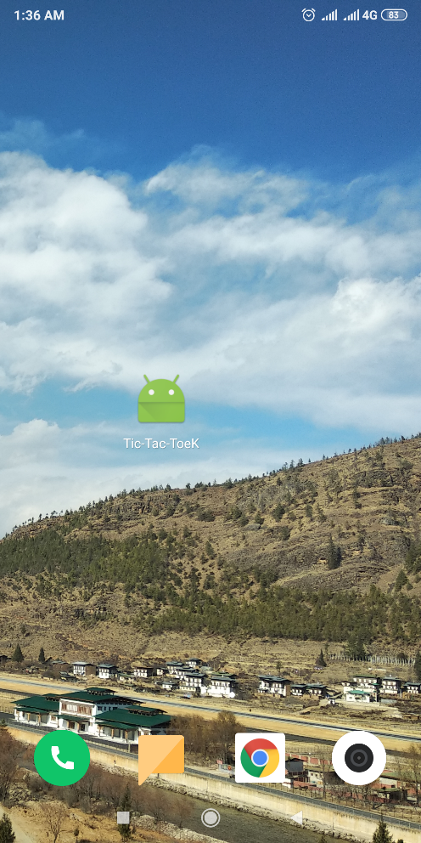 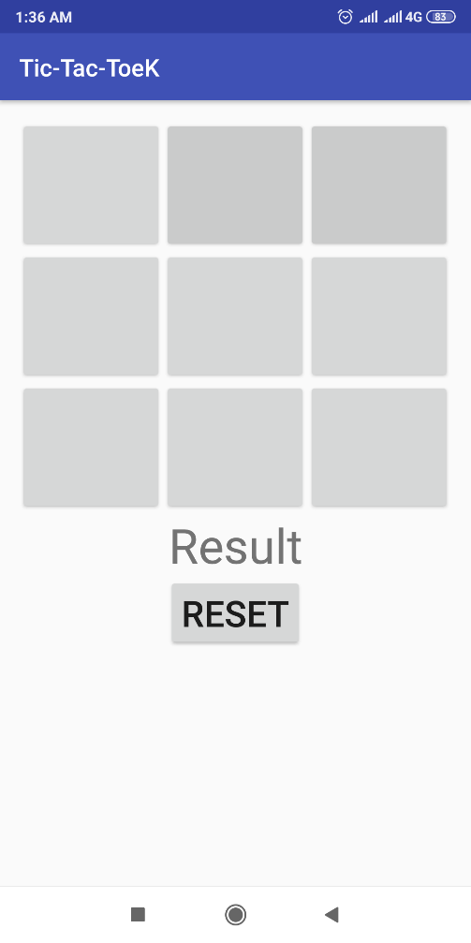

Figure 1: screen outlook of Tic_Tac_ToeK icon Figure 2: main game outlook

# **6. Game features:**

Here I’m attaching the win and draw pictures of Tic_Tac_ToeK.

Here player 1 is 0 (zero) and player two is X (cross).

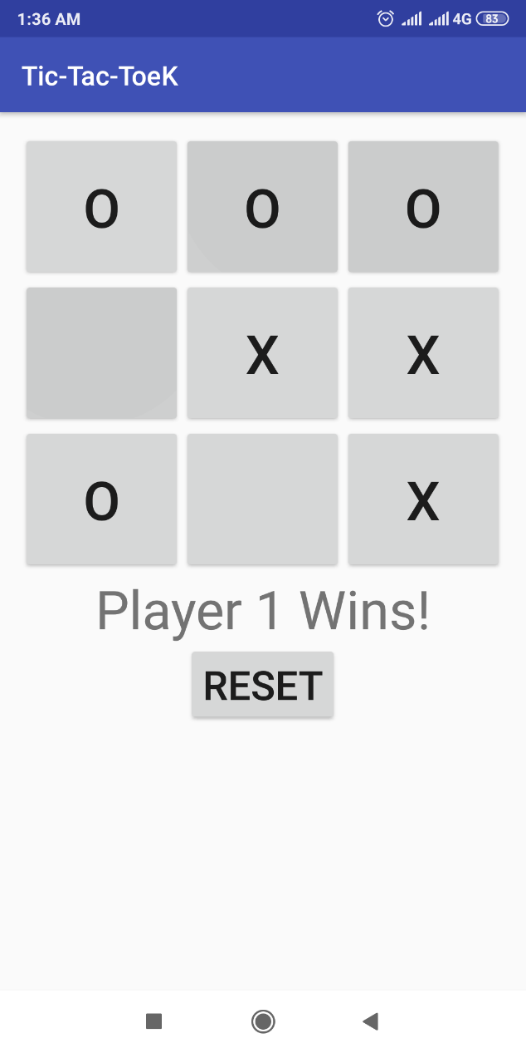 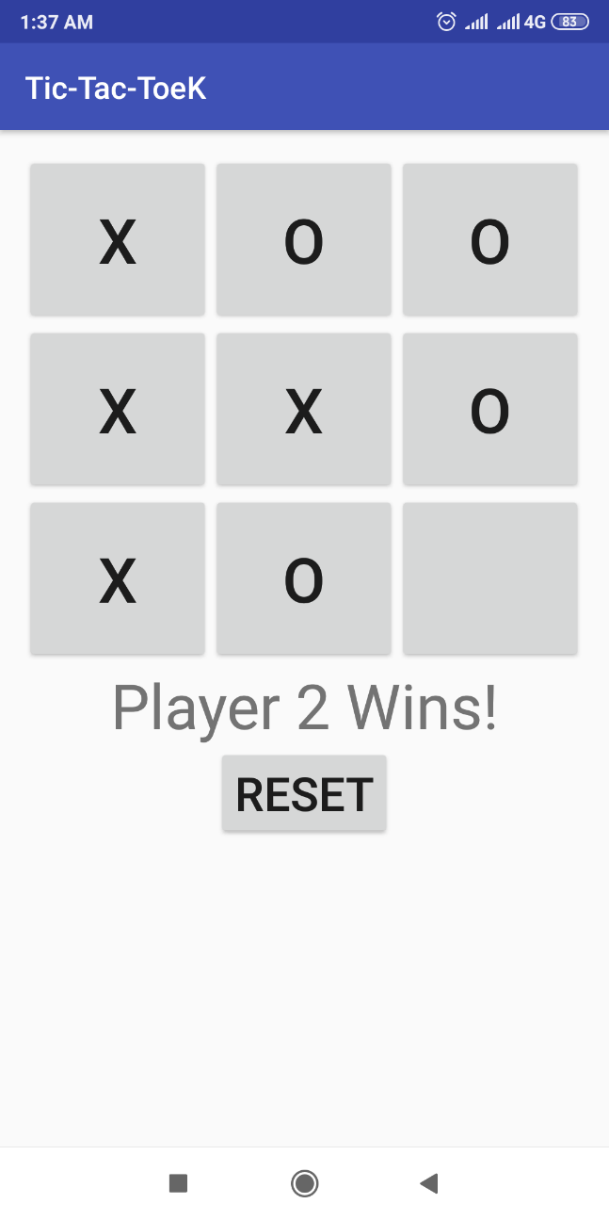

Figure : Player 1 (0) wins Figure : Player 2 (X) wins

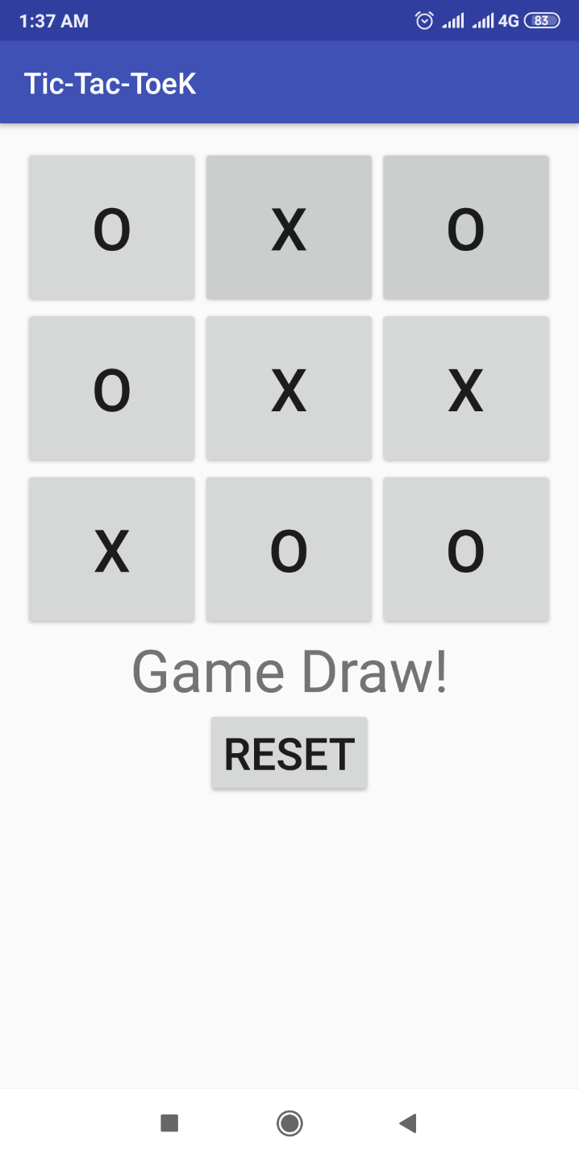

Figure : Game Draw!

# **7. Monetization:**

My application “**Tic_Tac_ToeK**” has some monetization plan also. From my point of view, whenever I’m creating an application for market, I need to think about the costing and the monitoring methods.

Generally for making this app or maintaining it’s further progress, mental labor is needed. If I think as businessman then I have to make some profit from this app. On that purpose I can take advertisements in my app. Whenever the app will open, there will be splash screen type advertisements. Also I can give advertisements in the side corners of the screen. Again I can give video advertisements when a game will end. By this I can make some earnings through this application. But as I had limited time which was less than a month, I couldn’t add those features unfortunately. Maybe in the next version, I will try to add those characteristics.

# **8. Business Strategy:**

User attention is one of the key things which one have to do for making an app as business product. User will play this game when they will know about it. This can be via social media, via handouts, even can be verbally circulated.

# **9. Further Plan:**

In this app, I have tried to add the 2 player feature only where there will be two players playing this game. Because of having less time, I couldn’t add more features. But in further plans, I’m planning to add AI feature here. By using the AI feature, users can play against computers. This basically indicates the AI will be developed in such way that it will be able to play against human.

# **10. Gantt chart:**

Here I’m attaching my Gantt chart’s screenshot.

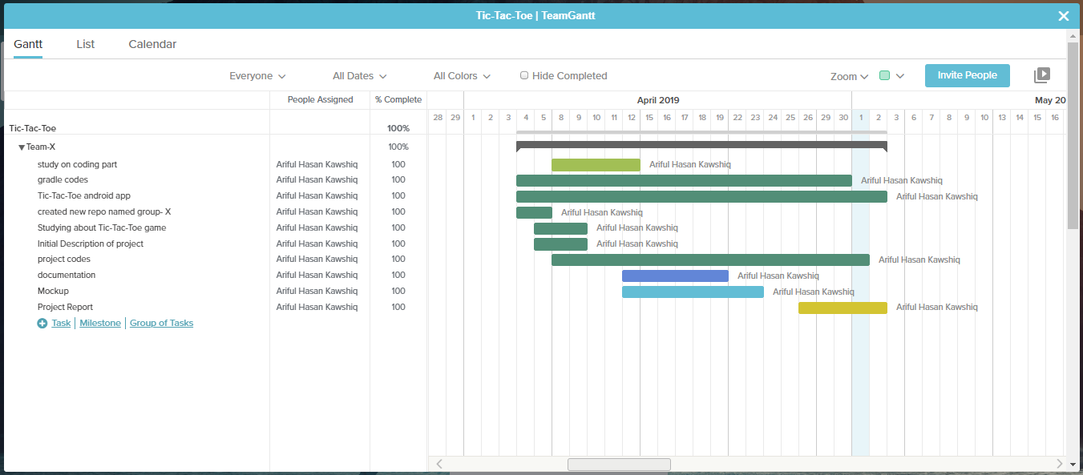

Figure : Trello_Gantt chart screenshot

# **11. Useful Links:**

The trello board link- <https://trello.com/b/4dygxD5U>

Github link- <https://github.com/KAWSHIQ/Group-X>

Slack channel- I don’t have any team members. As my project is only done by myself, I don’t have any slack channels.

# **12. Roadblocks:**

There were some roadblocks in making this project. Because of shortage of time, I couldn’t add some more features. There were some difficulties faced in java coding part where I took help different online platforms. I have mentioned those platforms in reference part. There were .xml files which I made, needed some help to learn how to make them. I used online videos, tutorial and took suggestions from those sites. I took 28 days to complete this project. I have already included my work progress through Gantt chart. There was my final exam also in the time of completing this project. That time I focused more on exam topics. 4-6 days were spent during this period. I have learned through having difficulties from many problems. That’s one of the achievement. But after of all roadblocks, I was able to complete the project.

# **13. References:**

* <https://en.wikipedia.org/wiki/Tic-tac-toe>
* <https://www.youtube.com/watch?v=apDL78MFR3o>
* <https://www.youtube.com/watch?v=9nVSYkQoV5I>
* <https://www.youtube.com/watch?v=HTO0QmZAbTg>
* <https://www.youtube.com/watch?v=YcP0HB-dgQs>
* <https://www.youtube.com/watch?v=Hq9T3rslYOA>
* <https://www.google.com/search?q=tic+tac+toe&oq=tic+tac+toe&aqs=chrome..69i57j69i60l3j0l2.4306j1j1&sourceid=chrome&ie=UTF-8>
* <https://github.com/bigbhowell/tic-tac-toe>
* <https://github.com/debck/tic-tac-toe>
* <https://www.javatpoint.com/>
* H.M.Deitel and P.J.Deital, Java How to program: Sixth Edition Herbert Schildt, The Complete Reference: Fifth edition
* <https://www.academia.edu/28164640/Project_Report_Tic_Tac_Toe>
* <https://www.ieee.org/conferences/publishing/templates.html>
* Mr. Shaikh Shawon Arefin Shimon, Lecturer, ECE, North South University