Table of Contents
Overview 2
Connecting with a Device 3
General navigation 4
Toolbar 4
Sidebar 4
The Tabs 6
In-Out Tab 6
Black Level Tab 9
White Balance Tab 10
Filter Tab 11
Multi Color Controller Tab 12
Knee Function Tab 13
Lookup Table Tab 14
Defect Pixel Correction Tab 16
Output Tab 18
Info Tab 19
Update Tab 21

Overview
This manual describes the usage of the ProVideo GUI by Dream Chip. The GUI is used to setup supported ProVideo devices which are attached over a serial interface. The GUI is currently available for Linux and Windows operating systems and supports the following devices:
- ATOM one
- ATOM one 4k
- ATOM one 4k Mini
- Cameleon
The goal of this document is to describe the full functionality of the GUI. Not all devices listed above support all features, so the actual appearance of the GUI might vary.
The screenshots in this documentation were created, while the GUI was connected to an ATOM one camera. The application was run on a desktop PC running Ubuntu 16.04, on other operating systems the style of the UI elements may vary.
The GUI mainly consists of two windows: The connection dialog is used to establish a connection to a device, while the main window is used to setup the device. They are described in detail in the following chapters.

Connecting with a Device
The GUI supports serial connections using either the RS485 or RS232 protocol. When using RS232 only one device can be connected at a time, with RS485 multiple devices can be connected over one bus. The standard power cable adapter provided with most devices uses RS485.
On application startup the GUI will automatically search for connected devices on the last used COM-Port. If one ore more devices are found, the GUI will connect to the first device and directly open the main window. If the scan process is aborted, or no device can be found the connect dialog will open. It has two pages, one for setting up RS485 the other for RS232 connections:
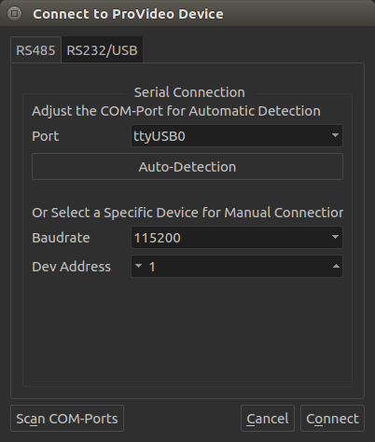
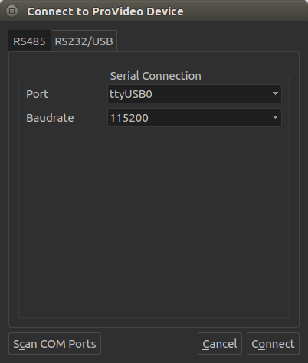
1
2
3
4
5
4
5
6
7
8
1
6
7
8
1 | Choose between RS485 or RS232 connection.
2 | COM-Port to which the device is connected. This will be “ttyUSBX” on Linux and “ComX” on Windows.
3 | The Auto-Detection will search for devices on the given COM-Port on all available Baudrates and Device Addresses (no need to configure them).
4 / 5 | When manually connecting to a device, Baudrate and Device Address have to match the device parameters.
6 | When connecting a new COM-Port device after the GUI was launched, click this button to add them to the Port list.
7 | Cancel the connection. This will close the application (returning to the main window without reconnection is not possible).
8 | Connect to the device which is specified through the above mentioned settings.

General navigation
After the connection was established, the main window will open. It has toolbar for general options and a sidebar to navigate through the sub pages of the GUI.

Toolbar
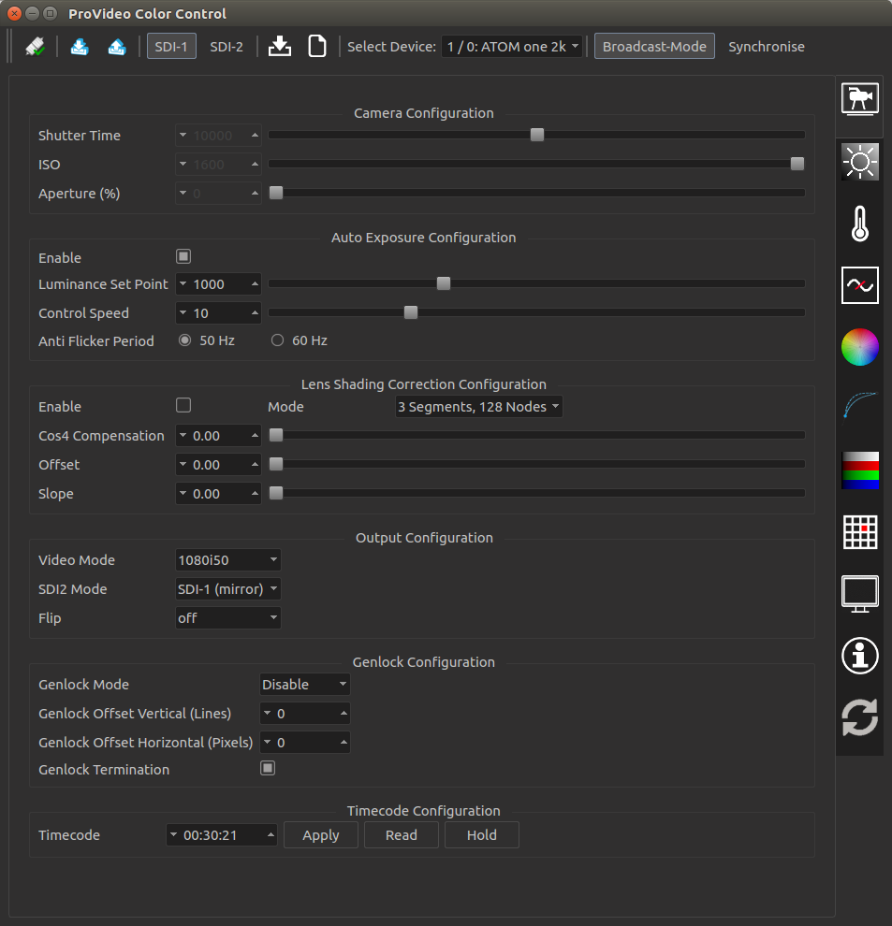
1
2
4
5
10
9
8
7
6
3
1 | Open the connect dialog (see chapter 2).
2 | Load settings from camera to GUI.
3 | Save settings from GUI to camera for startup configuration.
4 | On ATOM one (4k) devices: Switch to configuration of SDI 1 LUT  On Cameleon devices: Switch to configuration of complete SDI 1 chain
5 | On ATOM one (4k) devices: Switch to configuration of SDI 2 LUT  On Cameleon devices: Switch to configuration of complete SDI 2 chain
6 | Save current system settings to disk.
7 | Load settings from disk into GUI and transfer them to the device.
8 | Switch between connected devices. Only visible if the auto-detection was used to connect with the device over RS485. The first number represents the device address, the second number the device broadcast address.
9 | Toggle broadcast mode. In broadcast mode the currently selected device will be the broadcast master, all other devices in the same broadcast group will be slaves. Settings applied to the master will also be applied on all slaves.
10 | The Synchronise button is only enabled, if broadcast mode is active. Click it to apply the settings of the current device (broadcast master) on all other devices (broadcast slaves).

Sidebar
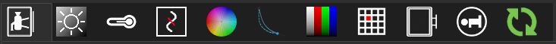
1
2
3
4
5
6
7
8
9
10
11
Note: for better presentability the screenshot of the sidebar has been turned left by 90 degrees. A click on a symbol opens the corresponding tab:
1 | In-Out Tab: Configure exposure settings, lens shading correction, video output, genlock and timecode features.
2 | Black Level Tab: Configure black levels and flare compensation.
3 | White Balance Tab: Configure white balance settings.
4 | Filter Tab: Configure denoise and detail filters.
5 | Multi Color Controller Tab: Configure color correction.
6 | Knee Function Tab: Configure the knee function.
7 | Lookup Table Tab: Configure the gamma correction lookup table.
8 | Defect Pixel Correction Tab: Setup the automatic defect pixel correction and create a defect pixel table.
9 | Output Tab: Configure the RGB to YcbCr matrix and fine tune the SDI output range.
10 | Info Tab: Show device and software information and change system settings.
11 | Update Tab: Perform device updates.

The tab pages will be described in detail in the following chapter.

The Tabs
Each tab focuses on a certain feature set of the device. Below is a list of all tabs currently available in the GUI. Depending on your device, some tabs or features might not be available.

In-Out Tab
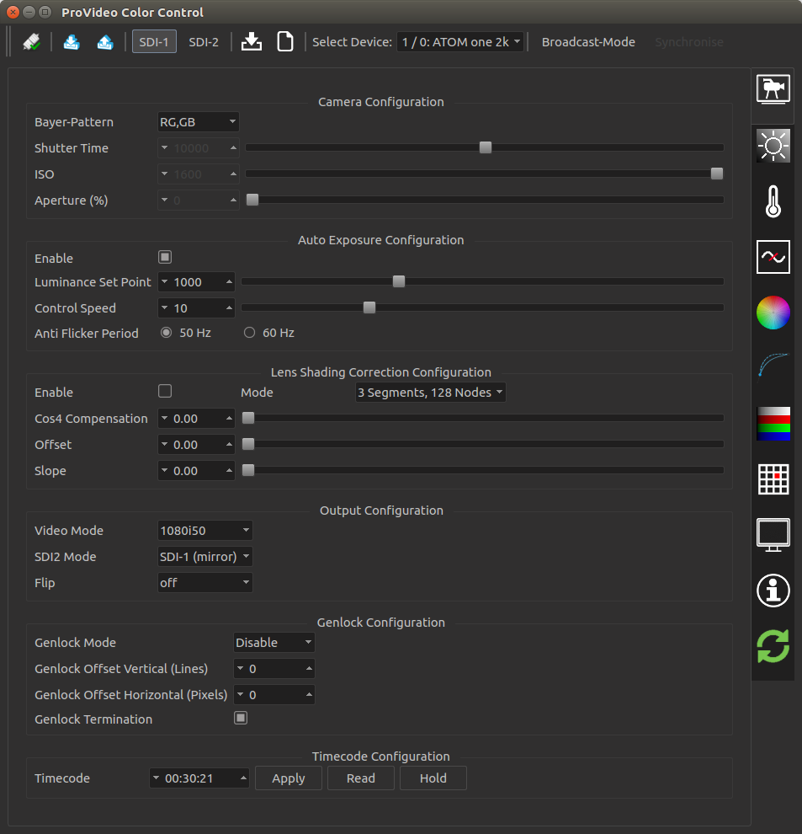
1
2
3
4
5
6
7
8
9
10
11
12
13
14
15
17
18
19
21
16
20
22
23
24
1 | Setup the bayer pattern of the sensor. This setting is only visible if “Engineering Mode” is enabled on the info tab and usually should not be changed by the user.
2 | Manually set the shutter time in microseconds. Can only be adjusted if auto exposure is disabled.
3 | Manually set the sensor gain (ISO). High values will lead to a brighter image bat also more noise. Can only be adjusted if auto exposure is disabled.
4 | Manually set the aparture in percent. This is not supported by current devices (no stepper motor present). Can only be adjusted if auto exposure is disabled.
5 | Enable auto exposure. This will automatically adjust shutter time, ISO and aperture (if available). Turn off to use manual settings (see points 2 – 4).
6 | The luminance set point defines how bright the auto exposure will set the output image.
7 | The control speed defines how fast the auto exposure reacts to changes in the light conditions. A lower value means a faster reaction, but setting the value too low might cause the controller to overshoot.
8 | Set the anti flicker period to the power frequency of your country (e.g. 50 Hz in Europe, 60 Hz in North America) to avoid screen flickering when the auto exposure is enabled.
9 | Enable lens shading correction. Please see the notes below this table for detailed instructions on how to setup the lens shading correction module.
10 | Set the lens shading correction mode. The default of “3 Segments, 128 Nodes” should yield the best results in most cases. Only try other modes if you are not satisfied with the results.
11 | The Cosine⁴ Compensation mainly adjusts the correction in the middle regions of the image.
12 | The Offset determines where the compensation of the outer image regions starts.
13 | The slope defines how strong the compensation in the outer image regions is.
14 | Set the video mode (resolution and timing).
15 | Set the mode of the second SDI output. In mirror mode the image is identical to the first output, in RAW-10 and RAW-12 modes a custom raw image will be output. Set it to “SDI-2 LUT” to use a custom de-gamma LUT for the second output. To configure the LUT of the second output additionally you have to switch to SDI-2 config in the Toolbar (see chapter 3.1, point 5 and chapter 4.7 for more details).
16 | Set the flip mode to mirror the image vertically, horizontally or both (rotate 180°).
17 | Enable genlock in slave mode (when connecting an external sync source) or master mode (to generate a genlock signal).
18 | Set the vertical genlock offset in lines.
19 | Set the horizontal genlock offset in pixels.
20 | Enable or disable genlock termination.
21 | Field to enter the timecode.
22 | Apply the currently entered timecode.
23 | Get the current timecode of the device.
24 | Hold the timecode. When enabled the device will stop incrementing the timdecode on the SDI output. The internal counter will keep running, so if you resume, the timecode will jump to the current value. This can be used to trigger external flash recorders.

Note: How to setup the lens shading correction:
- Point the camera at a homogeneous light source.
- Connect the camera to a wave monitor and select a line in the middle of the image, depending on the lens you use, you should see a decrease in luminescence towards the edges of the image.
- Enable lens shading correction, start with the Cosine⁴ Compensation, Offset and Slope set to 0.
- Now turn up the Cosine⁴ Compensation, this should correct the lens shading in the middle area of the image, the edges will probably still be not ideally illuminated. Make sure to not overcompensate, this will create a wavelike appearance of the luminescence on the monitor.
- Set the Offset to 0.5 and set to Slope to a high value like 1.5, you should now clearly see where the compensation starts. Now adjust the Slope until you hit the point where the luminescence starts decreasing. Finally decrease the Slope until the result is not overcompensated anymore.
- Make fine adjustments until you are satisfied with the result.
Please note that, depending on the optical lens used, the aperture and focal length have influence on the lens shading, so you should use your default setup for configuring the compensation. Also it might be helpful to turn off the auto exposure during the setup.

Black Level Tab
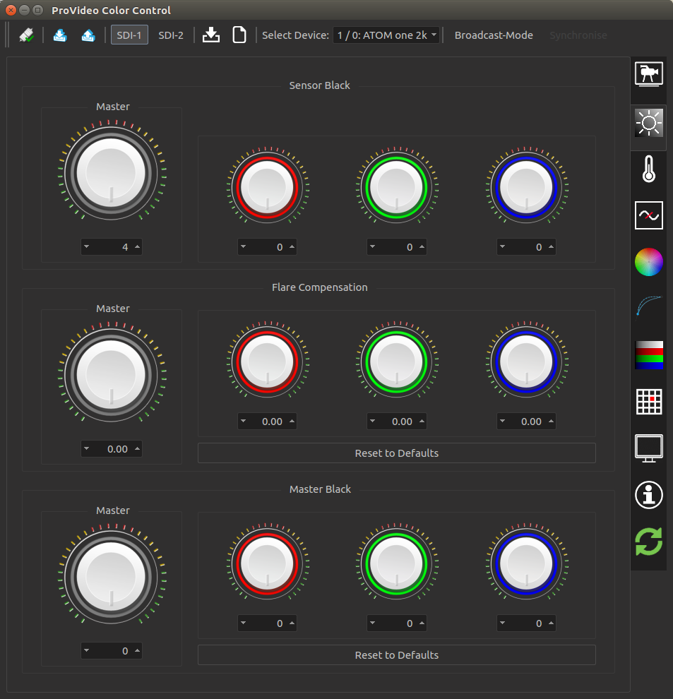
1
2
3
4
5
6
1 | Sensor black for all colors (only visible when “Engineering Mode” is enabled on the Info Tab).
2 | Sensor black for each component separate (only visible when “Engineering Mode” is enabled on the Info Tab).
3 | Flare compensation (defog) for all colors.
4 | Flare compensation (defog) for each component separate.
5 | Master black for all colors.
6 | Master black for each component separate.

White Balance Tab
1
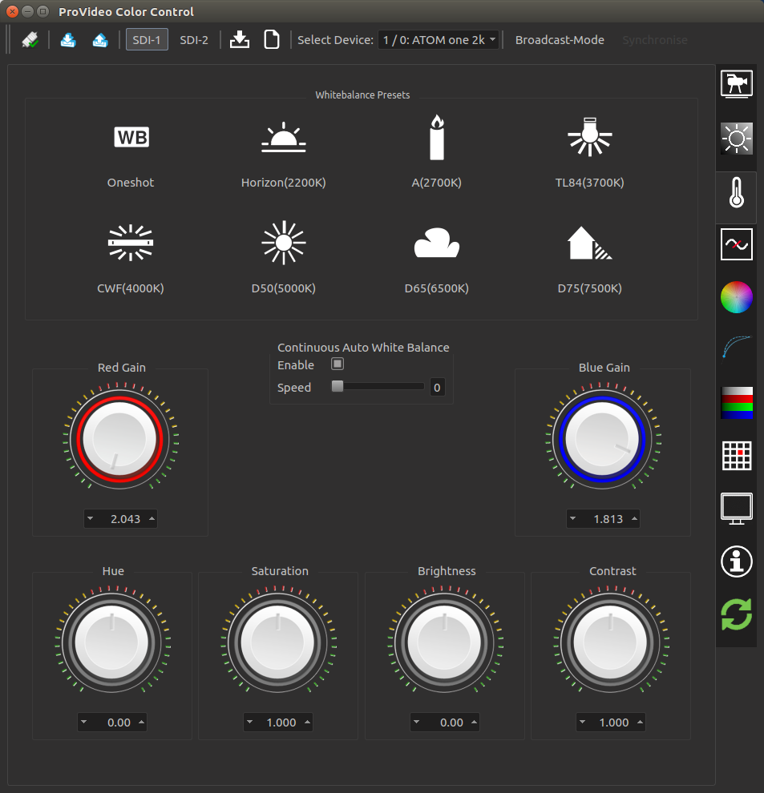
2
3
4
5
6
1 | Trigger automatic white balance (one shot, not continuous).
2 | Select a white balance preset: 2200K, 2700K, 3700K, 4000K, 5000K, 6500K or 7500K depending on the current lighting conditions.
3 | Manual red gain.
4 | Manual blue gain.
5 | Configure continuous automatic white balance (AWB). A higher speed means faster adjustment, but also a less fluid look of the AWB.
6 | Post processing: Hue, Saturation, Brightness, Contrast

Filter Tab
1
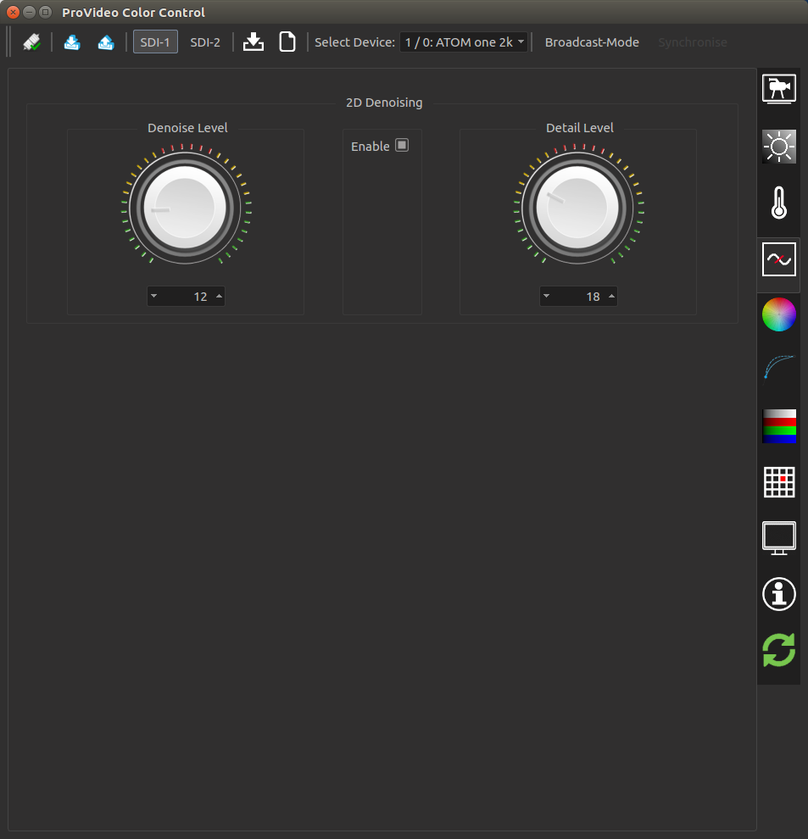
2
3
1 | Denoise / Detail filter enable.
2 | Set a higher denoise level to for a cleaner image with less noise and detail.
3 | Set a higher detail level to sharpen the image.

Multi Color Controller Tab
1
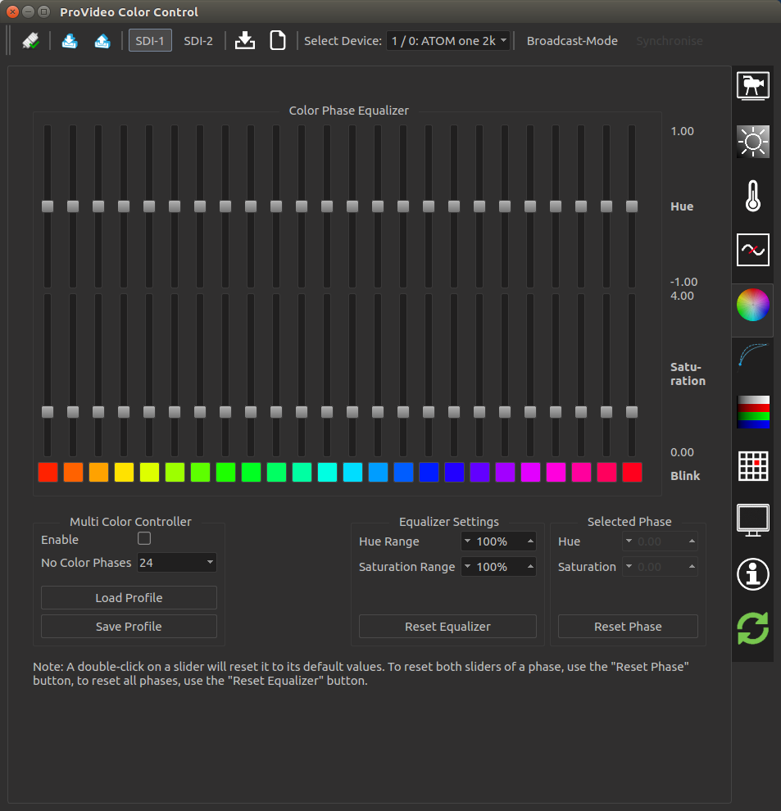
2
3
4
6
7
5
1 | Enable / disable the multi color controller and select the amount of phases (12, 16, 24 or 32). The more phases the finer you can tune the image color.
2 | Load or save the current color profile from / to file.
3 | Change the range of the hue and saturation sliders to make more accurate adjustments to the phases. The current minimum and maximum values are displayed on the right hand side of the equalizer sliders. Resetting the equalizer will set all sliders to their default values.
4 | Set hue and saturation of the currently selected color phase.
5 | The hue sliders will move the color of the selected phase to the neighboring color.
6 | The saturation sliders make the selected phase more or less prominent.
7 | Toggle the blink button of a phase to make it blink in the output image to spot which colors the phase will effect.

Knee Function Tab
1
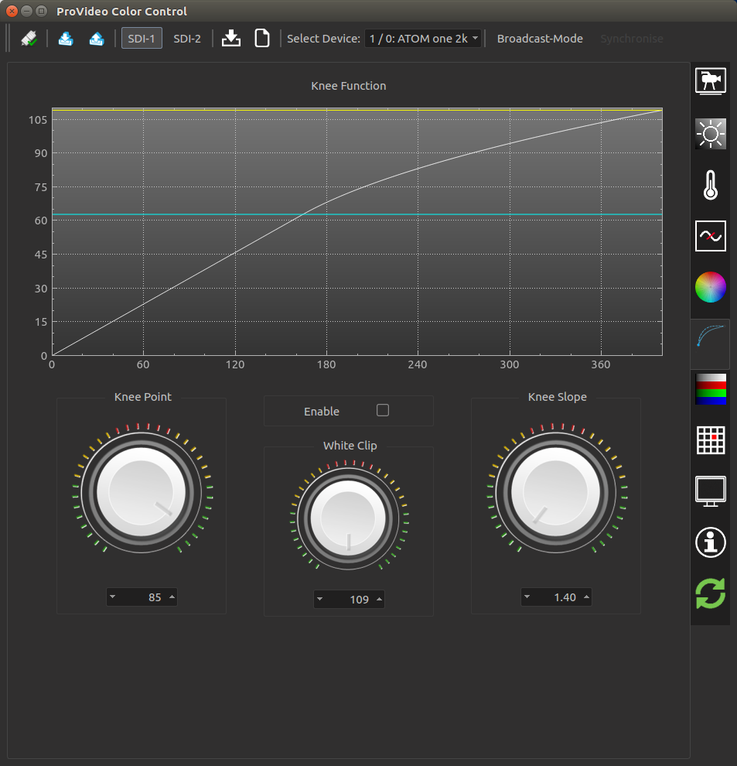
2
3
4
5
1 | Graphical view of current knee settings.
2 | Enable knee function.
3 | Set knee point (point where the curve bends, indicated by the blue line in the plot).
4 | Set white clipping point (maximum value of the knee function, indicated by the yellow line in the plot).
5 | Set knee slope (angle of the first part of the knee function till the knee point).

Lookup Table Tab
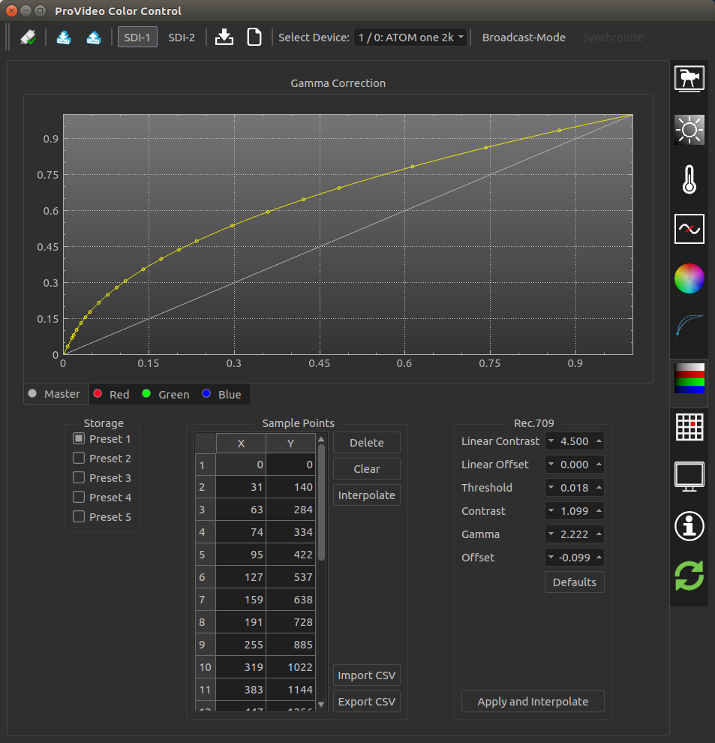
1
2
3
4
5
6
7
8
9
10
11
1 | Graphical representation of current gamma curve. Click anywhere in the plot to add
2 | Select channel for gamma. The RGB curves will be overlain with the master curve to create to resulting RGB curves. The GUI will show the resulting curve with a darker color.
3 | The device can store up to five different tables of sample points, use the storage selector to switch between them.
4 | Table of all sample points for the selected curve and preset. Entries can be edited by double clicking a value.
5 | Delete the currently selected entry out of the table.
6 | Clear all sample points from the table. This will create a linear de-gamma function for the currently selected curve and preset.
7 | Calculate LUT tables for given sample points on the device. This must be done to apply any changes.
8 | Load / save gamma curve from / to file.
9 | Save current gamma curve to file.
10 | By default the parameters in this box are set to generate a standard Rec.709 de-gamma curve. Fine tune the parameters to generate a custom de-gamma curve.
11 | Reset the Rec.709 parameters to their defaults to restore the standard Rec.709 de-gamma curve.
12 | Calculate the de-gamma curve based on the given parameters for the currently selected curve and preset. This will also apply the curve on the device. Please note that to generate the default behavior, the Master curve should be set to Rec.709 and the RGB curves should be linear.

Note: Some devices support a feature, where each of the two SDI output has its own lookup-table. To enable this feature the mode of the second SDI output has to be set to “SDI-2 LUT” (see chapter 4.1, point 15). Afterwards you can switch between the configuration of the two outputs by using the “SDI-1” and “SDI-2” buttons in the toolbar (see 3.1).

Defect Pixel Correction Tab
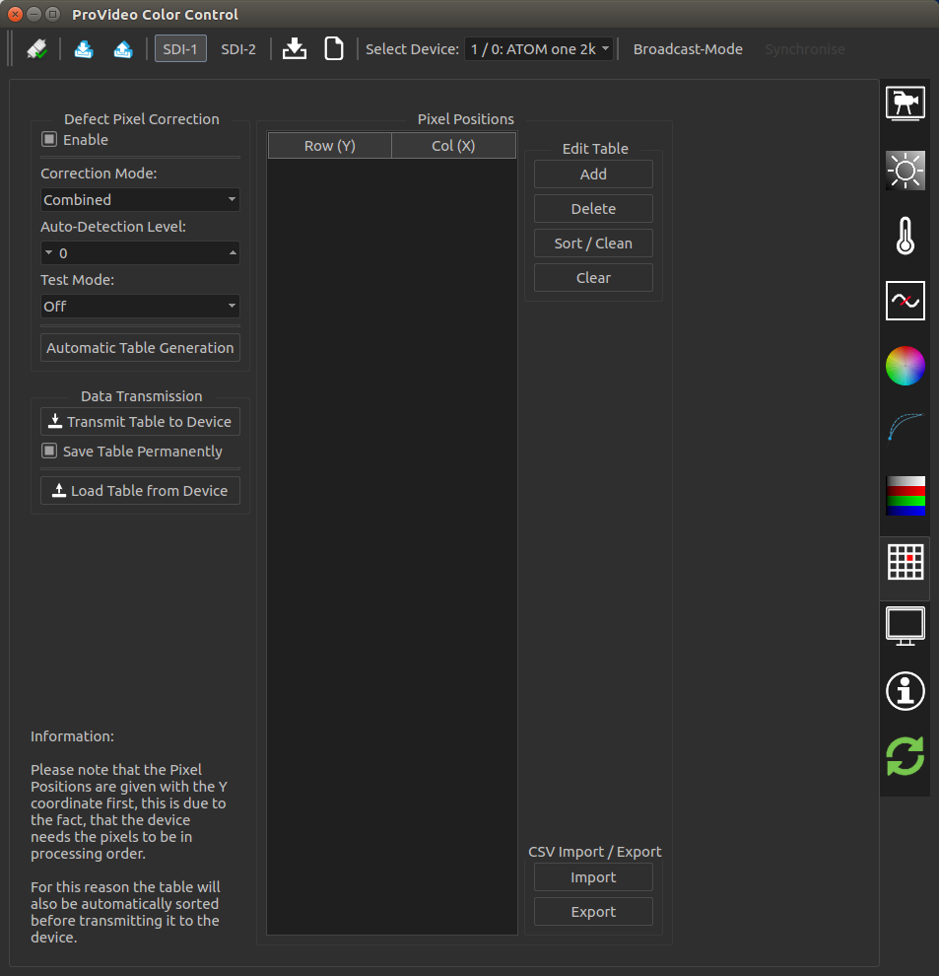
1
2
3
4
5
6
7
8
10
11
12
13
14
9
1 | Enable the defect pixel correction module.
2 | Set the correction mode. “Combined” will use both, automatic and table based detection.
3 | Increasing the auto-detection level will find more defect pixels, but will also increase the amount of false positives.
4 | The “Calibration” test mode will configure a black and white output mode, in which defect pixels can be spotted more easily. The “Validation” mode will turn the output image black and highlight currently detected or setup defect pixels.
5 | The automatic table generation will use the currently configured auto-detection level and perform a single shot detection run. The resulting defect pixels will be stored in the defect pixel table. Afterwards the automatic detection can be set to only table based to avoid the detection of false positives. Note: You should use defined lighting conditions and a grey test image to perform the automatic table generation.
6 | Transmit the pixels entered in the table to the device. You have to click this button to apply changes to the table.
7 | If this is box is checked the table will also be stored in the permanent memory and will be restored after a power cycle. If the box is not checked the table is only stored in the non-permanent memory and will be reset after a power cycle.
8 | Load the table from the device. This will always load from the permanent device memory!
9 | Table of defect pixel positions. Double-click a value to edit it.
10 | Add a position to the table.
11 | Delete the selected position from the table.
12 | Sort the table and remove duplicates.
13 | Delete all positions from the table.
14 | Import or export a CSV file with the defect pixel table.

Output Tab
1
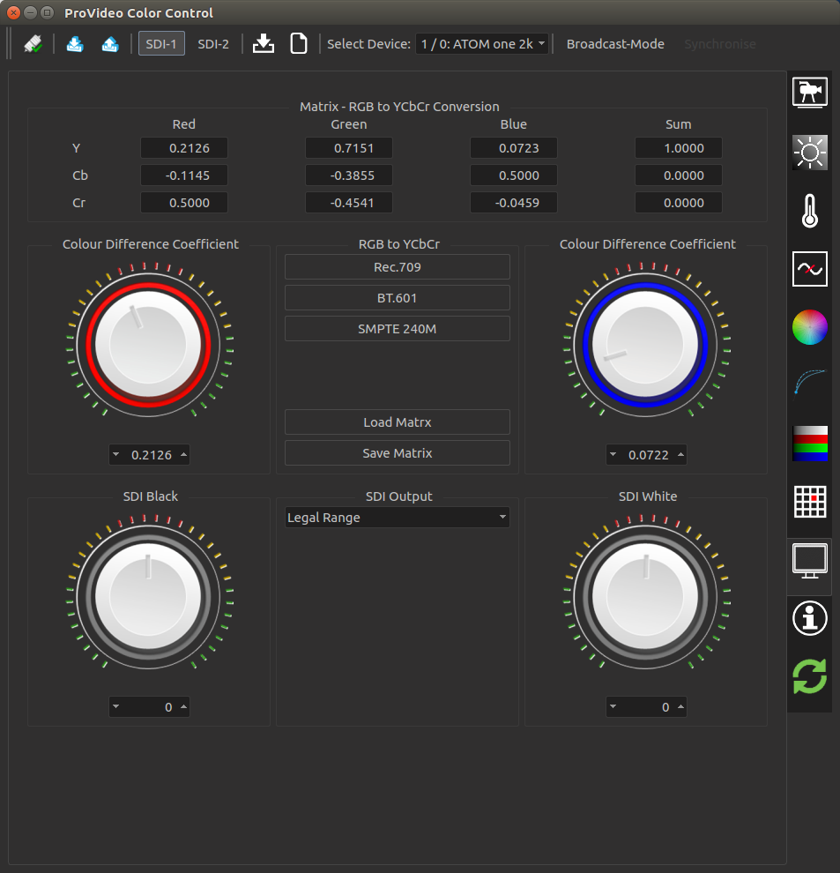
3
7
4
8
5
2
6
1 | Values of current color conversion matrix.
2 | Presets for color conversion. The default is Rec.709.
3 | Fine tuning of the matrix red balance.
4 | Fine tuning of the matrix blue balance.
5 | Load / save the color conversion matrix from / to file.
6 | Set SDI output range to legal or extended. In legal range mode, the black and white levels can be fine tuned (see below).
7 | Sets SDI black level (extend dynamic).
8 | Sets SDI while level (extend dynamic).

Info Tab
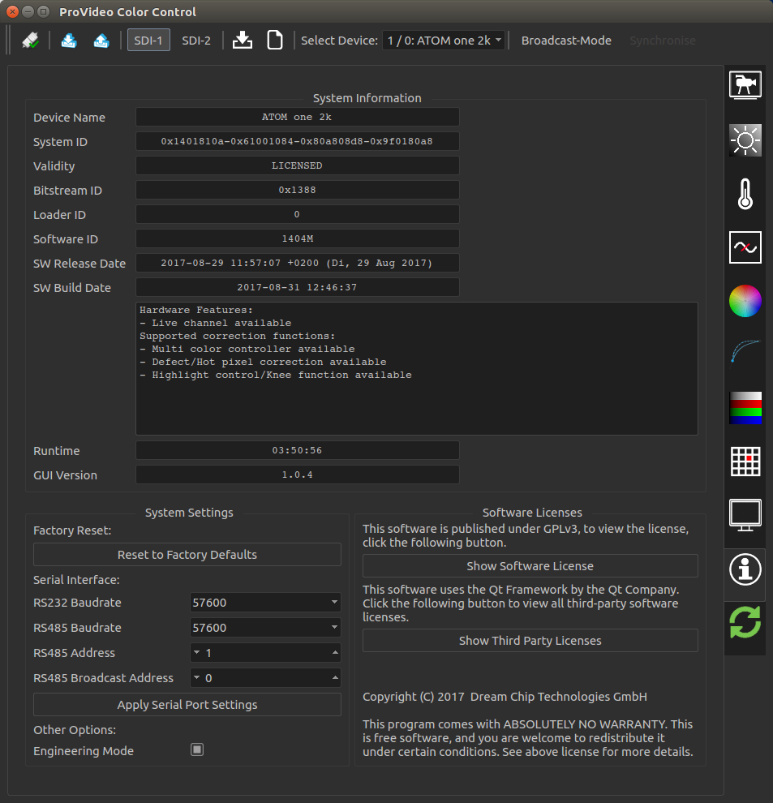
1
3
2
4
5
6
7
8
9
10
1 | The system information box gives some general information about the connected device. Check the “Software ID” to find out your current device version.
2 | Use this to reset all settings to factory defaults. Careful: This will delete any calibration you have done, e.g. to the multi color controller. If needed save those settings separately before performing a full reset!
3 | Change the baudrate of the RS232 port of the device. Usually this should be left at the default setting.
4 | Change the baudrate of the RS485 port of the device. Usually this should be left at the default setting.
5 | Change the RS485 address of the device. Before connecting multiple devices to one RS485 bus, make sure that all devices have different addresses, or you will have address conflicts!
6 | Change the RS485 broadcast address of the device. This is useful if you want to have multiple broadcast groups on one RS485 bus.
7 | Click this button to apply the new Serial interface settings. Without this step, the settings will be left unchanged.
8 | Enable the engineering mode to display additional GUI elements. Careful: Changing engineering settings can drastically decrease the image quality.
9 | Show the open source software license of the GUI software.
10 | Show the open source software licenses of third party software, which is used in the GUI.

Update Tab
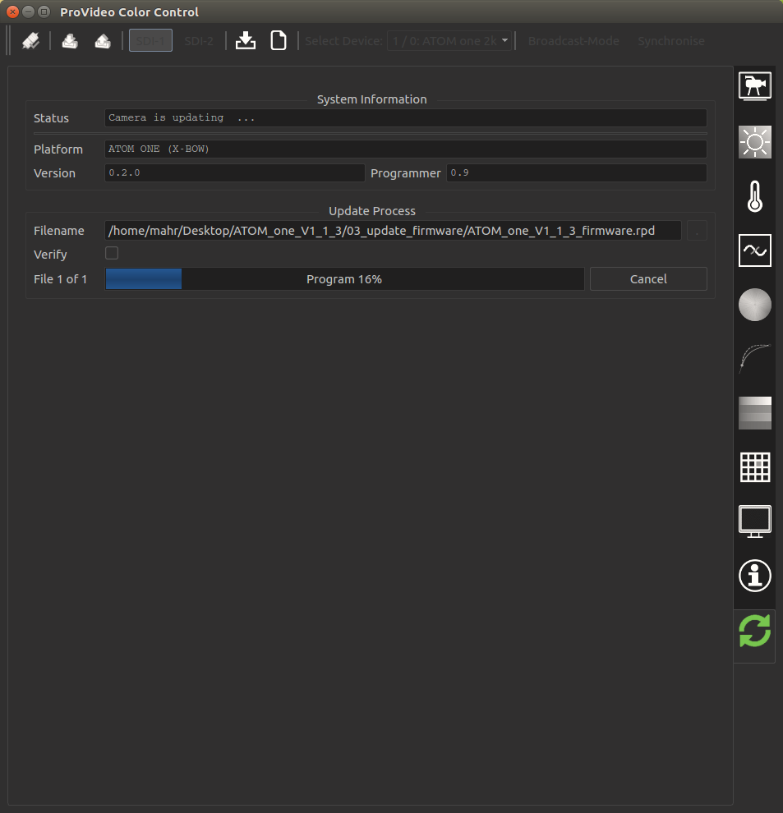
1
2
3
4
5
1 | Shows the current status of the device.
2 | Shows information about the firmware update components (device and local programmer tool).
3 | Click the “...” button to open a file open dialog. Navigate to the folder where the update files are placed and click “Open”. You do not have to select the file, the GUI will automatically choose the correct update file and display its name in the “Filename” field.
4 | If you wish you can run an additional verification check after the update was performed. Usually this is not needed, as the update process is safe.
5 | Click the start button to initiate the update process. The progress bar will inform you about the current status.

