Assignment 2 – Abstraction and Reasoning corpus

**List of tasks attempted**: 5582e5ca,3bdb4ada,5614dbcf

**Link to GitHub URL**: <https://github.com/KAZIMHU/ARC>

# Task 1: 5582e5ca

1. Color Image of Input-Output pair

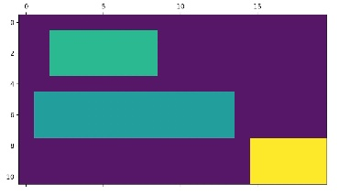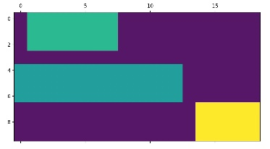

1. The aim of this task is to crop the pattern in the input grid and produce an output grid without the unnecessary spaces around it.
2. The solve function returns a numpy nd array by:
   1. The output NumPy array dimensions are found by obtaining the arrays where values are greater than 0 using the np.where function.
   2. The minimum_row, maximum_row, minimum_col and maximum_col value is found out using the min and max function.
   3. Traversing through the dimensions found above, we append all the grids found between them to an empty list and reshape it accordingly. Thus, producing an output grid as shown in the figure above.

# Task 2: 3bdb4ada

1. Color Image of Input-Output pair

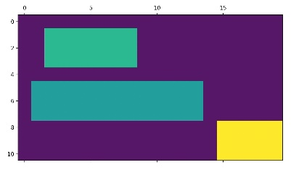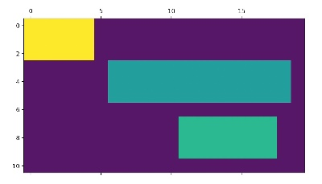

1. The aim of this task is to flip the pattern in the input grid and produce an output grid.
2. The solve function returns a numpy nd array by:
   1. flip function is used from NumPy package to reverse the order of elements in an array.
   2. The content is reordered but the shape is preserved.

# Task 3: 5614dbcf

1. Colour Image of Input-Output pair

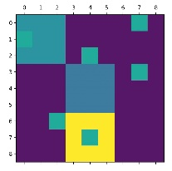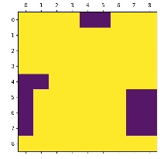

1. The aim of this task is to add a layer around the existing pattern in the input grid and produce an output grid.
2. The solve function returns a numpy nd array:
   1. The output NumPy array dimensions are found by obtaining the arrays where values are greater than 0 using the np.where function.
   2. We get couple of arrays as result of where function. It gives the positions of rows and corresponding columns
   3. By using Zip function, we are basically traversing through all the points.
   4. Then by the code logic we are assigning the requisite point value to the all edges of the point.

# Summary:

# Tools.py is used as a common utility function file which is used in all the three solutions. It contains functions to load the json files and plot the numpy array.

1. Numpy is used for the functionality implementation. Functions such as np.array, np.where, np.flip, np/reshape are used.
2. Matplotlib is used for plotting the numpy array.