**CHATBOT USING PYTHON**

TEAM MEMBER

963521106006:K.AKASH

PHASE 2

INNOVATION

**TITLE: Create a Chatbot using Python**

**Abstract:**

Chatbots are computer programs that can simulate conversation with humans. They are becoming increasingly popular in a variety of applications, such as customer service, education, and entertainment. Python is a popular programming language for chatbot development, due to its flexibility and ease of use. Chatbots are computer programs that can simulate conversation with humans.

# 

**Problem Definition:**

The challenge is to create a Chatbot in Python that provides exceptional customer service, answering user queries on a website or application. The objective is to deliver high-quality support to users, ensuring a positive user experience and customer satisfaction.

To **develop a chatbot in Python**, you will typically need to:

* Choose a Python module for chatbot development.
* Train the chatbot on some data. This data can be collected from a variety of sources, such as customer service transcripts, educational materials, or entertainment content.
* Implement the desired chatbot functionalities. This may involve using NLP techniques, machine learning algorithms, and dialog management techniques.
* Test the chatbot to ensure that it is working as expected.
* Deploy the chatbot to make it available to users.

**Innovation:**

We can use advanced techniques like using pre-trained language models such as ChatGPT and Google Bard to enhance the quality of responses.

Pre-trained program modules are pieces of code that have been trained on large datasets of text and code. These modules can be used to teach chatbots how to perform specific tasks, such as answering questions, translating languages, and generating text.

One advantage of using pre-trained program modules is that it can save time and effort in developing chatbots. Developers do not need to start from scratch when creating a new chatbot. Instead, they can use pre-trained program modules to provide the chatbot with the basic functionality it needs.

Another advantage of using pre-trained program modules is that it can make chatbots more adaptable. As new pre-trained program modules are developed, they can be easily integrated into existing chatbots. This allows chatbots to learn new skills and capabilities over time.

**Dataset:**

**Dataset Link:** [**https://www.kaggle.com/datasets/grafstor/simple-dialogs-for-chatbot**](https://www.kaggle.com/datasets/grafstor/simple-dialogs-for-chatbot)

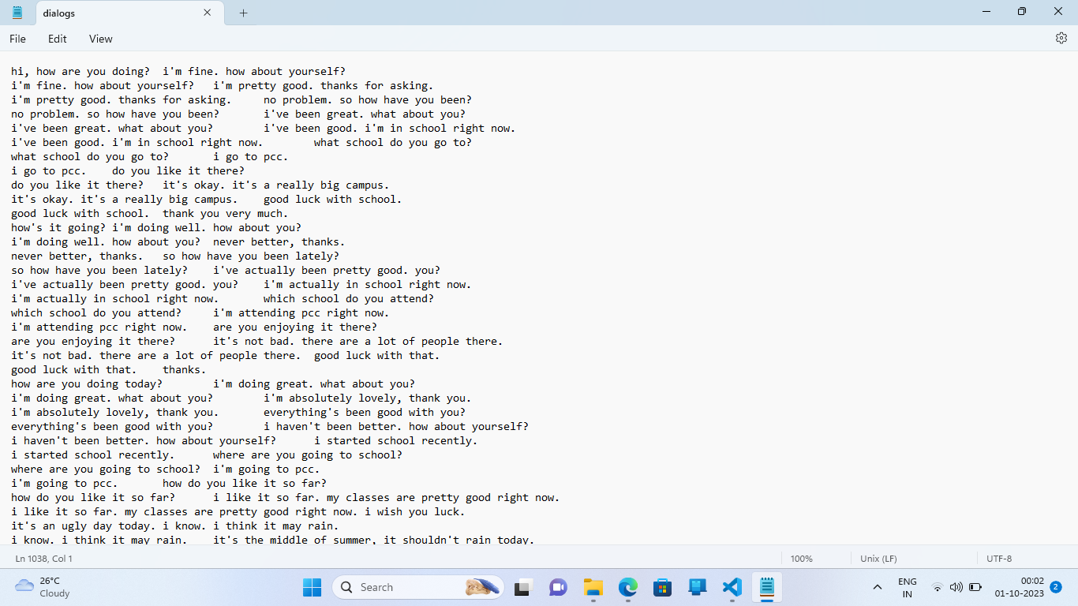

**Open AI ChatGPT 3.5:**

Using ChatGPT 3.5, we can access Chatbot using simple Python code provided with unique OpenAI API key.

**Python code**

import openai

import json

import time

import os

openai.api_key=”YOUR OPENAI API KEY HERE.”

timestamp = time.strftime(“%Y_%m_%d-%H_%M_%S”, time.gmtime())

filename = timestamp + “.txt

if not os.path.exists(filename):

with open(filename, ‘w’) as f:

f.write(“User: Welcome to OpenAI chat!\n”)

discussions=[{“role”: “system”,

“content”: “You are a helpful assistant.”}]

while (True):

p=input(“Enter quit to quit, or enter your prompt: “)

if (p==”quit”):

break

discussions.append({“role”: “user”, “content”:p})

completion = openai.ChatCompletion.create(

model=”gpt-3.5-turbo”,

messages=discussions

)

x=json.loads(str(completion))

response = x[“choices”][0][“message”][“content”]

discussions.append({“role”: “assistant”, “content”: response})

with open(filename, ‘a’) as f:

f.write(“User: “ + p + “\n”)

f.write(“AI: “ + response + “\n”)

print(“\nAI says: “, response, “\n”)

print(“Have a nice day!”)

**Output:**

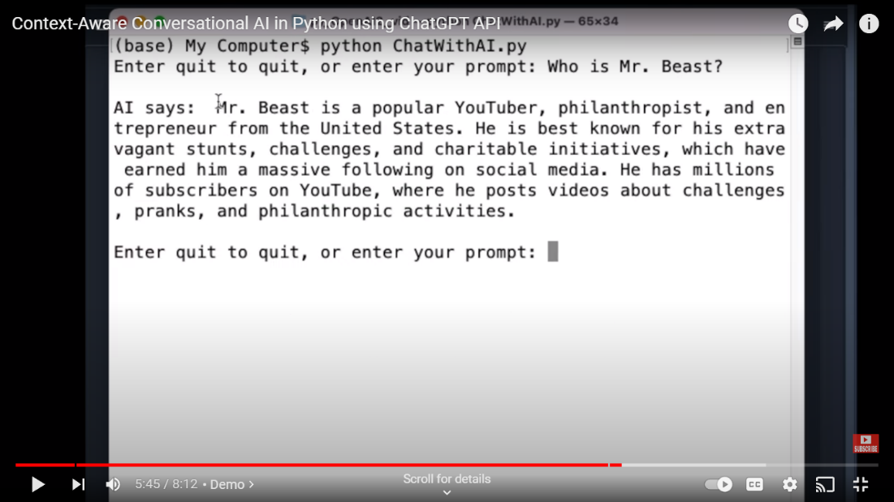

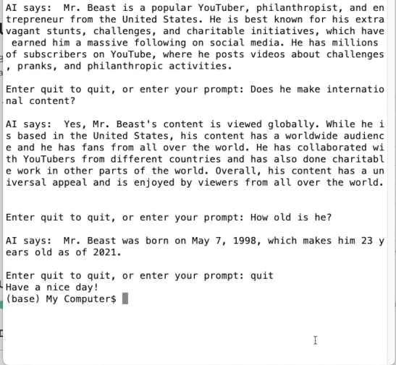

**Google Bard:**

Using Google Bard, we can access Chatbot using simple Python code provided with unique Google Bard’s API key.

## **Get the Session ID**

For security, we need to access Google Bard with Session ID or Token. It's a cookie that we can fetch:

The name is __Secure-1PSID, and we need to copy the value.

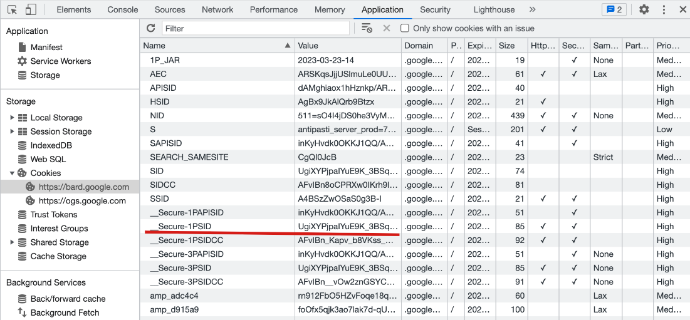

## **Python Code**

**The init function is to set the headers and some parameters**.

def __init__(self, session_id):

headers = {

"Host": "bard.google.com",

"X-Same-Domain": "1",

"User-Agent": "Mozilla/5.0 (Windows NT 10.0; WOW64) AppleWebKit/537.36 (KHTML, like Gecko) Chrome/91.0.4472.114 Safari/537.36",

"Content-Type": "application/x-www-form-urlencoded;charset=UTF-8",

"Origin": "https://bard.google.com",

"Referer": "https://bard.google.com/",

}

self._reqid = int("".join(random.choices(string.digits, k=4)))

self.conversation_id = ""

self.response_id = ""

self.choice_id = ""

self.session = requests.Session()

self.session.headers = headers

self.session.cookies.set("__Secure-1PSID", session_id)

self.SNlM0e = self.__get_snlm0e()

**The __Secure-1PSID is the session id we get from browser.**

**After the init done, we need to prepare some data, and then make a POST request to the bard.google.com:**

resp = self.session.post(

"https://bard.google.com/_/BardChatUi/data/assistant.lamda.BardFrontendService/StreamGenerate",

params=params,

data=data,

timeout=120,

)

chat_data = json.loads(resp.content.splitlines()[3])[0][2]

if not chat_data:

return {"content": f"Google Bard encountered an error: {resp.content}."}

json_chat_data = json.loads(chat_data)

results = {

"content": json_chat_data[0][0],

"conversation_id": json_chat_data[1][0],

"response_id": json_chat_data[1][1],

"factualityQueries": json_chat_data[3],

"textQuery": json_chat_data[2][0] if json_chat_data[2] is not None else "",

"choices": [{"id": i[0], "content": i[1]} for i in json_chat_data[4]],

**}**

## **Run the code**

python Bard.py --session 'UgiXYPjpaIYuE9K_3BSxxxxxxxxxxxxxxxxxxxxxxxxxxxxxxxxx'

ChatGPT - A command-line interface to Google's Bard (https://bard.google.com/)

You:

What is terrible-two?

Google Bard:

Terrible-two is a term used to describe the behavior of a child around the age of 2. It is a normal developmental phase that all children go through. During this time, children

are learning to assert their independence and explore the world around them. This can lead to tantrums, defiance, and other challenging behavior.

There are a few things that parents can do to help manage the terrible twos:

• Be patient and understanding. Remember that this is a normal phase and that your child is not trying to be difficult.

• Set clear boundaries and expectations. Children need to know what is expected of them.

• Be consistent with your discipline. If you are not consistent, your child will not learn what is right and wrong.

• Offer positive reinforcement. Praise your child for good behavior and help them feel good about themselves.

• Talk to your child's doctor if you are concerned about their behavior. Your doctor can offer advice and support.

The terrible twos can be a challenging time for parents, but it is important to remember that this is a normal phase and that your child will eventually grow out of it.

You:

how far is the moon?

Google Bard:

The Moon is an average of 238,855 miles (384,400 km) away from Earth. This distance varies slightly because the Moon's orbit is not a perfect circle. The Moon is closest to Earth

at perigee, which is when it is about 225,623 miles (363,104 km) away. It is farthest from Earth at apogee, which is when it is about 252,088 miles (405,696 km) away.

You:

how far is the sun?

Google Bard:

The Sun is about 93 million miles (150 million kilometers) away from Earth. That's about 1 Astronomical Unit (AU).

The Sun is the center of our solar system. All of the planets and other objects in our solar system orbit around the Sun. The Sun is a very large star. It is about 109 times the

diameter of Earth and about 330,000 times more massive than Earth. The Sun is made up of mostly hydrogen and helium. It is so hot that the hydrogen and helium are constantly

fusing together to create heavier elements. This process is called nuclear fusion. Nuclear fusion releases a lot of energy, which is what powers the Sun.

You:

how to cure a flu?

Google Bard:

There is no cure for the flu, but there are treatments that can help relieve symptoms and prevent complications. The most effective way to prevent the flu is to get a flu vaccine

every year.

If you get the flu, there are a few things you can do to feel better:

• Rest. Get plenty of sleep and avoid strenuous activity.

• Drink plenty of fluids. Water, juice, and soup are all good choices.

• Take over-the-counter pain relievers like acetaminophen or ibuprofen.

• Use a humidifier. The moisture can help soothe your throat and make it easier to breathe.

• See a doctor if you have severe symptoms or are at high risk of complications.

Here are some tips to help you prevent the flu:

• Get a flu vaccine every year. The flu vaccine is the best way to prevent the flu.

• Wash your hands often with soap and water. This helps to prevent the spread of germs.

• Avoid close contact with people who are sick. If you must be around someone who is sick, wear a mask.

• Clean and disinfect surfaces that may be contaminated with germs.

• Stay home from work or school if you are sick. This will help to prevent the spread of the flu.

• Eat a healthy diet and exercise regularly. A healthy immune system is better able to fight off infection.

You:

Exiting...

**Conclusion**

Chatbots are already having a significant impact on the way we interact with computers. As chatbot technology continues to innovate, we can expect to see chatbots become even more integral to our lives. Chatbots will be used to provide customer service, education, entertainment, and much more. The possibilities are endless.