Answer Key Practice Viewer
Use the toolbar below to browse for a blank page and solution page PDF file, then use the “Next” and “Last” buttons to change the page.
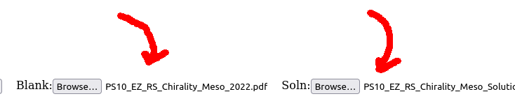
Simply use the mouse and drag on the page to reveal the answer sheet underneath. It will show up as inverted, so you know you’re looking at the answers.
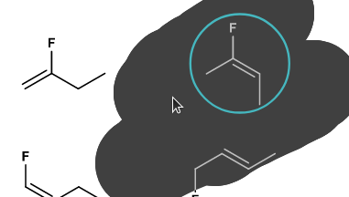
Try clicking below to reveal hidden contents:
???
It’s very quick and dirty, but it does the job. The source code is based on:
Mozilla’s PDF JS example (quite heavily, I might add): https://github.com/mozilla/pdf.js/blob/master/examples/learning/helloworld.html
And this CodePen: https://codepen.io/silvertae/pen/GRzdqpa

