TPT TESS Proposal Tool User Guide

Target audience: The TPT-TESS Proposal Tool is a web application designed for researchers and educators who want to create proposals for using the Transiting Exoplanet Survey Satellite (TESS). The target audience likely includes people with a background in astronomy or astrophysics, so the guide can assume a certain level of technical expertise.

The web app contains three screens.

Home screen: 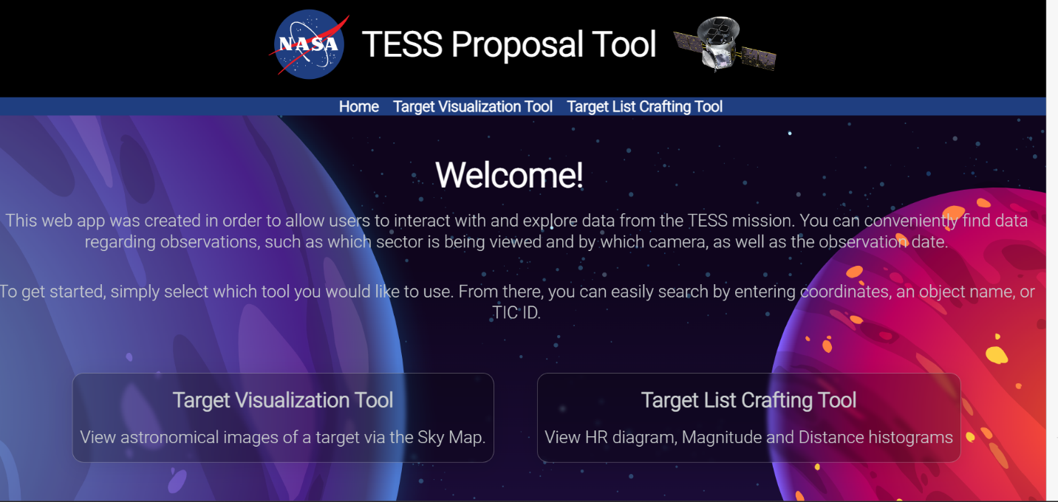

Users can select either of the following tools.

Target visualization tool: this will allow users to observe targets in the skymap.

The search box for a single target will accept entries like:

ObjectName (Cyg X-1),

TIC ID(12941989),

Ra,Dec(117.4150, -52.1204)

Users can also select csv files with the following format:

ObjectName (Cyg X-1),

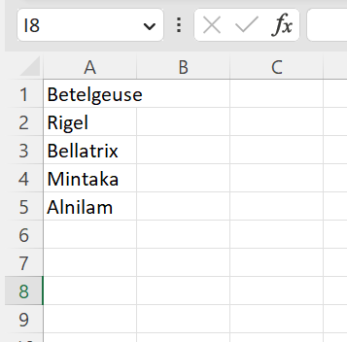

TIC ID(12941989),

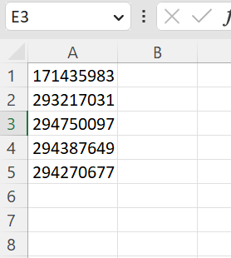

Ra,Dec(117.4150, -52.1204)

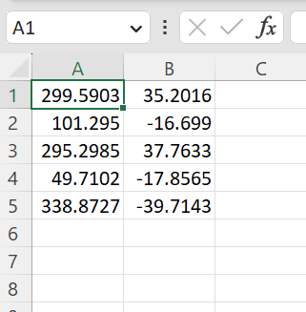

After entering the single target or csv file they will click in the search sky map btn and the sky map will move to the expected location drawing a red circle around the target/s. after this step, users can select a cycle to see if the target falls between any observed sector/cycle.

Example of target ra,dec (117.4150, -52.1204) and cycle 3 selected: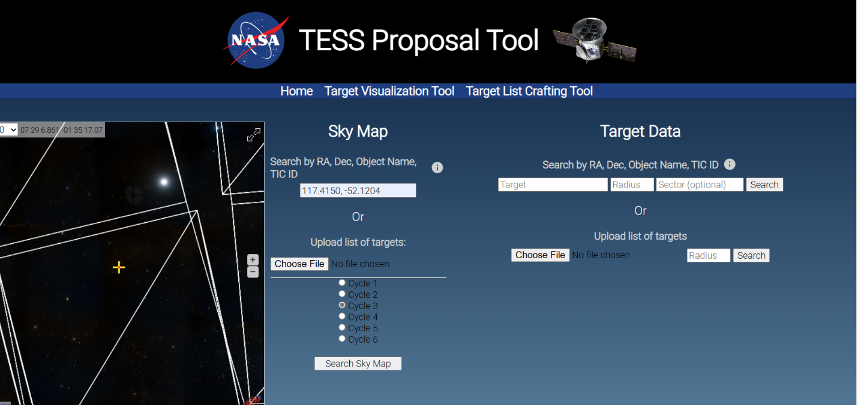

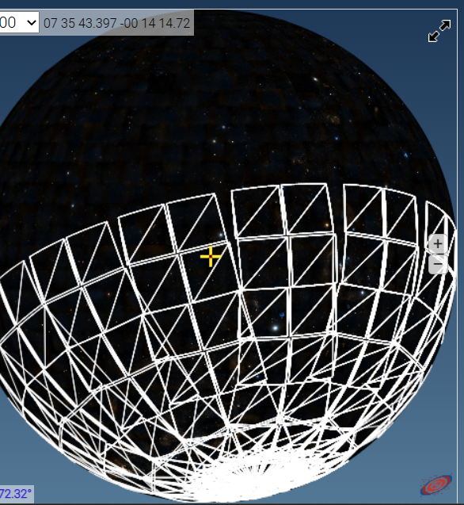

For the Target Data query table input box will accept the same format as above.

Here users will be able to optionally enter a sector number in case they only would like information about a specific sector.

The input box for radius will accept entries like 0.01, 0.1, 1(this will be big and can take some time to process)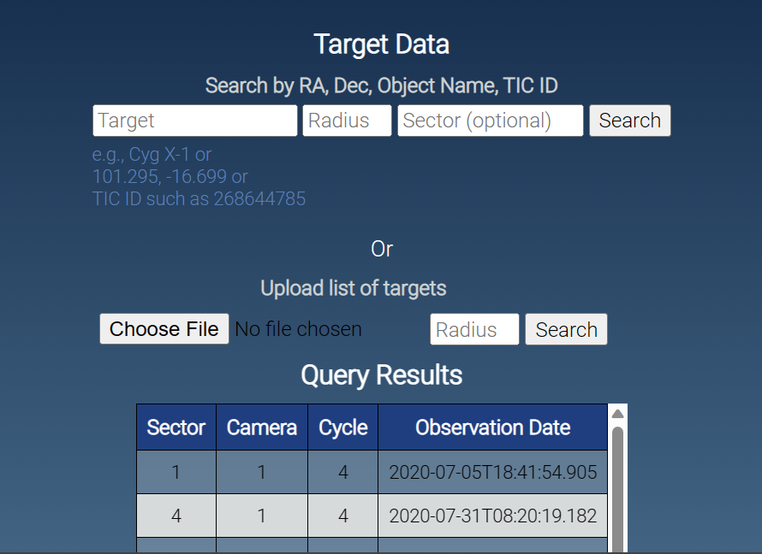

Target List Crafting Tool will accept only csv file with the same format stated above: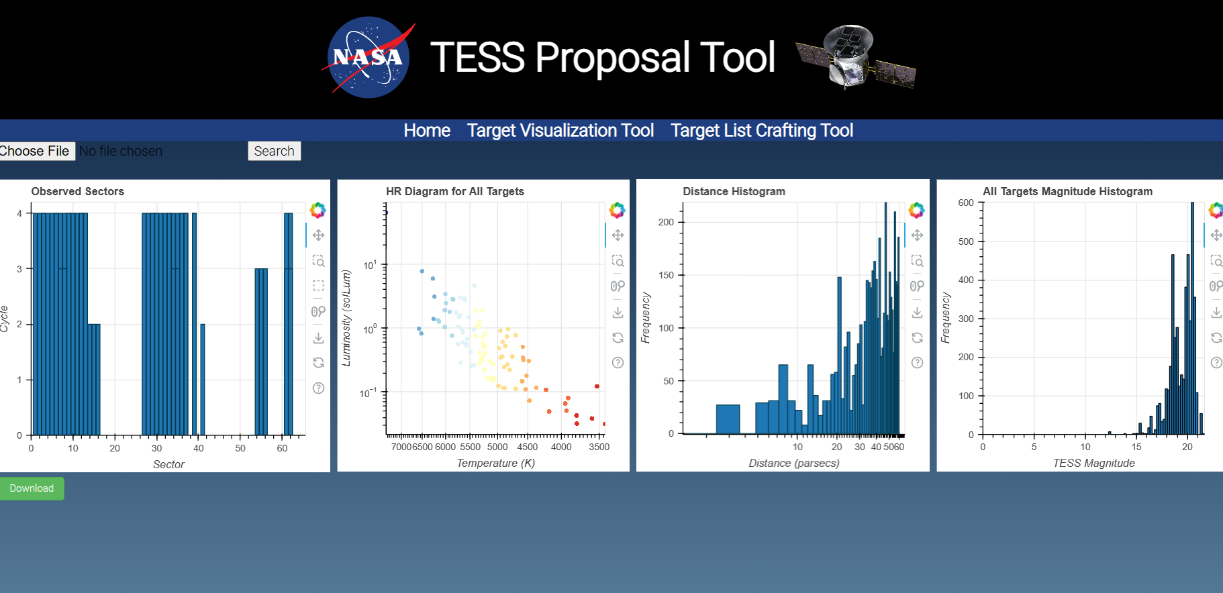

Users will be able to

Notice: usually there are more than 1 magnitude, frequency, temperature, and luminosity per target. The tic catalog retrieves more than one per target.

In the magnitude histogram, the values in the downloaded file correspond to the information in the ColumnDataSource used for the histogram plot. Each row of the data represents a single bin in the histogram:

* **top**: The frequency or count of items in each bin. This represents the number of stars with magnitudes in the range specified by the **left** and **right** values.
* **bottom**: The lower edge of the bin. In this case, it's always 0 since the histogram starts at 0 frequency.
* **left**: The lower limit of the bin on the x-axis (magnitude value).
* **right**: The upper limit of the bin on the x-axis (magnitude value).

For example, the first row of the data:

8 0 13.29982 15.44908

This indicates that there are 8 items (stars) in the bin with magnitudes ranging from 13.29982 to 15.44908. The **bottom** value of 0 represents the starting point for the frequency of the histogram.

Distance histogram:

* **top**: The frequency or count of items in each bin.
* **bottom**: The lower edge of the bin. In this case, it's always 0 since the histogram starts at 0 frequency.
* **left**: The lower limit of the bin on the x-axis (distance in parsecs).
* **right**: The upper limit of the bin on the x-axis (distance in parsecs).

For example, the first row of the data:

18 0 17.99368176 19.19311194

This indicates that there are 18 items in the bin with distances ranging from 17.99368176 to 19.19311194 parsecs. The **bottom** value of 0 represents the starting point for the frequency of the histogram.