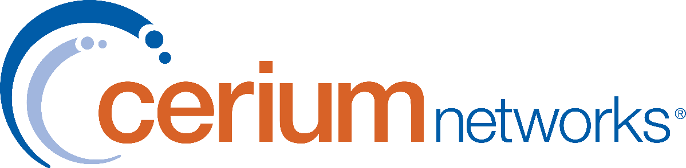

Statement of Work

{companyName}
Microsoft Secure AI Assessment

Implementation Services Statement of Work (SOW) for {companyName}
Date: | Services Performed By: | Services Performed For:
2/26/2026 | Cerium Networks, Inc.  3330 Colton Drive – Suite A  Helena, MT 59601 | {customerContact}  5 River Drive South  Great Falls, MT 56405
 | Cerium Account Executive: | Client Contact:
 | Holger Meyer  406-441-2139 | Tom Croskrey  (406) 791-8515

Table of Contents
Introduction 4
1.1 Modifications 4
1.2 Contract Return Date 4
2.0 Scope 5
2.1 Solution 5
2.1.1 Hardware and Software 5
2.1.2 Proposed Assessment 5
2.1.3 – Out of Scope 6
3.0 Client Responsibilities 7
3.1 Client Responsibilities 7
3.2 Client Point of Contact 7
4.0 Engagement Standards 7
4.1 Service Hours 7
4.2 Travel and Living Expenses 8
4.3 Project Invoicing 8
5.0 Post Assessment Support 9
5.1 Cerium Support Center 9
5.2 Cerium Support Web Portal 9
6.0 Signature Authorization 10

Introduction
This Statement of Work (SOW) is an attachment to Order No. ORD000205850 (“Order”) and is entered by and between Cerium Networks, (hereinafter referred to as Cerium) and Pacific Steel & Recycling (hereinafter referred to as Client). This SOW, when executed by both undersigned parties, together with the other documents, annexes or exhibits attached hereto or incorporated herein by reference, constitutes the complete contractual agreement between the undersigned parties with respect to the deliverables and/or services described herein.

Modifications
No verbal statements by Cerium or any other party shall constitute a modification of this SOW or representation that additional or different services will be performed. Services not written within this SOW are not assumed and will not be performed unless defined within this document. See Section – Engagement Standards – Change Management for more details.
In the event of a conflict between the Order, this SOW and any other Attachments, the following order of precedence shall apply: i) Order, ii) this SOW, and then iii) the Attachments (if any).

Contract Return Date
This SOW will become invalid if not accepted within 60 days from the SOW date documented in the previous section.

- Scope

Solution
{AI_Summary}

Hardware and Software
Cerium will provide only the hardware and software, including quantities, specifically listed within the Sales Order(s). Any hardware or software not expressly listed within the Sales Order is not included as a part of the project.
In the event the manufacturer recommends an amended or “patched” version of its software to resolve problematic feature/functionality, Cerium can perform this work at current time and material rates.

Proposed Assessment

The Client, in partnership with Cerium Networks, will have the following Microsoft Secure AI consulting services performed by Cerium personnel:
{AI_Scope}

Deliverables
- Secure AI Productivity Assessment Report
- CIS maturity scoring and findings summary
- Risk-to-recommendation mapping with Microsoft security tooling
- Prioritized remediation roadmap
- Copilot readiness and governance recommendations

2.1.3 – Out of Scope
- Active remediation or policy changes
- Licensing procurement
- Custom development or automation

- Client Responsibilities
Timely delivery of our services depends upon the prompt and effective completion of the responsibilities identified herein, among other things. Any delay in performance of Client responsibilities may result in additional charges and/or delays completing the project.

Client Responsibilities
To ensure the success of this project, Client agrees to:
- Provide access to M365 Tenant
- Availability of SMEs for interviews/workshops
- Participate in all aspects and phases of the assessment process as needed

Client Point of Contact
Prior to the project kickoff, Client will designate a Client Point of Contact to whom all communication relative to the project will be addressed. Client Point of Contact responsibilities include:
- To serve as the interface between Cerium and all Client personnel participating in or affected by the project.
- To work with Cerium Project Manager to manage project plans, schedules, etc.
- To attend and actively participate in all mutually scheduled required project meetings.
- To assist Cerium Project Manager with scheduling and coordinating Client resources.
- To coordinate Client vendors, subcontractors, and local exchange carrier interactions.
- To provide Cerium with information or documentation required to complete the projects
- To provide access to the systems required to complete the project.
- To help resolve or escalate issues encountered during the project.

- Engagement Standards

Service Hours
Standard hours of operations are 8:00 AM to 5:00 PM Pacific Standard Time Monday through Friday. It is understood that due to the nature of the industry and work performed, after-hours and weekend availability is often required. In the event Cerium resources are required to perform work outside of the standard hours of operation, agreed-upon work windows will be discussed and subsequently documented via email. It is also required that either a Client project stakeholder or a technical contact be either on location or on call during the agreed-upon weekend/after-hours work window(s).

Travel and Living Expenses
Should travel be required, travel expenses will be billed as actual for services performed onsite. Travel includes all that apply to airfare, hotel, meal per diem, car rental, mileage, and parking.

Project Invoicing
Unless specifically stated otherwise in the Client signed terms and conditions, milestone invoicing may be initiated by completion of any of the following conditions:
- Receipt of equipment, licenses, software, or other material.
- Completion of any major milestones as defined in the project plan.
- Completion of any other milestone as agreed upon by the Client and documented in the Cerium project plan.
- Scheduling of a specific assessment will be invoiced at one-third of the agreed cost with the remaining two-thirds invoiced at completion and delivery of final report.

- Post Assessment Support

Cerium Support Center
Client may contact Cerium in a variety of ways, such as:
    - Calling Cerium at 1-800-217-0933
    - Email: csc@ceriumnetworks.com
    - Web Site www.ceriumnetworks.com

Within 2 hours a response is sent to the Client via phone or email containing a case ID #, and contact information for the Cerium associate responsible to resolve your request.
Case ID information includes:
- (Company Name)
- (Contact) Name of Client contact calling with support issue
- Nature of request
- Status of request / SLA

Cerium Support Web Portal
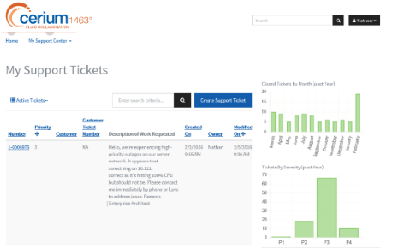
Our current Cerium support clients, when engaged with Cerium on an active case, may visit the Cerium support portal for real-time status updates and escalation contact information. After the case has been closed, return to the portal for historical and statistical information on all trouble tickets and service orders submitted.

The Cerium Support Web Portal is a self-service tool that is leveraged to provide another effective channel of communications with our active support clients.
Click here to enter text.

- Signature Authorization

YOUR SIGNATURE BELOW ACKNOWLEDGES THAT YOU HAVE READ, UNDERSTAND AND AGREE TO ALL SECTIONS OF THE STATEMENT OF WORK, INCLUDING DEPENDENCIES.

  X
  Client Signature
  Printed Name
  Title
  Date
  X
  Cerium Networks Signature
  Printed Name
  Title
  Date

Section9SectionSectio 1Sectio2 Sec4Sectio 5Sec n16Section17

