EPAM Systems
Work Instruction

Remote and Guest Access to Corporate Network Resources

REVISION HISTORY
Rev. | Description of Change | Author | Date | Approved
 |  |  |  | Name | Effective Date
0.1 | Transferred into the new template | Zoya Bialiankina | 31-Oct-2005
0.2 | Reviewed and updated | Vasili Hronski | 14-Nov-2005
0.3 | Reviewed | Tamas Kohegyi | 27-Jan-2006
0.4 | Reviewed, updated with Valery Maliutsin’s correction. | Tamas Kohegyi | 10-Apr-2006
1.0 | Updated and Reviewed | Balazs Fejes1 | 10-Apr-2006 | Balazs Fejes1 | 10-Apr-2006
1.1 | VPN setting for Kyiv and St. Petersburg offices were added | Zoya Bialiankina | 17-Jul-2006 | Tamas Kohegyi | 26-Jul-2006
1.2 | Updated Minsk office technical info | Siarhei Maltsau | 26-Mar-2007
1.3 | St. Petersburg VPN is removed. | Tamas Kohegyi | 10-Apr-2007
1.4 | Reviewed | Siarhei Maltsau | 28-Sep-2007
1.5 | Editorial review | Richard Bötös | 23-Nov-2007 | Balazs Fejes1 | 13-Dec-2007
1.6 | SSL Network extender updates | Vasili Hronski  Valery Maliutsin | 24-Sep-2008
1.7 | Editorial review of changes. | Richard Bötös | 30-Sep-2008 | Balazs Fejes1 | 28-Nov-2008
1.8 | Added SSTP Connection from Customer Network | Siarhei Maltsau,  Tamas Kohegyi | 07-Sep-2009
1.9 | Editorial review of changes | Mihaly Beviz | 10-Sep-2009 | Balazs Fejes1 | 29-Oct-2009
1.10 | Guest connection has been added  Dial-in has been removed | Valery Maliutsin | 22-Sep-2010
1.11 | QA review is performed | Andrei Zemliakou | 5-Nov-2010 | Balazs Fejes1 | 5-Dec-2010
1.12 | Updated Karaganda and Kyiv offices technical info, TSG access details | Siarhei Maltsau | 06-Jul-2011,  17-Oct-2011
1.13 | Added setting up VPN under Windows 7 and MAC OS instructions. Updated Wi-Fi Access instructions. | Vasili Gronski  Sviatlana Salauyova | 23-Nov-2011
1.14 | QA review | Andrei Zemliakou | 24-Nov-2011 | Andrei Kureichyk | 19-Dec-2011
1.15 | URL for certificates was updated | Siarhei Maltsau | 04-Jul-2012
1.16 | QA review | Andrei Zemliakou | 05-Jul-2012 | Andrei Kureichyk | 05-Jul-2012
1.17 | Added setting up VPN under Ubuntu 12.04 | Maksim Liauchuk  Aliaksandr Arlou1 | 09-Jul-2012
1.18 | QA review | Yury Rybkin | 10-Jul-2012 | Andrei Kureichyk | 31-Jul-2012
1.19 | p. “5. Connecting to EPAM Network via SSL Network Extender” was removed; Wi-Fi instruction was updated – p. 5. Wi-Fi Access | Vasili Gronski  Olga Sidorova | 31-Jul-2012
1.20 | QA review | Yury Rybkin | 06-Aug-2012
1.21 | Editorial review | Hanna Khaletskaya | 08-Aug-2012
1.22 | Ready for approval | Andrei Zemliakou | 09-Aug-2012 | Andrei Kureichyk | 09-Aug-2012
1.23 | VPN for Windows 8 added | Siarhei Maltsau | 18-Nov-2012
1.24 | QA review | Sviatlana Pushkina | 20-Nov-2012 | Andrei Kureichyk | 27-Nov-2012
1.3 | Wi-Fi instruction was updated – p. 5. Wi-Fi Access. P. 3.2.2.screenshot updated | Vasili Gronski | 31-January-2013 | Andrei Kureichyk | 18-Feb-2013
1.3.1 | p. 5, 2. Rules of Use was updated; p. 5, 3.1. Processing the Request for Access was updated | Liudmila Dzikevich | 17-April-2013 | Andrei Kureichyk | 15-May-2013

RELATED ARTIFACTS
Ref. | Related Documents
GLO | Common Glossary
WIAP | Work Instruction: Antivirus Protection

Acronyms & Abbreviations
DGI | Director, Global IT Operations
EPM | EPAM Systems
SSL | Secure Sockets Layer
QMS | Quality Management System
SEPG | Software Engineering Process Group
SSTP | Secure Socket Tunneling Protocol
WiFi | Wireless network
VPN | Virtual Private Network
SID | Security Identifier
TSG | Terminal Services Gateway

Contents
1. Introduction 5
1.1. Purpose 5
1.2. Scope 5
2. Rules of Use 5
3. Connecting to EPAM Network via Microsoft VPN Server 5
3.1. Processing the Request for Access 5
3.2. Logging of VPN Sessions 6
3.3. Configuring VPN Connection 6
3.3.1. Setting up your VPN under Windows 7 6
3.3.2. Setting up your VPN under Windows 8 8
3.3.3. Setting up your VPN under Mac OS X 10.6 10
3.3.4. Setting up your VPN under Ubuntu 12.04. 14
4. Connecting to EPAM Network via Terminal Services Gateways (TSG) 17
5. Wi-Fi Access 20
5.1. EPAM Guest Connection 20
5.2. EPAM Employee Connection 20
5.2.1. EPAMemployees 20
5.2.2. EPAM8021x 20
5.2.2.1. Windows 7 20
5.2.2.2. Windows XP SP3 21
5.2.2.3. MAC OS X Lion 10.7.4 21
5.2.2.4. Windows Mobile 5.x and 6.x 22
5.2.2.5. Android 22
5.2.2.6. iOS 5.x, 6.x 22
6. Appendix 1. VPN Gates 24
7. Appendix 2. TSG Gates 24

Introduction

Purpose
This work instruction defines the procedures for connecting to the Company’s network through VPN. The Company provides these services to encourage and improve efficient and high quality work and information exchange.

Scope
The work instruction applies to all Employees of the EPAM Systems.
The owner of this document is the DGI.
The approver of this document is the CTO.
SEPG is responsible for its maintenance and publishing, IT department for regular review/update.

Rules of Use
Only EPAM Systems Employees are authorized to access the internal EPAM network from the Internet over VPN in case they need services that cannot be accessed from the Internet. If the Company’s network has been accessed by a third party, the password of the domain account used to access the network must be changed immediately and the Help Desk must be promptly notified.
The VPN and Guest connections are to be used only for transmitting the work related data to and from the Company’s network.
The computing devices accessing the Company’s network shall:
- use a legally licensed operating system;
- have the latest service pack, updates and patches installed on the operating system;
- support Microsoft Point-to-Point Encryption (MPPE), which is the encryption type used by the EPAM VPN;
- have antivirus software installed (legally licensed), in use, and updated with the latest virus definitions (see [WIAP]);
- have the firewall turned on;
- have up-to-date antivirus enabled.
The following restrictions and recommendations must be observed and strictly adhered to:
- It is strictly prohibited to pass any details of connection information to any third party, or to allow any third party (including friends and family members) to access Company’s network or resources.
- It is strictly prohibited to use the VPN and Guest connections for Internet navigation not related to work activities.
- It is not recommended to use VPN connections only for browsing the Internet, even if it is work related.
- It is not recommended to use VPN and Guest connections for accessing the Company’s E-mail system.
- It is forbidden to allow the computer device accessing the Company’s network to act as a gateway between the Company’s network and another network.

Connecting to EPAM Network via Microsoft VPN Server

Processing the Request for Access
As an EPAM employee in order to obtain rights to use VPN connection to access Company’s network (in case you do not have such permissions yet) please send a request to Help Desk.
Help Desk performs the necessary actions to fulfill the request

Logging of VPN Sessions
The time and duration of all client VPN sessions are logged. There is a tracking system on connection usage if Company’s Administration requests this.

Configuring VPN Connection
The appendix 1 contains VPN server addresses of various EPAM locations.

Setting up your VPN under Windows 7
- Open Control Panel → choose Network and Sharing Center → click on Set up a new connection or network → select Connect to a workplace
INCLUDEPICTURE "cid:image001.jpg@01CB3AE4.9FA05330" \* MERGEFORMATINET INCLUDEPICTURE "cid:image001.jpg@01CB3AE4.9FA05330" \* MERGEFORMATINET INCLUDEPICTURE "cid:image001.jpg@01CB3AE4.9FA05330" \* MERGEFORMATINET INCLUDEPICTURE "cid:image001.jpg@01CB3AE4.9FA05330" \* MERGEFORMATINET INCLUDEPICTURE "cid:image001.jpg@01CB3AE4.9FA05330" \* MERGEFORMATINET 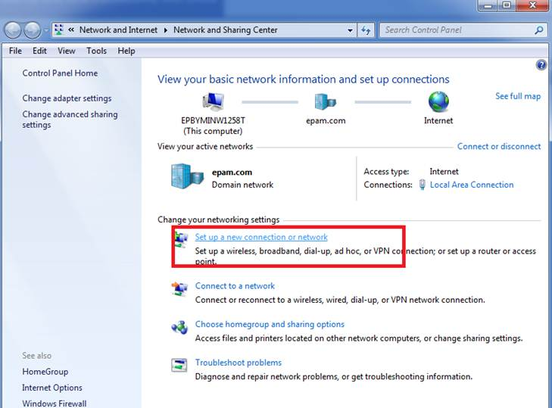 | INCLUDEPICTURE "cid:image002.png@01CB3AE4.9FA05330" \* MERGEFORMATINET INCLUDEPICTURE "cid:image002.png@01CB3AE4.9FA05330" \* MERGEFORMATINET INCLUDEPICTURE "cid:image002.png@01CB3AE4.9FA05330" \* MERGEFORMATINET INCLUDEPICTURE "cid:image002.png@01CB3AE4.9FA05330" \* MERGEFORMATINET INCLUDEPICTURE "cid:image002.png@01CB3AE4.9FA05330" \* MERGEFORMATINET 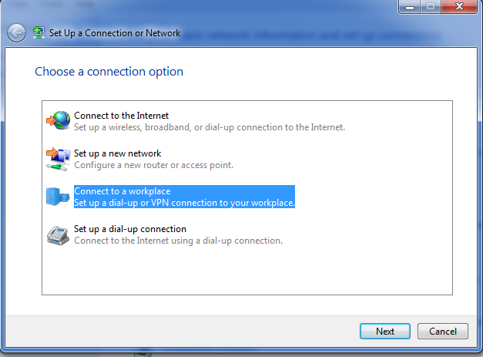
- Check radio button “No, create a new connection” -> choose Use my internet connection
INCLUDEPICTURE "cid:image003.png@01CB3AE4.9FA05330" \* MERGEFORMATINET INCLUDEPICTURE "cid:image003.png@01CB3AE4.9FA05330" \* MERGEFORMATINET INCLUDEPICTURE "cid:image003.png@01CB3AE4.9FA05330" \* MERGEFORMATINET INCLUDEPICTURE "cid:image003.png@01CB3AE4.9FA05330" \* MERGEFORMATINET INCLUDEPICTURE "cid:image003.png@01CB3AE4.9FA05330" \* MERGEFORMATINET 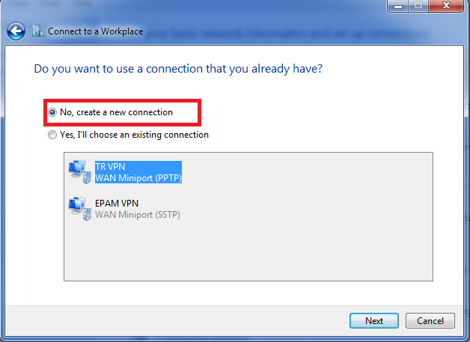 | INCLUDEPICTURE "cid:image004.png@01CB3AE4.9FA05330" \* MERGEFORMATINET INCLUDEPICTURE "cid:image004.png@01CB3AE4.9FA05330" \* MERGEFORMATINET INCLUDEPICTURE "cid:image004.png@01CB3AE4.9FA05330" \* MERGEFORMATINET INCLUDEPICTURE "cid:image004.png@01CB3AE4.9FA05330" \* MERGEFORMATINET INCLUDEPICTURE "cid:image004.png@01CB3AE4.9FA05330" \* MERGEFORMATINET 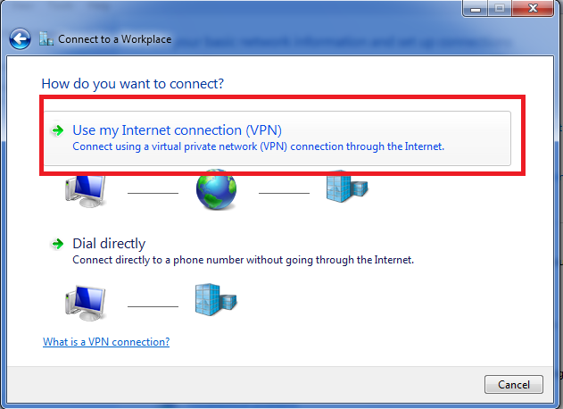
- Fill in the fields as follows:
Internet address: vpnmsq.epam.com
Destination name: EPAM VPN
INCLUDEPICTURE "cid:image005.png@01CB3AE4.9FA05330" \* MERGEFORMATINET INCLUDEPICTURE "cid:image005.png@01CB3AE4.9FA05330" \* MERGEFORMATINET INCLUDEPICTURE "cid:image005.png@01CB3AE4.9FA05330" \* MERGEFORMATINET INCLUDEPICTURE "cid:image005.png@01CB3AE4.9FA05330" \* MERGEFORMATINET INCLUDEPICTURE "cid:image005.png@01CB3AE4.9FA05330" \* MERGEFORMATINET 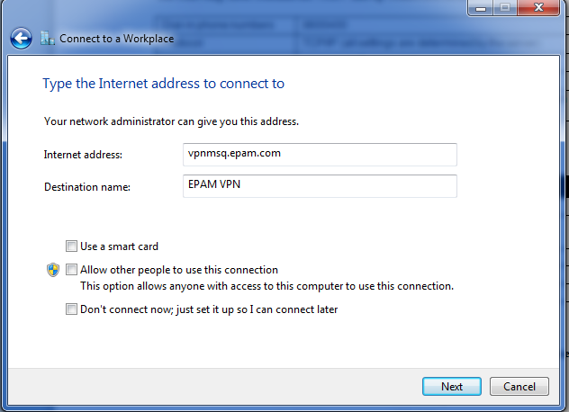
- Enter your EPAM e-mail address as User name (i.e. Firstname_Lastname@epam.com), and your domain password.
User name: First_Lastname@epam.com
Password: **********
INCLUDEPICTURE "cid:image006.png@01CB3AE4.9FA05330" \* MERGEFORMATINET INCLUDEPICTURE "cid:image006.png@01CB3AE4.9FA05330" \* MERGEFORMATINET INCLUDEPICTURE "cid:image006.png@01CB3AE4.9FA05330" \* MERGEFORMATINET INCLUDEPICTURE "cid:image006.png@01CB3AE4.9FA05330" \* MERGEFORMATINET INCLUDEPICTURE "cid:image006.png@01CB3AE4.9FA05330" \* MERGEFORMATINET 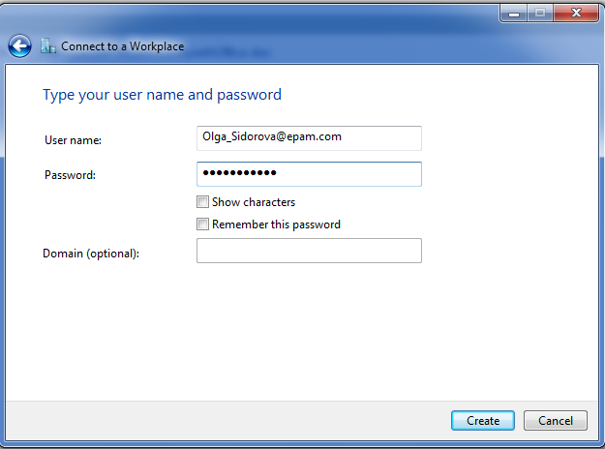
Note. Some vital for VPN connection functioning network ports can be restricted at customer’s or public places firewalls. In this case you can try to use SSTP connection.
SSTP is available:
- in Windows 8, Windows 7, Windows Server 2008, Windows Vista SP1 and later operating systems
- if Server Address/Internet address is set as the full DNS name, e.x.vpnmsq.epam.com
Configure VPN Connection properties as follows:
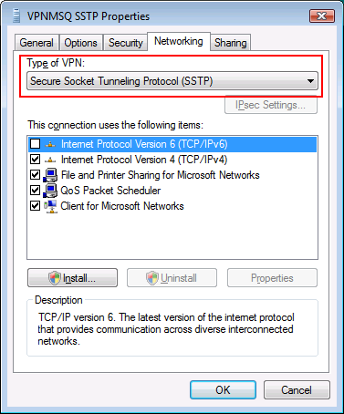
Usually it is not needed, as setting = Automatic is working well.

Setting up your VPN under Windows 8
- In Windows 8 you can use the Get Connected Wizard to create a VPN profile. Launch the wizard from Settings Search panel (Win+W), type in “vpn” in Settings field and then click Set up a virtual private network (VPN) connection.

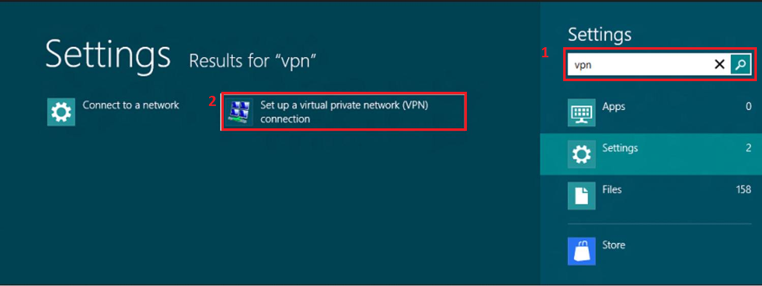

- Fill in the fields as follows:
Internet address: vpnmsq.epam.com (see appendix 1 for more information)
Destination name: EPAM VPN
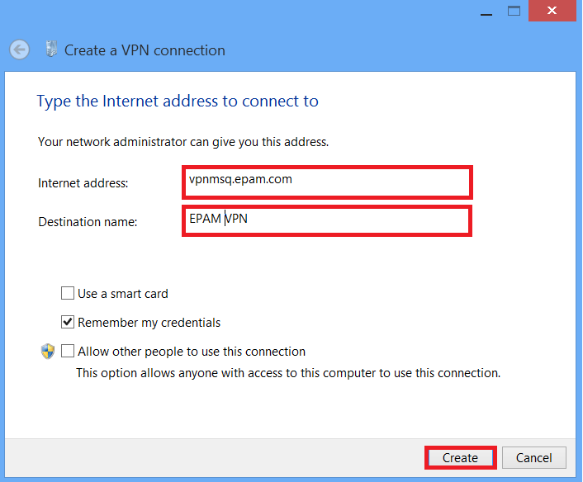
- Press Create Button.
- Press Win + i or click Settings from Charms (Win+C hotkey) to open up the Settings panel, click the network icon at the bottom part of the panel to open up the Network Connection side panel. You will see the created VPN connection listed there. Simply click or tap it and Connect.

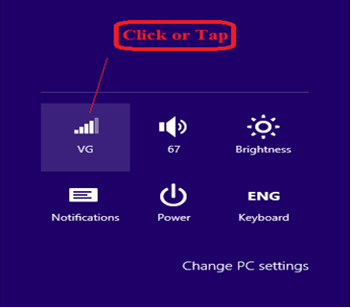

Note. Some vital for VPN connection functioning network ports can be restricted at customer’s or public places firewalls. In this case you can try to use SSTP connection.
SSTP is available:
- in Windows 8, Windows 7, Windows Server 2008, Windows Vista SP1 and later operating systems
- if Server Address/Internet address is set as the full DNS name, e.x.vpnmsq.epam.com
Configure VPN Connection properties as on the screenshot:

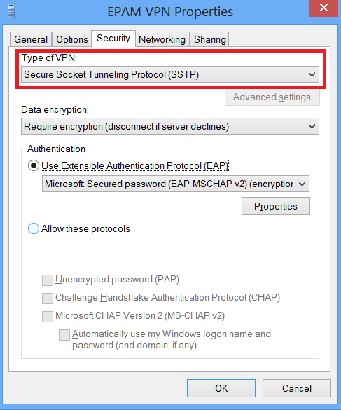

Setting up your VPN under Mac OS X 10.6
- Go to the Apple menu and choose System Preferences. Or choose System Preferences from the Dock.
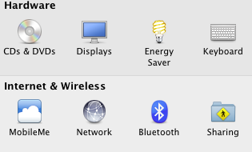

- Click on Network system preference.
- In the Network system preference there is a list of network connections on the left side. Click the '+' icon to make new VPN connection.
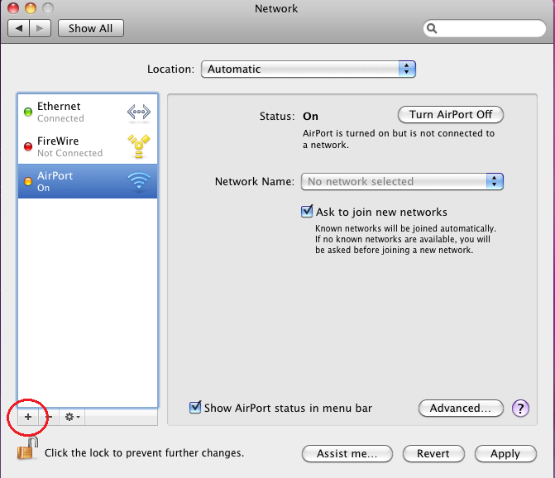

- On the new service sheet click on the Interface popup menu to see the list of choices and select VPN.
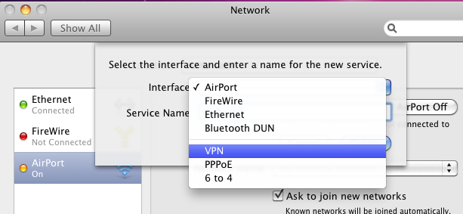

- Set VPN Type as PPTP
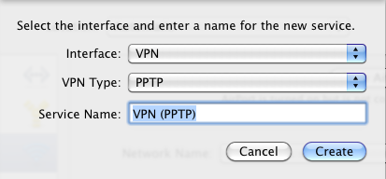

- Click Create to create a new connection
- Configure your VPN: click Configuration popup menu.
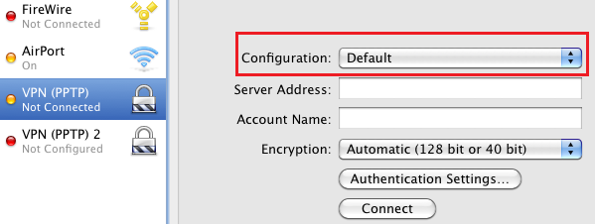

- If you've set the VPN up before, you may see configurations in the list.
- Click Add Configuration... to add the necessary VPN (PPTP) configuration.
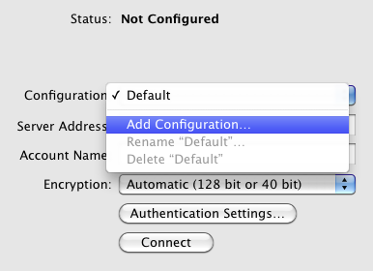

- Type the configuration name and click Create.
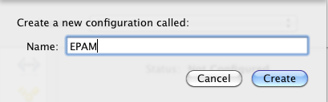

- Enter your VPN information:
In the Server address box, enter vpn server name in accordance with your location (e.x. vpnmsq.epam.com).
In the Account name box, enter your domain username as First_Lastname@epam.com.
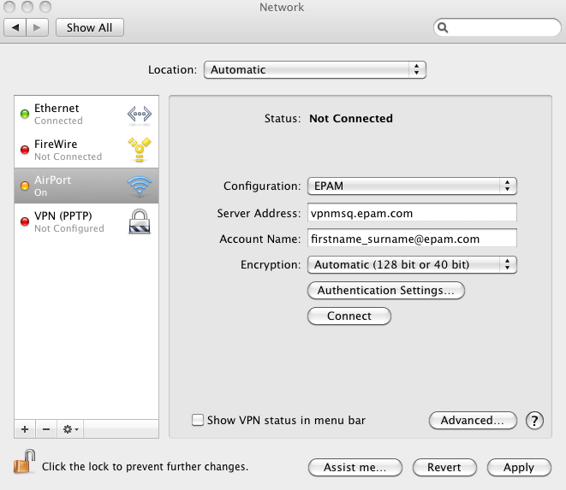

- To save the configuration, click Apply.
- To connect to the VPN, you can either choose the VPN configuration from the VPN menu or select your VPN connection in the connection list and click the Connect button.
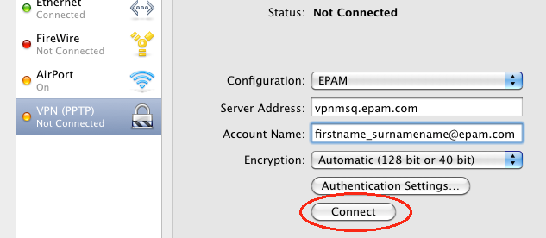

- Enter your domain password and click OK.
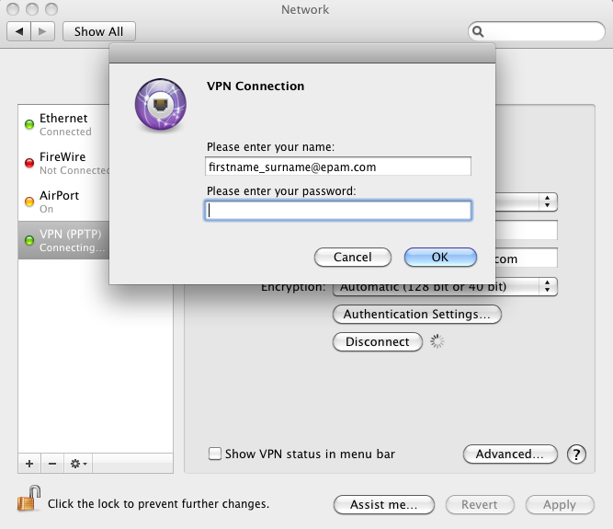
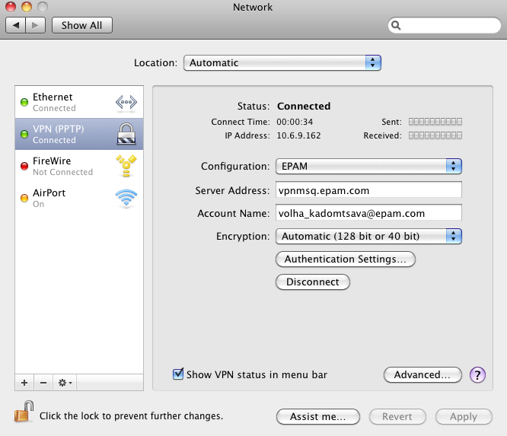

- To review the properties of the VPN connection check Send all traffic over VPN connection box.
INCLUDEPICTURE "cid:image012.png@01CC591A.2E3A0D80" \* MERGEFORMATINET INCLUDEPICTURE "cid:image012.png@01CC591A.2E3A0D80" \* MERGEFORMATINET INCLUDEPICTURE "cid:image012.png@01CC591A.2E3A0D80" \* MERGEFORMATINET INCLUDEPICTURE "cid:image012.png@01CC591A.2E3A0D80" \* MERGEFORMATINET INCLUDEPICTURE "cid:image012.png@01CC591A.2E3A0D80" \* MERGEFORMATINET 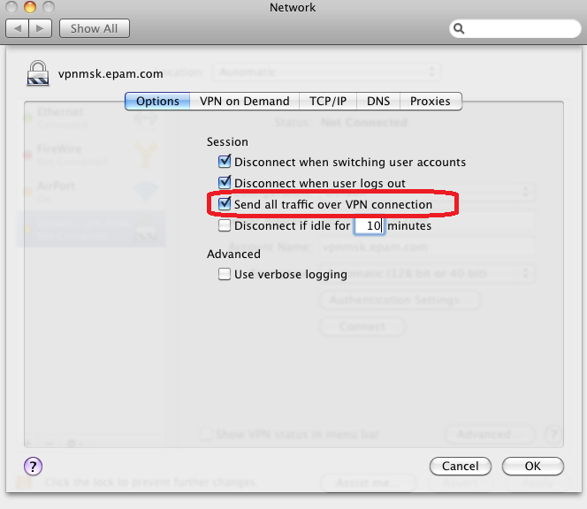

Setting up your VPN under Ubuntu 12.04.
- Open Dash and run Network Connections tool.
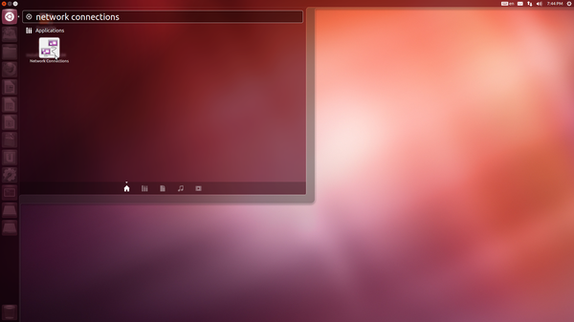
2. At VPN tab click Add to create a new VPN connection.
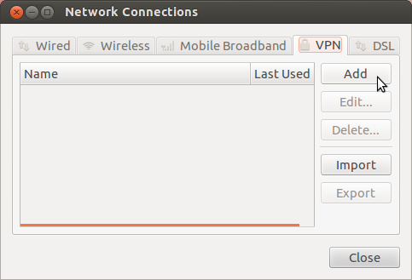
3. Choose Point-to-Point Tunneling Protocol (PPTP) as a type of VPN Connection and click Create...
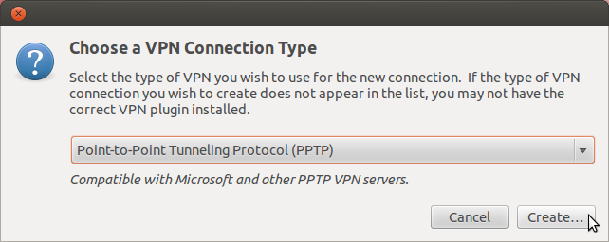
4. At IPv4 Settings tab, enter the following information:
In the Method box, select Automatic (VPN) addresses only.
In the DNS servers box, enter dns server addresses in accordance with your location (e.x. 10.6.0.6, 10.6.0.16).
In the Search domains box, enter search domain address in accordance with your location (e.x. minsk.epam.com).
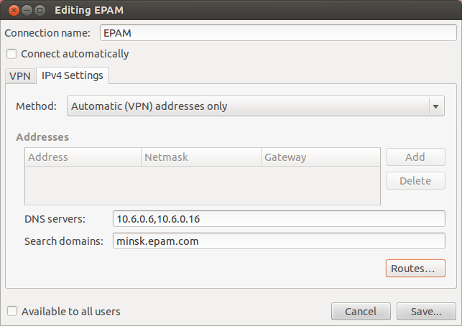
5. At VPN tab, enter your VPN information:
In the Connection name box, enter your preferred connection name.
In the Gateway box, enter vpn server name in accordance with your location (e.x. vpnmsq.epam.com).
In the User name box, enter your domain username as Firstname_Lastname@epam.com.
In the Password box, select Always Ask.
Make sure that both Connect automatically and Available to all users options are unchecked.
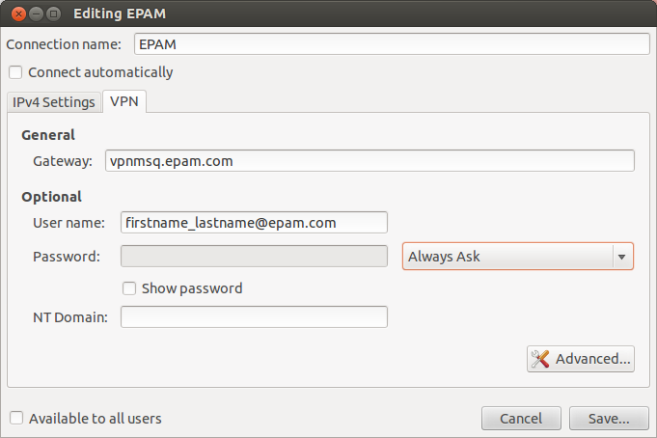
6. Click Advanced... to setup PPTP Advanced Options.
Uncheck all Authentication method options but MSCHAP and MSCHAPv2.
Check Use Point-to-Point Encryption (MPPE) option.
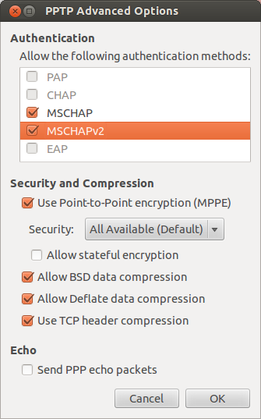
7. Click OK then Save... to save the VPN connection.

Connecting to EPAM Network via Terminal Services Gateways (TSG)

The feature is especially needed when there is no possibility to establish VPN access to the EPAM network (customer’s network restrictions, home networks, etc).
Feature is called Terminal Services Gateway. It uses HTTPS/SSL port 443, opened in most networks.
To use this connection method, do the following:
Make sure sleep mode is disabled on the workstation you try to connect to (this option is enabled for all EPAM workstations by default
How to turn off sleep mode in Windows 7:
- Go to Start → Control Panel → Power Options.
- Select Change when the computer sleeps.
- Choose Never from “Put the computer to sleep” option and Save changes.
In Win 8:
- Go to Start → Control Panel → Power Options.
- Select “Change plan settings”.
- Choose Never from “Put the computer to sleep” option and Save changes.
In Mac OS:
- Click on the blue/black apple icon in the upper left corner of your screen, and choose System Preferences;
- In the Hardware section, select Energy Saver;
- Make sure on the Settings for: drop-down box is set to Power Adapter
- On the Sleep tab, move the sliding bar labeled Put the computer to sleep when it is inactive for: to Never

Check your OS version. Windows XP SP3 needed. SP2 is not compatible. Windows Vista, Server 2008 and higher is recommended.
Remote Desktop Client v.6.1 is a MUST. Windows Vista and higher has it built-in. EPAM OS images of XP have it by default. Clean XP Sp3 does not have it. If working from some non-EPAM computer take the client here: http://www.microsoft.com/downloads/details.aspx?displaylang=en&FamilyID=6e1ec93d-bdbd-4983-92f7-479e088570ad
It is important to download and install the EPAM certificates: http://ca.epam.com/cert/cert.zip
If all of above (OS version + RDP client version) is OK, the usage is simple.
Open your RDP client (Remote desktop) connection, type the server in the EPAM network you want to connect to:
INCLUDEPICTURE "cid:image002.jpg@01CC89F3.A0333330" \* MERGEFORMATINET INCLUDEPICTURE "cid:image002.jpg@01CC89F3.A0333330" \* MERGEFORMATINET INCLUDEPICTURE "cid:image002.jpg@01CC89F3.A0333330" \* MERGEFORMATINET INCLUDEPICTURE "cid:image002.jpg@01CC89F3.A0333330" \* MERGEFORMATINET INCLUDEPICTURE "cid:image002.jpg@01CC89F3.A0333330" \* MERGEFORMATINET 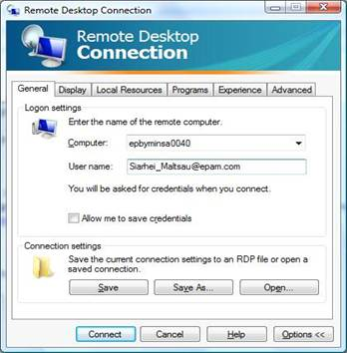
Then, open Advanced Tab, Press Setting button under “Connect from anywhere” section:
INCLUDEPICTURE "cid:image004.jpg@01CC89F3.A0333330" \* MERGEFORMATINET INCLUDEPICTURE "cid:image004.jpg@01CC89F3.A0333330" \* MERGEFORMATINET INCLUDEPICTURE "cid:image004.jpg@01CC89F3.A0333330" \* MERGEFORMATINET INCLUDEPICTURE "cid:image004.jpg@01CC89F3.A0333330" \* MERGEFORMATINET INCLUDEPICTURE "cid:image004.jpg@01CC89F3.A0333330" \* MERGEFORMATINET 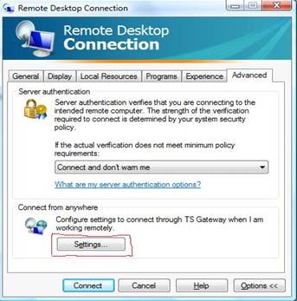
Set parameters as following: Server name – See appendix 2. Login method – Ask for password (NTLM). Under Vista OS Tick “use my TS Gateway credentials for remote computer”. This will allow you to enter your password once. Windows XP needs to enter password for connection twice. Press OK to connect. Enter your NT Domain password (First_Last@epam.com) 1(Vista) or 2(XP) times, when prompted.
INCLUDEPICTURE "cid:image006.jpg@01CC89F3.A0333330" \* MERGEFORMATINET INCLUDEPICTURE "cid:image006.jpg@01CC89F3.A0333330" \* MERGEFORMATINET INCLUDEPICTURE "cid:image006.jpg@01CC89F3.A0333330" \* MERGEFORMATINET INCLUDEPICTURE "cid:image006.jpg@01CC89F3.A0333330" \* MERGEFORMATINET INCLUDEPICTURE "cid:image006.jpg@01CC89F3.A0333330" \* MERGEFORMATINET 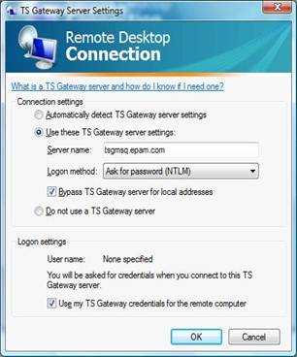
Please note the feature is intended only for EPAM employees, no customer’s access is possible.

Wi-Fi Access

EPAM Guest Connection
- Connect your computer to WiFi network with SSID “EPAMGuests”:
- Network name (SSID): EPAMGuests
- Network Authentication: Open
- Data encryption: Disabled.
- Open Internet Explorer (or other browser) and go to httpS://wifi.epam.com/login.html (your Internet browser will redirect you to the page automatically from some URL if http redirection is permitted in the settings of your browser).
- Use provided credentials for web authentication
- You can deauthenticate on page httpS://wifi.epam.com/logout.html
You will only be able to connect to the Internet with no access to the Company’s network
NOTE: Proxy should be disabled at your browser to be able to authenticate
In case of any problem, please contact Help Desk at help_desk@epam.com or call 50911 for assistance.

EPAM Employee Connection
There are two WiFi SSIDs for EPAM employee’s connections: EPAMemployees and EPAM8021x (please note that EPAM8021x SSID is preferable to use)

EPAMemployees
- Connect your computer to WiFi network with SSID “EPAMemployees”:
- Network name (SSID): EPAMemployees
- Network Authentication: WPA2
- Data encryption: AES
- Network key: Wi2177785Fi
- Open Internet Explorer (or other browser) and go to httpS://wifi.epam.com/login.html (your Internet browser will redirect you to the page automatically from some URL if http redirection is permitted in the settings of your browser).
- Use Username: <your EPAMusername>@epam.com and EPAM MS Windows password for web authentication
- We can deauthenticate on page httpS://wifi.epam.com/logout.html .
NOTE: Proxy should be disabled in your browser to be able to authenticate

EPAM8021x

Windows 7
- Please connect to “EPAMGuest” SSID and install both EPAM certificates Rootca and Intermediate certificate from the page http://cert.epam.com if it’s not been installed yet (Important! You have to install rootca to root certificate storage. Сlick rootca оn the web page → Open →Install Certificate → Next → Place all certificates in the following store → Browse → Trusted Root Certification Authorities → Ok → Next → Finish).
- Open Manage Wireless Networks by clicking the Start button→ Control Panel → Network and Internet → Network and Sharing Center, and then click Manage wireless networks in the left pane.
- Click Add, click Manually create a network profile:
Network name: EPAM8021x
Security type: 802.1X
- Click Next, Change connection settings, Security tab:
Security Type: WPA2-Enterprise
Encryption type: AES
Choose the network authentication method: Microsoft: Protected EAP (PEAP)
- Check Remember my credentials for this connection each time I’m logged on.
- Click Advanced settings.
- Check Specify authentication mode and choose User or computer authentication.
- Check Enable single sign on for this network and choose Perform immediately before user logon.
- Press Ok.
- Click Settings. Check Validate server certificate and installed EPAM certificates in Trusted Root Certification Authorities.
- Choose Secured password (EAP-MSCHAP v2) in the Select Authentication Method field.
- Check Enable Fast Reconnect.
- Press twice Ok and Close.
- Connect to the network by clicking the Start button → Control Panel → Network and Internet → Network and Sharing Center → Connect to a network, click EPAM8021x and press Connect.

Windows XP SP3
- Please connect to “EPAMGuest” SSID and install both EPAM certificates Rootca and Intermediate certificate from the page http://cert.epam.com if it is not installed yet (Important! You have to install rootca to root certificate storage. Сlick rootca on the web page → Open → Install Certificate → Next → Place all certificates in the following store → Browse → Trusted Root Certification Authorities → Ok → Next → Yes → Ok → Ok).
- Open Network Connections clicking the Start button → Control Panel → Network Connections. Right-click the wireless network adapter in Network Connections and click Properties. Press Wireless Networks.
- Press Add. Type the following settings:
Network name (SSID): EPAM8021x
Network Authentication: WPA2
Data encryption: AES
- Press Authentication tab and choose Protected EAP (PEAP) in EAP type field. Click Properties.
- Check Validate server certificate and installed EPAM certificates in Trusted Root Certification Authorities.
- Choose Secured password (EAP-MSCHAP v2) in Select Authentication Method field.
- Check Enable Fast Reconnect.
- Press three times Ok.
- Right-click the wireless network adapter in Network Connections and click View Available Wireless Networks. In either case, you should see the Choose a wireless network dialog box with EPAM8021x wireless network. Double-click the wireless network.

MAC OS X Lion 10.7.4
- Please connect to “EPAMGuest” SSID and install both EPAM root certificates from the page http://cert.epam.com if it is not installed yet (download rootca certificate from the web page. Twice click the certificate and press Always Trust, type your password and click Update Settings).
- Choose Apple menu > System Preferences, and then click Network.
- In the Wi-Fi main menu, if it’s necessary, click Turn WiFi On
- Select WiFi SSID EPAM8021x from the Network Name list at right
- Use Username: <your EPAMusername>@epam.com and EPAM MS Windows password for wireless authentication.
Note: If you had access to this SSID before but then your Windows password was changed, you may get the error "Could not join "EPAMemployees. A connection timeout occurred." You can fix the problem if you remove EPAM8021x (your stored password) from Launchpad → Utilities → Keychain Access → Keychains login.

Windows Mobile 5.x and 6.x
  - Import your personal certificate to the mobile device
  - Make sure that wireless is enabled on your phone and verify that your phone can support WPA2-Enterprise encryption. (Note: Windows Mobile 6 supports WPA2, but not all phones support WPA2. Please consult your phone's manual for further information).
  - Click Start and select Settings. Click the Connections tab and then Wi-Fi.
  - Click the wireless network, EPAM8021x.
  - Select The Internet from the Connects to drop-down menu. Click Next.
  - Select WPA2 from the Authentication drop-down menu.
  - Select AES from the Data Encryption drop-down menu. Select Next.
  - Select PEAP from the EAP Type drop-down menu.
  - Click Properties and Select your personal certificate.
  - Network Log On window should appear. Enter your EPAM MS Windows Username under "User name". Enter your Windows password under "Password".
  - Click OK.

Android
- Please connect to “EPAMGuest” SSID and install both EPAM certificates Rootca and Intermediate certificate from the page http://cert.epam.com if it’s not been installed yet (You can verify whether the certificates were installed at the page httS://radius.epam.com. If certificates are installed correctly then you don’t get any security alert on the page. Note1: Use standard Android Internet browser for installing certificates from web page. Note2: On some Android you can install certificates correctly only from SD card. Copy certificates in root folder SD card and go to Settings → Security → Credential storage → Install from storage. Note3: Some devices support only .crt extension of certificates files. Change extension from .cer to .crt before installing)
- From the Android Home screen, tap Menu then tap Settings.
- Tap Wireless and network and then tap Wi-Fi settings.
- Tap Wi-Fi to turn-on wireless (if not already on).
- From the list of Wi-Fi networks, tap EPAM8021x.
- Select PEAP from EAP method drop-down menu.
- Select MSCHAPV2 from Phase 2 authentication drop-down menu.
- Select installed root certificate from CA certificate
- Type your EPAM MS Windows Username in Identity field (correct format is <your EPAMusername>@epam.com).
- Client certificate and Anonymous identity has to be blank.
- Type your EPAM Windows password in Wireless password field.
- Click Connect.

iOS 5.x, 6.x
- Connect to “EPAMGUest” SSID and install both EPAM certificates Rootca and Intermediate certificate from the page http://cert.epam.com if it’s not been installed yet
- Connect to “EPAM8021x” SSID from Wi-Fi connections under Settings.
- Type your EPAM MS Windows Username (your EPAMusername@epam.com) and EPAM MS Windows password in Username and Password fields.
- Click Connect and Accept certificate button.
In case of any problem, please contact Help Desk at help_desk@epam.com or call 50911 for assistance.

Appendix 1. VPN Gates
VPN Server Address | VPN Server Location | Can be used for employees in Locations
vpnbud.epam.com | Budapest | Worldwide, EU is preferred
vpniev.epam.com | Kyiv | Worldwide, UA is preferred
vpnmsq.epam.com | Minsk | Worldwide, BY is preferred
vpnmsk.epam.com | Moscow | Worldwide, RU is preferred
vpnpct.epam.com | US | Worldwide, US is preferred
vpnkar.epam.com | Karaganda | Worldwide, KZ is preferred

Appendix 2. TSG Gates
TSG Server name | TSG Server Location | Can be used for employees in Location
TSGMSQ.epam.com | Minsk | Worldwide, ORG Employees
TSGUA.epam.com | Kyiv | Worldwide, ORG Employees
TSGEU.epam.com | Budapest | Worldwide, ORG Employees
TSGRU.epam.com | Moscow | Worldwide, ORG Employees

