// Create a Token

This Solidity program is a simple program that demonstrates the to create our own token using differnet functions. The purpose of this program is to make our own token and keep track of the balance.

// Description

This program is a simple contract written in Solidity, a programming language used for developing smart contracts on the Ethereum blockchain. The contract Mytoken has a two functions mint and burn. In simple terms we can add and delete the token balance.

// Executing program

To run this program, you can use Remix, an online Solidity IDE. To get started, go to the Remix website at https://remix.ethereum.org/.

Once you are on the Remix website, create a new file by clicking on the "+" icon in the left-hand sidebar. Save the file with a .sol extension. Copy and paste the following code into the file:

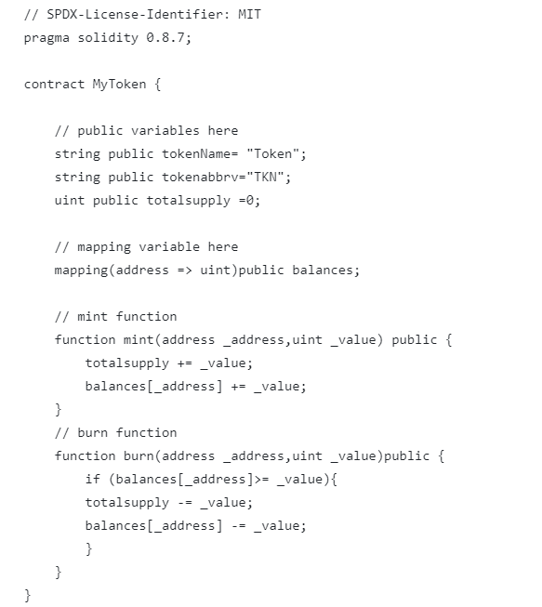

To compile the code, click on the "Solidity Compiler" tab in the left-hand sidebar. Make sure the "Compiler" option is set to "0.8.7" (or another compatible version), and then click on the compile button.

Once the code is compiled, you can deploy the contract by clicking on the "Deploy & Run Transactions" tab in the left-hand sidebar. Select the "Mytoken" contract from the dropdown menu, and then click on the "Deploy" button.

Once the contract is deployed, you can interact with it by calling the sayHello function. Click on the "Mytoken" contract in the left-hand sidebar, and then click on the "mint" and "burn" function. Finally, click on the "transact" button to execute the function and retrieve the "Balance".

// Authors

Kobid Aryal

// License

This project is licensed under the MIT License - see the LICENSE.md file for details