Whitewater River Rafting Website Notes

Tyler Hatton, BYU WDD130

LOGO IMAGE

<https://byui-cse.github.io/wdd130-ww-course/resources/images/logos/dryoarlogo3.png>

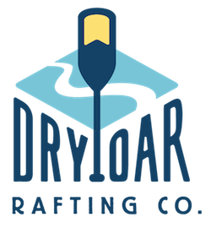

COLOR PALETTE

https://coolors.co/37541c-324362-b4e18b-96c1f0

- primary-color: #37541C

- Secondary-color: #324362

- accent1-color: #B4E18B

- accent2-color: #96C1F0

TYPOGRAPHY

- heading-font: Averia Libre 400, 700

- text-font: Crimson Text 400 and 600 (semibold)

<link rel="preconnect" href="https://fonts.googleapis.com">

<link rel="preconnect" href="https://fonts.gstatic.com" crossorigin>

<link href="https://fonts.googleapis.com/css2?family=Averia+Libre:wght@400;700&family=Crimson+Text:wght@400;600&display=swap" rel="stylesheet">

.averia-libre-regular {

font-family: "Averia Libre", system-ui;

font-weight: 400;

font-style: normal;

}

.averia-libre-bold {

font-family: "Averia Libre", system-ui;

font-weight: 700;

font-style: normal;

}

.crimson-text-regular {

font-family: "Crimson Text", serif;

font-weight: 400;

font-style: normal;

}

.crimson-text-semibold {

font-family: "Crimson Text", serif;

font-weight: 600;

font-style: normal;

}