Covid-19 Web Application

Submitted at the end of semester IV in partial fulfillment of requirements of Bachelors in Technology in Computer Engineering

By
Dhairye Gala
Roll No: 16010120070,
Khushal Jhaveri
Roll No: 16010120074,
Anannya Khedekar
Roll No: 16010120078

Guide
Prof. Bhakti Palkar

Department of Computer Engineering
K. J. Somaiya College of Engineering, Mumbai-77
(Autonomous College Affiliated to University of Mumbai)
Batch 2020 -2024

Certificate

This is to certify that the MINI PROJECT report
Covid-19 Web Application
entitled submitted by
Dhairye Gala,Khushal Jhaveri and Anannya Khedekar at the end of semester IV of SY B. Tech are bonafide record
for partial fulfillment of requirements for the
degree of Bachelors in Computer Engineering
of University of Mumbai

_____________ ___________________
Guide Head of the Department

Date:
Place: Mumbai-77

Certificate of Approval of Examiners

We certify that this MiniProject report entitled
Covid-19 web application
is bona fide record of Mini project work done by
Dhairye Gala,Khushal Jhaveri and Anannya Khedekar
during semester IV.
This Mini project work is submitted at the end of semester IV
in partial fulfillment of requirements for
the degree of Bachelors in Technology in Computer Engineering

___________________________ ____________________________
Internal Examiner 1 Internal Examiner 2

Date:
Place: Mumbai-77

DECLARATION
We declare that this written report submission represents the work done based on our and / or others’ ideas with adequately cited and referenced the original source. We also declare that we have adhered to all principles of intellectual property, academic honesty and integrity as we have not misinterpreted or fabricated or falsified any idea/data/fact/source/original work/ matter in my submission.
We understand that any violation of the above will be cause for disciplinary action by the college and may evoke the penal action from the sources which have not been properly cited or from whom proper permission is not sought.
___________________  Signature of the Student  Roll No. 16010120070 | ___________________  Signature of the Student  Roll No. 16010120074
___________________
Signature of the Student
Roll No. 16010120078

Date:
Place: Mumbai-77

Acknowledgments
Chapter 1
  - Introduction
Title of Mini Project: Covid-19 Web application

Scenario in the real world for which you are proposing a solution.

Corona virus and its increasing cases and a need for a multifeatured app where all related data is sorted so people don’t need to jump between different apps and hence reduce the hassle. And hospital resources for a particular city aren’t really stated in any website .

Problem Definition:
- In these times of covid it has become difficult to keep a track of cases around us and how safe it is to go out of our homes , the statistical data isn’t sufficient to determine the safety in any region.
- There are many websites available on the internet regarding covid 19 however we didnt find one that covered hospital and resources in Mumbai in one place therefore this project displays that

Objective of the project:
Web applications to create graphs and charts to show which place has shown higher number of cases. We will also be using real time data for the same . It also shows Mumbai hospital data like the beds available , vaccines etc .
And a hospital admin can login and update data anytime
This project will also help to spread awareness about the pandemic

Chapter 2: Project Design
  - System Design:
In these times of covid it has become difficult to keep track of cases around us and how safe it is to go out of our homes, the statistical data isn't sufficient to determine the safety in any area. This application will be made to integrate all the data into one single and simplified graph and chart. Here the application shows how safe it would be to go out in any area depending on the cases and vaccinations. it will also show hospital information such as beds available and other recommendations
  - System Architecture
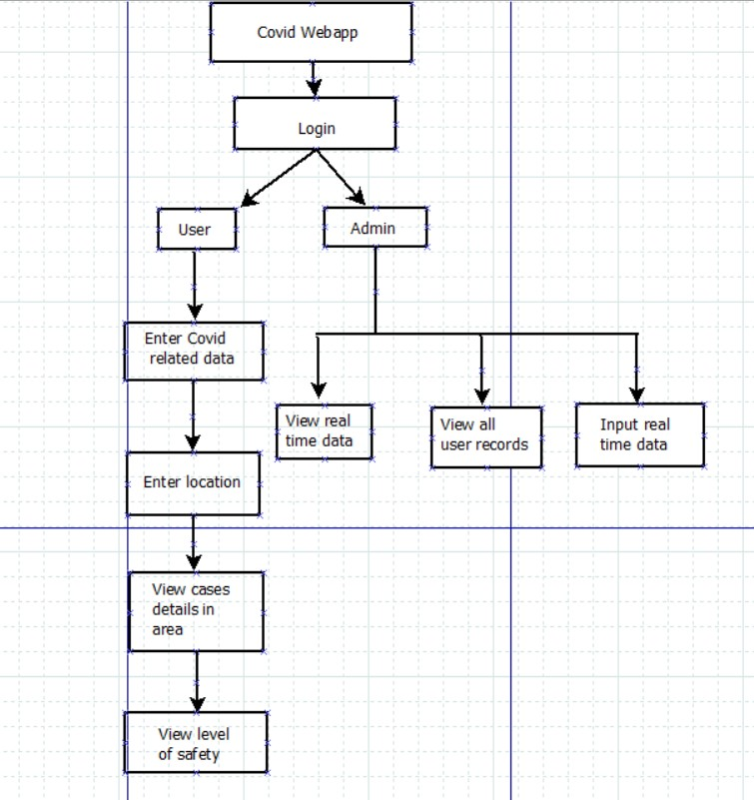
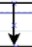
Show hospital information

Module wise flow diagram
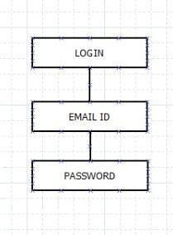
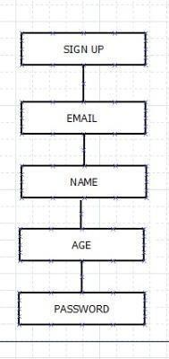
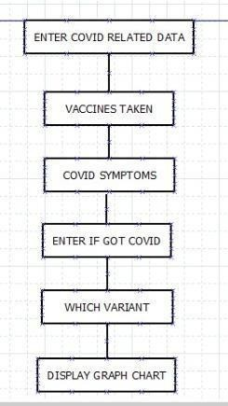
Show hospital information and other recommendations

2.4 System development
Programming languages:
We will be using HTML CSS Javascript Ajax for frontend
Python for backend
SQLAlchemy for database
Implementation details :
Database attributes:

ID , Name , Email ,Contact, Address , password, beds ,icu beds,oxygen , vaccine .
Table name: Hospital Routes :
backend using flask and bcrypt ,sessions and sqlalchemy

Frontend: html css javascript

Functions Implemented:

Precautions pages to raise awareness Links to scientific papers
Graphs on covid data all around the word
Comparing country to country affected by covid with the help of graphs and logs Mumbai hospital dynamic data on availability of beds and vaccines
Interface:

Home page:
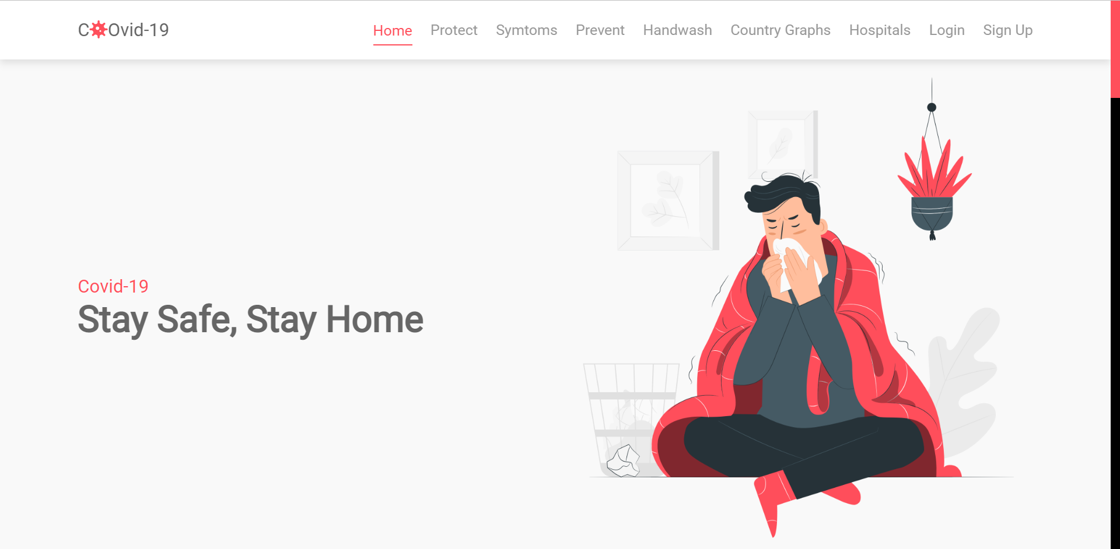
Precautions Pages:
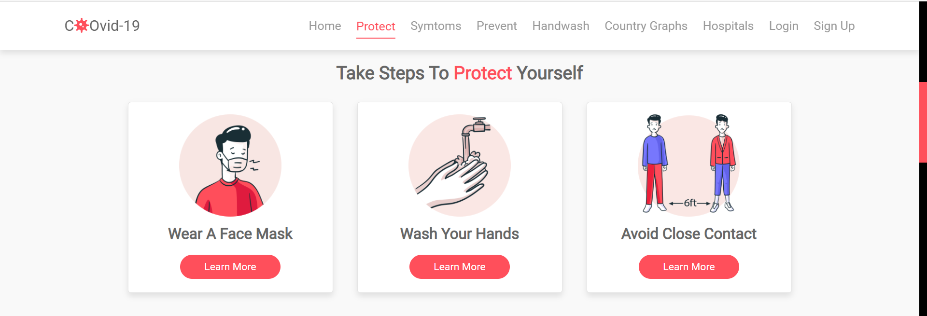
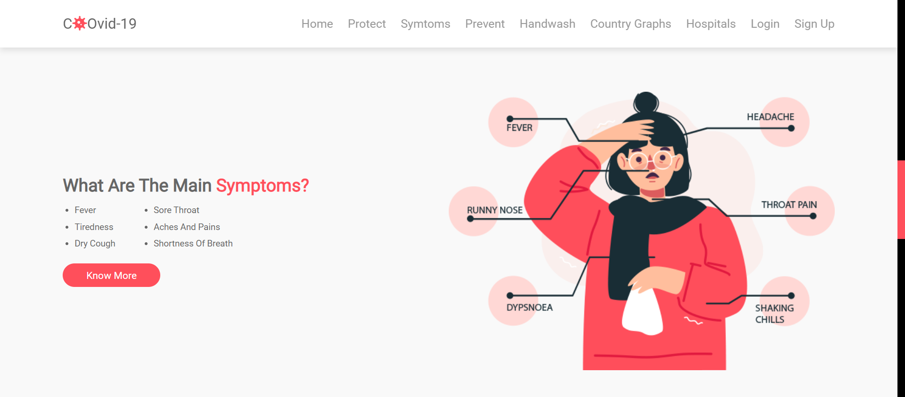
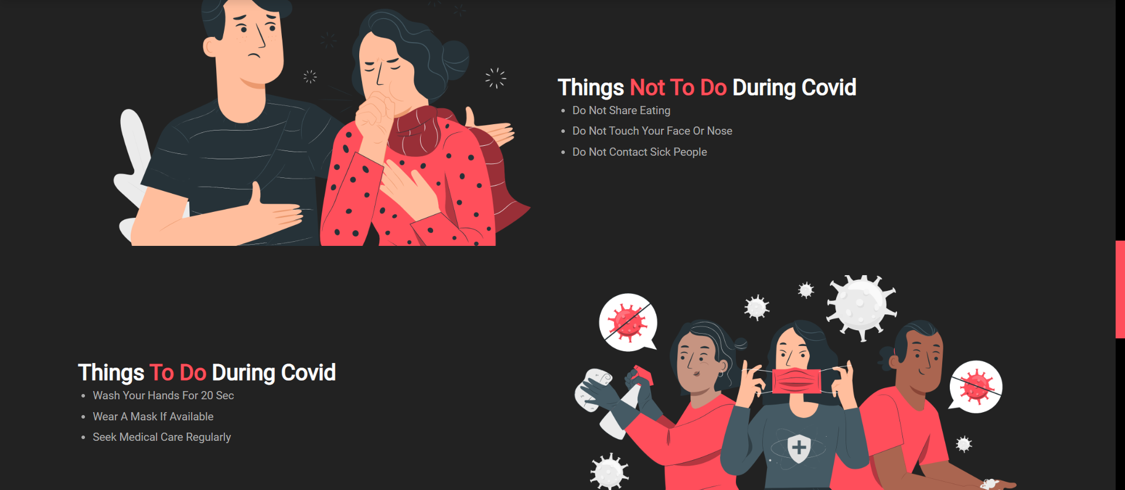
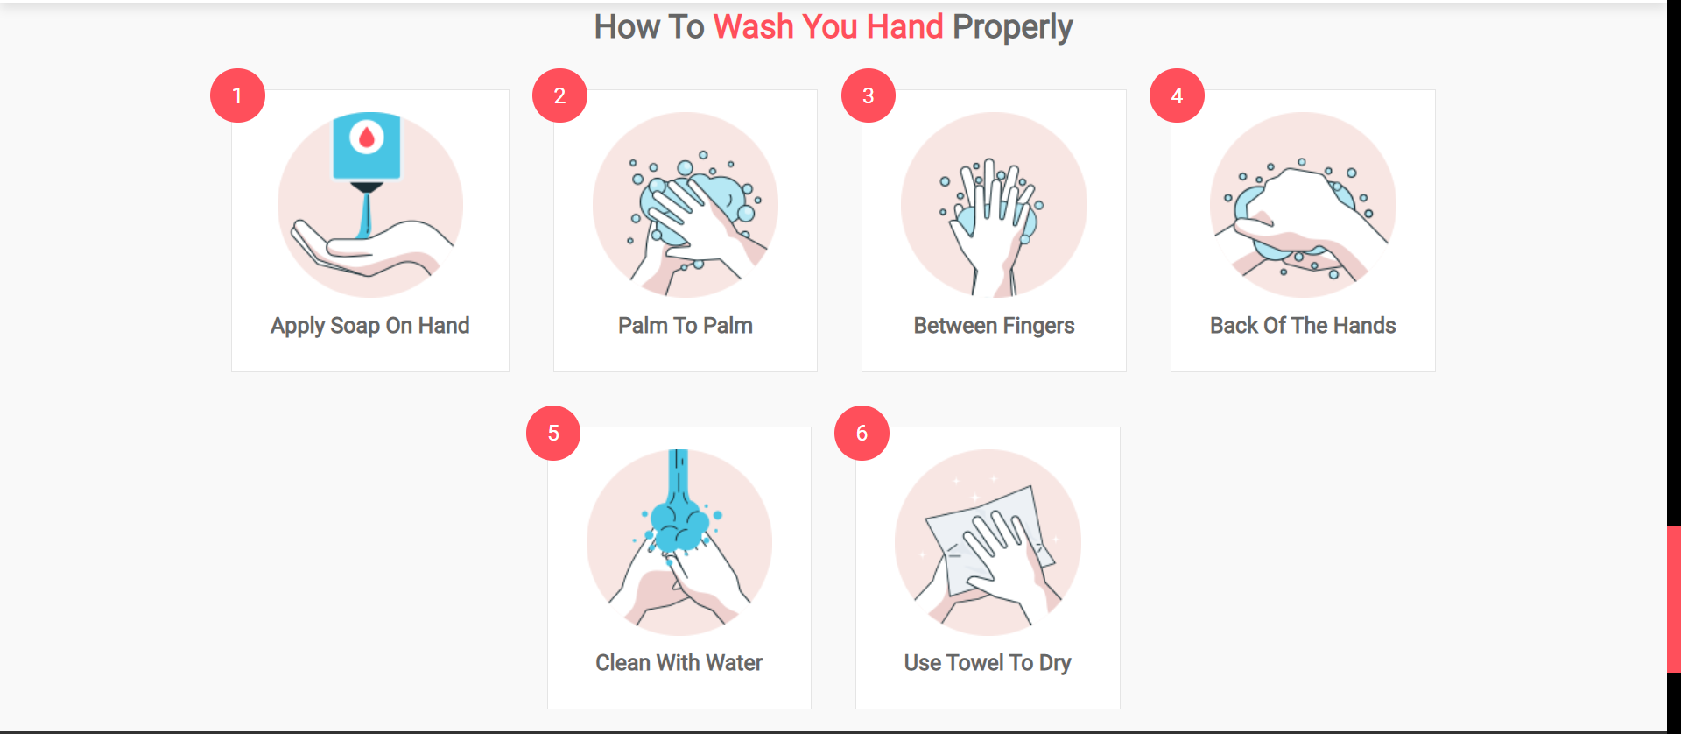
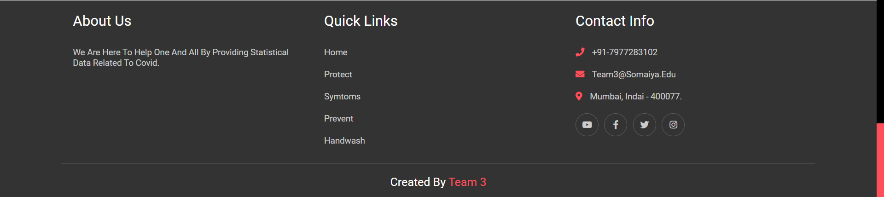
Graph page:
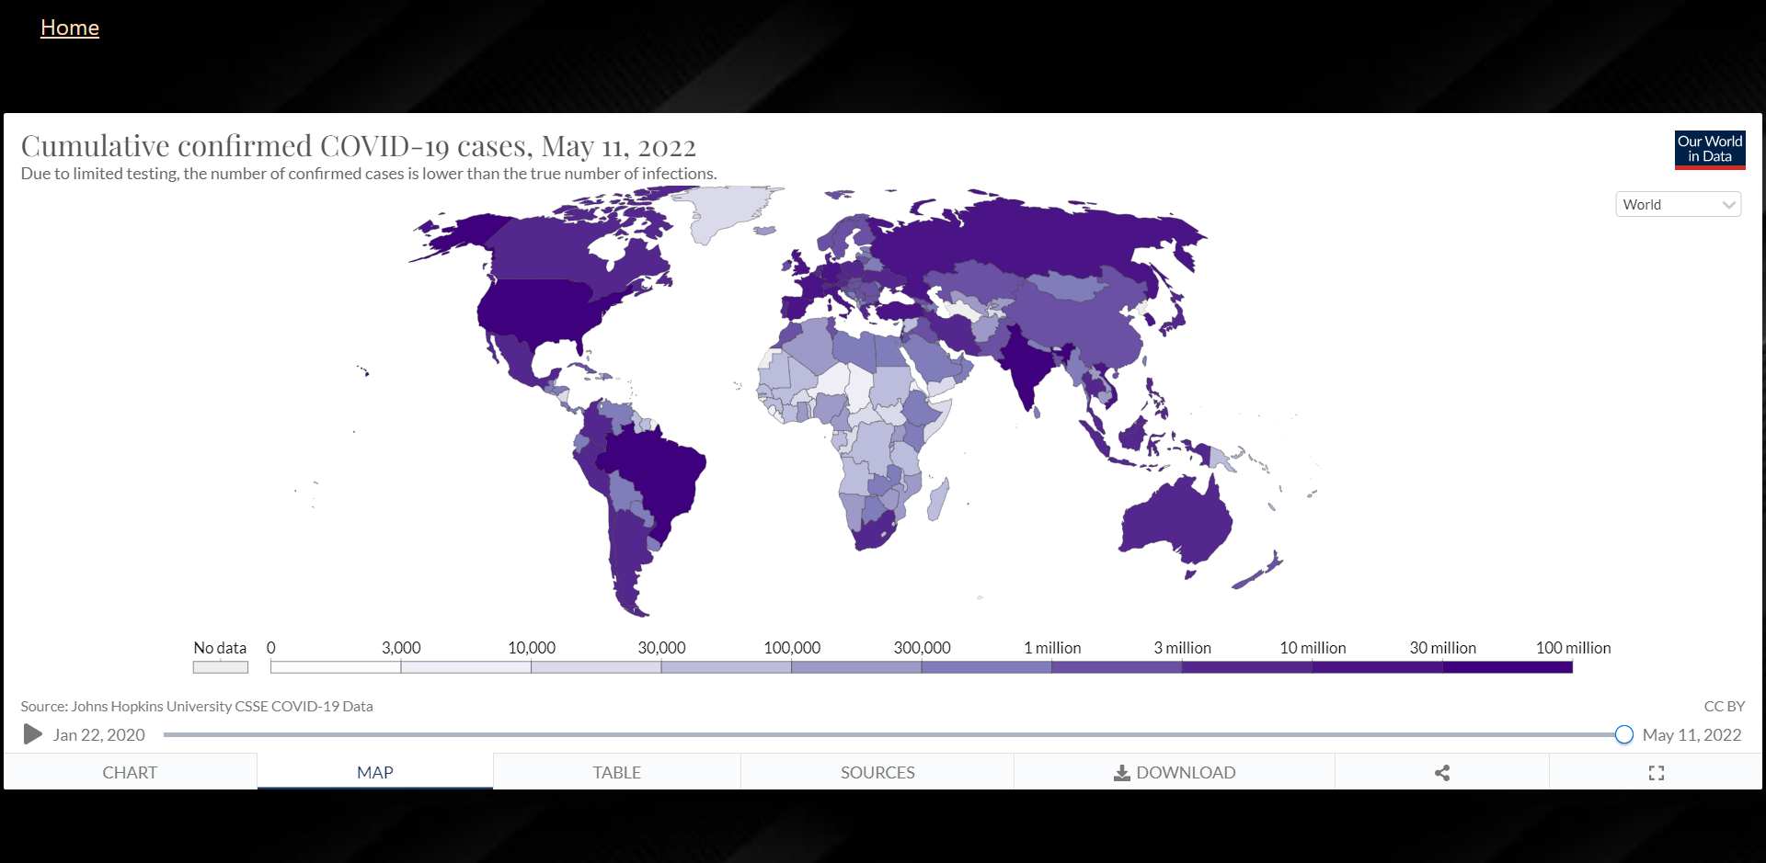

Hospital login:
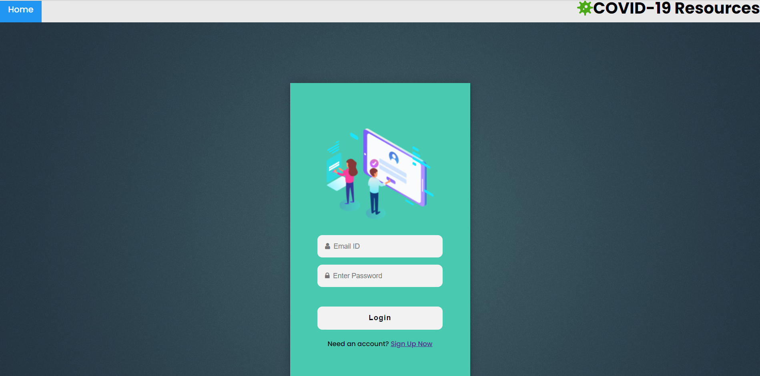
Hospital signup:
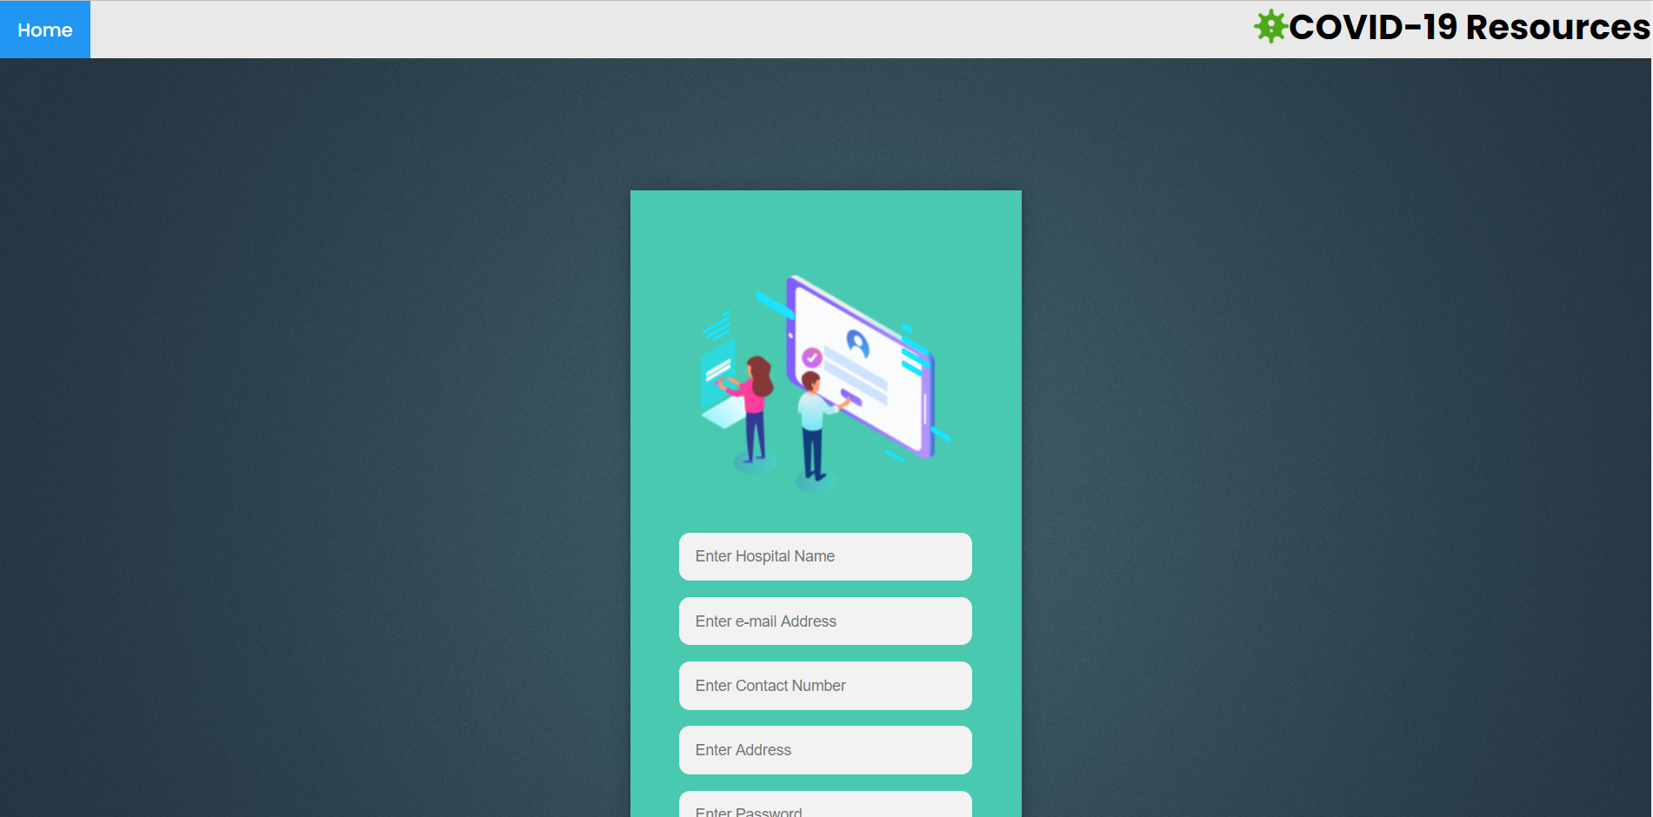
Hospital resources:
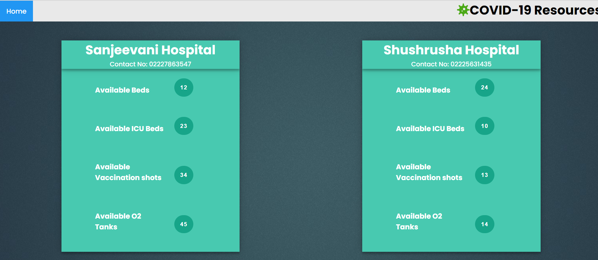
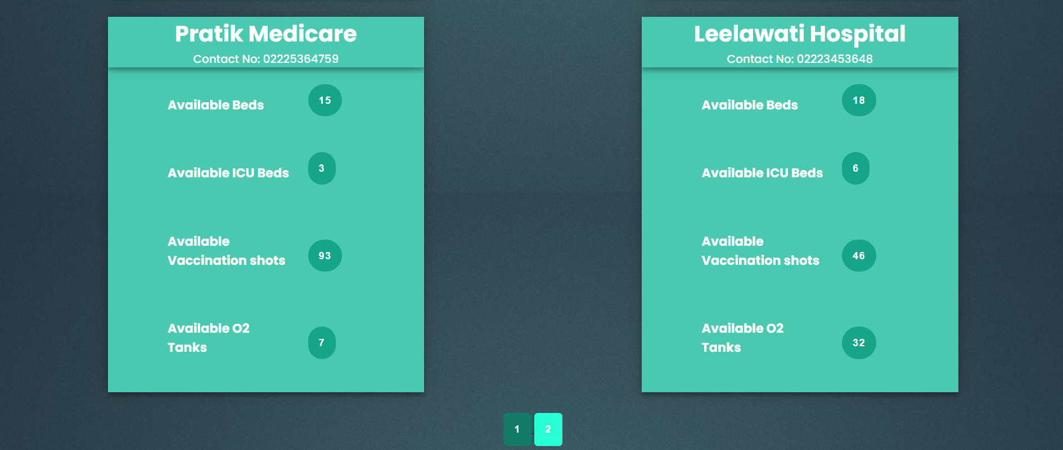

Chapter 4 : Testing

Test case | Description | Intended  result | Actual result | Completed by
UI | Login and signup pages | Password validation | Added  successfully | Dhairye
Graphs | Converting raw data in the form of graphs | Pie and bar  chart should be formed | Works | Khushal
precautions | Button links and scrollbar | Hyperlinks to scientific papers | successful | Anannya
Hospital | New Data added is shown in the website | It is presented | works | Dhairye
Transition between pages | Works between diff pages | Works between diff pages | works | Khushal , Anannya

Responsibilities : Put X in the rows if the task is done by member
Task | Member1  Name | Member2 Name | Member 3 Name
UI :
Design |  | X | X
Coding | X | X | X
Database :
Table design | X
Query design | X
Coding | X | X | X
Program:
Hospital | x |  | x
graph | x | x
Login |  | x | x
Sign up | x | x | x
Testing :
Testing approach | X | X | x
Test Cases | X | X | x
Presentation:
Powerpoint |  |  | x
Report | X | X | x

Major problems : Write related to problems faced in the project
Raw data was hard to be converted into graphs Dynamically changing hospital data
Continuous changes in the code leading to logical errors that needed to be solved

Software used:
HTML
CSS
Javascript
Ajax
VS code
SQLalchemy

Chapter 5: Github implementation and conclusion
Github implementation:
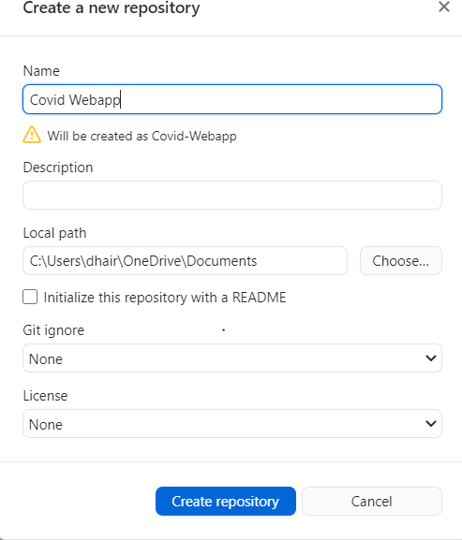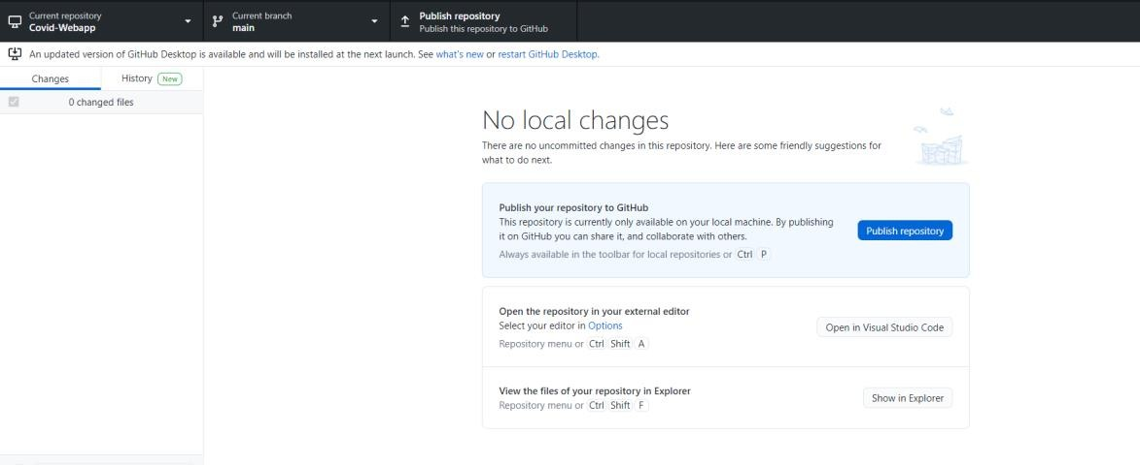
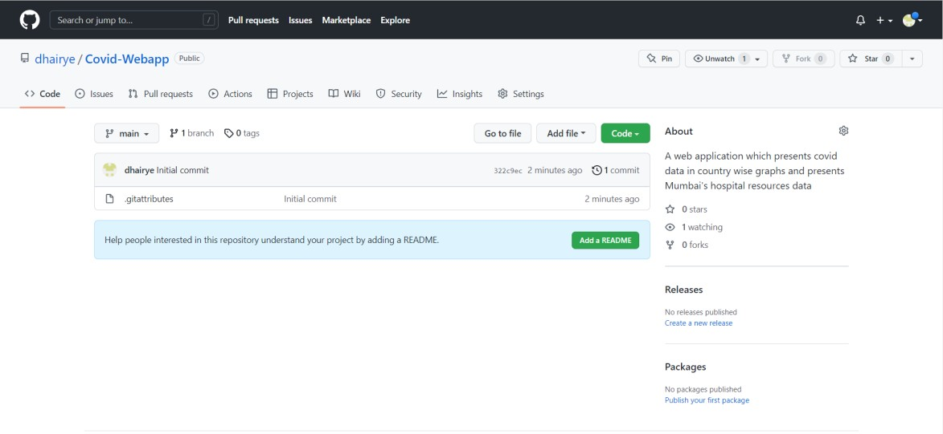

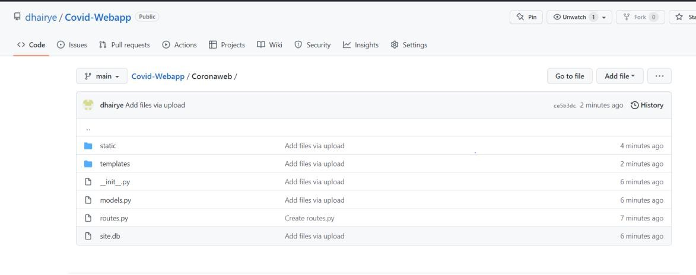

Result:
Github Link:
https://github.com/dhairye/Covid-Webapp.git

Conclusion:
Hence, we have created a Covid-19 web application
Acknowledgement:

We would like to express our gratitude to our Prof. Bhakti Palkar who gave us the opportunity to do this wonderful project, which helped us learn a lot of different concepts through a research-oriented approach

