Assignment 2 - Git & GitHub Fundamentals
Group Report
GitHub Collaboration & Automation
Unit Converter

Field | Details
Group Size | 3 members
Chosen Theme | Unit Converter
Full Names | Sara Benslimane; Amr Kabelma; Mira Negra
Student IDs | Sara Benslimane: 161206  Amr Kabelma: 145927  Mira Negra: 157694
Course Code | CSC3324 - Software Engineering
GitHub Usernames | Sara Benslimane: sarabenslimane14  Amr Kabelma: KBLLL05  Mira Negra: Amramix108
GitHub Repository URL | https://github.com/KBLLL05/unit-converter
GitHub Pages Target URL | https://kblll05.github.io/unit-converter/

28 October 2026

1. Project & Role Distribution
The group followed the three-member path and developed a Python unit converter with three comparable feature areas. Amr implemented temperature conversion, Sara implemented length conversion and continuous integration, and Mira implemented weight conversion and the static project page. Each member developed program logic and unit tests on a separate feature branch.
Member | Feature area | Additional responsibility
Amr Kabelma | Celsius and Fahrenheit | Repository setup and code review.
Sara Benslimane | Metres, kilometres, and miles | GitHub Actions workflow and validation reviews.
Mira Negra | Kilograms, grams, and pounds | Shared weight validation and project-page creation.

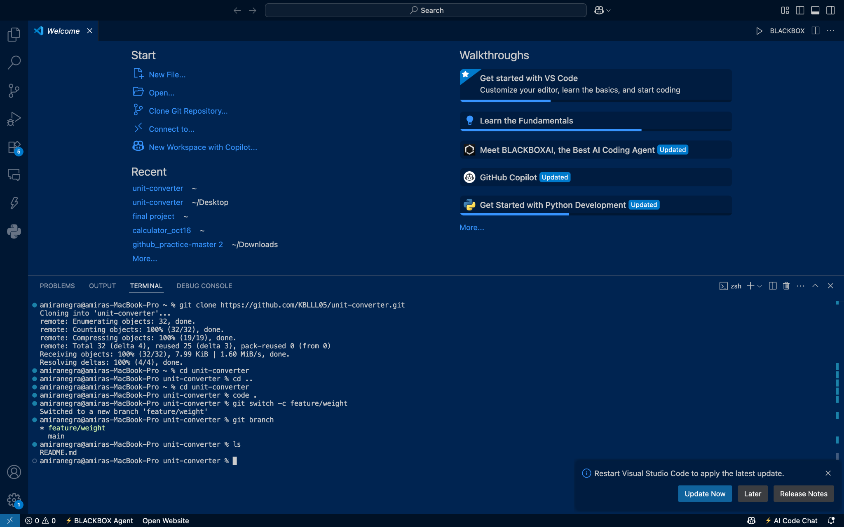
Figure 1. Mira clones the shared repository and creates the feature/weight branch in her own local copy.

2. Branches, Commits & Contributions
All three members used feature branches and meaningful commits. Amr separated the temperature implementation from its tests and documentation. Sara added length logic and tests, configured the workflow, and committed later corrections on feature/length. Mira separated the initial weight logic and tests, then added a validation correction on feature/weight.
Member and branch | Selected meaningful commits
Amr: feature/temperature | a7278cd: Add bidirectional temperature conversion and validation.  c9642c4: Add temperature tests and documentation.
Sara: feature/length | 8f259ee: Add length conversion functions and tests.  3cc40fc: Configure pytest and GitHub Actions.  6eaead0: Correct the workflow.  d8b5470: Add parametrized invalid-input tests.
Mira: feature/weight | b478bd5: Implement weight conversions.  fc098b6: Add weight tests.  c4c60c8: Improve validation and edge-case tests.

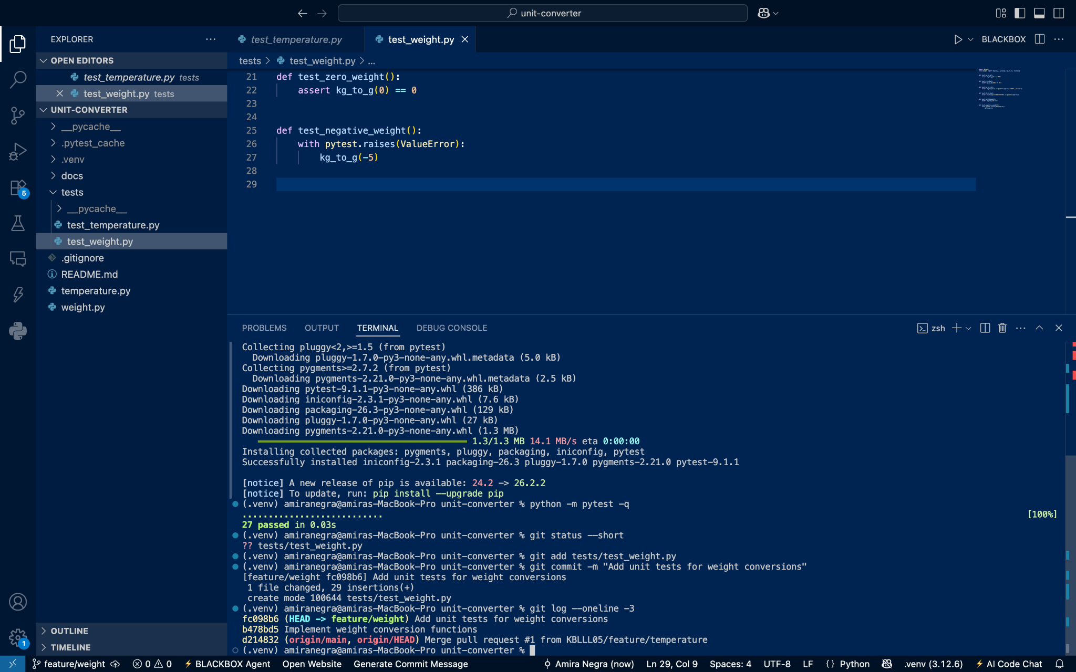
Figure 2. Mira records separate implementation and test commits; this early branch snapshot passes 27 cases.

3. Pull Requests & Code Review
Amr authored temperature PR #1. Sara reviewed the validation code and asked whether an extremely large integer such as 10**1000 should receive an additional test because math.isfinite can raise OverflowError for that input. Sara and Mira approved the PR before it was merged.
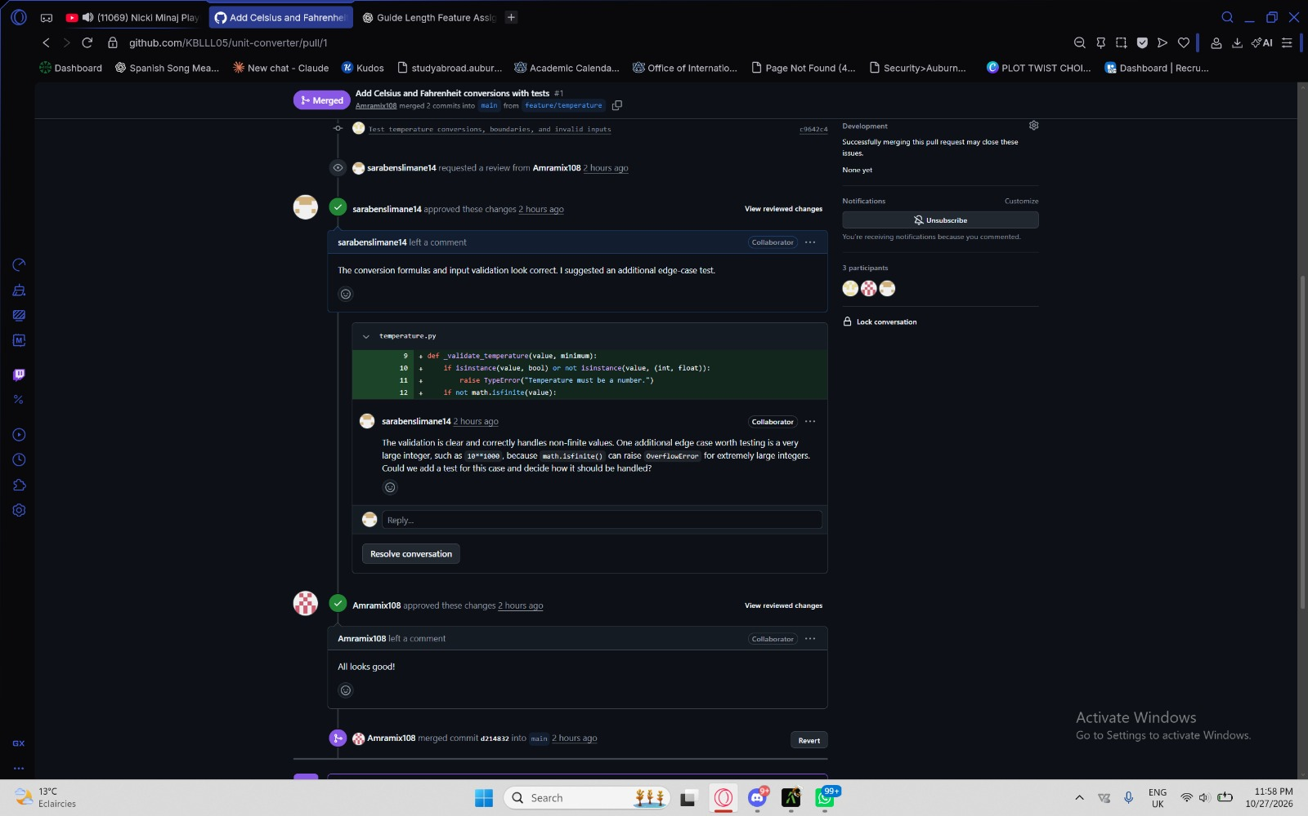
Figure 3. Sara leaves a specific line comment on temperature validation; the PR also records both teammates' approvals.
Sara authored length PR #2. Amr submitted Request changes because the validator's rejection of booleans, NaN, and infinity lacked test coverage. Sara added the requested parametrized tests in d8b5470 on the same feature/length branch. Amr reviewed the correction, verified the combined 42-case suite, and approved the existing PR before it was merged.
Length PR #2: requested tests, same-branch correction, and approval
Mira authored weight PR #3. Sara's line comment requested numeric and finite-value validation because NaN could bypass a simple negative-value check. Mira introduced a shared validator and tests for True, text, NaN, and infinity in c4c60c8. Amr reviewed and approved the corrected feature before its merge.
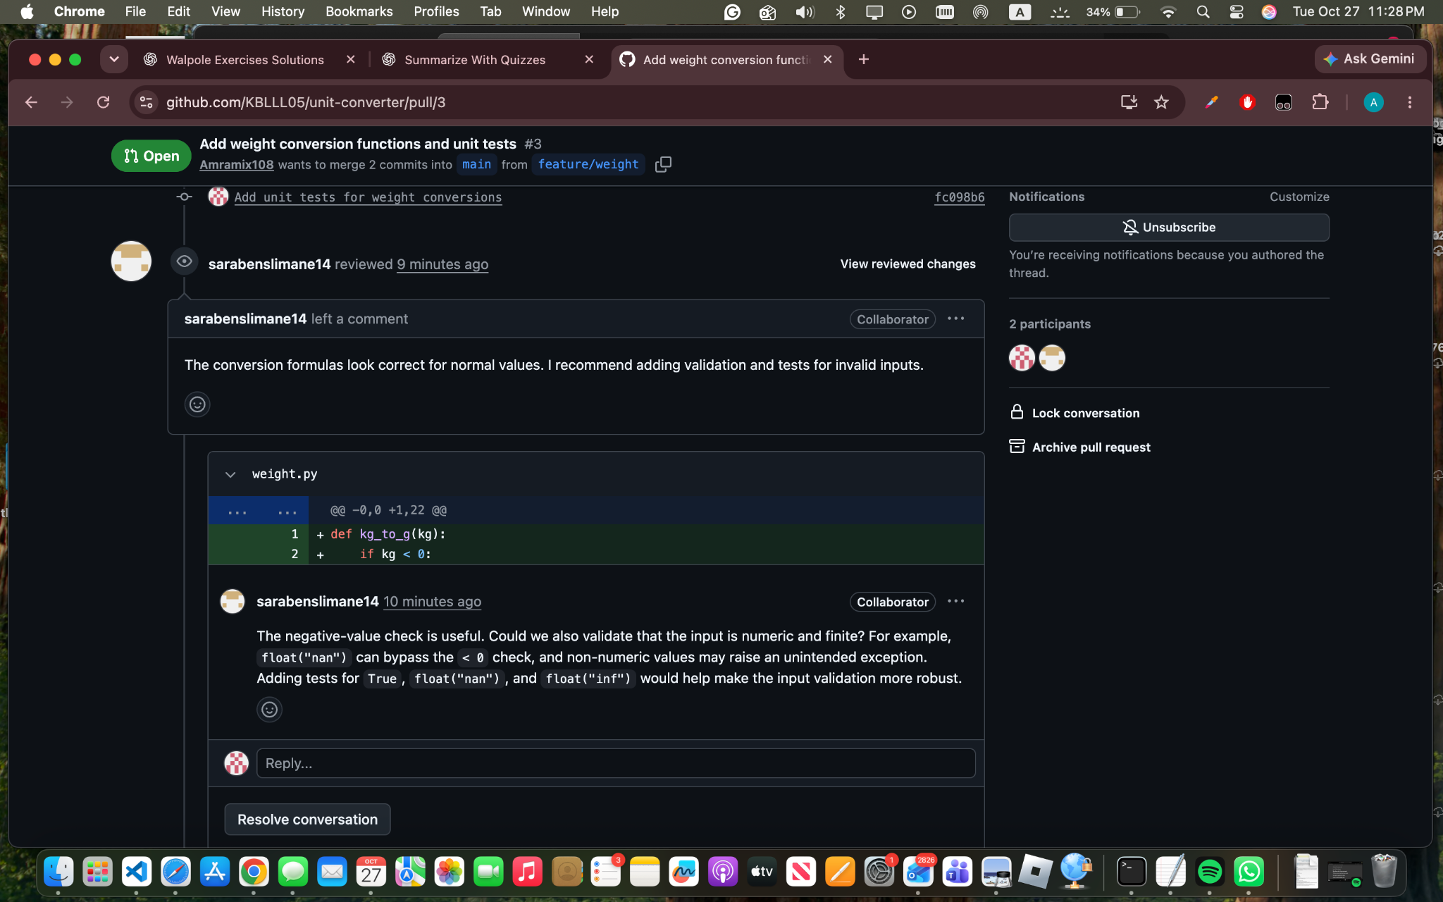
Figure 4. Sara's weight review requests validation for numeric, finite inputs and corresponding tests.
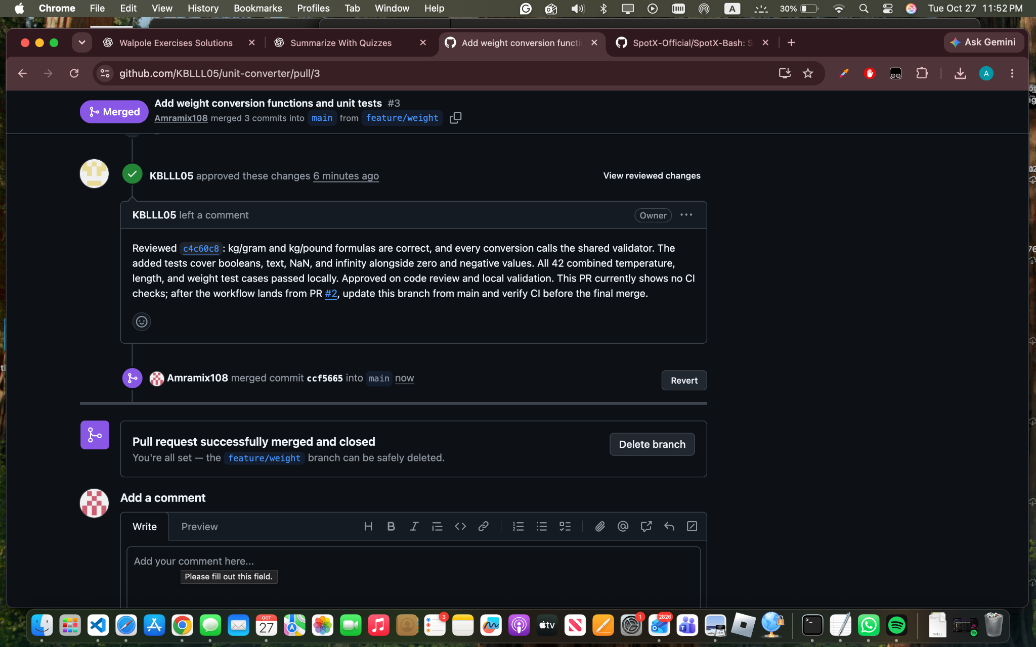
Figure 5. Amr approves the corrected weight feature; GitHub records the merge of PR #3.

4. Merge Conflict
README.md defines the shared line "Project status: Development in progress." A controlled conflict uses two branches from the same main commit, with each member changing that exact line differently. After the first status PR is merged, merging origin/main into the second branch brings the two competing versions together.
The reference example below comes from the separate redaalch/unit-converter repository. It illustrates the conflict markers and the distinction between Current/HEAD, which contains the checked-out branch's status, and Incoming/origin/main, which contains the status already merged into main.
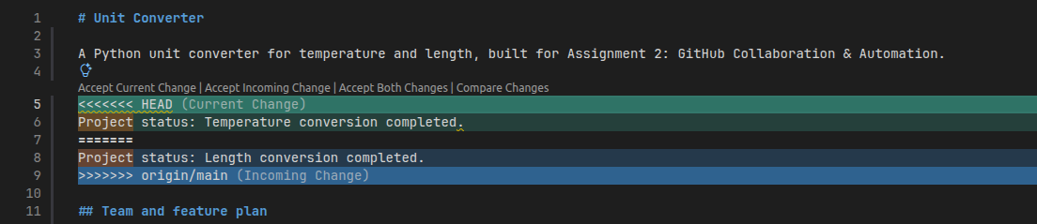
Figure 6. Reference example from redaalch/unit-converter: competing README status lines appear under Current and Incoming markers.
The resolution method is to rewrite the two versions into one sensible status line, remove the markers, stage README.md, and commit and push the resolution on the same branch. In a three-member group, the third member reviews the conflict-resolution PR. A combined status for this project would identify temperature, length, and weight conversion together.

5. Unit Tests
The verified main snapshot, commit 33c4f2e, contains 22 test functions that expand to 42 pytest cases through parameterization. Each member exceeds the three-member requirement of two meaningful tests. Approximate comparisons use pytest.approx for floating-point conversions.
Feature | Test functions | Collected cases
Amr: temperature | 6 | 21
Sara: length | 9 | 11
Mira: weight | 7 | 10
Total | 22 | 42

Case category | Examples covered
Normal behavior | 0 C to 32 F; 1609.344 metres to one mile; 2 kg to 2000 g.
Boundary or edge | Absolute-zero temperatures; zero length and weight; a length round trip.
Invalid input or error | Below-absolute-zero temperatures; negative length and weight; booleans, text, NaN, and infinity. Temperature uses TypeError for nonnumeric inputs and ValueError for non-finite or below-boundary values.

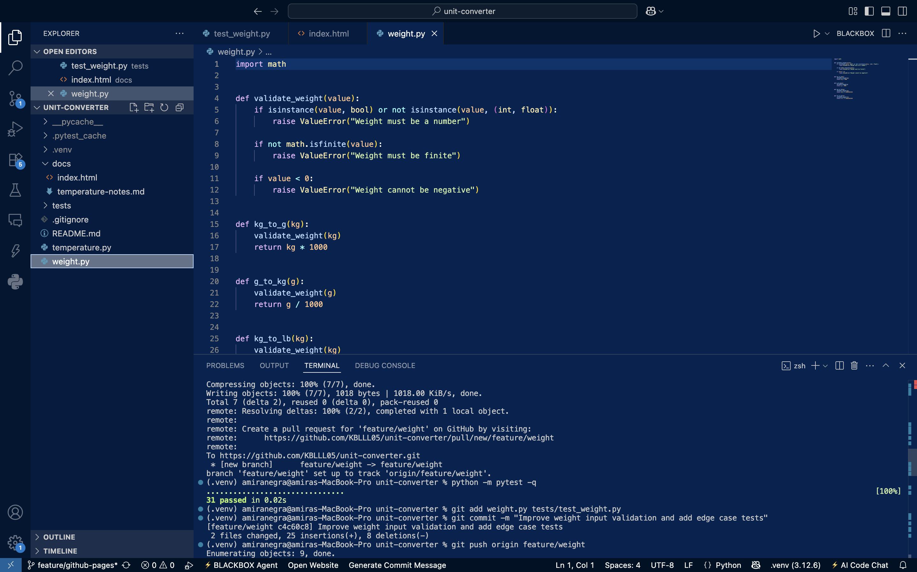
Figure 7. The improved weight validator and a local 31-case result are shown before the length feature is integrated.
The complete main snapshot was verified again locally with Python 3.10.12. GitHub Actions also passed all 42 cases using Python 3.12.15. The local command output was:
$ python3 -m pytest -q
.......................................... [100%]
42 passed in 0.02s

6. Continuous Integration
Sara configured .github/workflows/tests.yml on feature/length. The Python Tests workflow runs on push and pull_request events. Its test job uses ubuntu-latest, checks out the repository, prepares Python 3.12, installs requirements.txt, and executes python -m pytest -v. The workflow uses actions/checkout@v4 and actions/setup-python@v5.
The first workflow commit, 3cc40fc, added an empty workflow file. Run 40574729415 failed before a test job started. Sara corrected the workflow in 6eaead0 on the same branch, after which both push and PR runs succeeded. The later d8b5470 commit added the review-requested invalid-input tests, and the merged main run 40611619519 passed all 42 cases.
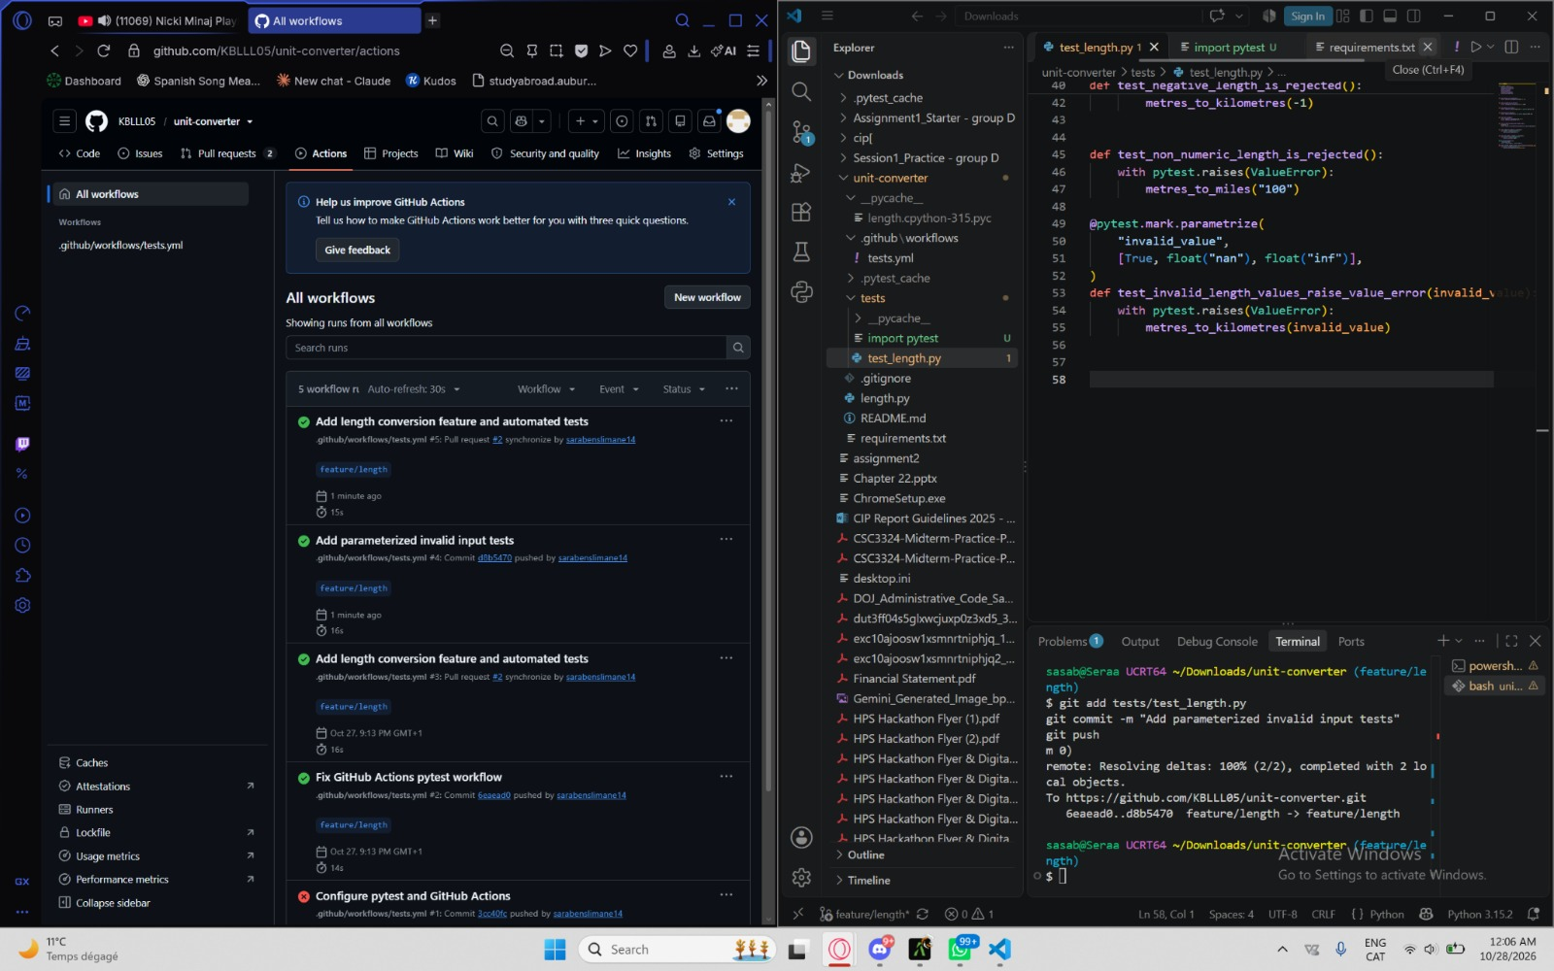
Figure 8. Actions history shows the initial failed configuration and later successful runs beside Sara's added validation tests.
Initial failed workflow run
Successful run after the workflow correction
Successful 42-case main run

7. Ruleset & Protected main
The active Protect main ruleset targets the default branch. It requires a Pull Request with one approving review and blocks branch deletion and force pushes. The weight PR demonstrates the approval requirement: GitHub displayed Review required and prevented merging before an approving review was submitted.
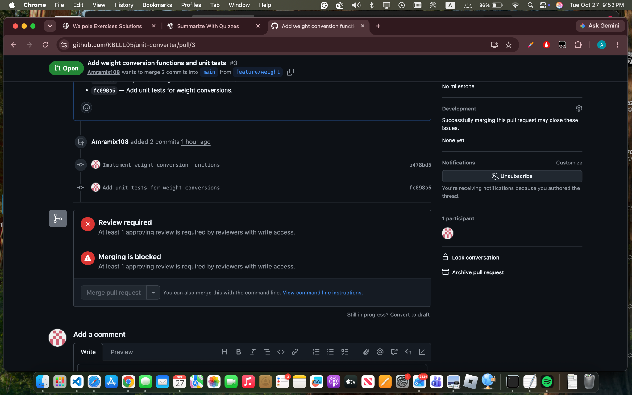
Figure 9. Weight PR #3 is blocked while its required approval is missing.
Amr's later approval satisfied the review requirement for the weight PR. The Actions runs separately record automated test results, including the successful combined suite on main. The ruleset and workflow provide the review and test records used to assess integration changes.
Protect main ruleset

8. Continuous Deployment
Mira created the static project page in docs/index.html on feature/github-pages and committed it as b1f9cd2. The page describes the three conversion features, lists all members and their responsibilities, gives dependency and pytest instructions, and links the repository. She submitted the page through PR #4.
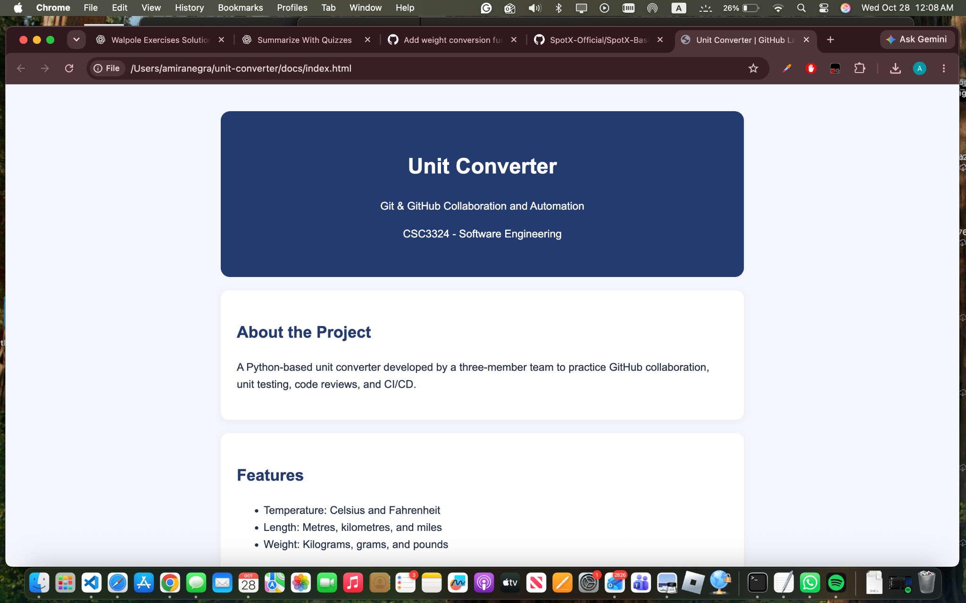
Figure 10. Local browser preview of the project page, showing its title, course, and feature overview.
The page is designed for GitHub Pages publication from main and /docs, with docs/index.html as the entry file. The target address is https://kblll05.github.io/unit-converter/. Publication is verified by checking that a successful Pages build serves the merged page at that address; a later visible change is verified against the next deployment.
Project-page Pull Request #4

9. Contribution Summary
Member | Branches and PRs | Logic and test contribution
Amr Kabelma | feature/temperature; authored PR #1; reviewed PRs #2 and #3. | Bidirectional Celsius/Fahrenheit conversion; 6 test functions / 21 cases; validation and review feedback.
Sara Benslimane | feature/length; authored PR #2; reviewed PRs #1 and #3. | Six length conversion functions; 9 test functions / 11 cases; workflow setup and correction; review-requested tests.
Mira Negra | feature/weight and feature/github-pages; authored PRs #3 and #4; approved PRs #1 and #2. | Four weight conversion functions; 7 test functions / 10 cases; shared validation correction; static project page.

10. Fair Use of AI
AI assistance was used to draft Amr's temperature functions, validation, tests, and feature notes, and to prepare this report. Prompts concerned converter logic, numeric validation, boundary cases, and test documentation. The temperature draft was checked with pytest, and the group evaluated the work through peer reviews, corrections, local test runs, and Actions results. Sara's length tests and Mira's weight validator were updated in response to review feedback. Each member remains responsible for understanding the code, tests, Git commands, and review actions attributed to their account.

11. Sources & Reflection
[1] Course assignment. Assignment 2 - GitHub Collaboration & Automation, including the report template.
[2] Course slides. Session 2 - Collaboration & Automation.
[3] Project repository, PRs #1 to #4, commit history, and Actions runs.
[4] Temperature feature notes: usage, validation, tests, and AI assistance.
[5] Reference example of a controlled README conflict from a separate unit-converter project.
One difficult integration issue was validating unusual numeric inputs consistently across the converters. Sara's review showed that a negative-value check alone did not reject NaN, so Mira added a shared validator and regression tests. If a test or workflow behaved unexpectedly, the group would first inspect the failing input, the checked-out branch, and the workflow definition. For review or publication problems, the first checks would be the required approvals, the merged file location, and the deployment result.

