Home Assistant Entity Analysis & Predictive Automation Report
This enhanced report provides a comprehensive analysis of Home Assistant entity data, complete with charts, tables, and insights.

Entity Type Distribution
This chart shows the number of entities per type (e.g., sensor, update, person).
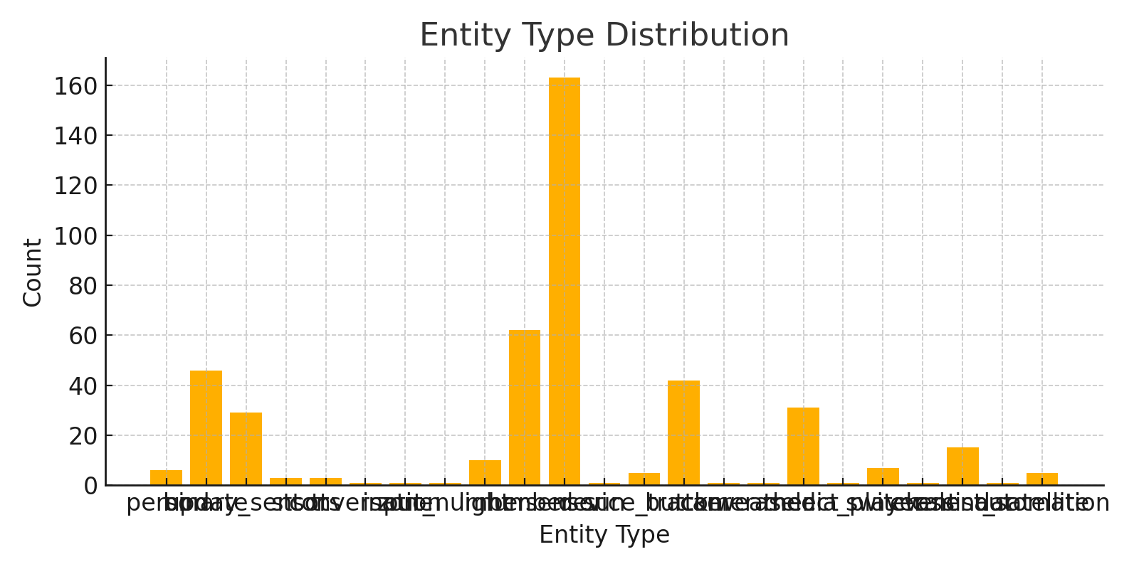

Entity State Distribution
This chart shows how entity states are distributed, highlighting 'unknown', 'on', 'off', etc.
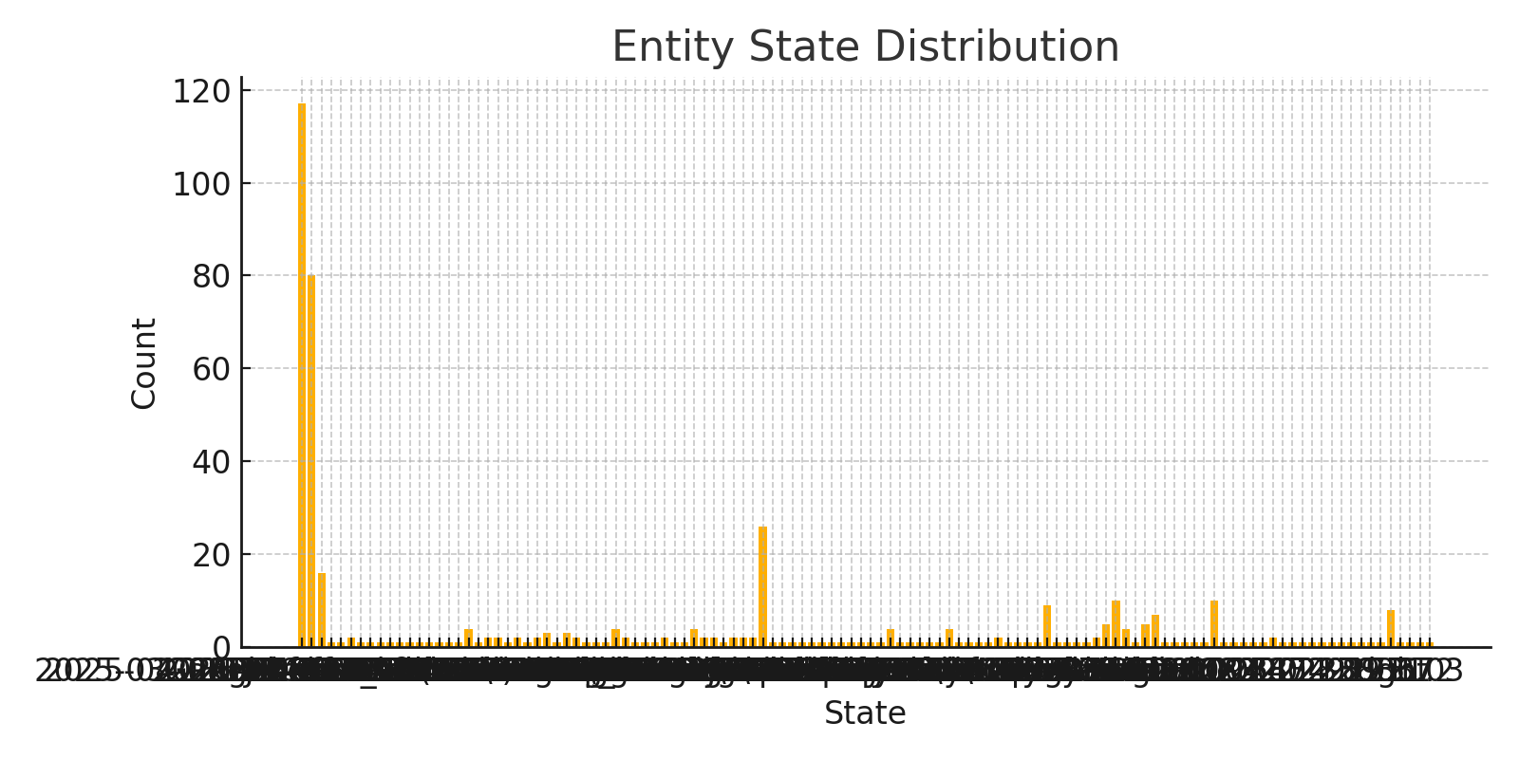

Predictive Trigger Modeling
These are potential automation rules derived from the entity behavior patterns.
Trigger Entity | Action Entity | Suggested Rule
xxx.xxx.x.x Focus | Smart plug LED 1 | If 'xxx.xxx.x.x Focus' changes → then 'Smart plug LED 1' should activate
xxx.xxx.x.x Focus | Smart plug LED 2 | If 'xxx.xxx.x.x Focus' changes → then 'Smart plug LED 2' should activate
xxx.xxx.x.x Focus | smart plug LED 3 | If 'xxx.xxx.x.x Focus' changes → then 'smart plug LED 3' should activate
xxx.xxx.x.x Focus | Home Assistant Voice 093f20 Media Player | If 'xxx.xxx.x.x Focus' changes → then 'Home Assistant Voice 093f20 Media Player' should activate
xxx.xxx.x.x Focus | Home Assistant Voice 093f20 Mute | If 'xxx.xxx.x.x Focus' changes → then 'Home Assistant Voice 093f20 Mute' should activate
xxx.xxx.x.x Focus | Home Assistant Voice 093f20 Wake sound | If 'xxx.xxx.x.x Focus' changes → then 'Home Assistant Voice 093f20 Wake sound' should activate
xxx.xxx.x.x Focus | Home Assistant Voice 093f20 LED Ring | If 'xxx.xxx.x.x Focus' changes → then 'Home Assistant Voice 093f20 LED Ring' should activate
xxx.xxx.x.x Focus | IKEA tradfri driver 1 Light | If 'xxx.xxx.x.x Focus' changes → then 'IKEA tradfri driver 1 Light' should activate
xxx.xxx.x.x Focus | IKEA tradfri driver 2 Light | If 'xxx.xxx.x.x Focus' changes → then 'IKEA tradfri driver 2 Light' should activate
xxx.xxx.x.x Focus | IKEA tradfri driver 3 light | If 'xxx.xxx.x.x Focus' changes → then 'IKEA tradfri driver 3 light' should activate
xxx.xxx.x.x Focus | IKEA tradfri driver laser cutter Light | If 'xxx.xxx.x.x Focus' changes → then 'IKEA tradfri driver laser cutter Light' should activate
xxx.xxx.x.x Focus | IKEA tradfri driver 4 Light | If 'xxx.xxx.x.x Focus' changes → then 'IKEA tradfri driver 4 Light' should activate
xxx.xxx.x.x Focus | Generic Zigbee Coordinator (EZSP) makerspace lights | If 'xxx.xxx.x.x Focus' changes → then ' Generic Zigbee Coordinator (EZSP) makerspace lights' should activate
xxx.xxx.x.x Focus | Smart plug 1 LED | If 'xxx.xxx.x.x Focus' changes → then 'Smart plug 1 LED' should activate
xxx.xxx.x.x Focus | Smart plug LED 2 | If 'xxx.xxx.x.x Focus' changes → then 'Smart plug LED 2' should activate
xxx.xxx.x.x Focus | Library Smart Plug | If 'xxx.xxx.x.x Focus' changes → then 'Library Smart Plug' should activate
xxx.xxx.x.x Focus | smart plug LED 3 | If 'xxx.xxx.x.x Focus' changes → then 'smart plug LED 3' should activate
xxx.xxx.x.x Focus | Generic Zigbee Coordinator (EZSP) makerspace lights | If 'xxx.xxx.x.x Focus' changes → then ' Generic Zigbee Coordinator (EZSP) makerspace lights' should activate
xxx.xxx.x.x Geocoded Location | Smart plug LED 1 | If 'xxx.xxx.x.x Geocoded Location' changes → then 'Smart plug LED 1' should activate
xxx.xxx.x.x Geocoded Location | Smart plug LED 2 | If 'xxx.xxx.x.x Geocoded Location' changes → then 'Smart plug LED 2' should activate

