**Assignment 3 report**

We first analyze the correlation between the features and filter out the features that are highly correlated with revenue for further visual analysis. It can be obtained that the following features are highly correlated with revenue:

From the positive correlation between ratings and income in Figure 1, it can be seen that user satisfaction has a significant impact on the performance of the bank in terms of revenue. Therefore, improving user satisfaction with ATM services can not only enhance the bank's brand image, but also increase ATM usage and revenue. In order to improve the service quality and customer satisfaction of ATM, it can be realized by optimizing the operation process of ATM station and providing better user experience. For example, the maintenance and maintenance of ATM equipment can be strengthened to keep it in good working condition; in addition, some useful interactive functions can be added to the ATM machine, such as voice navigation, advertisement placement, etc., to optimize user experience and improve average length of stay in the bank, and additional service offerings. In conclusion, investing more money and energy in the maintenance and operation of ATM equipment has the potential to bring higher returns.

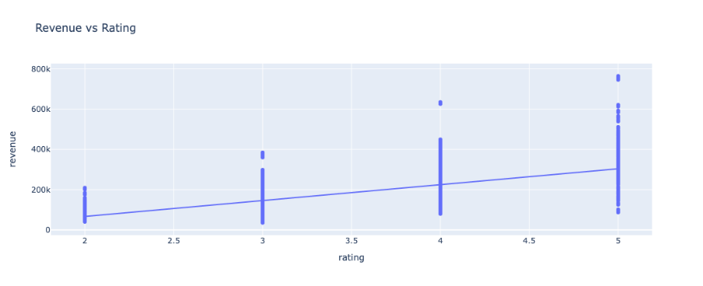

**Figure 1. Scatterplot of Ratings vs Revenue**

Figure 2 describes the relationship between the average waiting time and revenue. We notice that revenue tends to rise when the average wait time is low. However, as the waiting time becomes longer, revenue will start to drop. This result shows that when customers have a shorter waiting time, they are more willing to choose to make transactions at the bank's ATM because they will spend less time waiting. However, if the wait time is too long, customers may start to choose other competitors' services, which will lead to a decline in the bank's ATM usage and corresponding decline in revenue. Therefore, it was crucial for the bank to provide the shortest possible average wait time. To achieve this goal, the bank could consider speeding up the transaction processing speed of ATM machines or increasing the number of ATM machines to serve customers more quickly. In addition, the bank may consider adjusting staffing arrangements during peak periods to better meet customer needs. If the bank can strike a balance between wait time and revenue, it may be able to increase its ATM usage and profitability.

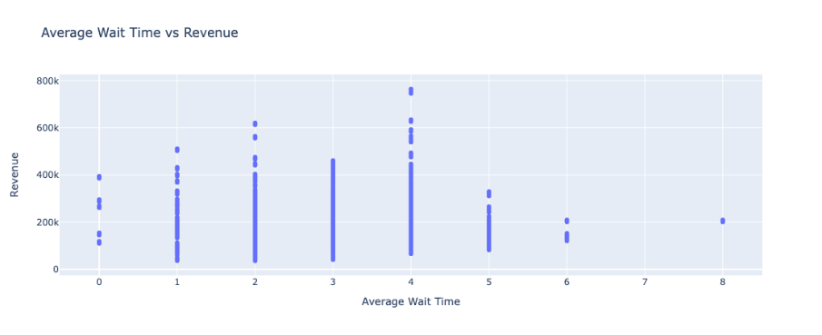

**Figure 2. average wait time vs revenue**

It is worth noting that although there is a certain positive correlation between ATM_Location_TYPE and revenue, it does not mean that all types of ATMs can generate the same high revenue. From the box plot in Figure 3, it can be seen that the average Revenue of Passbook Printing and Withdraw ATMs is relatively high, probably because this type of ATMs are located in places where financial transactions are frequent, such as bank outlets and commercial centers. The Deposit and Withdraw type of ATM is relatively low. The reason may be that it is located in some places with high traffic, but it does not actually cause much actual transaction volume. In addition, ATMs that only provide withdrawal services have some prominent high-income situations, and these places may have more special user needs. Based on these analyzes, we can draw a preliminary conclusion that placing Passbook Printing and Withdraw ATMs in high-traffic financial transaction places may bring relatively good returns.

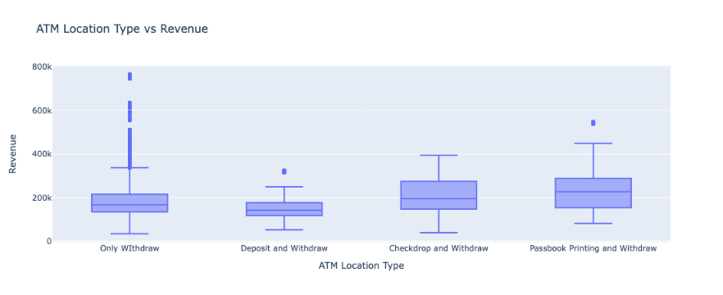

**Figure 3. Different types of ATM locations and income boxes**

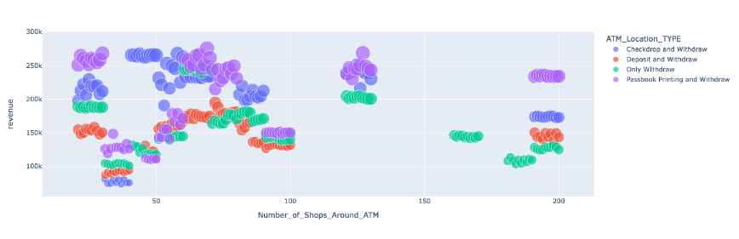

**Figure 4. The impact of the number of stores and different types of ATM locations on revenue**

The analysis results in Figure 4 show that the Passbook Printing and Withdraw and Checkdrop and Withdraw services of the bank’s ATMs seem to be more popular in the areas where the number of stores is between 20-30 and between 60-70, thus bringing higher income. This may be due to the higher foot traffic around these stores. As the number of stores continues to increase, ATM machine performance may encounter some limitations, such as lag in the transaction process or degradation of service quality, which may lead to customer dissatisfaction and reduced revenue. Therefore, in order to maximize the utilization rate and revenue of ATM machines, the bank can consider increasing the number of ATM machines in areas with dense stores to meet the needs of consumers. In addition, the bank may consider cooperating with stores to set up ATM machines around the store to further increase the utilization rate and revenue of ATM machines. In summary, the bank can increase its ATM usage and profitability by providing appropriate and improved service at ATMs around stores.

Based on the above analysis results, it is suggested that the bank could consider the following factors when selecting ATM locations to help the bank increase its ATM utilization rate and revenue, improve user experience and brand image, so as to better compete with other competitors and gain a larger market share:

1. Choose financial transaction places with high traffic flow, such as bank outlets, commercial centers, and areas with dense stores, which can increase the utilization rate and revenue of ATMs.

2. Emphasize the arrangement of Passbook Printing and Withdraw type ATMs, because these ATMs are relatively high in terms of revenue. In addition, additional functions should also be considered, such as foreign currency transactions, mobile phone top-up, etc., to attract more users.

3. Ensure regular maintenance of ATM machines to avoid machine failures and transaction delays, and improve users' transaction experience.

4. Optimize the operation process of ATM and improve service quality, such as providing interactive functions and voice navigation, etc., to further improve customer satisfaction.

5. Fine-tune the number and location of ATM machines, and conduct regular evaluation and optimization based on factors such as the number of stores and the flow of people to maximize revenue.